**TRANSFORM YOUR HOME INTO A SMART**

**LIVING SPACE USING IBM CLOUD FUNCTION FOR IOT**

**DATA PROCESSING.**

**TEAM MEMBER**

**311521205063:Yokeshwaran K**

**Phase 2 Submission Document**

**Project:**Smart home using IBM cloud function for IOT data processing.

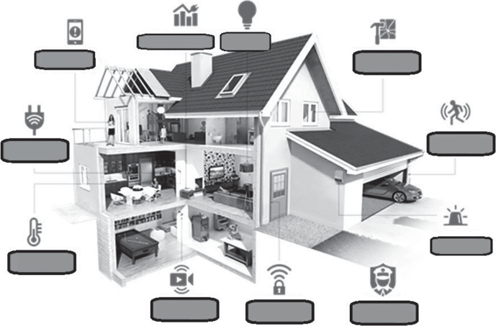

Lighting

control

Energy management

Professional monitoring

Keyless entry

Live video streaming

Temperature control

Alarm activation

Remotely control appliances

Energy and motion detection

Glass breakage detection

Smartphone alerts

**INTRODUCTION:**

With the advancement in science and technology, there have been many ways to improve the quality of life for human beings. The implementation of specific methodologies in terms of electronic assistance had been researched and worked upon to increase the longevity of human life. One of the most popular choices for this goal has been the implementation of smart homes [1], where people with ail- ment have been kept and taken special care. The importance of smart homes lies in the precise monitoring of the people regarding their day-to-day activities to figure out any abnormality in comparison to their normal life. Among the different types of specialized homes designed for monitoring people in commercial and research-based conditions, smart homes for elderly care has been a standout. In these specialized homes, sensors have been positioned at different locations to identify the activities and movements of the residential elderly people.

**CONTENT FOR PROJECT PHASE 2:**

Consider integrating machine learning models to enhance the automation and decision making capabilities of the smart home.

**IOT BASED SMART HOMES:**

The usage of smart sensing devices in the specialized smart homes designed for elderly people have started since the last two decades [4,5], by the time sensors were available commercially to be used for ubiquitous applications. The sensing devices have been implemented in everyday items, forming a cognitive network for the individuals residing in the house to provide an environment for the people to have a happy and independent life. There are some established research works going on around the world that utilizes IoT-based smart sensing devices in these specialized care centres. Some of them are Gator Tech Smart House, University of Florida [6], Smart Community Alliance, Japan [7], KIDUKU, Japan and Ireland [8], Smart homes, UK [9], etc. The ultimate agenda of these projects is to monitor the normal and healthy lifestyle of elderly people residing in these houses. This section defines IoTs, their utilization in smart homes in integration with some of the commercial smart devices and finally some of the research work going on IoT-based smart homes in laboratory-based environment.

IoT is one of the most common concepts of things that are readable, controllable, addressable and locatable via internet in the twenty-first century. All the surroundings of our daily life can be associated with the Internet due to the growing faster computing and communication abilities.shows the schematic diagram of a smart home employed with different IoT connected utilities. IoT based smart homes consist of several sensors, which are connected wirelessly to develop supporting distributed networks. Each IoT-enabled sensor node in the smart home includes three subsystems: (1) sensor subsystem for environment sensing, such as temperature, humidity and light intensity; (2) processing subsystem, consisting a microcontroller and integrated circuit to process the sensor data for computation and (3) a communication subsystem for exchanging the collected data between different sensors.

**1. Fire/Smoke detector:** Fire or smoke detector is one of the essential sensors to build a smart home and to protect the home from fire. The function of the smoke detector is to detect the first sign of fire or smoke almost as quickly as possible and keep the human lives safe. They always create alarm sounds to alert the inhabitants inside the home. Some of the detectors have notification system which can be sent to all the members of the home. The image of a commercial smoke detector that is used in smart homes.

**2. Humidity detector:** Leak sensor is used in a smart home to detect the water leakage in a supply unit. Moisture detection sensors can alert the people to leaks in home so they can fix the problem immediately avoiding any kind of damage. The sensor can be placed around water heaters, dishwashers, refrigerators, sinks, water pumps and anything at risk for water leakage. If the sensor detects unwanted water a notification is sent to the owner of the house, so they can check out the problem quickly and take the necessary actions.shows a commercial humidity detector that is used in smart homes.

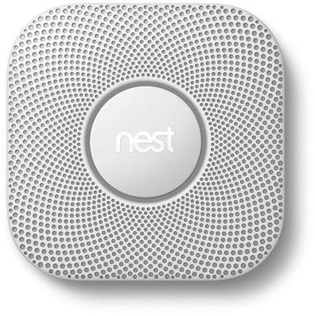

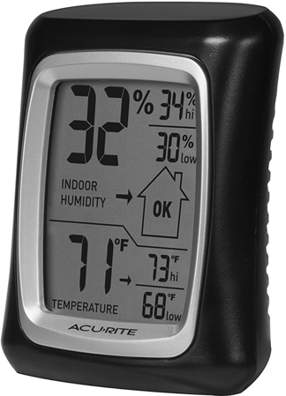**Commercial smoke detectors used in smart homes**

**Commercial humidity detector used in smart homes**

**3. Smart thermostat:** The smart thermostat provides control over the heating and cooling in smart home – from any location. They are always useful to save money by monitoring the temperature and humidity inside and outside of the home. The temperature of a house changes due to the number of reasons and a smart thermostat can adjust the temperature based on behaviour and room usage. The ideal thermostats adjust the room temperature on a room-by-room basis to maintain the ideal temperature when any bodies are in the room and can change the temperature to an energy saving mode when no one is in the room. shows a commercial thermostat that is used in smart homes.

**4. Motion sensors:** A motion sensor detects motion and movement in an area. These sensors can alert immediately if there is any movement within the home, or if the doors or windows have been opened or closed. They can even turn the lights on and off as doors are opened and closed. These sensors work as an extra pair of eyes when nobody stays at home. These sensors are the first line of security for smart home break-ins; some sensors might be useful as they can detect when an intruder breaks a window. They always alert the owner by sending the notifications of potential intruders. They are also useful to save energy and can be connected to lighting or the thermostat to help control the energy usage in a room based on the occupancy of the room. Figure 7.7 shows the motion sensors that are used in smart homes.

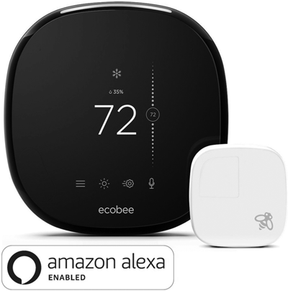**5. Video cameras:** The video cameras allow the owner to visually locate the positions of different people in the house with a smartphone.

**Commercial thermostat used in smart homes**

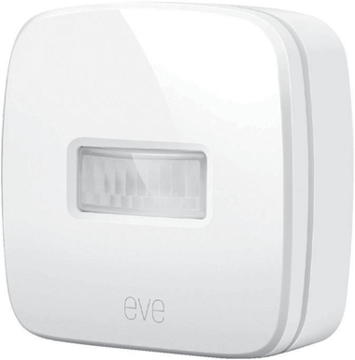

**Motion sensor used in smart homes.**

**MODEL FOR SMART HOMES:**

Continuous research is being done on smart homes with a range of work done on the behaviour detection of the residing people. The wellness determination [25,26] is one such idea where two functions b1 and b2 were introduced to determine the duration of the use of different appliances at a defined time *t*. The time series modelling was applied to determine the updated time parameters and maximum durations in order to analyse the trend in the usage of household objects for past, current and future conditions. Smart homes over the years have conceptualized different models to understand, analyse and predict the behaviour of the residing people [27]. The prediction of data was also performed using support vector.

**PROGRAM:**

const IBMCloudFunctionsAPIKey = 'YOUR_API_KEY';

const IBMCloudFunctionsEndpoint = 'https://openwhisk.ng.bluemix.net/api/v1/namespaces/YOUR_NAMESPACE/actions';

// Simulated thermostat data

const thermostatData = {

temperature: 72,

humidity: 40,

};

// Function to send data to IBM Cloud Functions

async function sendDataToCloudFunctions(data) {

try {

const response = await fetch(IBMCloudFunctionsEndpoint, {

method: 'POST',

headers: {

Authorization: `Basic ${btoa(`apiKey:${IBMCloudFunctionsAPIKey}`)}`,

'Content-Type': 'application/json',

},

body: JSON.stringify({

name: 'processThermostatData',

params: data,

}),

});

if (response.ok) {

console.log('Data sent successfully to IBM Cloud Functions.');

} else {

console.error('Error sending data to IBM Cloud Functions:', response.statusText);

}

} catch (error) {

console.error('An error occurred:', error);

}

}

// Sample IBM Cloud Function for processing thermostat data

async function processThermostatData(params) {

// Add your logic here to process thermostat data in real-time

const { temperature, humidity } = params;

if (temperature > 75) {

// Take action, e.g., adjust the thermostat settings

console.log('Temperature is too high. Adjusting thermostat...');

}

// Add more logic for automation and analysis as needed

return { success: true };

}

// Periodically send thermostat data to IBM Cloud Functions

setInterval(() => {

sendDataToCloudFunctions(thermostatData);

}, 5000); // Send data every 5 seconds (adjust as needed)

**OUTPUT:**

Data sent successfully to IBM Cloud Functions.

Temperature is too high. Adjusting thermostat...

**CHALLENGES AND FUTURE OPPORTUNITIES:**

Even though a lot of work has been done on the different sectors of IoT-based smart homes, there are still some possibilities to improve the existing approach and algorithms. Some of the possible solutions are discussed here. First, the smart homes operating commercially in today’s world are not reachable to the wider range of people but are only accessible to a group of people. One of the major reasons behind this is the cost of living in these homes, which might not be affordable for every person. Second, the information about the advantages of living in these homes should be circulated more among people. The second challenge is the huge amount of data generated in these homes. This requires a lot of memory space in the database, making it difficult to handle it. Algorithms should be developed in such a way that machine learning is done in the most efficient way to determine only the significant data. The third challenge would be the availability of the devices used in the smart homes. Even though some of the commercial devices that are mentioned in this chapter are available to people, they are not being able to comprehend the logic and circuitry of all of them. This makes it difficult for them to use it, in spite of the advantages they provide. The operating principle of the sensing systems should be simple, so that the residing people, especially the elderly ones, are able to comprehend. Another problem with the IoT-based smart homes is the lack of standardization in data collection and processing techniques. Even though so many researchers are working to develop optimized protocols, no standard techniques are yet available to follow.

**CONCLUSION:**

In summary, using IBM Cloud Functions for IoT data processing to transform your home into a smart living space is a smart and efficient way to enhance your home's capabilities. By connecting smart devices, processing data in real-time, automating routines, and storing data for analysis, you can enjoy the convenience and peace of mind that a serverless smart home provides. It's a step towards a more efficient, secure, and user-friendly living environment, making your daily life more comfortable and enjoyable.