class04.R

nancy

2022-10-06

#This is a comment   
x <- 1:50  
plot(x, sin(x))

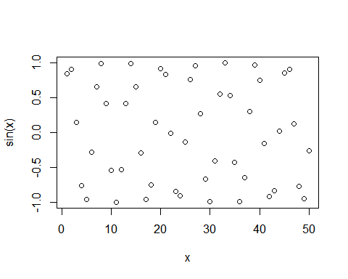

#Add more input  
plot(x,sin(x),type="l",color="blue",lwd=3)

## Warning in plot.window(...): "color" is not a graphical parameter

## Warning in plot.xy(xy, type, ...): "color" is not a graphical parameter

## Warning in axis(side = side, at = at, labels = labels, ...): "color" is not a  
## graphical parameter  
  
## Warning in axis(side = side, at = at, labels = labels, ...): "color" is not a  
## graphical parameter

## Warning in box(...): "color" is not a graphical parameter

## Warning in title(...): "color" is not a graphical parameter

