# GUESS MY NUMBER

# USER MANUEL

**Hüseyin ULAŞ**

# Game Info

The game called “Guess My Number” is played between two people. Players will pick a random four-digit number in their mind of which all digits are different than each other and ask the other player to guess it. After having numbers picked, both players start guessing the other player’s number and after each guess taken, the corresponding player must give a clue so that the process is based on educated guesses rather than random.

# The Rules of Picking a Number

* The numbers players pick should be four-digit number and all digits should be different. For instance, the player can’t pick 1158 since 1 is repetitive digit.
* The first digit shouldn’t be 0 because the number must be a 4-digit and the number starting with 0 can’t be 4-digit.

# How to Give a Clue

* Player A should check any guess taken by the player B with the picked number whether or not there is any same number/digit between the guessed number and picked number. If both the number and the digit placement are matched, a “+1” is added under pro clues. However, if the number is included but in different digit, then a “-1” is added under con clues. For example, player A picks “3065’ and player B guesses “3056”. In this case, the clue player A should give would be “+2, -2”. It is because “3” and “0” are a match for both the number and the digit, however, “5” and “6” are correct numbers but in different digit.
* When a player guesses a number that has a repetitive number in it and if that number is a “+” match (meaning both number and digit placement are correct), then only “+1” is added under pro clues. For instance, player A picks “3065” and player B guesses “3378” where “3” is the repetitive number. In this case, the clue player A should give should be only “+1” for the number “3” that is in the right place even though second number “3” qualifies for “-1” clue.

# Use the Software

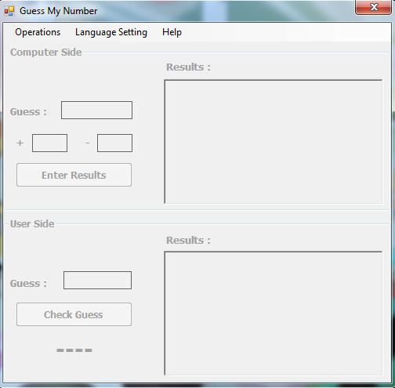

The image of the main screen is shown above. There is a menu at the top of the screen. A detailed description of the menu is available in the following sections.

# Operations Section

The operations menu is as follows.

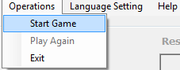

* **Start Game:** This button uses for start the game. After the game starts, this button becomes passive.
* **Play Again:** This button is used to play again after the game is over. This button is passive when the software is first turned on. It becomes active after the game starts.
* **Exit:** This button uses exit the software.

# Language Setting

The language setting menu is as follows.

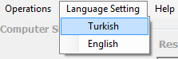

* **Turkish:** Sets the language of the software in Turkish.
* **English:** Sets the language of the software in English.

# Help

The help menu is as follows.

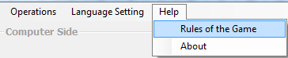

* **Rules of the Game:** The screen showing the rules of the game to the user. The screen view is shown below.

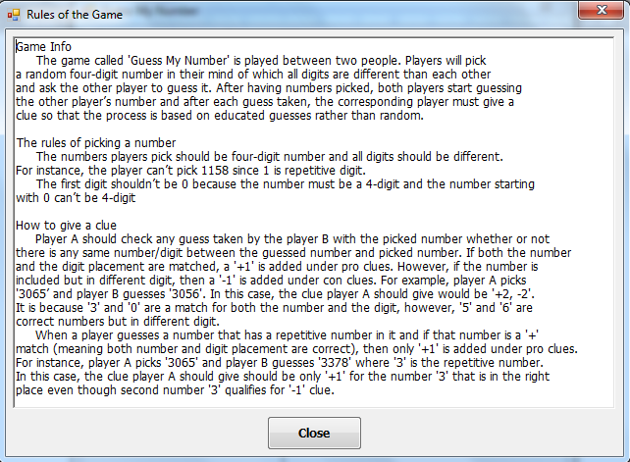

* **About:** Information about the software is shown. The screen view is shown below.

