Servlet, JSP and Spring Core Skill Based Assessment

1. Write a JSP that takes the user’s name and age from a form. -Echo backs the name and age along with a message stating the price of movie tickets. -The price is determined by the age passed to the JSP. -If the age is greater than 62, the movie ticket price is $7.00. -If the user is less than 10 years old, the price is $5.00. -For everyone else, the price is $9.50.

Movie.html

<%@ page language="java" contentType="text/html; charset=ISO-8859-1"

pageEncoding="ISO-8859-1"%>

<!DOCTYPE html PUBLIC "-//W3C//DTD HTML 4.01 Transitional//EN" "http://www.w3.org/TR/html4/loose.dtd">

<html>

<head>

<meta http-equiv=*"Content-Type"* content=*"text/html; charset=ISO-8859-1"*>

<title>Insert title here</title>

</head>

<body>

<form action=*"MovieMain.jsp"* method=*"post"*>

Name:<input type=*"text"* name=*"username"*><br>

age<input type=*"text"* name=*"age"*><br>

<input type=*"submit"* value=*"Submit"*>

</form>

</body>

</html>

MovieMain.jsp

<%@ page language=*"java"* contentType=*"text/html; charset=ISO-8859-1"*

pageEncoding=*"ISO-8859-1"*%>

<!DOCTYPE html PUBLIC "-//W3C//DTD HTML 4.01 Transitional//EN" "http://www.w3.org/TR/html4/loose.dtd">

<html>

<head>

<meta http-equiv=*"Content-Type"* content=*"text/html; charset=ISO-8859-1"*>

<title>Insert title here</title>

</head>

<body>

<jsp:useBean id=*"u"* class=*"jspproject.Details"*></jsp:useBean>

<jsp:setProperty property=*"username"* name=*"u"*/>

<jsp:setProperty property=*"age"* name=*"a"*/>

Name: <jsp:getProperty property=*"username"* name=*"u"*/><br>

Age: <jsp:getProperty property=*"age"* name=*"a"*/><br>

<%Integer age=Integer.parseInt(request.getParameter("age")); %>

<%**if**(age>62){

out.println("Ticket price = $7.00");

}

**else** **if**(age<10){

out.println("Ticket price = $5.00");

}

**else**{

out.println("Ticket price = $9.50");

}

%>

</body>

</html>

Details.java

**package** jspproject;

**public** **class** Details

{

String name;

String age;

**public** String getName() {

**return** name;

}

**public** **void** setName(String name) {

**this**.name = name;

}

**public** String getAge() {

**return** age;

}

**public** **void** setAge(String age) {

**this**.age = age;

}

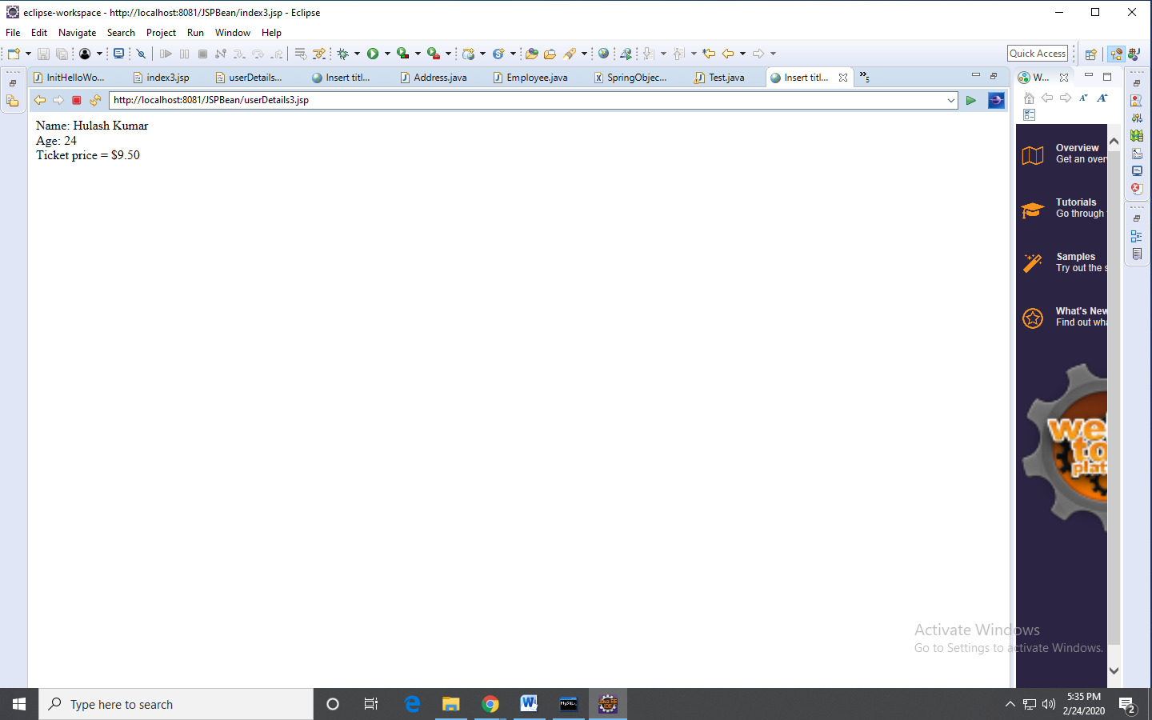}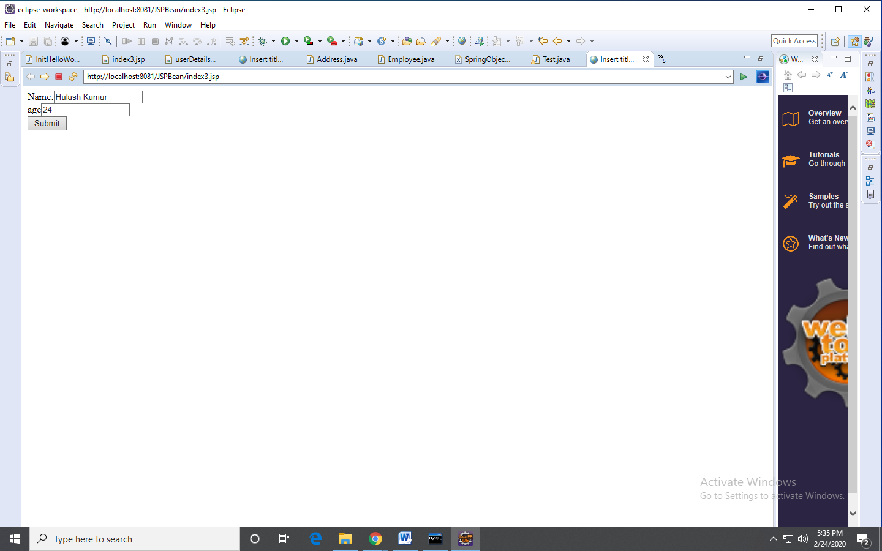

1. Write a spring program which will demonstrates the spring life cycle bean post processor methods.

Employee.java

**package** Assessment;

**public** **class** Employee {

**public** String getName() {

**return** name;

}

**public** **void** setName(String name) {

**this**.name = name;

}

**public** String getDept() {

**return** dept;

}

**public** **void** setDept(String dept) {

**this**.dept = dept;

}

**public** **void** Init() {

System.***out***.println("Initialization of Employee");

}

**public** **void** display()

{

System.***out***.println("name is "+name+"dept is ="+dept);

}

String name,dept;

}

Initebean.java

package Assessment;

import org.springframework.beans.BeansException;

import org.springframework.beans.factory.config.BeanPostProcessor;

public class initebean implements BeanPostProcessor

{

public Object postProcessBeforeInitialization(Object bean,String beanName)

throws BeansException{

System.out.println("Before Initialization");

return bean;

}

public Object postProcessAfterInitialization(Object bean,String beanName)

throws BeansException{

System.out.println("After Initialization");

return bean;

}

}

Bean4.xml

<?xml version = *"1.0"* encoding = *"UTF-8"*?>

<beans xmlns = *"http://www.springframework.org/schema/beans"*

xmlns:xsi = *"http://www.w3.org/2001/XMLSchema-instance"*

xsi:schemaLocation = *"http://www.springframework.org/schema/beans*

*http://www.springframework.org/schema/beans/spring-beans-3.0.xsd"*>

<bean id = *"emp"* class = *"Assessment.Employee"* init-method=*"Init"*>

<property name = *"name"* value = *"Swaroop don "*/>

<property name = *"dept"* value = *"Gang of hyderabad"*/>

</bean>

<bean class= *"Assessment.initebean"* />

</beans>

EmployeeMain.java

package Assessment;

import org.springframework.context.ApplicationContext;

import org.springframework.context.support.AbstractApplicationContext;

import org.springframework.context.support.ClassPathXmlApplicationContext;

import org.springframework.context.support.FileSystemXmlApplicationContext;

public class EmployeeMain {

public static void main(String[] args) {

// TODO Auto-generated method stub

AbstractApplicationContext context = new ClassPathXmlApplicationContext("bean4.xml");

Employee obj1 = (Employee) context.getBean("emp");

obj1.display();

context.registerShutdownHook();

}

}

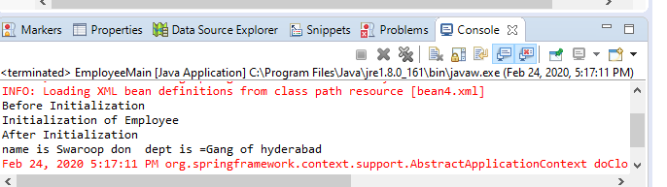

1. Write a simple spring program to implement Dependency injection using constructor method for dependent objects and Map objects.

Map4.java

package Assessment;

import java.util.Iterator;

import java.util.List;

import java.util.Map;

import java.util.Map.Entry;

import java.util.Set;

public class Map4 {

public Map4(int qid, String question, Map<String,String> answers) {

super();

this.qid = qid;

this.question = question;

this.answers = answers;

}

public int getQid() {

return qid;

}

public void setQid(int qid) {

this.qid = qid;

}

public String getQuestion() {

return question;

}

public void setQuestion(String question) {

this.question = question;

}

public Map<String, String> getAnswers() {

return answers;

}

public void setAnswers(Map<String, String> answers) {

this.answers = answers;

}

int qid;

String question;

Map<String, String> answers;

public void displayAnswers() {

System.out.println("QId: "+qid +"Question: "+question);

Set entry=answers.entrySet();

Iterator itr=entry.iterator();

while(itr.hasNext()) {

Map.Entry<String, String> m1=(Entry<String, String>) itr.next();

System.out.println(m1.getValue()+" Answered :"+m1.getKey());

}

}

}

Map4.xml

<?xml version = *"1.0"* encoding = *"UTF-8"*?>

<beans xmlns = *"http://www.springframework.org/schema/beans"*

xmlns:xsi = *"http://www.w3.org/2001/XMLSchema-instance"*

xsi:schemaLocation = *"http://www.springframework.org/schema/beans*

*http://www.springframework.org/schema/beans/spring-beans-3.0.xsd"*>

<bean id = *"Q"* class = *"Assessment.Map4"*>

<constructor-arg value=*"22"*></constructor-arg>

<constructor-arg value=*"What is Java"*></constructor-arg>

<constructor-arg >

<map>

<entry key=*"Java is oops concept"* value=*"Ajay kumar"*></entry>

<entry key=*"Java is a platform Independent"* value=*"Swaroop"*></entry>

<entry key=*"Java has Exception handling"* value=*"Chhota chetan"*></entry>

</map>

</constructor-arg>

</bean>

</beans>

Map4Main.java

package Assessment;

import org.springframework.context.ApplicationContext;

import org.springframework.context.support.ClassPathXmlApplicationContext;

public class Map4Main {

public static void main(String[] args) {

// TODO Auto-generated method stub

ApplicationContext context=new ClassPathXmlApplicationContext("Map4.xml");

Map4 Qm=(Map4) context.getBean("Q");

Qm.displayAnswers();

}

}

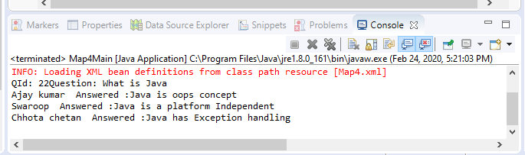

1. Write a spring jdbc program to display all the records from any table from the mysql database.

Student1.java

**package** Assessment;

**public** **class** Student1 {

**public** **int** getId() {

**return** id;

}

**public** **void** setId(**int** id) {

**this**.id = id;

}

**public** **int** getAge() {

**return** age;

}

**public** **void** setAge(**int** age) {

**this**.age = age;

}

**public** String getName() {

**return** name;

}

**public** **void** setName(String name) {

**this**.name = name;

}

**private** **int** id,age;

**private** String name;

}

Student1Dao.java

package Assessment;

import java.util.List;

import Assessment.Student1;

public interface Student1Dao {

//JdbcTemplate JdbcTemplate;

public List<Student1>listStudent1();

/*This is the method to be uswd to delete a record from the Student table*/

}

StudentDaoImpl

package Assessment;

import java.sql.PreparedStatement;

import java.sql.ResultSet;

import java.sql.SQLException;

import java.util.ArrayList;

import java.util.List;

import javax.swing.tree.RowMapper;

import org.springframework.dao.DataAccessException;

import org.springframework.jdbc.core.JdbcTemplate;

import org.springframework.jdbc.core.PreparedStatementCallback;

import org.springframework.jdbc.core.ResultSetExtractor;

//import org.springframework.jdbc.core.RowMapper;

import Assessment.Student1;

public class StudentDaoImpl implements Student1Dao {

public void setJdbcTemplate(JdbcTemplate jdbcTemplate) {

this.jdbcTemplate = jdbcTemplate;

}

JdbcTemplate jdbcTemplate;

@Override

public List<Student1> listStudent1() {

// TODO Auto-generated method stub

return jdbcTemplate.query("select * from student1",new ResultSetExtractor<List<Student1>>(){

@Override

public List<Student1>extractData(ResultSet rs) throws SQLException,DataAccessException{

List<Student1> list=new ArrayList<Student1>();

while(rs.next()) {

Student1 e=new Student1();

e.setId(rs.getInt(1));

e.setName(rs.getString(2));

e.setAge(rs.getInt(3));

list.add(e);

}

return list;

}

});

}

}

AssessmentStudent.xml

<?xml version=*"1.0"* encoding=*"UTF-8"*?>

<beans

xmlns=*"http://www.springframework.org/schema/beans"*

xmlns:xsi=*"http://www.w3.org/2001/XMLSchema-instance"*

xmlns:p=*"http://www.springframework.org/schema/p"*

xsi:schemaLocation=*"http://www.springframework.org/schema/beans*

*http://www.springframework.org/schema/beans/spring-beans-3.0.xsd"*>

<bean id=*"ds"* class=*"org.springframework.jdbc.datasource.DriverManagerDataSource"*>

<property name=*"driverClassName"* value=*"com.mysql.cj.jdbc.Driver"*/>

<property name=*"url"* value=*"jdbc:mysql://localhost:3306/cts"* />

<property name=*"username"* value=*"root"* />

<property name=*"password"* value=*"root"* />

</bean>

<bean id=*"jdbcTemplate"* class=*"org.springframework.jdbc.core.JdbcTemplate"*>

<property name=*"dataSource"* ref=*"ds"*></property>

</bean>

<bean id=*"edao"* class=*"Assessment.StudentDaoImpl"*>

<property name=*"jdbcTemplate"* ref=*"jdbcTemplate"*></property>

</bean>

</beans>

StudentMain.java

package Assessment;

import java.util.List;

import java.util.Scanner;

import org.springframework.context.ApplicationContext;

import org.springframework.context.support.ClassPathXmlApplicationContext;

import Assessment.StudentDaoImpl;

import Assessment.Student1;

public class StudentMain {

public static void main(String[] args) {

// TODO Auto-generated method stub

ApplicationContext context=new ClassPathXmlApplicationContext("AssessmentStudent.xml");

//Scanner sc=new Scanner(System.in);

StudentDaoImpl sdao=(StudentDaoImpl) context.getBean("edao");

List<Student1> list = sdao.listStudent1();

for (Student1 s : list) {

System.out.print(s.getId()+" "+s.getName()+" "+s.getAge());

System.out.println();

}

}

}

