Name: DIXIT GURUNG

Class and Section: EGR 223 -02

Instructor: Professor Baine

Laboratory # 7

Laboratory Title: Visualization of the Two-Dimensional CDF/PDF

Date: 03/20/20

**Introduction:**

The main goal of this laboratory is to explore properties of joint and marginal CDF’s and PDF’s. Also, to study 2-D, 3-D plotting, diff and trapz function.

**Procedure and Results:**

The first part of the lab (1-3) was to theoretically and analytically solve for the answers.

**Question1:**

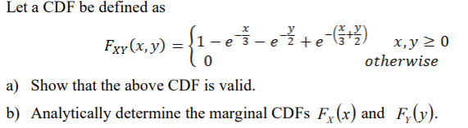

It was found that the given CDF was **valid**, and the marginal CDFs were calculated analytically.

Fx(x)

0 elsewhere

Fy(y)

0 elsewhere

The work for this part can be found in **appendix A** below.

**Question2:**

Consider the PDF associated with the CDF from step (1).

a) Analytically determine an expression for f (x y) XY , and show that it is a valid PDF.

b) Analytically determine the marginal PDFs f (x) X and f (y) Y.

The expression for joint pdf was found to be

fxy(x,y)

1. elsewhere

Double integration of the pdf was equal to 1, Therefore the above pdf is a **valid** pdf.

The marginal PDF’s were found to be

fx(x)

1. elsewhere

fy(y)

1. elsewhere

The work for this part can be found in **appendix A** below.

**Question3:**

Analytically determine if X and Y are independent. Justify your answer.

It was found that X and Y are independent.

The work for this part can also be found in **Appendix A** below.

**Question4:**

Let F (x y) XY , be as defined in step (1). Plot F (x y) XY , over a suitable range of your own choosing making sure that the probability range of 0 to 1 is adequately shown with an appropriate viewing angle (that is, at the corner representing the maximum x and y values, your curve should have a value imperceptibly close to 1; be sure to pick these maximum x and y values such that the curve reaches 1).

The joint CDF was plotted wrt appropriate range of x and y. mesh function was used to obtain the 3D plot. The well labeled plot of the above CDF can be seen in **figure 1** below.

The code for this part can be found in **Appendix B** below.

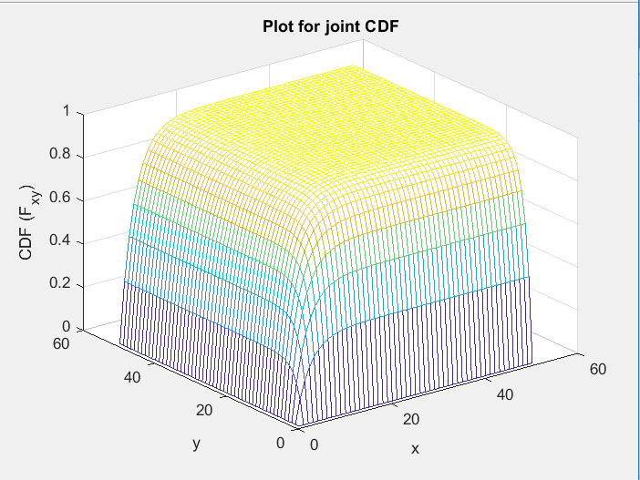

**Figure 1:** 3D plot for joint CDF Fxy(x,y)

**Question5:**

Consider the marginal CDFs F (x) X and F (y) Y :

• Using just your 2-D numerical data from part (4), empirically estimate both of the marginal CDFs and plot them.

• Now, plot your analytical solution for the marginal CDFs. Compare the analytical curve with the one generated from your data; they should agree – do they?

For empirical Fx(x), y was set to infinity and x was ranged from 0 to 50. Then same process was used as question 4 to calculate the marginal CDF. For Fy(y), x was set to infinity and y was ranged from 0 to 50. Next, the analytical marginal CDF equation was plotted and compared with empirical marginal CDF using the subplot feature. The comparison can be seen in **figure 2** below. According to the figure below, the empirical and analytical marginal looks very similar. The code for this portion can be found in **Appendix B** below.

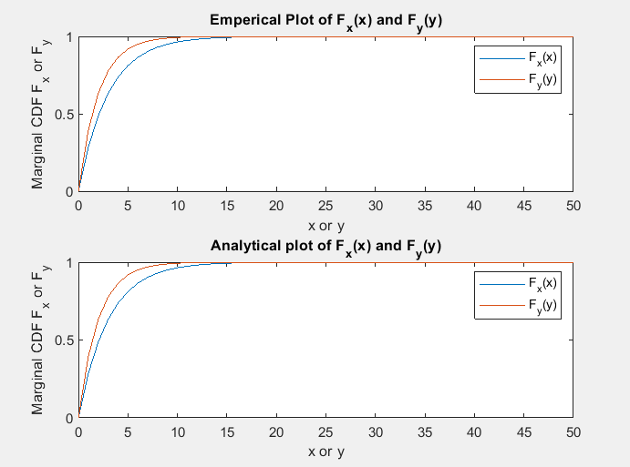

**Figure 2:** Comparison of empirical and analytical marginal CDF’s

**Question6:**

Consider the joint PDF f (x y) XY , :

• Using just your 2-D numerical data from part (4) and the diff command, empirically estimate f (x y) XY , and plot the result.

• Now, plot your analytical solution for the joint PDF. Compare the analytical curve with the one generated from your data; they should agree – do they?

The partial derivatives of above equation was taken to calculate the empirical joint PDF.

Inbuilt diff function was used two times to find the partial derivative. For example, diff(z,1,1) means1st derivative of z w.r.t x. The final output of this part is a matrix with 2 less dimension. This matrix represents the joint PDF. Next, the analytically obtained joint PDF was plotted and compared with the empirical PDF using the subplot feature. Again, the mesh command was used to 3D plot. The comparison can be seen in **figure 3** below. Both plots look very similar. The code for this part can also be found in **Appendix B** below.

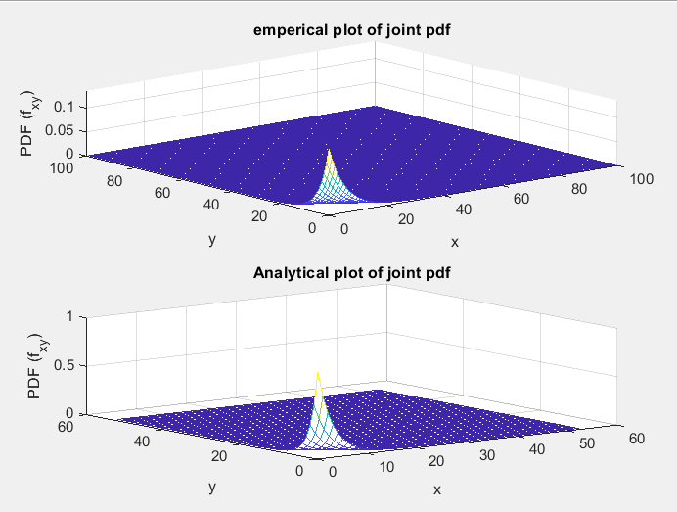

**Figure 3:** Comparison of empirical and analytical joint PDF

**Question7:**

Consider the marginal PDFs f (x) X and f (y) Y :

• Using just your 2-D numerical data from part (6) and the trapz command, empirically estimate the marginal PDFs and plot the result.

• Now, plot your analytical solution for the marginal PDFs. Compare the analytical curve with the one generated from your data; they should agree – do they?

For this part, the above obtained matrix (Joint PDF) was integrated to obtain the desired marginal pdf. For instance, joint PDF was integrated wrt x to obtain fx(x). The trapz function was used to calculate the marginal PDF. Next, the analytical marginal pdf was plotted and compared with empirical marginal PDF using the subplot feature. The comparison can be seen in **figure 4** below. Both plots look very similar. The codes for this part can be found in **Appendix B** below.

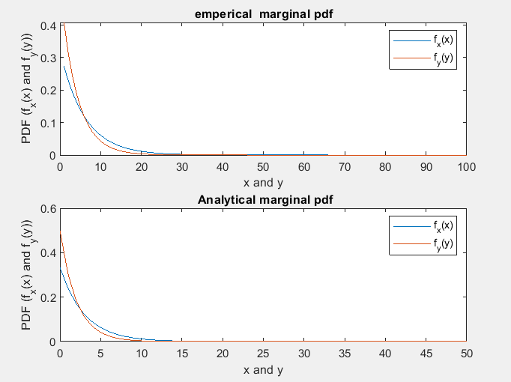

**Figure 4:** Comparison of empirical and analytical marginal PDF.

**Conclusion:**

In brief the whole experiment was a success and went very smoothly and was a good practice for joint CDF, PDF and marginal CDF, PDF. In addition to that I feel very comfortable creating and using 3D plots.

**APPENDIX A**

Pictures of work for question 1 – 3

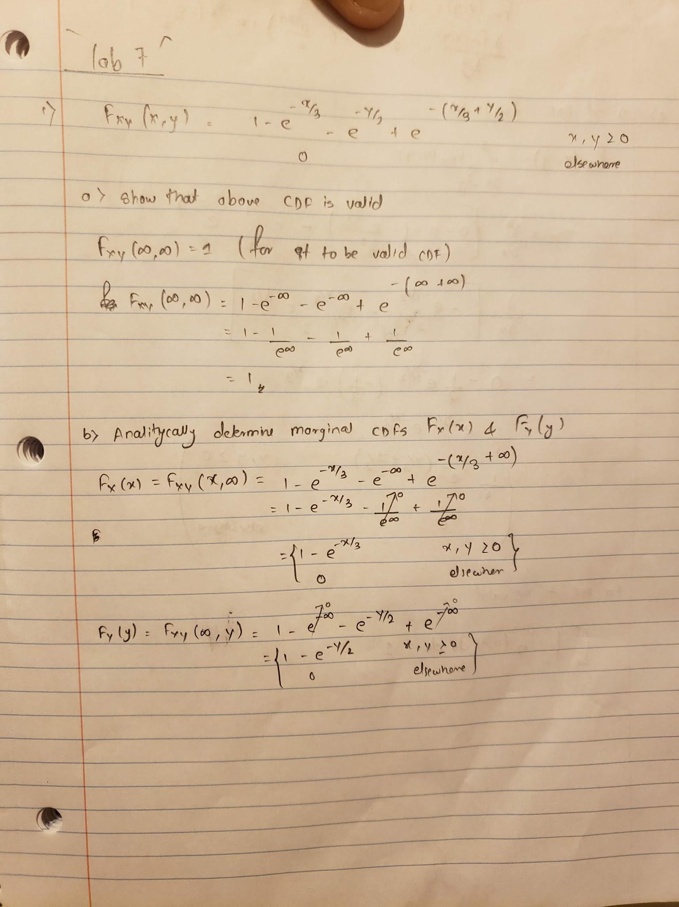

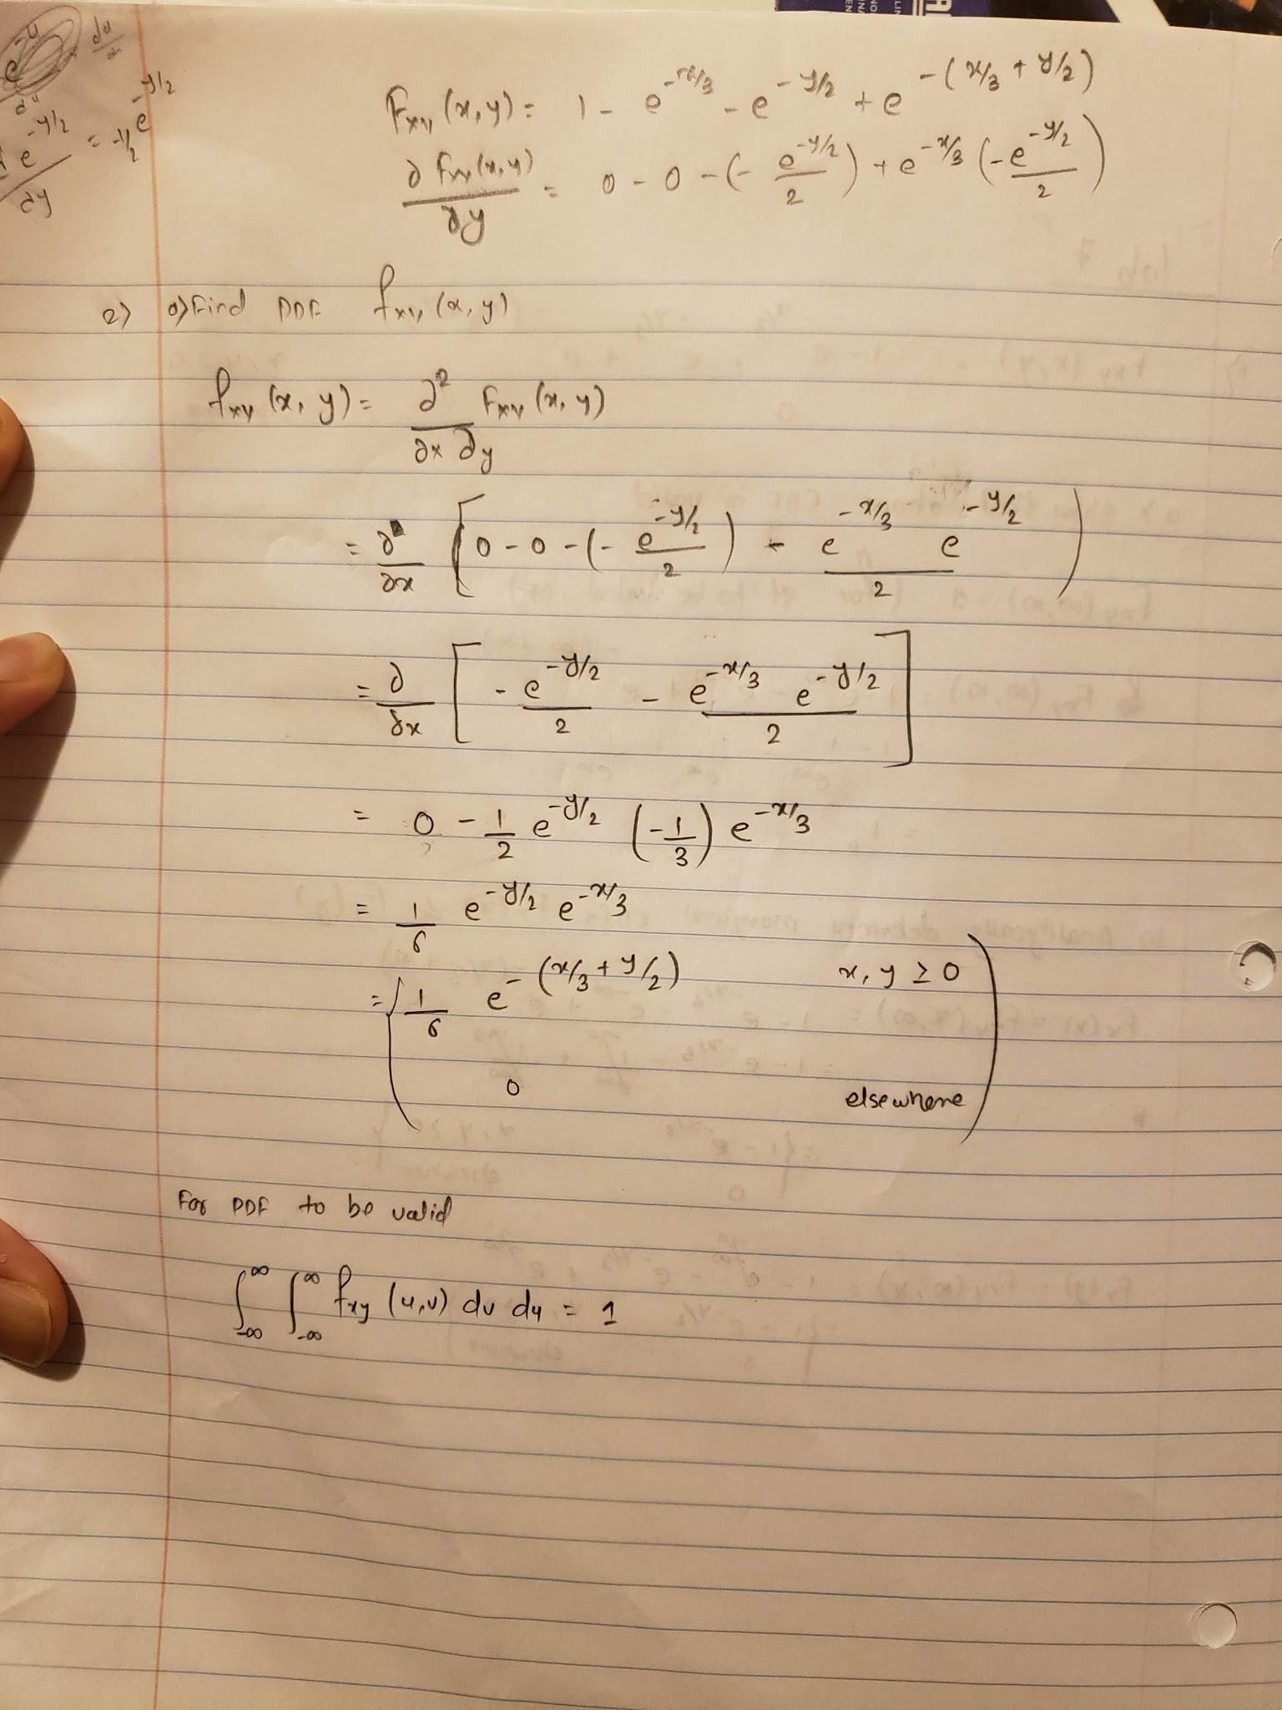

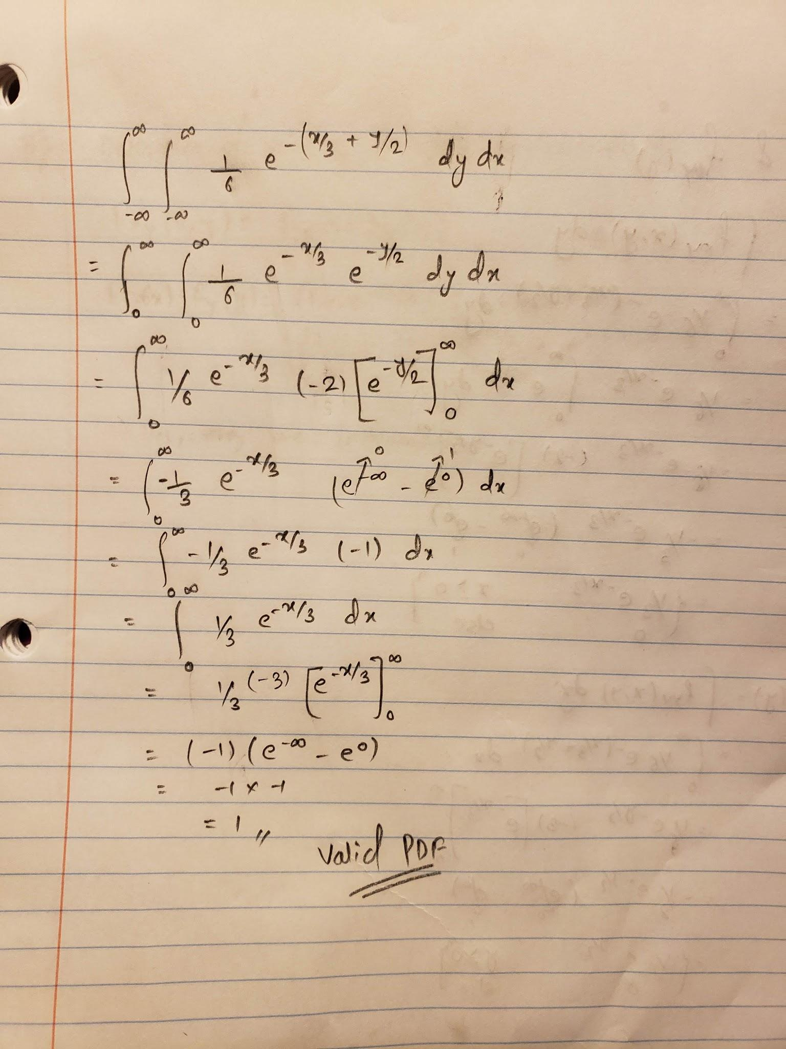

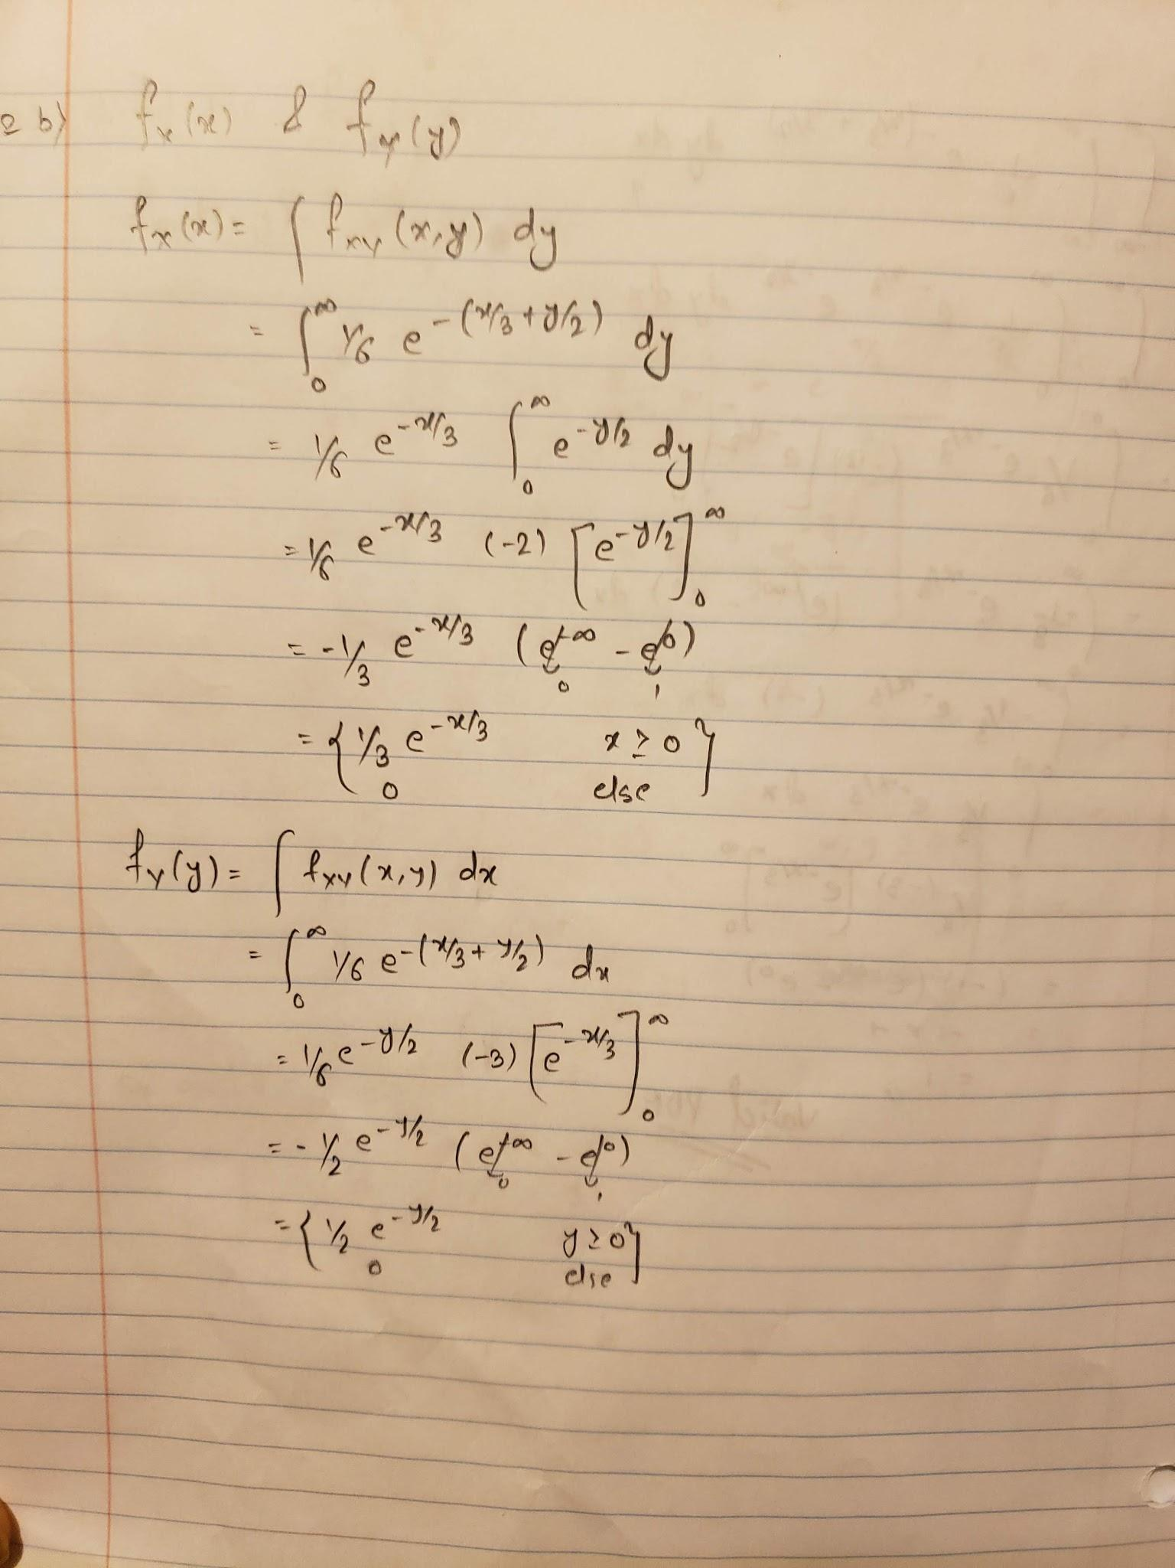

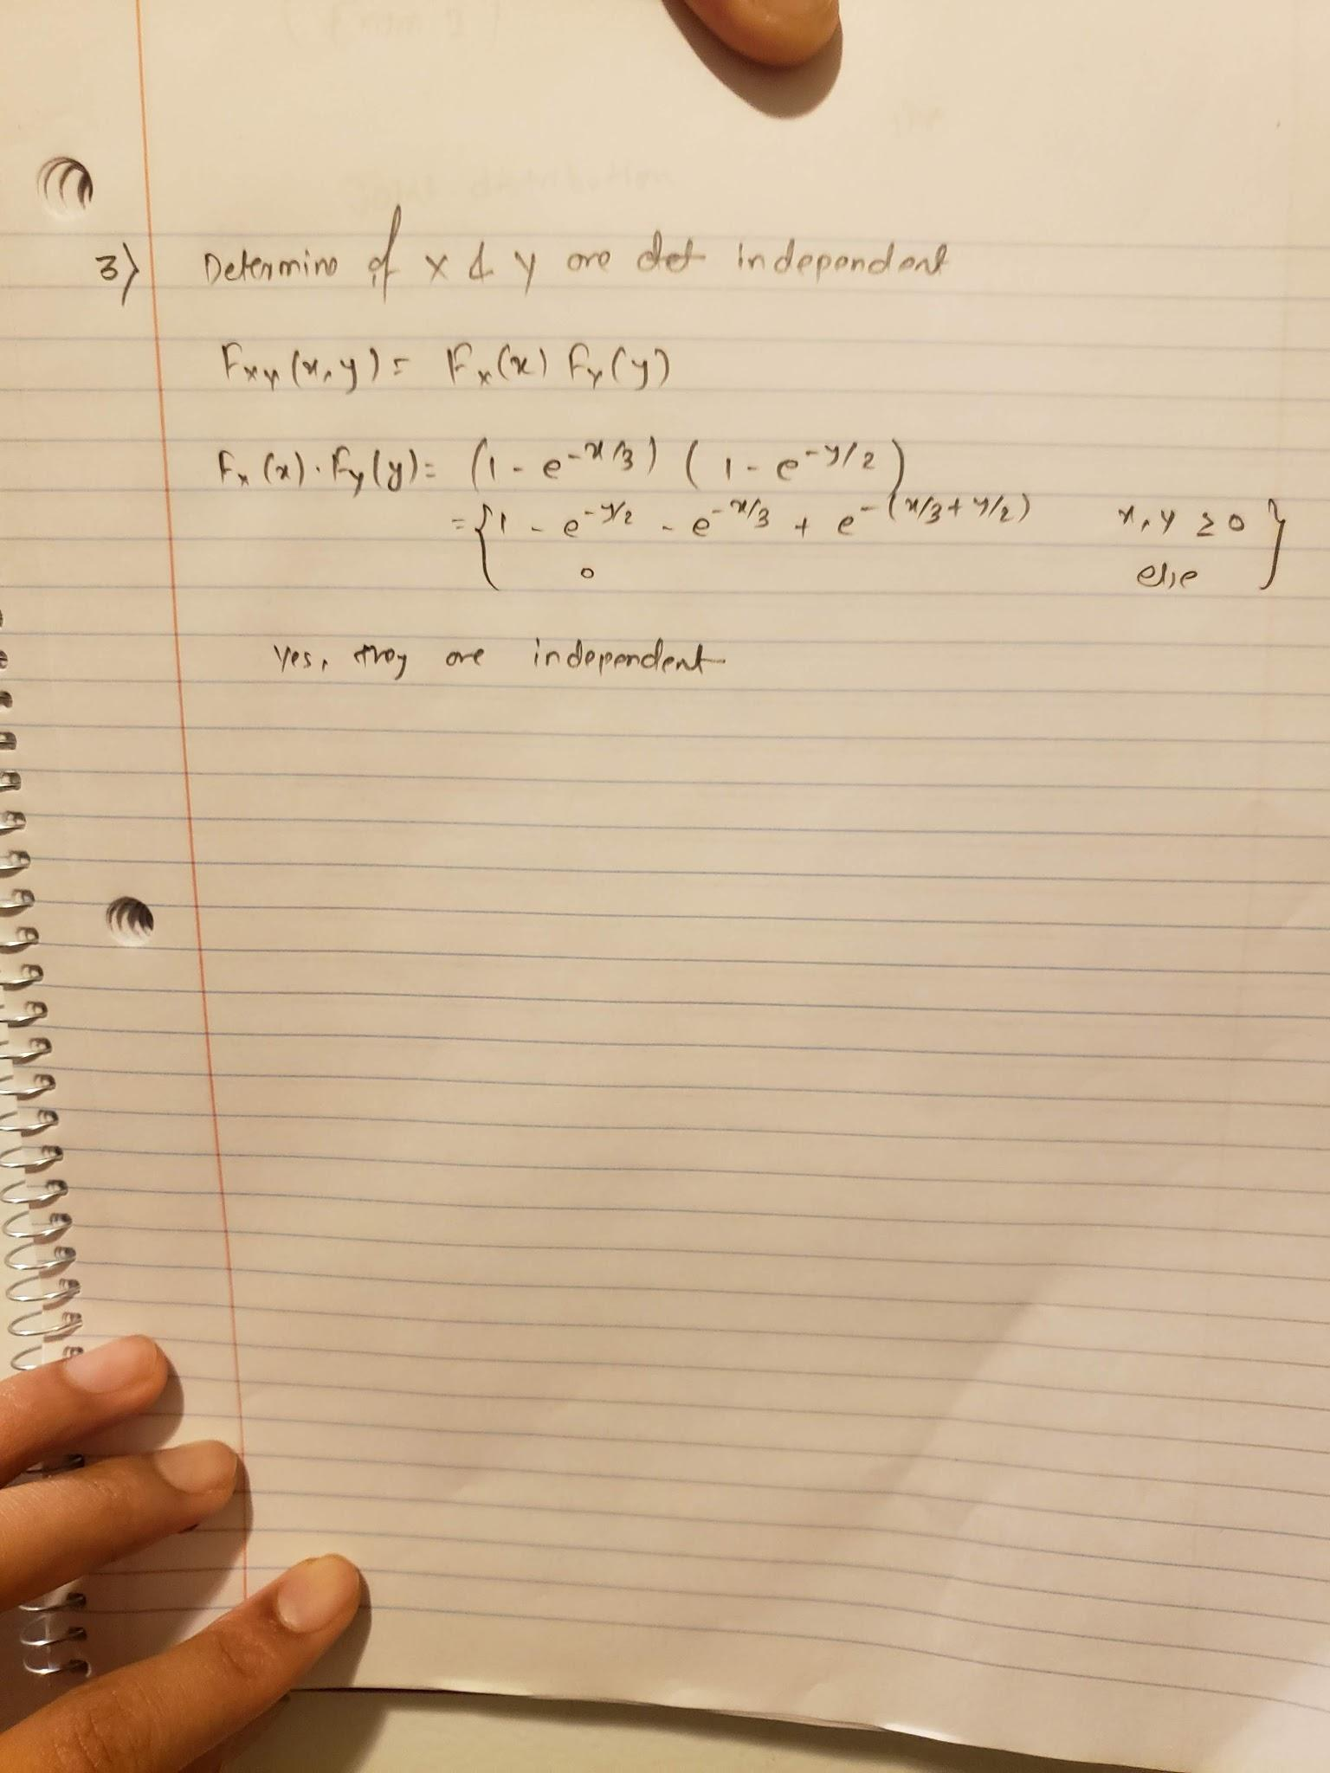

**APPENDIX B**

Lab7.m

%%%%%%%%%%%%%%%%%%%%%%%%%%%%%%%%%%%%%%%%%%%%%%%%%%%%%%%%%%%%%%%%%%%%%%%%%%%

% Title: EGR223-02 Lab 7

% Filename: lab7.m

% Author: Dixit Gurung

% Date: 3/15/2020

% Instructor: Dr. Nicholas Baine

% Description: Exploring Joint CDF , PDF and 3D plots

% note: diff and trapz functions were also explored for derivative and

% integration

%%%%%%%%%%%%%%%%%%%%%%%%%%%%%%%%%%%%%%%%%%%%%%%%%%%%%%%%%%%%%%%%%%%%%%%%%%%

close all

clear all

clc

%Question 4 %%%%%%%%%%%%%%%%%%%%%%%%%%%%%%%%%%%%%%%%%%%%%%%%%%%%%%%%%%%%%%%

[x,y] = meshgrid(0:1:50,0:1:50);

F_xy = 1 - exp(-x/3) - exp(-y/2) + exp(-((x/3)+(y/2)));

figure

mesh(F_xy);

title('Plot for joint CDF');

xlabel('x');

ylabel('y');

zlabel('CDF (F_x_y)');

%Question 5 %%%%%%%%%%%%%%%%%%%%%%%%%%%%%%%%%%%%%%%%%%%%%%%%%%%%%%%%%%%%%%%

%empericl portion

x = 0:1:50;

y = inf;

F_x = 1 - exp(-x/3) - exp(-y/2) + exp(-((x/3)+(y/2)));

figure

subplot(2,1,1);

plot(x,F_x);

% for Fy(y)

x = inf;

y = 0:1:50;

F_x = 1 - exp(-x/3) - exp(-y/2) + exp(-((x/3)+(y/2)));

hold on

plot(y,F_x);

title('Emperical Plot of F_x(x) and F_y(y)');

xlabel('x or y');

ylabel('Marginal CDF F_x or F_y');

legend('F_x(x)','F_y(y)')

hold off

%Analytical solution calculation and plots

x = 0:1:50;

F_x = 1- exp(-x/3);

subplot(2,1,2);

plot(x,F_x);

hold on

y = 0:1:50;

F_y = 1- exp(-y/2);

plot(y,F_y);

title('Analytical plot of F_x(x) and F_y(y)');

xlabel('x or y');

ylabel('Marginal CDF F_x or F_y');

legend('F_x(x)','F_y(y)')

hold off

%Question 6%%%%%%%%%%%%%%%%%%%%%%%%%%%%%%%%%%%%%%%%%%%%%%%%%%%%%%%%%%%%%%%%

%empericl portion

dx = 0.5;

dy = 0.5;

[x,y] = meshgrid(0:dx:50,0:dy:50);

%diff function was used two times for partial derivative

%diff(z,1,1) 1st derivative of z wrt x(1) and y(2)

F_xy = 1 - exp(-x/3) - exp(-y/2) + exp(-((x/3)+(y/2)));

f_x = (diff(F_xy,1,1))/dx; %Partial derivative wrt x

f_xy_pdf = (diff(f_x,1,2))/dy; %Partial derivative wrt y

figure

subplot(2,1,1);

mesh(f_xy_pdf);

title('emperical plot of joint pdf');

xlabel('x');

ylabel('y');

zlabel('PDF (f_x_y)');

view(320,50)

%Analytical solution and plot

[x,y] = meshgrid(-2:1:50,-2:1:50);

fxy = (1/6) * exp(-((x/3)+(y/2)));

subplot(2,1,2);

mesh(fxy);

title('Analytical plot of joint pdf');

xlabel('x');

ylabel('y');

zlabel('PDF (f_x_y)');

%Question 7%%%%%%%%%%%%%%%%%%%%%%%%%%%%%%%%%%%%%%%%%%%%%%%%%%%%%%%%%%%%%%%%

%empericl portion

dx = 0.5;

dy = 0.5;

x = 0:dx:49.5;

y = 0:dx:49.5;

%0-49.5 because of length of x and y should be equal to dimension of f_xy_pdf

%using trapz function to inegrate

fx_pdf = dx * trapz(f_xy_pdf,1); %choosing 2 will integrate over x

fy_pdf = dy * trapz(f_xy_pdf,2); %choosing 2 will integrate over y

figure

subplot(2,1,1);

plot(fx_pdf);

title ('emperical marginal pdf');

xlabel('x and y');

ylabel('PDF (f_x(x) and f_y(y))');

hold on

%mesh(fy_pdf);

plot(fy_pdf);

legend('f_x(x)','f_y(y)')

hold off

%Analyticall solution and plot

x = 0:1:50;

y = 0:1:50;

fx_pdf = (1/3) * exp( (-x/3) );

subplot(2,1,2);

plot(x,fx_pdf);

title(' Analytical marginal pdf');

xlabel('x and y');

ylabel('PDF (f_x(x) and f_y(y))');

hold on

fy_pdf = (1/2) * exp( (-y/2) );

plot(y,fy_pdf);

legend('f_x(x)','f_y(y)')

hold off