Name: DIXIT GURUNG

Class and Section: EGR 223 -02

Instructor: Professor Baine

Laboratory # 3

Laboratory Title: Total Probability Theorem

Date: 01/31/20

Introduction:

The main goal of this laboratory was to practice creating simulations for Total Probability Theorem and Bayes’ Rule. And, explore more on custom made functions in MATLAB.

Procedure:

PRELAB

**Missile target practice problem (discussed in class but restated here with modified numbers): Suppose that independent missiles A, B and C have probabilities 0.52, 0.48 and 0.375 of hitting a practice target, respectively. Assume that the target will be destroyed with probability 0.25 if hit by a single missile, 0.49 if hit with two missiles and 0.88 if hit by all three missiles. Find:**

1. The probability that the target is destroyed

Let   
D = {Target was destroyed}  
H0= {0 missile hit}  
H1= {1 missile hit}  
H2= {2 missile hit}  
H3= {3 missile hit}  
A = {A hit}  
B = {B hit}  
C = {C hit}

From question  
P(A) = 0.52 P(D|H0) = 0  
P(B) = 0.48 P(D|H1) = 0.25  
P(C) = 0.375 P(D|H2) = 0.49  
 P(D|H3) = 0.88

Using Total probability theorem  
P(D) = P(D|H0) P(H0) + P(D|H1) P(H1) + P(D|H2) P(H2) + P(D|H3) P(H3)

P(H0) = p (One missile hit)  
 =P(A`*B`*C`)  
 = 0.48*0.52*0.625  
 = 0.156

P(H1) = (one missile hit)  
 = P(AB`C` + A’BC’ + A’B’C)  
 = 0.4066

P(H2) = (Two missile hit)  
 = P(ABC` + A`BC + ABC`)  
 = 0.3438

P(H3) = (Three missile hit)  
 = P(A) P(A) P(C)  
 = 0.0936

P(D) = P(D|H0) P(H0) + P(D|H1) P(H1) + P(D|H2) P(H2) + P(D|H3) P(H3)  
 = 0.25*0.4066 + 0.49*.3438 + 0.88*0.0936  
 = 0.35248

**b)** The probability that the target is destroyed by a single missile knowing that it is destroyed.  
P(H1|D) =

=

= 0.288

**c)** The probability that the target is destroyed by missile B knowing that it is destroyed.  
P(B|D) = ?

P(B|D) = P(D|B) * P(A) / P(D)

P(D|B) = P(D|H1) P(A’C’) + P(D|H2) (P(A’C) + P(AC’)) + P(D|H3) P(AC)

= 0.49405

**A company producing electric relays has three manufacturing plants producing 33, 42 and 25 percent, respectively, of its product. Suppose that the probabilities that a relay manufactured by these plants is defective are 0.01, 0.005 and 0.03, respectively.**

Let   
A = relay produced by company A   
B = relay produced by company B  
C = relay produced by company C  
D = defective relay

From the question   
P(A) = 0.33 P(D|A) = 0.01  
P(B) = 0.42 P(D|B) = 0.005  
P(C) = 0.25 P(D|C) = 0.03

**a)** P(D) = ?  
P(D) = P(D|A) P(A) + P(D|B) P(B) + P(D|C) P(C)  
 = 0.0129

**b)** P(C|D) = ?

P(C|D) = $\frac{P\left(D | C\right)*P(C)}{P\left(D\right)}$  
 = 0.5814

After solving problem 1 & 2 theoretically, a missile.m function was created as part of pre-lab to simulate a single instance of target practice on the ship. The function accepted 6 parameters the probability of successful strikes for missiles A, B and C and the probabilities of the ship being destroyed if hit by 1, 2 or all 3 missiles. It returned 6 parameters: a series of flag (0 or 1) to indicate if missile A, B or C hit and a flag to indicate the target is destroyed if hit by 1, 2 or 3 missiles. Multiple rand statement was used in this function. These parameter names are described in missile.m file. The detail description of these parameters can be found in missile.m function. The screen shot of this function can be seen in **APPENDIX A** below.

PART 1

The first part of the lab was to create a script file named lab03.m to simulate one instance of the experiment. For this part I choose to simulate 1.b from problem 1 which was finding the probability that the target is destroyed by a single missile knowing that it is destroyed. A for loop was used to run the missile function multiple time. Two conditional statements were used, one to check if **Destroyed_1_flag** is true and another to check any of the destroyed flag is true. If the conditional statements were true, the **Destroyed_1** was used to count number of times the target was destroyed when hit by 1 missile and the **Destroyed** was used to count the total number of times the target was destroyed. The ratio of **Destroyed_1** and **Destroyed** was used to find the probability that the target is destroyed by a single missile knowing that it is destroyed. Then the percentage difference was calculated between the empirical and theoretical values. Finally, the results were printed on the console. The codes and output for this section can be found in **APPENDIX B** below.

PART 2  
The second part of the lab was very similar to part 1, to simulate one instance of simulating the manufacture of the relays. For this part, a function named relay.m was created from the idea of missile.m function. The relay.m had 6 input parameters the probability of company A, B or C manufacturing relay and probability of a relay manufactured by these companies being defective and returns 7 parameters: a series of flag (0 or 1) to indicate if the relay was manufactured in plant A, B or C and a flag to indicate the defective relay was manufactured in plant A, B or C. Since the manufacture of the relay is a disjoint event only one rand was used to assign the active manufacturing plant. And another rand was used to determine if the part was defective. The code for this function can be seen in **APPENDIX A** below.

After creating the relay.m function, code was added in lab03.m script file to simulate one instance of the experiment (Problem 2.b). A for loop was used to run the experiment **L** times. Two conditional statements were used to count the total number of defective relays produced by plant C (**Damage_C**) and total number of defective relay produced by all there plants (**Damage)**. Finally, the ratio of **Damage_C** to **Damage** was used to calculate the probability of relay being defective produced by plant C. The codes and output for this section can be found in **APPENDIX B** below.

**Conclusion**

In brief the whole experiment was a success and went very smoothly and was a good practice for Total probability theorem and Bayes’ rule. In addition to that I feel very comfortable creating and using custom functions. Since I was enjoying the idea of simulating the problem in MATLAB, I simulated all parts of both problems.

**Q&A**

**Compare your results. Do the empirical and theoretical results agree? Why or why not? Briefly discuss.**

For all the simulation, the theoretical and empirical results agree. We know that the theoretical values are correct since it was calculated using Total probability theorem and Bayes’ rule. Also, I double checked with friends. The empirical values were calculated by running the calculation many times (200,000 times). The percentage difference for all the simulation were found to be less than 10%. A screenshot of the output terminal can be seen in **Figure 1** below.

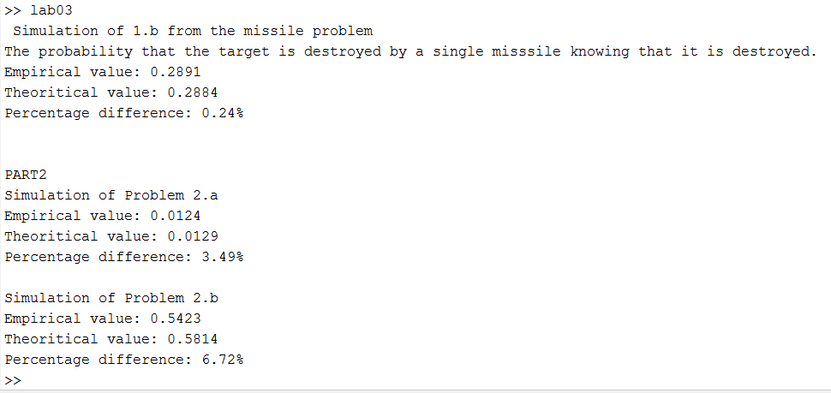

**Figure 1:** Screenshot of the output terminal for all parts

**Do the numbers you obtain make sense? Briefly discuss why the probabilities you arrived at do or do not match what your intuition says they should.**

Yes, all the values made sense. For the first problem (missile problem) I compared the answers with the missile problem that we did in the class. The values were reasonable. Next, for the relay problem, I compared the probability values given in the question and probability I got for answer. They seemed reasonable and the simulation also backed up the theoretical answers.

**APPENDIX A**

Missile.m and relay.m

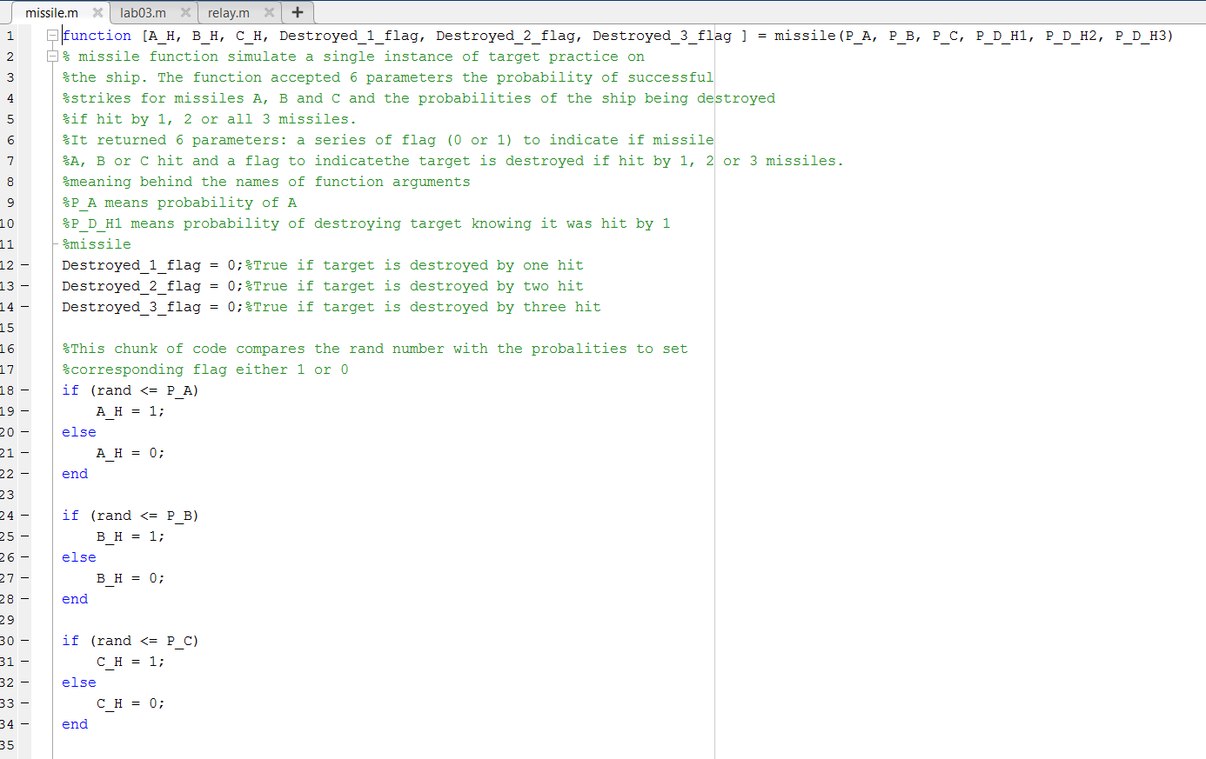

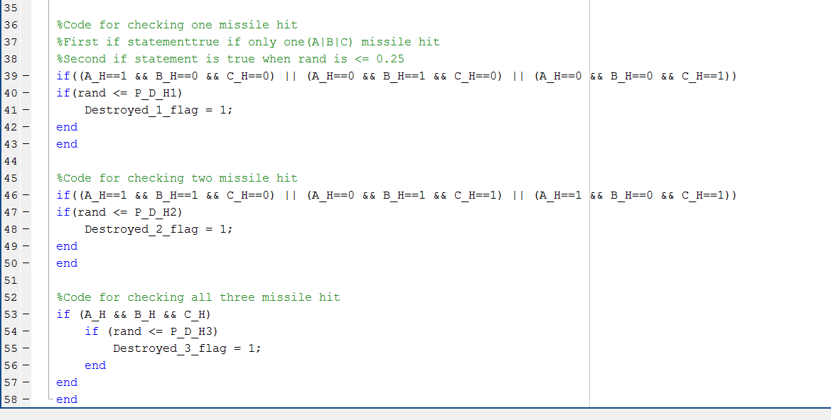

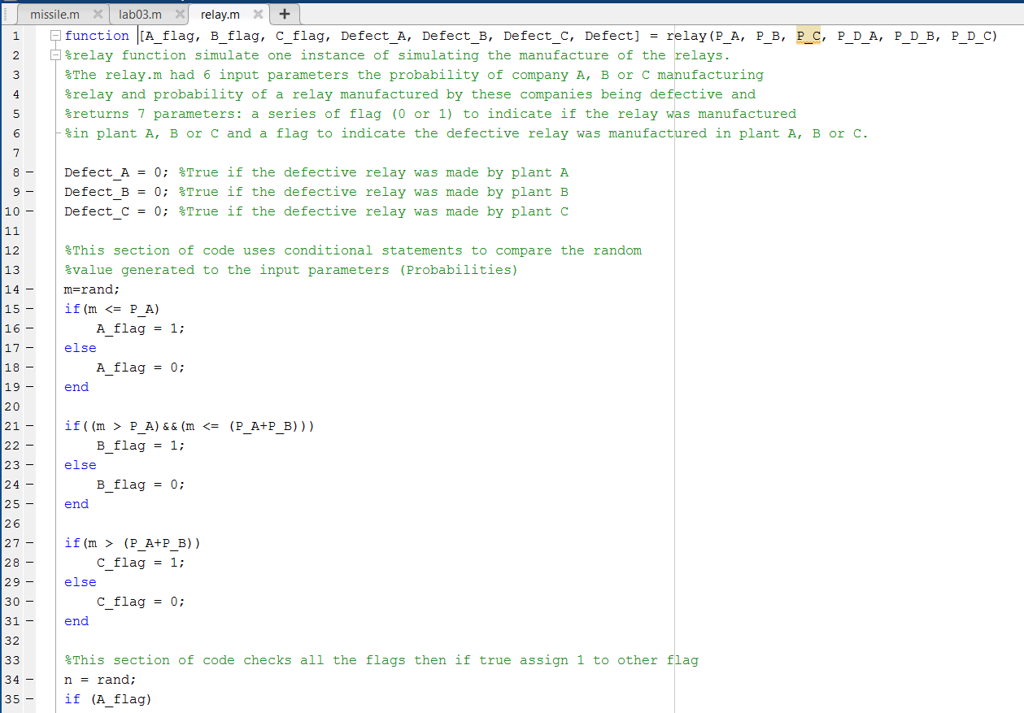

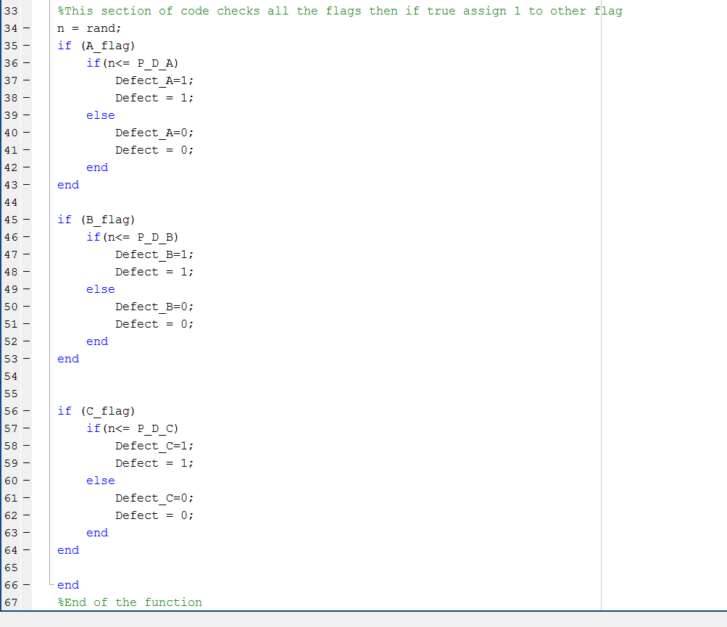

**APPENDIX B**

Lab03.m and the output terminal

%%%%%%%%%%%%%%%%%%%%%%%%%%%%%%%%%%%%%%%%%%%%%%%%%%%%%%%%%%%%%%%%%%%%%%%%%%  
% Title: Lab 03 part 1 and 2  
% Filename: lab03.m  
% Author: Dixit Gurung  
% Date: 1/30/2020  
% Instructor: Prof. N Baine  
% Description: This program uses the missile and relay functions to simulate one of the  
% instance form missile and relay problem. In addition, it also calculate  
% theoritical value and percentage difference between them.  
%NOTE: I choose question 1.b for the simulation part which was finding the  
%probability that the target is destroyed by a single misssile knowing that  
%it is destroyed.  
%%%%%%%%%%%%%%%%%%%%%%%%%%%%%%%%%%%%%%%%%%%%%%%%%%%%%%%%%%%%%%%%%%%%%%%%%%  
  
clear all %Remove items from workspace, freeing up system memory  
rng('shuffle') %seeds the random number generator based on the current time.  
L = 200000; %no of time the experiment is repeated/ used in for loop below  
Destroyed_1 = 0; %Stores the number of time the target was destroyed when hit by single missile  
Destroyed = 0; %Stores the number of time the target was destroyed when hit by 1 or 2 or 3 missiles  
  
%Known values form the question  
P_A = 0.52; %probability of missile A hitting the target  
P_B = 0.48; %probability of missile B hitting the target  
P_C = 0.375; %probability of missile C hitting the target  
P_D_H1 = 0.25; %probability of destroying the target when hit by 1 missile  
P_D_H2 = 0.49; %probability of destroying the target when hit by 2 missile  
P_D_H3 = 0.88; %probability of destroying the target when hit by 3 missile  
  
%This for loop runs for L times and counts the number of times the target  
%was destroyed by one missile and total no of time the target was destoryed  
%using conditional statements  
for i =1: L  
  
[A_H, B_H, C_H, Destroyed_1_flag,Destroyed_2_flag, Destroyed_3_flag ] = missile(P_A, P_B, P_C, P_D_H1, P_D_H2, P_D_H3);  
 if(Destroyed_1_flag)  
 Destroyed_1 = Destroyed_1+1;  
 end  
  
 if(Destroyed_1_flag|| Destroyed_2_flag|| Destroyed_3_flag )  
 Destroyed = Destroyed +1;  
 end  
end  
  
%Probability that the target is destroyed by a single misssile knowing that  
%it is destroyed can be calculated by dividing the total no of times the  
%target was destroyed by one missile by total no of times the target was destroyed.  
P_H1_D_emp = Destroyed_1/Destroyed;  
  
  
  
%Calculating theroitical value for question  
P_H1_D_theory = 0; %term we need to find, Probability that the target is  
 %destroyed by a single misssile knowing that it is hit.  
 % P_D_H1 is given by the question  
P_H1 = 0.4066; %Probability of hitting target by SINGLE missile  
 %Calculated from theory as part of prelab  
P_D = 0.35248; %Probability of DESTROYING the target  
 %Calculated from theory as part of prelab  
  
%Using baye's rule  
P_H1_D_theory = (P_D_H1 * P_H1)/P_D;  
  
%Calculating percentage difference between Emperical and theoritical value  
percentage_diff = 0; %Stores the percenage difference  
  
percentage_diff = ((P_H1_D_theory - P_H1_D_emp)*100)/P_H1_D_theory;  
percentage_diff = abs(percentage_diff);  
  
  
%Printing the the percentage difference, Emperical and theoritical values  
fprintf(' Simulation of 1.b from the missile problem\n');  
fprintf('The probability that the target is destroyed by a single misssile knowing that it is destroyed.\n');  
fprintf('Empirical value: %.4f\n',P_H1_D_emp);  
fprintf('Theoritical value: %.4f\n',P_H1_D_theory );  
fprintf('Percentage difference: %0.2f%%\n',percentage_diff);  
  
  
%PART 2  
%%%%%%%%%%%%%%%%%%%%%%%%%%%%%%%%%%%%%%%%%%%%%%%%%%%%%%%%%%%%%%%%%%%%%%%%%%%  
%%%%%%%%%%%%%%%%%%%%%%%%%%%%%%%%%%%%%%%%%%%%%%%%%%%%%%%%%%%%%%%%%%%%%%%%%%%  
L = 20000;  
P_A = 0.33; %Probability that the rely was manufactured in plant A  
P_B = 0.42; %Probability that the rely was manufactured in plant B  
P_C = 0.25; %Probability that the rely was manufactured in plant C  
P_D_A = 0.01; %Probability of relay produced by plant A is defective  
P_D_B = 0.005;%Probability of relay produced by plant B is defective  
P_D_C = 0.03; %Probability of relay produced by plant C is defective  
  
%Problem 2.a  
%Checking probability of relay being defective  
Damage = 0;  
P_D_emp = 0;  
P_D_theory = 0;  
  
for i = 1:L  
 [A_flag, B_flag, C_flag, Defect_A, Defect_B, Defect_C, Defect] = relay(P_A, P_B, P_C, P_D_A, P_D_B, P_D_C);  
  
 if(Defect == 1)  
 Damage = Damage +1;  
 end  
end  
  
P_D_emp = Damage/L;  
P_D_theory = (P_D_A*P_A)+(P_D_B*P_B)+(P_D_C*P_C);  
  
%calculating %diff  
percentage_diff = ((P_D_theory - P_D_emp)*100)/P_D_theory;  
percentage_diff = abs(percentage_diff);  
  
%Printing the the percentage difference, Emperical and theoritical values  
fprintf('\n\nPART2\n');  
fprintf('Simulation of Problem 2.a\n');  
fprintf('Empirical value: %.4f\n',P_D_emp);  
fprintf('Theoritical value: %.4f\n',P_D_theory );  
fprintf('Percentage difference: %0.2f%%\n',percentage_diff);  
  
%--------------------------------------------------------------------------  
%Problem 2.b  
%Checking probability of relay was manufactured in 3rd plant(C) knowing it  
%was defective  
%In notation P_C_D  
  
P_D = 0.0129; %Calculated from theory as part of prelab  
Damage = 0;  
Damage_C = 0;  
  
for i = 1:L  
 [A_flag, B_flag, C_flag,Defect_A, Defect_B,Defect_C, Defect] = relay(P_A, P_B, P_C, P_D_A, P_D_B, P_D_C);  
  
 if(Defect == 1)  
 Damage = Damage +1;  
 end  
  
 if(Defect_C == 1)  
 Damage_C = Damage_C +1;  
 end  
  
end  
  
P_C_D_emp = Damage_C/Damage;  
P_C_D_theory = (P_D_C*P_C)/P_D;  
  
%calculating %diff  
percentage_diff = ((P_C_D_theory - P_C_D_emp)*100)/P_C_D_theory;  
percentage_diff = abs(percentage_diff);  
  
%Printing the the percentage difference, Emperical and theoritical values  
fprintf('\nSimulation of Problem 2.b\n');  
fprintf('Empirical value: %.4f\n',P_C_D_emp);  
fprintf('Theoritical value: %.4f\n',P_C_D_theory );  
fprintf('Percentage difference: %0.2f%%\n',percentage_diff);

Simulation of 1.b from the missile problem  
The probability that the target is destroyed by a single misssile knowing that it is destroyed.  
Empirical value: 0.2844  
Theoritical value: 0.2884  
Percentage difference: 1.36%  
  
  
PART2  
Simulation of Problem 2.a  
Empirical value: 0.0120  
Theoritical value: 0.0129  
Percentage difference: 6.98%  
  
Simulation of Problem 2.b  
Empirical value: 0.5720  
Theoritical value: 0.5814  
Percentage difference: 1.62%

[*Published with MATLAB® R2018a*](https://www.mathworks.com/products/matlab)