**DIXIT GURUNG**

**EGR 326 901**

**PRELAB 07**

**10/16/20**

**Interfacing a DC Stepper Motor to the MSP432 MCU**

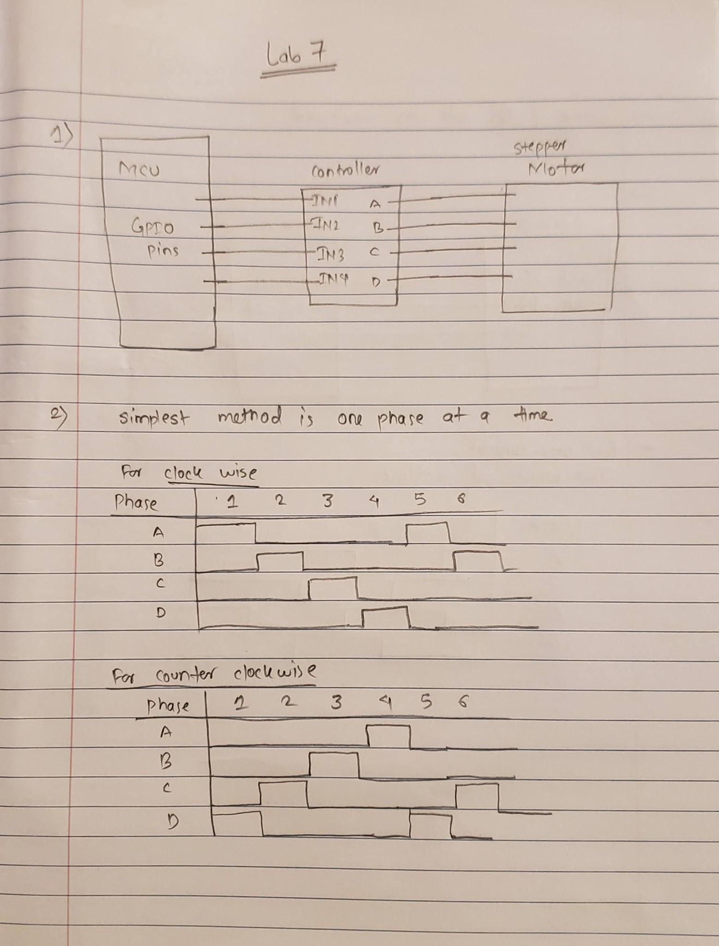

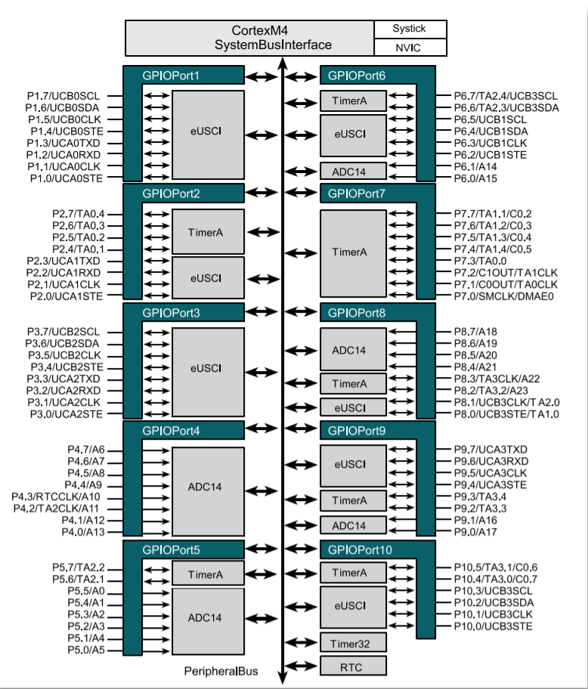

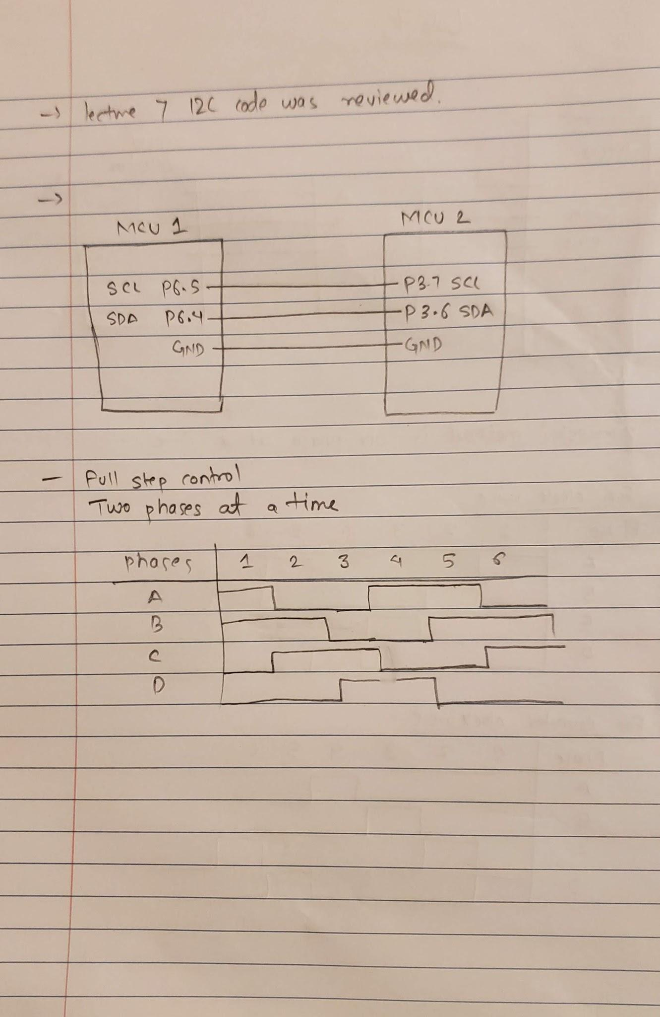

->MC-motor interface schematic and MC-MC I2C interface schematics can be seen in figures above.