**DIXIT GURUNG**

**EGR 326 901**

**PRELAB 06**

**10/09/20**

**Interfacing a Graphic LCD to the MSP432 MCU**

**4)Describe the features of the control module and how it is used to draw text and bitmapped graphics using a program running on the microcontroller.**

The control module writes data for 16-bit/pixel (RGB 5-6-5-bit input).

**5)Include a schematic diagram showing all wired connections between the MSP432 and the display in your notebook. Be sure to include pin numbers.**

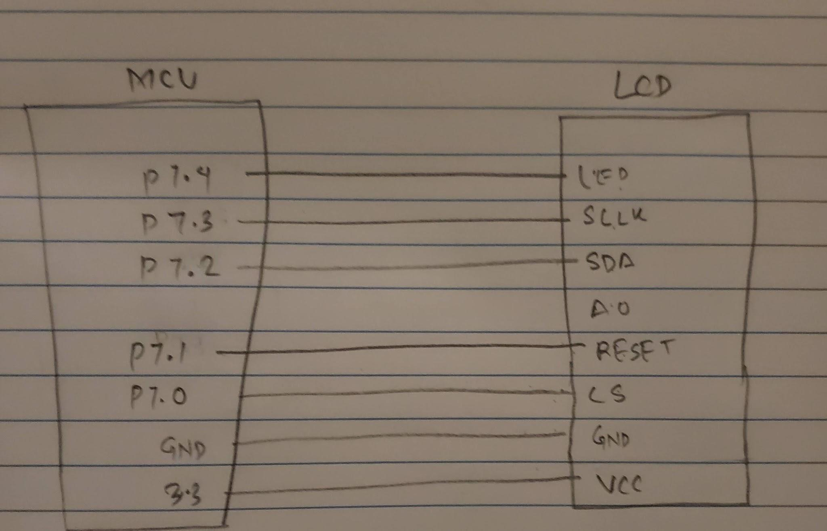

Figure 1: Schematic diagram for interfacing LCD with MCU

**1. What is the name and function of each of the four signals that implement the SPI interface and what pins are connected to the MSP432 eUSCI module? Are all four SPI signals used in the example code?**

The four signals that implement the SPI interface are SCLK, MOSI, MISO, and SS. As per my understanding, the MSP432 has 4 eUSCIA module that supports SPI. Some of the pins that support SPI are P9.5 for CLK, P9.7 for TxD, P9.6 for RxD. Additional pins for SPI can be found in figure 2 below.

In the example, only two of four SPI pins are used, TxD and CLK pins, because we are only transmitting data.

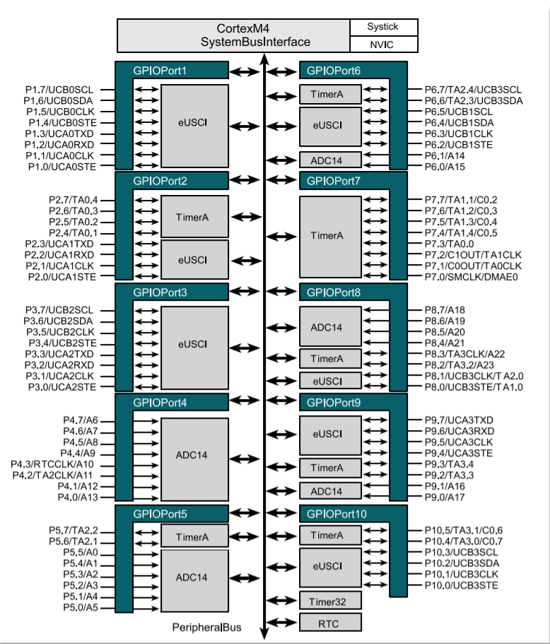

Figure 2: Ports for eUSCIA SPI

**2. In the example code: What is the SPI data rate set up in the MCU? Is the eUSCI configured to use interrupts? What is the format for sending bytes to the display controller?**

BRW is set to 4MHz baud clock.

The eUSCI interrupt is disabled.

The first for sending bytes to the display controller is 16-bit/pixel ( 5-6-5-bit input

