**Progress Report**

**Personal Contribution**

Data Exploration -> I handled missing data as well as one hot encoded non numerical value. I also tried to box plot original numerical values

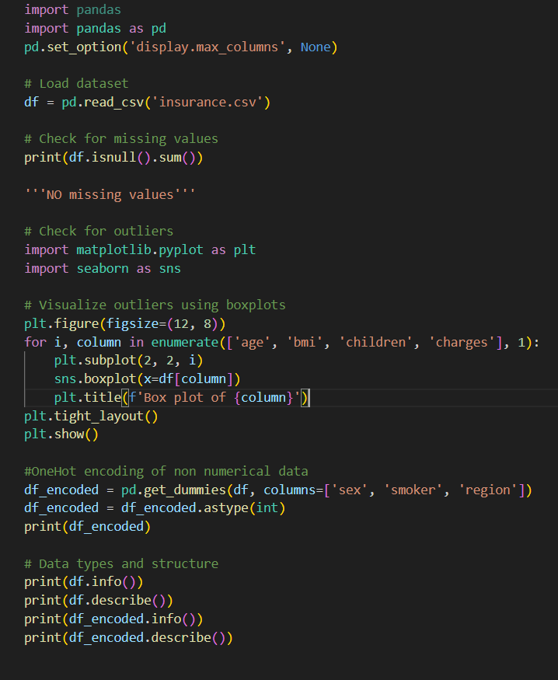Sample code:

I applied Basic Descriptive statistics on the gender, smoker, and region column of our dataset.

These are my temporary findings (Prone to changes).

I am also currently creating code to generate plots for gender, smoker, and region column.  
This is a sample screenshot of my ongoing code.

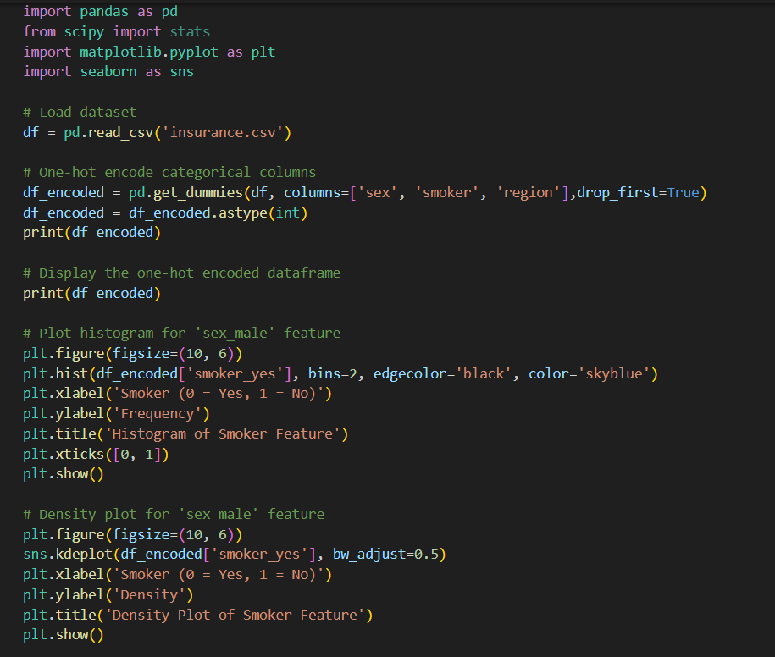

**PROJECT PROGRESS**

Each team members have been given assigned tasks for the project. 3 members are responsible for analyzing the data while 2 members are responsible for creating the presentation. Each data analysis member was given an assignment to generate graphs as well as compute basic descriptive statistics. Right now, we are working on our designated tasks. Each data analysis members are applying statistical methods to analyze their assigned parts. We set the deadline for the data analysis this Thursday so that the 2 members will have time creating the presentation.

This is a glimpse of what our dataset looks like  
