Plotting

HISTOGRAM  
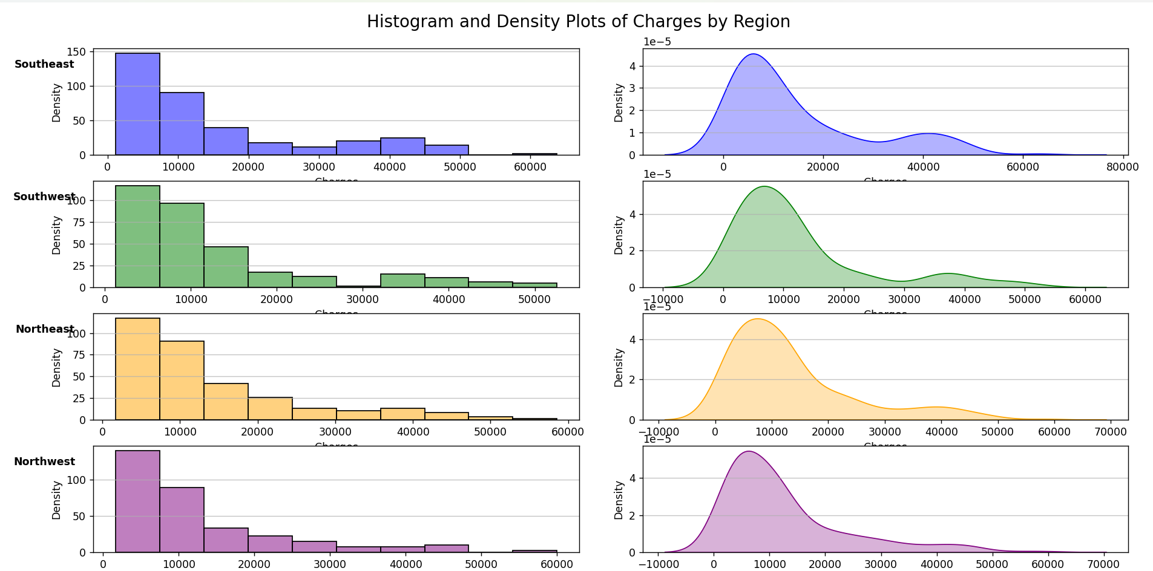

-Charges exhibits a right skewed distribution across regions

-All regions displays a similar pattern where majority of charges leans on the lower range(less than 20000) and few cases leaning on the higher range

BOXPLOT

-All regions have several outliers with charges above 40,000

-The South East region has the highest median charge also has a larger spread which indicates higher variability in charges compared to other regions.