This feature indicates the Gender of the Person represented as binary values.

Unique values: 0 (female), 1 (male)

**Basic Descriptive Statistics**

**Mean**: 0.505232

-indicates that roughly 50.5% of the observations are male (value 1).

- even split between male and female.

**Median**: 1.0

- more than half of the population are male (value 1).

- resulting in a slight skew towards male.

**Mode**: 1

-indicates more male observation than females.

**Standard Deviation**: 0.50016

-indicates a roughly even distribution between the two categories considering that it is binary in nature.

**Variance**: 0.25016

-indicates a balance distribution.

-values are spread closely from the mean.

**Minimum**: 0

**Maximum**: 1

**Range**: 1

**Percentiles (25th, 50th, 75th)**:

**25th Percentile**: 0.0 - at least 25% of observations are female.

**50th Percentile (Median)**: 1.0 - at least half of the observations are male.

**75th Percentile**: 1.0 - 75% of the values are either 1 (male) or 0(female), with most being 1

PLOTTING

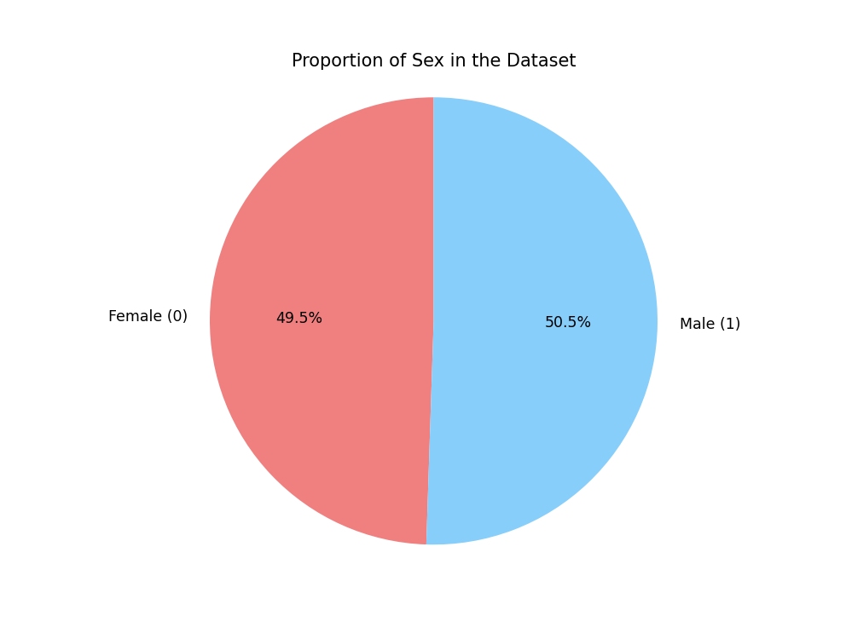

-contains an almost even distribution of males (50.5%) and females (49.5%).

-ensures that analyses between the correlation of sex and charges are not skewed due to underrepresentation of either gender.

The median charges for males are slightly higher compared to females. Outliers are present in both distribution indicating significant number of individuals incur higher charges. The spread of charges for each sex appears to be similar but males tend to have a slightly more variability when it comes to range.