|  |  |  |  |  |
| --- | --- | --- | --- | --- |
| **Name of Team:** Comrades | | | | |
| **First name:**  Bayram Furkan | **Last name:**  Bayar | **York Email:**  [bfurkan@my.yorku.ca](mailto:bfurkan@my.yorku.ca) | **Lecture Section: O** | **Lab Section:** 1 |
| **First name:**  Hulya | **Last name:**  Yasar | **York Email:**  [hulya00@my.yorku.ca](mailto:hulya00@my.yorku.ca) | **Lecture Section: O** | **Lab Section: 1** |
| **First name:**  Muhammed Erdem | **Last name:**  Calikoglu | **York Email:**  [erdem@yorku.ca](mailto:erdem@yorku.ca) | **Lecture Section:**  O | **Lab Section: 1** |
| **First name:**  Spencer | **Last name:**  Samra | **York Email:**  [ss248@my.yorku.ca](mailto:ss248@my.yorku.ca) | **Lecture Section:**  O | **Lab Section: 2** |
| **Project Title:**  What Number Am I Thinking Of? | | | | |
| **Project Description:** The project consists of the computer selecting a random number and the user making a right guess while counting the number of attempts it takes for the right guess. Whilst the project seems hard for the user to guess correctly in a small number of tries, an implementation of hints (most probably after an "n" amount of tries) might lead the user to the correct path. As the project is stating, there is no upper limit which makes it almost impossible, so narrowing it down on each step might increase the enthusiasm of the user to keep trying. | | | | |

**Phase 1**

**Requirements Definition:**

What Number Am I Thinking Of? will be a game that purely depends on the user trying to guess the number selected depending on the different levels of difficulty. For instance, the easy mode will be in a range from 0 to 100, moderate from 0 to 500, and hard will be from 0 to 1000 (bounds are subject to change depending on how testing goes). In each guess, the computer will give hints to the user depending on how close the guess was to the selected number. The user will have a limited amount of attempts to guess the number, if the user cannot make a right guess until the last attempt the program will narrow the bounds down and will try to help the user as much as it can. This number of attempts will change according to the level of difficulty. In each game, the program will keep counting the number of guesses and the time elapsed. All relevant information will be stored in a database, on which the username, amount of guesses, and the time elapsed. This database will be used to generate a leaderboard at the beginning of the program and will get refreshed at the end of the game.

**Project Details**

* Greeting messages will be displayed in the middle of the screen and Leaderboard will be displayed on the top right of the screen. Player have to click “Continue button” on the bottom of the page
* Player page will be shown, and the user need to choose how many players will play game from buttons which displayed on the middle of the page.
  + 1 Player
  + 2 Player
* Mode selection page will be displayed to the user and user needs to choose these modes from buttons which displayed on the middle of the page.
  + Easy Mode (0 - 100)
  + Normal Mode (0-500)
  + Hard Mode (0-1000)
* Game Page will be open
  + Scoreboard on the left top of the page
  + Player Name Display on the middle top of the page
  + Time Counter on the right top of the page
  + Game input button will be middle of the page and Next Button bottom right of the page
  + Game Table (User Guess) on the middle of the page
  + Exit button on the bottom left of the page
  + After the game finishes greeting page will be open

**Phase 2**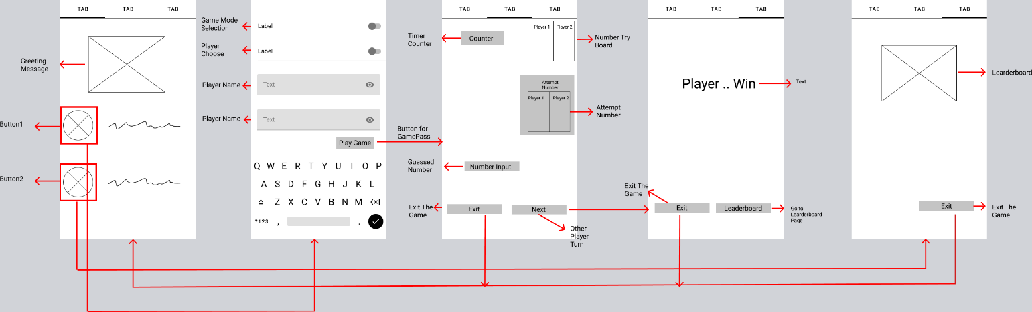

f

Technologies

Firebase Database

Android Studio

Figma

Code Explanation

Public class Game

Game will be on this class

Public Class Main Activity

Parent child relation with others.

Public Class Leaderboard

Input taking name and Points. Sending this information to database. Creating leaderboard

Public Class GameSelection

Input as difficulty,

We can choose who will start first

Difficulties selection

Start guesses

Taking users name

It send all the information to database