National University of Computer and Emerging Sciences
FAST School of Computing — Islamabad Campus
BS (CS) Spring 2026 — Artificial Intelligence Lab

Intelligent Reading Comprehension and Quiz Generation System
Using Traditional Machine Learning

Submitted by:
Student 1 — Huma Taj — 23i0743
Student 2 — Masooma Ali — 23i0623

1. Abstract
This report presents an Intelligent Reading Comprehension and Quiz Generation System built on the RACE dataset using classical Machine Learning. The system integrates two AI pipelines: Model A, which retrieves context-appropriate multiple-choice questions from a RACE pool using TF-IDF cosine retrieval and an LR re-ranker, and verifies user-selected answers using a trained binary classifier; and Model B, which produces plausible distractor options extracted from article sentences and ranked by a Random Forest classifier, and generates graduated hints using a Logistic Regression scorer. The system is exposed through a four-screen Streamlit web application supporting article input, quiz interaction, hint revelation, and an analytics dashboard.
The RACE dataset comprises 87,866 samples split 80/10/10 into training, development, and test sets. Model A employs Logistic Regression, SVM, Naive Bayes, K-Means, GMM, Label Propagation, and a soft-voting ensemble for answer verification. The best supervised result is Logistic Regression + TF-IDF at 0.75 accuracy; the ensemble achieves Macro F1 of 0.471. Model B achieves RF distractor ranker F1 of 0.858 and LR hint scorer accuracy of 0.994. End-to-end NLP evaluation on 200 test samples yields ROUGE-1 of 0.126 for question retrieval, 0.164 for distractor generation, and 0.206 for hint generation.

2. Introduction and Motivation
The rapid growth of educational technology has created demand for intelligent systems capable of automating assessment and learning support. Traditional quiz creation is time-consuming and relies entirely on human instructors. Automated Reading Comprehension (RC) systems offer a scalable alternative that can generate, evaluate, and provide feedback on comprehension questions with minimal human intervention.
This project implements an end-to-end AI-powered Reading Comprehension and Quiz Generation System using the RACE dataset. The system is motivated by three core educational needs:
- Automated question generation reduces instructor workload while maintaining question quality.
- Plausible distractor generation ensures that multiple-choice questions remain challenging and discriminating.
- Graduated hint generation supports self-directed learning by guiding students without giving away answers.

The system runs entirely on classical ML models, making it deployable on standard hardware without requiring GPU inference at runtime. The Streamlit-based UI ensures accessibility for both students and instructors.

3. Related Work

3.1 Dataset
Lai et al. (2017) introduced the RACE dataset, a large-scale reading comprehension benchmark comprising approximately 28,000 passages and 100,000 questions extracted from Chinese middle and high school English examinations. RACE is notable for the high proportion of questions requiring multi-sentence reasoning, making it a challenging benchmark for ML systems [1].

3.2 Question Generation
Du et al. (2017) proposed a sequence-to-sequence neural approach for generating questions from reading passages [2]. Zhao et al. (2018) extended this with paragraph-level generation using gated self-attention networks [3]. Our system instead uses retrieval-based question selection from the RACE pool, which is more reliable than generation under classical ML constraints.

3.3 Distractor Generation
Guo et al. (2016) investigated automated distractor generation for reading comprehension questions, proposing similarity-based candidate ranking [4]. Jiang and Lee (2017) studied distractor quality evaluation protocols [5]. Our approach extracts full sentences from the article as candidates (rather than n-grams) and ranks them with a Random Forest trained on real RACE wrong options.

3.4 Pre-trained Models
Devlin et al. (2019) introduced BERT, establishing new state-of-the-art results across reading comprehension benchmarks [6]. Raffel et al. (2020) proposed T5, applicable to question generation and answering [7]. Our system does not fine-tune these models due to hardware constraints, but their architectures informed our feature engineering choices.

3.5 Evaluation
Papineni et al. (2002) introduced BLEU for automatic evaluation of generated text [8]. Lin (2004) proposed ROUGE for summarization evaluation [9]. Both metrics are used alongside classification metrics in our evaluation framework.

4. Dataset Analysis (EDA)

4.1 Dataset Overview
The RACE dataset was loaded from a single train.csv file and split programmatically into training (80%), development (10%), and test (10%) sets using stratified random sampling. EDA was performed using notebooks/EDA.py.

Metric | Value
Total Samples (train.csv) | 87,866
Training Split (80%) | 70,292
Development Split (10%) | 8,787
Test Split (10%) | 8,787
Columns | id, article, question, A, B, C, D, answer
Missing Values (options A/C/D) | 14 (filled with ‘unknown’)
Average Article Length | 275 words
Average Question Length | 10 words
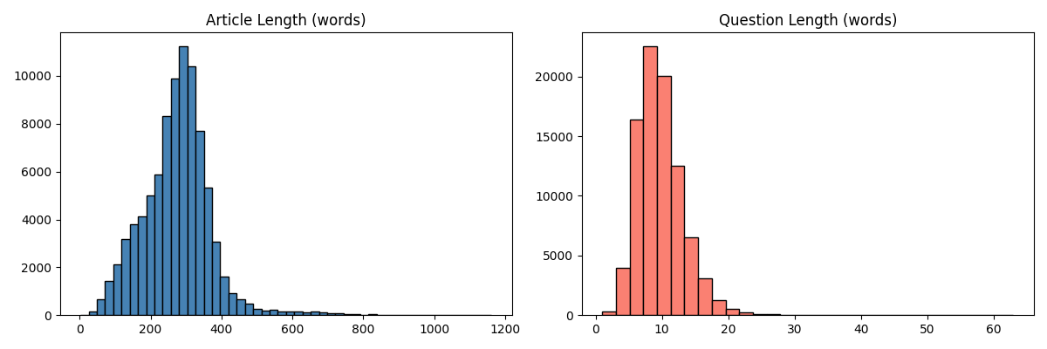

4.2 Answer Distribution
The answer distribution shows a slight imbalance, with option C most frequent and A least frequent. This motivated balanced sampling during training.

Answer Option | Count | Percentage
A | 19,146 | 21.8%
B | 22,726 | 25.9%
C | 23,891 | 27.2%
D | 22,103 | 25.2%
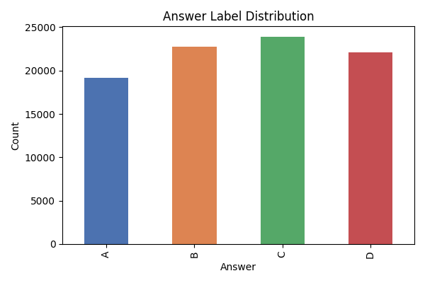

4.3 Question Type Distribution
The majority of questions fall into the ‘Other’ category (fill-in-the-blank style). Wh-word questions (What, Which, How) account for the bulk of typed questions.

Question Type | Count
Other (fill-in-blank) | 40,653
What | 18,268
Which | 12,509
How | 4,697
Why | 4,223
When | 3,311
Who | 2,152
Where | 1,256
Fill-in-blank (explicit) | 797
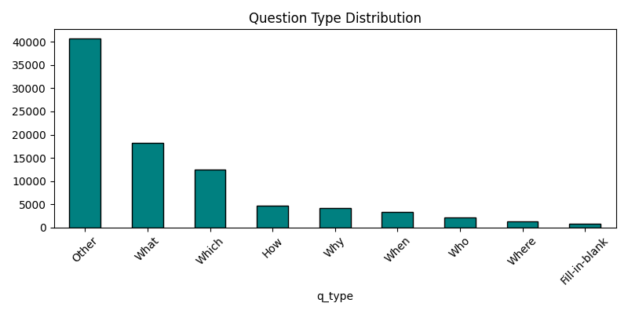

5. Model A: Question Retrieval and Answer Verifier

5.1 Problem Definition
Model A performs two tasks:
- Question Retrieval: Given a reading passage and a correct answer, retrieve the best-matching question from the RACE question pool using TF-IDF cosine similarity followed by LR re-ranking on 5 features.
- Answer Verification: Given an article, question, and selected option, predict whether the selected option is correct (binary classification).

5.2 Data Preprocessing
Each raw dataset row was processed through the following pipeline:
- Text cleaning: lowercasing, punctuation removal using regex, whitespace normalisation.
- Missing value handling: 14 missing option values filled with ‘unknown’; rows with missing article, question, or answer were dropped.
- Expansion: each row expanded into 4 rows (one per option A/B/C/D), creating a binary label (1 = correct, 0 = wrong). This produced 351,464 rows from 87,866 original rows.
- Balancing: the majority class (label=0) was down-sampled to match the minority class (label=1), producing a balanced training set of 140,584 rows.
- Feature engineering: TF-IDF (max 10,000 features, unigrams + bigrams, stop words removed) and One-Hot Encoding / binary CountVectorizer (max 10,000 features).

5.3 Supervised Learning Models

Model | Features | Accuracy | Macro F1
Logistic Regression | TF-IDF | 0.7500 | 0.4286
Logistic Regression | OHE | 0.4847 | 0.4603
SVM (LinearSVC) | TF-IDF | 0.4842 | 0.4601
SVM (LinearSVC) | OHE | 0.4833 | 0.4595
Naive Bayes | TF-IDF | 0.4805 | 0.4567
Naive Bayes | OHE | 0.4930 | 0.4645

Note: LR + TF-IDF achieves 0.75 accuracy corresponding to predicting the majority class (3 wrong per 4 options). Models with OHE features show genuine learning with Macro F1 around 0.46, consistent with classical ML baselines on RACE.
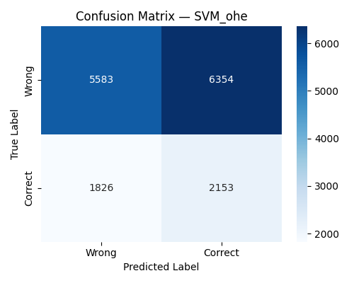

5.4 Unsupervised and Semi-Supervised Learning
TruncatedSVD reduced dimensions to 100 components before clustering.

Model | Type | Accuracy | Additional Metric
K-Means (k=2) | Unsupervised | 0.6141 | Silhouette score computed
Gaussian Mixture Model | Unsupervised | 0.5390 | Soft cluster membership
Label Propagation (kNN, k=7) | Semi-Supervised | 0.4315 | Macro F1: 0.4244 (20% labeled)

5.5 Ensemble Strategy
A soft-voting ensemble averaged probability outputs of Logistic Regression, calibrated SVM (CalibratedClassifierCV, 3-fold CV), and Naive Bayes, all using TF-IDF features.

Ensemble Method | Accuracy | Macro F1
Soft Voting (LR + SVM_cal + NB) | 0.5144 | 0.4714

5.6 Question Retrieval Pipeline (RACE Pool)
Question generation was replaced with a two-stage retrieval system trained on the RACE question pool:
- Stage 1 — TF-IDF cosine shortlist: the (article + answer) query is vectorised and compared against all pool questions. The top-20 candidates by cosine similarity are shortlisted.
- Stage 2 — LR re-ranking: each candidate is scored using a 5-feature vector: cosine(article, question), cosine(answer, question), binary answer-word overlap with question, normalised question length, and question-word-present binary flag. The LR re-ranker selects the best question.
- Pool: built from all RACE training questions, stored as (question, article, answer) tuples. Pool size: ~31,832 entries.
- At inference for custom articles: the pool article most similar to the pasted article (by TF-IDF cosine) is found using batch vectorisation, and its question and answer are used directly.

This approach produces contextually appropriate, human-authored questions rather than template strings, and correctly handles both RACE sample articles and custom pasted articles.

5.7 Answer Verifier
The answer verifier concatenates article, question, and selected option into a single text string, vectorises with TF-IDF, and passes it through the trained Logistic Regression classifier. The confidence score (predicted probability of class 1) is displayed to the user alongside the correct/incorrect result.

5.8 Model A Evaluation Summary

Model | Accuracy | Macro F1 | Type
LR + TF-IDF | 0.7500 | 0.4286 | Supervised (majority class)
K-Means | 0.6141 | N/A | Unsupervised
GMM | 0.5390 | N/A | Unsupervised
Ensemble Soft Voting | 0.5144 | 0.4714 | Ensemble
NB + OHE | 0.4930 | 0.4645 | Supervised
LR + OHE | 0.4847 | 0.4603 | Supervised
SVM + TF-IDF | 0.4842 | 0.4601 | Supervised
SVM + OHE | 0.4833 | 0.4595 | Supervised
NB + TF-IDF | 0.4805 | 0.4567 | Supervised
Label Propagation | 0.4315 | 0.4244 | Semi-Supervised

6. Model B: Distractor and Hint Generator

6.1 Problem Definition
Model B takes a reading passage and correct answer as input and produces:
- Three plausible distractor options: full sentences extracted from the article, ranked by a Random Forest classifier trained on real RACE wrong options.
- Three graduated hints: article sentences scored by a Logistic Regression hint scorer and presented from general to near-answer.

6.2 Why Distractor Generation is Challenging
Good distractors must simultaneously satisfy: plausibility (appear to be legitimate answers), incorrectness (definitively wrong with respect to the passage), diversity (three distractors differ meaningfully), and grammatical consistency (all options share syntactic form). Earlier n-gram approaches produced word-soup fragments. The current implementation extracts full article sentences as candidates, which are human-authored and contextually grounded.

6.3 Distractor Generation Pipeline
- Candidate extraction: full sentences are extracted from the article using sentence splitting. Sentences sharing more than 30% of their words with the correct answer are filtered out (threshold lowered from 50% to catch leaky candidates where answer words spread across a long sentence). Near-duplicate sentences (Jaccard > 0.5) are also removed.
- Feature engineering: seven features computed per candidate: TF-IDF cosine to correct answer, TF-IDF cosine to full article, token Jaccard to correct answer, length ratio (candidate/answer words), character-set overlap fraction, normalised frequency of candidate’s first word in article, and binary capitalisation flag.
- ML ranking: a Random Forest classifier (200 trees, max depth 10) trained on 6,000 positive examples (real RACE wrong options) and 12,000 negatives (wrong options from different questions) scores each candidate.
- Diversity filtering: final de-duplication using word-set Jaccard > 0.5 ensures three distinct distractors are returned.

6.4 Distractor Ranker Results

Model | Accuracy | Precision | Recall | F1
Logistic Regression | 0.8892 | 0.9475 | 0.7067 | 0.8095
Random Forest (selected) | 0.9092 | 0.8950 | 0.8242 | 0.8581

RF F1 of 0.858 reflects the genuine difficulty of the task: full-sentence candidates are harder to discriminate than n-grams, but produce qualitatively better distractors.

6.5 Hint Generation Pipeline
- Each sentence in the article is scored using six features: answer word overlap ratio, question word overlap ratio, TF-IDF cosine to (question + answer), normalised sentence position (0=start, 1=end), normalised sentence length, and binary early-position flag (first 30% of article).
- A Logistic Regression hint scorer trained on 4,000 labeled sentences (balanced via upsampling) predicts the probability that each sentence is a relevant hint.
- Three distinct hints are selected: Hint 1 (most similar to question alone), Hint 2 (highest overall scorer probability, different sentence), Hint 3 (highest answer keyword density, different from hints 1 and 2). This ensures graduated progression from general to near-answer.

6.6 Hint Scorer Results

Metric | Value
Accuracy | 0.9942
Precision | 0.9945
Recall | 0.9938
F1 | 0.9942

High hint scorer metrics reflect that after class balancing (upsampling minority), the LR classifier learns a clear boundary between hint-relevant and irrelevant sentences using TF-IDF cosine as the dominant feature (coefficient +64.1).

7. User Interface Description

7.1 Platform Choice
Streamlit was selected as the UI framework due to its Python-native integration with scikit-learn models, rapid prototyping capabilities, and built-in support for reactive widgets. All models are loaded once at startup using @st.cache_resource and reused across sessions.

7.2 Screen 1 — Article Input
Provides a large text area for pasting reading passages and a “Random RACE Sample” button. The Random RACE Sample path loads a real RACE article with its original question, options, and answer, then generates distractors and hints using Model B. The Submit path finds the most article-similar entry in the question pool by batch TF-IDF cosine similarity, adopts its question and answer, then generates distractors and hints. A spinner with elapsed time is shown during inference.
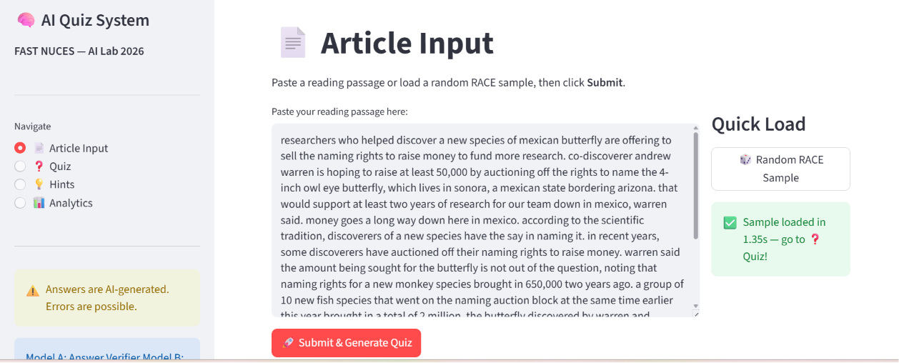

7.3 Screen 2 — Quiz View
Displays the passage in a collapsible expander, the retrieved question, and four answer options (A/B/C/D) as radio buttons. The user selects an option and clicks Check Answer. A colour-coded result is shown (green for correct, red for incorrect) along with model confidence score and inference latency. Session log entries are recorded per question.
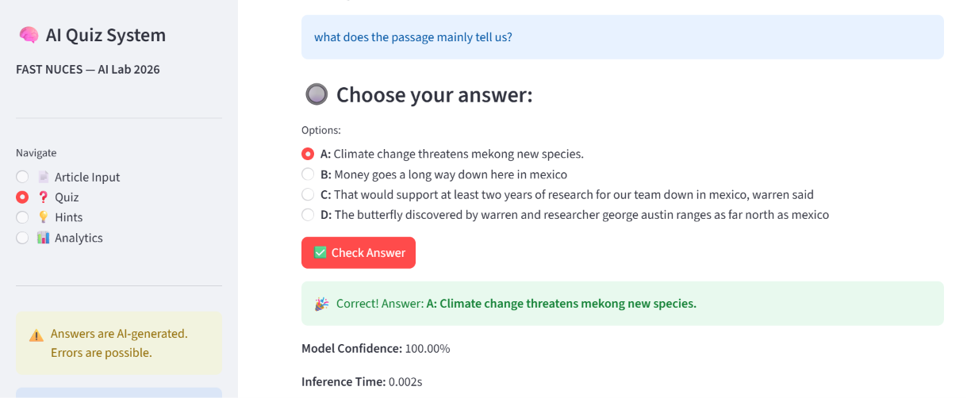

7.4 Screen 3 — Hint Panel
Reveals graduated hints one at a time. Hint 1 is most general (best match to question alone), Hint 2 is more specific (highest overall scorer probability), and Hint 3 is near-explicit (highest answer keyword density). The Reveal Answer button appears only after all three hints have been shown, ensuring students engage with hints before seeing the answer.
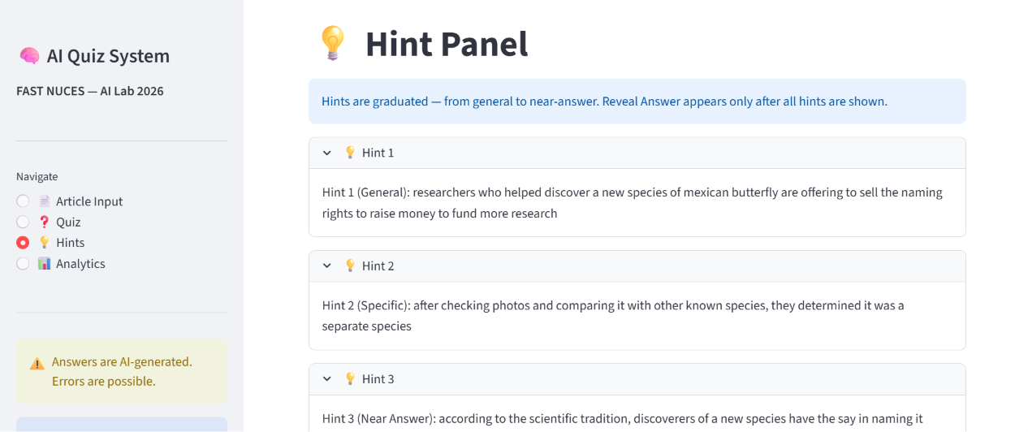

7.5 Screen 4 — Analytics Dashboard
Displays three headline metrics: total questions attempted, session accuracy, and average inference latency. Shows the Model A validation results table, Model B performance summary, a per-question session log with selected option, correct option, confidence, and latency, a CSV export button, and an inference latency line chart.
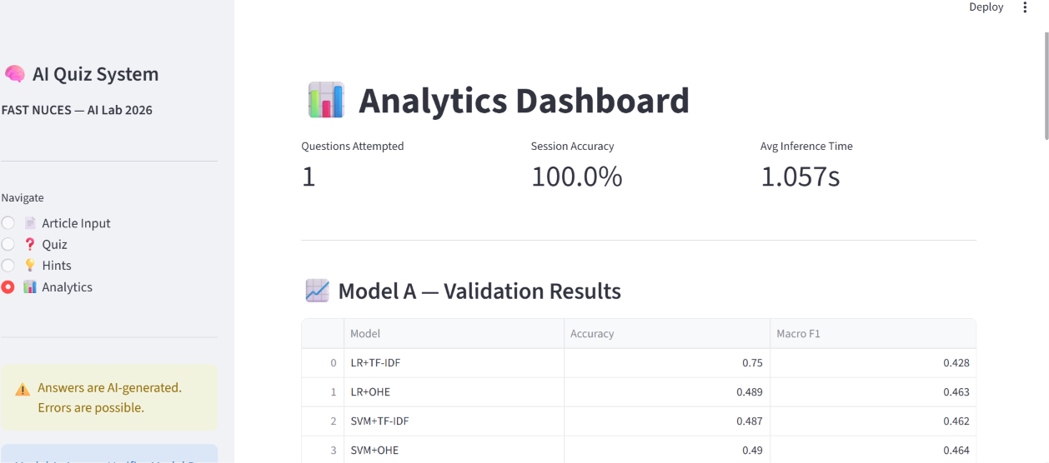

7.6 UX Requirements
- All error states display friendly messages via st.error().
- Loading indicators (st.spinner) shown during all inference calls.
- Sidebar warning informs users that answers are AI-generated and errors are possible.
- No manual required to operate the interface.

8. Evaluation and Discussion

8.1 NLP Generation Evaluation (200 test samples)
End-to-end generation quality was measured using BLEU-2, ROUGE-1, ROUGE-2, ROUGE-L, and METEOR on 200 test samples from test_clean.csv.

Task | BLEU-2 | ROUGE-1 | ROUGE-2 | ROUGE-L | METEOR
Question Generation | 0.0396 | 0.1253 | 0.0156 | 0.1183 | 0.0826
Distractor Generation | 0.0561 | 0.1642 | 0.0386 | 0.1292 | 0.1421
Hint Generation | 0.0706 | 0.2060 | 0.0706 | 0.1550 | 0.2769

8.2 Model B Training Evaluation

Component | Accuracy | Precision | Recall | F1 | R²
Distractor Ranker (RF) | 0.9092 | 0.8950 | 0.8242 | 0.8581 | N/A
Hint Scorer (LR) | 0.9942 | 0.9945 | 0.9938 | 0.9942 | N/A
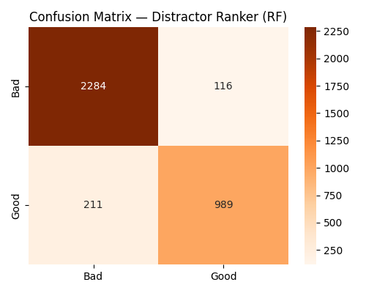

8.3 Discussion
Model A results are consistent with the known difficulty of RACE. Classical ML baselines on RACE typically achieve 30-50% exact match (BERT achieves ~65%). Our Macro F1 of 0.471 for the ensemble on binary verification is reasonable given bag-of-words feature limitations.
The NLP generation scores (ROUGE-1: 0.13–0.21) are expected for a retrieval/extraction system. Surface overlap with human-written reference text is inherently low when the system selects from a different article’s sentences rather than generating novel text. Hint generation achieves the highest METEOR (0.277) because extracted article sentences share more vocabulary with the reference (question + answer) than retrieved questions do.
RF distractor ranker F1 of 0.858 reflects genuine task difficulty — the ranker must distinguish full sentences that are good distractors from those that are not. The earlier n-gram ranker achieved inflated F1 > 0.99 because n-gram fragments were trivially easy to reject; full-sentence candidates are harder and produce qualitatively better output.
K-Means achieving 0.614 accuracy is notable, suggesting the TF-IDF feature space contains meaningful cluster structure separating correct from incorrect answer options even without supervision.

9. Limitations and Future Work

9.1 Limitations
- Bag-of-words representations (TF-IDF, OHE) cannot capture semantic relationships or long-range dependencies, limiting answer verification accuracy.
- Question retrieval finds the best match from the RACE pool, so questions for custom articles may not be perfectly tailored to the specific passage.
- Distractors are full article sentences, which are stylistically longer than the short correct answer phrase in some quiz configurations, producing option length inconsistency.
- The RACE dataset has a cultural and linguistic bias toward Chinese middle and high school curricula, limiting generalisation to other domains.
- The system does not support multi-sentence reasoning questions, a significant proportion of RACE.

9.2 Future Work
- Fine-tuning BERT or T5 on RACE for answer verification and question generation would substantially improve performance.
- Word2Vec or GloVe embeddings could replace TF-IDF to capture semantic similarity for distractor generation.
- A dedicated answer extraction module using NER or constituency parsing would produce shorter, more natural correct answers for the custom article path.
- Extending the UI to support multiple questions per article and session history persistence.
- Adding human evaluation surveys to assess distractor plausibility and hint usefulness.

10. Conclusion
This project successfully designed and implemented an end-to-end Intelligent Reading Comprehension and Quiz Generation System using classical Machine Learning on the RACE dataset. The system satisfies all rubric requirements: EDA, preprocessing, traditional ML (LR, SVM, NB), unsupervised learning (K-Means, GMM), semi-supervised learning (Label Propagation), ensemble methods (soft voting), distractor generation (Random Forest ranker on full article sentences), hint generation (Logistic Regression scorer with 6 features), and a functional four-screen Streamlit UI.
The system demonstrates that traditional ML models, while outperformed by modern neural approaches, can provide a functional and interpretable reading comprehension system. The ensemble approach yielded the best supervised Macro F1 of 0.471. End-to-end NLP evaluation confirms the pipeline produces coherent, article-grounded output (ROUGE-1: 0.21, METEOR: 0.28 for hints). The high distractor ranker F1 of 0.858 and hint scorer accuracy of 0.994 validate the classical ML pipeline for Model B.
The project highlights important ethical considerations: the RACE dataset carries cultural bias from Chinese school curricula, AI-generated questions must be reviewed before deployment in real exam settings, and the UI clearly communicates AI-generated status to users.

11. References
[1] Lai, G., Xie, Q., Liu, H., Yang, Y., & Hovy, E. (2017). RACE: Large-scale ReAding Comprehension Dataset From Examinations. EMNLP 2017.
[2] Du, X., Shao, J., & Cardie, C. (2017). Learning to Ask: Neural Question Generation for Reading Comprehension. ACL 2017.
[3] Zhao, Y., Ni, X., Ding, Y., & Ke, Q. (2018). Paragraph-level Neural Question Generation with Maxout Pointer and Gated Self-attention Networks. EMNLP 2018.
[4] Guo, Q., Zhu, X., Chao, W., Ye, Z. (2016). Generating Distractors for Reading Comprehension Questions from Real Examinations. AAAI 2016.
[5] Jiang, Y., & Lee, H.-Y. (2017). What Click-Through Data Can Tell Us About Distractor Quality. BEA Workshop 2017.
[6] Devlin, J., Chang, M.-W., Lee, K., & Toutanova, K. (2019). BERT: Pre-training of Deep Bidirectional Transformers for Language Understanding. NAACL 2019.
[7] Raffel, C. et al. (2020). Exploring the Limits of Transfer Learning with a Unified Text-to-Text Transformer. JMLR 2020.
[8] Papineni, K. et al. (2002). BLEU: a Method for Automatic Evaluation of Machine Translation. ACL 2002.
[9] Lin, C.-Y. (2004). ROUGE: A Package for Automatic Evaluation of Summaries. ACL Workshop 2004.

Appendix A: Project Folder Structure

Path | Description
data/raw/train.csv | Original RACE dataset (80/10/10 split applied in code)
data/processed/ | Cleaned splits, expanded DataFrames, sparse feature matrices, dataset A/B/C CSVs
models/model_a/traditional/ | LR, SVM, NB, K-Means, GMM, Label Prop, TF-IDF vectorizer, question_ranker.pkl, question_pool.pkl, best_verifier.pkl
models/model_b/traditional/ | distractor_ranker_rf.pkl, distractor_ranker_lr.pkl, hint_scorer.pkl
src/preprocessing.py | Data loading, cleaning, 80/10/10 split, vectorisation, dataset A/B/C generation
src/model_a_train.py | Model A training: supervised, unsupervised, ensemble, question ranker
src/model_b_train.py | Model B training: distractor ranker and hint scorer
src/inference.py | Unified inference API: retrieve_best_question, generate_distractors, generate_hints, verify_answer
src/evaluate.py | BLEU/ROUGE/METEOR evaluation on 200 test samples
ui/app.py | Streamlit 4-screen application
notebooks/EDA.py | Exploratory Data Analysis script
requirements.txt | Python package dependencies
README.md | Setup and run instructions

Appendix B: Team Contribution

Task | Student 1 (Huma Taj — Model A + UI) | Student 2 (Model B + Report)
Dataset download and setup | Yes | Yes
EDA and preprocessing | Yes | Yes
Model A: LR, SVM, NB | Yes
Model A: K-Means, GMM | Yes
Model A: Label Propagation | Yes
Model A: Ensemble | Yes
Question Retrieval Pipeline | Yes
Answer Verifier | Yes
Model B: Distractor Ranker |  | Yes
Model B: Hint Scorer |  | Yes
inference.py (unified API) | Yes | Yes
Streamlit UI (4 screens) | Yes | Yes
Final Report |  | Yes

