SELLER AND INVENTORY MANAGEMENT
Amazon – E-Commerce Database Management System
1.Database Design
1.1 Seller Table
Attribute | Data Type | Key | Description
Seller_ID | NUMBER | PK | Unique seller ID
Seller_Name | VARCHAR2(50) | - | Seller name
Business_Name | VARCHAR2(100) | - | Business name
Email | VARCHAR2(50) | UK | Seller email
Phone_Number | VARCHAR2(10) | UK | Seller phone
GST_Number | VARCHAR2(20) | UK | GST number
Address | VARCHAR2(100) | - | Seller address
Rating | NUMBER(2,1) | - | Seller rating

1.2 Inventory Table
Attribute | Data Type | Key | Description
Inventory_ID | NUMBER | PK | Unique inventory ID
Product_ID | NUMBER | FK | References Product
Warehouse_ID | NUMBER | FK | References Warehouse
Available_Stock | NUMBER | - | Available stock quantity
Last_Updated | DATE | - | Last updated date

2. Table Relationship Diagram
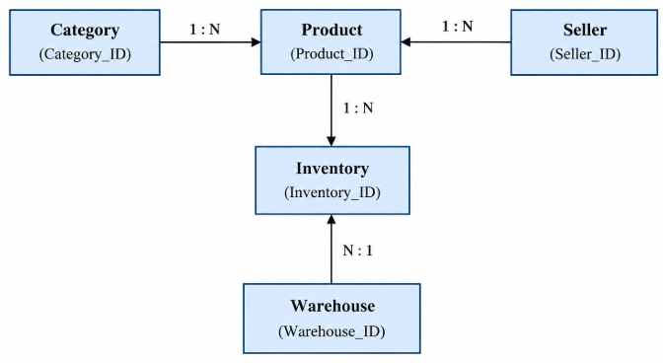
3. Table Creation
3.1 creating seller table
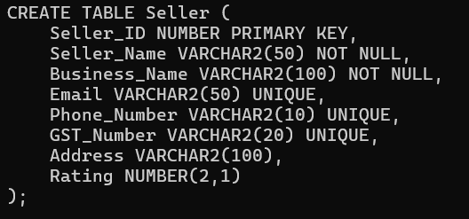

3.2 creating Inventory Table
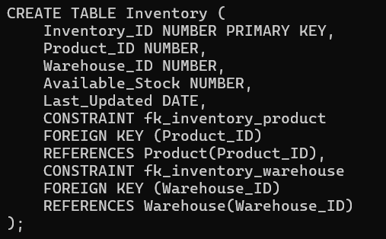
4. Seller Data Insertion
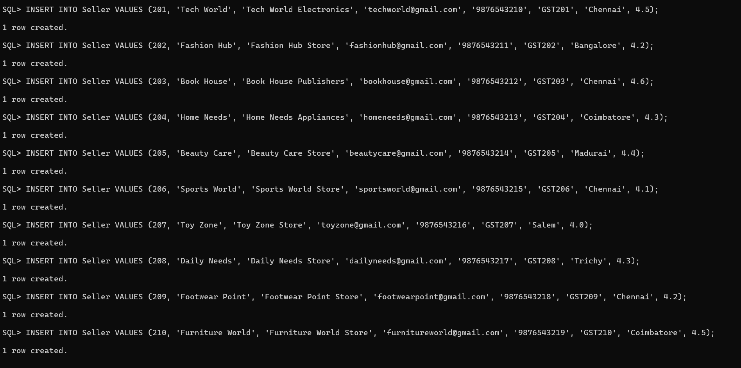
5. Inventory Data Insertion
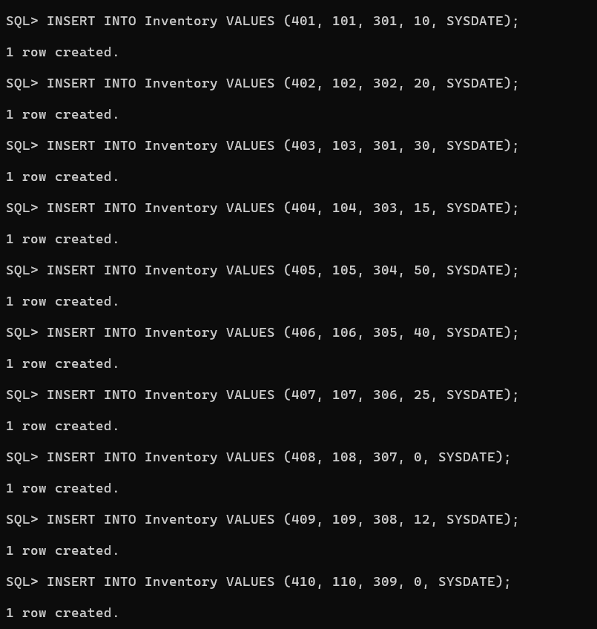

6. Seller Product Information
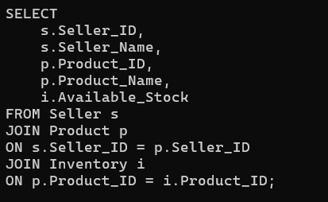
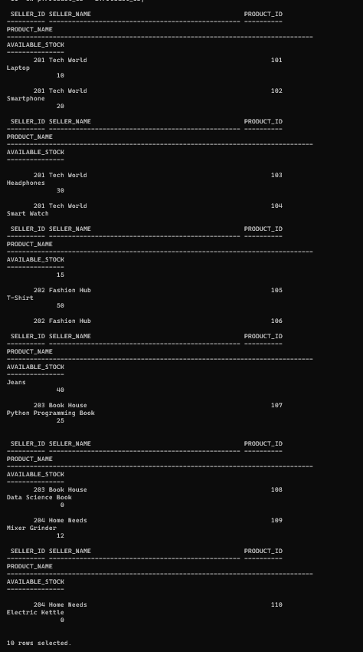

7. Inventory Status
7.1 Display Available Products
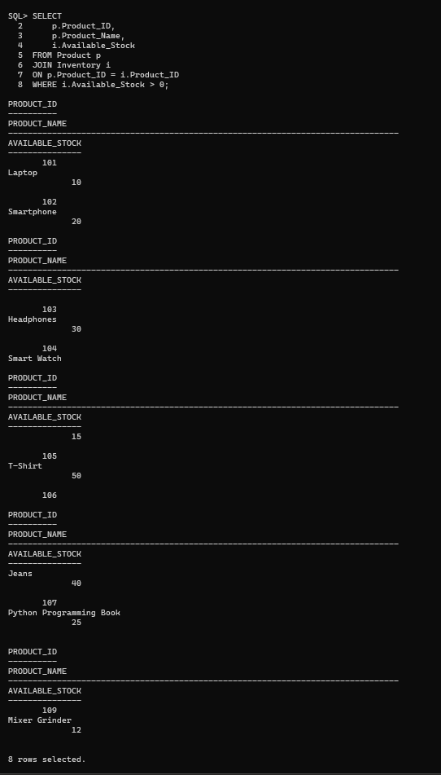
7.2 Display Unavailable Products
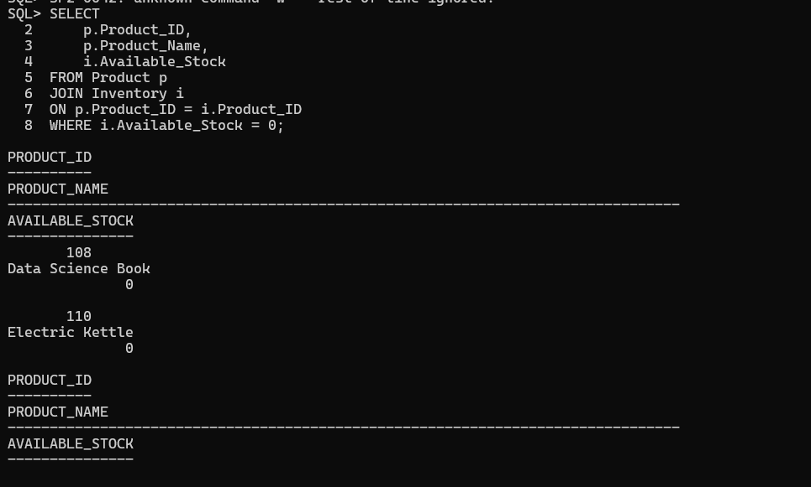

8.Inventory Status Reports
8.1 Complete Inventory Report
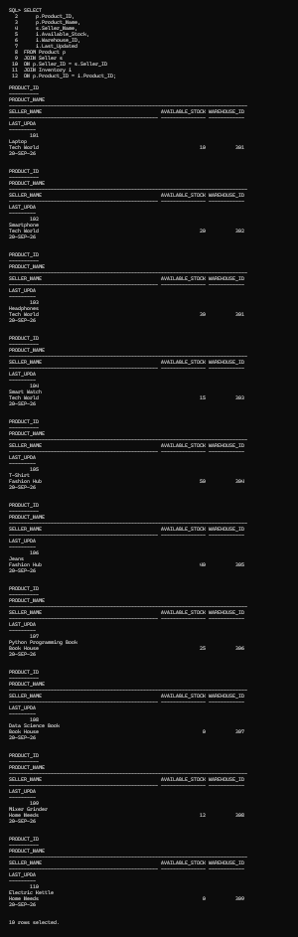

8.2 Available and Unavailable Product Count.
8.3 Total Stock by Seller
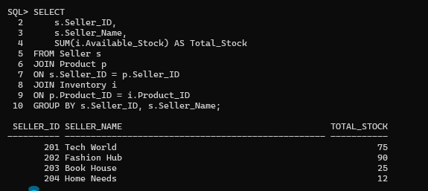
8.4 Products with Zero Stock
