PeakPilot
System Architecture & ML Methodology
Final Year Project Report — Technical Supplement
[Your Name]
[Your Institution]
[Date]

Table of Contents

1. System Architecture
PeakPilot is a full-stack fitness coaching application composed of a React (Vite) single-page frontend, a Flask REST API backend, a SQLite relational database, an external large language model (Google Gemini) for generative plan creation, and a locally trained machine learning recommendation engine built with scikit-learn. Figure 1 shows how these components interact.
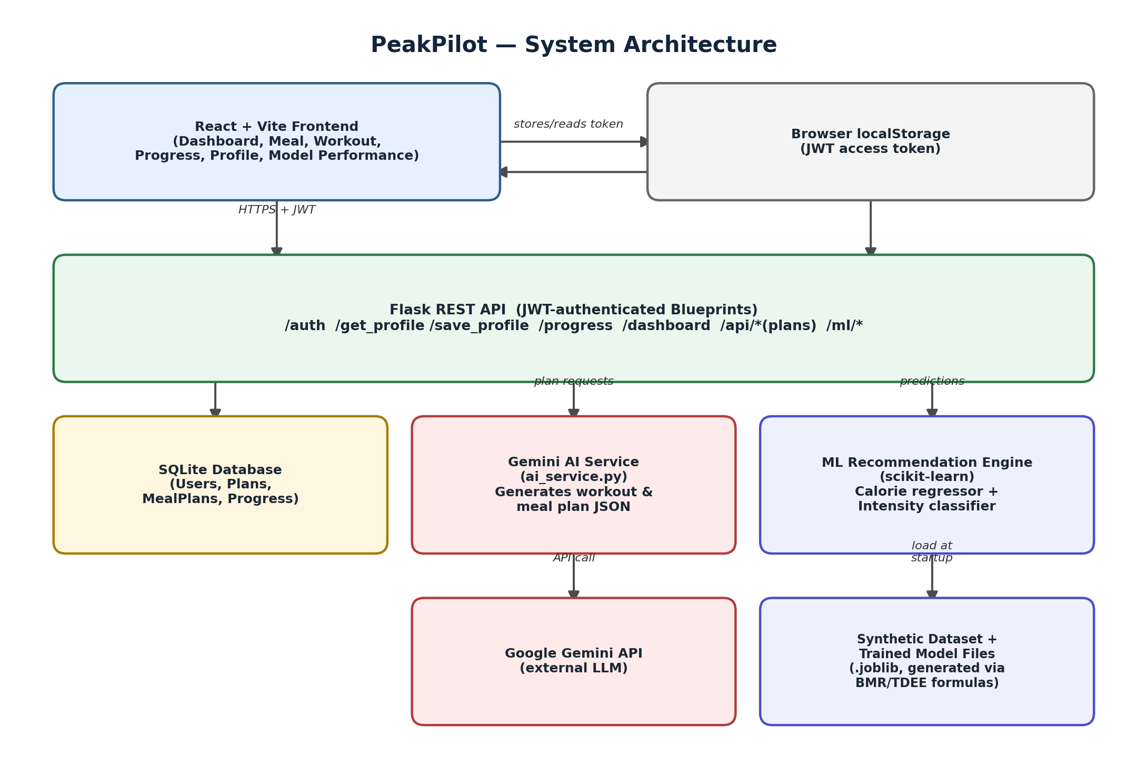
Figure 1. PeakPilot high-level system architecture.

1.1 Frontend
The client is a React application built with Vite, organized into page-level components (Dashboard, Meal, Workout, Progress, Profile, and Model Performance) that consume a shared Axios-based API client. Authentication state is held as a JWT access token in browser storage and attached to every request via an Authorization header.

1.2 Backend API
The backend is a Flask application organized into Blueprints, each responsible for a bounded area of functionality: authentication, profile management, progress tracking, plan generation, the aggregated dashboard endpoint, and the ML recommendation endpoints. All routes other than authentication are protected using Flask-JWT-Extended, ensuring that user data is only ever returned to the authenticated owner of that data.

1.3 Data Persistence
User accounts, generated plans, meal plans, and daily progress entries are persisted in a SQLite database via SQLAlchemy ORM models. This keeps the project lightweight and fully self-contained for development and demonstration, while remaining straightforward to migrate to PostgreSQL or MySQL for production deployment, since SQLAlchemy abstracts the underlying engine.

1.4 Generative Plan Creation (Gemini)
Workout and meal plans are generated by prompting Google's Gemini API with the user's profile data (goals, activity level, dietary preferences, and constraints), and parsing the structured JSON response into the Plan and MealPlan database models. This provides rich, varied, and naturally-worded plans that would be impractical to hand-author for every possible user profile.

1.5 ML Recommendation Engine
Running alongside the generative plan system is a locally trained machine learning engine that produces two live, numerically-grounded predictions for the user: a recommended daily calorie target and a recommended workout intensity band. Unlike the Gemini-generated plans, these predictions come from models trained and evaluated in-house, giving a measurable, reportable accuracy figure — the subject of Section 2.

2. ML Recommendation Engine — Methodology

2.1 Problem Definition
Two related but distinct prediction problems were identified from the application's requirements:
- A regression problem: predicting a user's optimal daily calorie target from their body statistics, activity level, and goal.
- A classification problem: predicting an appropriate workout intensity band (Low, Moderate, or High) from the same profile information plus training frequency and recovery indicators.

2.2 Dataset Generation
No real-world labelled dataset of user profiles mapped to expert-verified calorie and intensity recommendations was available at the time of development. Rather than hand-crafting a purely deterministic lookup formula — which a model could trivially memorize with 100% accuracy and which would provide no meaningful evidence of learning — a synthetic dataset generation pipeline was built to produce data that behaves like real observational data:
- 6,000 synthetic user profiles were sampled with realistic distributions for age, gender, height, weight, goal weight, activity level, training goal, workout frequency, sleep, and water intake.
- Ground-truth calorie targets were computed using the Mifflin-St Jeor equation for Basal Metabolic Rate (BMR), scaled by standard activity multipliers to obtain Total Daily Energy Expenditure (TDEE), and adjusted by goal-specific surplus/deficit percentages (for example, a 20% deficit for fat-loss goals).
- Realistic measurement noise (±6%) was injected into the calorie targets to simulate natural variability rather than an exact formula output.
- Workout intensity labels were derived from a weighted composite of activity level, training goal, workout frequency, age, and sleep quality, with additional random noise, then discretized into Low / Moderate / High bands.

2.3 Feature Engineering
Ten input features were used for both models: age, height, weight, goal weight, workout days per week, sleep hours, water intake (numeric features passed through unchanged), and gender, goal, and activity level (categorical features encoded via one-hot encoding). A single shared preprocessing pipeline, built with scikit-learn's ColumnTransformer, ensures identical feature handling is applied consistently at both training and inference time.

2.4 Model Selection & Training
Random Forest models were selected for both tasks (RandomForestRegressor for calorie prediction, RandomForestClassifier for intensity classification) due to their robustness to mixed numeric/categorical inputs, resistance to overfitting on moderate-sized datasets, and ability to capture non-linear interactions between features (for example, the interaction between activity level and training goal) without extensive manual feature engineering. Each model used 300 estimators with a maximum depth of 12, and the classifier applied balanced class weighting to compensate for the mild class imbalance produced by the labelling procedure. Data was split 80/20 into training and test sets, with the classifier split additionally stratified by intensity label to preserve class proportions.

2.5 Evaluation Results
Both models were evaluated on the held-out 20% test split (never seen during training). Results are summarized in Table 1.

Model | Metric | Value | Test Samples
Calorie Regressor | R² Score | 0.9159 | 1,200
Calorie Regressor | MAE | 138.86 kcal | 1,200
Intensity Classifier | Accuracy | 80.17% | 1,200
Intensity Classifier | F1 (macro) | 0.7661 | 1,200
Table 1. Held-out test-set performance for both models.
An R² of 0.92 indicates the calorie regression model explains the large majority of variance in target calories, with a mean absolute error of approximately 139 kcal — a margin well within normal day-to-day caloric variability for an individual. The intensity classifier achieves 80.2% accuracy and a macro-averaged F1 score of 0.77, indicating reasonably balanced performance across all three intensity classes rather than bias toward the majority class.

2.6 Serving the Models
Trained model pipelines are serialized with joblib and loaded once, lazily, by the Flask backend on first request. A dedicated recommender module builds a single-row feature frame from the requesting user's stored profile, applies the same preprocessing pipeline used at training time, and returns both predictions alongside a macro-nutrient split derived from the predicted calorie target. If model files are unavailable, the system falls back to the deterministic BMR/TDEE formula rather than failing, ensuring the feature degrades gracefully.

3. Limitations and Future Work
- The training data is synthetic. While generated from validated physiological formulas with injected noise, it does not capture real inter-individual variation, adherence behavior, or edge cases present in genuine user data. Collecting real, consented user outcome data would allow retraining on ground truth rather than formula-derived approximations.
- The workout intensity label is a proxy constructed for this project rather than an expert-annotated ground truth; a future iteration could validate this against certified trainer judgments.
- The models were evaluated with a single train/test split rather than k-fold cross-validation; cross-validation would give a more robust estimate of generalization performance and could be added with minimal code change given the existing scikit-learn pipeline.
- As more real progress data accumulates through the application's Progress Tracker, the models could be periodically retrained on a blended real/synthetic dataset, gradually shifting toward real-world grounding.

