Artificial Intelligence and Its Effects on Human Thinking and Critical Skills

HUMAIRA ALI

Department of Business Administration

Outline
- Abstract.
- Keywords.
- Introduction.
- Problem Statement.
- Background study.
- Objectives of the Report.
- Dataset Description.
- Dataset Design.
- Methodology.
- Results.
- Conclusion.
- References.
Abstract
Artificial Intelligence (AI) is now used in daily life, education, and work. It helps people in decision making and solving problems. This study explains how AI affects human thinking, critical thinking, problem-solving skills, and confidence level.
AI gives quick and useful suggestions, which can improve decisions. However, if people depend too much on AI, they may stop thinking deeply and solving problems on their own. This can also reduce their confidence in their own decisions.
In this study, a human–AI interaction dataset is used to see how people change their decisions and confidence after getting advice from AI. The results show that AI can help people make better decisions, but it can also make them rely too much on it.
This study suggests that AI should be used as a support tool, not a replacement for human thinking. It helps teachers, managers, and developers understand how to use AI in a way that improves thinking skills and confidence.
Keywords
Artificial Intelligence (AI).
Human Thinking.
Critical Thinking.
Decision Making.
Problem Solving Skills.
Confidence Level.

- INTRODUCTION
Artificial Intelligence, or AI, is a kind of technology that exemplifies learning, solving problems, and making decisions. Today, AI is commonly used in schools, businesses, and everyday life. Critical thinking, which is also known as human thinking, is the ability to look at information carefully and make your own choices. It's important to study how AI affects human thinking because AI often helps people make decisions. Although AI can be useful, depending too much on it might make people less able to think for themselves and less confident. This study is about understanding how AI influences human thinking and critical skills.
- BACKGROUND STUDY
Critical thinking is understanding information, thinking about options, and making your own decisions. It helps people solve problems logically, think about the situation carefully, and act confidently. As AI becomes more common in everyday life, it is important to understand how it impacts human thinking. While AI helps us quickly and accurately in decision making, depending too much on it reduces problem solving skills and critical thinking.
Research shows that people often listen to AI suggestions. Then making choices, while this can lead to better results, undermines confidence in their personal judgment. This study looks at the human AI interaction dataset to track human decision making and confidence before and after AI advice. Studying this data shows how AI changes decision making and critical skills, helping educators, managers, and developers create AI tools that support rather than replace human thinking.
- PROBLEM STATEMENT
Recently, artificial intelligence has become a part of our daily life, education, and work. It helps people by giving suggestions, predictions, and guidance, and helping decisions happen more quickly. However, there is concern about relying too much on AI for human thinking and problem-solving skills. Overdependence on AI could diminish the ability to think carefully, solve problems on our own, and trust our own choices. This research looks at how AI guidance affects human decisions and confidence. Knowing this can help people use AI in a better way without losing our own thinking skills. This research looks at the human -AI interaction dataset to track how often people change their choices after getting AI advice and how confident they feel. It further looks at patterns in how people rely on AI, showing whether it helps or harms their thinking.
The key question is, “Does AI actually help us with decision making and thinking, or does it make people overdependent?”
The results guide teachers, managers, and AI developers to help people stay confident and think for themselves.
- OBJECTIVES OF THE REPORT

- Analyze how AI affects human decision-making.
- Track changes in people’s confidence before and after receiving AI advice.
- Examine patterns of human reliance on AI.
- Determine whether AI supports or diminishes critical thinking.
- Use a database efficiently to store and analyze data.

- DATASET DESCRIPTION
The Human AI Interaction Dataset is used in this study to analyze the effects of AI on human decision making and confidence. The dataset is collected from experiments where participants performed tasks before and after receiving AI advice. The dataset is stored in CSV format and includes attributes like participant ID, task name, initial response, AI advice, final response, and confidence levels. Each record represents a single interaction between a human and an AI system.
- DATASET DESIGN
We created a table called Human_AI_Data to store the dataset. The participant_id serves as the primary key to uniquely identify each record. Text based attributes are stored using varchar data types, while confidence levels are stored as integers. This structure allows for efficient analysis of decision and confidence changes.
- METHODOLOG
Data Analysis Using Orange
The dataset was analyzed before and after using the orange tool. Originally, the file contained 4,000 rows and 26 features, with some missing values. Post processing the dataset in Orange, all missing values were found and corrected, resulting in a complete dataset ready for further analysis.
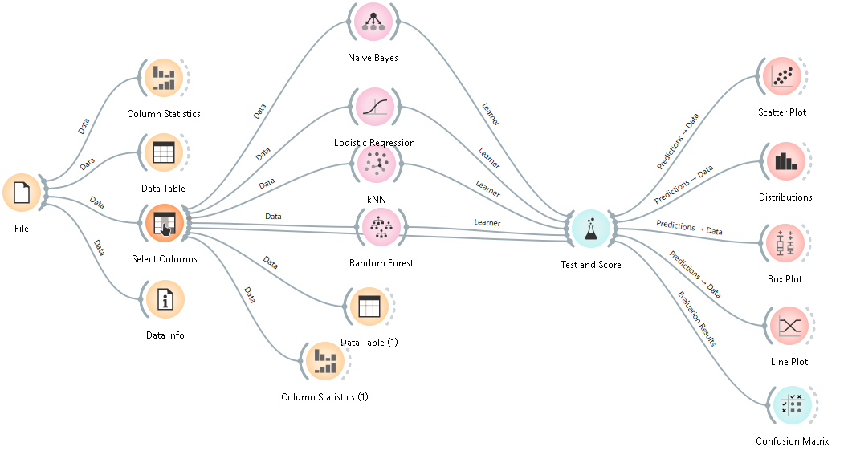
FIGURE NO: 1 Machine learning workflow in Orange Data Mining

Figure 1 shows the machine learning workflow implemented using Orange Data Mining. The process begins with loading and exploring the data through visualisation and statistical analysis widgets, followed by feature selection to prepare the data for modelling. Four classification algorithms Naive Bayes, Logistic Regression, k- nearest neighbours, and Random Forest are trained on the same dataset. The Test and Score tool are used to compare the models. The prediction results are then further analyzed using visualizations such as scatter plots, box plots, and distribution plots. Finally, a confusion matrix is used to check the overall accuracy.

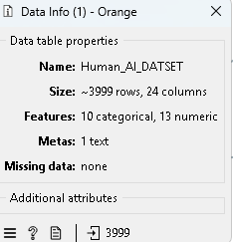
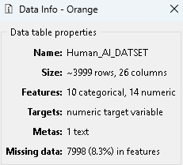

Figure no 1.1 Figure no 1.2
Data information of the Human_AI_DATASET Data information of the Human_AI_DATASET before preprocessing in Orange after preprocessing in Orange

- Model Validation

- RANDOM FOREST
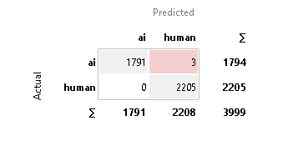

FIGURE NO: 1.3 Random Forest Model Validation: Confusion Matrix.
- Interpretation
The confusion matrix is structured as follows:

 | Predicted: AI | Predicted: Human | Total (Actual)
Actual: AI | 1,791 (True Negatives – TN) | 3 (False Positives – FP) | 1,794
Actual: Human | 0 (False Negatives – FN) | 2,205 (True Positives – TP) | 2,205
Total (Predicted) | 1,791 | 2,208 | 3,999

- Explanation of Terms:
The confusion matrix for the Random Forest model shows how well it made predictions. True Negatives (TN = 1,791) mean the model correctly predicted “AI”, and True Positives (TP = 2,205) mean it correctly predicted “Human”. There were 3 False Positives (FP = 3), where the model predicted “Human” instead of “AI”, and no False Negatives (FN = 0), meaning it never predicted “AI” instead of “Human”. These numbers show where the model was correct and where it made mistakes.
- Key Performance Metrics:
Using the confusion matrix and treating “Human” as the positive class, the Random Forest model is assessed using accuracy, precision, recall, and F1-score. These measures provide a balanced view of the model’s prediction quality.
- Accuracy
Overall, how often is the classifier is correct?
Formula:
TP+TN/TOTAL
Calculation:
(2,205 + 1,791) / 3,999 = 3,996 / 3,999
Result: 0.999 or 99.9%
b) Precision
When the model predicts “Human”, how often it is correct.
Formula:
$$TP/(TP+FP)$$
Calculation:
2,205 / (2,205 + 3) = 2,205 / 2,208
Result: 0.999 or 99.9%
c) Recall (for class “Human”)
What proportion of actual “Human” cases are correctly identified.
Formula:
$$TP/(TP+FN)$$
Calculation:
2,205 / (2,205 + 0)
Result: 1.000 or 100%
d) F1-Score
Harmonic mean of Precision and Recall.
Formul
Calculation:
2 × (0.999 × 1.000) / (0.999 + 1.000)
Result: ≈ 0.999 or 99.9%
e) Specificity
What proportion of actual “AI” cases are correctly identified.
Formula:
TN / (TN + FP)
Calculation:
1,791 / (1,791 + 3) = 1,791 / 1,794
Result: 0.998 or 99.8%
- Naïve Bayes
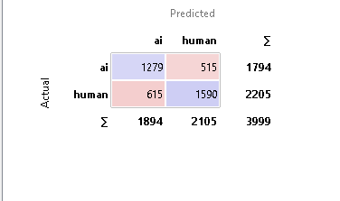
FIGURE NO: 1.4 Naïve Bayes Model Validation: Confusion Matrix.
- Interpretation
The confusion matrix is structured as follows:
 | Predicted: AI | Predicted: Human | Total (Actual)
Actual: AI | 1279 (TN) | 515 (FP) | 1794
Actual: Human | 615 (FN) | 1590 (TP) | 2205
Total (Predicted) | 1894 | 2105 | 3999

- Explanation of Terms:
The confusion matrix for the Naïve Bayes model shows how well it made predictions. True Negatives (TN = 1,279) mean the model correctly predicted “AI,” and True Positives (TP = 1,590) mean it correctly predicted “Human.” There were 515 False Positives (FP = 515), where the model predicted “Human” instead of “AI,” and 615 False Negatives (FN = 615), meaning it predicted “AI” instead of “Human.” These numbers show where the model was correct and where it made mistakes.
- Key Performance Metrics:
Using the confusion matrix and treating “Human” as the positive class, key metrics like accuracy, precision, recall, and F1 score show how well the Naïve Bayes model correctly identified both AI and Human text. These metrics summarize the model’s prediction quality.
a) Accuracy
Formula:
$$(TP+TN)/Total$$
Calculation:
$$(1,590+1,279)/3,999=2,869/3,999$$
Result: 0.717 or 71.7%
b) Precision
Formula:
$$TP/(TP+FP)$$
Calculation:
$$1,590/(1,590+515)=1,590/2,105$$
Result: 0.756 or 75.6%
c) Recall
Formula:
$$TP/(TP+FN)$$
Calculation:
$$1,590/(1,590+615)=1,590/2,205$$
Result: 0.721 or 72.1%
d) F1-Score

Formula:
$$2×\frac{Precision×Recall}{Precision+Recall}$$
Calculation:
$$2×\frac{0.756×0.721}{0.756+0.721}$$

Result: ≈ 0.738 or 73.8%
e) Specificity
Formula:
$$TN/(TN+FP)$$
Calculation:
$$\frac{1,279}{1,279+515}=\frac{1,279}{1,794}$$

Result: 0.713 or 71.3%
- Logistic Regression
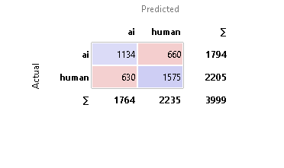
FIGURE NO: 1.4 Logistic Regression Model Validation: Confusion Matrix.
- Interpretation
The confusion matrix is structured as follows:
 | Predicted: AI | Predicted: Human | Total (Actual)
Actual: AI | 1134 (TN) | 660 (FP) | 1794
Actual: Human | 630 (FN) | 1575 (TP) | 2205
Total (Predicted) | 1764 | 2235 | 3999

- Explanation of Terms:
The confusion matrix shows how well the Logistic Regression model made predictions. True Negatives (TN = 1,134) mean the model correctly predicted “AI,” and True Positives (TP = 1,575) mean it correctly predicted “Human.” There were 660 False Positives (FP = 660), where the model predicted “Human” instead of “AI,” and 630 False Negatives (FN = 630), meaning it predicted “AI” instead of “Human.” These numbers show where the model was correct and where it made mistakes.
- Key Performance Metrics:
Accuracy, precision, recall, and F1 score, calculated from the confusion matrix, show how well the Logistic Regression model predicted Human and AI texts. Together, they provide a clear view of its reliability.
a) Accuracy
Formula:
$$(TP+TN)/Total$$
Calculation:
$$\frac{1,575+1,134}{3,999}=\frac{2,709}{3,999}$$

Result: 0.677 or 67.7%
b) Precision
Formula:
$$TP/(TP+FP)$$
Calculation:
$$1,575/(1,575+660)=1,575/2,235$$
Result: 0.705 or 70.5%
c) Recall
Formula:
$$TP/(TP+FN)$$
Calculation:
$$1,575/(1,575+630)=1,575/2,205$$
Result: 0.714 or 71.4%
d) F1-Score
Formula:
$$2×(Precision×Recall)/(Precision+Recall)$$
Calculation:
$$2×(0.705×0.714)/(0.705+0.714)$$
Result: ≈ 0.709 or 70.9%
e) Specificity
Formula:
$$TN/(TN+FP)$$
Calculation:
$$1,134/(1,134+660)=1,134/1,794$$
Result: 0.632 or 63.2%
- kNN
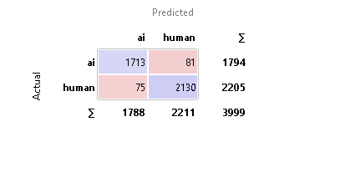
FIGURE NO: 1.5 kNN Model Validation: Confusion Matrix
- Interpretation
The confusion matrix is structured as follows:
 | Predicted: AI | Predicted: Human | Total (Actual)
Actual: AI | 1713 (TN) | 81 (FP) | 1794
Actual: Human | 75 (FN) | 2130 (TP) | 2205
Total (Predicted) | 1788 | 2211 | 3999

- Explanation of Terms:
The confusion matrix shows how well the model made predictions. TN = 1,713 means the model correctly predicted “AI”, and TP = 2,130 means it correctly predicted “Human”. There was FP = 81, where the model predicted “Human” instead of “AI”, and FN = 75, meaning it predicted “AI” instead of “Human”. These numbers show where the model was correct and where it made mistakes.
- Key Performance Metrics:
By treating “Human” as the positive class, accuracy, precision, recall, and F1 score show how effectively the model distinguished human from AI text. These metrics summarise the model’s performance.
a) Accuracy
Formula:
$$(TP+TN)/Total$$
Calculation:
$$(2,130+1,713)/3,999=3,843/3,999$$
Result: 0.961 or 96.1%
b) Precision
Formula:
$$TP/(TP+FP)$$
Calculation:
$$2,130/(2,130+81)=2,130/2,211$$
Result: 0.964 or 96.4%
c) Recall
Formula:
$$TP/(TP+FN)$$
Calculation:
$$2,130/(2,130+75)=2,130/2,205$$
Result: 0.966 or 96.6%
d) F1-Score
Formula:
$$2×(Precision×Recall)/(Precision+Recall)$$
Calculation:
$$2×(0.964×0.966)/(0.964+0.966)$$
Result: ≈ 0.965 or 96.5%
e) Specificity
Formula:
$$TN/(TN+FP)$$
Calculation:
$$\frac{1,713}{1,713+81}=\frac{1,713}{1,794}$$

Result: 0.955 or 95.5%
SUMMARY
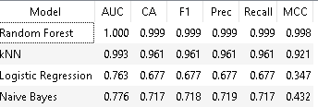
FIGURE NO: 1.6

- RESULTS
Many participants adjust their decision after AI advice; confidence generally increases after receiving AI suggestions. Some participants rely heavily on AI advice, reducing independent critical thinking. Data shows AI can improve decision making but may affect critical thinking if overused. Charts and graphs make it easy to see decisions and confidence differences.
- CONCLUSION
AI significantly impacts human thinking and critical skills. It can enhance decision making efficiency and enhance confidence, but overdependence may decrease independent problem solving abilities. A study using the Human-AI Interaction Dataset demonstrates how AI shapes decisions and confidence levels. The findings provide a foundation for educators, managers, and AI developers designing AI systems that support human judgement without keeping independence. Used wisely, AI can sharpen critical thinking if used in moderation.
- REFERENCES

- Maadi, Mansoureh, Hadi Akbarzadeh Khorshidi, and Uwe Aickelin. 2021. “A Review on Human–AI Interaction in Machine Learning and Insights for Medical Applications.” International Journal of Environmental Research and Public Health 18, no. 4: Article 2121. https://doi.org/10.3390/ijerph18042121
- Wang, F. (2025). Collaborative foresight in the age of AI: A framework for evolving human-AI dynamics in strategic decision-making and futures research. Journal of International DBA Studies, 1(001). Retrieved from https://www.eaj.ebujournals.lu/index.php/JIDS/article/view/155
- Vassilakopoulou, P., Haug, A., Salvesen, L. M., & Pappas, I. O. (2023). Developing human/AI interactions for chat-based customer services: Lessons learned from the Norwegian government. European Journal of Information Systems, 32(1), 10–22. https://doi.org/10.1080/0960085X.2022.2096490
- Heyder, T., Passlack, N., & Posegga, O. (2023). Ethical management of human-AI interaction: Theory development review. The Journal of Strategic Information Systems, 32(3), Article 101772. https://doi.org/10.1016/j.jsis.2023.101772
- Ueno, T., Sawa, Y., Kim, Y., Urakami, J., Oura, H., & Seaborn, K. (2022). Trust in human-AI interaction: Scoping out models, measures, and methods. In CHI 2022 Extended Abstracts on Human Factors in Computing Systems (pp. 1-7). Association for Computing Machinery. https://doi.org/10.1145/3491101.3519772
- Li, T., Vorvoreanu, M., DeBellis, D., & Amershi, S. (2023). Assessing human-AI interaction early through factorial surveys: A study on the guidelines for human-AI interaction. ACM Transactions on Computer-Human Interaction, 30(5), Article 69. https://doi.org/10.1145/3511605
- Kim, S. S. Y., Watkins, E. A., Russakovsky, O., Fong, R., & Monroy-Hernández, A. (2023). “Help Me Help the AI”: Understanding how explainability can support human-AI interaction. In Proceedings of the 2023 CHI Conference on Human Factors in Computing Systems (pp. 1–17). Association for Computing Machinery. https://doi.org/10.1145/3544548.3581001
- Raees, M., Meijerink, I., Lykourentzou, I., Khan, V.-J., & Papangelis, K. (2024). From explainable to interactive AI: A literature review on current trends in human–AI interaction. International Journal of Human-Computer Studies, 189, Article 103301. https://doi.org/10.1016/j.ijhcs.2024.103301
- Sun, Z., Siemon, D., & Robra-Bissantz, S. (2023). Decision control and explanations in human-AI collaboration: Improving user perceptions and compliance. Computers in Human Behavior Reports, 10, 100725. https://doi.org/10.1016/j.dim.2023.100048
- Yang, D., Wu, S. T., & Hearst, M. A. (2024). Human-AI interaction in the age of LLMs. In Proceedings of the 2024 Conference of the North American Chapter of the Association for Computational Linguistics: Human Language Technologies (Volume 5: Tutorial Abstracts) (pp. 34–38). Association for Computational Linguistics. https://doi.org/10.18653/v1/2024.naacl-tutorials.5
- Sundar, A., Russell-Rose, T., Kruschwitz, U., & Machleit, K. (2025). The AI interface: Designing for the ideal machine-human experience. Computers in Human Behavior, 165, Article 108539. https://doi.org/10.1016/j.chb.2024.108539
- Chen, M., Zhang, H., & Others. (2025). Human-AI interaction: Human behavior routineness shapes AI performance. IEEE Transactions on Knowledge and Data Engineering. https://ieeexplore.ieee.org/document/10716500
- Sreedharan, S., Kulkarni, A., & Kambhampati, S. (2024). Explainable human-AI interaction: A planning perspective. arXiv Preprint. https://arxiv.org/abs/2405.15804
- Mehrotra, S., Degachi, C., Vereschak, O., Jonker, C. M., & Tielman, M. L. (2024). A systematic review on fostering appropriate trust in human-AI interaction: Trends, opportunities and challenges. ACM Journal on Responsible Computing. https://doi.org/10.1145/3696449
- Author(s). (2025). How artificial intelligence will revolutionize management studies: a Savagean perspective. Journal of Knowledge Management. https://doi.org/10.1108/JKM-03-2025-0401
- McGrath, M. J., Duenser, A., Lacey, J., & Paris, C. (2025). Collaborative human-AI trust (CHAI-T): A process framework for active management of trust in human-AI collaboration. Computers in Human Behavior: Artificial Humans, 6, 100200. https://doi.org/10.1016/j.chbah.2025.100200

