Employee Analysis
Apache Spark
Group Members
Humaira 2023-ag-9552
Minahil Fatima 2023-ag -9588

Apache Spark for Employee Data Analysis
Hands-on Demonstration and Workflow

1. Import and Read Dataset
The initial stage in PySpark analysis involves loading the dataset in any PySpark workflow. The spark.read.csv() function reads a CSV file into a Spark DataFrame, with header=True to use the first row as column names and inferSchema=True to automatically detect data types. The df.show() method displays the first 20 rows, and df.printSchema() prints the column names along with their inferred data types (string, integer, double, etc.).
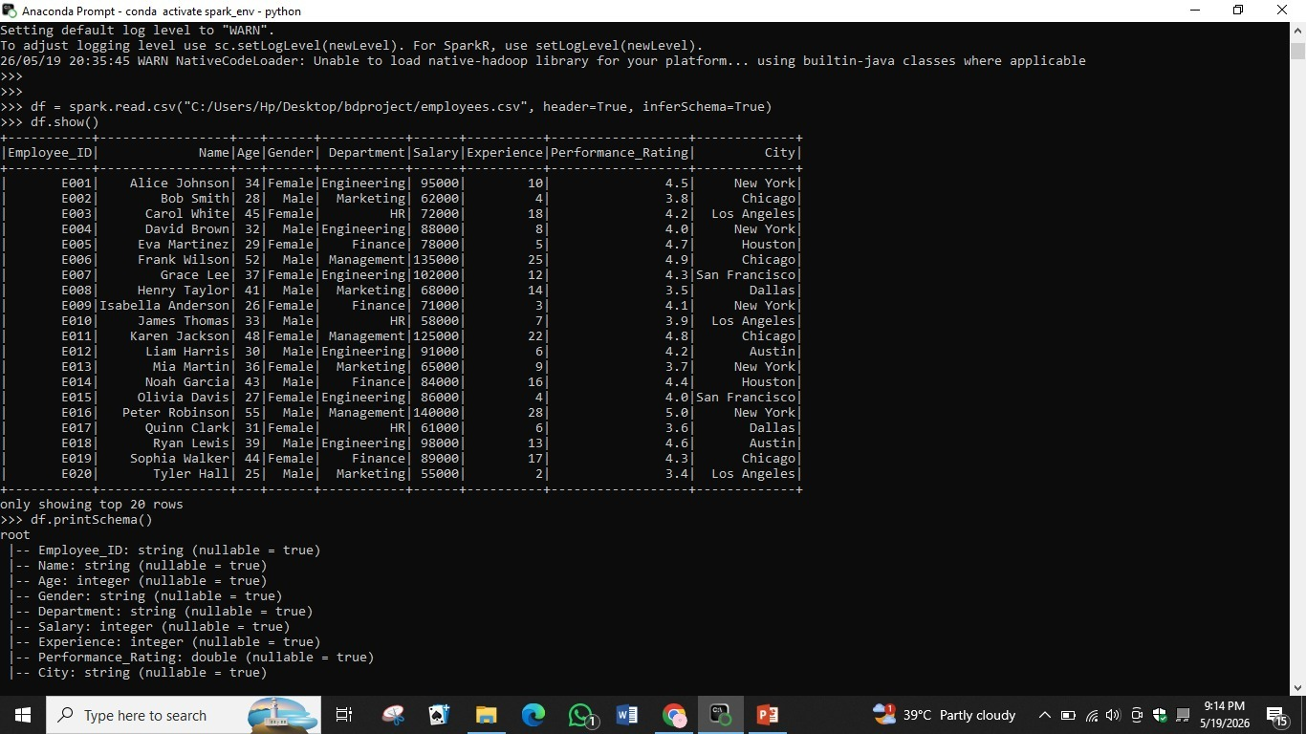
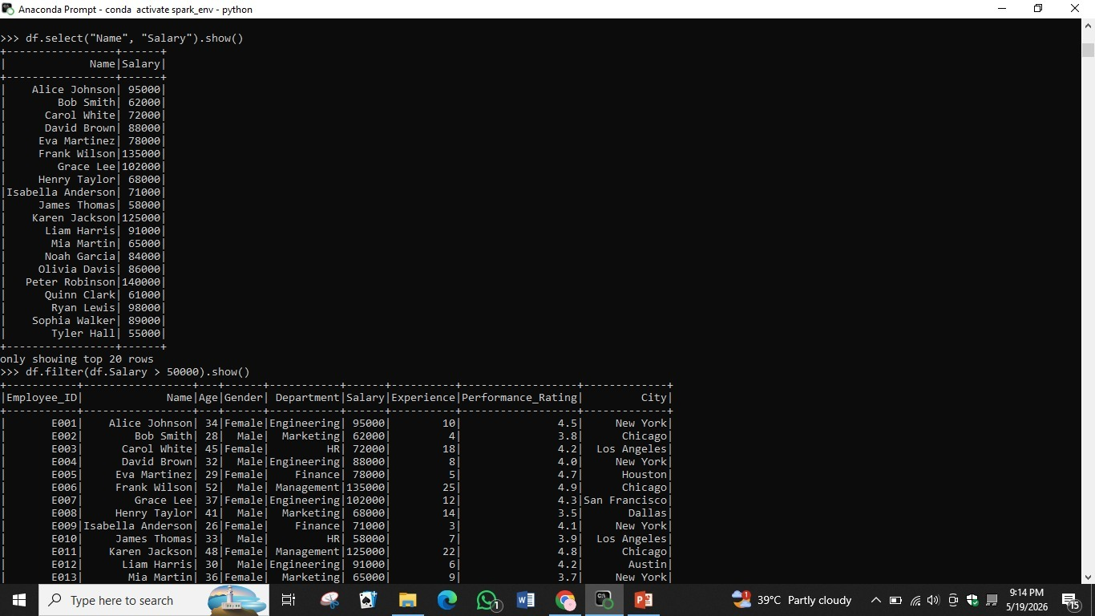

2. View and Inspect Records

After importing the DataFrame, you can display specific columns using df.select(). For example, df.select('Name', 'Salary').show() retrieves only those two columns for all rows. You can also apply filters using df.filter() to display only records that meet a condition — for instance, df.filter(df.Salary > 50000).show() returns all employees whose salary exceeds 50,000.

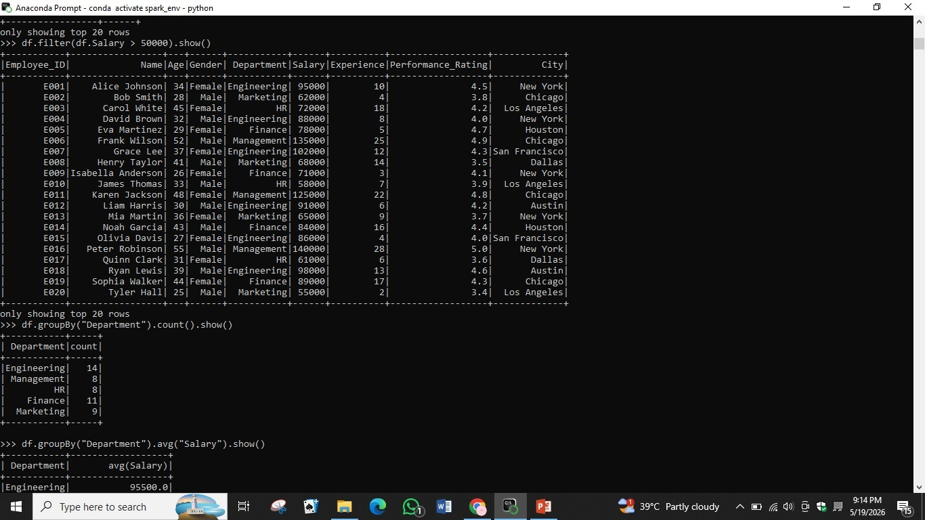

3. Apply Conditional Filtering (Salary > 50000)

Data filtering helps isolate to extract a subset of rows that satisfy a given condition. The df.filter() method (or equivalently df.where()) accepts a column condition and returns a new DataFrame with only matching rows. In this example, all employees with a salary greater than 50,000 are displayed. Filtering is essential for data exploration and reducing dataset size before further processing
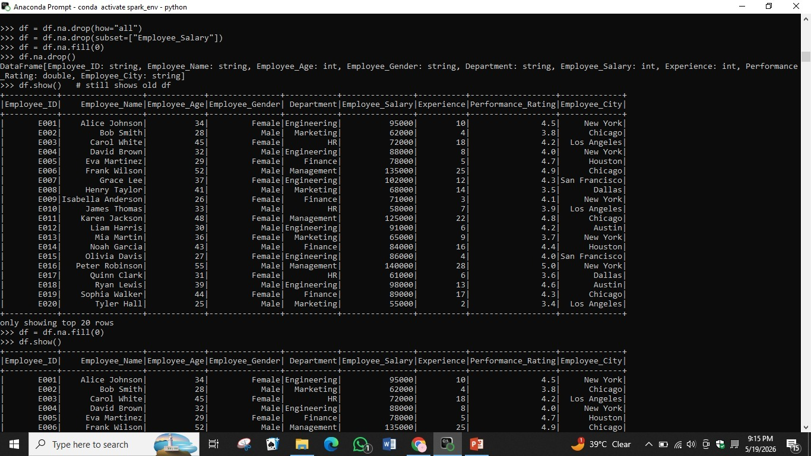

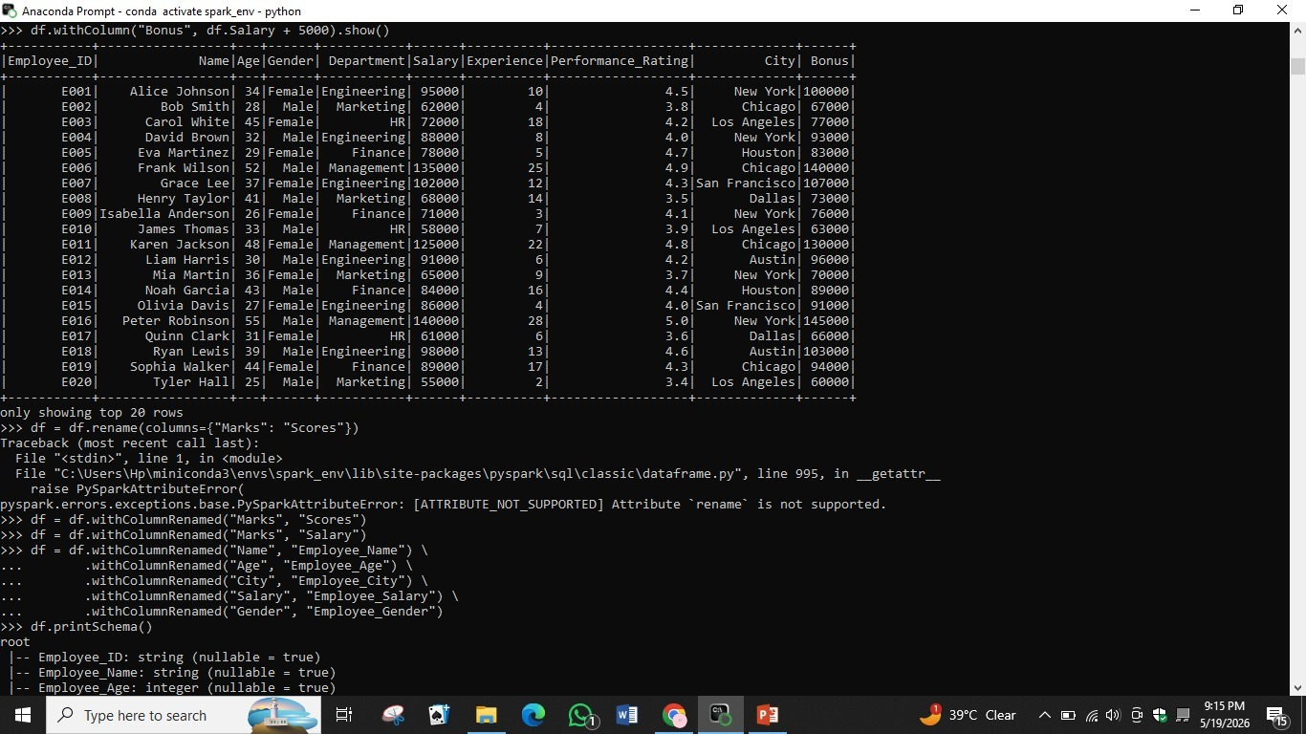

4. Department-wise Aggregation

The groupBy() function groups rows by one or more columns and applies an aggregate function. Here, df.groupBy('Department').count().show() counts the number of employees in each department. The result shows that Engineering has 14 employees, Finance has 11, Marketing has 9, while HR and Management each have 8. This is useful for summarizing categorical data.

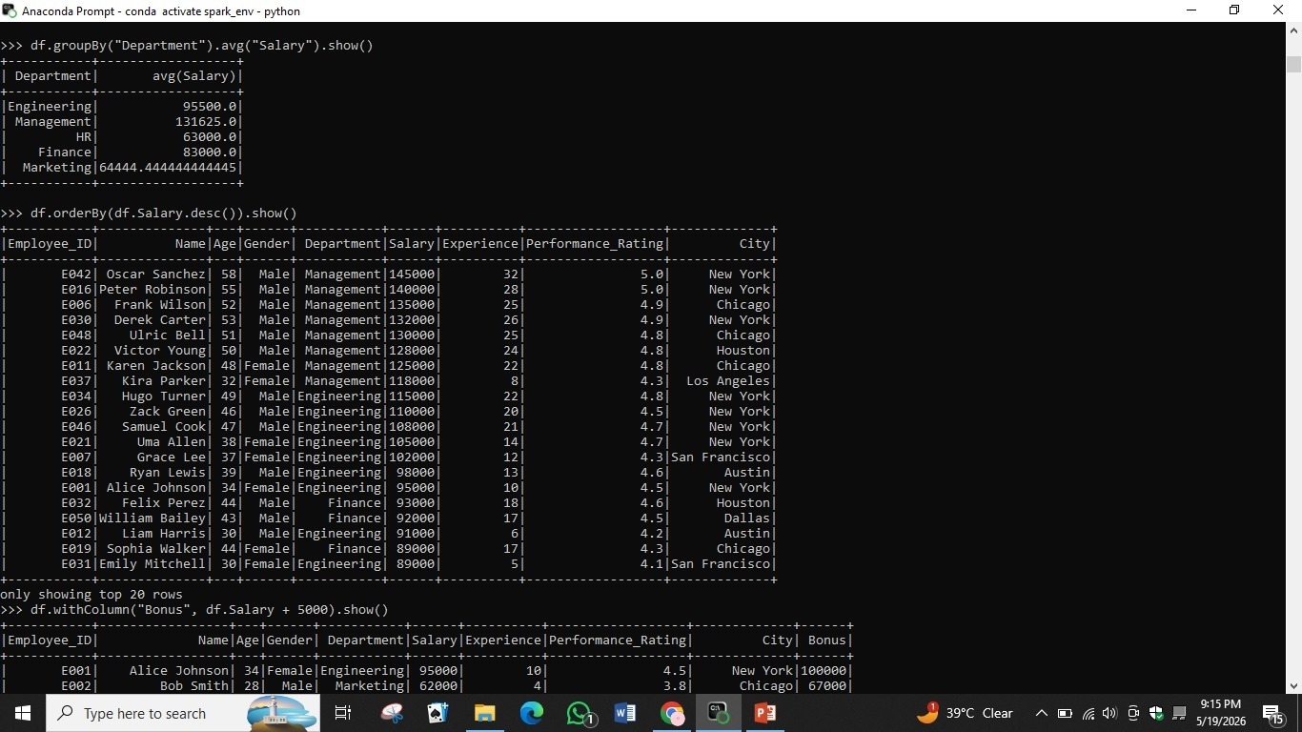

5. Compute Salary Statistics

PySpark provides aggregate functions provides powerful aggregate functions. Using F.avg(), F.max(), F.min(), and F.count() inside a df.select() call allows you to compute multiple statistics in a single query. The result shows 50 total employees, a maximum salary of 145,000, a minimum of 55,000, and an average salary of 87,740. These statistics give a high-level overview of the dataset's numeric columns.

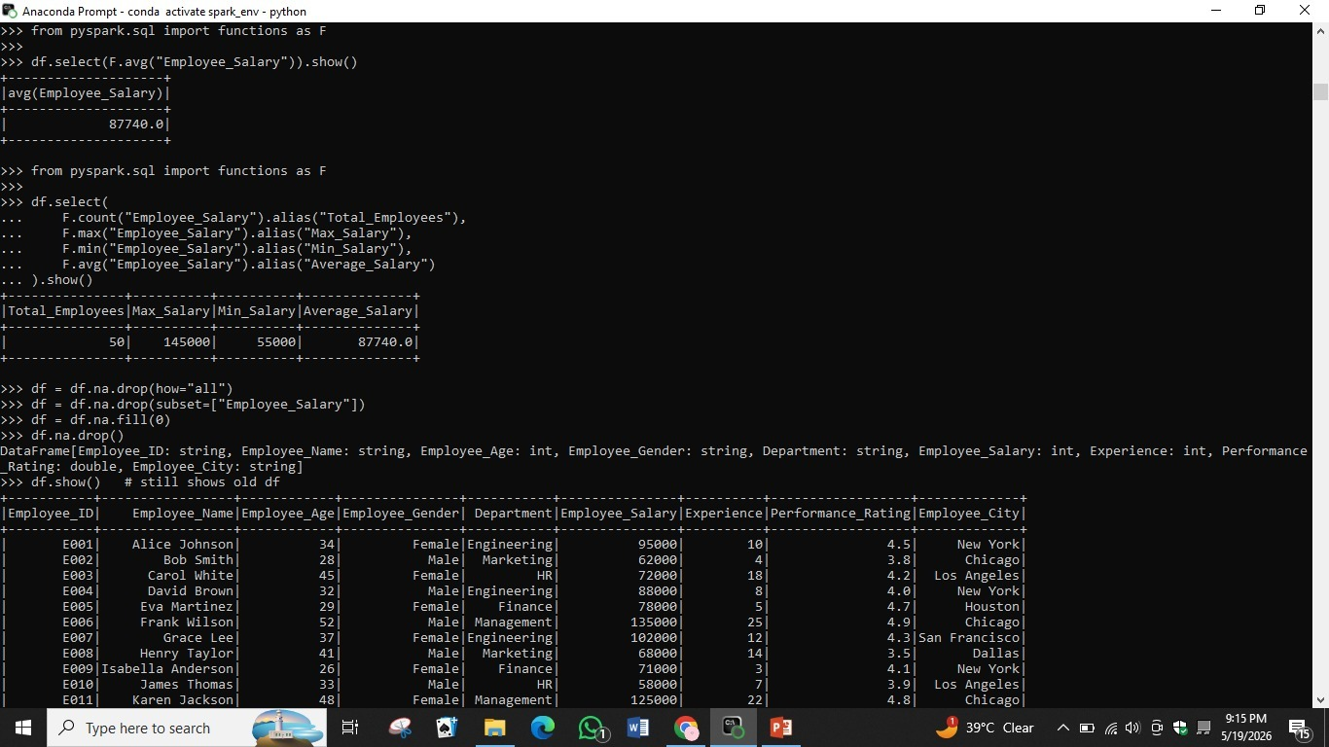

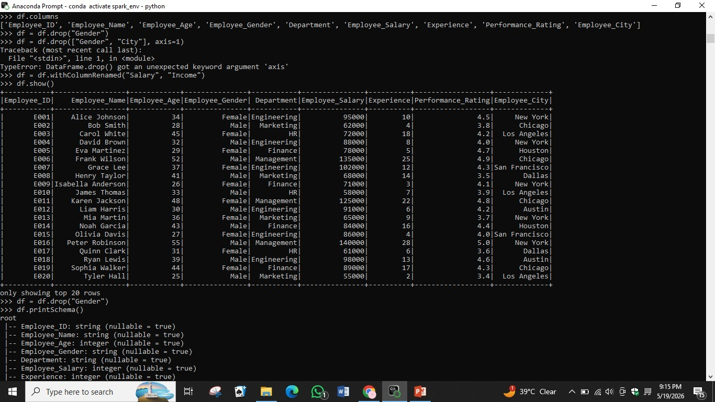

6. Organize Data by Salary

DataFrames can be sorted is done using df.orderBy(). By calling df.orderBy(df.Salary.desc()).show(), employees are listed from the highest to the lowest salary. The top earner is Oscar Sanchez in Management with a salary of 145,000, followed by Peter Robinson at 140,000. Sorting helps identify top and bottom performers and is often used before applying ranking or reporting logic.



7. Create Additional Fields

Additional columns may be created to a DataFrame using the df.withColumn() method. In this example, df.withColumn('Bonus', df.Salary + 5000) creates a new 'Bonus' column by adding 5,000 to each employee's salary. Columns can also be renamed using df.withColumnRenamed(). Note that df.rename() is not supported in PySpark — withColumnRenamed() must be used instead, and multiple renames can be chained together.



8. Handle Missing Entries

Managing missing values is critical in data preprocessing. PySpark provides df.na.drop() to remove rows containing null values, and df.na.fill(0) to replace nulls with a specified value (such as 0 for numeric fields). You can also use df.na.drop(how='all') to only remove rows where every column is null, or df.na.drop(subset=['Employee_Salary']) to drop rows where a specific column is null. Since DataFrames are immutable, the result must be reassigned to a new variable.

