

**CSE464: Advance Database Systems**

**[Fall 2022]**

**Section: 01**

**Project SRS**

**Cash Transfer**

**Submitted by:**

|  |  |
| --- | --- |
| **Student ID** | **Student Name** |
| **2019-1-60-243** | **Humaira Tabassum** |
| **2018-3-60-058** | **Kawshik Das** |

**Cash Transfer**

**Introduction:**

**Cash Transfer** is a web-based application where a person can easily transfer or get cash easily.

People that have a large amount distance between them but need to transfer or receive cash can easily do it in the site.

**Technologies:**

We had use **Python (Django)** to develop this system because python is a very secure language and easy to use. For designing, we had use **HTML, CSS, JavaScript, Bootstrap.** We had use **Xampp Control Panel** as a main server because it is a locally created virtual server in which we can easily create **Apache** **MySQL** server for our project. Moreover, Xampp is free of cost and easy to use.

**Trigger,Function and Procedure Commands:**

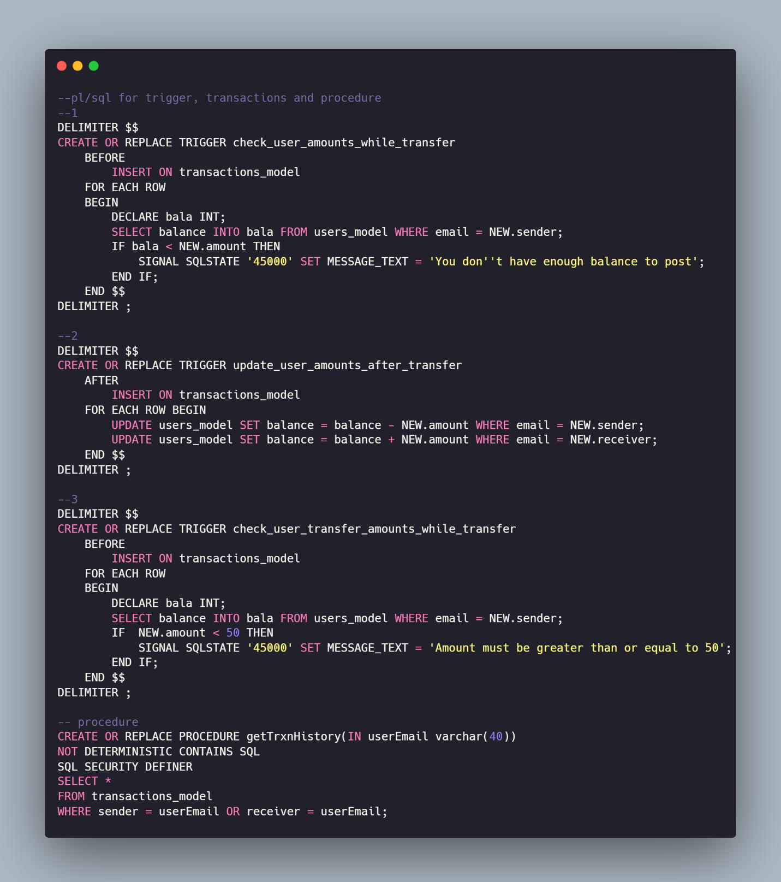

**Fig: Trigger and Procedure Commands**

**Databases:**

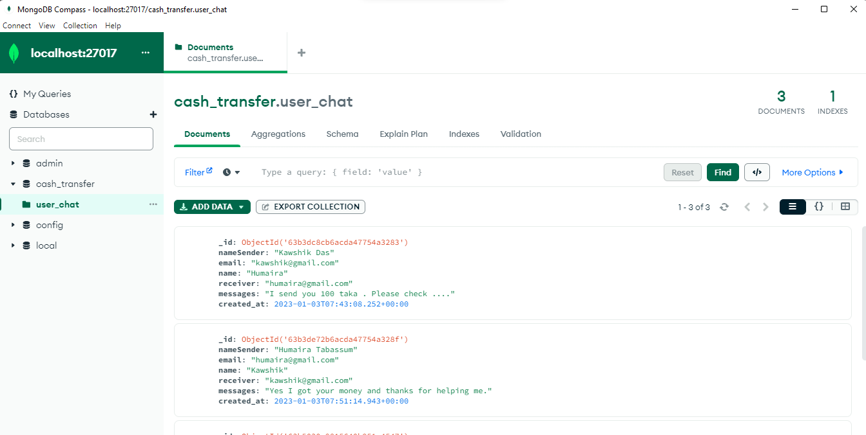

**Fig1: MongoDB**

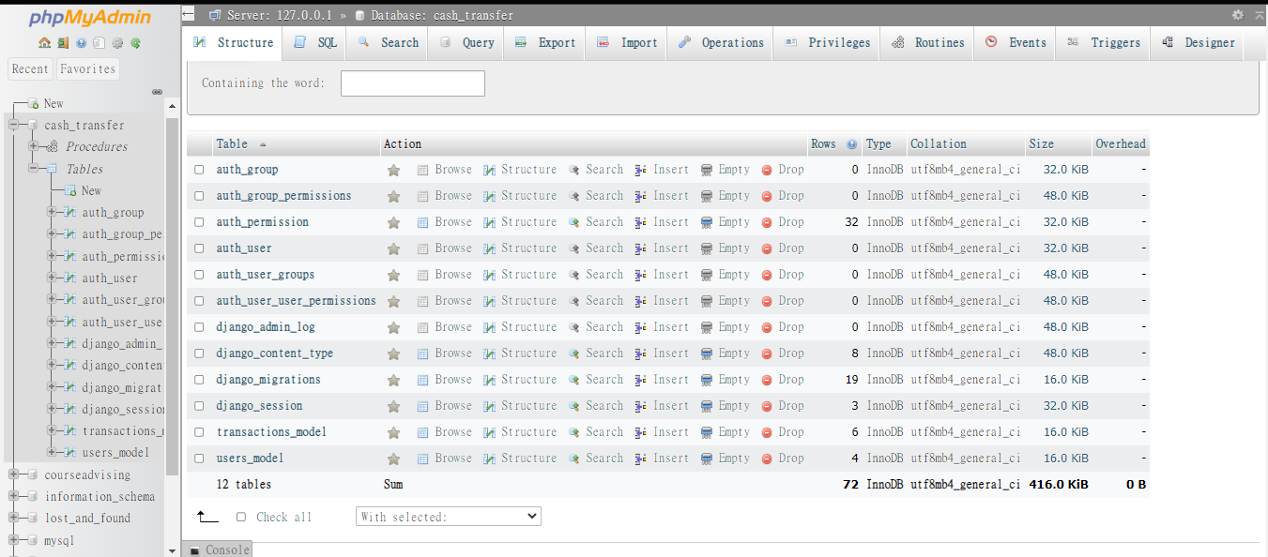

**Fig1: MySQL**

**GUI Screenshots:**

