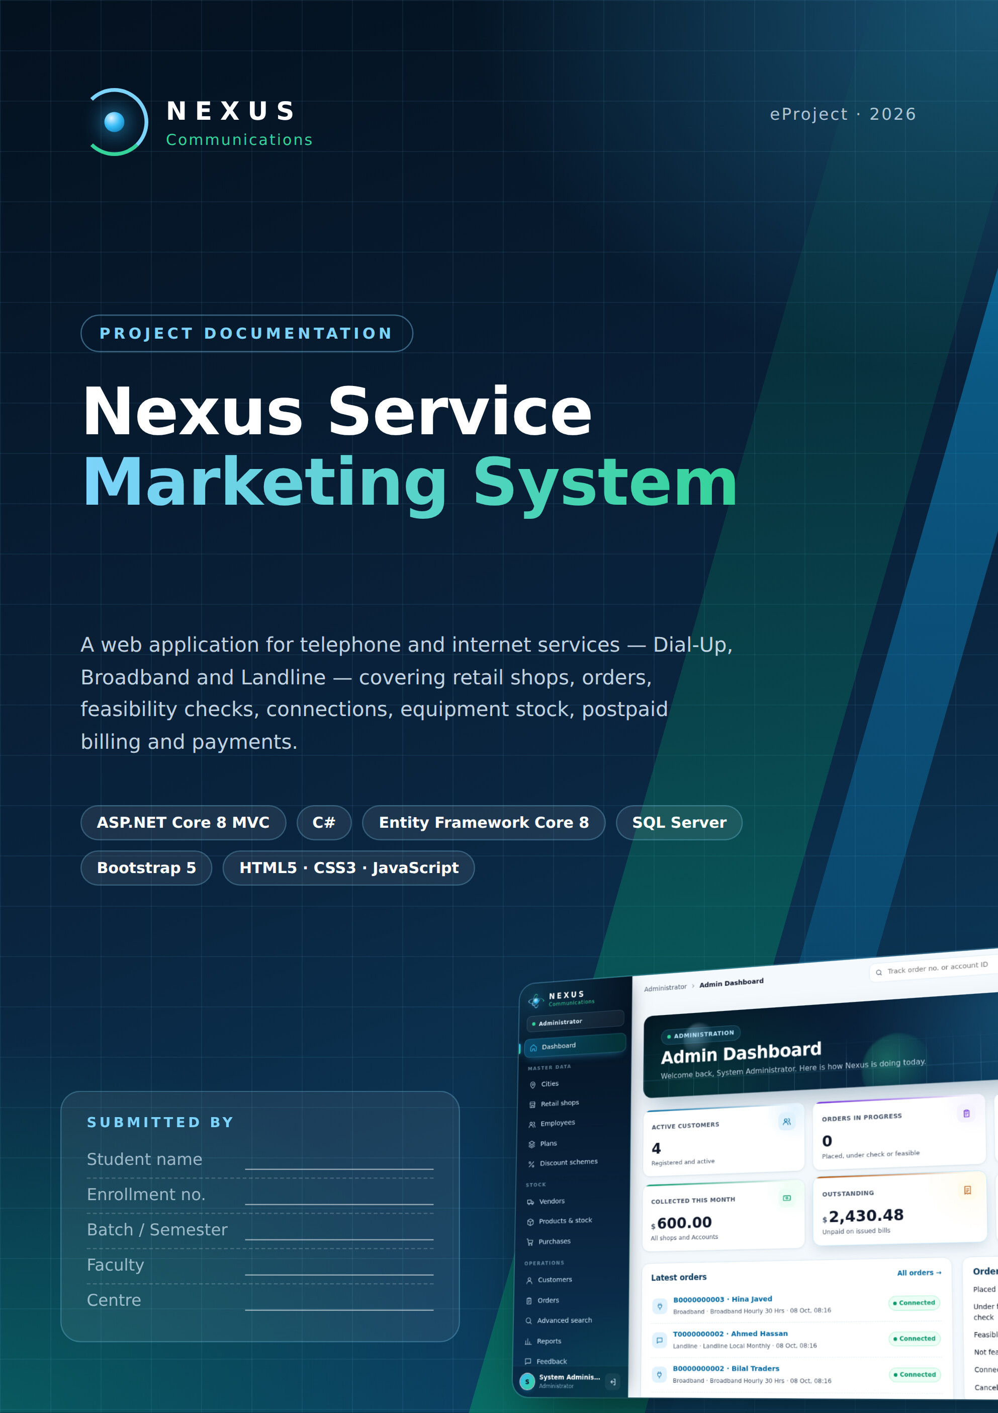

Acknowledgement
I would like to thank my faculty and the staff of the Aptech centre for their guidance and support during this eProject. Their feedback on analysis, database design and testing helped turn the problem statement into a working application.
I am also thankful to my family and friends for their encouragement throughout the project.

Certificate
This is to certify that the eProject titled "Nexus Service Marketing System" has been completed by the student named on the cover page, as part of the curriculum, under the guidance of the faculty named there.

______________________ ______________________
Faculty signature Centre manager

Table of Contents
1. Introduction 5
1.1 Objectives 5
1.2 Scope 5
1.3 Technology stack 6
2. Problem Definition 7
3. Customer Requirements Specification 8
3.1 Users and roles 8
3.2 Functional requirements 8
3.3 Non-functional requirements 9
3.4 Business rules 9
4. System Design 10
4.1 Architecture 10
4.2 Modules 11
4.3 Services (business layer) 11
4.4 Security design 11
5. Database Design 13
5.1 Tables 14
5.2 Integrity rules 14
5.3 Data dictionary 14
6. Process Design 24
6.1 Context diagram (DFD level 0) 24
6.2 DFD level 1 25
6.3 Use case diagram 26
6.4 Workflow flowchart 27
6.5 Status life cycles 27
7. User Interface Design 28
7.1 Design system 28
7.2 Motion and overlays 28
7.3 Public website 30
7.4 Administrator 33
7.5 Retail staff 37
7.6 Technical team 39
7.7 Accounts 42
7.8 Customer portal 43
7.9 Mobile view 45
8. Testing 46
9. Installation Guide 48
9.1 Requirements 48
9.2 Connect SQL Server 48
9.3 Create the database 48
9.4 First login 48
9.5 Troubleshooting 49
10. User Guide 50
10.1 Getting around 50
10.2 Administrator 50
10.3 Retail staff 50
10.4 Technical team 50
10.5 Accounts 50
10.6 Customer 51
11. Developer Guide 52
11.1 Folder structure 52
11.2 Adding a feature 52
12. Conclusion and Future Enhancements 53
Future enhancements 53

1. Introduction
Nexus Communications provides telephone and internet services - Dial-Up, Broadband and Landline - through retail shops in several cities. The Nexus Service Marketing System is a web application that runs the whole business in one place: plans and prices, retail shops, employees, customers, orders, feasibility checks, connections, equipment stock, postpaid bills and payments.
Every user signs in to a dashboard for their own role. Customers can register, order and follow their order online; retail staff serve walk-in customers and collect payments; the technical team checks feasibility and creates connections; accounts staff generate bills; and the administrator maintains the master data and watches the whole operation.

1.1 Objectives
- Replace manual registers with one database that every department shares.
- Give each role exactly the screens it needs, protected by role-based login.
- Generate order numbers and account IDs automatically in the format of the specification.
- Calculate bills correctly: plan fee, call charges, usage, deposit, bulk discount and 12.24 % service tax.
- Show the status of every order, connection and bill at any time, including amounts due.
- Present it in a modern, fast and easy interface that also works on tablets and phones.

1.2 Scope
Table 1. Project scope
In scope | Out of scope
Dial-Up, Broadband and Landline orders and connections | Online card payment gateway (payments are recorded by staff)
Five user roles + public visitors | Physical network / exchange equipment management
Feasibility checks, provisioning, equipment issue and replacement | SMS / e-mail notifications
Postpaid billing, partial payments, overdue suspension | Payroll and HR
Advanced search, tracking, reports, customer documents, feedback | Mobile app (the website is responsive instead)

1.3 Technology stack
Table 2. Technology stack
Layer | Technology
Front end | Razor views, HTML5, CSS3, JavaScript, Bootstrap 5, Google Fonts (Space Grotesk, DM Sans)
Back end | ASP.NET Core 8 MVC (C# 12), Areas per role, cookie authentication, role authorization
Data access | Entity Framework Core 8 (code-first, 5 migrations), LINQ
Database | Microsoft SQL Server 2019 / 2022 (any edition, incl. Express)
Tools | Visual Studio 2022, SQL Server Management Studio, .NET 8 SDK, dotnet-ef, Google Chrome

2. Problem Definition
Nexus Communications sells Dial-Up, Broadband and Landline connections from retail shops in several cities. Today each shop keeps its own registers for customers and orders, the technical team receives orders on paper, and the accounts department prepares bills by hand. This causes:
- Lost and duplicated orders - no single order number that every department can follow.
- Slow feasibility and installation - technical staff do not see new orders until paperwork arrives.
- Billing mistakes - plan fees, call charges, deposits, bulk discounts and the 12.24 % service tax are calculated by hand.
- No view of dues - shops cannot see what a customer owes, and overdue connections stay active.
- Equipment losses - modems and routers issued to customers are not tracked against stock.
- No self-service - customers must visit or phone a shop to know the status of their order.
The company needs a central, role-based web system where every order gets a unique number, moves through feasibility, connection, billing and payment in one database, and where every user sees the information they need instantly.
Identifier formats required by the specification
Order number - 11 characters: service letter (D Dial-Up, B Broadband, T Telephone) + 10 digits, e.g. B0000000001.
Account ID - 16 characters: service letter + 3-digit city code + 12-digit serial, e.g. B001000000000001.
Both are generated by the server and protected by CHECK constraints in the database.

3. Customer Requirements Specification

3.1 Users and roles
Table 3. Users and roles
Role | Who | Main responsibilities
Visitor | Anyone | View plans and prices, track an order / account, register as a customer
Customer | Registered customer | Profile, place orders, follow orders, connections, bills and amount due, documents, feedback
Retail staff | Shop employee | Register walk-in customers, place orders, view shop connections, collect payments, payment history, search
Technical | Technical team | Feasibility checks, create connections, issue / replace equipment, change plan, suspend overdue and reactivate, stock
Accounts | Accounts department | Generate bills, record payments, view unpaid and overdue bills, search
Administrator | Head office | Cities, shops, employees and logins, plans, discount schemes, vendors, products, purchases, customers, orders, reports, feedback

3.2 Functional requirements
Table 4. Functional requirements
ID | Requirement | Role
FR-01 | Secure login for every role; passwords stored as salted hashes; change password | All
FR-02 | Maintain cities (unique 3-digit code) and retail shops | Admin
FR-03 | Maintain employees with a role, shop (for retail staff) and login | Admin
FR-04 | Add, edit, search and delete plans for Dial-Up, Broadband and Landline | Admin
FR-05 | Maintain bulk discount bands (10-14: 25 %, 15-24: 50 %, 25-49: 75 %, 50+: 100 %) | Admin
FR-06 | Maintain vendors, products and stock; record purchases that increase stock | Admin
FR-07 | Register customers (individual or corporate) with a login | Retail, Customer, Admin
FR-08 | Place an order; generate the 11-character order number; apply bulk discount | Retail, Customer
FR-09 | Dial-up needs a Nexus landline: order both together or link an existing line | Retail, Customer, Technical
FR-10 | Record landline and internet feasibility (distance, server availability, result) | Technical
FR-11 | Create connections from feasible orders; generate account IDs; issue equipment from stock | Technical
FR-12 | Set connections temporarily or permanently inactive; change plan; replace spoiled equipment | Technical
FR-13 | Generate bills: plan fee per validity period, call charges, usage, deposit, discount, 12.24 % tax, brought-forward balance | Accounts
FR-14 | Record full or partial payments; never more than the outstanding amount | Accounts, Retail
FR-15 | List active connections with overdue bills; suspend them; reactivate when paid | Technical
FR-16 | Track an order number or account ID publicly; amounts only after sign-in | All
FR-17 | Advanced search by ID, name, contact, connection type and date range | Admin, Retail, Technical, Accounts
FR-18 | Upload private customer documents (PDF / PNG / JPEG, 5 MB) filed by year and city | Customer, Retail, Admin
FR-19 | Collect customer feedback; reports for the administrator | Customer, Admin
FR-20 | Role dashboards with live figures and items that need attention | All signed-in users

3.3 Non-functional requirements
Table 5. Non-functional requirements
Area | Requirement
Security | Cookie authentication, role-based authorization on every controller, anti-forgery tokens on every form, PBKDF2 password hashes, private document storage, customers can only open their own records
Data integrity | Primary / foreign keys, 47 CHECK constraints, unique indexes, row-version concurrency on orders and connections, no cascade deletes
Usability | Sidebar navigation per role, dashboards, consistent status colours, inline validation, confirm dialogs before destructive actions
Performance | Server-side paging limits (300 rows), AsNoTracking reads, indexes on foreign keys and identifiers
Portability | Runs on any SQL Server edition; one connection string in appsettings.json; database created by migrations or one SQL script
Accessibility | Keyboard focus styles, skip link, ARIA labels, WCAG contrast for text, animations disabled for "reduced motion" users
Responsiveness | Works from 360 px phones to wide desktop screens

3.4 Business rules
- A plan fee is charged once per plan validity period (e.g. a quarterly plan every 3 months).
- Call charges = local, STD and messaging-for-mobile minutes x the plan's per-minute rates.
- The security deposit and the bulk discount appear on the first bill only.
- Service tax of 12.24 % is applied to the whole bill.
- The unpaid amount of earlier bills is shown as brought forward.
- A bill past its due date and not fully paid makes an active connection overdue; Technical can set it temporarily inactive, and reactivate it once all bills are paid.
- Equipment replaced because the customer spoiled it is charged on the next bill (once).
- A multi-connection order records device serials after provisioning, one per connection.

4. System Design

4.1 Architecture
The application follows a three-layer architecture. The presentation layer (areas, controllers and Razor views) never talks to the database directly; it calls services, which hold every business rule and use Entity Framework Core to read and write SQL Server.
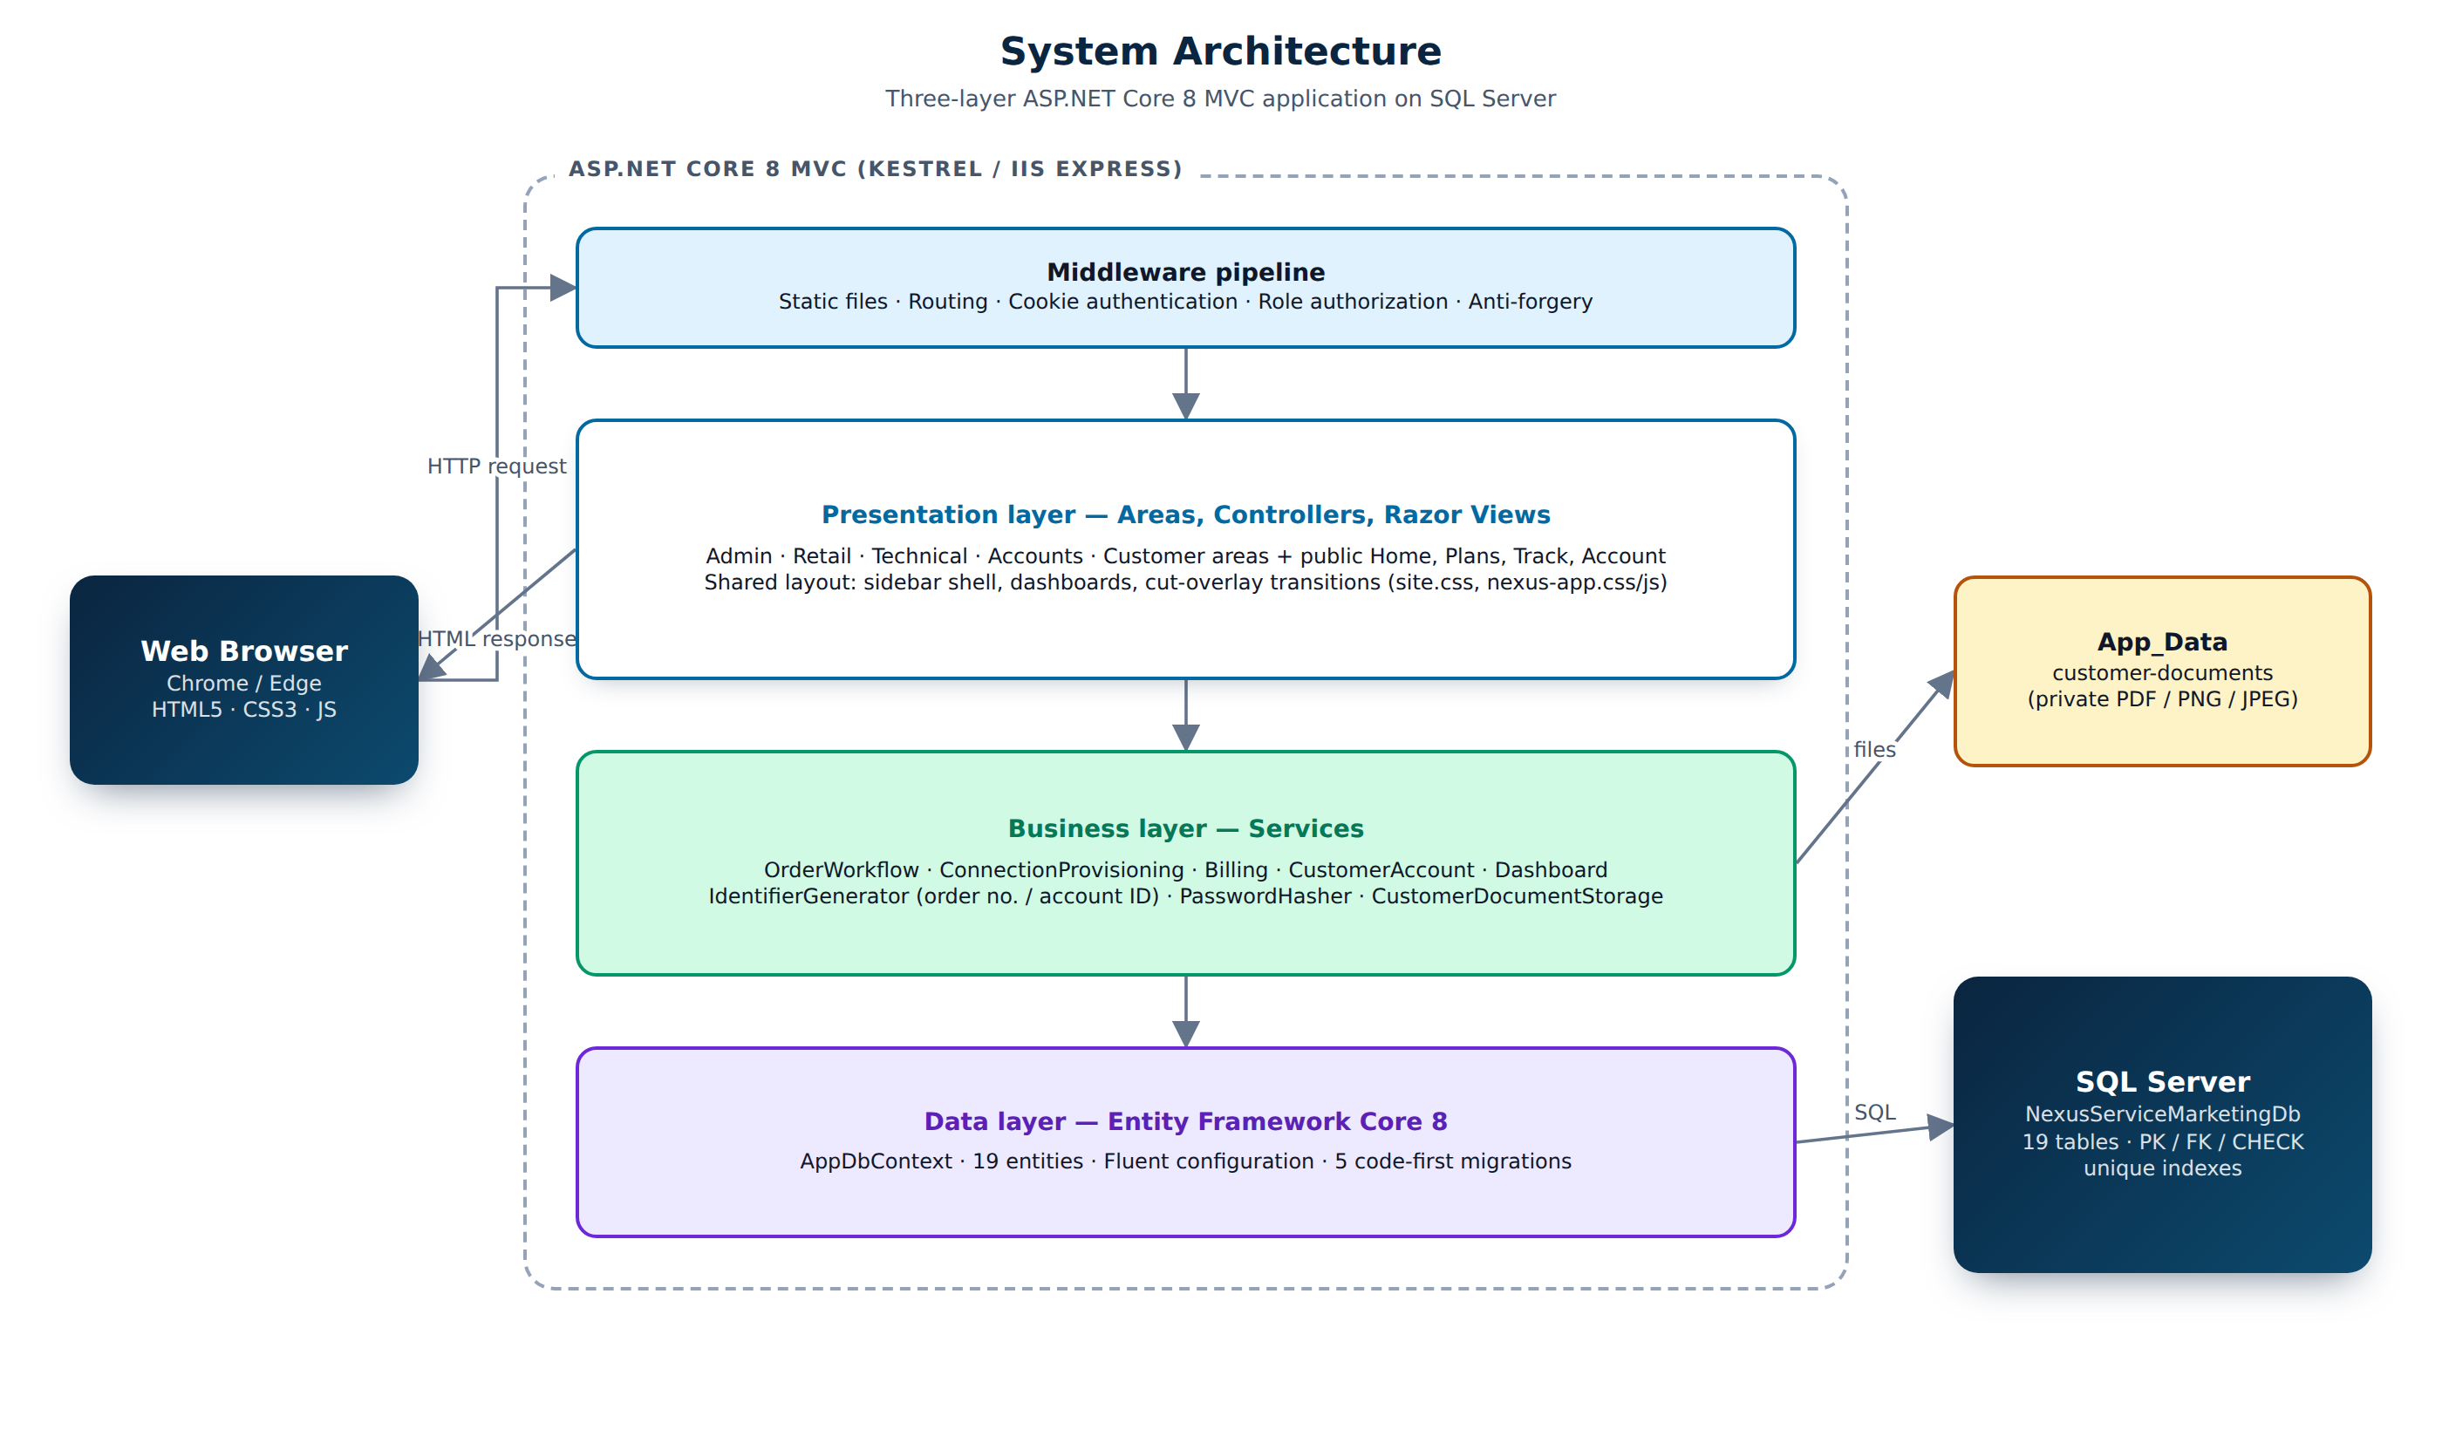
Figure 1. System architecture

4.2 Modules
Table 6. Application modules
Module (Area) | Controllers | Purpose
Public | Home, Catalog, Track, Account | Landing page, plans and prices, order / account tracking, login, registration, change password
Admin | Home, Cities, RetailShops, Employees, Plans, DiscountSchemes, Vendors, Products, Purchases, Customers, Operations | Master data, stock, customers, orders, advanced search, reports, feedback
Retail | Home, Customers, Orders, Connections, Payments | Walk-in customers and orders, shop connections, collect payments, payment history
Technical | Home, Feasibility, Connections, Products | Feasibility queue, provisioning, status changes, overdue list, equipment and stock
Accounts | Home, Bills | Bill generation with charge preview, payments
Customer | Home, Orders, Portal, Documents | Self-service orders, connections, bills, profile, documents, feedback
Search | Search | Advanced search shared by Retail (own shop), Technical and Accounts

4.3 Services (business layer)
Table 7. Business services
Service | Responsibility
OrderWorkflowService | Validates and places orders, applies discount bands, dial-up + landline rule, starts and records feasibility checks, cancels orders
ConnectionProvisioningService | Creates connections and account IDs, issues equipment, changes status / plan, replaces equipment, finds overdue and cleared connections
BillingService | Previews and generates bills (plan fee, calls, usage, deposit, discount, 12.24 % tax, brought-forward), records payments
CustomerAccountService | Registers customers with a login, updates profiles
IdentifierGenerator | Thread-safe order numbers and account IDs using the IdentifierCounters table
DashboardService | Read-only figures for the five role dashboards
PasswordHasherService / CustomerDocumentStorage | Password hashing; private file storage under App_Data

4.4 Security design
- Each area controller carries [Authorize(Roles = ...)]; anonymous users are redirected to Login and wrong roles to Access denied.
- Every POST form has an anti-forgery token ([ValidateAntiForgeryToken]).
- Passwords are hashed with PBKDF2 and a random salt; the admin account is created at first start and should change its password.
- Customers, retail shops and employees see only their own data (shop and customer filters in every query).
- Customer documents are stored outside wwwroot and are downloaded only through an authorized action.

5. Database Design
The database NexusServiceMarketingDb has 19 tables. It is created by five Entity Framework migrations (InitialCreate, CustomerSelfServiceOrders, VendorProductPurchases, CustomerDocumentFiling, SpecGapFixes) or by the equivalent script Database/NexusServiceMarketingDb-schema.sql. The migrations also seed 18 tariff plans and 4 bulk-discount bands.
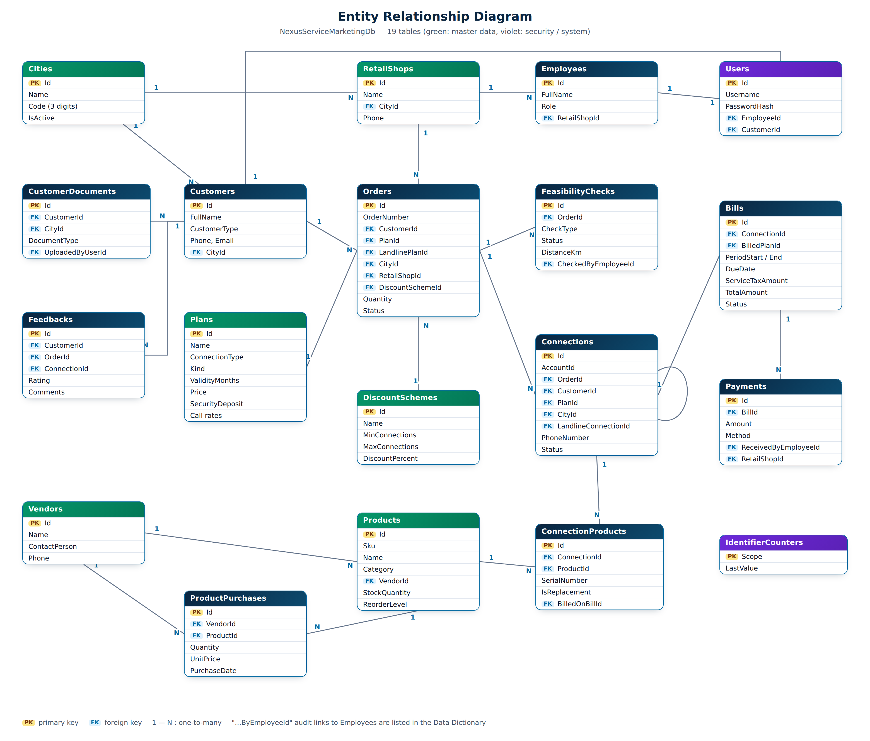
Figure 2. Entity relationship diagram

5.1 Tables
Table 8. Table groups
Group | Tables
Master data | Cities, RetailShops, Plans, DiscountSchemes, Vendors, Products
People and security | Employees, Customers, Users
Orders and connections | Orders, FeasibilityChecks, Connections, ConnectionProducts
Billing | Bills, Payments
Stock, documents, other | ProductPurchases, CustomerDocuments, Feedbacks, IdentifierCounters

5.2 Integrity rules
- Every relationship is a foreign key with ON DELETE NO ACTION; records in use are deactivated (IsActive = 0) instead of deleted.
- Unique indexes: OrderNumber, AccountId, Username, city Code and Name, product Sku, plan Name, vendor Name, one bill per connection per period.
- CHECK constraints guard identifier formats, status values, amounts (>= 0), percentages (0-100) and plan kinds.
- Money uses decimal(18,2); call rates decimal(10,4); dates date / datetime2 in UTC.

5.3 Data dictionary
The dictionary below was exported from the live database, so it matches the delivered schema exactly.

Bills
Postpaid bill of one connection for one billing period, with every charge stored as issued.
Column | Data type | Null | Key | Description
Id | int | No | PK | Primary key (identity)
ConnectionId | int | No | FK | References Connections.Id
PeriodStart | date | No
PeriodEnd | date | No
IssueDate | date | No
DueDate | date | No |  | Pay-by date; unpaid after this = overdue
PlanCharge | decimal(18,2) | No
UsageCharge | decimal(18,2) | No
SecurityDepositCharge | decimal(18,2) | No
ReplacementCharge | decimal(18,2) | No
DiscountAmount | decimal(18,2) | No
SubTotal | decimal(18,2) | No
ServiceTaxRate | decimal(5,2) | No |  | Service tax rate (12.24 %)
ServiceTaxAmount | decimal(18,2) | No |  | Tax amount on the bill
TotalAmount | decimal(18,2) | No |  | Bill total after tax
Status | varchar(30) | No |  | Workflow status (CHECK list of values)
GeneratedByEmployeeId | int | No | FK | References Employees.Id
GeneratedAtUtc | datetime2 | No
RowVersion | rowversion | No |  | Concurrency token (row version)
BilledPlanId | int | Yes | FK | References Plans.Id
CallCharge | decimal(18,2) | No
LocalMinutes | int | No
MobileMinutes | int | No
PlanValidUntil | date | Yes
PreviousBalance | decimal(18,2) | No |  | Unpaid amount brought forward from earlier bills
StdMinutes | int | No

Cities
Cities served; the 3-digit code is part of every account ID.
Column | Data type | Null | Key | Description
Id | int | No | PK | Primary key (identity)
Name | nvarchar(100) | No |  | Display name
Code | char(3) | No |  | 3-digit city code (CHECK: [0-9][0-9][0-9])
IsActive | bit | No |  | Inactive records are hidden from new work (soft delete)

ConnectionProducts
Equipment (modem, router, handset) issued to a connection, including replacements.
Column | Data type | Null | Key | Description
Id | int | No | PK | Primary key (identity)
ConnectionId | int | No | FK | References Connections.Id
ProductId | int | No | FK | References Products.Id
Quantity | int | No |  | Number of connections / items (>= 1)
SerialNumber | nvarchar(60) | Yes |  | Device serial number (unique per product)
IsReplacement | bit | No
IssuedAtUtc | datetime2 | No
ReturnedAtUtc | datetime2 | Yes
Notes | nvarchar(500) | Yes
BilledOnBillId | int | Yes | FK | References Bills.Id
ReplacementChargeAmount | decimal(18,2) | No

Connections
A working Dial-Up, Broadband or Landline connection created from a feasible order.
Column | Data type | Null | Key | Description
Id | int | No | PK | Primary key (identity)
AccountId | char(16) | No |  | D/B/T + 3-digit city + 12-digit serial, unique (CHECK)
OrderId | int | No | FK | References Orders.Id
CustomerId | int | No | FK | References Customers.Id
PlanId | int | No | FK | References Plans.Id
ConnectionType | char(1) | No |  | Service letter: D = Dial-Up, B = Broadband, T = Telephone (CHECK)
CityId | int | No | FK | References Cities.Id
InstallationAddress | nvarchar(300) | No |  | Where the connection is installed
PhoneNumber | nvarchar(20) | Yes |  | Telephone number of a landline
LandlineConnectionId | int | Yes | FK | References Connections.Id
Status | varchar(30) | No |  | Workflow status (CHECK list of values)
SecurityDepositAmount | decimal(18,2) | No
CreatedByEmployeeId | int | No | FK | References Employees.Id
ActivatedAtUtc | datetime2 | No
StatusChangedAtUtc | datetime2 | No
RowVersion | rowversion | No |  | Concurrency token (row version)

CustomerDocuments
Private customer files (address proof, application form, receipts) filed by year and city.
Column | Data type | Null | Key | Description
Id | int | No | PK | Primary key (identity)
CustomerId | int | No | FK | References Customers.Id
CityId | int | No | FK | References Cities.Id
DocumentType | varchar(30) | No
DocumentYear | int | No
OriginalFileName | nvarchar(255) | No
StorageName | nvarchar(80) | No |  | Random file name on disk (private)
ContentType | nvarchar(100) | No
SizeBytes | bigint | No |  | File size (max 5 MB)
Notes | nvarchar(500) | Yes
UploadedByUserId | int | No | FK | References Users.Id
UploadedAtUtc | datetime2 | No

Customers
Individual or corporate customers.
Column | Data type | Null | Key | Description
Id | int | No | PK | Primary key (identity)
FullName | nvarchar(150) | No |  | Person or company name
CustomerType | varchar(30) | No
CompanyName | nvarchar(150) | Yes
Email | nvarchar(256) | Yes |  | E-mail address
Phone | nvarchar(20) | No |  | Contact phone
AddressLine | nvarchar(300) | No
PostalCode | nvarchar(20) | Yes
CityId | int | No | FK | References Cities.Id
IsActive | bit | No |  | Inactive records are hidden from new work (soft delete)
CreatedAtUtc | datetime2 | No |  | Created at (UTC)

DiscountSchemes
Bulk / corporate discount bands by number of connections.
Column | Data type | Null | Key | Description
Id | int | No | PK | Primary key (identity)
Name | nvarchar(100) | No |  | Display name
MinConnections | int | No
MaxConnections | int | Yes
DiscountPercent | decimal(5,2) | No |  | Percentage 0-100 (CHECK)
AppliesToAdvance | bit | No
AppliesToSecurityDeposit | bit | No
IsActive | bit | No |  | Inactive records are hidden from new work (soft delete)
CreatedAtUtc | datetime2 | No |  | Created at (UTC)

Employees
Staff of Nexus: Admin, Accounts, Technical and Retail staff.
Column | Data type | Null | Key | Description
Id | int | No | PK | Primary key (identity)
FullName | nvarchar(150) | No |  | Person or company name
Email | nvarchar(256) | No |  | E-mail address
Phone | nvarchar(20) | No |  | Contact phone
Role | varchar(30) | No |  | Admin, Accounts, Technical or RetailStaff
RetailShopId | int | Yes | FK | References RetailShops.Id
IsActive | bit | No |  | Inactive records are hidden from new work (soft delete)
CreatedAtUtc | datetime2 | No |  | Created at (UTC)

FeasibilityChecks
Landline and / or internet feasibility check of an order.
Column | Data type | Null | Key | Description
Id | int | No | PK | Primary key (identity)
OrderId | int | No | FK | References Orders.Id
CheckType | varchar(30) | No |  | Landline or Internet
Status | varchar(30) | No |  | Workflow status (CHECK list of values)
DistanceKm | decimal(8,2) | Yes |  | Distance from exchange / server (km)
ServerAvailable | bit | Yes |  | Internet server port available
Remarks | nvarchar(500) | Yes
CheckedByEmployeeId | int | Yes | FK | References Employees.Id
CheckedAtUtc | datetime2 | Yes
CreatedAtUtc | datetime2 | No |  | Created at (UTC)

Feedbacks
Customer feedback with a 1-5 rating.
Column | Data type | Null | Key | Description
Id | int | No | PK | Primary key (identity)
CustomerId | int | No | FK | References Customers.Id
OrderId | int | Yes | FK | References Orders.Id
ConnectionId | int | Yes | FK | References Connections.Id
Rating | int | No |  | Rating 1-5
Comments | nvarchar(2000) | No
SubmittedAtUtc | datetime2 | No

IdentifierCounters
Running counters used to generate order numbers and account IDs safely.
Column | Data type | Null | Key | Description
Scope | varchar(40) | No | PK | Counter name (e.g. order type)
LastValue | bigint | No |  | Last number issued

Orders
A request for one or more connections of one service type.
Column | Data type | Null | Key | Description
Id | int | No | PK | Primary key (identity)
OrderNumber | char(11) | No |  | D/B/T + 10 digits, unique (CHECK)
CustomerId | int | No | FK | References Customers.Id
ConnectionType | char(1) | No |  | Service letter: D = Dial-Up, B = Broadband, T = Telephone (CHECK)
PlanId | int | No | FK | References Plans.Id
CityId | int | No | FK | References Cities.Id
InstallationAddress | nvarchar(300) | No |  | Where the connection is installed
Quantity | int | No |  | Number of connections / items (>= 1)
RetailShopId | int | Yes | FK | References RetailShops.Id
PlacedByEmployeeId | int | Yes | FK | References Employees.Id
DiscountSchemeId | int | Yes | FK | References DiscountSchemes.Id
DiscountPercent | decimal(5,2) | No |  | Percentage 0-100 (CHECK)
Status | varchar(30) | No |  | Workflow status (CHECK list of values)
PlacedAtUtc | datetime2 | No
StatusChangedAtUtc | datetime2 | No
Remarks | nvarchar(500) | Yes
RowVersion | rowversion | No |  | Concurrency token (row version)
LandlinePlanId | int | Yes | FK | References Plans.Id

Payments
Full or partial payment against a bill, at a retail shop or at Accounts.
Column | Data type | Null | Key | Description
Id | int | No | PK | Primary key (identity)
BillId | int | No | FK | References Bills.Id
Amount | decimal(18,2) | No |  | Amount paid
Method | varchar(30) | No |  | Cash, Card, BankTransfer, Cheque or Online
Reference | nvarchar(100) | Yes
PaidAtUtc | datetime2 | No
ReceivedByEmployeeId | int | No | FK | References Employees.Id
RetailShopId | int | Yes | FK | References RetailShops.Id

Plans
Tariff plans for Dial-Up, Broadband and Landline with prices, deposits and call rates.
Column | Data type | Null | Key | Description
Id | int | No | PK | Primary key (identity)
Name | nvarchar(150) | No |  | Display name
Description | nvarchar(500) | Yes
ConnectionType | char(1) | No |  | Service letter: D = Dial-Up, B = Broadband, T = Telephone (CHECK)
Kind | varchar(30) | No |  | Hourly, Unlimited, LocalRental or StdRental (CHECK)
IncludedHours | int | Yes
SpeedKbps | int | Yes
ValidityMonths | int | No |  | Plan validity (> 0)
Price | decimal(18,2) | No |  | Plan fee per validity period
SecurityDeposit | decimal(18,2) | No |  | Refundable deposit charged on the first bill
LocalCallRatePerMinute | decimal(10,4) | Yes
StdCallRatePerMinute | decimal(10,4) | Yes
MobileMessagingRatePerMinute | decimal(10,4) | Yes
IsActive | bit | No |  | Inactive records are hidden from new work (soft delete)
CreatedAtUtc | datetime2 | No |  | Created at (UTC)

ProductPurchases
Equipment bought from a vendor; receipts increase stock.
Column | Data type | Null | Key | Description
Id | int | No | PK | Primary key (identity)
VendorId | int | No | FK | References Vendors.Id
ProductId | int | No | FK | References Products.Id
Quantity | int | No |  | Number of connections / items (>= 1)
UnitPrice | decimal(18,2) | No
AmountPaid | decimal(18,2) | No
PurchaseDate | date | No
SupplierReference | nvarchar(100) | Yes
Notes | nvarchar(500) | Yes
RecordedByEmployeeId | int | No | FK | References Employees.Id
RecordedAtUtc | datetime2 | No

Products
Equipment catalogue and stock level.
Column | Data type | Null | Key | Description
Id | int | No | PK | Primary key (identity)
Sku | nvarchar(40) | No |  | Unique stock-keeping unit
Name | nvarchar(150) | No |  | Display name
Category | varchar(30) | No
Description | nvarchar(500) | Yes
VendorId | int | No | FK | References Vendors.Id
PurchasePrice | decimal(18,2) | No
ReplacementCharge | decimal(18,2) | No
StockQuantity | int | No |  | Units in stock
ReorderLevel | int | No |  | Low-stock warning level
IsActive | bit | No |  | Inactive records are hidden from new work (soft delete)
CreatedAtUtc | datetime2 | No |  | Created at (UTC)
RowVersion | rowversion | No |  | Concurrency token (row version)

RetailShops
Nexus retail outlets, one or more per city.
Column | Data type | Null | Key | Description
Id | int | No | PK | Primary key (identity)
Name | nvarchar(150) | No |  | Display name
AddressLine | nvarchar(300) | No
Phone | nvarchar(20) | Yes |  | Contact phone
CityId | int | No | FK | References Cities.Id
IsActive | bit | No |  | Inactive records are hidden from new work (soft delete)

Users
Login accounts (username + hashed password) linked to an employee or a customer.
Column | Data type | Null | Key | Description
Id | int | No | PK | Primary key (identity)
Username | nvarchar(50) | No |  | Unique login name
PasswordHash | nvarchar(500) | No |  | PBKDF2 password hash - never the plain password
IsActive | bit | No |  | Inactive records are hidden from new work (soft delete)
CreatedAtUtc | datetime2 | No |  | Created at (UTC)
LastLoginAtUtc | datetime2 | Yes
EmployeeId | int | Yes | FK | References Employees.Id
CustomerId | int | Yes | FK | References Customers.Id

Vendors
Equipment manufacturers and suppliers.
Column | Data type | Null | Key | Description
Id | int | No | PK | Primary key (identity)
Name | nvarchar(150) | No |  | Display name
ContactPerson | nvarchar(100) | Yes
Email | nvarchar(256) | Yes |  | E-mail address
Phone | nvarchar(20) | No |  | Contact phone
AddressLine | nvarchar(300) | Yes
IsActive | bit | No |  | Inactive records are hidden from new work (soft delete)
CreatedAtUtc | datetime2 | No |  | Created at (UTC)

6. Process Design

6.1 Context diagram (DFD level 0)
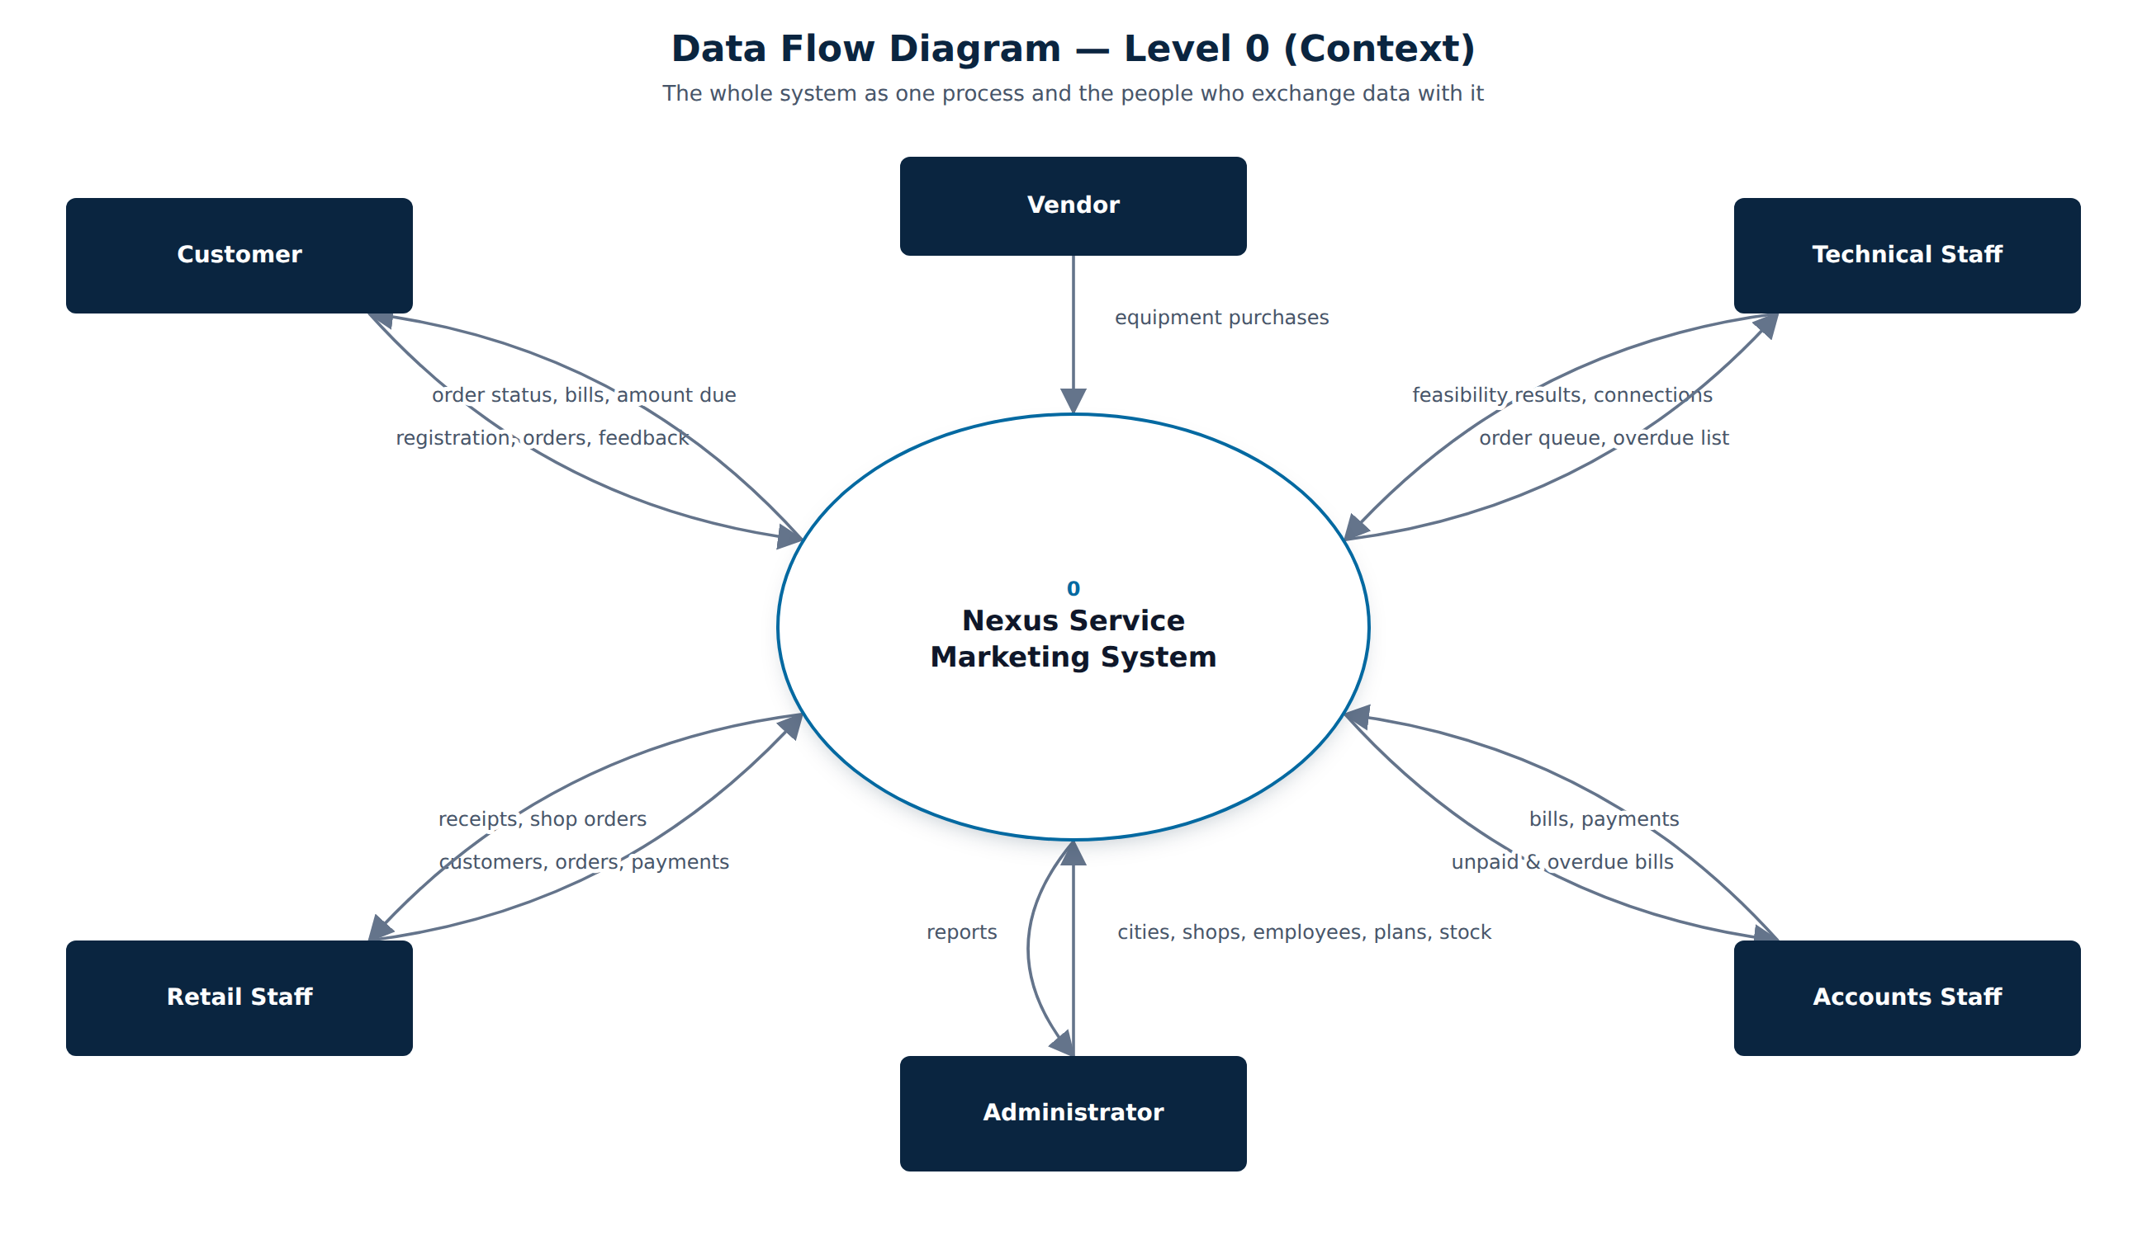
Figure 3. Data flow diagram - level 0

6.2 DFD level 1
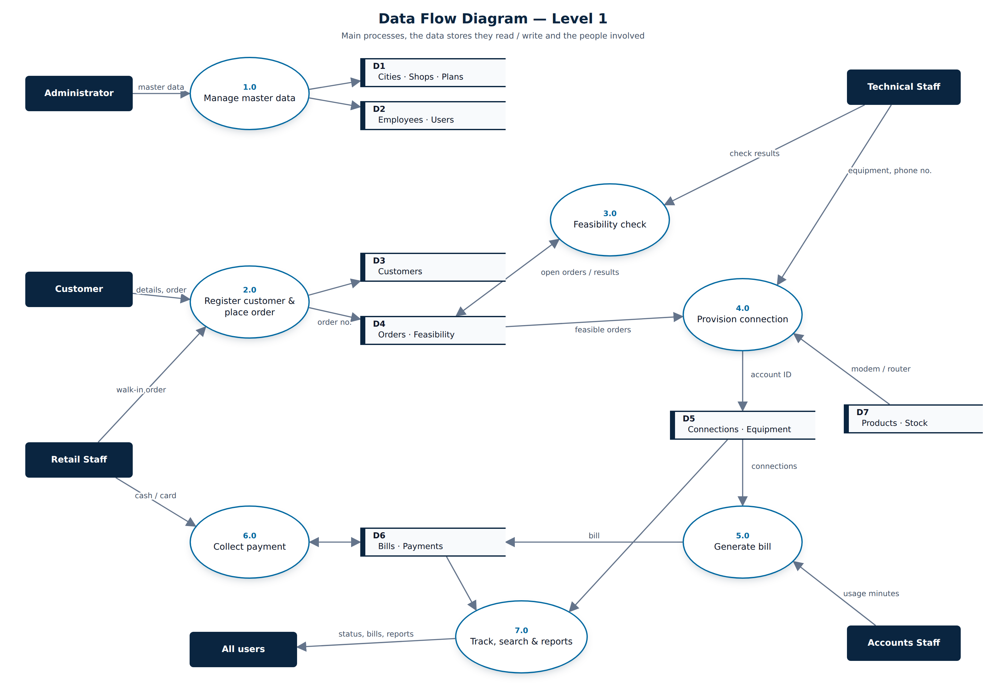
Figure 4. Data flow diagram - level 1

6.3 Use case diagram
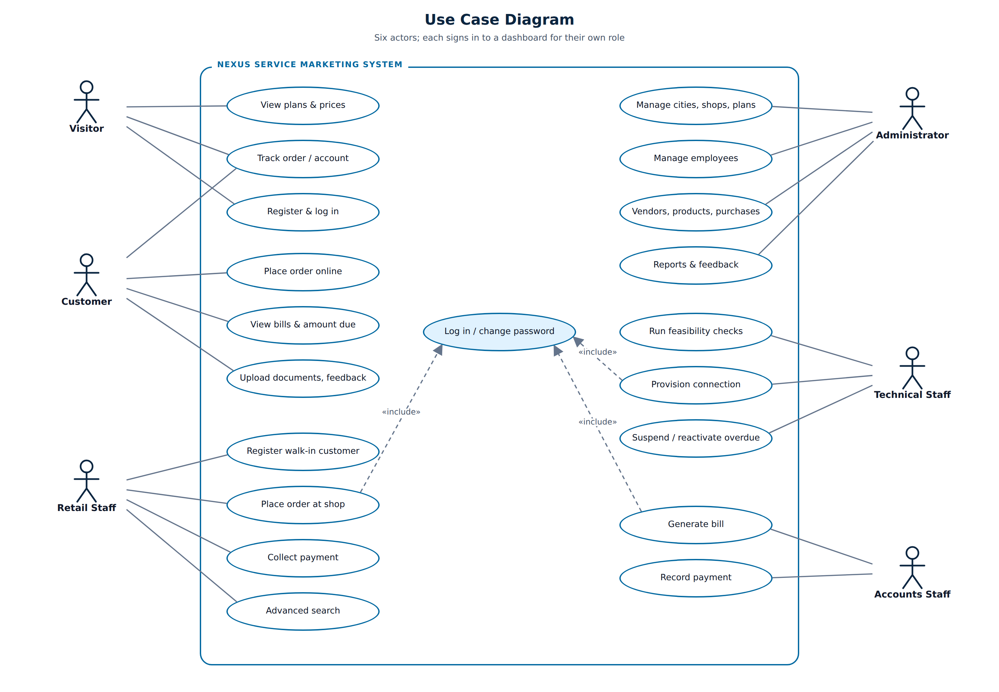
Figure 5. Use case diagram

6.4 Workflow flowchart
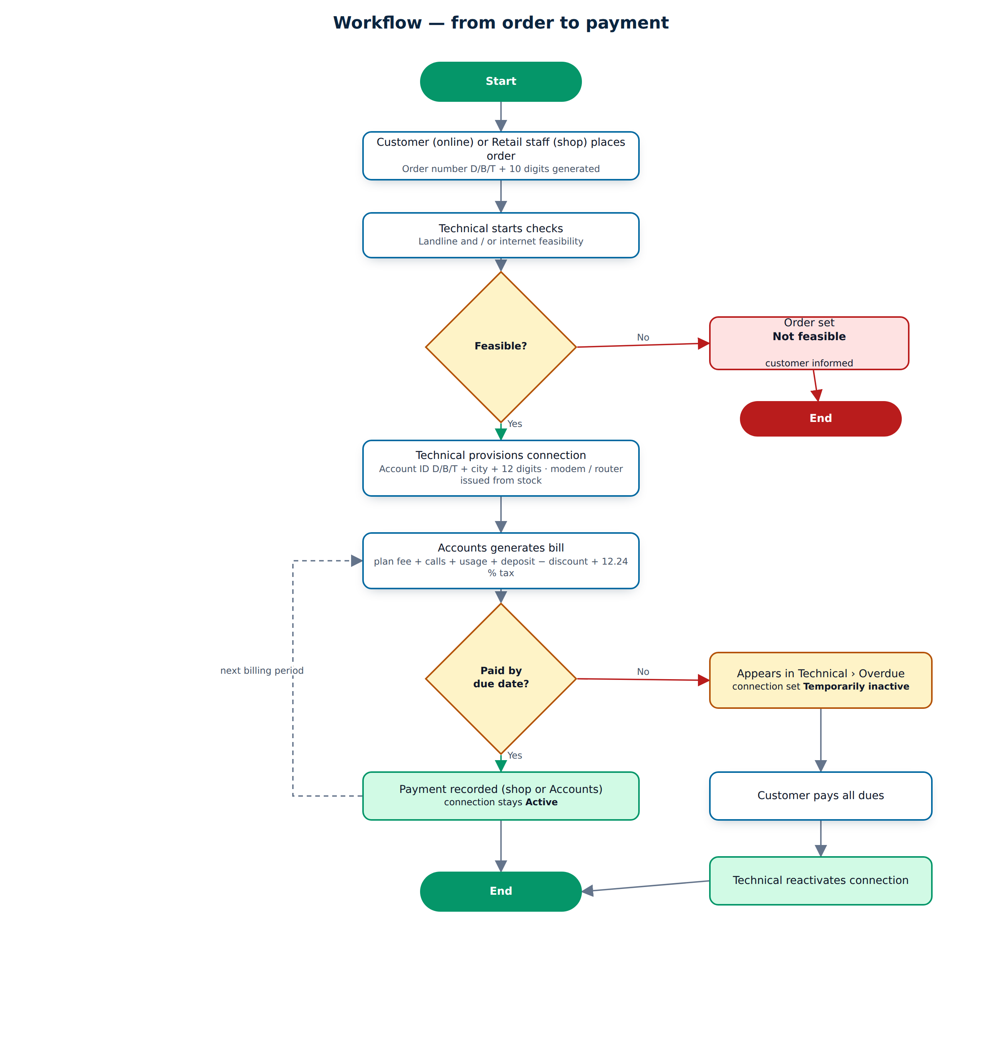
Figure 6. Order-to-payment workflow

6.5 Status life cycles
Table 9. Status life cycles
Object | Statuses (in order)
Order | Placed -> Under feasibility check -> Feasible / Not feasible -> Connected (or Cancelled before connection)
Feasibility check | Pending -> Feasible / Not feasible
Connection | Active <-> Temporarily inactive -> Permanently inactive
Bill | Issued -> Partially paid -> Paid (or Cancelled)

7. User Interface Design
The interface was designed as two experiences: a marketing website for visitors (immersive hero, 3D globe, plans) and a work application for signed-in users (sidebar, dashboards, dense tables). Both share one design system.

7.1 Design system
Table 10. Design system
Element | Choice
Colours | Primary blue #0369A1, navy #0A2540 (sidebar, hero), emerald #059669 (success / call to action), soft ice background #F3F8FC
Typography | Space Grotesk for headings and numbers, DM Sans for text
Status colours | Grey = placed / pending, Blue = in progress / issued, Amber = feasible / partially paid / temporarily inactive, Green = active / connected / paid, Red = overdue / not feasible / closed
Layout | Fixed sidebar (268 px) with sections per role, sticky glass top bar with breadcrumb, quick Track box and account menu; content up to 1480 px
Components | KPI cards with icon and count-up number, attention feed, bar chart, quick actions, badges, toasts, confirm overlay
Responsive | Below 992 px the sidebar becomes an off-canvas drawer opened by the menu button; cards stack on phones

7.2 Motion and overlays
- Cut-overlay page transition - three angled panels (emerald, blue, navy) sweep across the screen when a link is followed and sweep away on the next page, with the Nexus logo in the middle.
- Confirm overlay - Delete, Deactivate, Suspend, Replace and Cancel order open a blurred overlay with a warning icon instead of the browser's plain confirm box.
- Toasts - success messages slide in at the top right, count down and disappear; hovering pauses them.
- Micro-interactions - count-up dashboard numbers, growing chart bars, staggered reveal of cards and table rows, ripple on buttons, 3D tilt on tiles, loading spinner on submit to prevent double posts.
- All motion uses only transform and opacity and is switched off for users who prefer reduced motion.

Figure 7. Cut-overlay transition while moving between pages
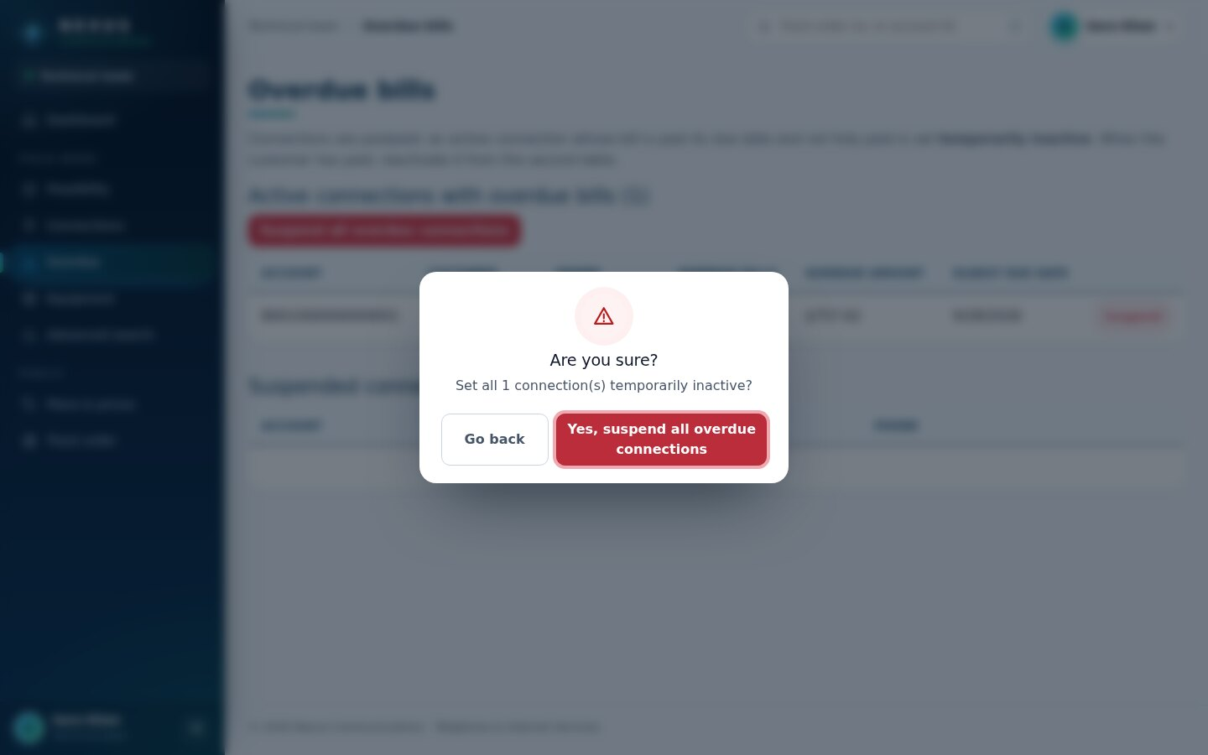
Figure 8. Confirm overlay before suspending overdue connections
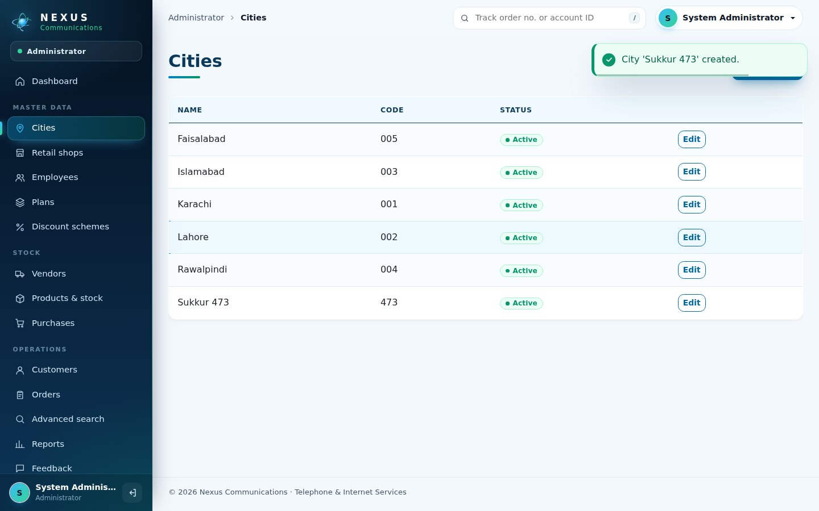
Figure 9. Success toast after saving a city

7.3 Public website
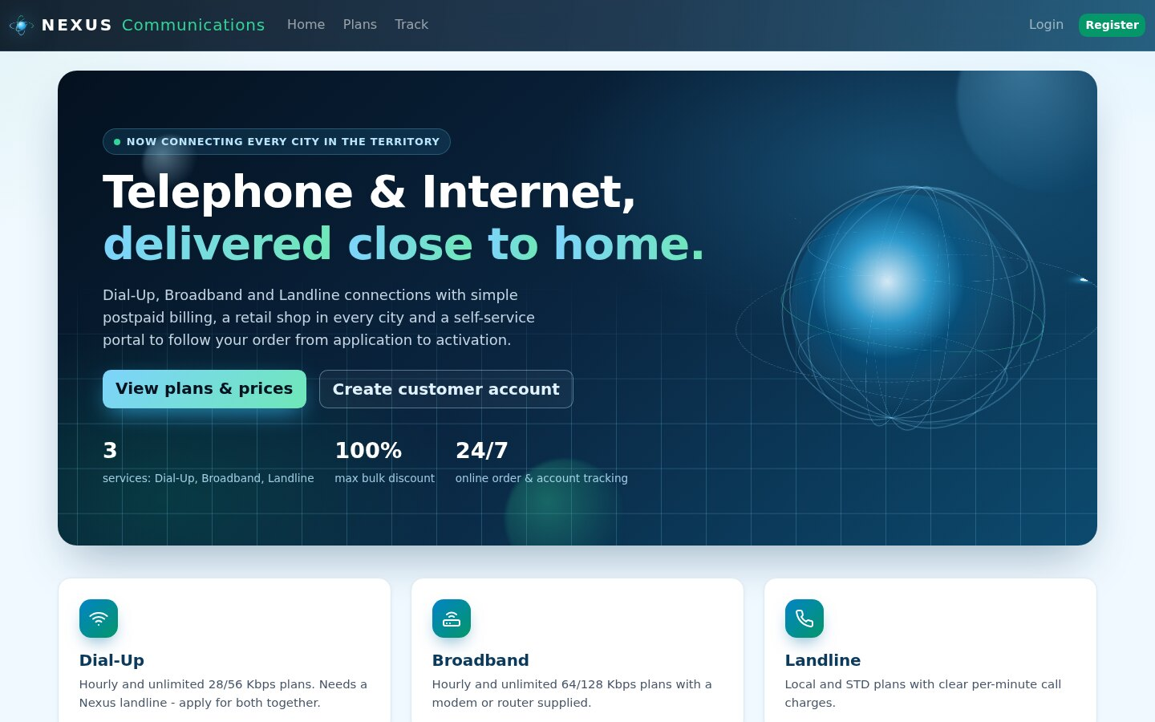
Figure 10. Home page
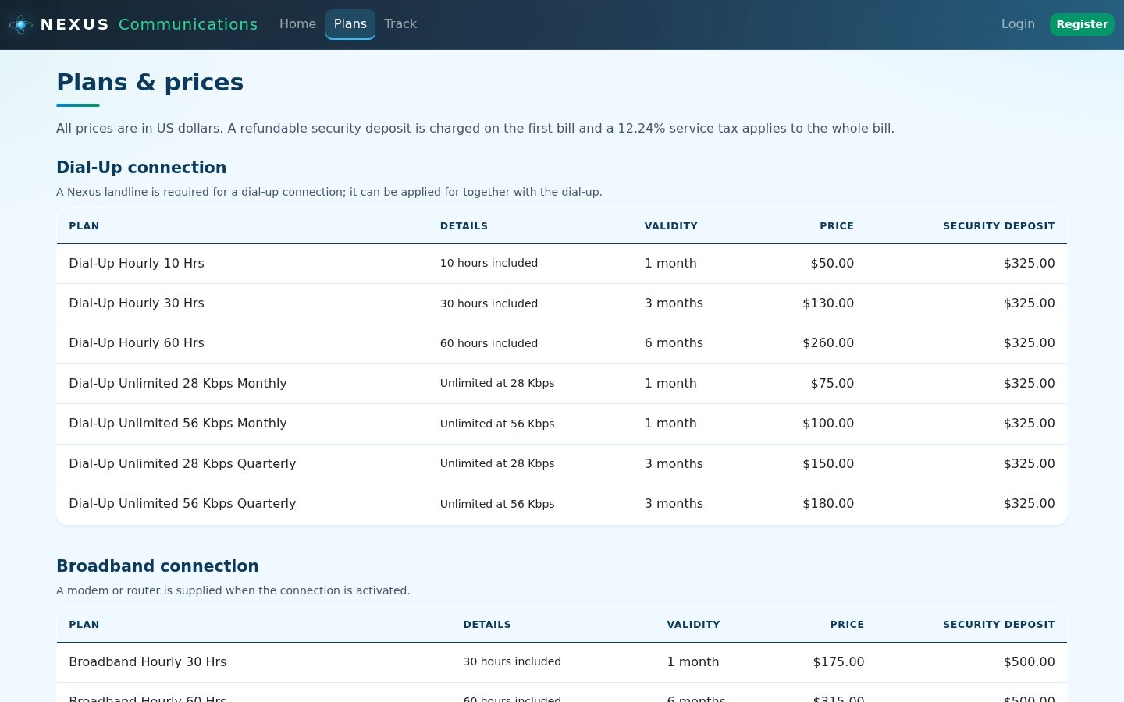
Figure 11. Plans and prices
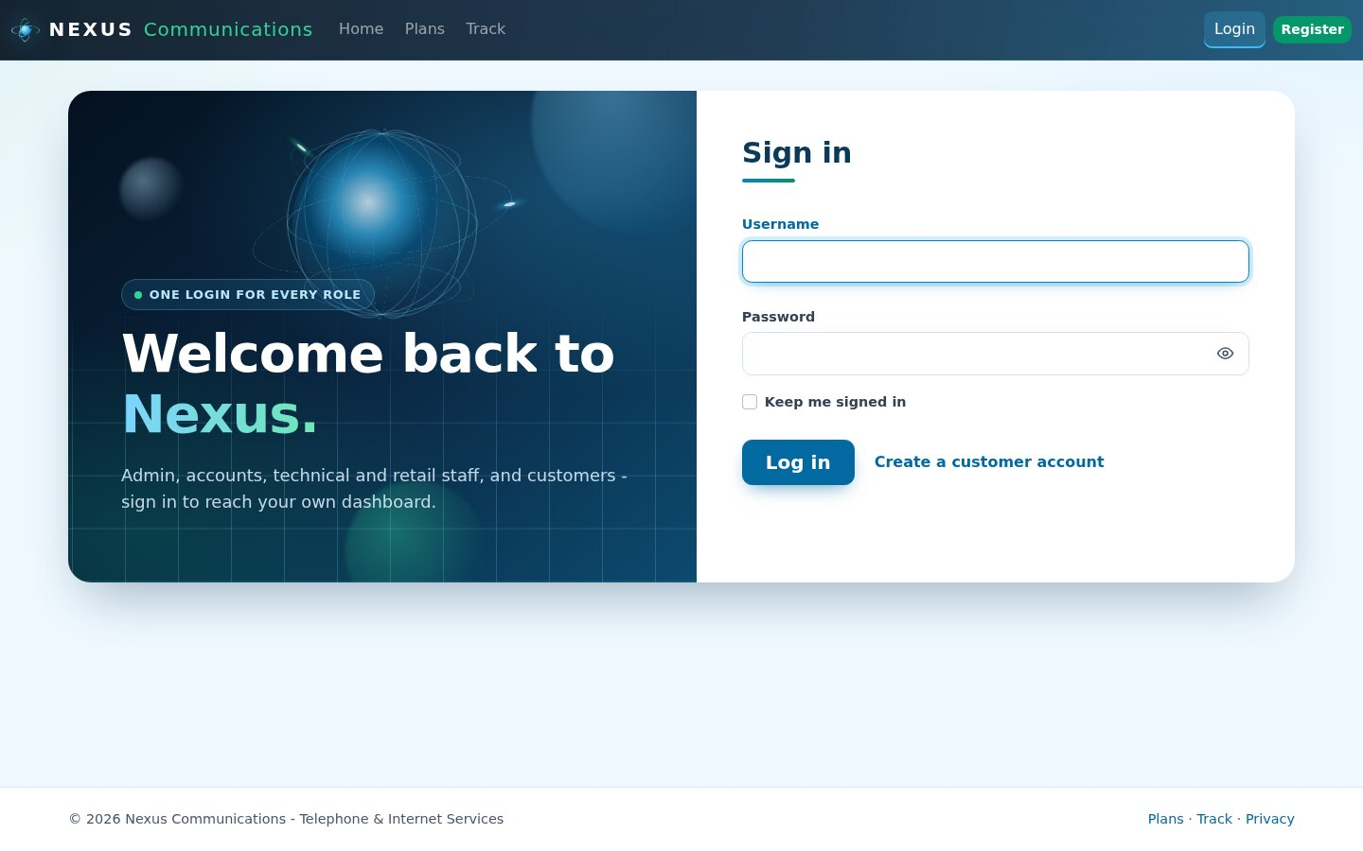
Figure 12. Login (one login for every role)
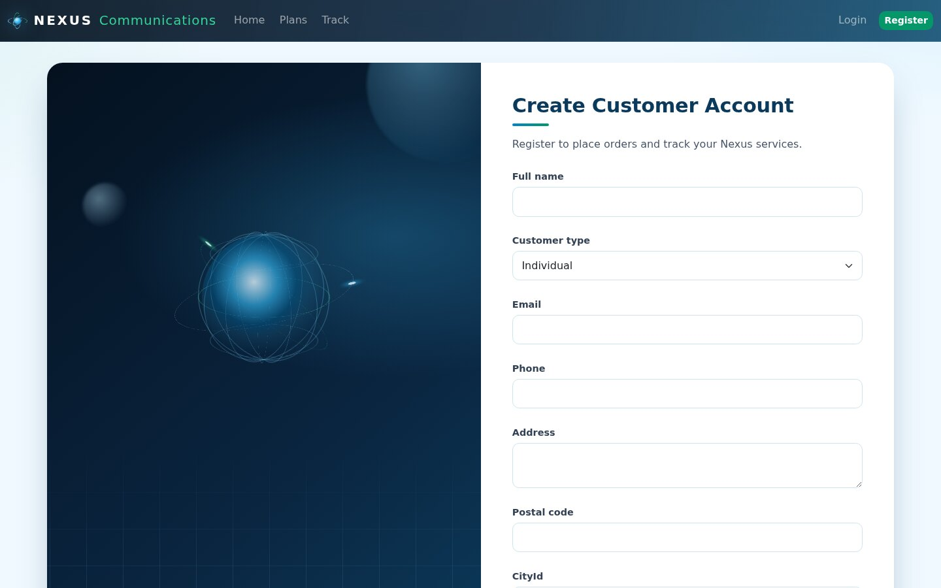
Figure 13. Customer registration
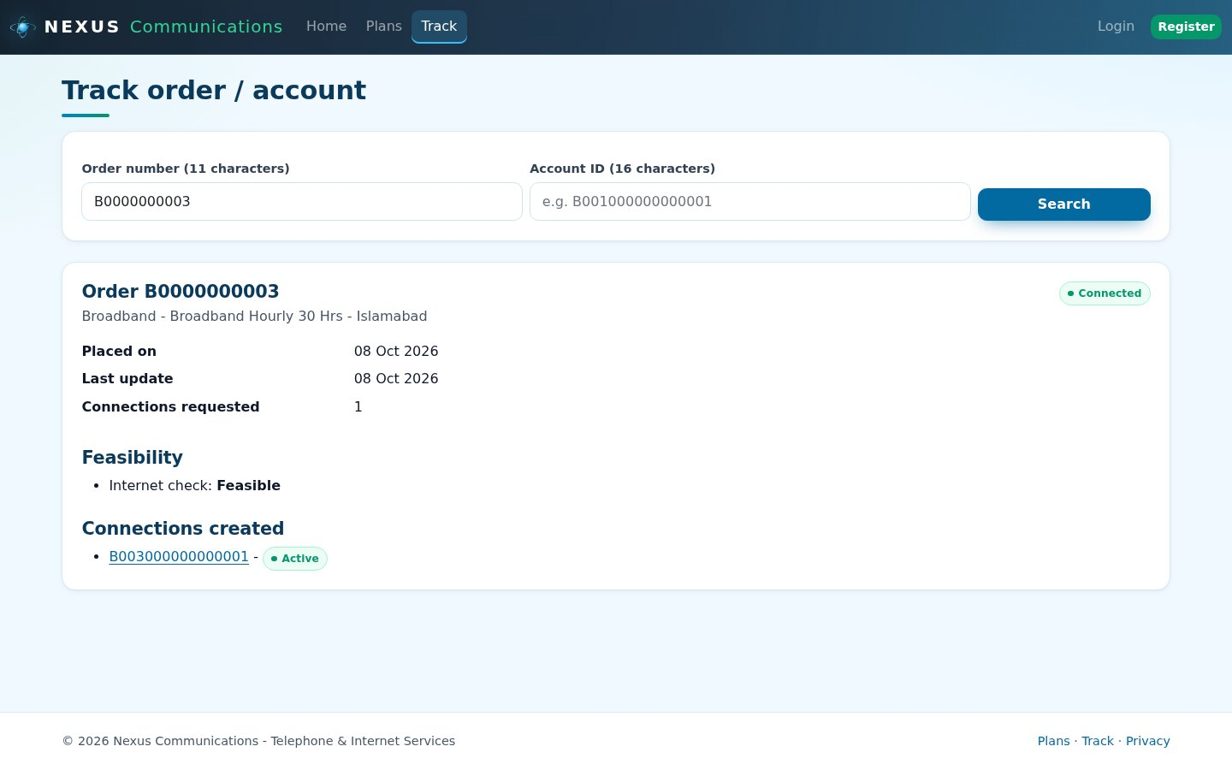
Figure 14. Public order tracking

7.4 Administrator
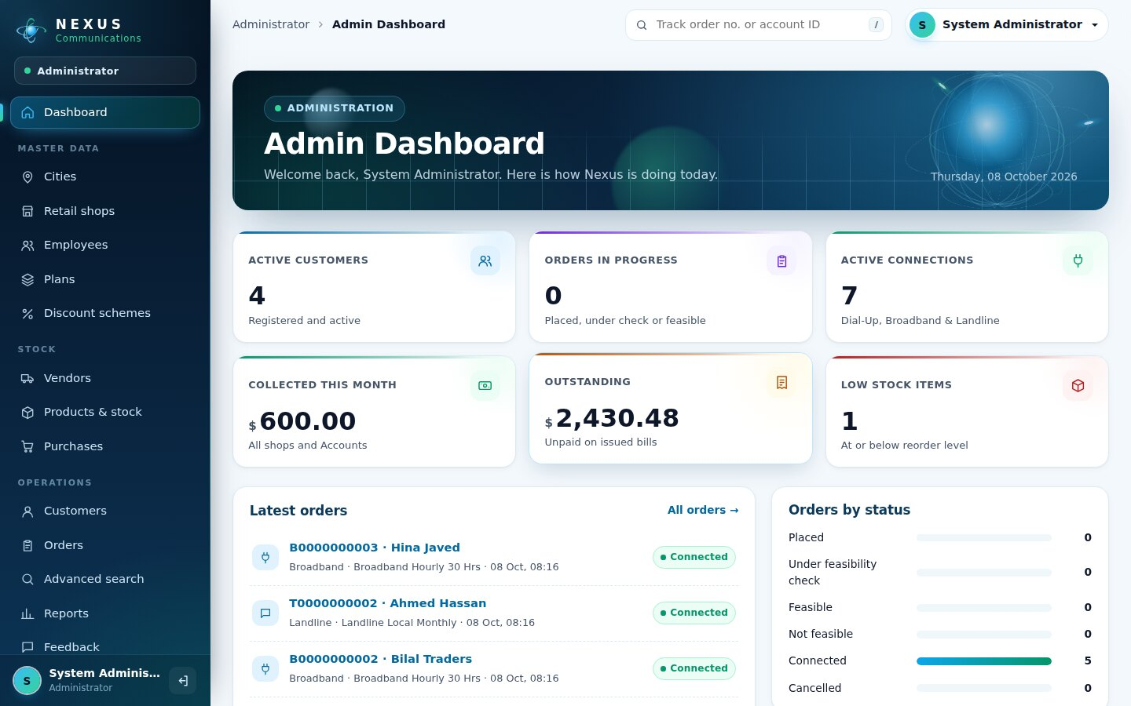
Figure 15. Admin dashboard with live figures
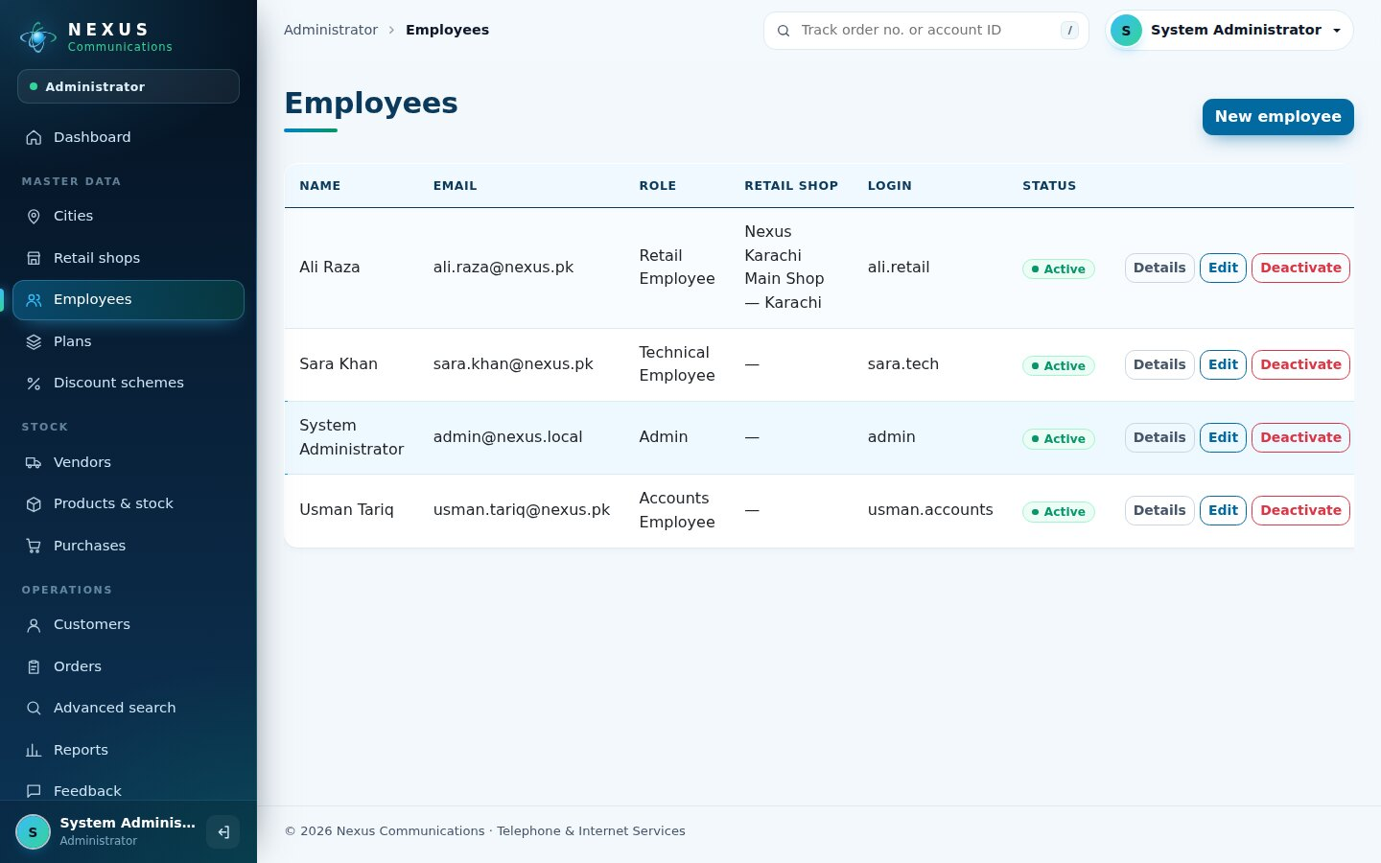
Figure 16. Employees and their logins
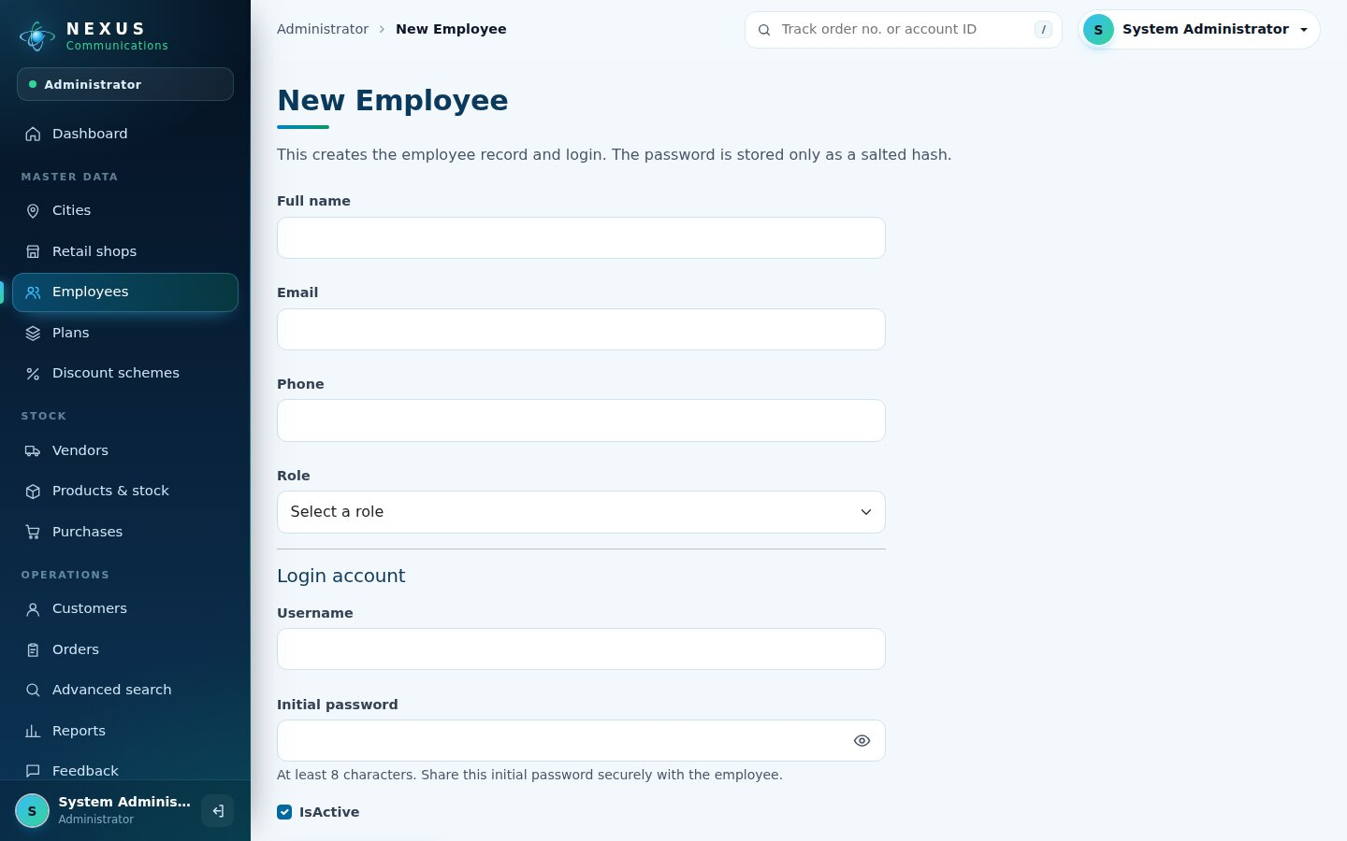
Figure 17. New employee form
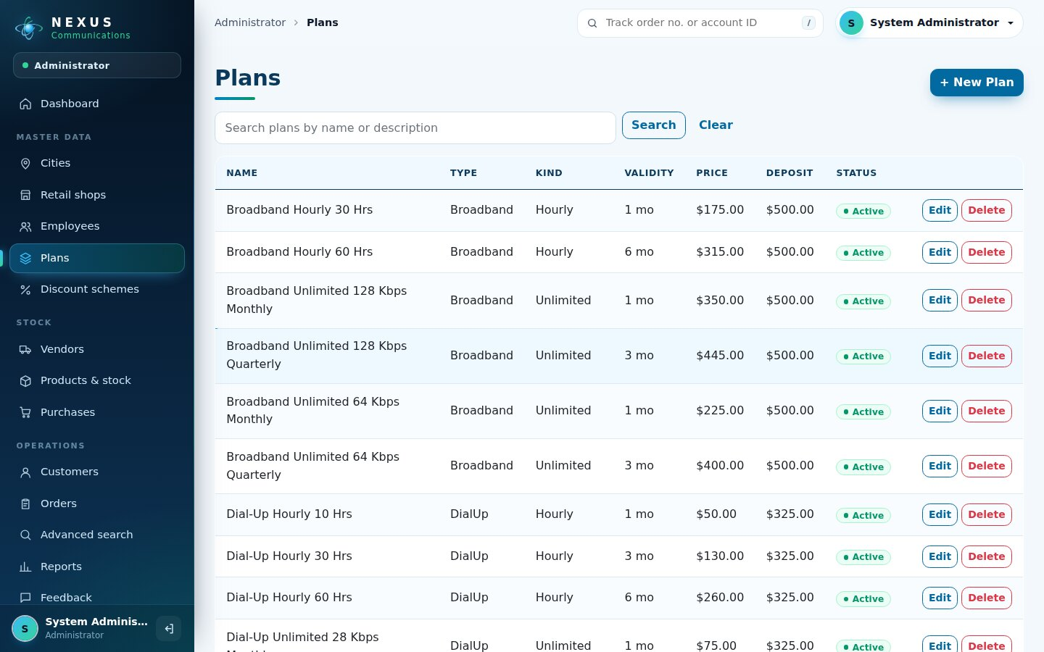
Figure 18. Plans with search and delete
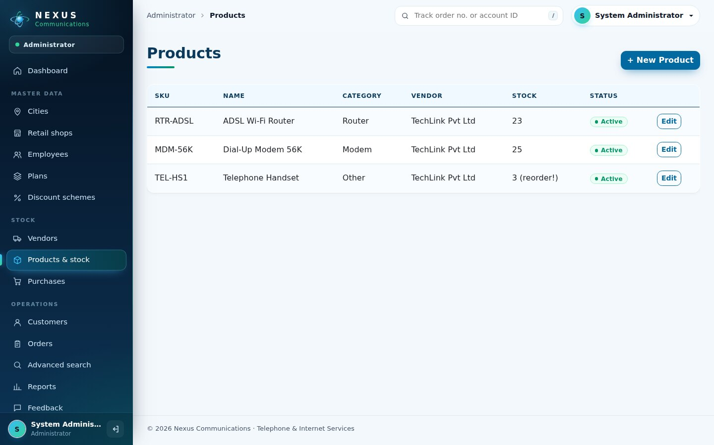
Figure 19. Products and stock (low-stock badge)
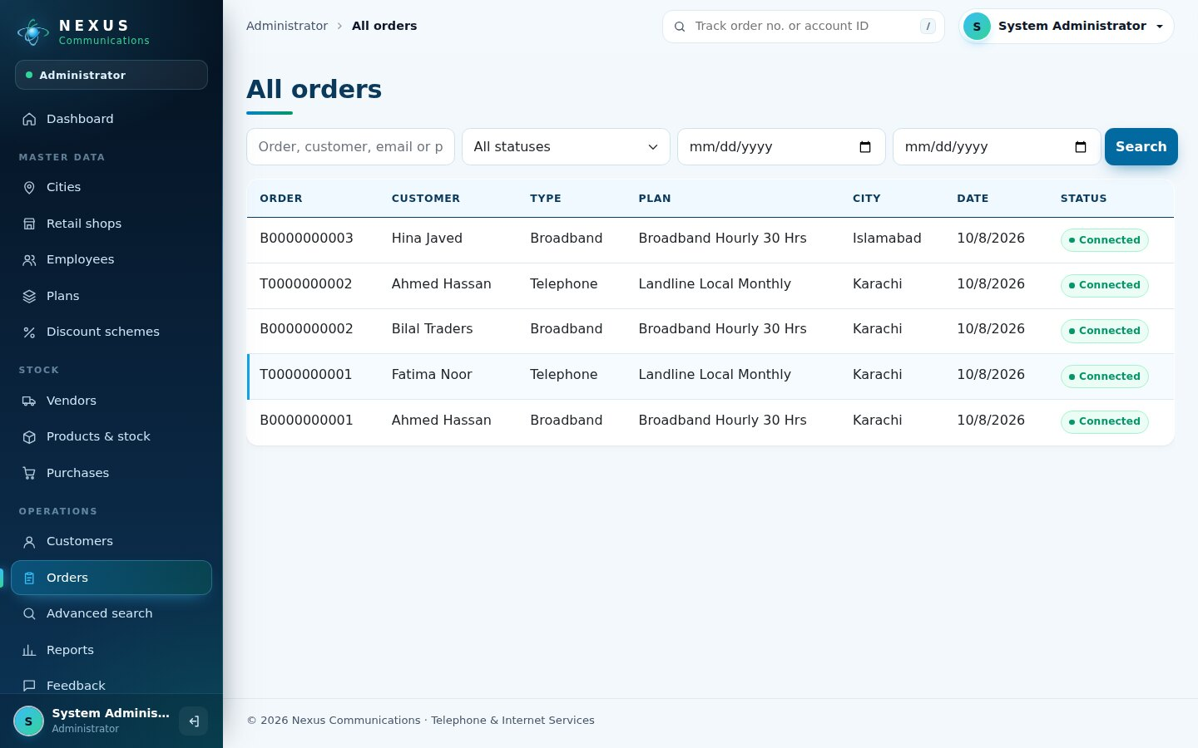
Figure 20. All orders with filters
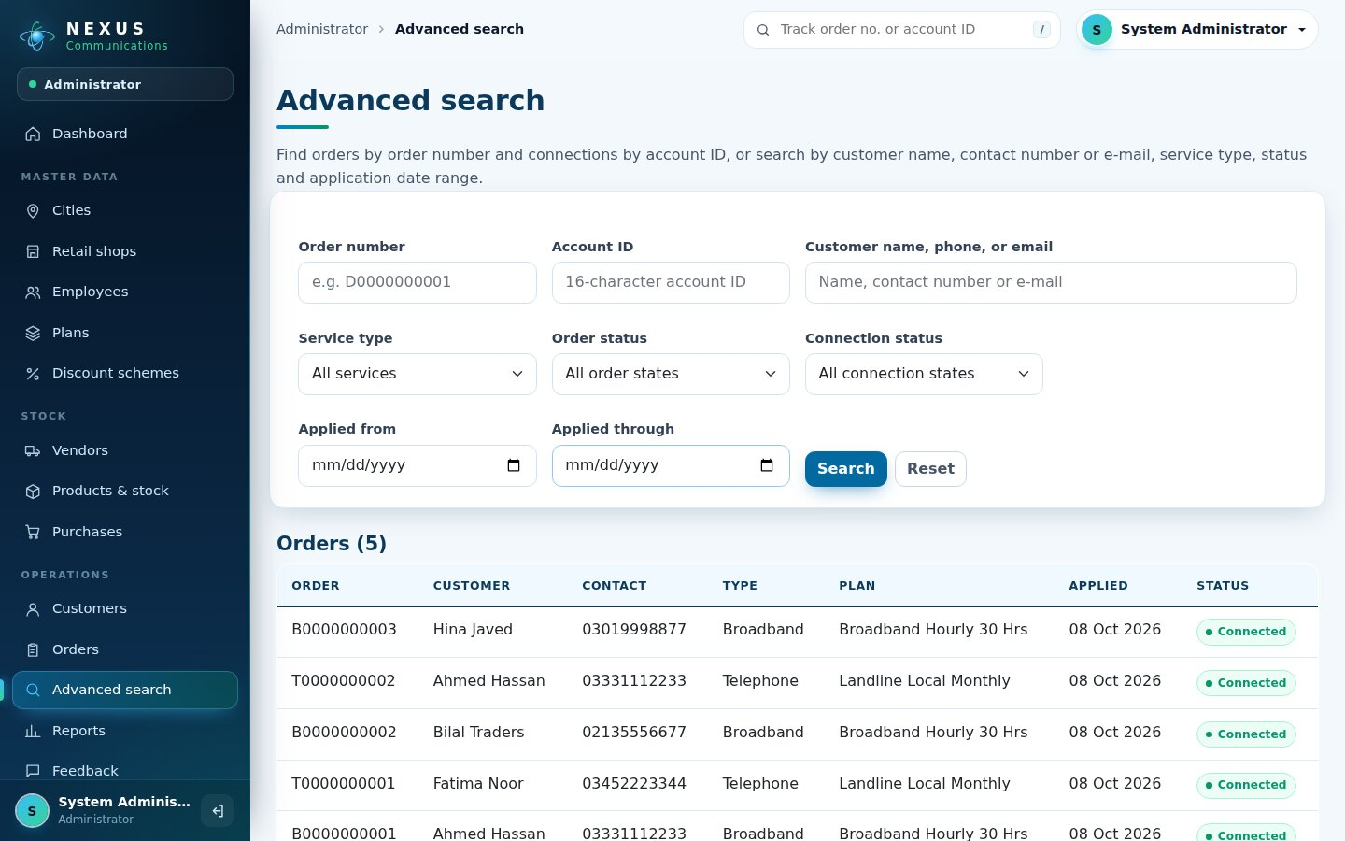
Figure 21. Advanced search
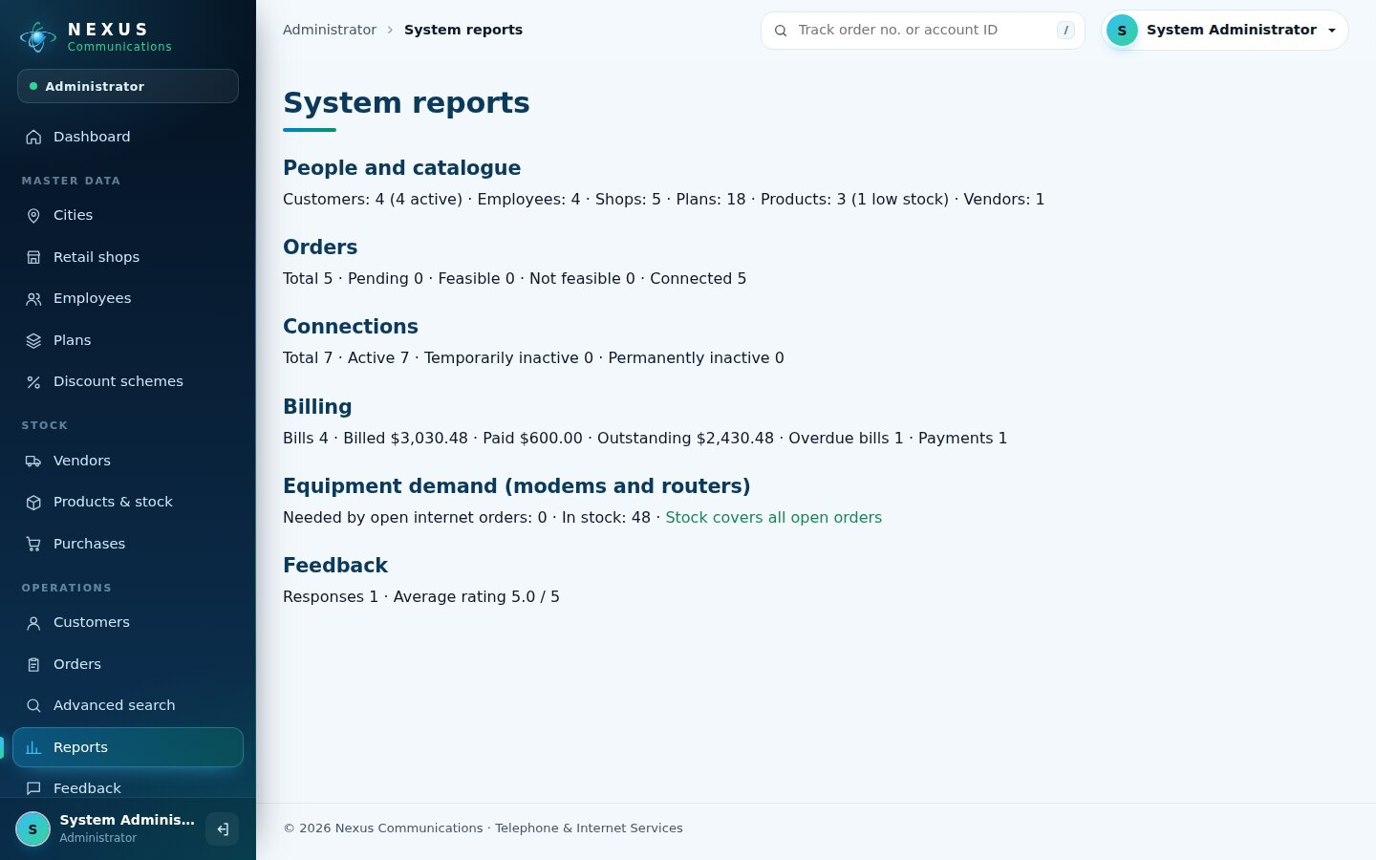
Figure 22. System reports

7.5 Retail staff
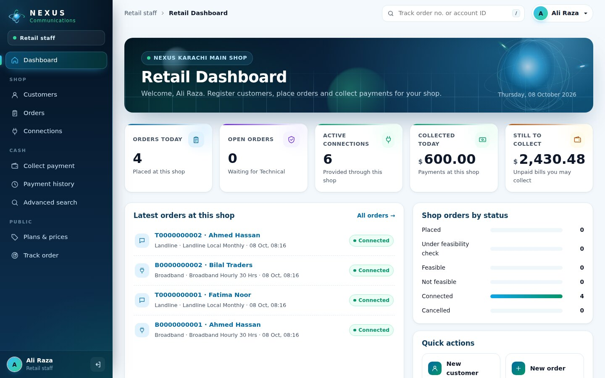
Figure 23. Retail dashboard for one shop
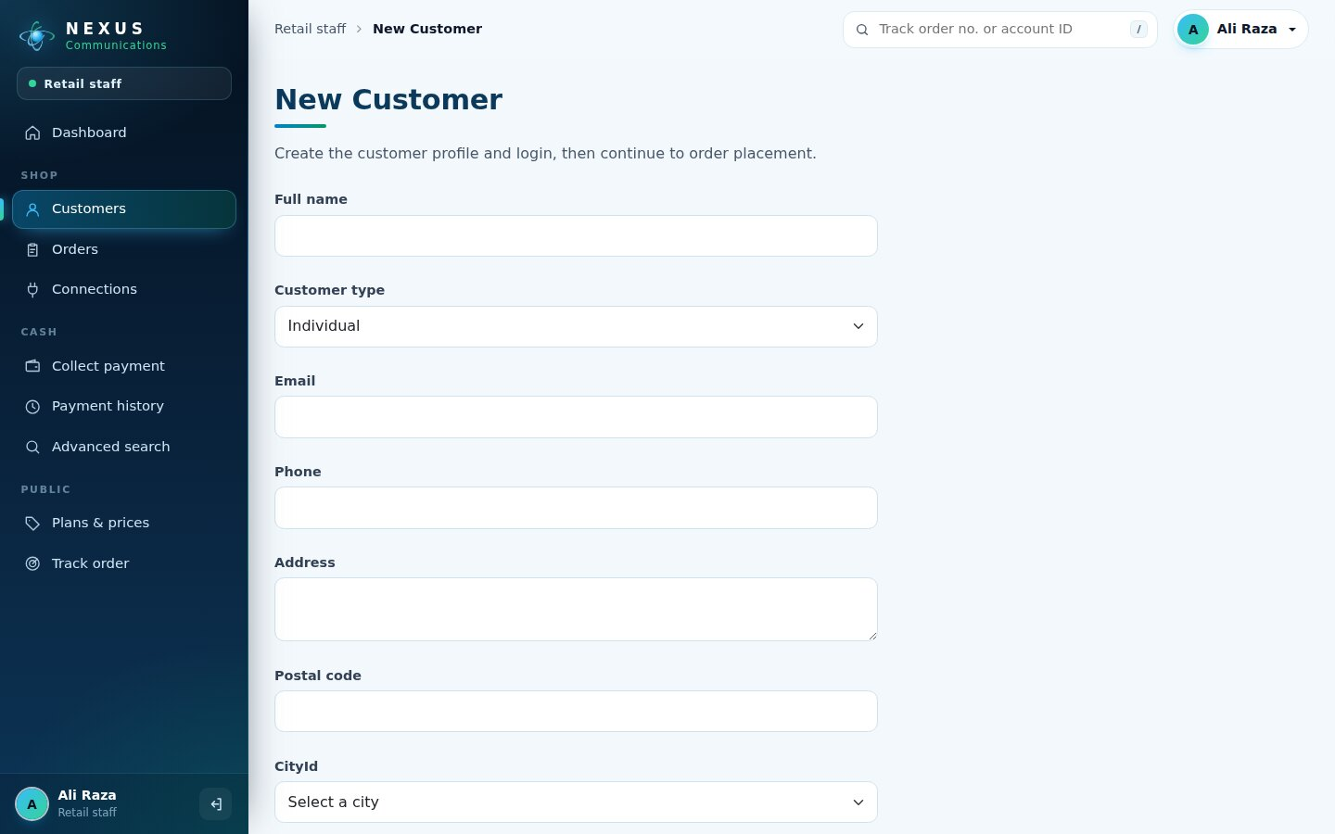
Figure 24. Register a walk-in customer
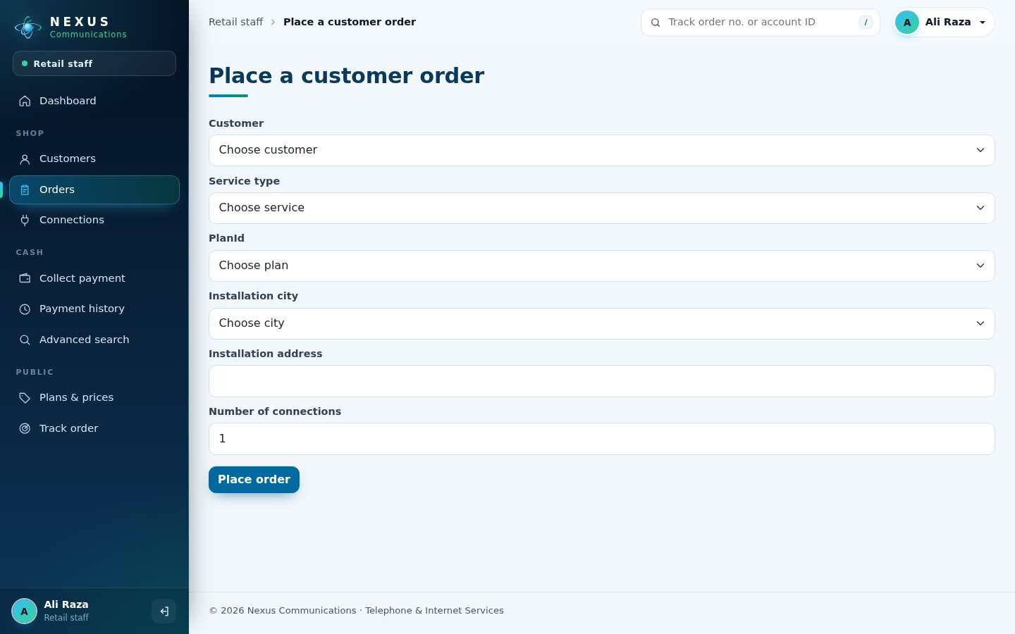
Figure 25. Place an order
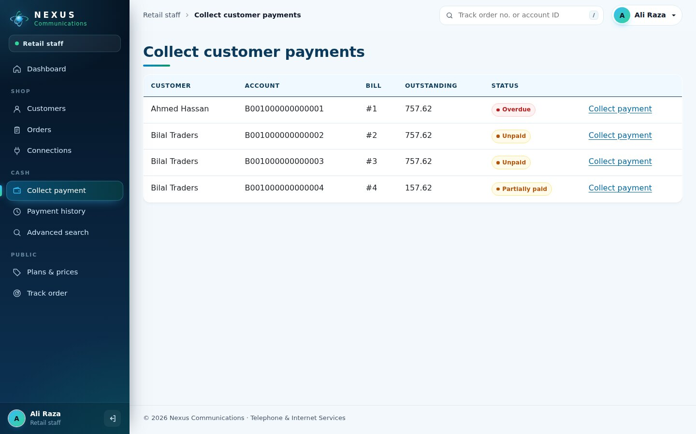
Figure 26. Collect customer payments
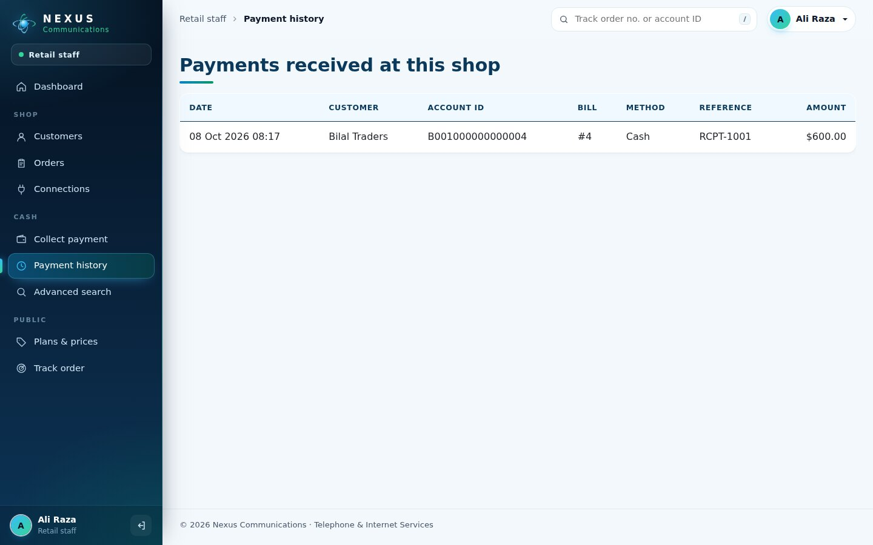
Figure 27. Payment history

7.6 Technical team
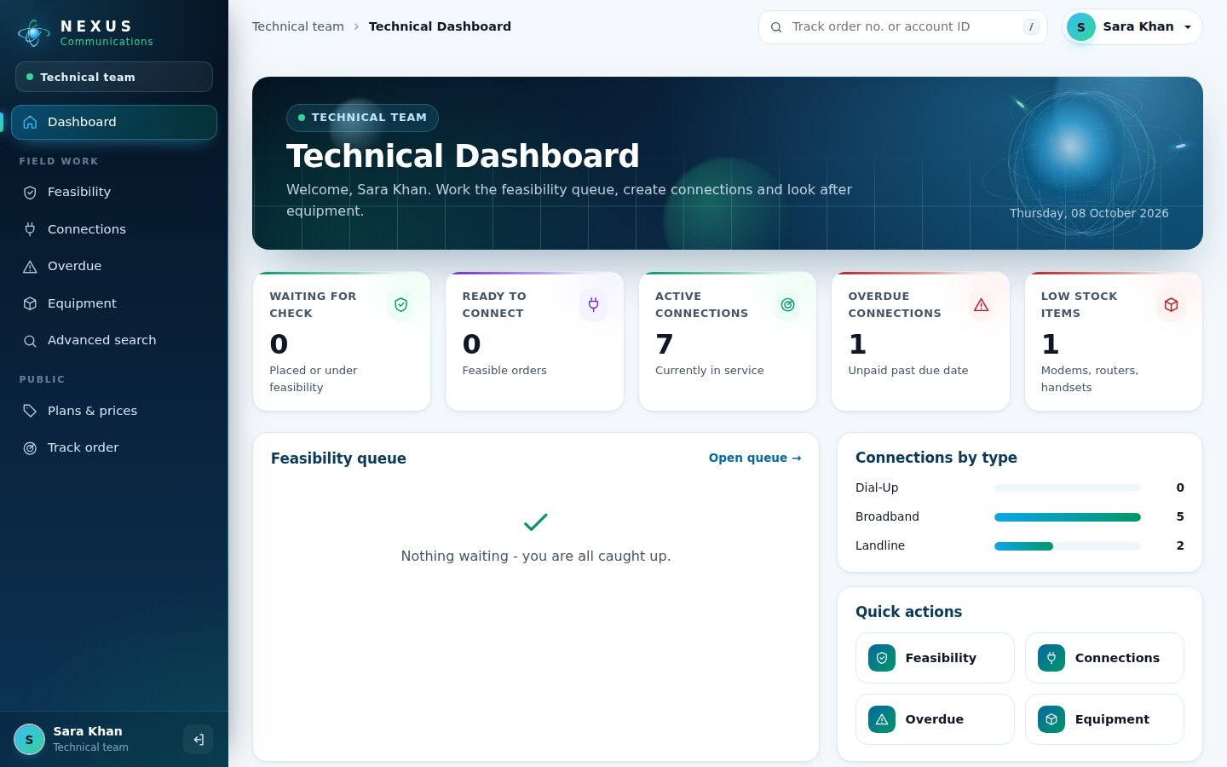
Figure 28. Technical dashboard
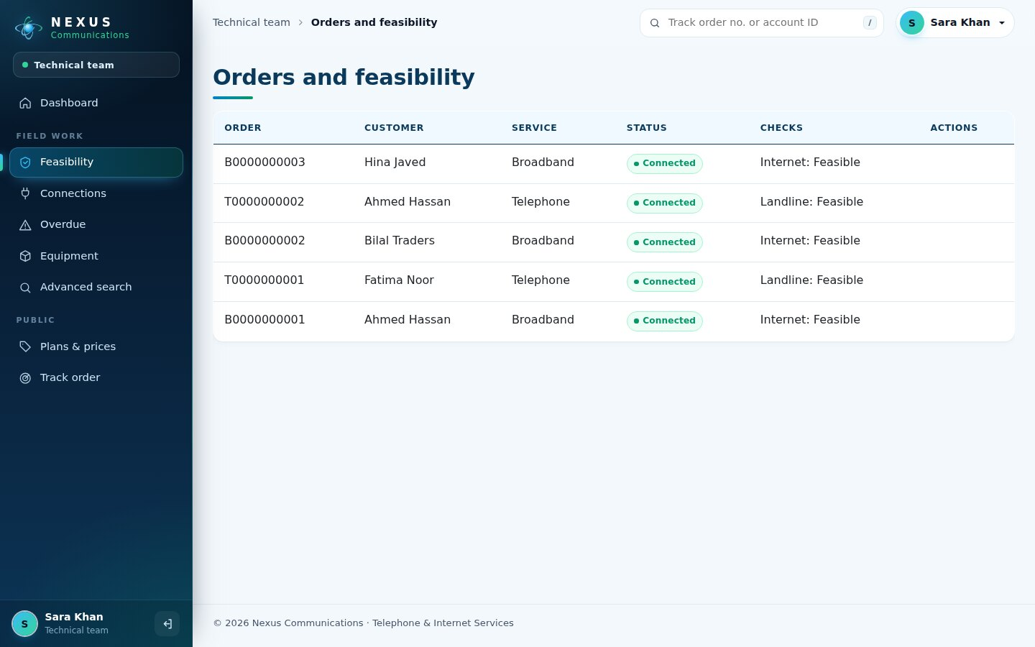
Figure 29. Orders and feasibility
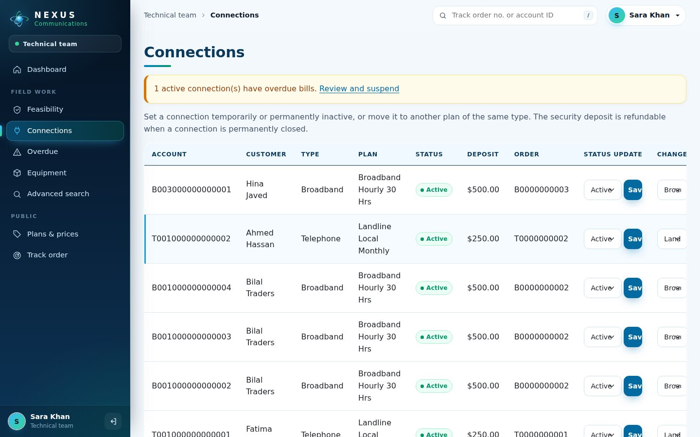
Figure 30. Connections: status, plan change, equipment replacement
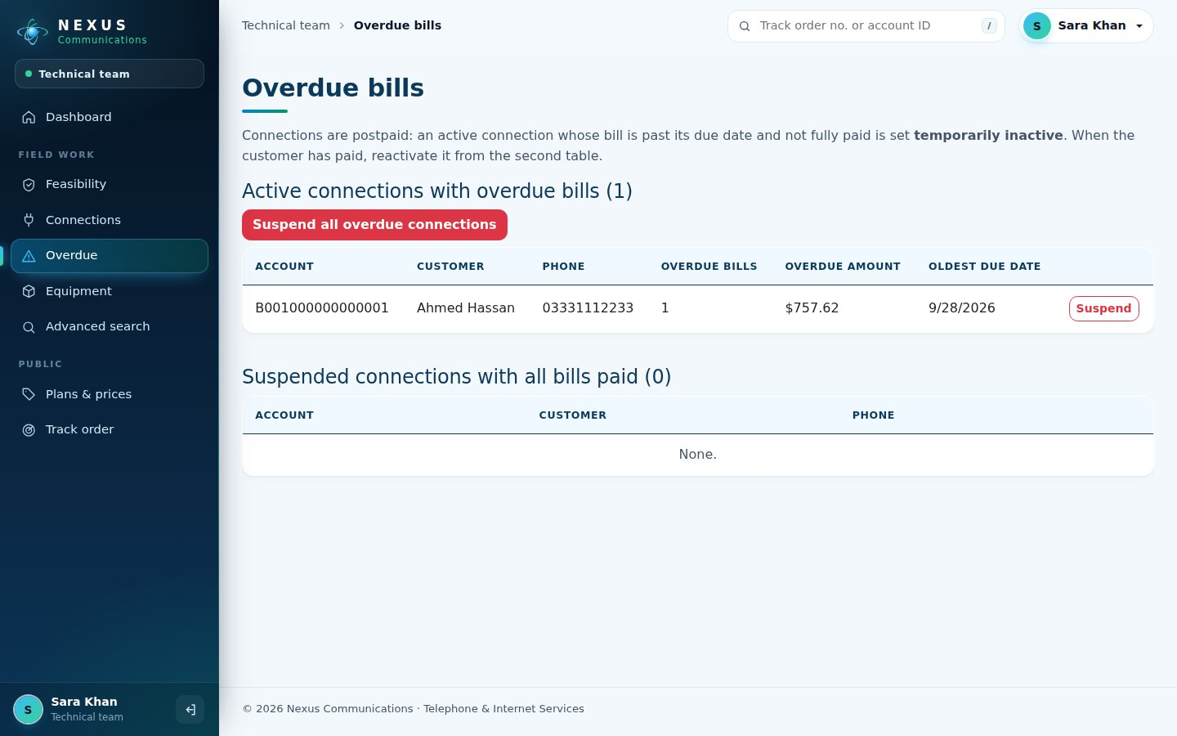
Figure 31. Overdue connections
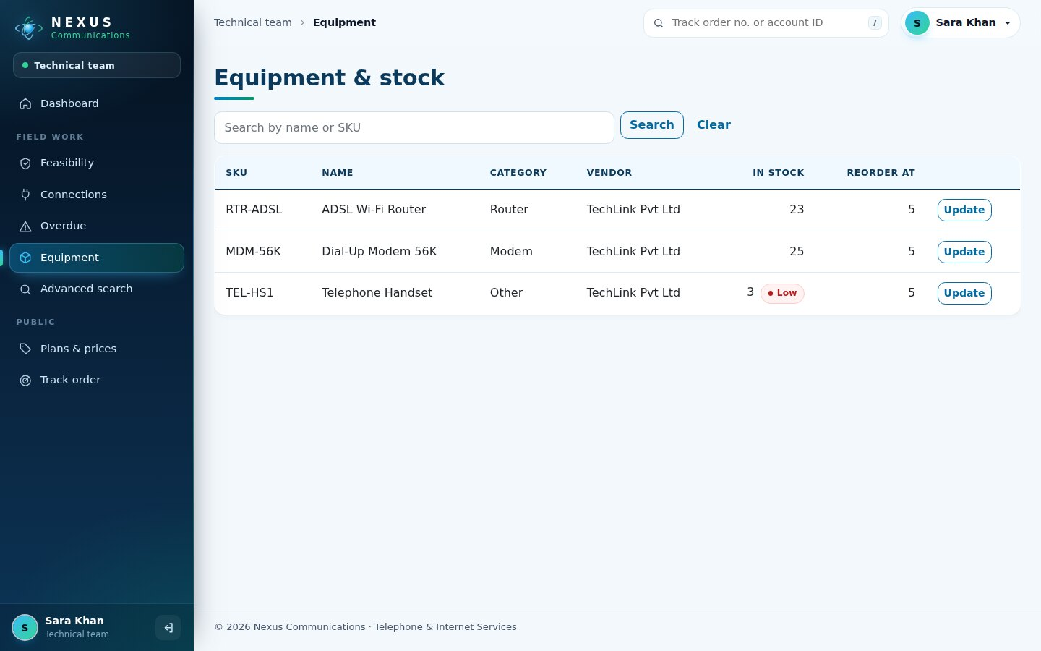
Figure 32. Equipment and stock

7.7 Accounts
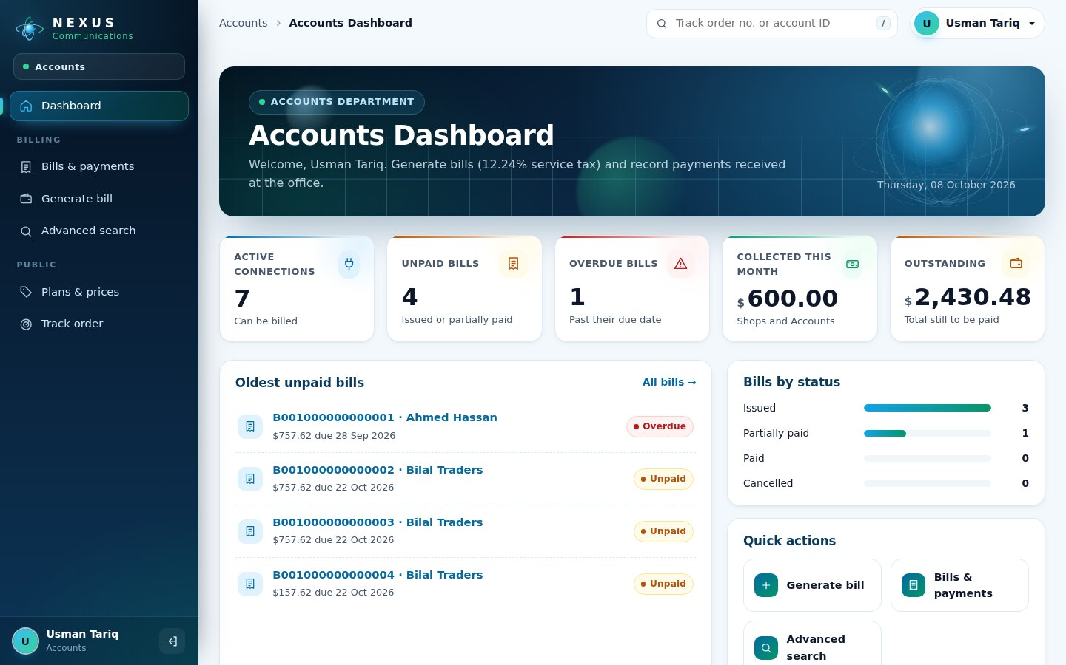
Figure 33. Accounts dashboard
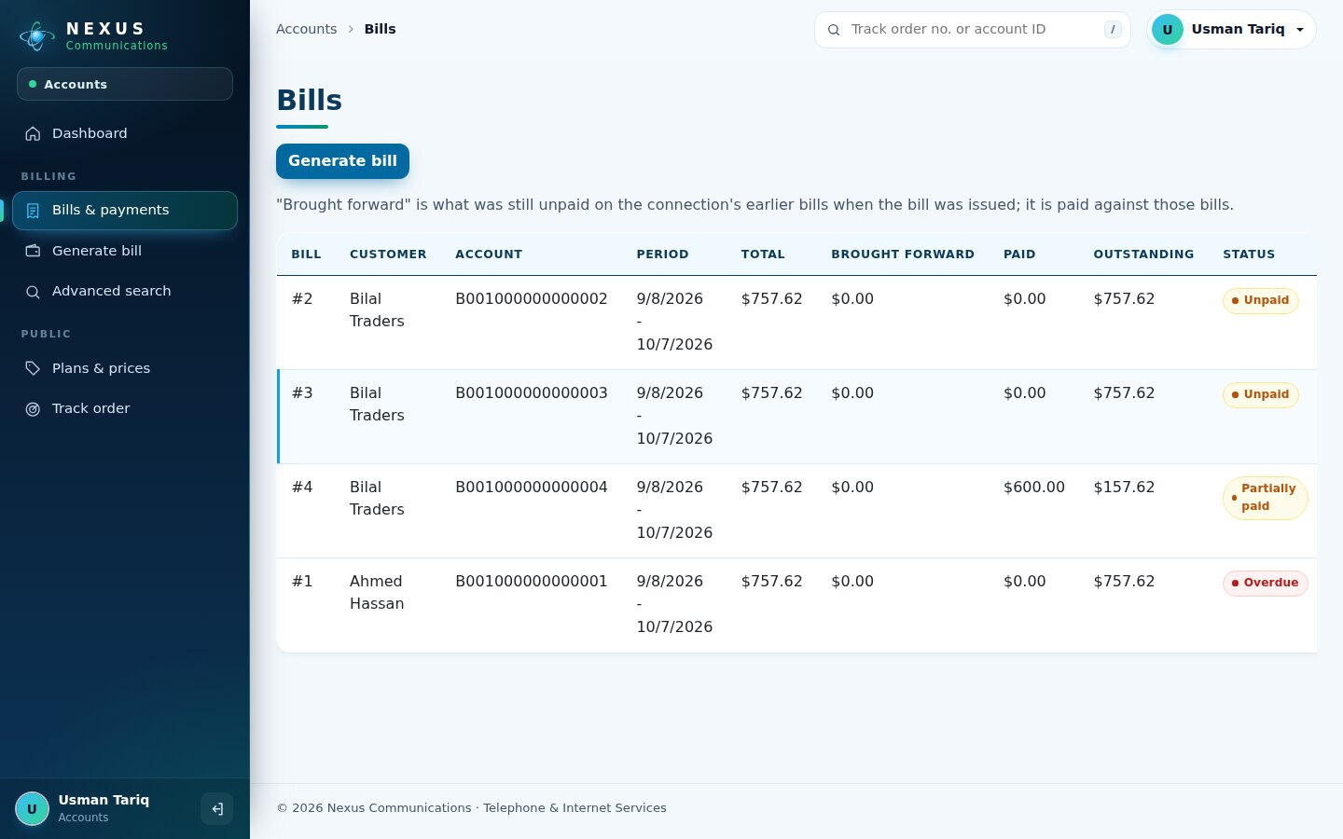
Figure 34. Bills and outstanding amounts
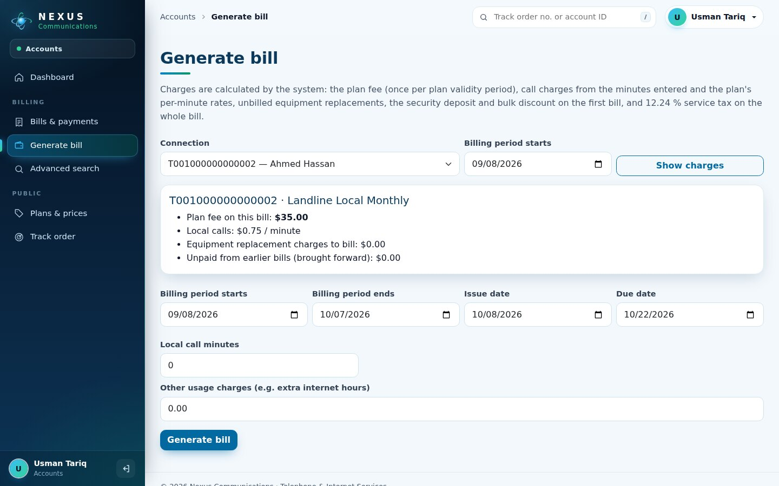
Figure 35. Generate a bill with charge preview

7.8 Customer portal
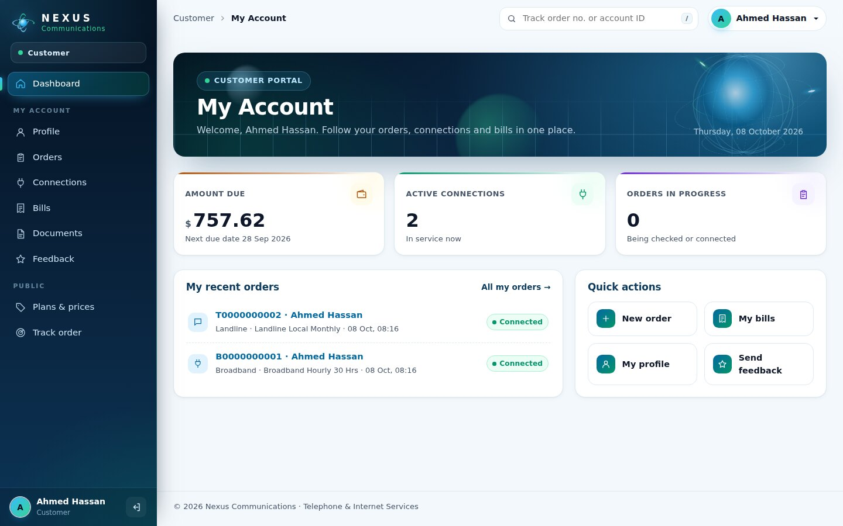
Figure 36. Customer dashboard with amount due
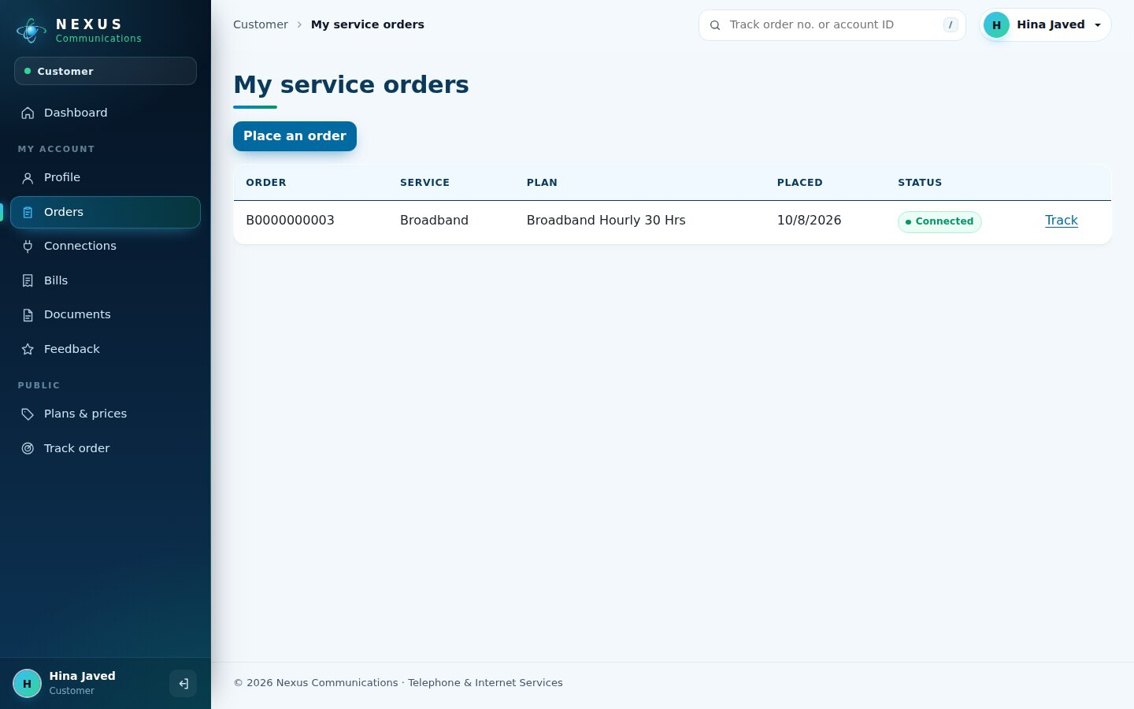
Figure 37. My orders
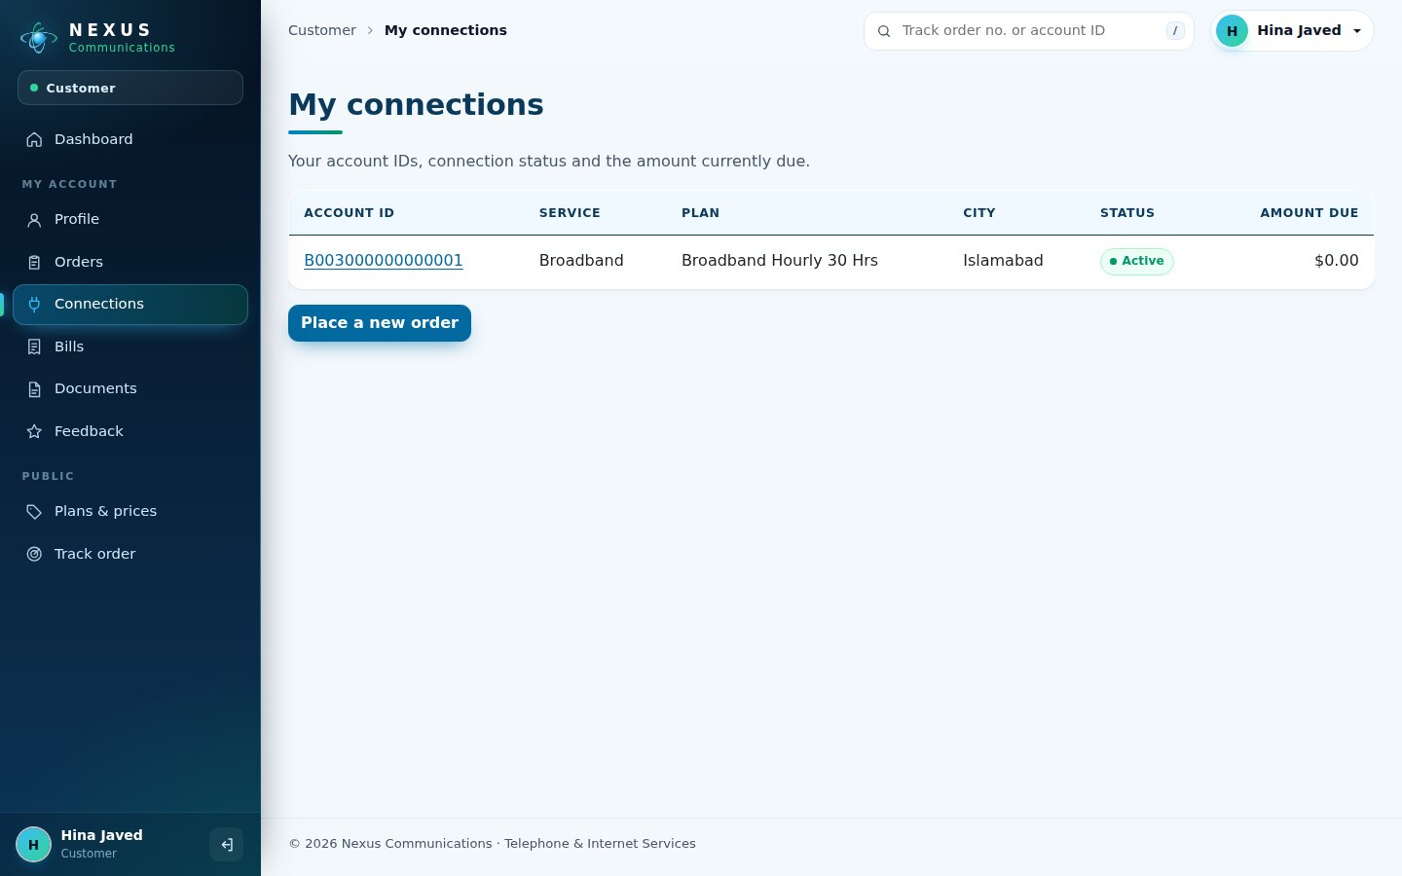
Figure 38. My connections
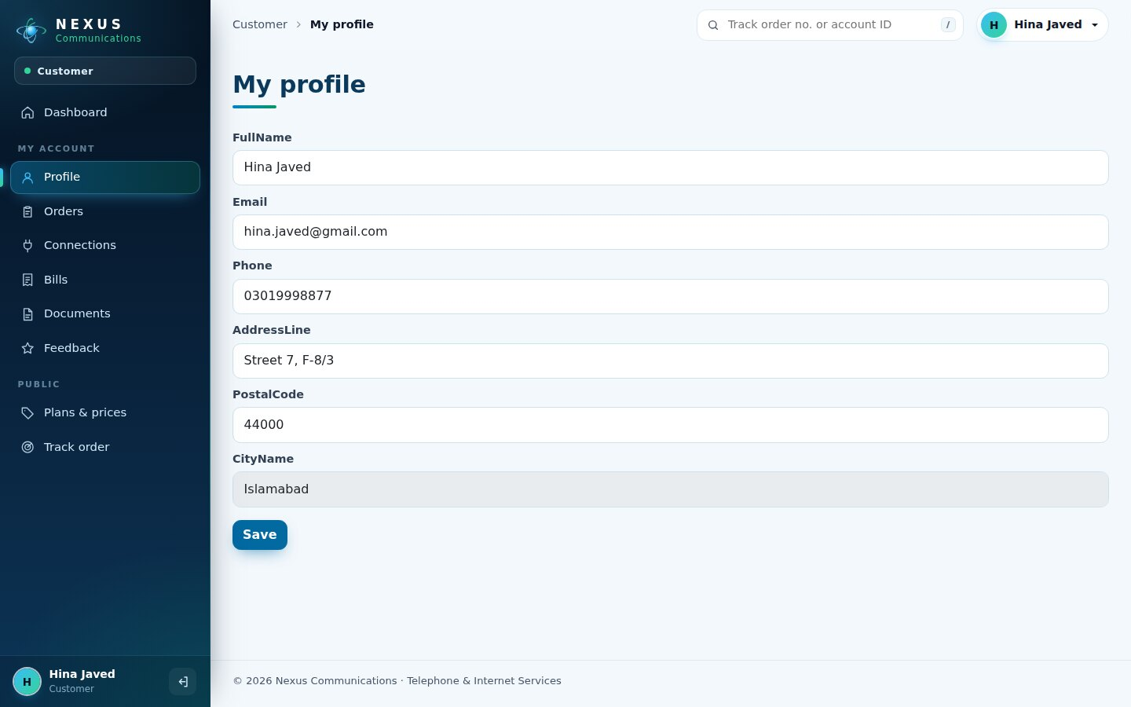
Figure 39. My profile

7.9 Mobile view
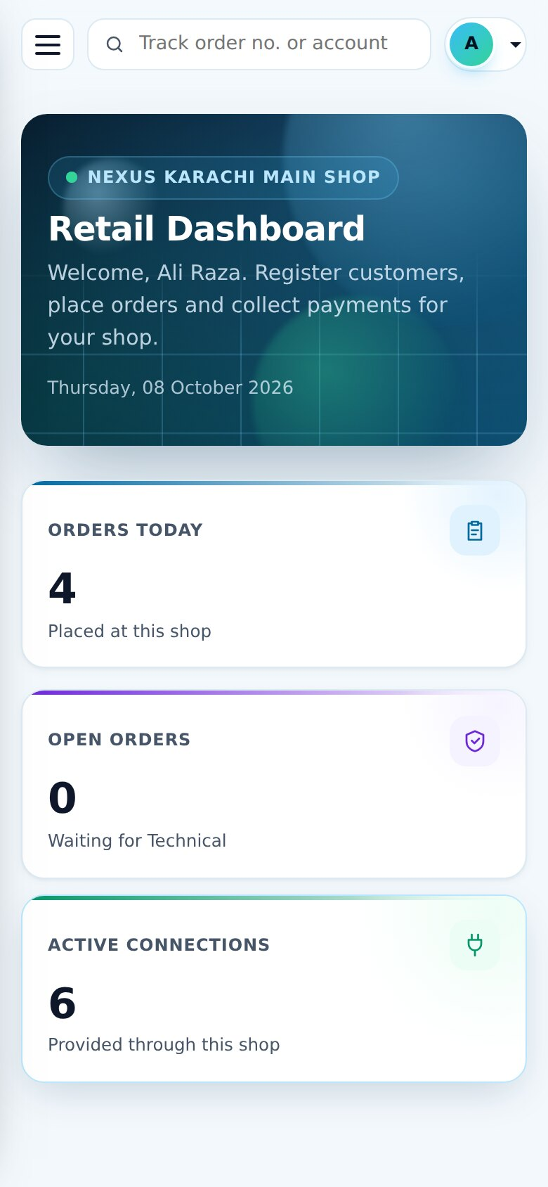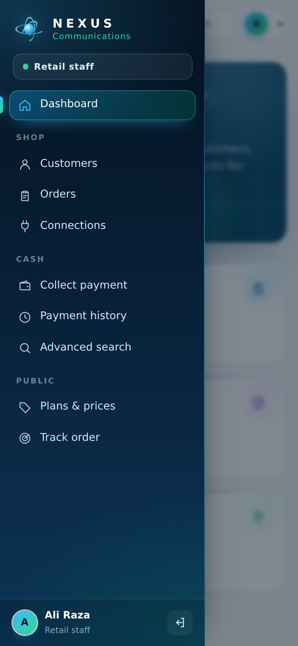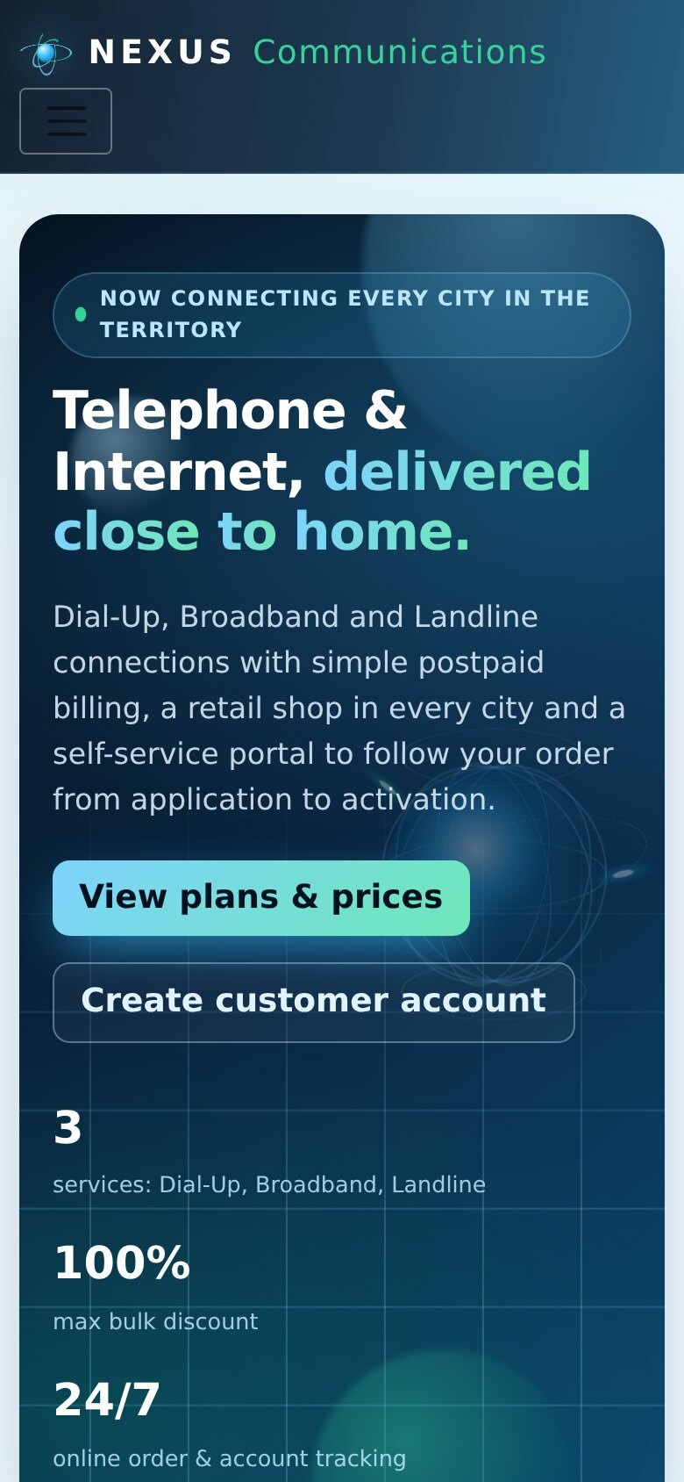
Figure 40. Phone: dashboard, sidebar drawer and home page

8. Testing
Testing combined manual checks with an automated browser run (Playwright, Chromium) that signs in as every role and performs the complete workflow through the real screens - the same screens shown in chapter 7. Negative tests check validation, security and the new overlays.
Table 11. Test cases
ID | Test | Expected result | Result
TC-01 | Admin creates vendor, 3 products, a purchase and 3 employees (retail, technical, accounts) | Records saved, purchase increases stock | Pass
TC-02 | Retail staff registers 2 individual and 1 corporate customer | Customers and logins created | Pass
TC-03 | Corporate customer without company name | Error "Company name is required for a corporate customer" | Pass
TC-04 | Retail places Broadband and Telephone orders (one with quantity 3) | Order numbers B0000000001, T0000000001 ... generated | Pass
TC-05 | Visitor registers, logs in and places an order online | Order B0000000003 for the customer | Pass
TC-06 | Technical starts checks and records 5 feasibility results | Orders become Feasible | Pass
TC-07 | Multi-connection order provisioned with one serial number | Error: enter serials individually after provisioning | Pass
TC-08 | Technical provisions all feasible orders | 7 connections with 16-character account IDs; stock reduced | Pass
TC-09 | Accounts generates 4 bills (one back-dated) | Bills with plan fee, calls, deposit and 12.24 % tax; back-dated bill overdue | Pass
TC-10 | Retail collects more than the outstanding amount | Error "Payment exceeds the outstanding balance" | Pass
TC-11 | Retail collects a partial payment | Bill becomes Partially paid; history updated | Pass
TC-12 | Customer sends feedback | Feedback listed for Admin with rating | Pass
TC-13 | Login with a wrong password | "Invalid username or password." | Pass
TC-14 | Retail staff opens /Admin/Cities | Redirected to Access denied | Pass
TC-15 | Anonymous user opens /Accounts/Bills | Redirected to Login | Pass
TC-16 | Track an order number that does not exist | "No order was found for B9999999999" | Pass
TC-17 | Quick Track box with "ABC" / with "b0000000001" | Box shakes and stays / opens the order | Pass
TC-18 | New city with an existing code 001 | "A city with this code already exists." | Pass
TC-19 | New city with code "12A" | "City code must be exactly 3 digits" | Pass
TC-20 | Deactivate employee, then "Go back" in the confirm overlay | Nothing changes | Pass
TC-21 | Employee with a 3-character password | Minimum length 8 error | Pass
TC-22 | Registration with different password and confirmation | "Confirm password and Password do not match" | Pass
TC-23 | Customer opens another customer's order by URL | HTTP 404 - not shown | Pass
TC-24 | Technical suspends overdue connection, customer pays, Technical reactivates | Status Active -> Temporarily inactive -> Active | Pass

Result
All 24 test cases passed on SQL Server 2022 with .NET 8.
The database schema was additionally checked against the entity model: 19 tables, 5 migrations, 47 CHECK constraints.

9. Installation Guide

9.1 Requirements
- Windows 10 / 11 with .NET 8 SDK (dotnet --version shows 8.x).
- SQL Server 2019 / 2022 (Express, Developer or Standard) and SQL Server Management Studio.
- Visual Studio 2022 (optional) and Google Chrome.

9.2 Connect SQL Server
In SSMS choose Database Engine, Server name . (this computer), SQL Server Authentication, Login sa, Password aptech, Encryption *Mandatory* with Trust server certificate ticked, then Connect.
The project already contains this connection in appsettings.json:
appsettings.json
"DefaultConnection": "Server=.;Database=NexusServiceMarketingDb;User Id=sa;Password=aptech;MultipleActiveResultSets=true;TrustServerCertificate=True"
For SQL Express write Server=.\\SQLEXPRESS (the backslash is doubled inside JSON).

9.3 Create the database
Open PowerShell in the folder that contains NexusServiceMarketingSystem.csproj and run the commands one at a time:
Table 12. Commands
Step | Command | What it does
1 | dotnet tool install --global dotnet-ef --version 8.* | Installs the EF Core tool (first time only; use "update" if installed)
2 | dotnet ef dbcontext info | Shows the server it will use - Data source must be "."
3 | dotnet ef database update | Applies the 5 migrations: database, 19 tables, plans and discount bands
4 | dotnet run | Starts the website at http://localhost:5294

Without dotnet-ef: in SSMS run CREATE DATABASE NexusServiceMarketingDb;, select the new database, open Database/NexusServiceMarketingDb-schema.sql and press F5. The website also applies migrations automatically when it starts.

9.4 First login
Table 13. Default login
Role | Username | Password
Administrator (created automatically) | admin | Admin@123

After the first login: change the admin password, check the 5 starter cities and shops, create employees (Retail, Technical, Accounts) and start taking orders.

9.5 Troubleshooting
Table 14. Troubleshooting
Message | Solution
Login failed for user 'sa' | Check the password; in SSMS > Server properties > Security choose "SQL Server and Windows Authentication mode" and restart the SQL Server service.
A network-related or instance-specific error | Wrong server name - use "." or ".\SQLEXPRESS".
Database created but not visible in SSMS | Run "dotnet ef dbcontext info"; the Data source must be the same server SSMS is connected to. Refresh the Databases folder.
dotnet-ef is not recognized | Close and reopen the terminal after installing, or use the SQL script method.
Port already in use | Close the other running copy, or run: dotnet run --urls http://localhost:5300

10. User Guide

10.1 Getting around
- After login every user lands on their dashboard. The sidebar lists only the pages of that role; the current page is highlighted.
- Type an order number or account ID in the Track box at the top and press Enter (press / to jump to the box).
- Click any order number or account ID in a table to copy it.
- On a phone, open the menu with the button at the top left.

10.2 Administrator
- Master data > Cities: add each city with its unique 3-digit code.
- Retail shops: add at least one shop per city.
- Employees: create Retail (choose the shop), Technical and Accounts staff with their username and first password.
- Plans and Discount schemes: check prices; plans already used cannot be deleted, deactivate them instead.
- Stock > Vendors, Products, Purchases: keep modems and routers in stock (low-stock items show in red).
- Operations > Orders, Advanced search, Reports and Feedback to monitor the business.

10.3 Retail staff
- Customers > New customer for a walk-in customer (corporate customers need a company name).
- Orders > Place order: choose customer, service, plan, city, address and number of connections. For dial-up without a Nexus line, also choose a landline plan.
- Collect payment: open a bill, enter the amount (full or partial), method and reference.
- Connections and Payment history show everything handled by the shop.

10.4 Technical team
- Feasibility: press *Start checks* on a new order, then *Record result* for each check.
- For feasible orders press *Provision*: choose the modem / router, serial and (for landlines) phone numbers.
- Connections: change status, change plan or replace spoiled equipment.
- Overdue: suspend connections with overdue bills; reactivate them when the customer has paid.

10.5 Accounts
- Generate bill: choose the connection and period start, press *Show charges*, enter minutes and other usage, then *Generate bill*.
- Bills & payments: see outstanding amounts and record payments received at the office.

10.6 Customer
- Register on the website, then log in.
- Orders > New order to apply for a connection and follow its status.
- The dashboard shows the amount due and next due date; Bills lists every bill and payment.
- Upload documents and send feedback from the sidebar.

11. Developer Guide

11.1 Folder structure
Table 15. Project structure
Folder / file | Contents
Areas/<Role>/Controllers, Views | Admin, Retail, Technical, Accounts, Customer areas
Controllers, Views | Public pages: Home, Catalog, Track, Account, Search
Services/ | Workflows (orders, provisioning, billing, customers), Dashboard, Identifiers, Security, Documents
Data/ | AppDbContext, design-time factory, converters, seeders
Migrations/ | Five EF Core migrations and the model snapshot
Models/ | Entities (19), enums, view models, dashboard models, NexusIcons
Views/Shared/ | _Layout (app shell), _SideNav, Dashboard, partials
wwwroot/css | site.css (design tokens, public site, components), nexus-app.css (shell, dashboards, overlays)
wwwroot/js | site.js (loader, reveal, tilt, forms), nexus-app.js (sidebar, quick track, toasts, confirm, badges, counters)
Database/ | Full SQL script and Run-Migration.bat

11.2 Adding a feature
- Add or change the entity in Models/Entities and its configuration in AppDbContext.
- Create a migration: dotnet ef migrations add <Name> then dotnet ef database update.
- Put the rule in a service (never in the controller), register it in Program.cs.
- Add the controller action with [Authorize(Roles = ...)] and [ValidateAntiForgeryToken] on POST.
- Add the view; add a sidebar link in Views/Shared/_SideNav.cshtml.

12. Conclusion and Future Enhancements
The Nexus Service Marketing System meets the problem statement: every order has a unique number and moves through feasibility, connection, billing and payment in one shared SQL Server database; every role has its own secure dashboard; and bills are calculated by the system with the required discount and tax rules. The new interface - sidebar shell, live dashboards, cut-overlay transitions and confirm overlays - makes the system modern and quick to use.

Future enhancements
- Online payments through a payment gateway and automatic receipts by e-mail / SMS.
- Call detail records imported from the exchange so bills calculate minutes automatically.
- Stock movement ledger and connection status history for full audit trails.
- Charts of monthly revenue and new connections per city on the admin dashboard.
- A mobile app for field technicians with photo upload at installation.

Demo logins used in this document
Admin: admin / Admin@123
Retail: ali.retail / Nexus@12345 - Technical: sara.tech / Nexus@12345 - Accounts: usman.accounts / Nexus@12345
Customers: ahmed.hassan, hina.javed / Customer@123 (created during testing; a fresh database contains only the admin)

