eProject · User Guide
Nexus Service Marketing System
How to use the system - for customers, retail shop staff, technical staff, accounts staff and the administrator
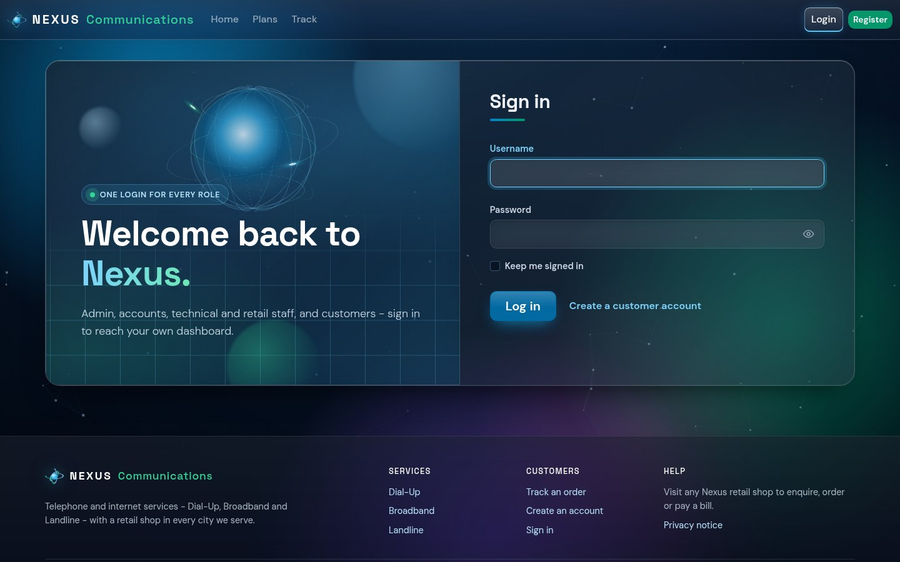

Item | Details
Project title | Nexus Service Marketing System
Document | User Guide
Student name | [Your name]
Enrollment no. | [Your enrollment number]
Batch / Group | [Batch] / [Group]
Submission date | [DD/MMM/YYYY]

Table of Contents

1. Introduction
Nexus Communications sells Dial-Up, Broadband and Landline connections through a retail shop in every city. The Nexus Service Marketing System keeps every step on record: the order, the feasibility check, the connection, the equipment, the monthly postpaid bill and the payment.
This guide explains, screen by screen, how each type of user works with the system. Every user signs in on the same login page and is taken to their own dashboard.

1.1 Who uses the system
Role | What they do | Section
Visitor | Reads about the services, compares plans, tracks an order, registers | 3
Customer | Places and tracks orders, sees connections and bills, uploads documents, gives feedback | 4
Retail shop staff | Registers walk-in customers, places orders, collects bill payments | 5
Technical staff | Checks feasibility, creates connections, issues equipment, suspends overdue connections | 6
Accounts staff | Generates monthly bills and records payments | 7
Administrator | Maintains cities, shops, employees, plans, discounts, vendors, stock; watches reports | 8

1.2 The life of an order
- The customer (or a retail shop) places an order. The system gives it an order number, for example D0000000001.
- Technical staff check whether the address can be served (feasibility).
- If it is feasible, technical staff create the connection. The customer receives a 16-character account ID, for example B001000000000001.
- Every month the accounts team generates a postpaid bill. The first bill includes the refundable security deposit.
- The customer pays at any Nexus shop. Unpaid bills past their due date can lead to the connection being suspended.

2. Getting Started

2.1 What you need
- A computer, tablet or phone with an up-to-date web browser (Chrome, Edge, Firefox or Safari).
- The address of the Nexus website (when running locally: http://localhost:5294).
- A username and password. Customers register themselves; staff accounts are created by the administrator.

2.2 Registering as a customer
- Click Register at the top right of any page.
- Fill in your name, contact details, address and city, then choose a username and password.
- Click Create account. You are signed in and taken to your customer dashboard.
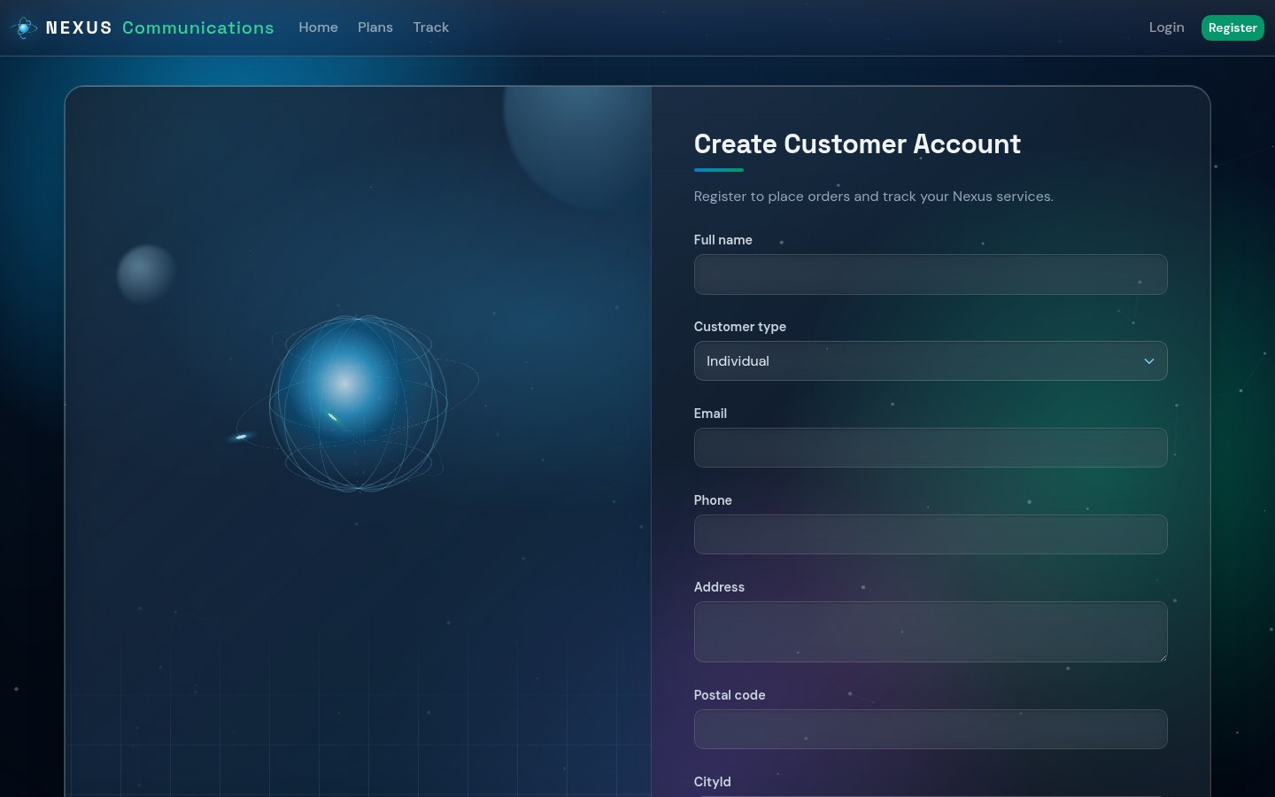
Figure 1 - Register page

2.3 Signing in and out
- Click Login at the top right.
- Enter your username and password and click Log in.
- You are taken to your dashboard. Your menu shows only the pages for your role.
- To sign out, open your name at the top right and choose Logout.
Figure 2 - One login page for every role
Tips
The menu item of the page you are on is highlighted as a clear-glass button.
Cards you can click light up and turn clear when you point at them.

3. Public Pages

3.1 Home page
The home page introduces the three services, the cities served, the bulk discount bands and how the process works. From here you can compare plans, track an order or register.
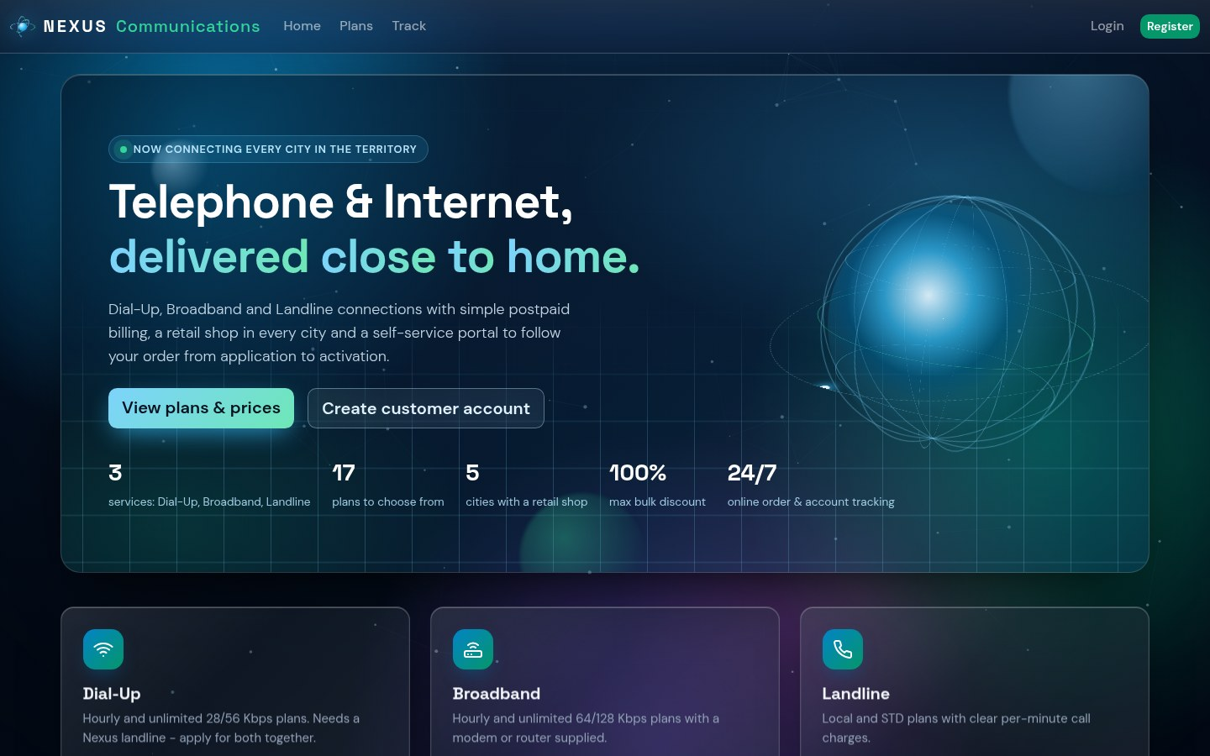
Figure 3 - Home page

3.2 Plans and prices
Click Plans in the menu. Plans are grouped by service; use the Dial-Up / Broadband / Landline tabs to jump to a group. Each card shows the price, the period it covers, what is included and the refundable deposit.
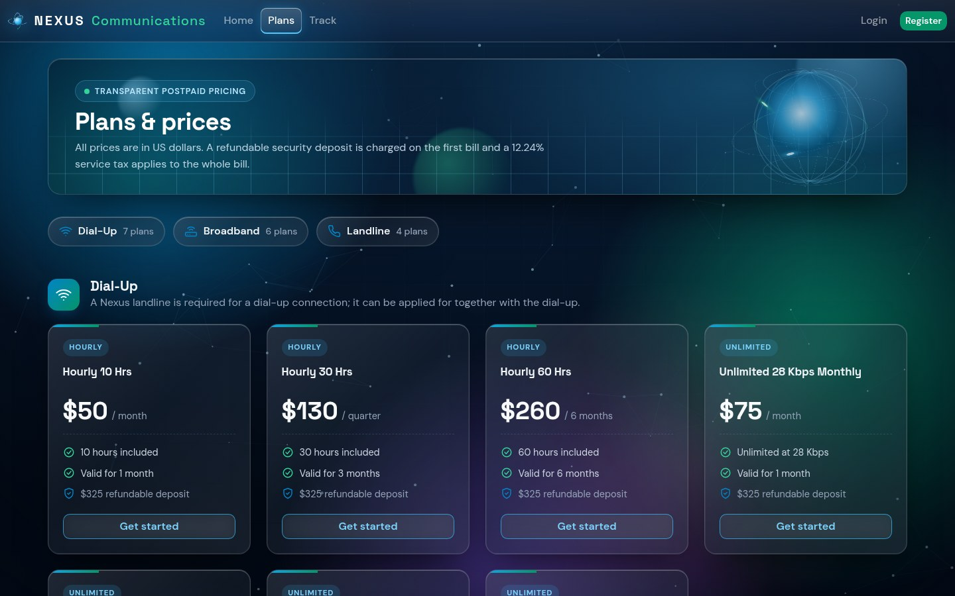
Figure 4 - Plans and prices

3.3 Tracking an order or connection
- Click Track in the menu.
- Enter your 11-character order number (for example D0000000001) or your 16-character account ID.
- Click Search to see the current stage of the order or connection (on the home page the button is Check status).
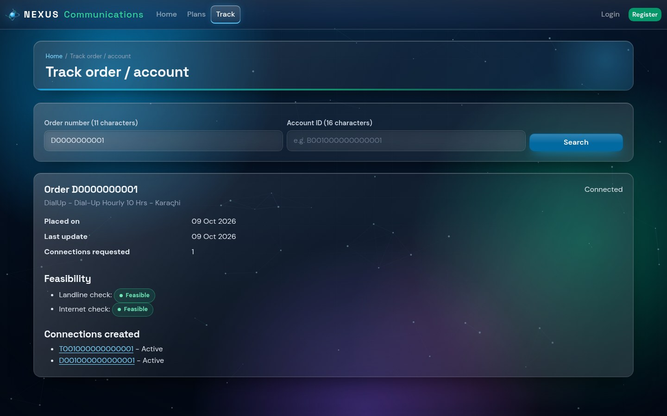
Figure 5 - Tracking an order

4. Customer Guide

4.1 Dashboard
After signing in you see your dashboard: open orders, active connections, the balance still due and quick links to every customer page.
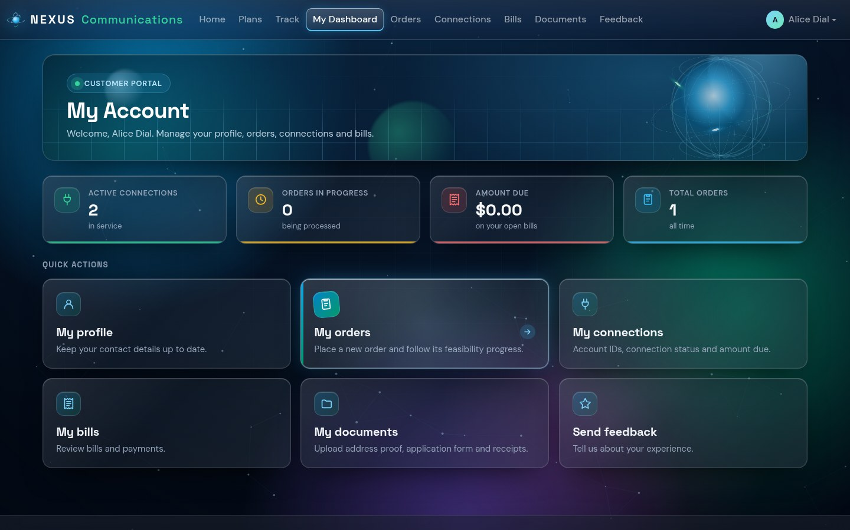
Figure 6 - Customer dashboard

4.2 Placing an order
- Open Place order from the dashboard or the menu.
- Choose the connection type - Dial-Up, Broadband or Landline - and then a plan.
- Dial-Up needs a Nexus landline. If you do not have one, also choose a landline plan: both are ordered together.
- Enter the installation address and city, and the number of connections (10 or more gives a bulk discount).
- Click Place order. Note the order number shown - you can track it at any time.
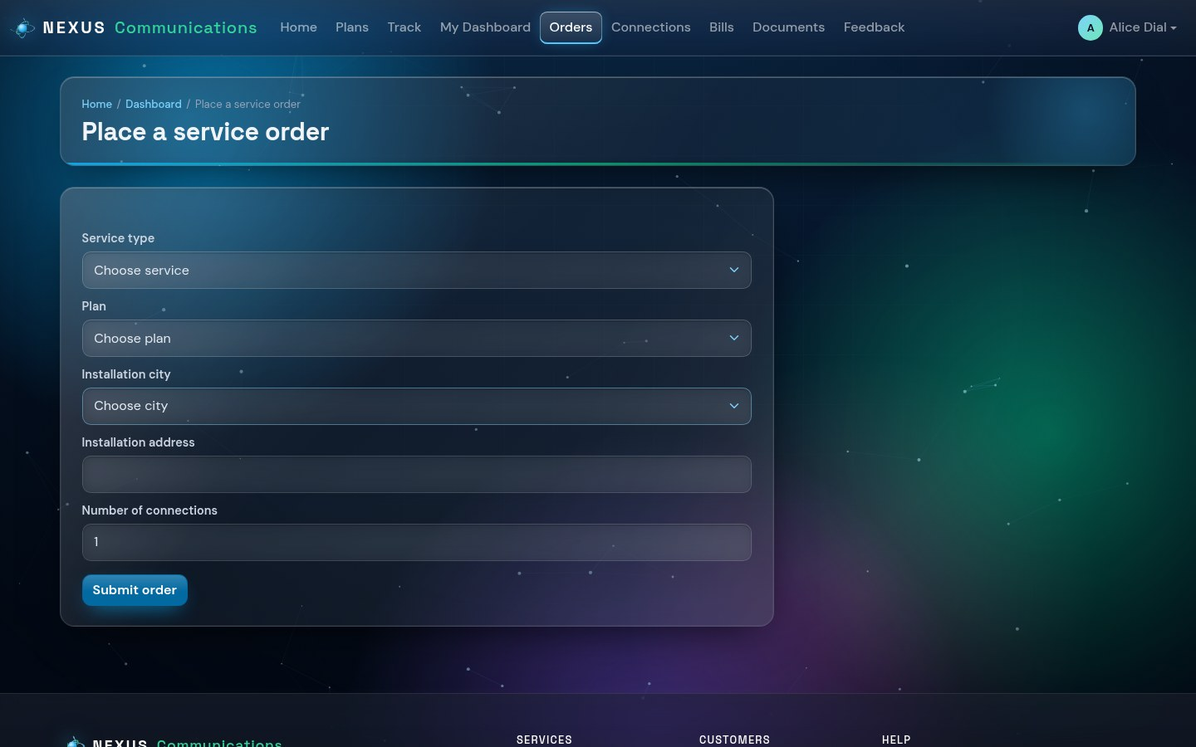
Figure 7 - Placing an order

4.3 My orders
My orders lists every order with its status. Open an order to see its details. An order that has not yet been connected can be cancelled with Cancel order.
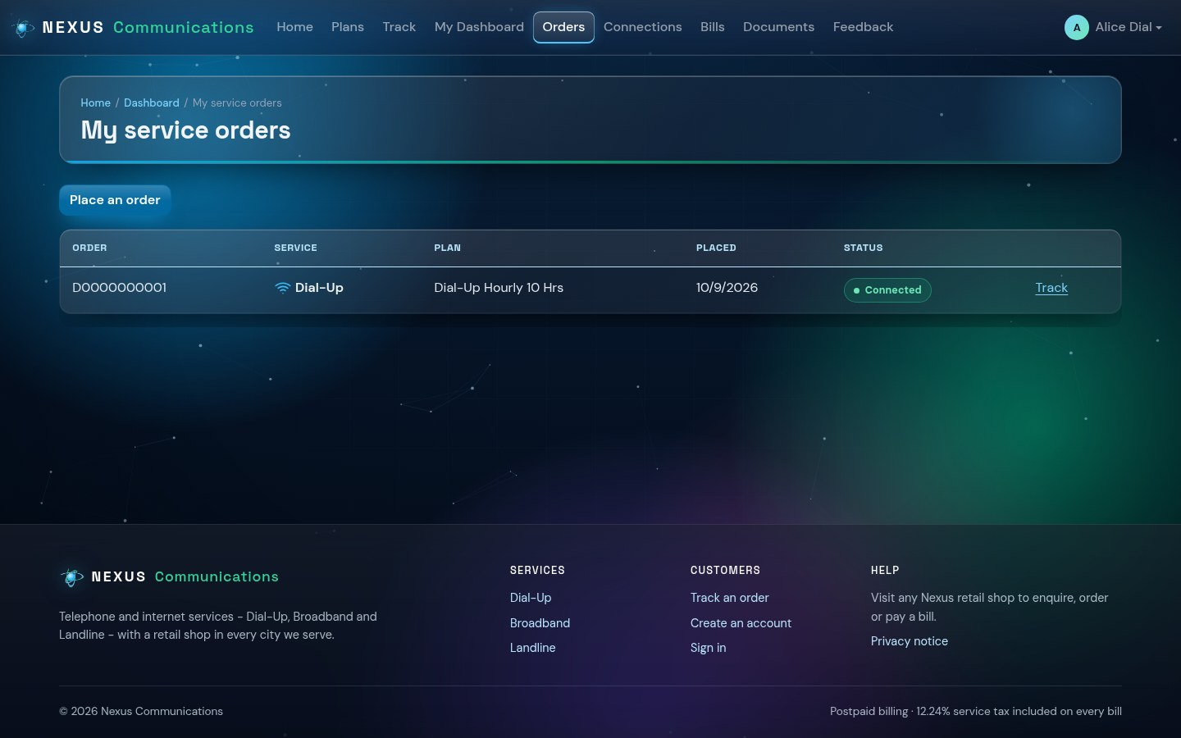
Figure 8 - My orders

4.4 Connections
Connections lists your connections with their account IDs, plan, status (Active, Temporarily inactive, Permanently inactive) and the equipment supplied.
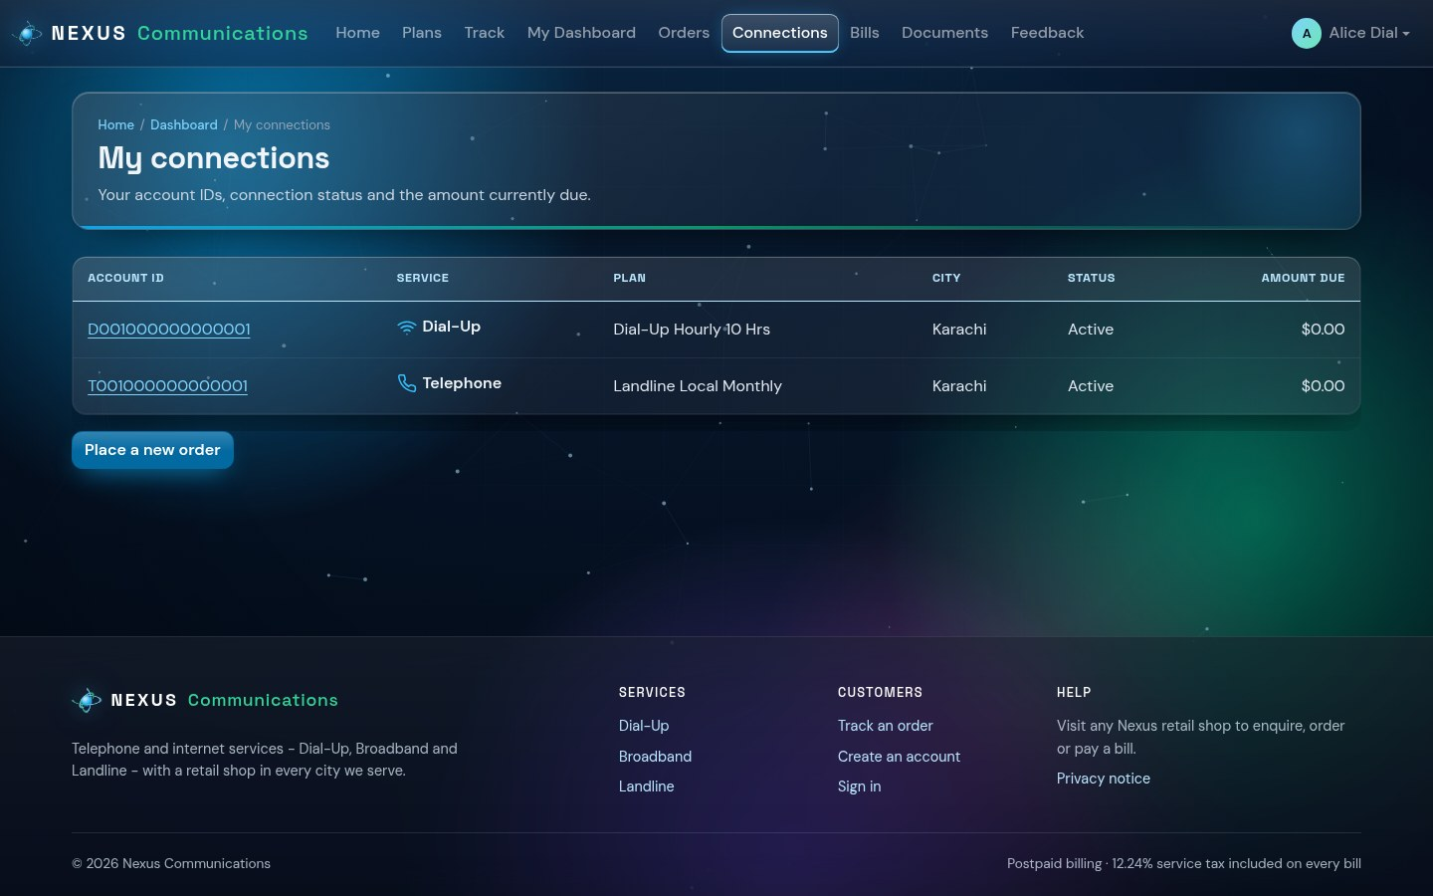
Figure 9 - My connections

4.5 Bills
Bills shows every bill, itemised: plan charge, call charges, deposit, discount and 12.24% service tax, with what has been paid and what is still due. Pay at any Nexus retail shop.
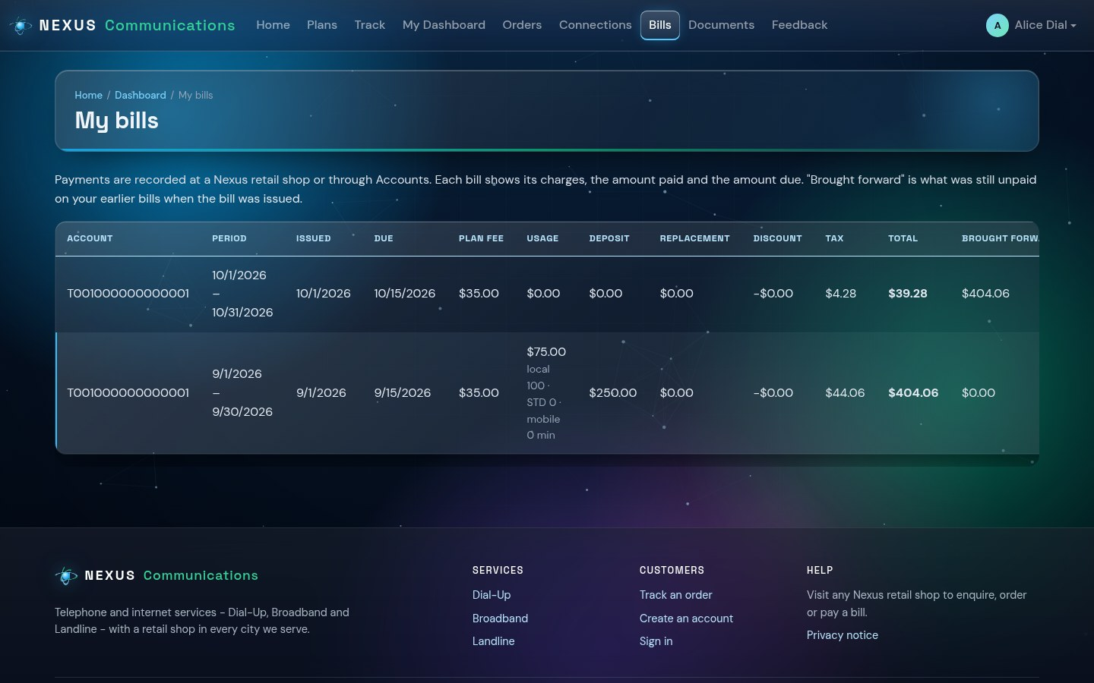
Figure 10 - Itemised bills

4.6 Documents, profile and feedback
- Documents - upload proof of identity or address (PDF or image) and download what you uploaded.
- Profile - update your phone number, e-mail and address.
- Feedback - send a comment or complaint to Nexus; the administrator reads every message.
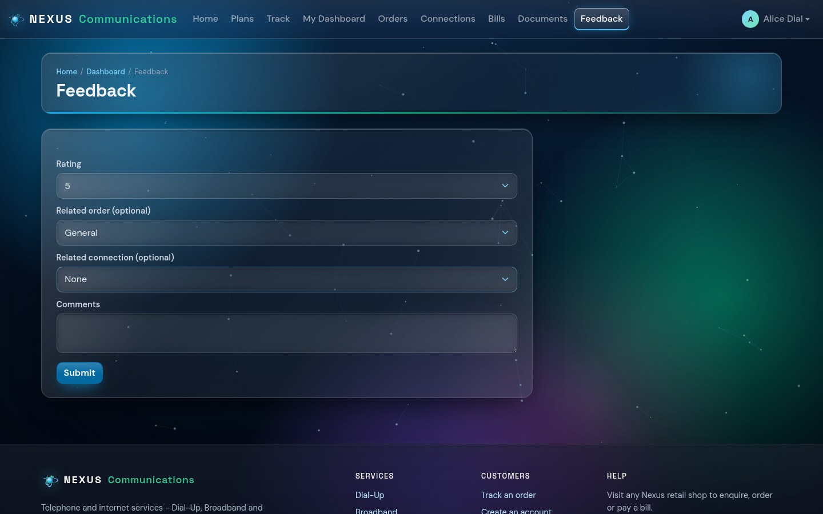
Figure 11 - Feedback form

5. Retail Shop Staff Guide
Retail staff work for one shop. They see only their own shop's customers, orders and bills.
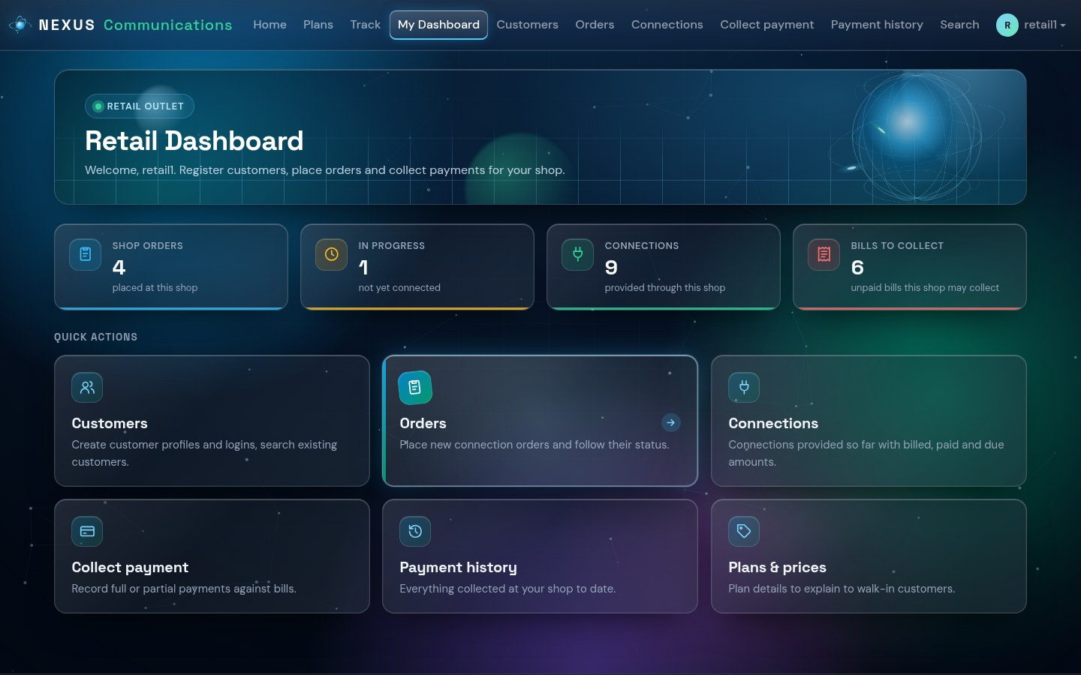
Figure 12 - Retail dashboard

5.1 Registering a walk-in customer
- Open Customers and click New customer.
- Enter the customer's details; the city is set to your shop's city.
- Save. The customer can now be given an order.

5.2 Placing an order for a customer
- Open Place order and choose the customer.
- Choose the connection type and plan (and a landline plan when a Dial-Up customer has no landline).
- Enter the installation address and the number of connections, then click Place order.
- Give the customer the order number printed on the confirmation.
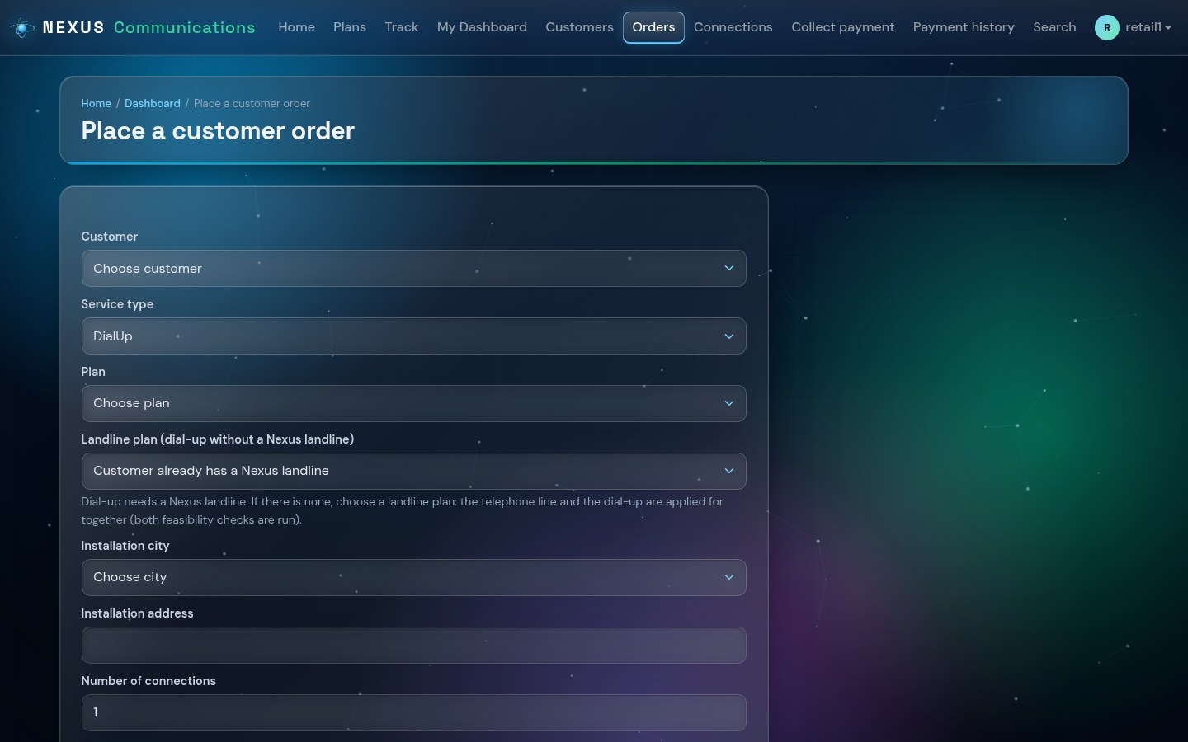
Figure 13 - Placing an order at the shop

5.3 Collecting a bill payment
- Open Collect payment. Bills with money still due are listed.
- Click Record payment next to the bill, enter the amount and payment method, and save.
- The bill status changes to Partially paid or Paid. Earlier unpaid bills are paid first.
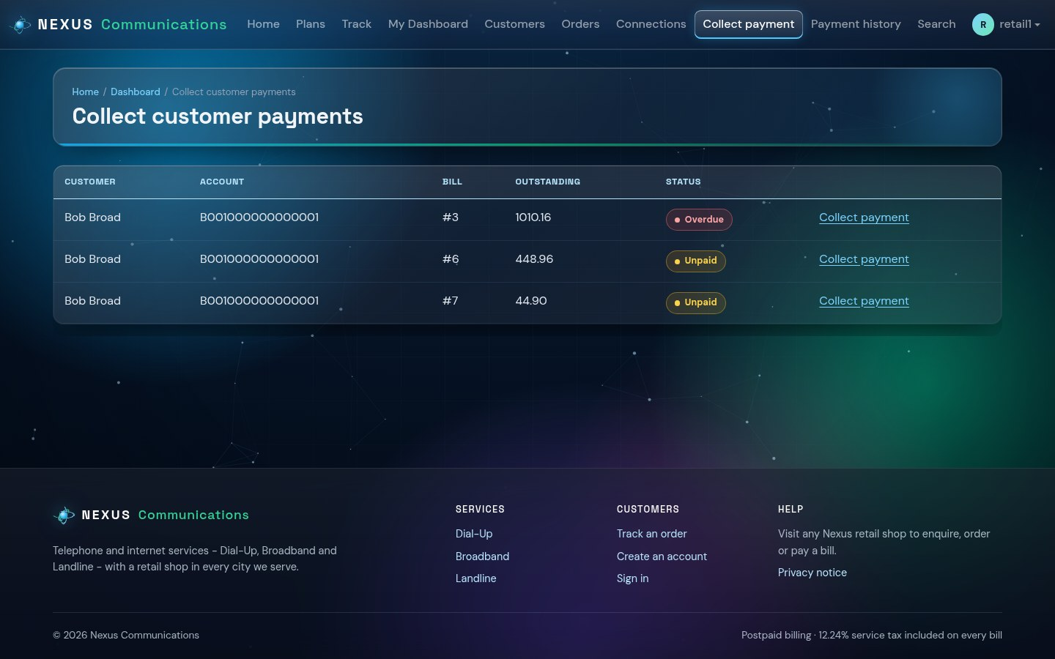
Figure 14 - Bills the shop can collect

6. Technical Staff Guide
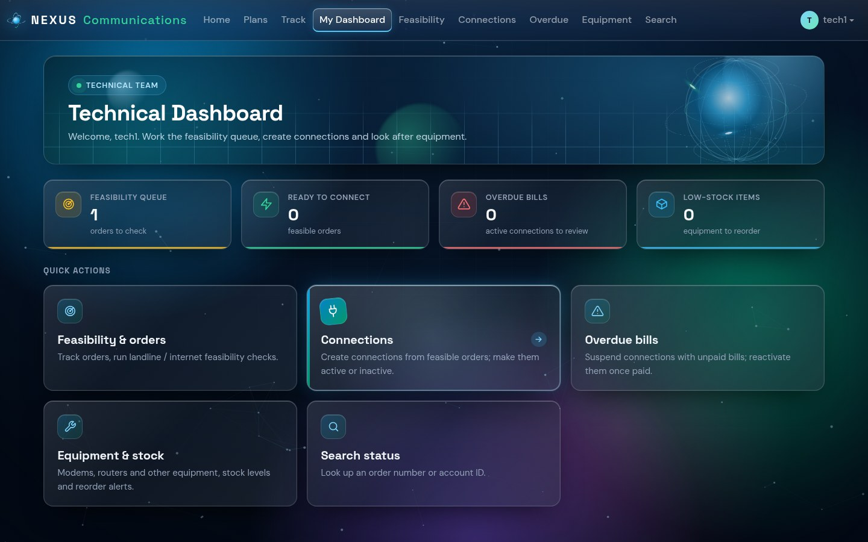
Figure 15 - Technical dashboard

6.1 Feasibility check
- Open Feasibility. New orders waiting for a check are listed.
- Click Start checks on an order. A distance check and a server-capacity check are created.
- Click Record result on each check, choose Feasible or Not feasible, add remarks and click Save result.
- When both checks are feasible the order becomes Feasible; the customer sees the result when tracking it.
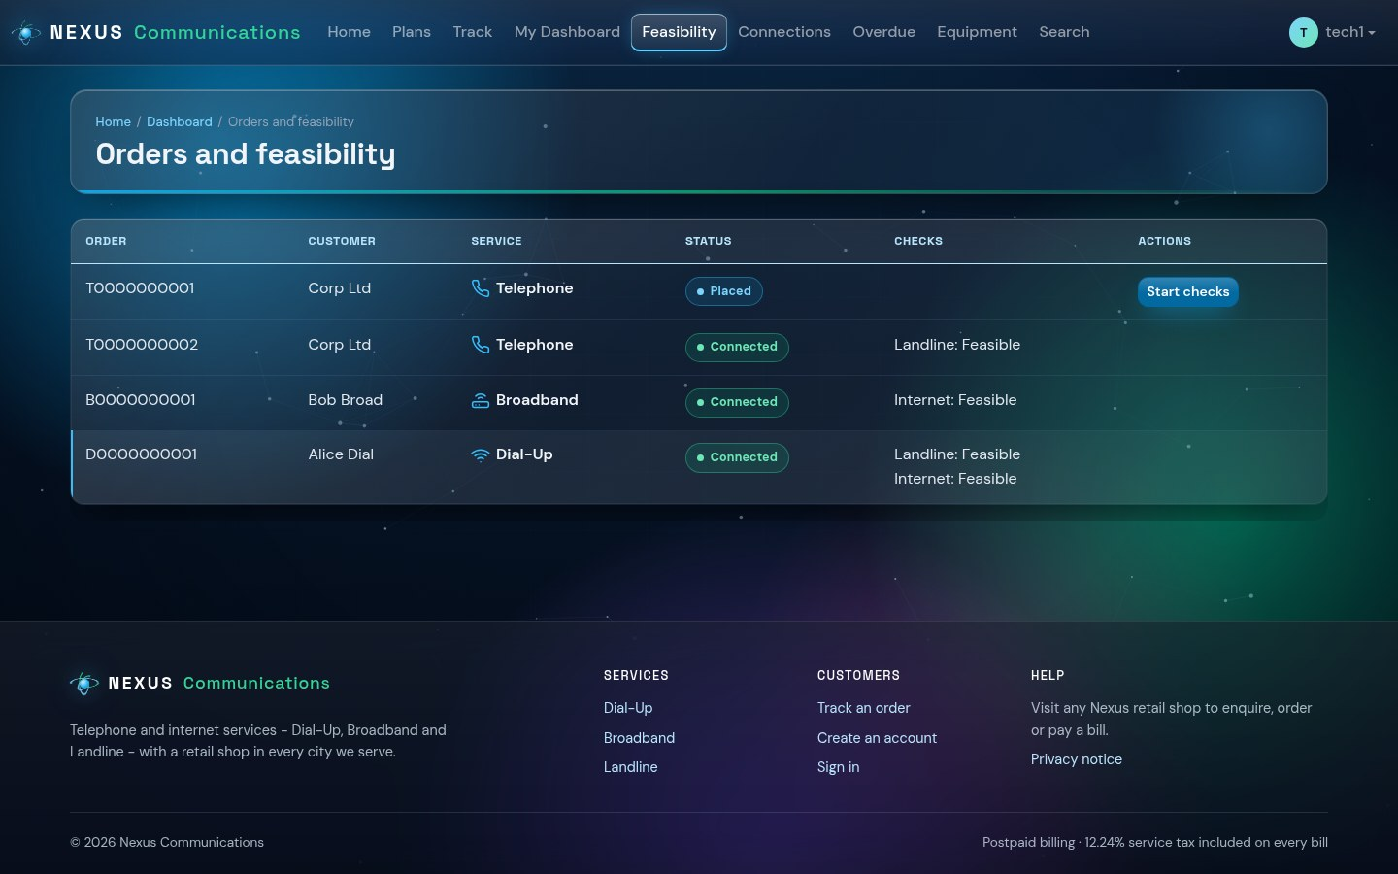
Figure 16 - Feasibility queue

6.2 Creating a connection
- On the Feasibility page click Provision next to a feasible order.
- Enter the phone number (landline), choose the equipment to supply and its serial number - stock is reduced automatically.
- Click Provision connections. The system creates the connection and its 16-character account ID.
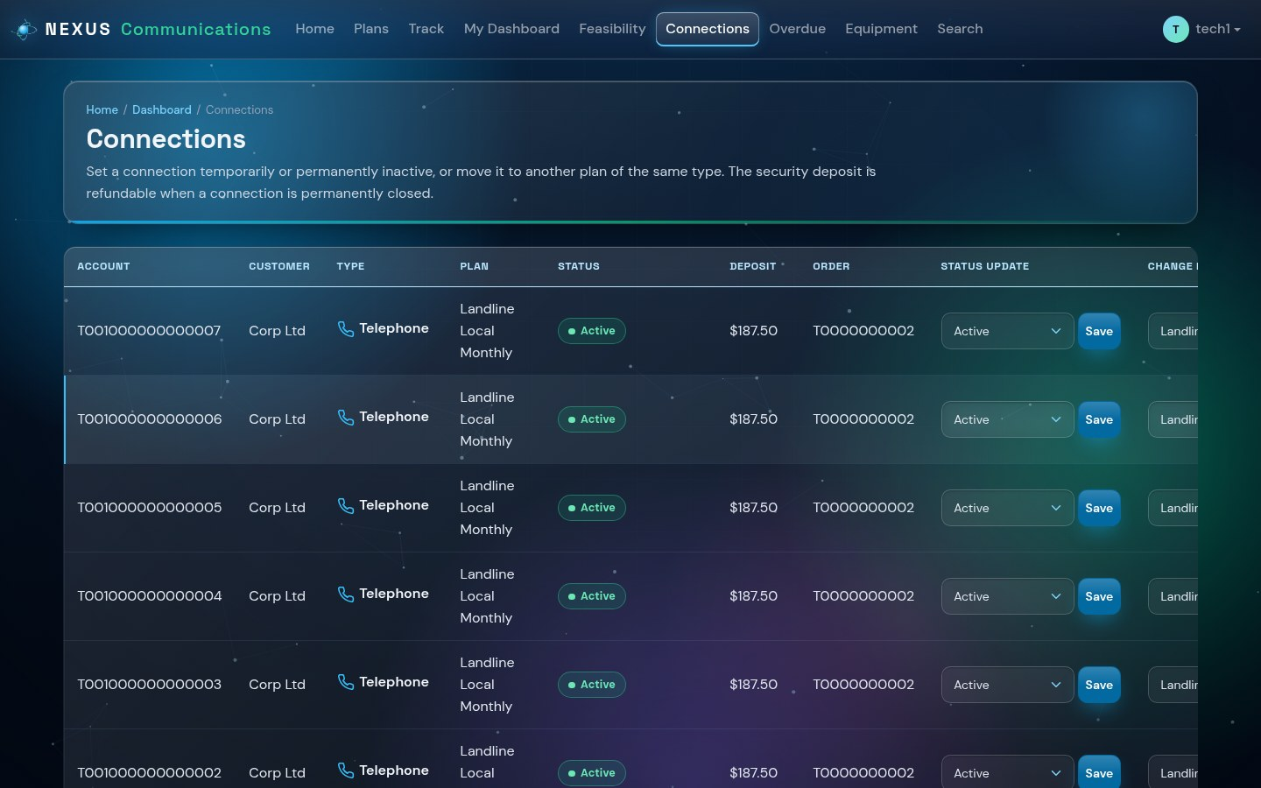
Figure 17 - Connections

6.3 Overdue bills - suspend and reactivate
Overdue lists active connections that have a bill past its due date. Click Suspend for one connection or Suspend all. When every bill of a suspended connection has been paid, it appears with a Reactivate button.
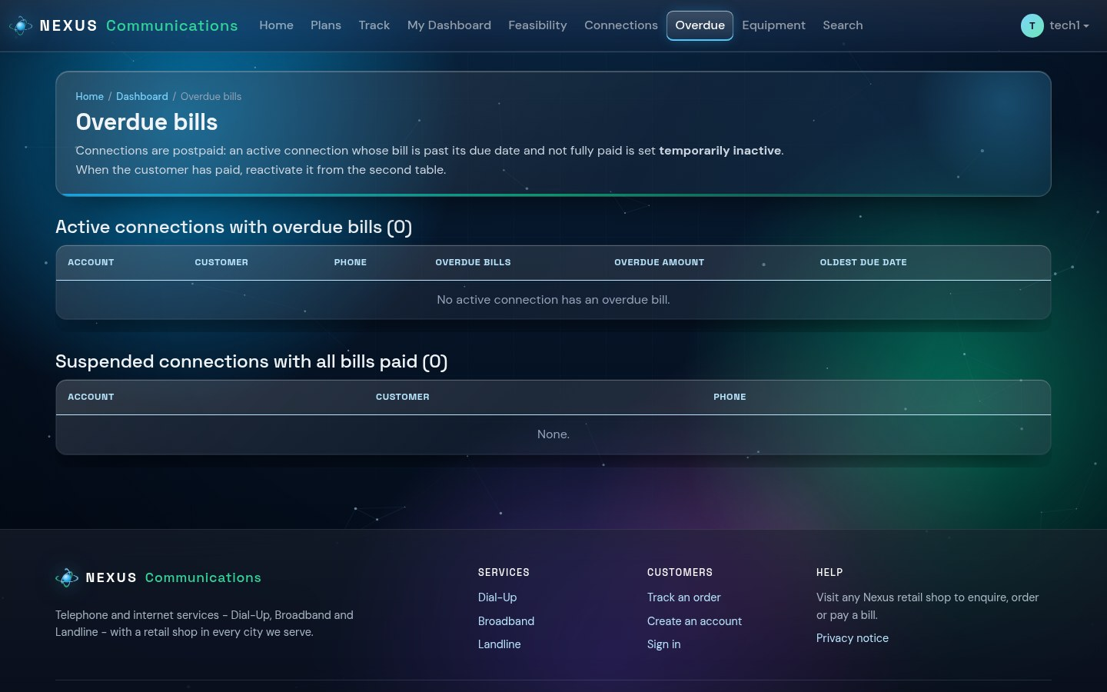
Figure 18 - Overdue connections

6.4 Other tasks
- Change a connection's plan, or close it permanently (the deposit becomes refundable).
- Replace faulty equipment; the old item is recorded and the new one is taken from stock.

7. Accounts Staff Guide
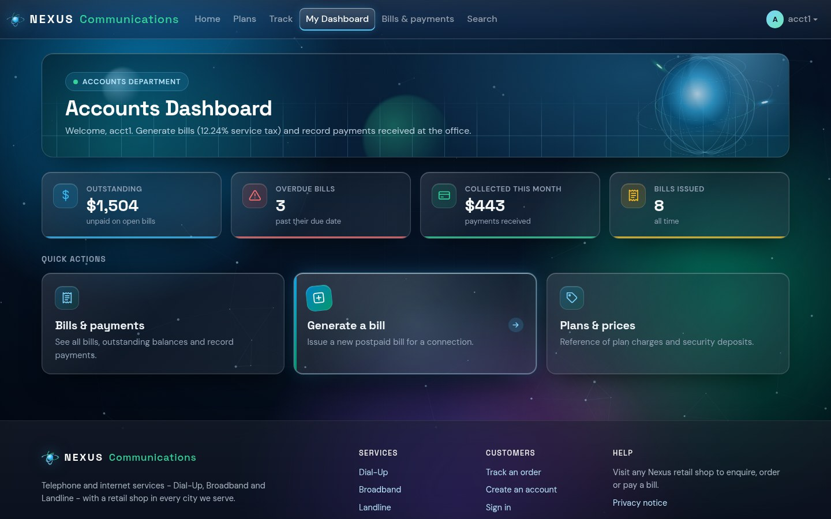
Figure 19 - Accounts dashboard

7.1 Generating a bill
- Open Generate bill and choose the connection and the billing period.
- For a landline, enter the local, STD and mobile call minutes and any other usage charge.
- Check the charges preview: plan charge, calls, deposit on the first bill, bulk discount and 12.24% tax.
- Click Generate bill. The bill is issued with a due date.
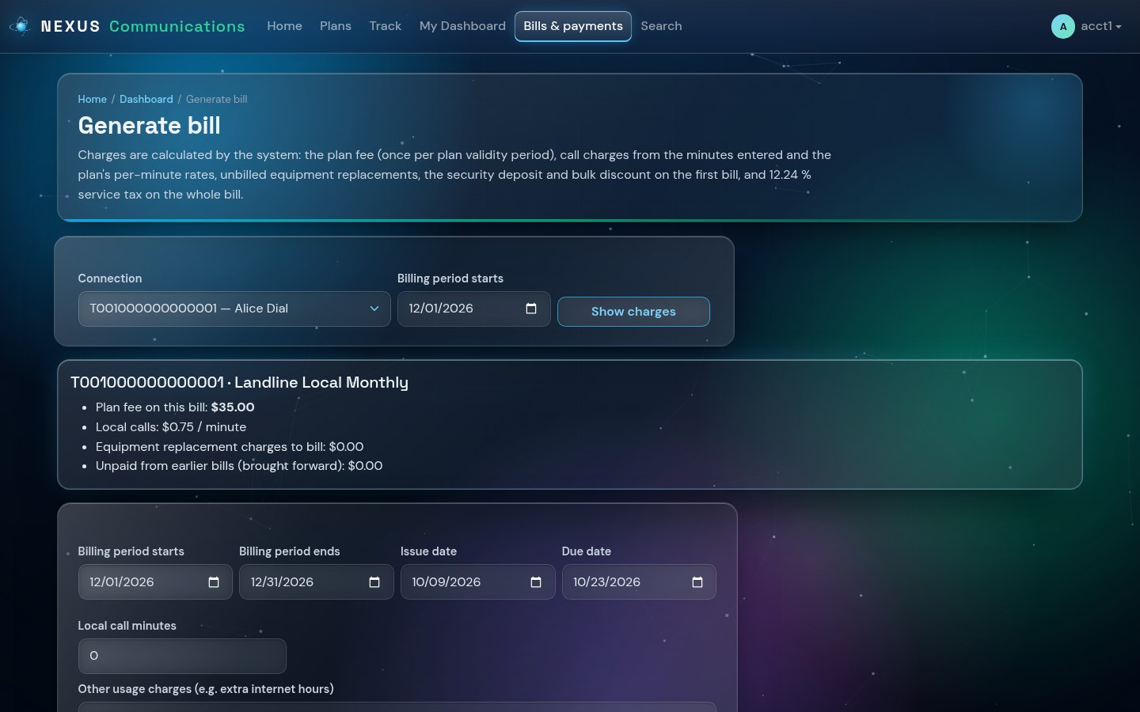
Figure 20 - Generating a bill with the charges preview

7.2 Bills and payments
Bills & payments lists every bill with its total, the amount brought forward from earlier unpaid bills, what has been paid and what is outstanding. Use Record payment to record a payment received at the head office.
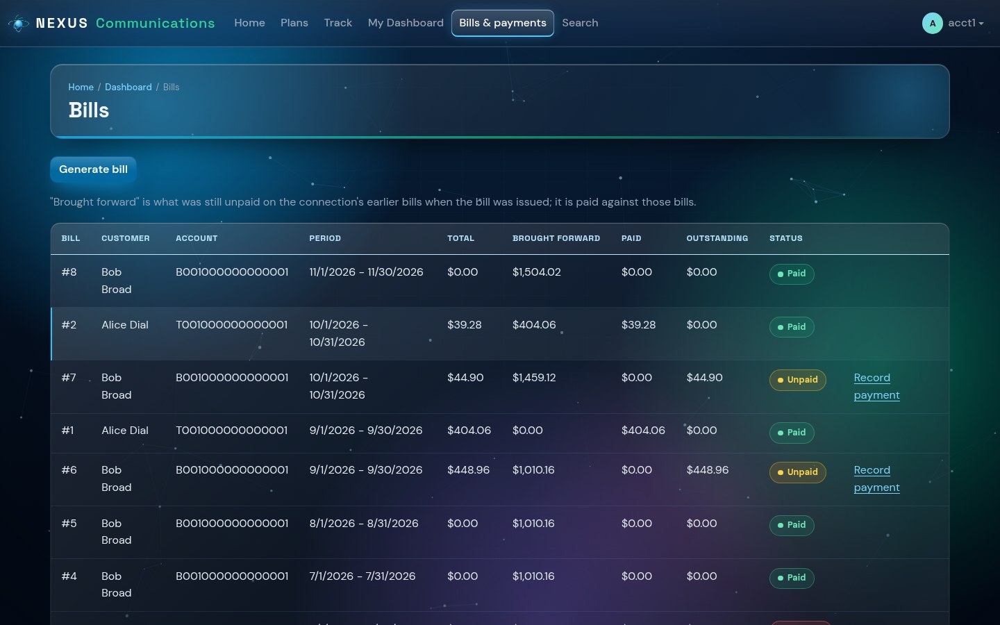
Figure 21 - All bills with status badges

8. Administrator Guide
The administrator signs in with the account created when the system was installed and should change its password after the first sign-in.
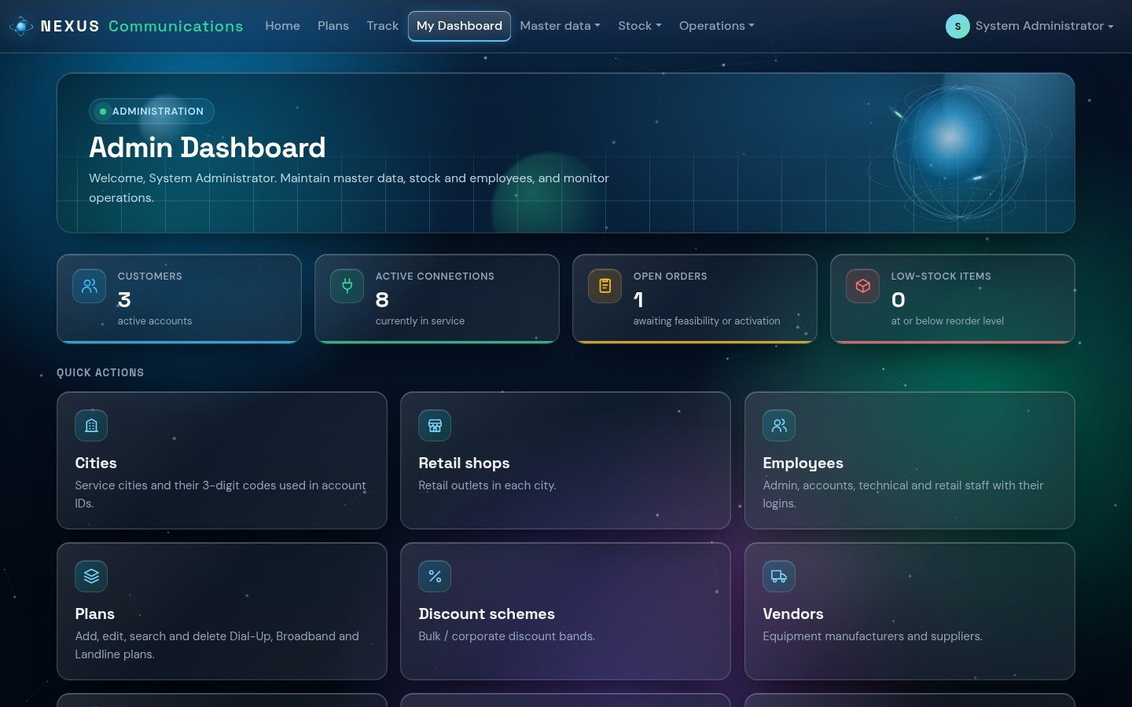
Figure 22 - Admin dashboard

8.1 Master data
Page | What to do there
Cities | Add the cities served. Each has a 3-digit code that becomes part of every account ID issued there.
Retail shops | Add one shop per city with its address and phone number.
Employees | Create staff logins and choose their role (Admin, Accounts, Technical, Retail) and shop.
Plans | Add, edit, search and delete Dial-Up, Broadband and Landline plans, prices and deposits.
Discount schemes | Set the bulk discount bands (for example 10-14 connections: 25%).
Vendors | Equipment manufacturers and suppliers.
Products & stock | Modems, routers and other equipment with stock and reorder level.
Equipment purchases | Record purchases from vendors; receiving them adds to stock.
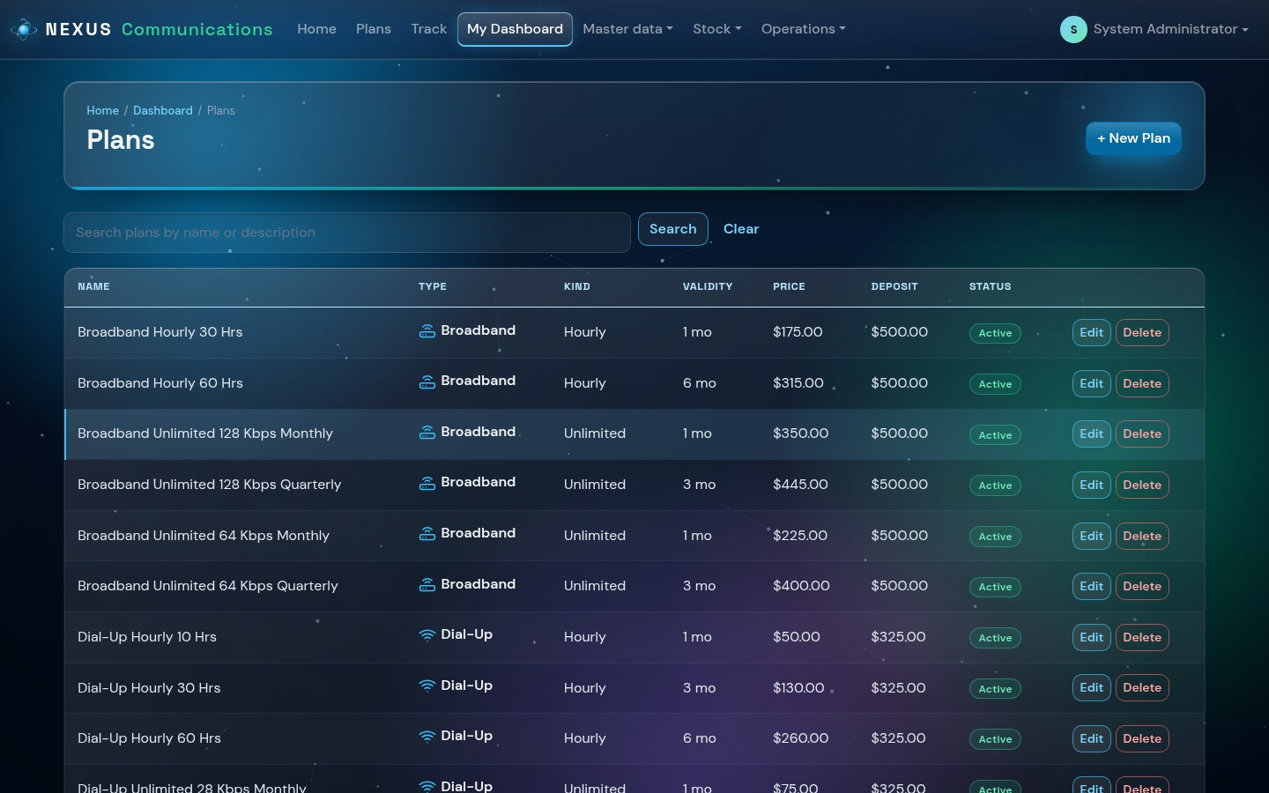
Figure 23 - Managing plans
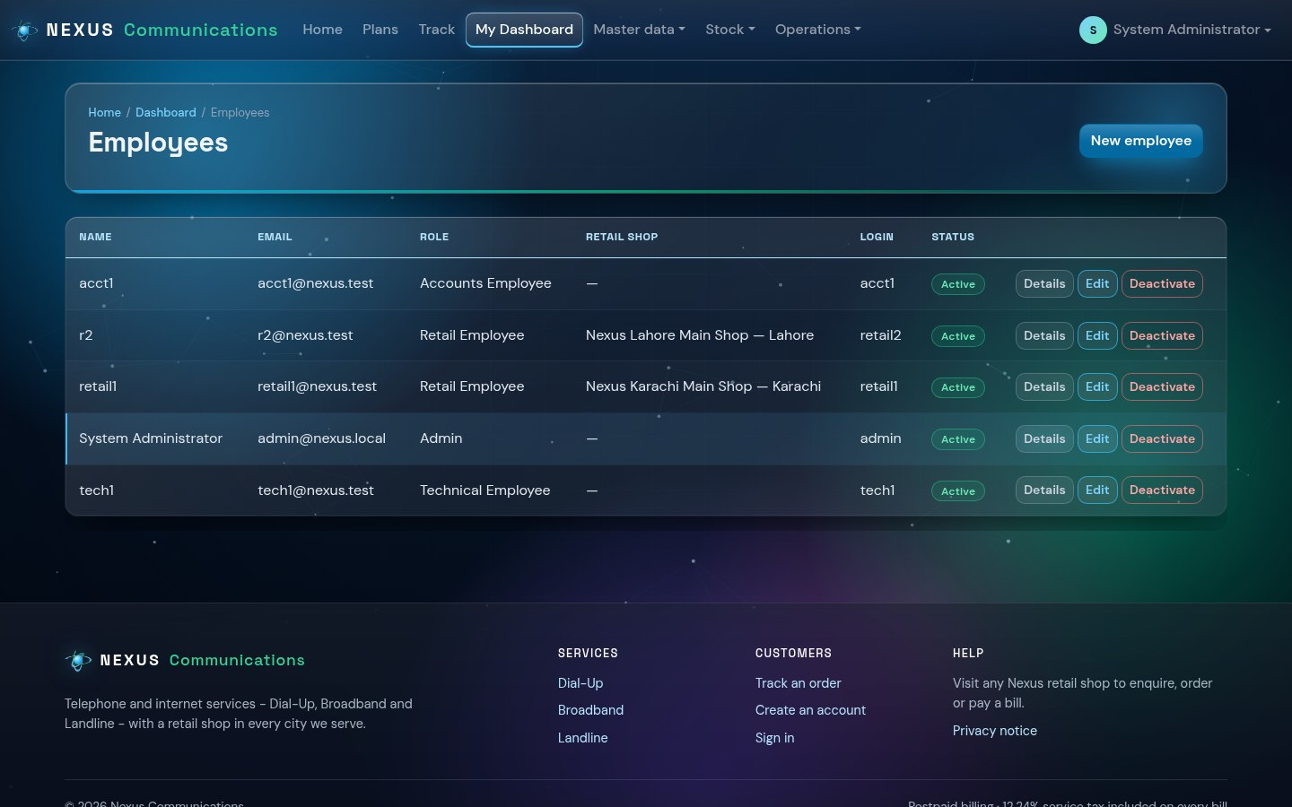
Figure 24 - Employees and their roles
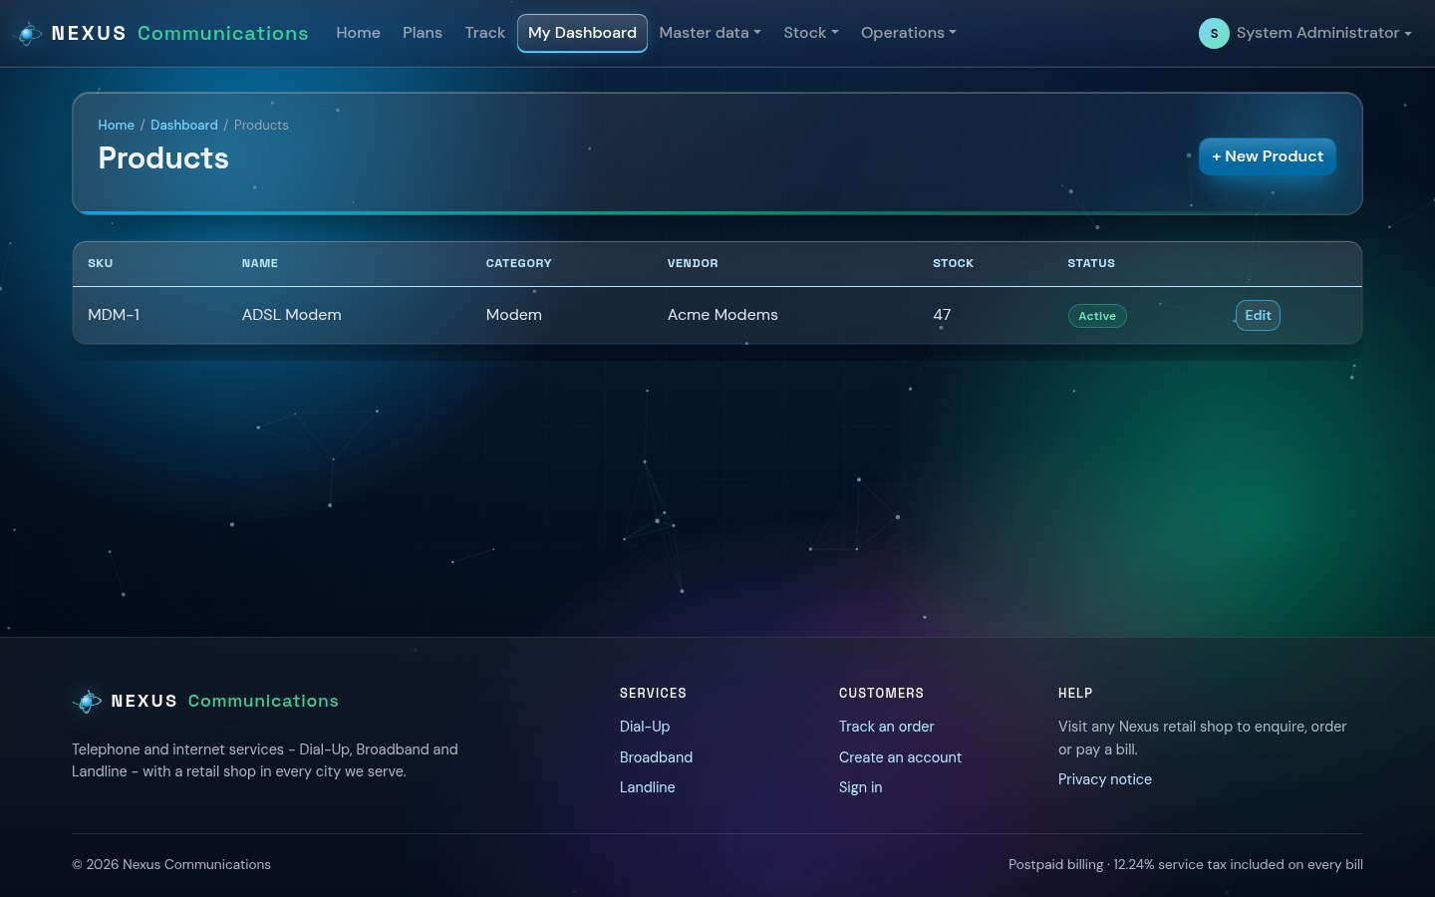
Figure 25 - Products and stock

8.2 Operations
- Orders - every order in every city and its progress.
- Advanced search - find orders and connections by ID, customer name, contact number, type or date.
- Reports & feedback - orders, connections, billing, equipment demand, low stock and customer feedback.
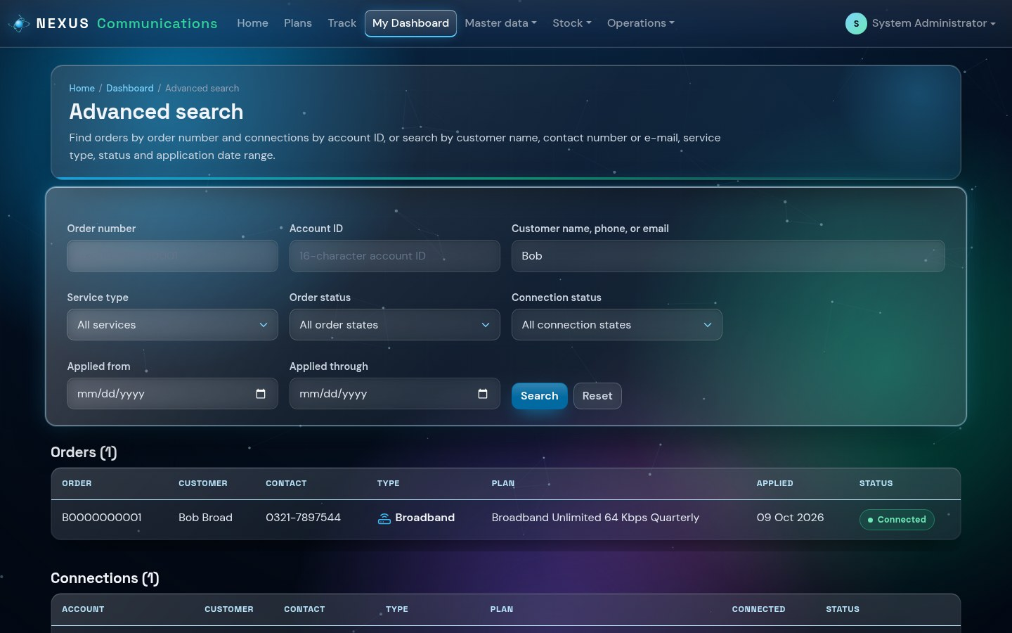
Figure 26 - Advanced search
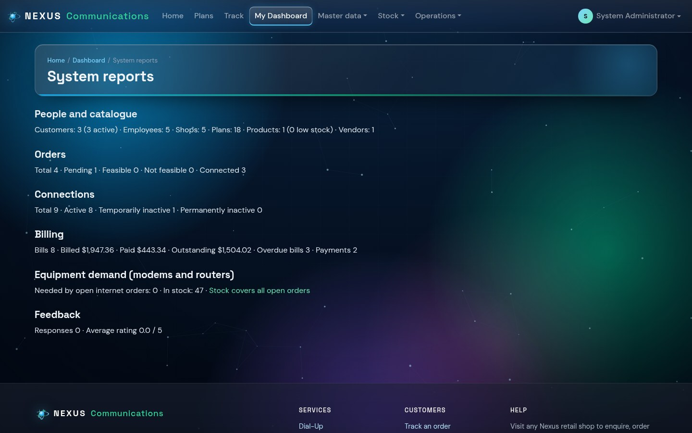
Figure 27 - Reports

9. Quick Reference

9.1 Status meanings
Item | Status | Meaning
Order | Placed | Received; nothing checked yet
Order | Under feasibility check | Technical staff are checking the area
Order | Feasible / Not feasible | Result of the check
Order | Connected | The connection has been created
Order | Cancelled | Withdrawn by the customer or staff
Connection | Active | In service
Connection | Temporarily inactive | Suspended, usually for an overdue bill
Connection | Permanently inactive | Closed
Bill | Issued / Partially paid / Paid | How much of the bill has been paid

9.2 Identifier formats
Identifier | Format | Example
Order number | Service letter (D, B, T) + 10 digits | D0000000001
Account ID | Service letter + 3-digit city code + 12 digits | B001000000000001

9.3 Bulk discount
Connections | Discount on advance and deposit
10 - 14 | 25%
15 - 24 | 50%
25 - 49 | 75%
50 or more | 100%

9.4 Troubleshooting
Problem | What to do
Cannot sign in | Check Caps Lock and the username. Staff: ask the administrator to reset the password.
A page says Access denied | The page belongs to another role. Use the menu, which shows only your pages.
Dial-Up plan cannot be ordered | A Dial-Up connection needs a landline - choose a landline plan in the same order.
Order shows Not feasible | The address cannot be served yet; contact the retail shop.
Connection suspended | Pay the overdue bills at any shop; technical staff then reactivate it.

