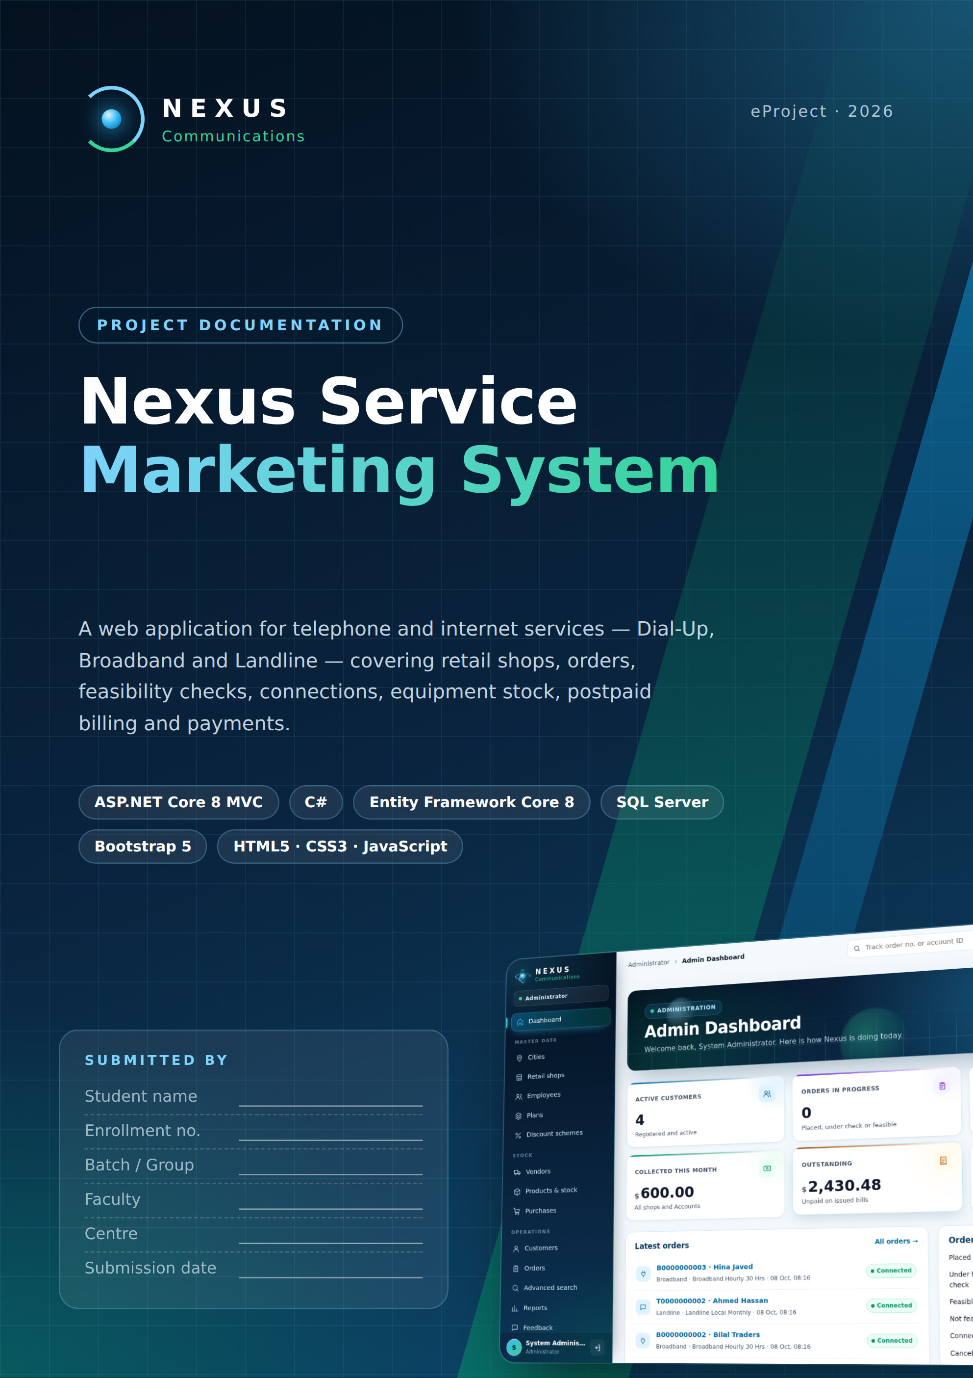

Acknowledgement
I would like to thank my faculty and the staff of the Aptech centre for their guidance and support during this eProject. Their feedback on analysis, database design and testing helped turn the problem statement into a working application.
I am also thankful to my family and friends for their encouragement throughout the project.

Certificate
This is to certify that the eProject titled "Nexus Service Marketing System" has been completed by the student named on the cover page, as part of the curriculum, under the guidance of the faculty named there.

______________________ ______________________
Faculty signature Centre manager

Table of Contents
1. Introduction 5
1.1 Objectives 5
1.2 Scope 5
1.3 Technology stack 6
1.4 Project plan 6
2. Problem Definition 7
3. Customer Requirements Specification 8
3.1 Users and roles 8
3.2 Functional requirements 8
3.3 Non-functional requirements 9
3.4 Business rules 9
3.5 Requirement traceability 10
3.6 Plan price list (seeded) 11
4. System Design 12
4.1 Architecture 12
4.2 Modules 13
4.3 Services (business layer) 13
4.4 Security design 13
5. Database Design 15
5.1 Tables 16
5.2 Integrity rules 16
5.3 Data dictionary 16
6. Process Design 26
6.1 Context diagram (DFD level 0) 26
6.2 DFD level 1 27
6.3 Use case diagram 28
6.4 Workflow flowchart 29
6.5 Status life cycles 29
6.6 Algorithms 29
7. User Interface Design 31
7.1 Design system 31
7.2 Motion and overlays 31
7.3 Public website 33
7.4 Administrator 36
7.5 Retail staff 40
7.6 Technical team 42
7.7 Accounts 45
7.8 Customer portal 46
7.9 Mobile view 48
8. Testing 49
8.1 System test cases 49
8.2 Unit testing checklist (development phase) 50
9. Installation Guide 51
9.1 Requirements 51
9.2 Connect SQL Server 51
9.3 Create the database 51
9.4 First login 51
9.5 Troubleshooting 52
10. User Guide 53
10.1 Getting around 53
10.2 Administrator 53
10.3 Retail staff 53
10.4 Technical team 53
10.5 Accounts 53
10.6 Customer 54
11. Developer Guide 55
11.1 Folder structure 55
11.2 Adding a feature 55
12. Project Management 56
12.1 Task sheet 56
12.2 Project review and monitoring report 56
12.3 Final checklist 57
13. Conclusion and Future Enhancements 58
Future enhancements 58

1. Introduction
Nexus Communications provides telephone and internet services - Dial-Up, Broadband and Landline - through retail shops in several cities. The Nexus Service Marketing System is a web application that runs the whole business in one place: plans and prices, retail shops, employees, customers, orders, feasibility checks, connections, equipment stock, postpaid bills and payments.
Every user signs in to a dashboard for their own role. Customers can register, order and follow their order online; retail staff serve walk-in customers and collect payments; the technical team checks feasibility and creates connections; accounts staff generate bills; and the administrator maintains the master data and watches the whole operation.

1.1 Objectives
- Replace manual registers with one database that every department shares.
- Give each role exactly the screens it needs, protected by role-based login.
- Generate order numbers and account IDs automatically in the format of the specification.
- Calculate bills correctly: plan fee, call charges, usage, deposit, bulk discount and 12.24 % service tax.
- Show the status of every order, connection and bill at any time, including amounts due.
- Present it in a modern, fast and easy interface that also works on tablets and phones.

1.2 Scope
Table 1. Project scope
In scope | Out of scope
Dial-Up, Broadband and Landline orders and connections | Online card payment gateway (payments are recorded by staff)
Five user roles + public visitors | Physical network / exchange equipment management
Feasibility checks, provisioning, equipment issue and replacement | SMS / e-mail notifications
Postpaid billing, partial payments, overdue suspension | Payroll and HR
Advanced search, tracking, reports, customer documents, feedback | Mobile app (the website is responsive instead)

1.3 Technology stack
Table 2. Technology stack
Layer | Technology
Front end | Razor views, HTML5, CSS3, JavaScript, Bootstrap 5, Google Fonts (Space Grotesk, DM Sans)
Back end | ASP.NET Core 8 MVC (C# 12), Areas per role, cookie authentication, role authorization
Data access | Entity Framework Core 8 (code-first, 5 migrations), LINQ
Database | Microsoft SQL Server 2019 / 2022 (any edition, incl. Express)
Tools | Visual Studio 2022, SQL Server Management Studio, .NET 8 SDK, dotnet-ef, Google Chrome

1.4 Project plan
Table 3. Project plan
Phase | Work | Output
1. Analysis | Study the problem statement, roles and business rules | Requirement list
2. Design | ER diagram, tables, ID formats, screens, interface design | Database design, GUI standards
3. Database | EF Core entities, configurations, migrations, seed data | 19 tables in SQL Server
4. Development | Five role areas; services for orders, connections and billing | Working website
5. UI design | App shell, dashboards, motion, overlays, responsive layout | site.css / nexus-app.css, site.js / nexus-app.js
6. Testing | Automated browser workflow, negative tests, unit checklist | Test results (chapter 8)
7. Delivery | Documentation, presentation, database backup, source ZIP | Final submission

2. Problem Definition
Nexus Communications sells Dial-Up, Broadband and Landline connections from retail shops in several cities. Today each shop keeps its own registers for customers and orders, the technical team receives orders on paper, and the accounts department prepares bills by hand. This causes:
- Lost and duplicated orders - no single order number that every department can follow.
- Slow feasibility and installation - technical staff do not see new orders until paperwork arrives.
- Billing mistakes - plan fees, call charges, deposits, bulk discounts and the 12.24 % service tax are calculated by hand.
- No view of dues - shops cannot see what a customer owes, and overdue connections stay active.
- Equipment losses - modems and routers issued to customers are not tracked against stock.
- No self-service - customers must visit or phone a shop to know the status of their order.
The company needs a central, role-based web system where every order gets a unique number, moves through feasibility, connection, billing and payment in one database, and where every user sees the information they need instantly.
Identifier formats required by the specification
Order number - 11 characters: service letter (D Dial-Up, B Broadband, T Telephone) + 10 digits, e.g. B0000000001.
Account ID - 16 characters: service letter + 3-digit city code + 12-digit serial, e.g. B001000000000001.
Both are generated by the server and protected by CHECK constraints in the database.

3. Customer Requirements Specification

3.1 Users and roles
Table 4. Users and roles
Role | Who | Main responsibilities
Visitor | Anyone | View plans and prices, track an order / account, register as a customer
Customer | Registered customer | Profile, place orders, follow orders, connections, bills and amount due, documents, feedback
Retail staff | Shop employee | Register walk-in customers, place orders, view shop connections, collect payments, payment history, search
Technical | Technical team | Feasibility checks, create connections, issue / replace equipment, change plan, suspend overdue and reactivate, stock
Accounts | Accounts department | Generate bills, record payments, view unpaid and overdue bills, search
Administrator | Head office | Cities, shops, employees and logins, plans, discount schemes, vendors, products, purchases, customers, orders, reports, feedback

3.2 Functional requirements
Table 5. Functional requirements
ID | Requirement | Role
FR-01 | Secure login for every role; passwords stored as salted hashes; change password | All
FR-02 | Maintain cities (unique 3-digit code) and retail shops | Admin
FR-03 | Maintain employees with a role, shop (for retail staff) and login | Admin
FR-04 | Add, edit, search and delete plans for Dial-Up, Broadband and Landline | Admin
FR-05 | Maintain bulk discount bands (10-14: 25 %, 15-24: 50 %, 25-49: 75 %, 50+: 100 %) | Admin
FR-06 | Maintain vendors, products and stock; record purchases that increase stock | Admin
FR-07 | Register customers (individual or corporate) with a login | Retail, Customer, Admin
FR-08 | Place an order; generate the 11-character order number; apply bulk discount | Retail, Customer
FR-09 | Dial-up needs a Nexus landline: order both together or link an existing line | Retail, Customer, Technical
FR-10 | Record landline and internet feasibility (distance, server availability, result) | Technical
FR-11 | Create connections from feasible orders; generate account IDs; issue equipment from stock | Technical
FR-12 | Set connections temporarily or permanently inactive; change plan; replace spoiled equipment | Technical
FR-13 | Generate bills: plan fee per validity period, call charges, usage, deposit, discount, 12.24 % tax, brought-forward balance | Accounts
FR-14 | Record full or partial payments; never more than the outstanding amount | Accounts, Retail
FR-15 | List active connections with overdue bills; suspend them; reactivate when paid | Technical
FR-16 | Track an order number or account ID publicly; amounts only after sign-in | All
FR-17 | Advanced search by ID, name, contact, connection type and date range | Admin, Retail, Technical, Accounts
FR-18 | Upload private customer documents (PDF / PNG / JPEG, 5 MB) filed by year and city | Customer, Retail, Admin
FR-19 | Collect customer feedback; reports for the administrator | Customer, Admin
FR-20 | Role dashboards with live figures and items that need attention | All signed-in users

3.3 Non-functional requirements
Table 6. Non-functional requirements
Area | Requirement
Security | Cookie authentication, role-based authorization on every controller, anti-forgery tokens on every form, PBKDF2 password hashes, private document storage, customers can only open their own records
Data integrity | Primary / foreign keys, 47 CHECK constraints, unique indexes, row-version concurrency on orders and connections, no cascade deletes
Usability | Sidebar navigation per role, dashboards, consistent status colours, inline validation, confirm dialogs before destructive actions
Performance | Server-side paging limits (300 rows), AsNoTracking reads, indexes on foreign keys and identifiers
Portability | Runs on any SQL Server edition; one connection string in appsettings.json; database created by migrations or one SQL script
Accessibility | Keyboard focus styles, skip link, ARIA labels, WCAG contrast for text, animations disabled for "reduced motion" users
Responsiveness | Works from 360 px phones to wide desktop screens

3.4 Business rules
- A plan fee is charged once per plan validity period (e.g. a quarterly plan every 3 months).
- Call charges = local, STD and messaging-for-mobile minutes x the plan's per-minute rates.
- The security deposit and the bulk discount appear on the first bill only.
- Service tax of 12.24 % is applied to the whole bill.
- The unpaid amount of earlier bills is shown as brought forward.
- A bill past its due date and not fully paid makes an active connection overdue; Technical can set it temporarily inactive, and reactivate it once all bills are paid.
- Equipment replaced because the customer spoiled it is charged on the next bill (once).
- A multi-connection order records device serials after provisioning, one per connection.

3.5 Requirement traceability
Table 7. Requirement traceability
No. | Requirement (from the problem statement) | Where implemented
1 | Separate logins for Admin, Accounts, Technical, Retail employees and Customers | Role-based Areas, cookie login, hashed passwords
2 | Admin maintains employees, stock, vendors, retail shops, plans (insert, update, delete, search) | Admin area
3 | Order ID: 11 characters, first letter D / T / B + serial (e.g. D0000000001) | IdentifierGenerator, DB check constraint
4 | Account ID: type letter + 3-digit city code + 12-digit serial (16 characters) | IdentifierGenerator, Cities.Code
5 | Only retail employees (and customers themselves) place orders | Retail and Customer areas
6 | Feasibility: landline + internet for Dial-Up; internet only if the customer already has a Nexus landline | OrderWorkflowService
7 | Technical updates orders, creates connections, sets them temporarily / permanently inactive, maintains equipment | Technical area, ConnectionProvisioningService
8 | Accounts generate bills; payments recorded by Accounts and Retail staff | Accounts and Retail areas, BillingService
9 | Bulk discount 10-14: 25 %, 15-24: 50 %, 25-49: 75 %, 50+: 100 % on advance and deposit | DiscountSchemes, OrderWorkflowService
10 | Service tax 12.24 % on the whole bill | BillingService
11 | Search order status by order ID and connection status (with due amount) by account ID | Public Track page, quick Track box
12 | Advanced search by ID, name, connection type, date / period, contact number | Admin and staff Advanced search
13 | Customer sees contact details, places orders, tracks orders, views bills | Customer area and dashboard
14 | Address proofs, application forms and receipts filed by year and area | Customer Documents
15 | Customer feedback; customers can change plan | Feedback page; Technical > Change plan
16 | Plan details with security deposits and call charges | Plans table (18 plans seeded), public Plans page

3.6 Plan price list (seeded)
Table 8. Plan price list
Type | Plan | Price | Security deposit
Dial-Up | Hourly 10 / 30 / 60 hrs | $50 / $130 / $260 | $325
Dial-Up | Unlimited 28 Kbps monthly / quarterly | $75 / $150 | $325
Dial-Up | Unlimited 56 Kbps monthly / quarterly | $100 / $180 | $325
Broadband | Hourly 30 / 60 hrs | $175 / $315 | $500
Broadband | Unlimited 64 Kbps monthly / quarterly | $225 / $400 | $500
Broadband | Unlimited 128 Kbps monthly / quarterly | $350 / $445 | $500
Landline | Local: yearly rental ($0.55 / min), monthly ($0.75 / min) | $75 / $35 | $250
Landline | STD: monthly, half-yearly, yearly (yearly price not given in the specification; seeded inactive) | $125 / $420 / - | $250

4. System Design

4.1 Architecture
The application follows a three-layer architecture. The presentation layer (areas, controllers and Razor views) never talks to the database directly; it calls services, which hold every business rule and use Entity Framework Core to read and write SQL Server.
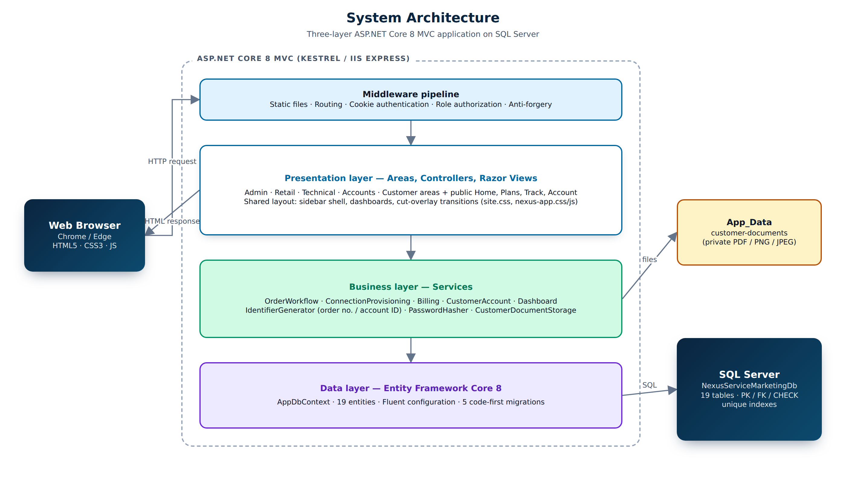
Figure 1. System architecture

4.2 Modules
Table 9. Application modules
Module (Area) | Controllers | Purpose
Public | Home, Catalog, Track, Account | Landing page, plans and prices, order / account tracking, login, registration, change password
Admin | Home, Cities, RetailShops, Employees, Plans, DiscountSchemes, Vendors, Products, Purchases, Customers, Operations | Master data, stock, customers, orders, advanced search, reports, feedback
Retail | Home, Customers, Orders, Connections, Payments | Walk-in customers and orders, shop connections, collect payments, payment history
Technical | Home, Feasibility, Connections, Products | Feasibility queue, provisioning, status changes, overdue list, equipment and stock
Accounts | Home, Bills | Bill generation with charge preview, payments
Customer | Home, Orders, Portal, Documents | Self-service orders, connections, bills, profile, documents, feedback
Search | Search | Advanced search shared by Retail (own shop), Technical and Accounts

4.3 Services (business layer)
Table 10. Business services
Service | Responsibility
OrderWorkflowService | Validates and places orders, applies discount bands, dial-up + landline rule, starts and records feasibility checks, cancels orders
ConnectionProvisioningService | Creates connections and account IDs, issues equipment, changes status / plan, replaces equipment, finds overdue and cleared connections
BillingService | Previews and generates bills (plan fee, calls, usage, deposit, discount, 12.24 % tax, brought-forward), records payments
CustomerAccountService | Registers customers with a login, updates profiles
IdentifierGenerator | Thread-safe order numbers and account IDs using the IdentifierCounters table
DashboardService | Read-only figures for the five role dashboards
PasswordHasherService / CustomerDocumentStorage | Password hashing; private file storage under App_Data

4.4 Security design
- Each area controller carries [Authorize(Roles = ...)]; anonymous users are redirected to Login and wrong roles to Access denied.
- Every POST form has an anti-forgery token ([ValidateAntiForgeryToken]).
- Passwords are hashed with PBKDF2 and a random salt; the admin account is created at first start and should change its password.
- Customers, retail shops and employees see only their own data (shop and customer filters in every query).
- Customer documents are stored outside wwwroot and are downloaded only through an authorized action.

5. Database Design
The database NexusServiceMarketingDb has 19 tables. It is created by five Entity Framework migrations (InitialCreate, CustomerSelfServiceOrders, VendorProductPurchases, CustomerDocumentFiling, SpecGapFixes) or by the equivalent script Database/NexusServiceMarketingDb-schema.sql. The migrations also seed 18 tariff plans and 4 bulk-discount bands.
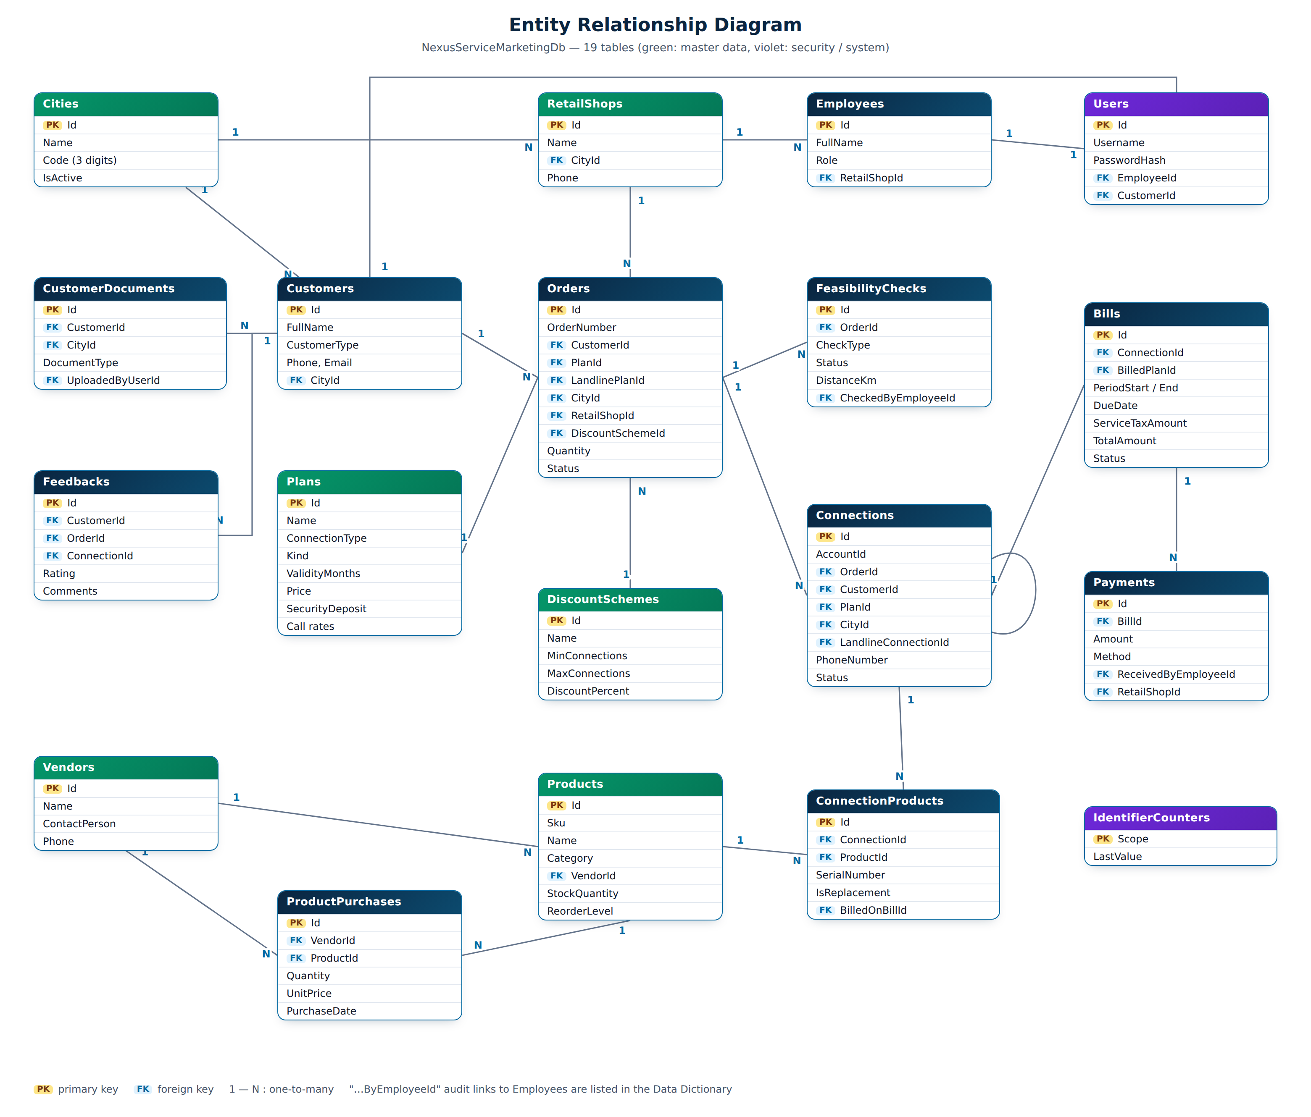
Figure 2. Entity relationship diagram

5.1 Tables
Table 11. Table groups
Group | Tables
Master data | Cities, RetailShops, Plans, DiscountSchemes, Vendors, Products
People and security | Employees, Customers, Users
Orders and connections | Orders, FeasibilityChecks, Connections, ConnectionProducts
Billing | Bills, Payments
Stock, documents, other | ProductPurchases, CustomerDocuments, Feedbacks, IdentifierCounters

5.2 Integrity rules
- Every relationship is a foreign key with ON DELETE NO ACTION; records in use are deactivated (IsActive = 0) instead of deleted.
- Unique indexes: OrderNumber, AccountId, Username, city Code and Name, product Sku, plan Name, vendor Name, one bill per connection per period.
- CHECK constraints guard identifier formats, status values, amounts (>= 0), percentages (0-100) and plan kinds.
- Money uses decimal(18,2); call rates decimal(10,4); dates date / datetime2 in UTC.

5.3 Data dictionary
The dictionary below was exported from the live database, so it matches the delivered schema exactly.

Bills
Postpaid bill of one connection for one billing period, with every charge stored as issued.
Column | Data type | Null | Key | Description
Id | int | No | PK | Primary key (identity)
ConnectionId | int | No | FK | References Connections.Id
PeriodStart | date | No
PeriodEnd | date | No
IssueDate | date | No
DueDate | date | No |  | Pay-by date; unpaid after this = overdue
PlanCharge | decimal(18,2) | No
UsageCharge | decimal(18,2) | No
SecurityDepositCharge | decimal(18,2) | No
ReplacementCharge | decimal(18,2) | No
DiscountAmount | decimal(18,2) | No
SubTotal | decimal(18,2) | No
ServiceTaxRate | decimal(5,2) | No |  | Service tax rate (12.24 %)
ServiceTaxAmount | decimal(18,2) | No |  | Tax amount on the bill
TotalAmount | decimal(18,2) | No |  | Bill total after tax
Status | varchar(30) | No |  | Workflow status (CHECK list of values)
GeneratedByEmployeeId | int | No | FK | References Employees.Id
GeneratedAtUtc | datetime2 | No
RowVersion | rowversion | No |  | Concurrency token (row version)
BilledPlanId | int | Yes | FK | References Plans.Id
CallCharge | decimal(18,2) | No
LocalMinutes | int | No
MobileMinutes | int | No
PlanValidUntil | date | Yes
PreviousBalance | decimal(18,2) | No |  | Unpaid amount brought forward from earlier bills
StdMinutes | int | No

Cities
Cities served; the 3-digit code is part of every account ID.
Column | Data type | Null | Key | Description
Id | int | No | PK | Primary key (identity)
Name | nvarchar(100) | No |  | Display name
Code | char(3) | No |  | 3-digit city code (CHECK: [0-9][0-9][0-9])
IsActive | bit | No |  | Inactive records are hidden from new work (soft delete)

ConnectionProducts
Equipment (modem, router, handset) issued to a connection, including replacements.
Column | Data type | Null | Key | Description
Id | int | No | PK | Primary key (identity)
ConnectionId | int | No | FK | References Connections.Id
ProductId | int | No | FK | References Products.Id
Quantity | int | No |  | Number of connections / items (>= 1)
SerialNumber | nvarchar(60) | Yes |  | Device serial number (unique per product)
IsReplacement | bit | No
IssuedAtUtc | datetime2 | No
ReturnedAtUtc | datetime2 | Yes
Notes | nvarchar(500) | Yes
BilledOnBillId | int | Yes | FK | References Bills.Id
ReplacementChargeAmount | decimal(18,2) | No

Connections
A working Dial-Up, Broadband or Landline connection created from a feasible order.
Column | Data type | Null | Key | Description
Id | int | No | PK | Primary key (identity)
AccountId | char(16) | No |  | D/B/T + 3-digit city + 12-digit serial, unique (CHECK)
OrderId | int | No | FK | References Orders.Id
CustomerId | int | No | FK | References Customers.Id
PlanId | int | No | FK | References Plans.Id
ConnectionType | char(1) | No |  | Service letter: D = Dial-Up, B = Broadband, T = Telephone (CHECK)
CityId | int | No | FK | References Cities.Id
InstallationAddress | nvarchar(300) | No |  | Where the connection is installed
PhoneNumber | nvarchar(20) | Yes |  | Telephone number of a landline
LandlineConnectionId | int | Yes | FK | References Connections.Id
Status | varchar(30) | No |  | Workflow status (CHECK list of values)
SecurityDepositAmount | decimal(18,2) | No
CreatedByEmployeeId | int | No | FK | References Employees.Id
ActivatedAtUtc | datetime2 | No
StatusChangedAtUtc | datetime2 | No
RowVersion | rowversion | No |  | Concurrency token (row version)

CustomerDocuments
Private customer files (address proof, application form, receipts) filed by year and city.
Column | Data type | Null | Key | Description
Id | int | No | PK | Primary key (identity)
CustomerId | int | No | FK | References Customers.Id
CityId | int | No | FK | References Cities.Id
DocumentType | varchar(30) | No
DocumentYear | int | No
OriginalFileName | nvarchar(255) | No
StorageName | nvarchar(80) | No |  | Random file name on disk (private)
ContentType | nvarchar(100) | No
SizeBytes | bigint | No |  | File size (max 5 MB)
Notes | nvarchar(500) | Yes
UploadedByUserId | int | No | FK | References Users.Id
UploadedAtUtc | datetime2 | No

Customers
Individual or corporate customers.
Column | Data type | Null | Key | Description
Id | int | No | PK | Primary key (identity)
FullName | nvarchar(150) | No |  | Person or company name
CustomerType | varchar(30) | No
CompanyName | nvarchar(150) | Yes
Email | nvarchar(256) | Yes |  | E-mail address
Phone | nvarchar(20) | No |  | Contact phone
AddressLine | nvarchar(300) | No
PostalCode | nvarchar(20) | Yes
CityId | int | No | FK | References Cities.Id
IsActive | bit | No |  | Inactive records are hidden from new work (soft delete)
CreatedAtUtc | datetime2 | No |  | Created at (UTC)

DiscountSchemes
Bulk / corporate discount bands by number of connections.
Column | Data type | Null | Key | Description
Id | int | No | PK | Primary key (identity)
Name | nvarchar(100) | No |  | Display name
MinConnections | int | No
MaxConnections | int | Yes
DiscountPercent | decimal(5,2) | No |  | Percentage 0-100 (CHECK)
AppliesToAdvance | bit | No
AppliesToSecurityDeposit | bit | No
IsActive | bit | No |  | Inactive records are hidden from new work (soft delete)
CreatedAtUtc | datetime2 | No |  | Created at (UTC)

Employees
Staff of Nexus: Admin, Accounts, Technical and Retail staff.
Column | Data type | Null | Key | Description
Id | int | No | PK | Primary key (identity)
FullName | nvarchar(150) | No |  | Person or company name
Email | nvarchar(256) | No |  | E-mail address
Phone | nvarchar(20) | No |  | Contact phone
Role | varchar(30) | No |  | Admin, Accounts, Technical or RetailStaff
RetailShopId | int | Yes | FK | References RetailShops.Id
IsActive | bit | No |  | Inactive records are hidden from new work (soft delete)
CreatedAtUtc | datetime2 | No |  | Created at (UTC)

FeasibilityChecks
Landline and / or internet feasibility check of an order.
Column | Data type | Null | Key | Description
Id | int | No | PK | Primary key (identity)
OrderId | int | No | FK | References Orders.Id
CheckType | varchar(30) | No |  | Landline or Internet
Status | varchar(30) | No |  | Workflow status (CHECK list of values)
DistanceKm | decimal(8,2) | Yes |  | Distance from exchange / server (km)
ServerAvailable | bit | Yes |  | Internet server port available
Remarks | nvarchar(500) | Yes
CheckedByEmployeeId | int | Yes | FK | References Employees.Id
CheckedAtUtc | datetime2 | Yes
CreatedAtUtc | datetime2 | No |  | Created at (UTC)

Feedbacks
Customer feedback with a 1-5 rating.
Column | Data type | Null | Key | Description
Id | int | No | PK | Primary key (identity)
CustomerId | int | No | FK | References Customers.Id
OrderId | int | Yes | FK | References Orders.Id
ConnectionId | int | Yes | FK | References Connections.Id
Rating | int | No |  | Rating 1-5
Comments | nvarchar(2000) | No
SubmittedAtUtc | datetime2 | No

IdentifierCounters
Running counters used to generate order numbers and account IDs safely.
Column | Data type | Null | Key | Description
Scope | varchar(40) | No | PK | Counter name (e.g. order type)
LastValue | bigint | No |  | Last number issued

Orders
A request for one or more connections of one service type.
Column | Data type | Null | Key | Description
Id | int | No | PK | Primary key (identity)
OrderNumber | char(11) | No |  | D/B/T + 10 digits, unique (CHECK)
CustomerId | int | No | FK | References Customers.Id
ConnectionType | char(1) | No |  | Service letter: D = Dial-Up, B = Broadband, T = Telephone (CHECK)
PlanId | int | No | FK | References Plans.Id
CityId | int | No | FK | References Cities.Id
InstallationAddress | nvarchar(300) | No |  | Where the connection is installed
Quantity | int | No |  | Number of connections / items (>= 1)
RetailShopId | int | Yes | FK | References RetailShops.Id
PlacedByEmployeeId | int | Yes | FK | References Employees.Id
DiscountSchemeId | int | Yes | FK | References DiscountSchemes.Id
DiscountPercent | decimal(5,2) | No |  | Percentage 0-100 (CHECK)
Status | varchar(30) | No |  | Workflow status (CHECK list of values)
PlacedAtUtc | datetime2 | No
StatusChangedAtUtc | datetime2 | No
Remarks | nvarchar(500) | Yes
RowVersion | rowversion | No |  | Concurrency token (row version)
LandlinePlanId | int | Yes | FK | References Plans.Id

Payments
Full or partial payment against a bill, at a retail shop or at Accounts.
Column | Data type | Null | Key | Description
Id | int | No | PK | Primary key (identity)
BillId | int | No | FK | References Bills.Id
Amount | decimal(18,2) | No |  | Amount paid
Method | varchar(30) | No |  | Cash, Card, BankTransfer, Cheque or Online
Reference | nvarchar(100) | Yes
PaidAtUtc | datetime2 | No
ReceivedByEmployeeId | int | No | FK | References Employees.Id
RetailShopId | int | Yes | FK | References RetailShops.Id

Plans
Tariff plans for Dial-Up, Broadband and Landline with prices, deposits and call rates.
Column | Data type | Null | Key | Description
Id | int | No | PK | Primary key (identity)
Name | nvarchar(150) | No |  | Display name
Description | nvarchar(500) | Yes
ConnectionType | char(1) | No |  | Service letter: D = Dial-Up, B = Broadband, T = Telephone (CHECK)
Kind | varchar(30) | No |  | Hourly, Unlimited, LocalRental or StdRental (CHECK)
IncludedHours | int | Yes
SpeedKbps | int | Yes
ValidityMonths | int | No |  | Plan validity (> 0)
Price | decimal(18,2) | No |  | Plan fee per validity period
SecurityDeposit | decimal(18,2) | No |  | Refundable deposit charged on the first bill
LocalCallRatePerMinute | decimal(10,4) | Yes
StdCallRatePerMinute | decimal(10,4) | Yes
MobileMessagingRatePerMinute | decimal(10,4) | Yes
IsActive | bit | No |  | Inactive records are hidden from new work (soft delete)
CreatedAtUtc | datetime2 | No |  | Created at (UTC)

ProductPurchases
Equipment bought from a vendor; receipts increase stock.
Column | Data type | Null | Key | Description
Id | int | No | PK | Primary key (identity)
VendorId | int | No | FK | References Vendors.Id
ProductId | int | No | FK | References Products.Id
Quantity | int | No |  | Number of connections / items (>= 1)
UnitPrice | decimal(18,2) | No
AmountPaid | decimal(18,2) | No
PurchaseDate | date | No
SupplierReference | nvarchar(100) | Yes
Notes | nvarchar(500) | Yes
RecordedByEmployeeId | int | No | FK | References Employees.Id
RecordedAtUtc | datetime2 | No

Products
Equipment catalogue and stock level.
Column | Data type | Null | Key | Description
Id | int | No | PK | Primary key (identity)
Sku | nvarchar(40) | No |  | Unique stock-keeping unit
Name | nvarchar(150) | No |  | Display name
Category | varchar(30) | No
Description | nvarchar(500) | Yes
VendorId | int | No | FK | References Vendors.Id
PurchasePrice | decimal(18,2) | No
ReplacementCharge | decimal(18,2) | No
StockQuantity | int | No |  | Units in stock
ReorderLevel | int | No |  | Low-stock warning level
IsActive | bit | No |  | Inactive records are hidden from new work (soft delete)
CreatedAtUtc | datetime2 | No |  | Created at (UTC)
RowVersion | rowversion | No |  | Concurrency token (row version)

RetailShops
Nexus retail outlets, one or more per city.
Column | Data type | Null | Key | Description
Id | int | No | PK | Primary key (identity)
Name | nvarchar(150) | No |  | Display name
AddressLine | nvarchar(300) | No
Phone | nvarchar(20) | Yes |  | Contact phone
CityId | int | No | FK | References Cities.Id
IsActive | bit | No |  | Inactive records are hidden from new work (soft delete)

Users
Login accounts (username + hashed password) linked to an employee or a customer.
Column | Data type | Null | Key | Description
Id | int | No | PK | Primary key (identity)
Username | nvarchar(50) | No |  | Unique login name
PasswordHash | nvarchar(500) | No |  | PBKDF2 password hash - never the plain password
IsActive | bit | No |  | Inactive records are hidden from new work (soft delete)
CreatedAtUtc | datetime2 | No |  | Created at (UTC)
LastLoginAtUtc | datetime2 | Yes
EmployeeId | int | Yes | FK | References Employees.Id
CustomerId | int | Yes | FK | References Customers.Id

Vendors
Equipment manufacturers and suppliers.
Column | Data type | Null | Key | Description
Id | int | No | PK | Primary key (identity)
Name | nvarchar(150) | No |  | Display name
ContactPerson | nvarchar(100) | Yes
Email | nvarchar(256) | Yes |  | E-mail address
Phone | nvarchar(20) | No |  | Contact phone
AddressLine | nvarchar(300) | Yes
IsActive | bit | No |  | Inactive records are hidden from new work (soft delete)
CreatedAtUtc | datetime2 | No |  | Created at (UTC)

6. Process Design

6.1 Context diagram (DFD level 0)
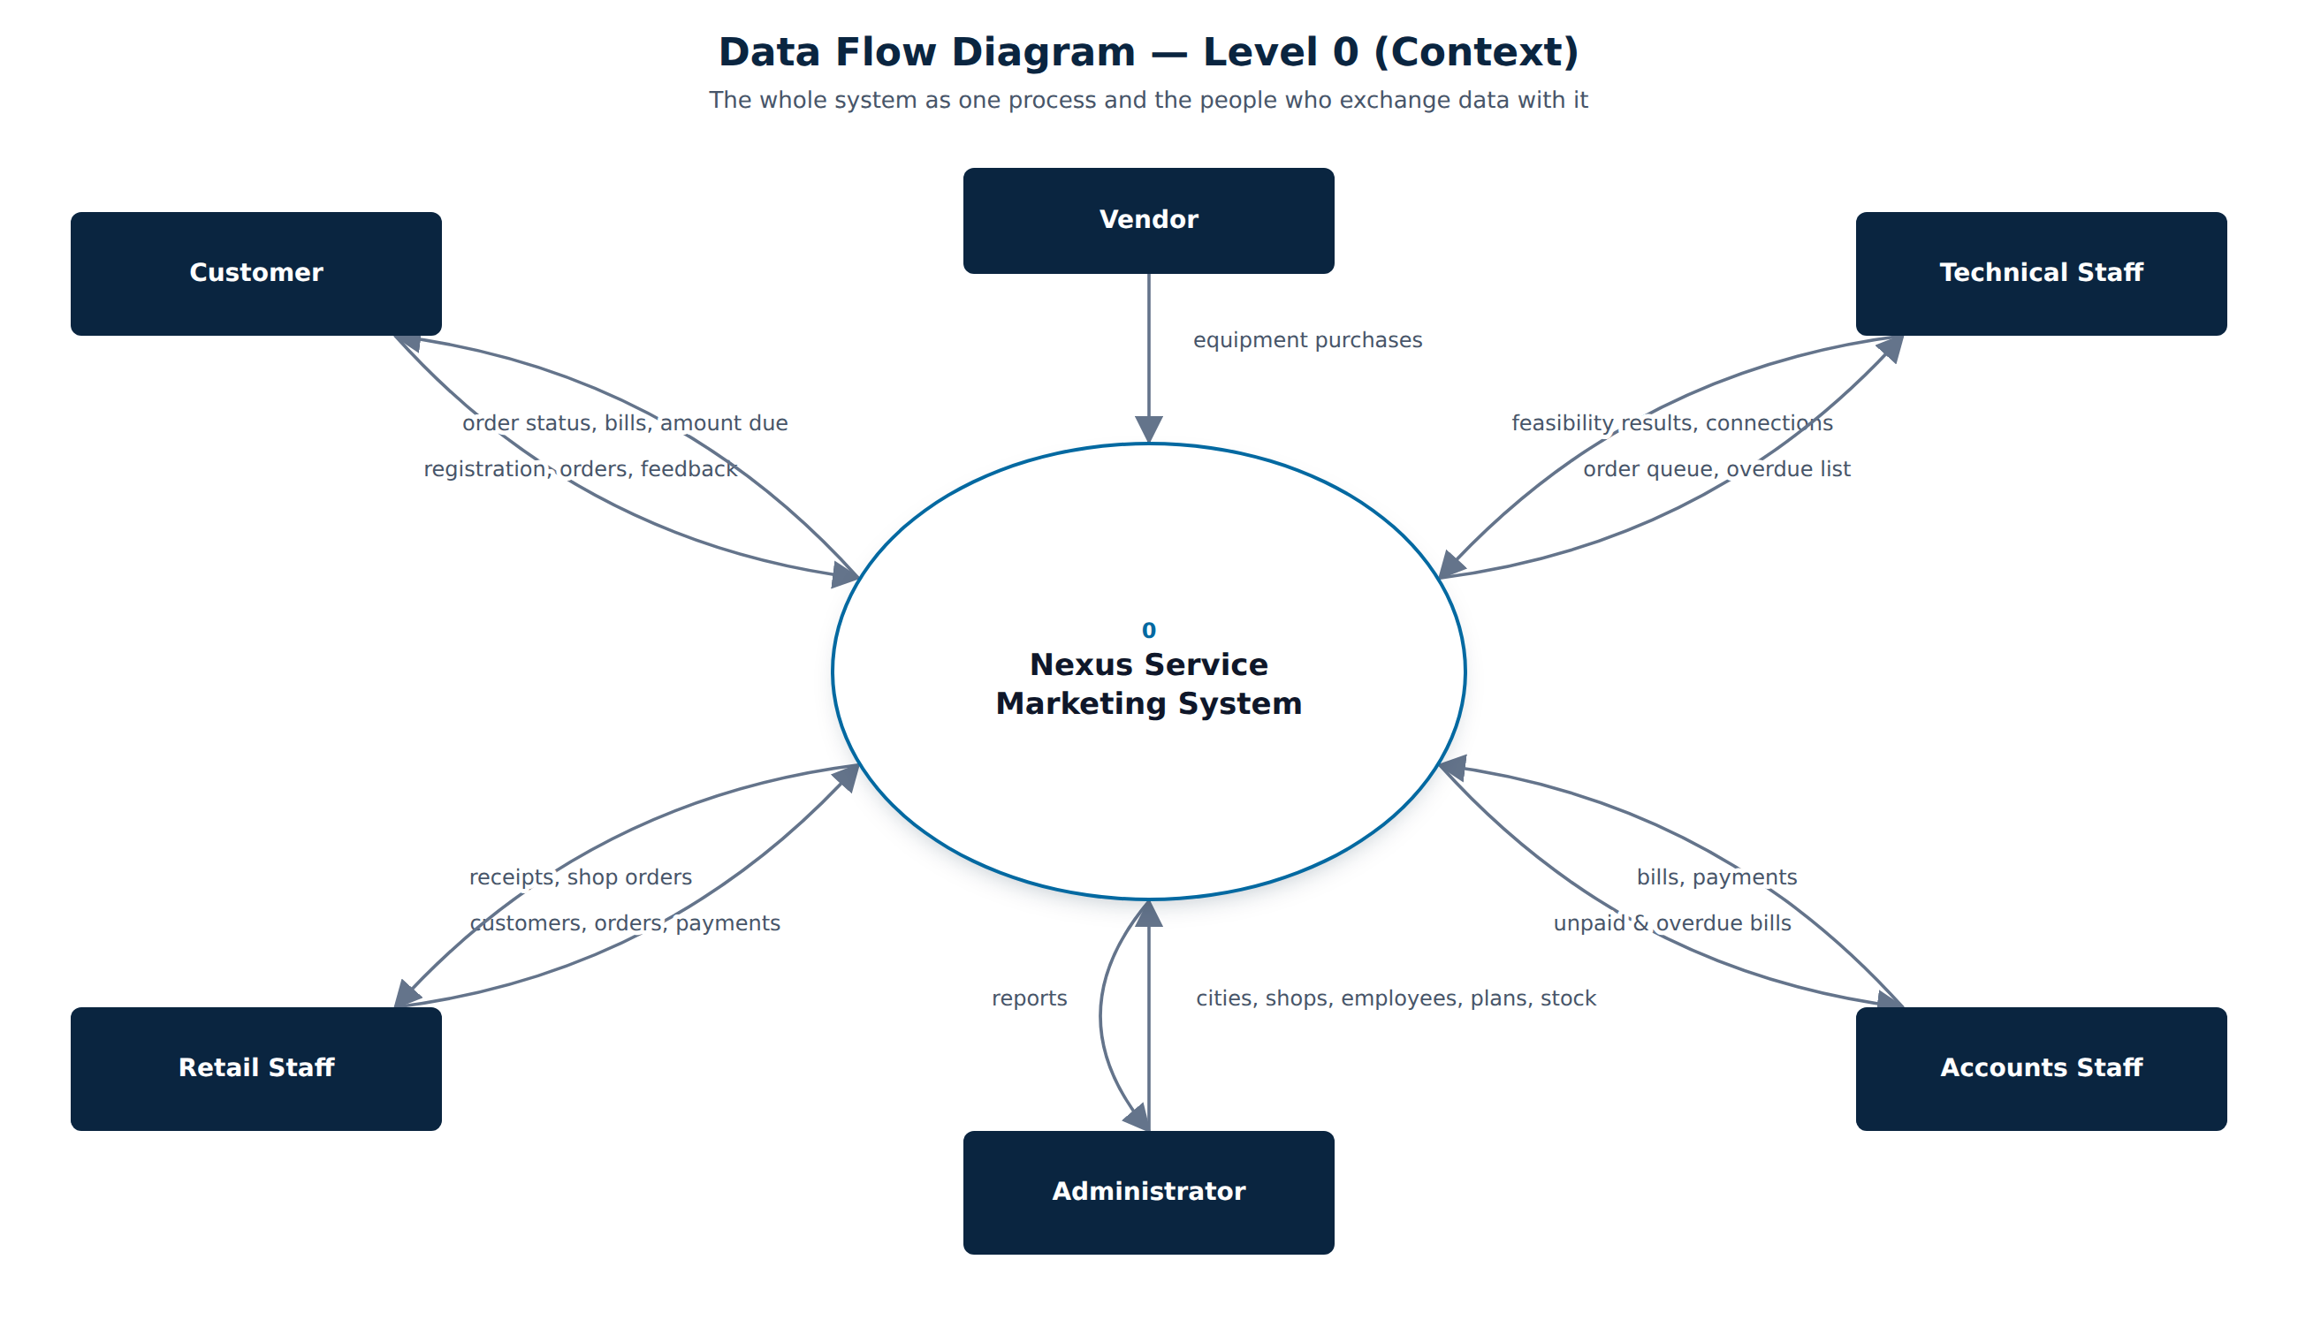
Figure 3. Data flow diagram - level 0

6.2 DFD level 1
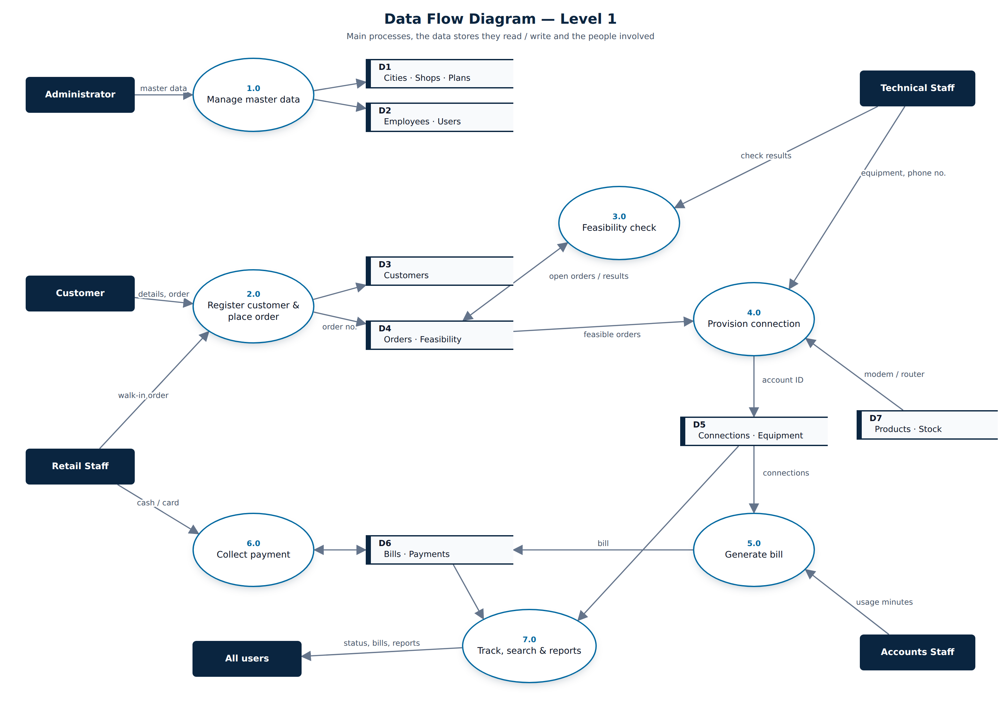
Figure 4. Data flow diagram - level 1

6.3 Use case diagram
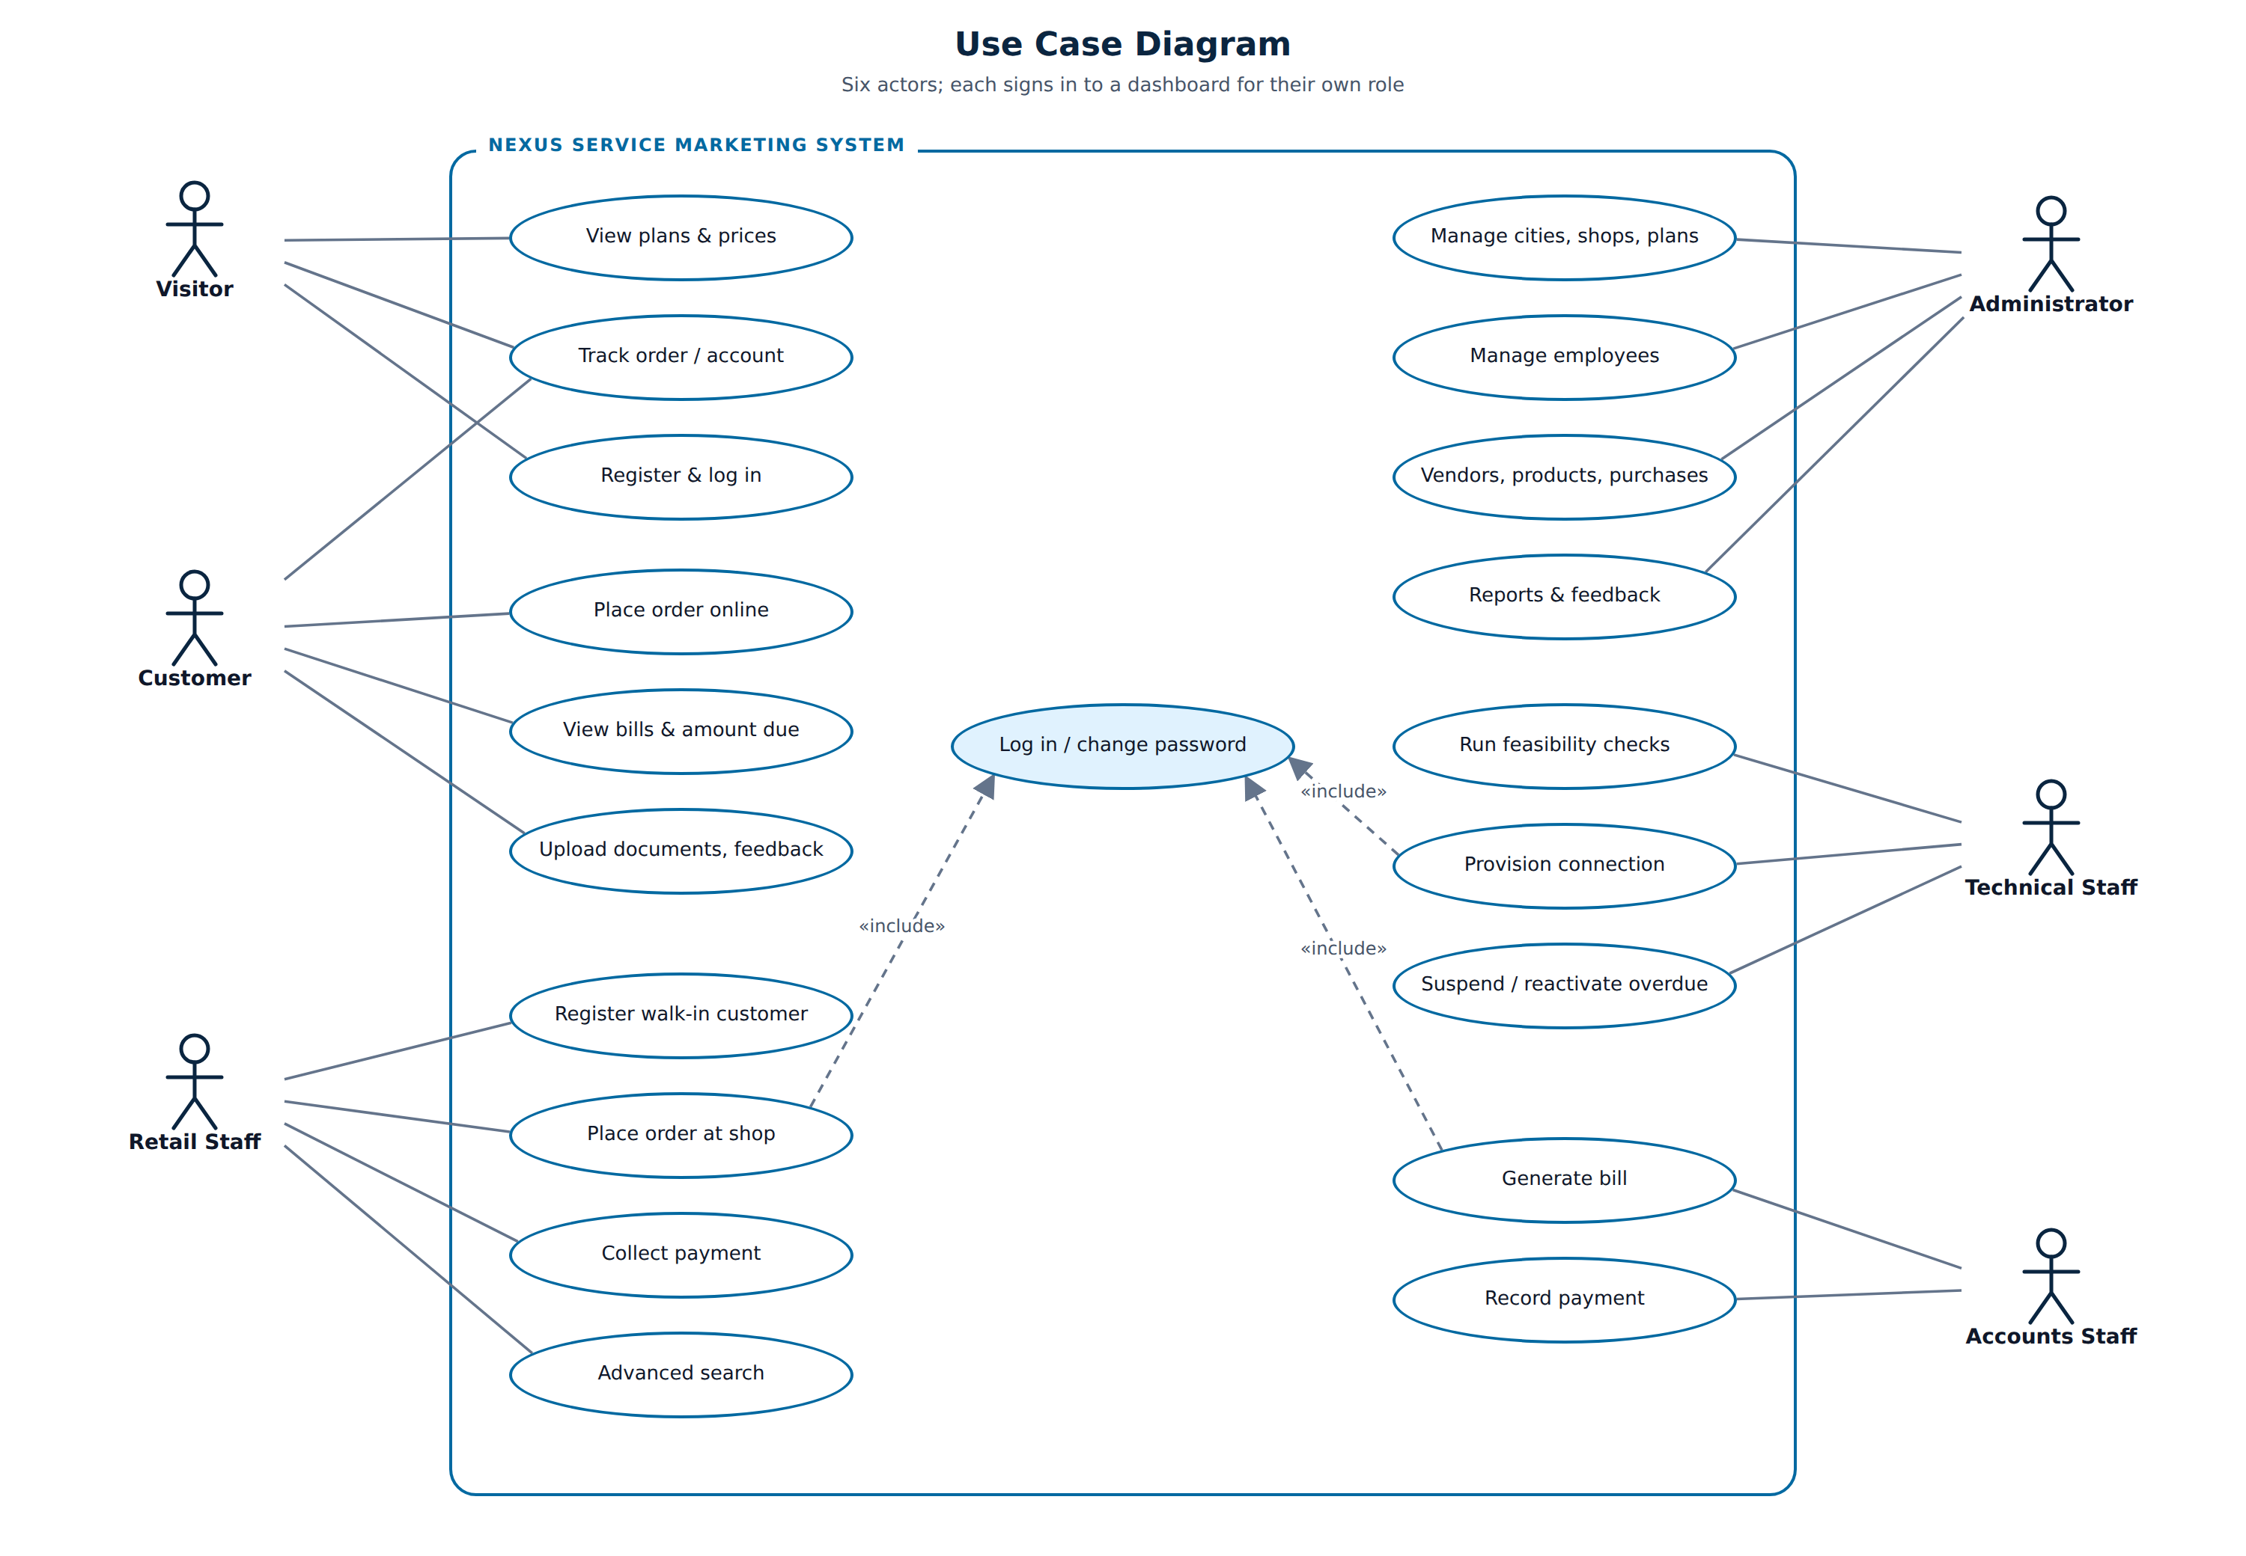
Figure 5. Use case diagram

6.4 Workflow flowchart
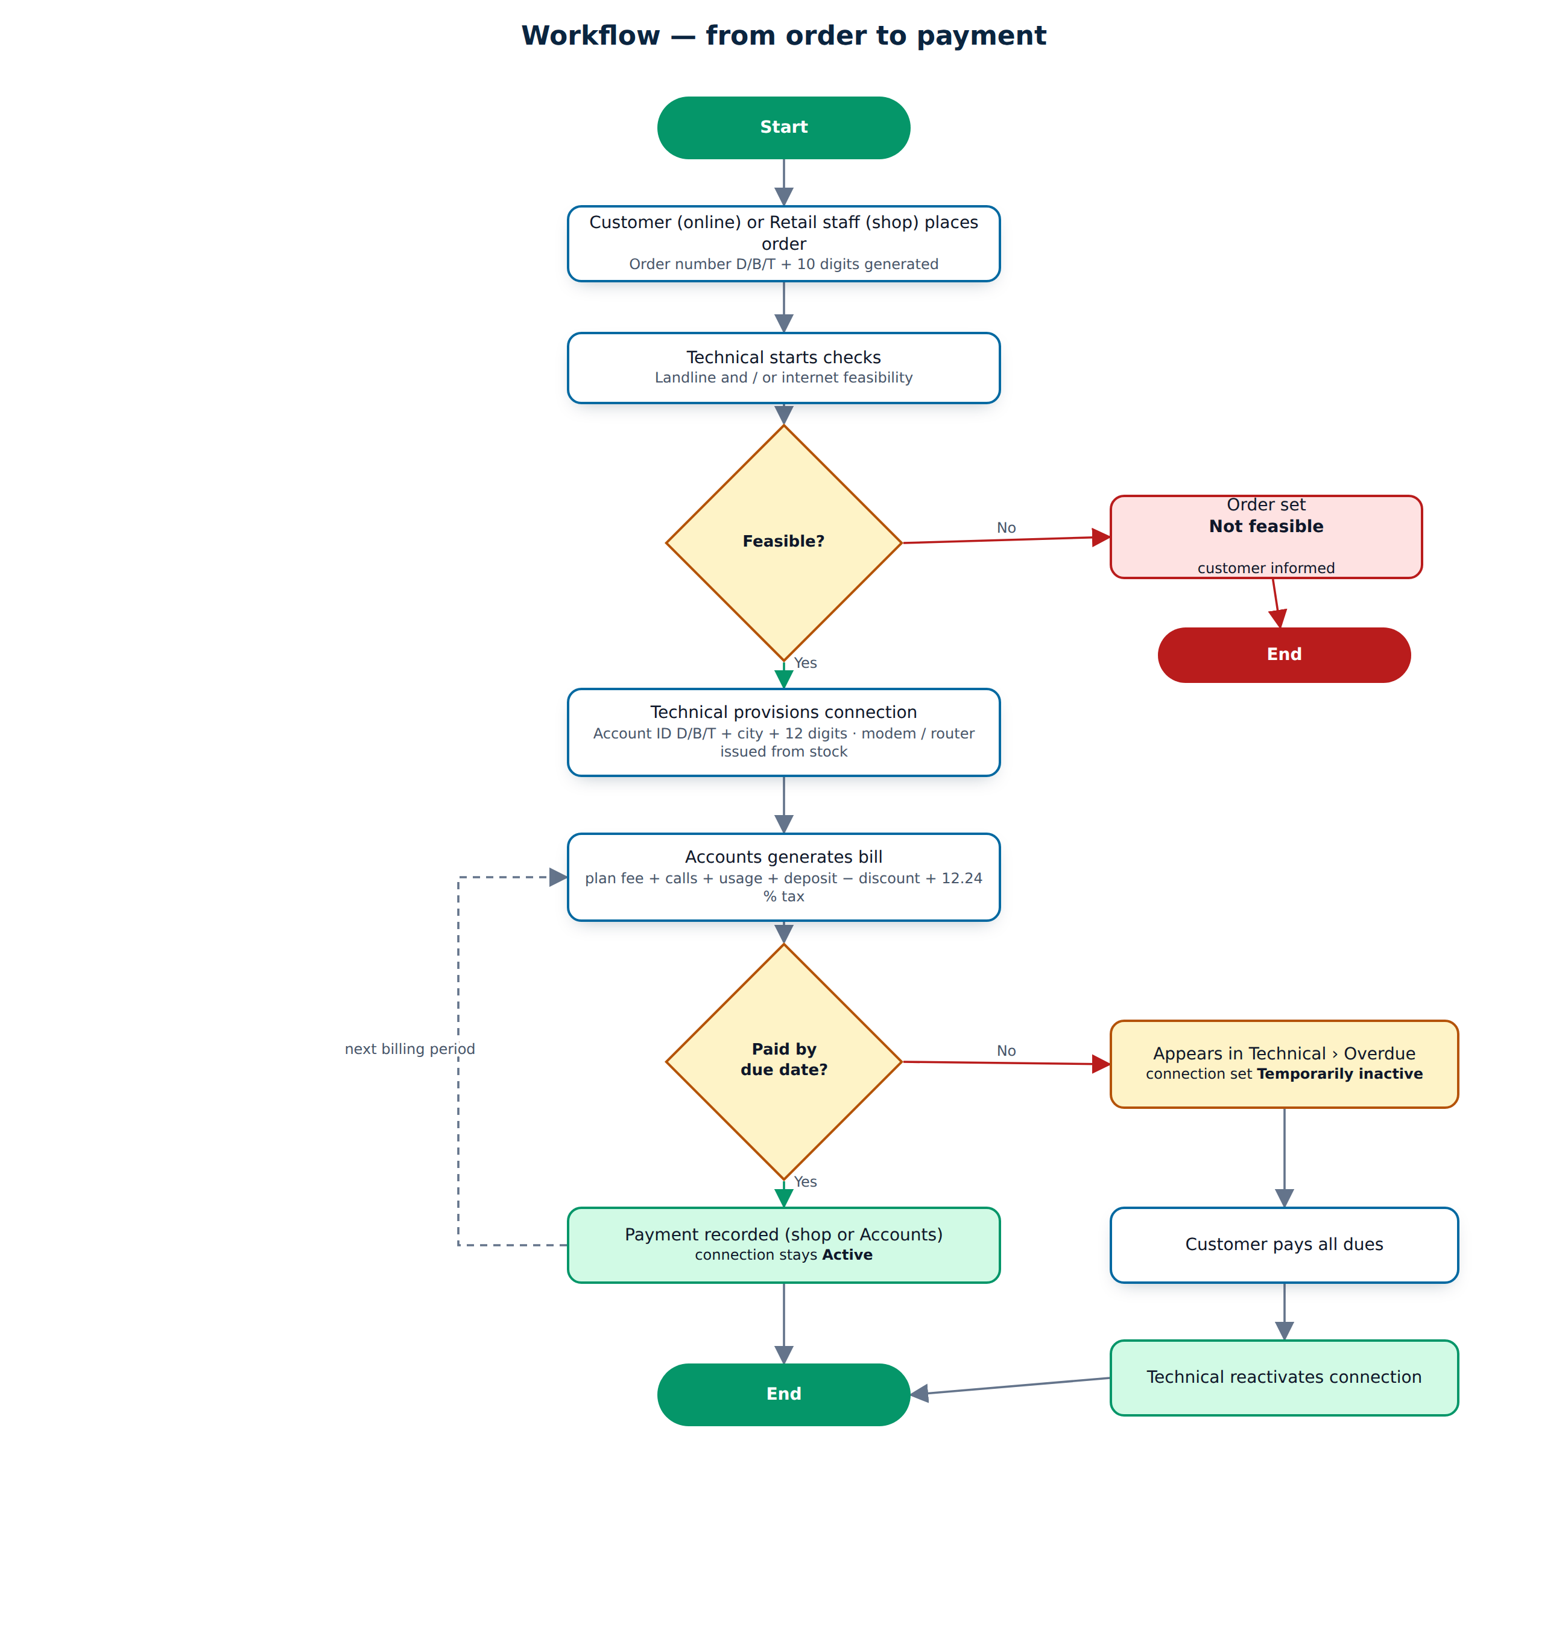
Figure 6. Order-to-payment workflow

6.5 Status life cycles
Table 12. Status life cycles
Object | Statuses (in order)
Order | Placed -> Under feasibility check -> Feasible / Not feasible -> Connected (or Cancelled before connection)
Feasibility check | Pending -> Feasible / Not feasible
Connection | Active <-> Temporarily inactive -> Permanently inactive
Bill | Issued -> Partially paid -> Paid (or Cancelled)

6.6 Algorithms

Order placement
- Retail employee or customer selects connection type, plan, city, address and quantity.
- The system checks that the plan matches the type and the city is active.
- Connections already provided, orders in progress and the new order are counted; if the total is 10 or more the matching discount scheme is attached.
- The next serial for the type is taken from IdentifierCounters and the order number is built (letter + 10 digits).
- The order is saved with status Placed.

Feasibility check
- Technical opens a Placed order and starts the checks.
- Dial-Up: if the customer has an active Nexus landline only an internet check is created, otherwise landline and internet checks. Broadband: internet check. Telephone: landline check.
- For each check the distance and, for internet, the server availability are recorded.
- All checks feasible: the order becomes Feasible; any check not feasible: the order becomes Not feasible.

Connection creation
- The order must be Feasible; equipment is chosen from stock and the stock quantity is reduced.
- Security deposit = plan deposit, reduced by the discount percent when the scheme applies.
- Account ID = type letter + city code + 12-digit serial. The connection starts Active and the order becomes Connected.

Bill generation
- Accounts selects the connection and period; the system previews the plan fee, rates, unbilled replacements and brought-forward balance.
- Call charges = minutes x per-minute rates; other usage is added as an amount.
- First bill: add the security deposit and subtract the discount.
- SubTotal = plan fee + calls + usage + deposit + replacements - discount; tax = 12.24 % of SubTotal; Total = SubTotal + tax.
- Payments reduce the outstanding amount; the status moves Issued -> Partially paid -> Paid.

7. User Interface Design
The interface was designed as two experiences: a marketing website for visitors (immersive hero, 3D globe, plans) and a work application for signed-in users (sidebar, dashboards, dense tables). Both share one design system.

7.1 Design system
Table 13. Design system
Element | Choice
Colours | Primary blue #0369A1, navy #0A2540 (sidebar, hero), emerald #059669 (success / call to action), soft ice background #F3F8FC
Typography | Space Grotesk for headings and numbers, DM Sans for text
Status colours | Grey = placed / pending, Blue = in progress / issued, Amber = feasible / partially paid / temporarily inactive, Green = active / connected / paid, Red = overdue / not feasible / closed
Layout | Fixed sidebar (268 px) with sections per role, sticky glass top bar with breadcrumb, quick Track box and account menu; content up to 1480 px
Components | KPI cards with icon and count-up number, attention feed, bar chart, quick actions, badges, toasts, confirm overlay
Responsive | Below 992 px the sidebar becomes an off-canvas drawer opened by the menu button; cards stack on phones

7.2 Motion and overlays
- Cut-overlay page transition - three angled panels (emerald, blue, navy) sweep across the screen when a link is followed and sweep away on the next page, with the Nexus logo in the middle.
- Confirm overlay - Delete, Deactivate, Suspend, Replace and Cancel order open a blurred overlay with a warning icon instead of the browser's plain confirm box.
- Toasts - success messages slide in at the top right, count down and disappear; hovering pauses them.
- Micro-interactions - count-up dashboard numbers, growing chart bars, staggered reveal of cards and table rows, ripple on buttons, 3D tilt on tiles, loading spinner on submit to prevent double posts.
- All motion uses only transform and opacity and is switched off for users who prefer reduced motion.

Figure 7. Cut-overlay transition while moving between pages
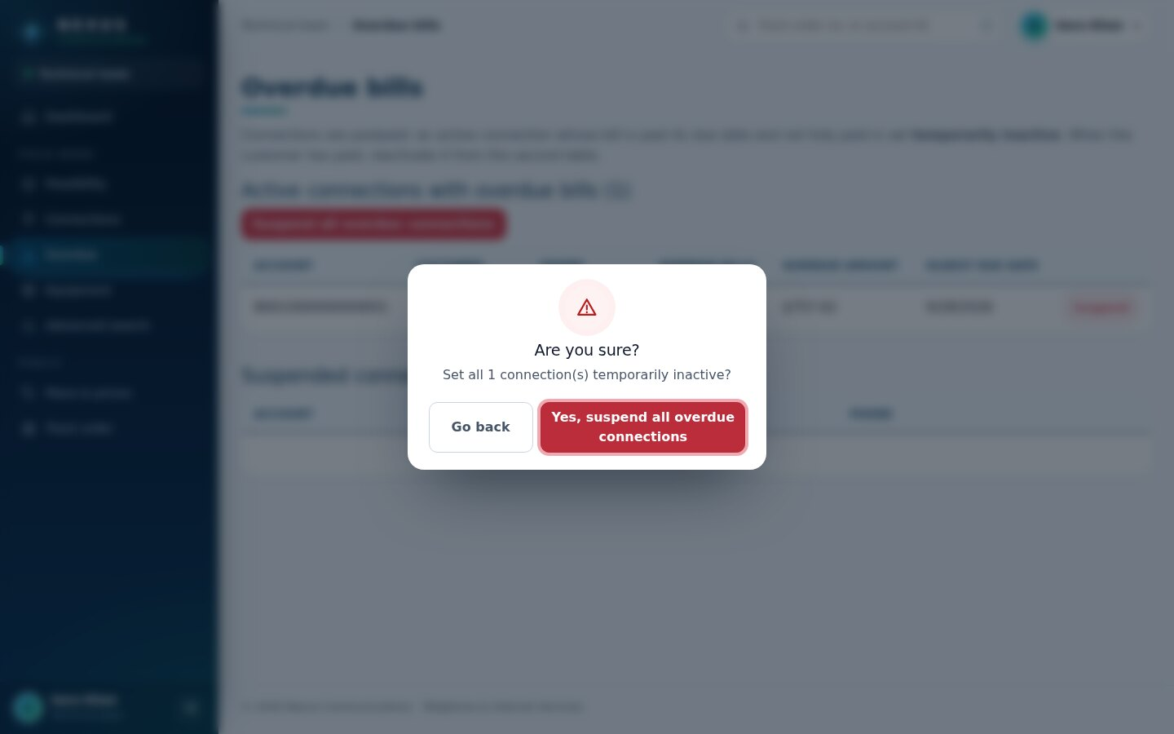
Figure 8. Confirm overlay before suspending overdue connections
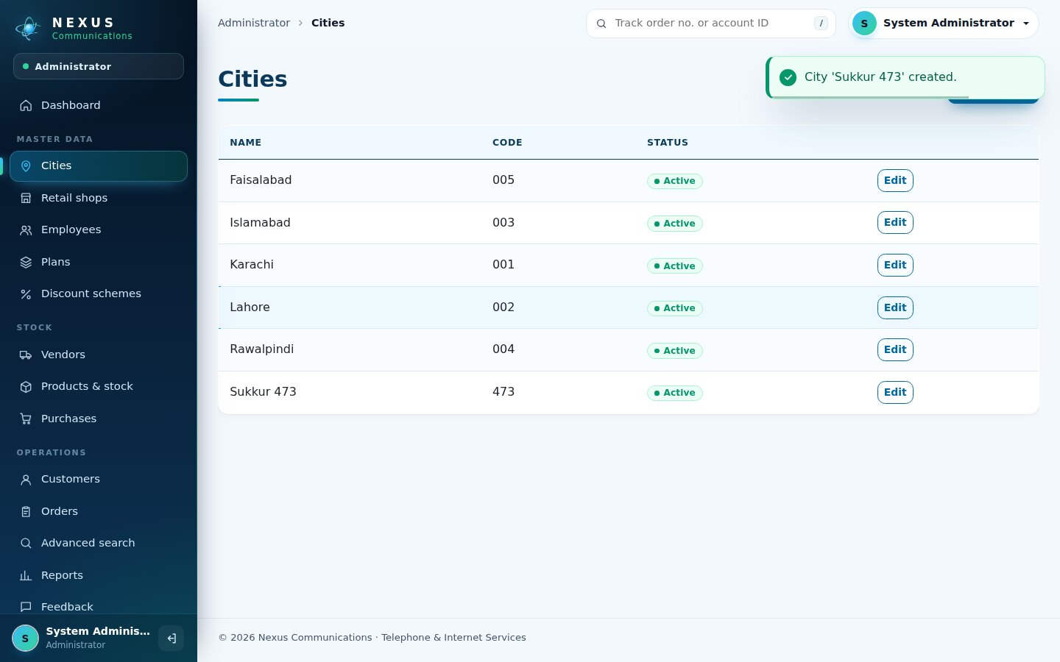
Figure 9. Success toast after saving a city

7.3 Public website
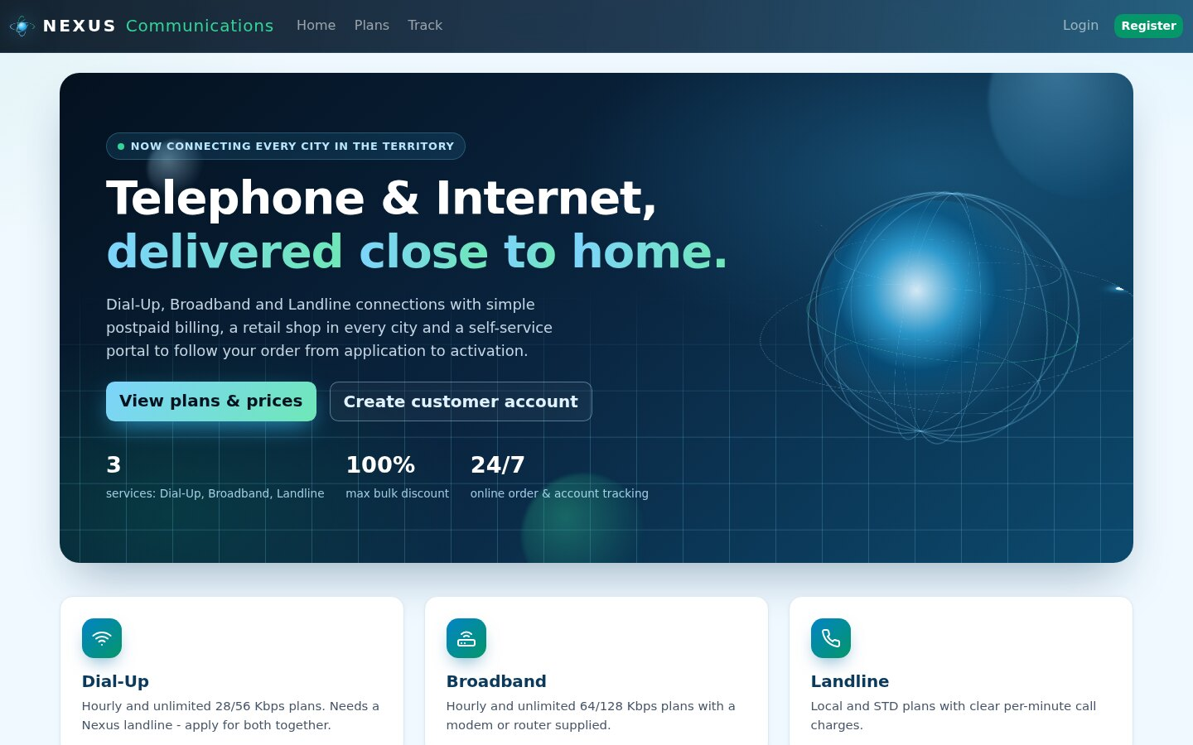
Figure 10. Home page
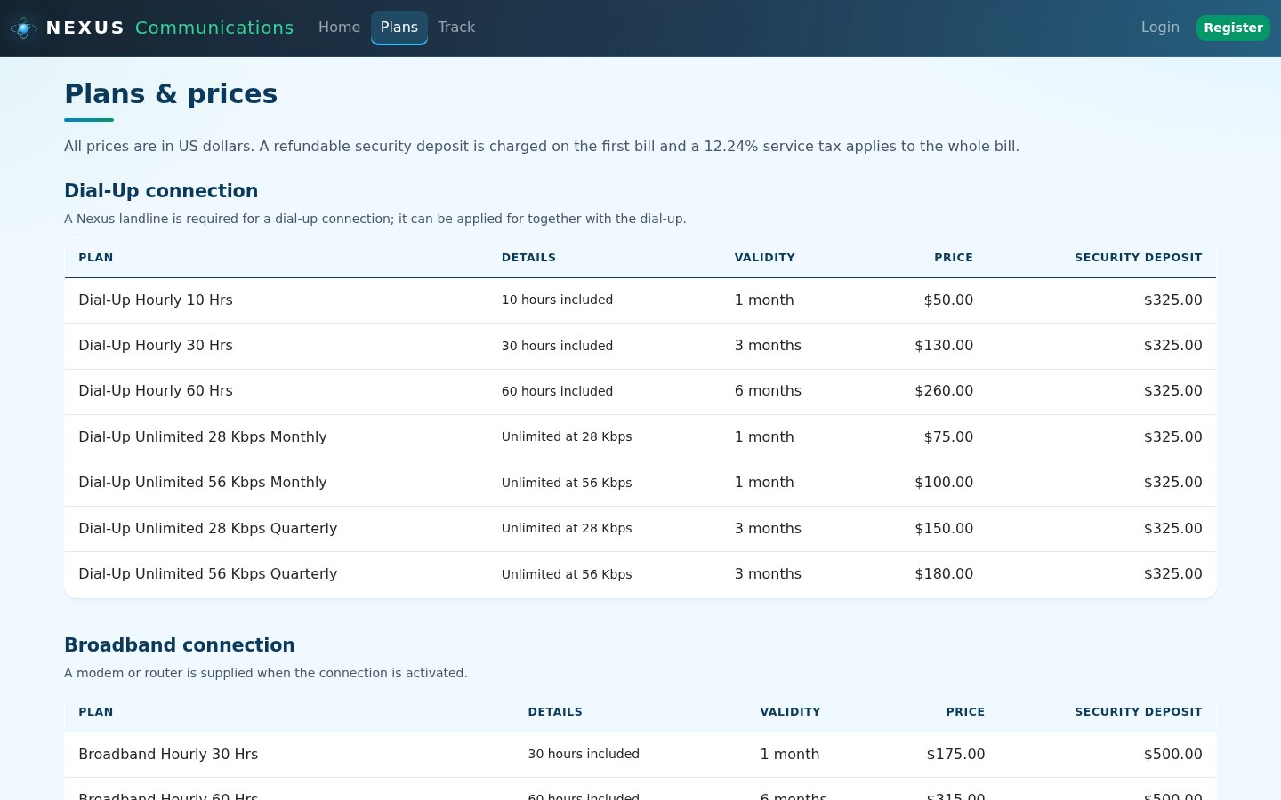
Figure 11. Plans and prices
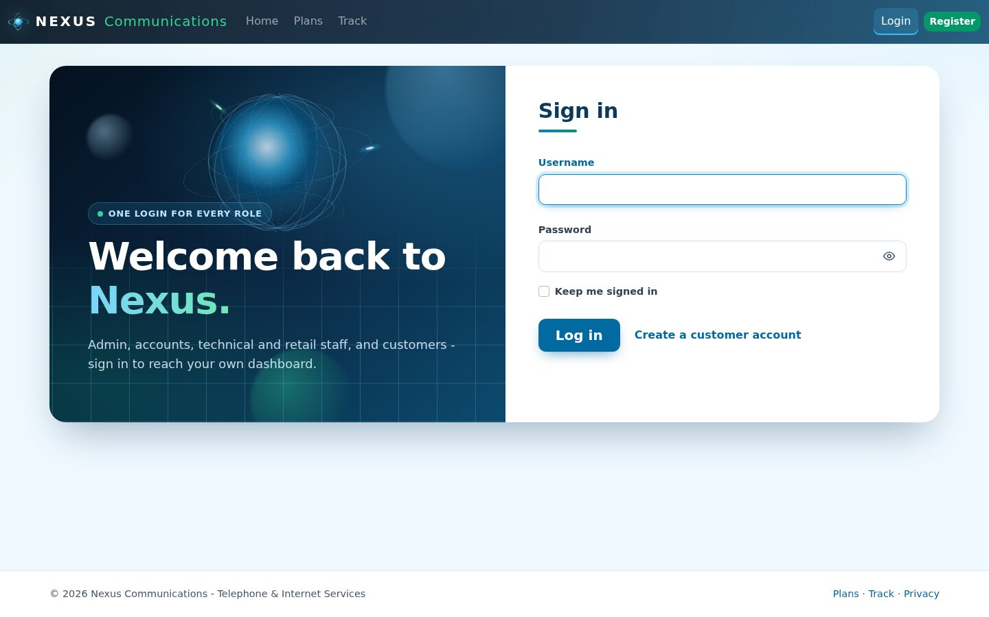
Figure 12. Login (one login for every role)
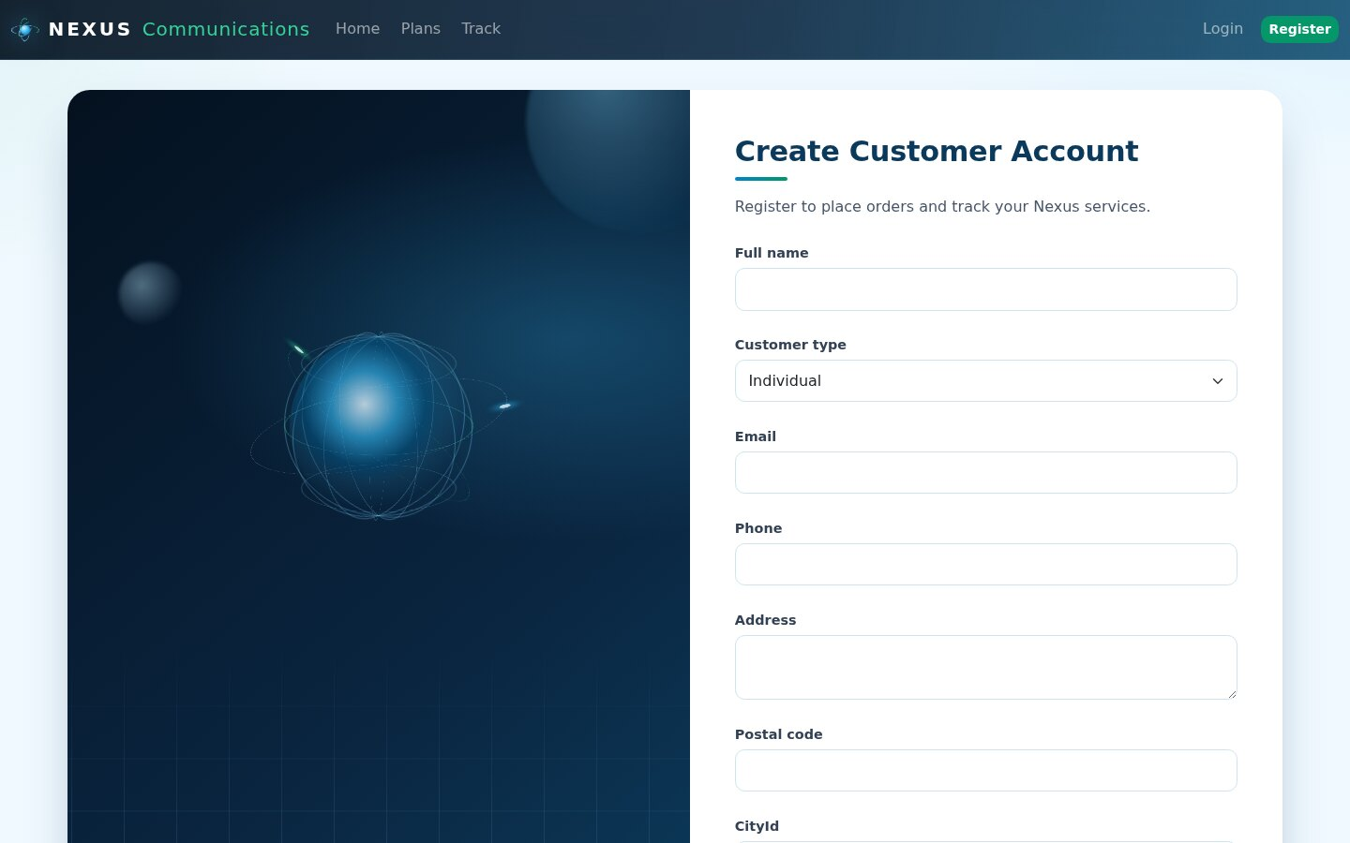
Figure 13. Customer registration
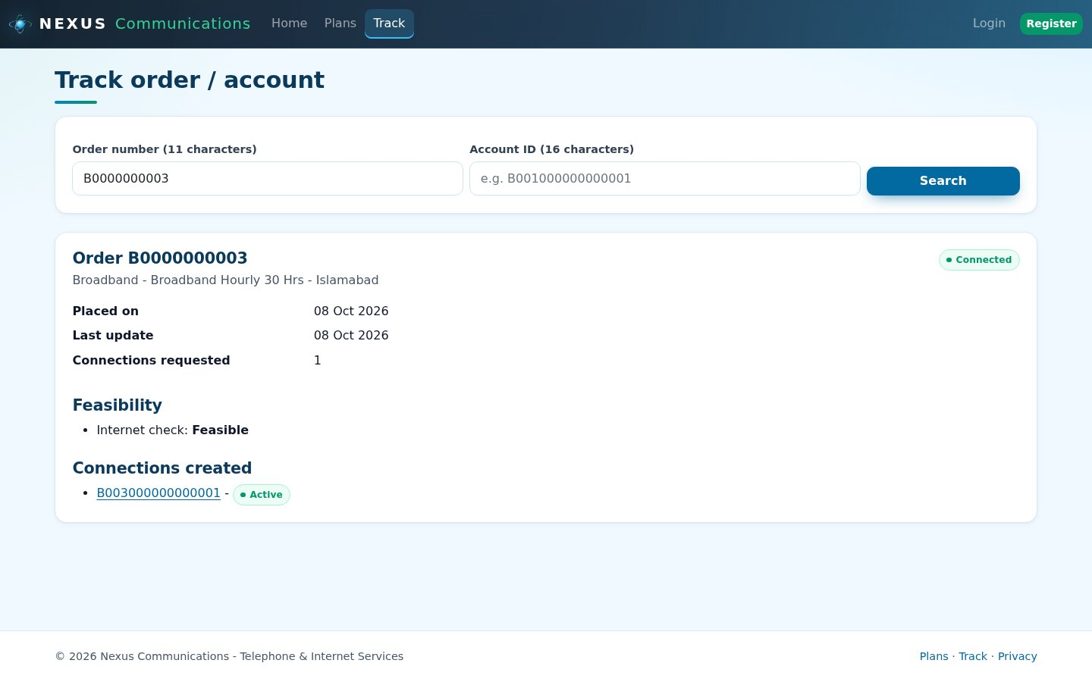
Figure 14. Public order tracking

7.4 Administrator
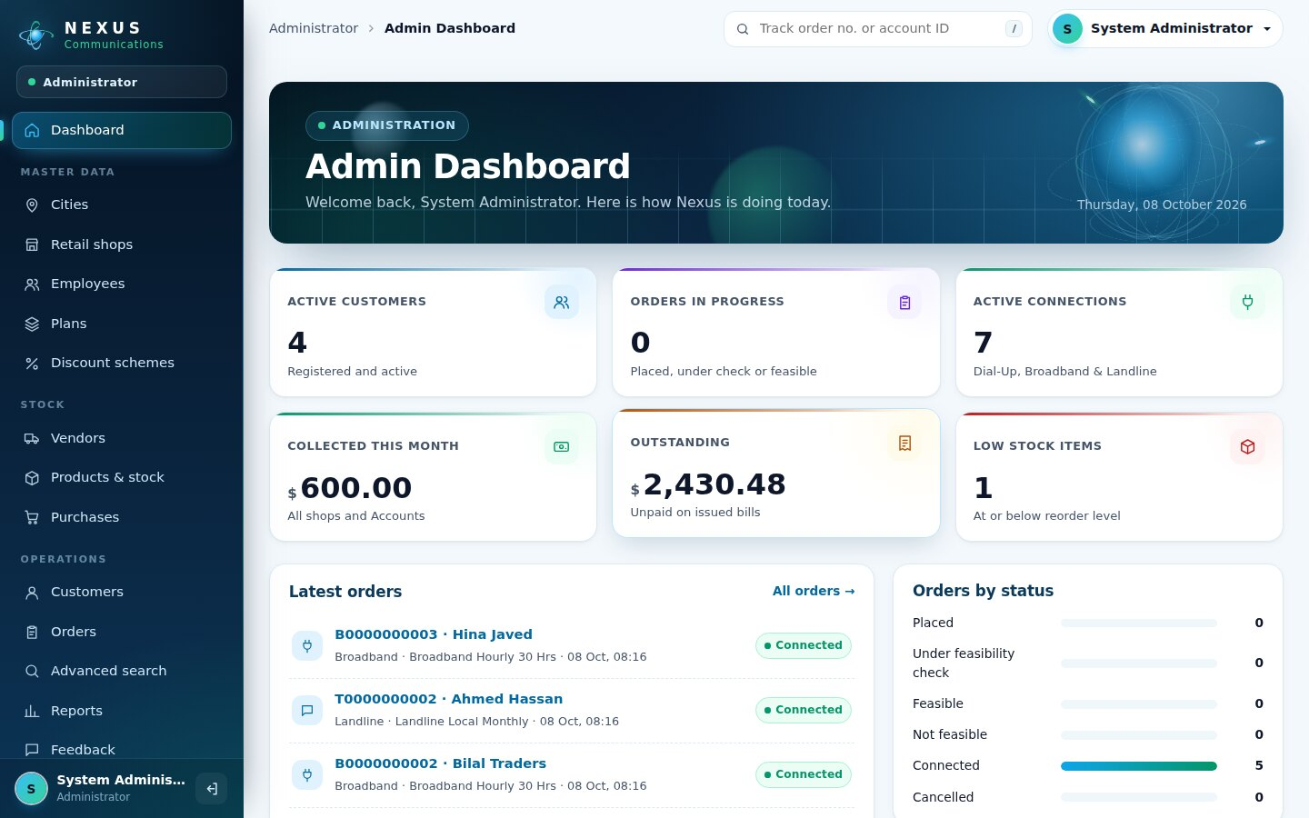
Figure 15. Admin dashboard with live figures
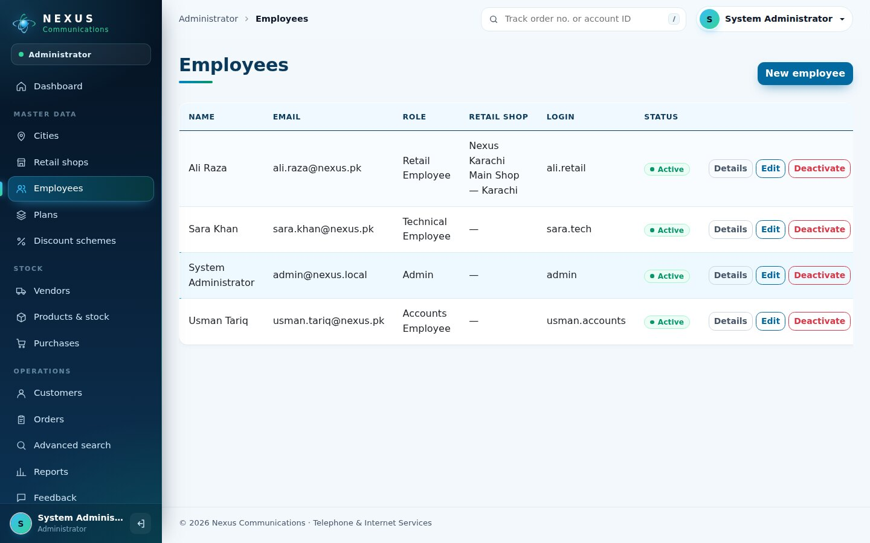
Figure 16. Employees and their logins
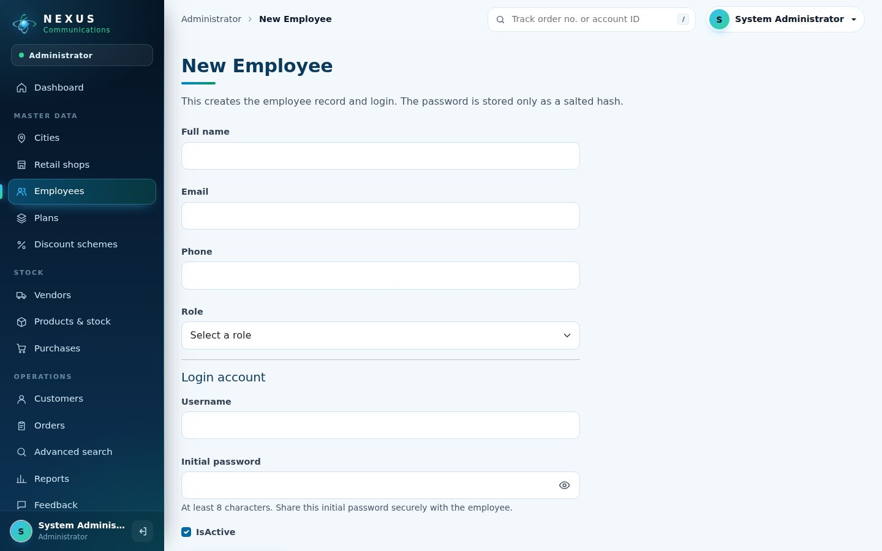
Figure 17. New employee form
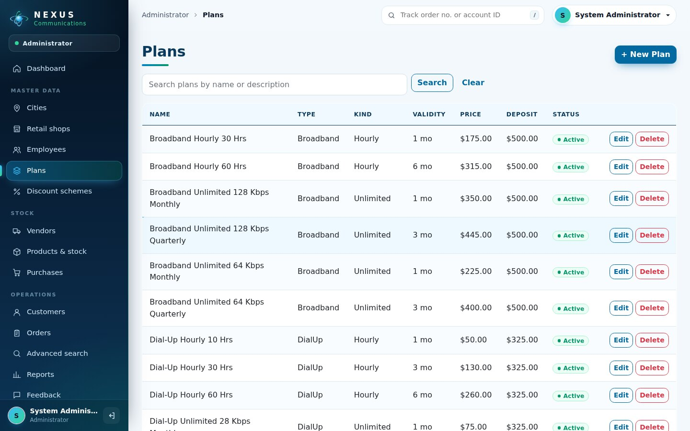
Figure 18. Plans with search and delete
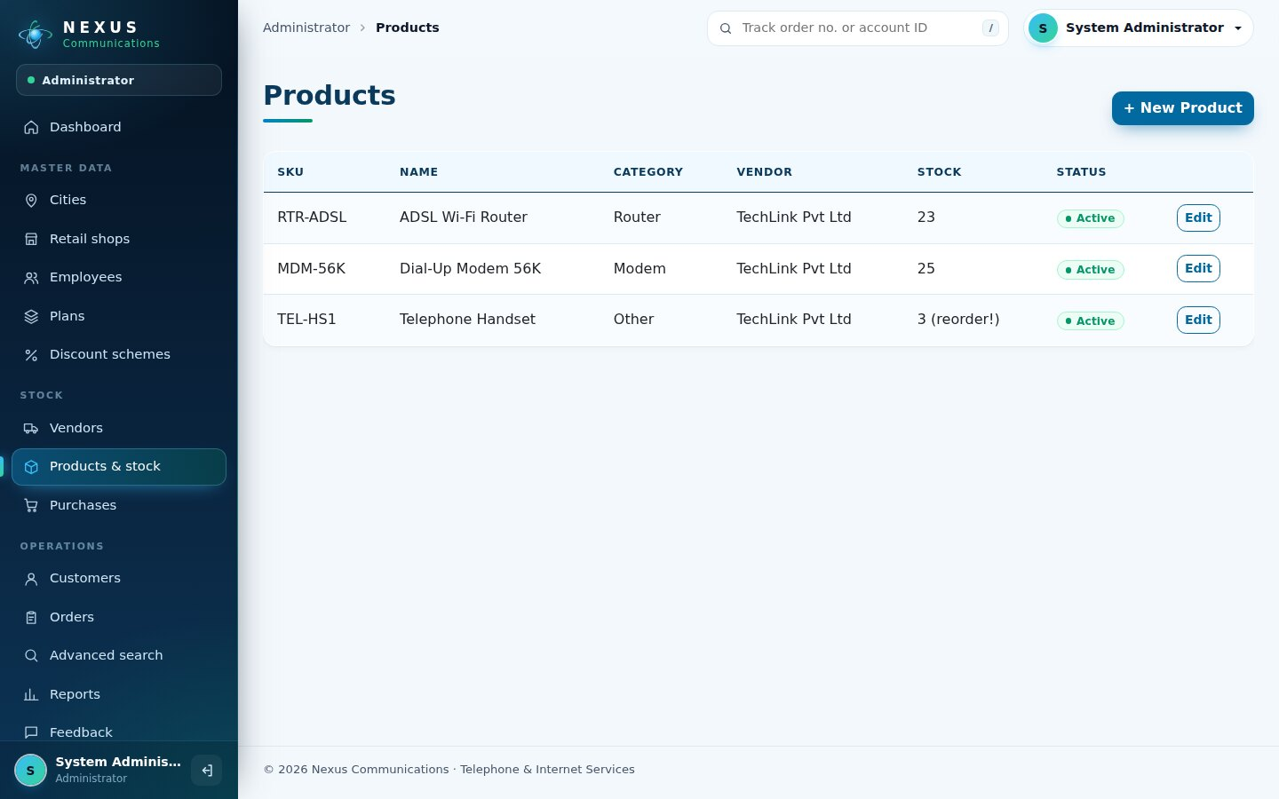
Figure 19. Products and stock (low-stock badge)
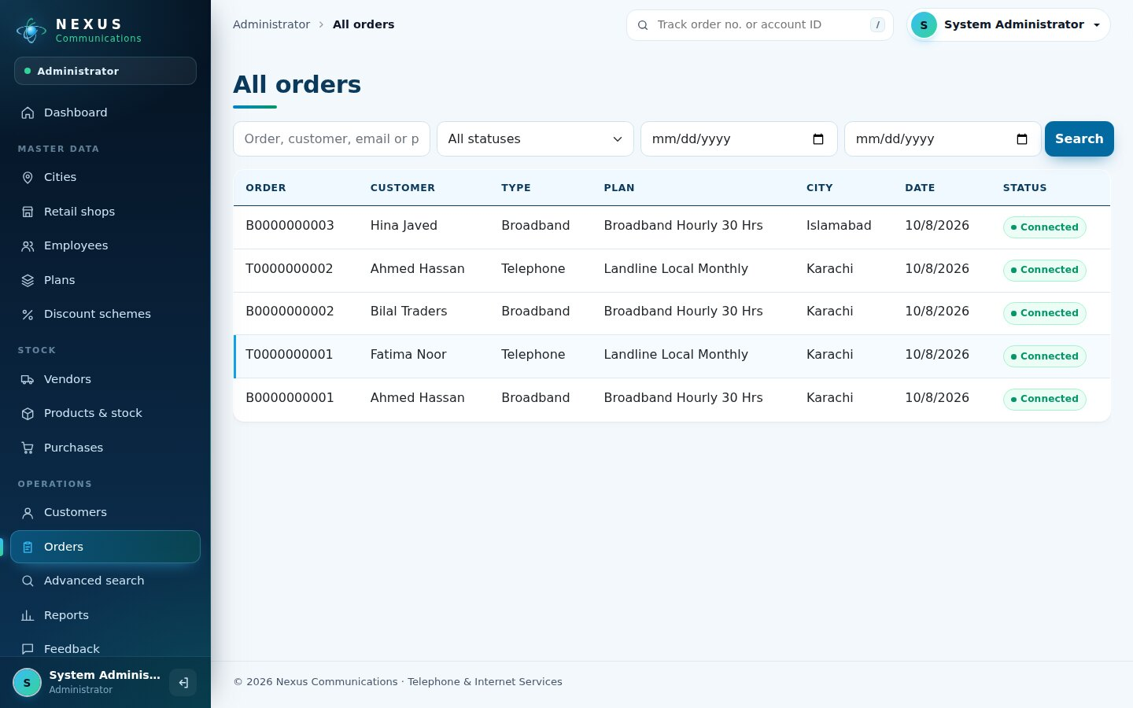
Figure 20. All orders with filters
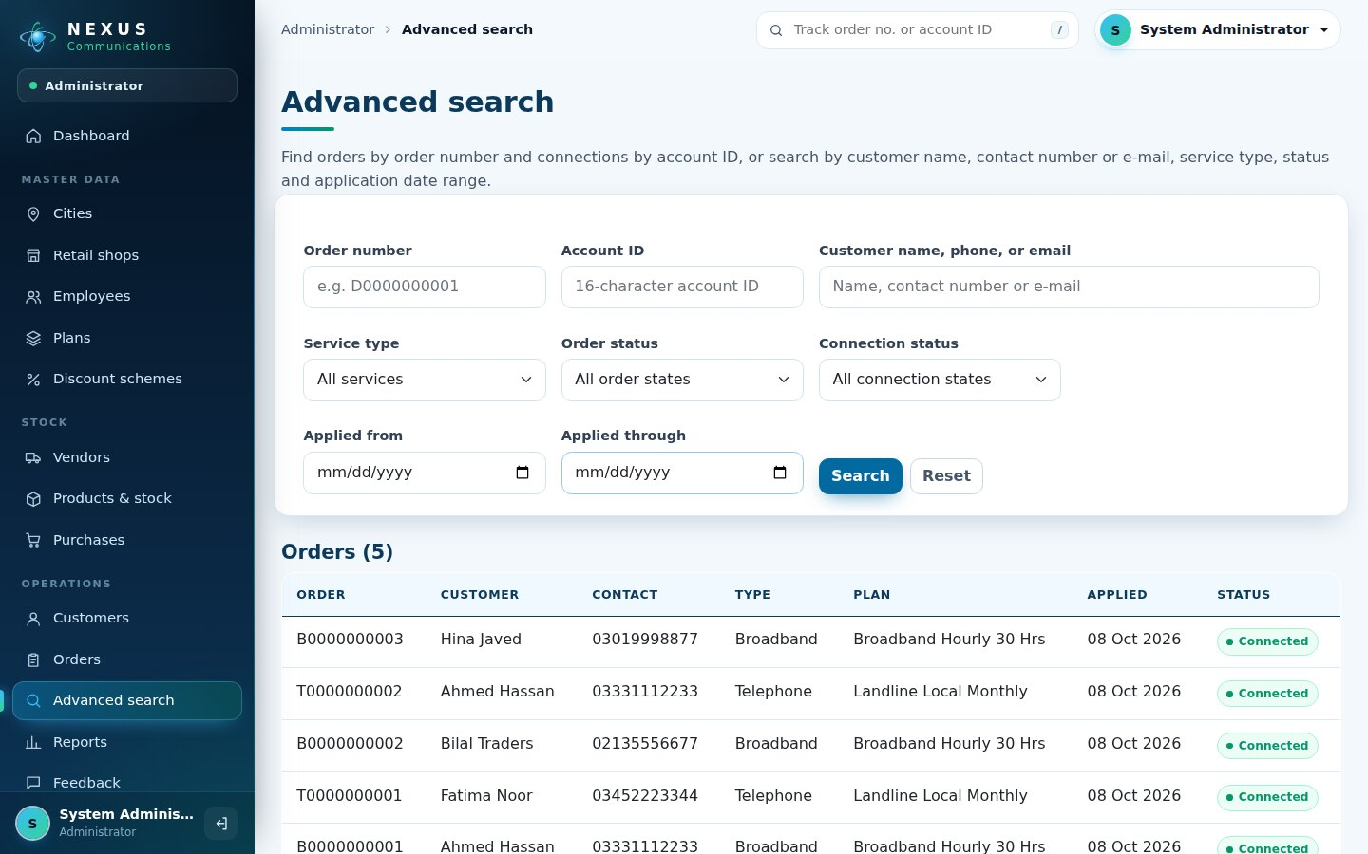
Figure 21. Advanced search
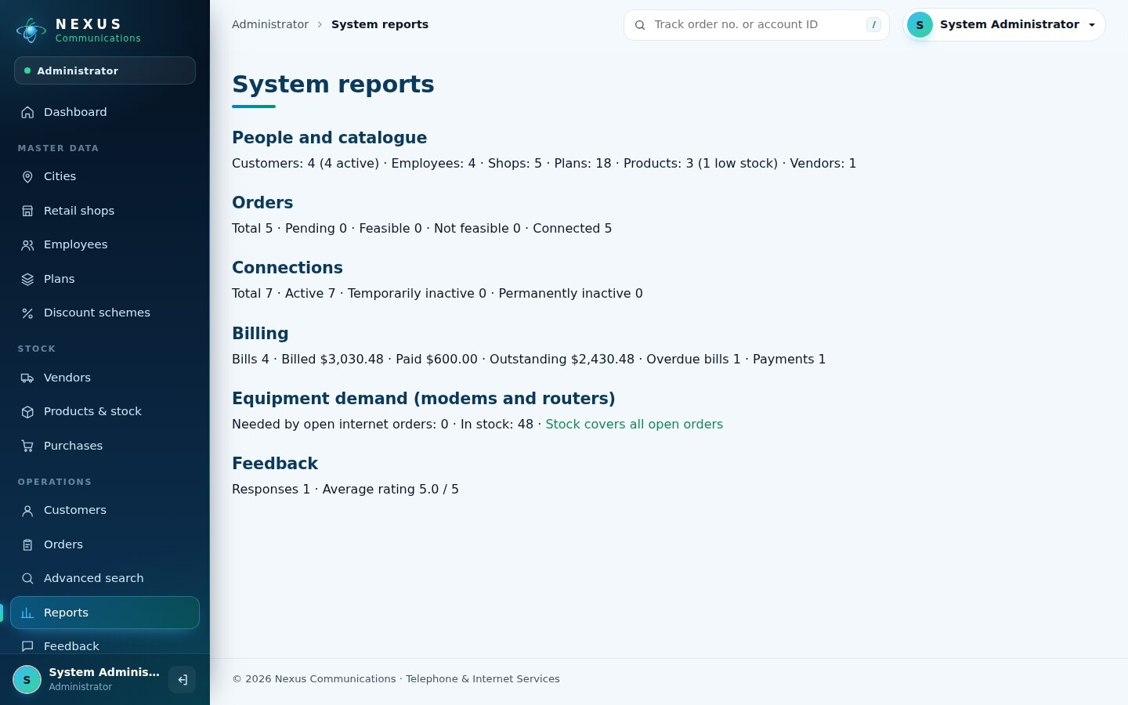
Figure 22. System reports

7.5 Retail staff
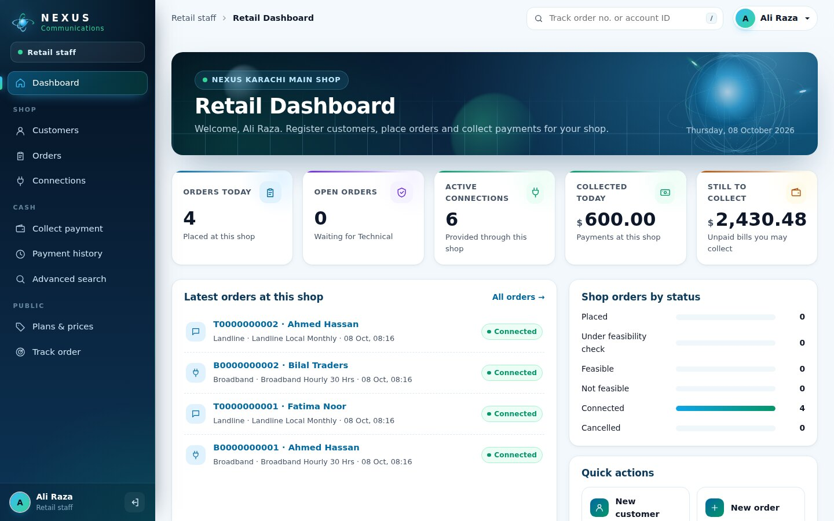
Figure 23. Retail dashboard for one shop
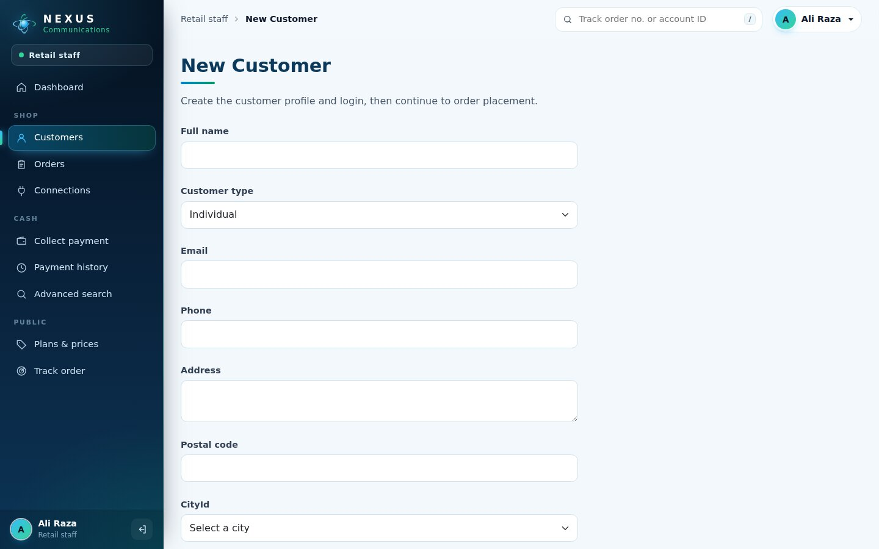
Figure 24. Register a walk-in customer
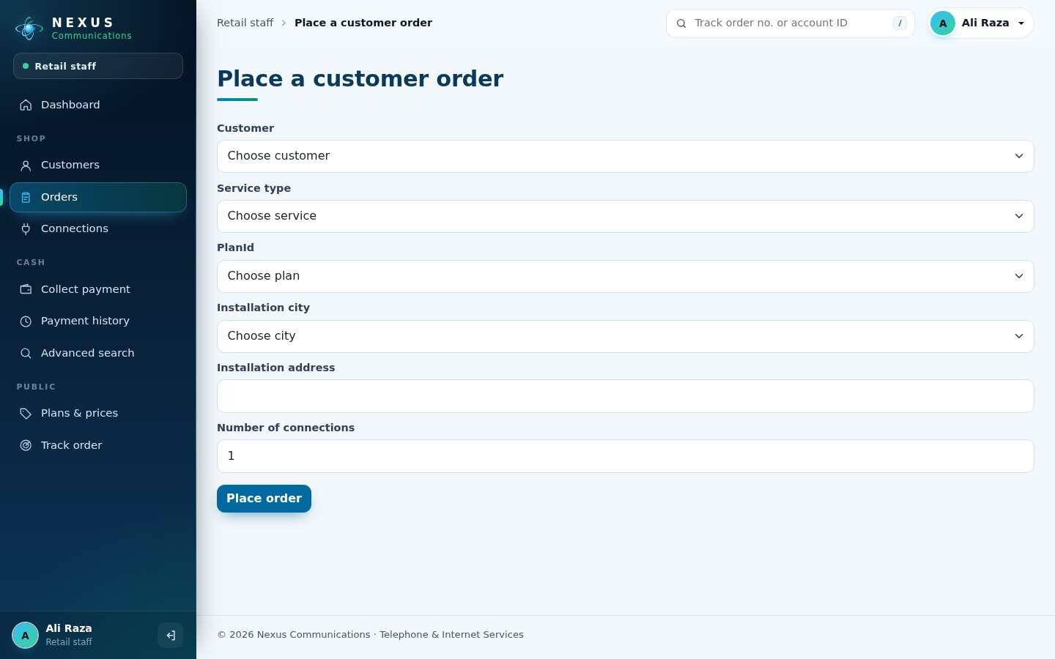
Figure 25. Place an order
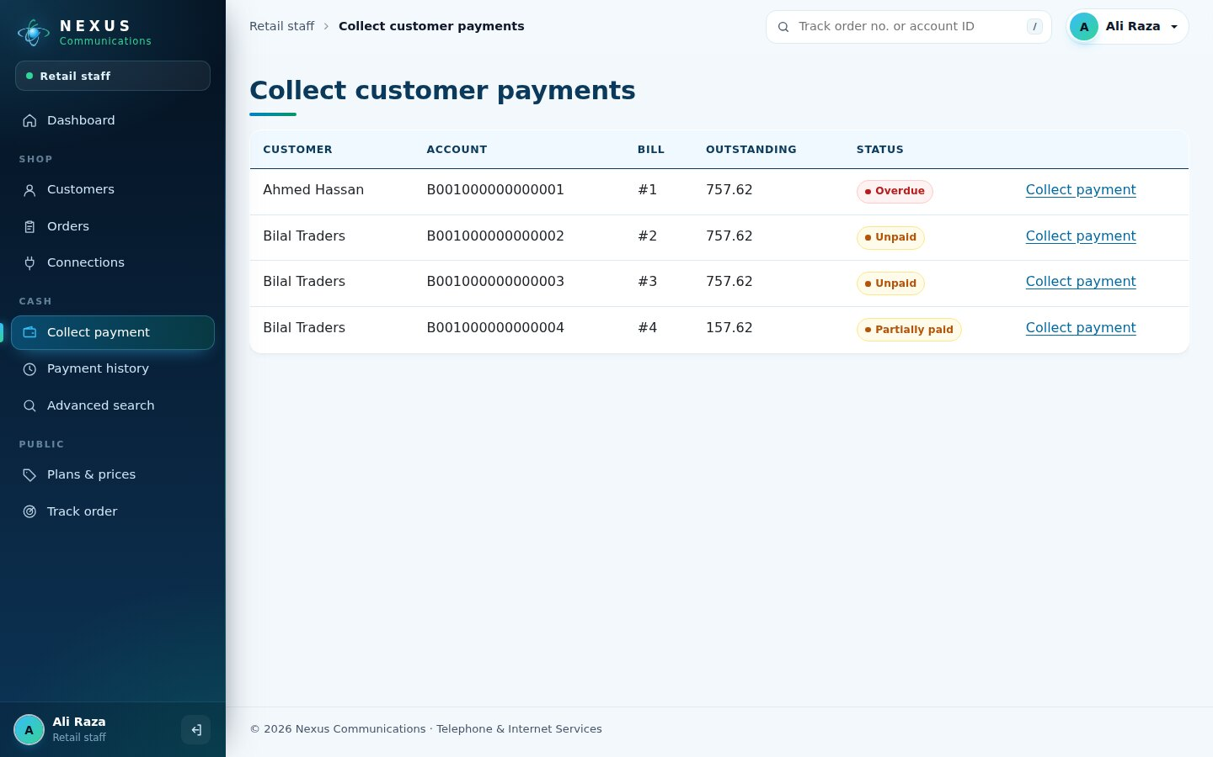
Figure 26. Collect customer payments
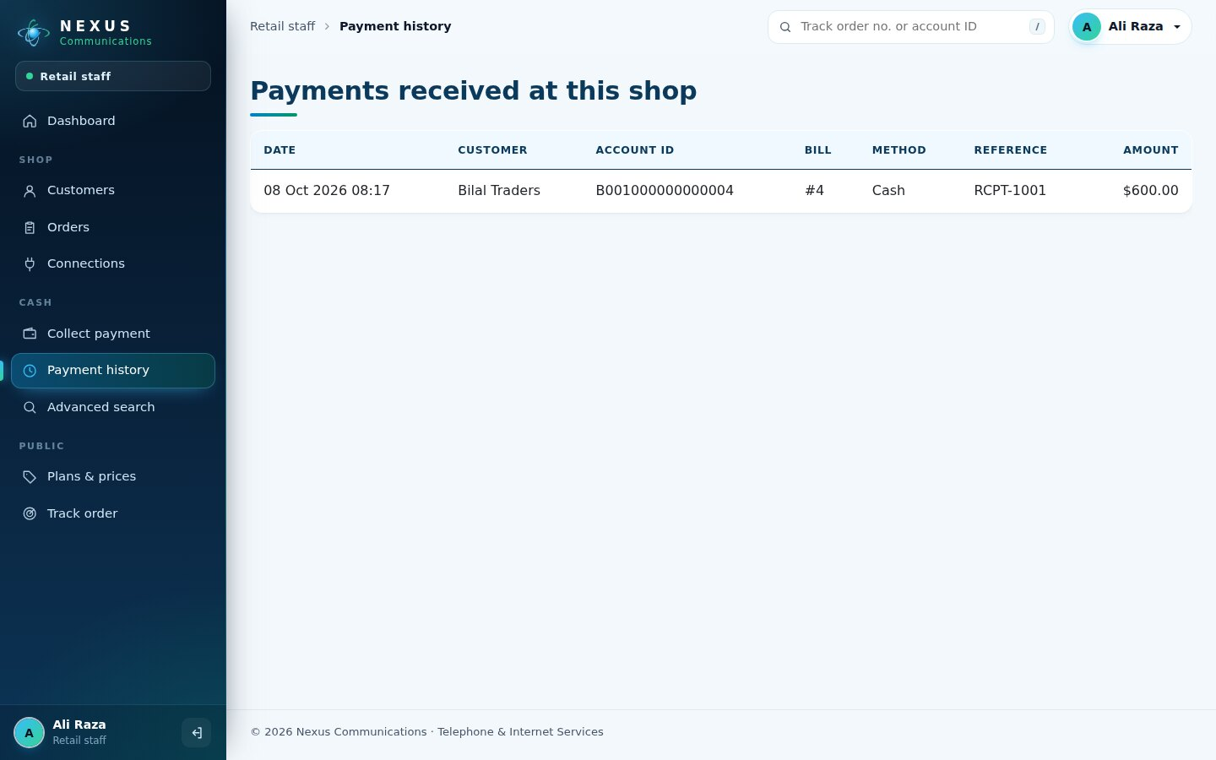
Figure 27. Payment history

7.6 Technical team
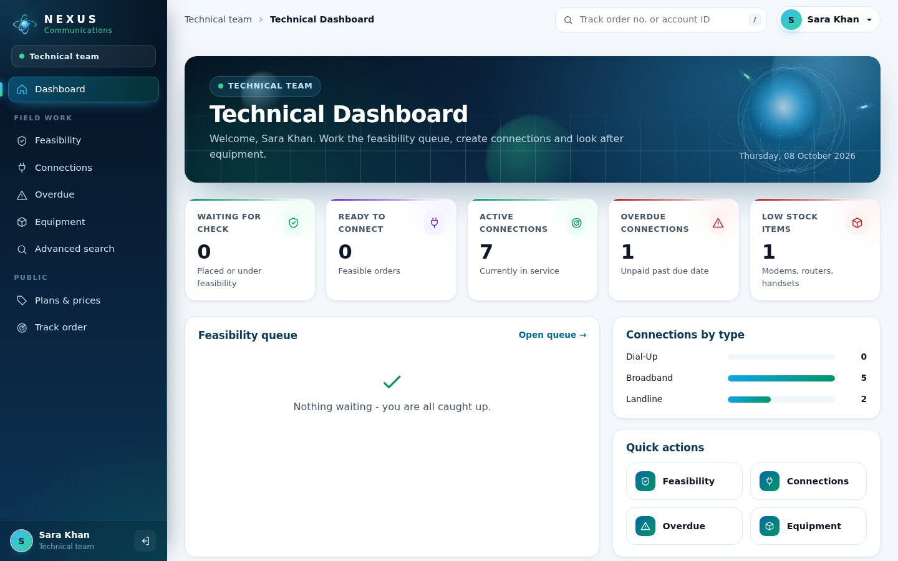
Figure 28. Technical dashboard
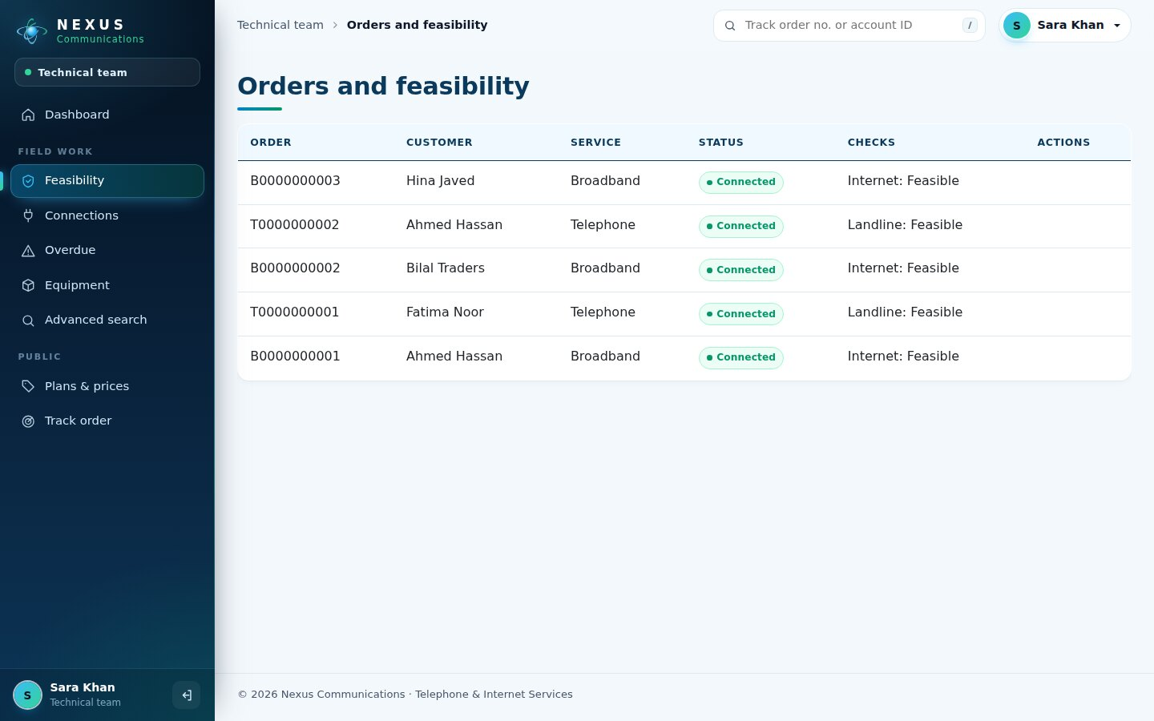
Figure 29. Orders and feasibility
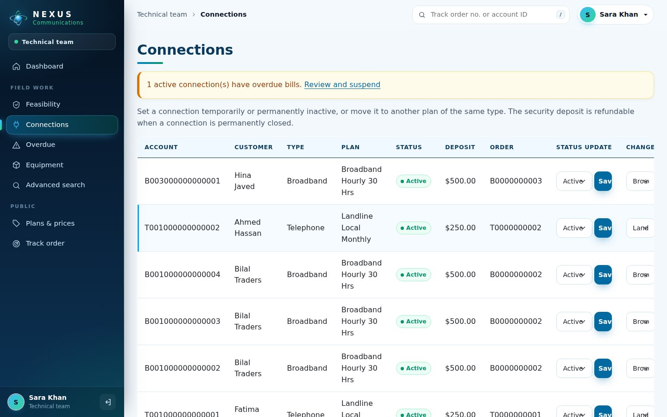
Figure 30. Connections: status, plan change, equipment replacement
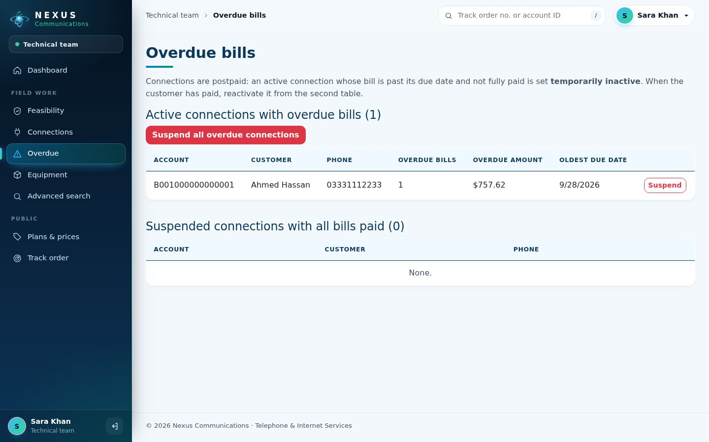
Figure 31. Overdue connections
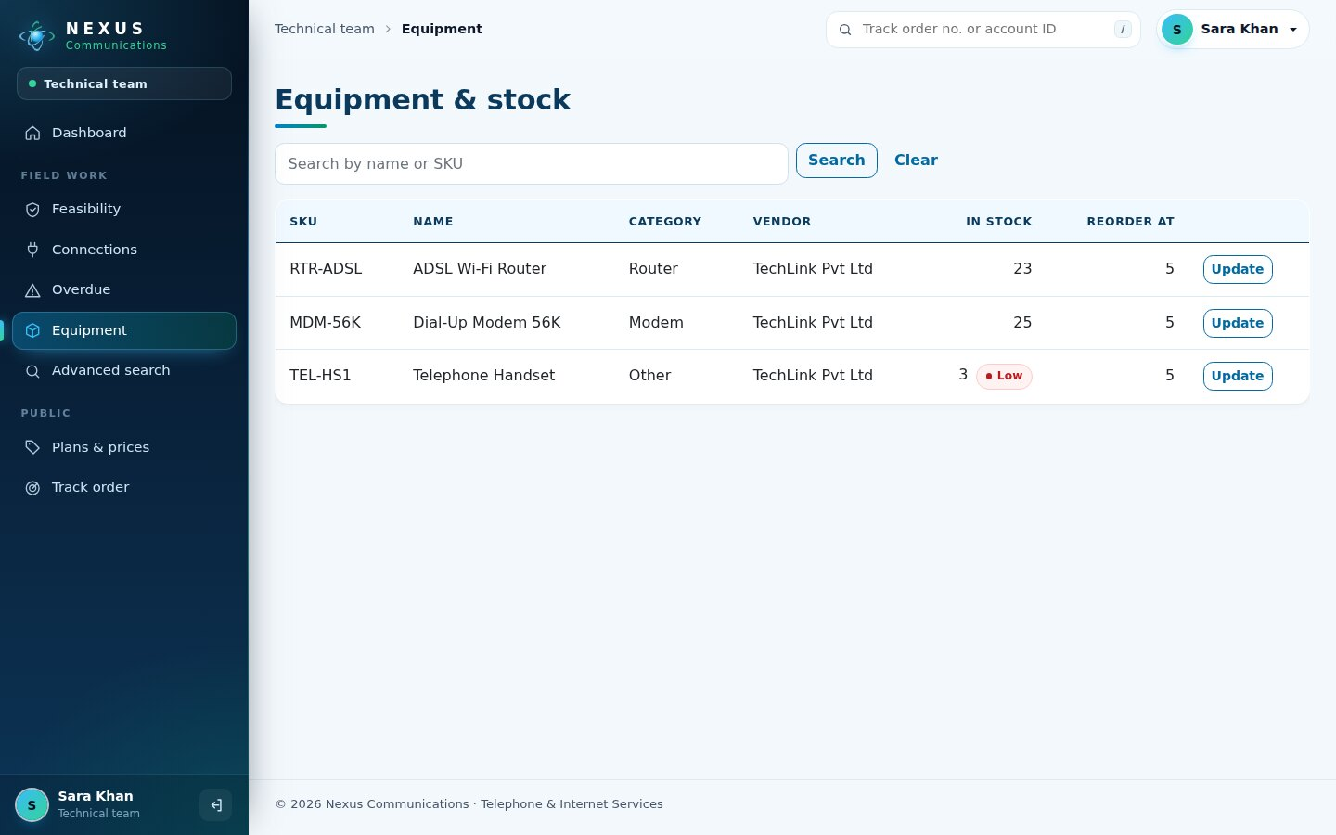
Figure 32. Equipment and stock

7.7 Accounts
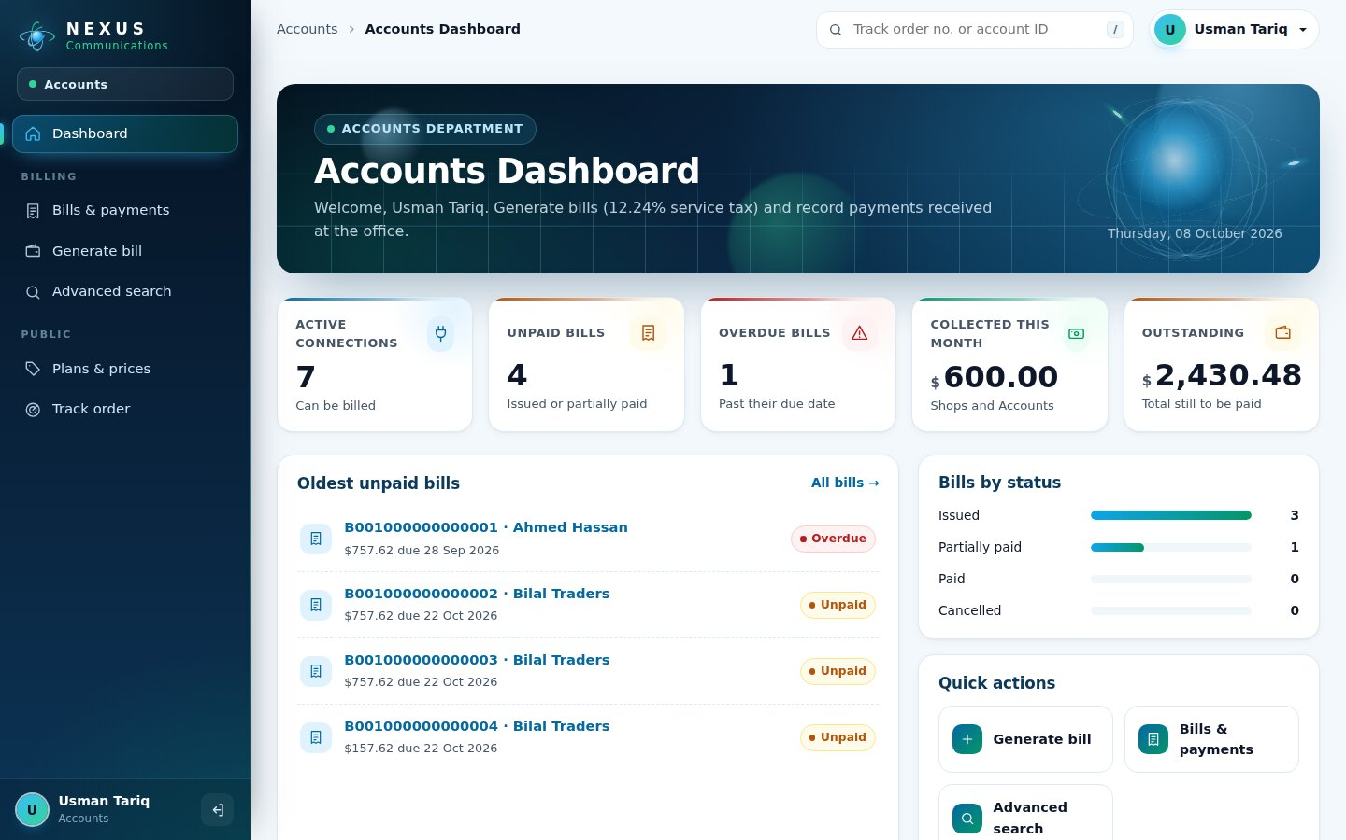
Figure 33. Accounts dashboard
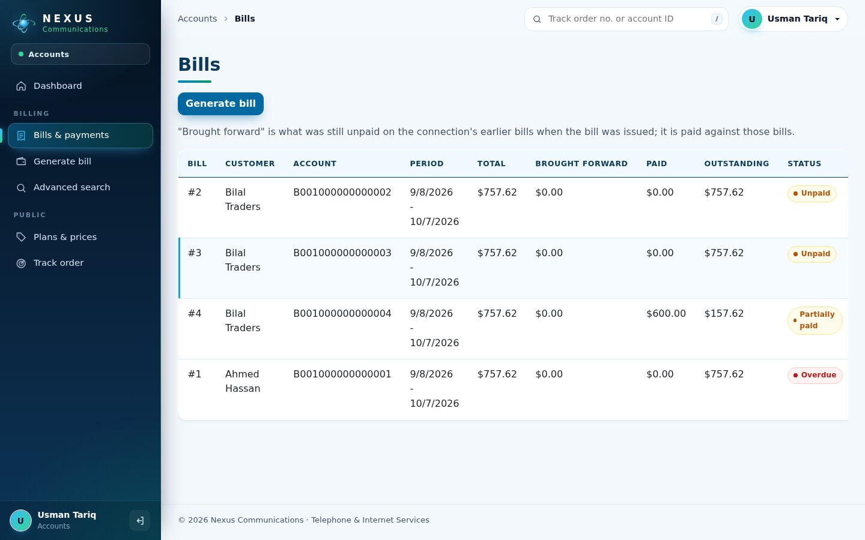
Figure 34. Bills and outstanding amounts
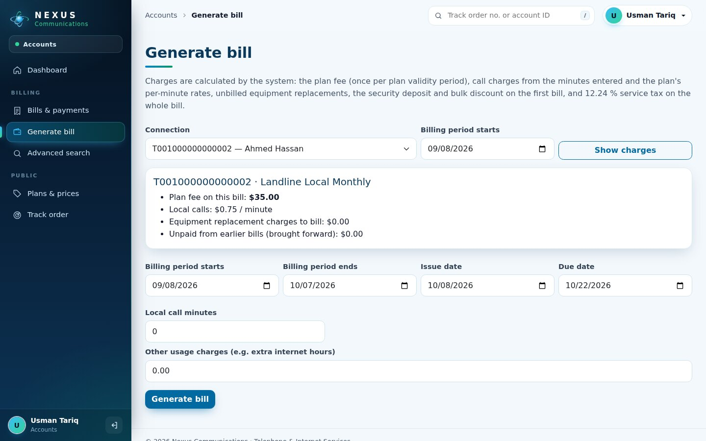
Figure 35. Generate a bill with charge preview

7.8 Customer portal
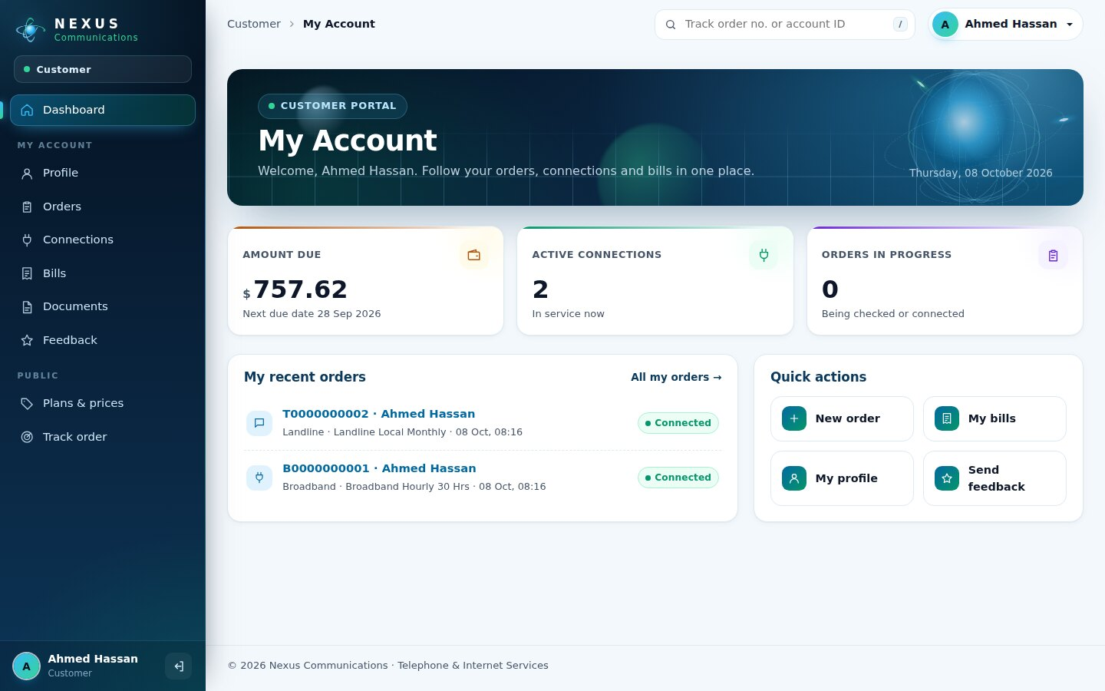
Figure 36. Customer dashboard with amount due
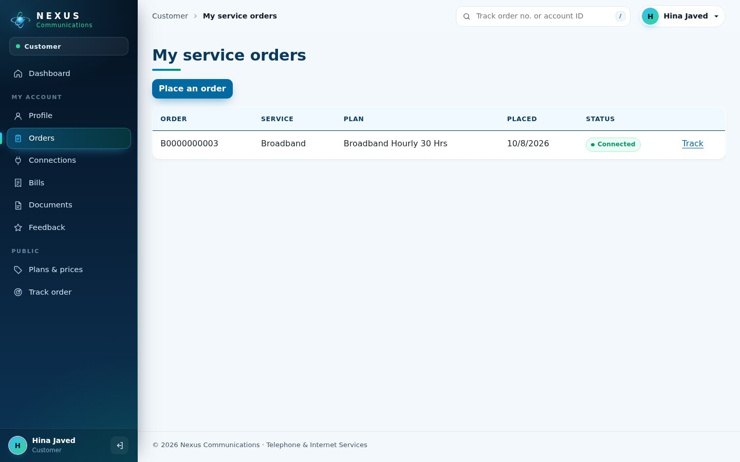
Figure 37. My orders
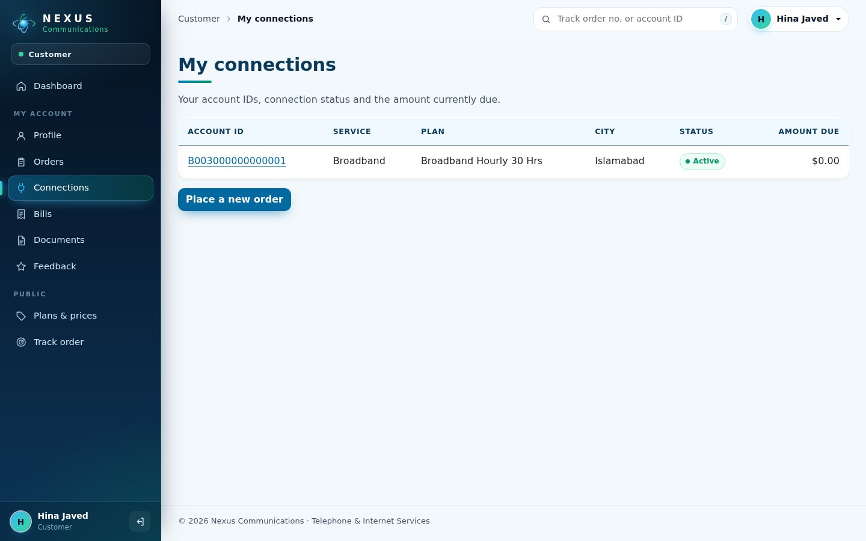
Figure 38. My connections
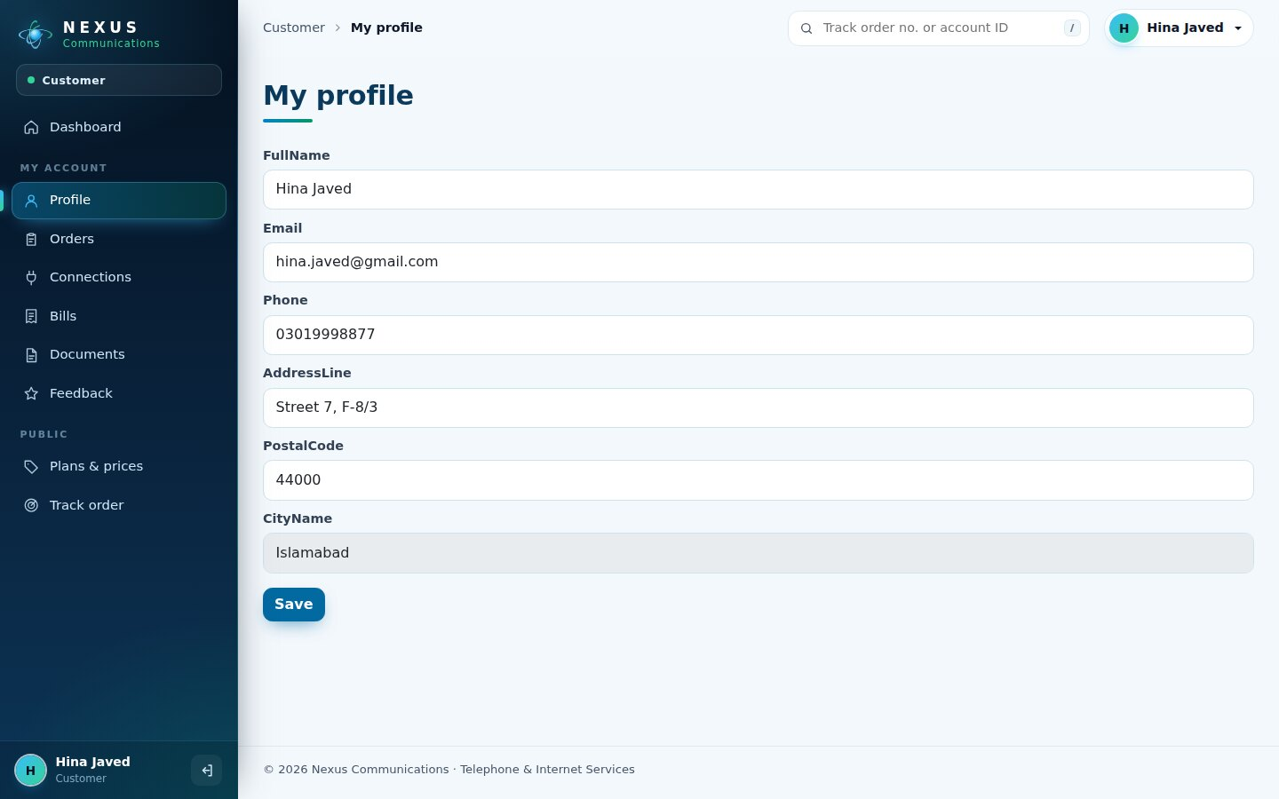
Figure 39. My profile

7.9 Mobile view
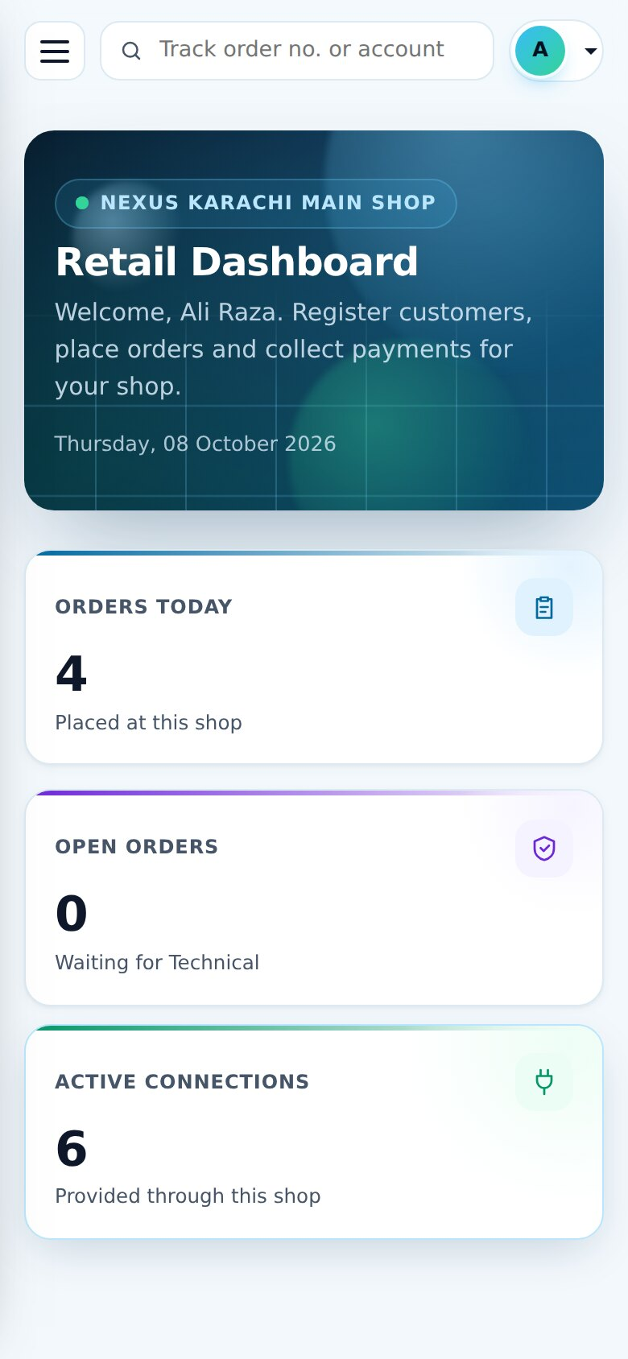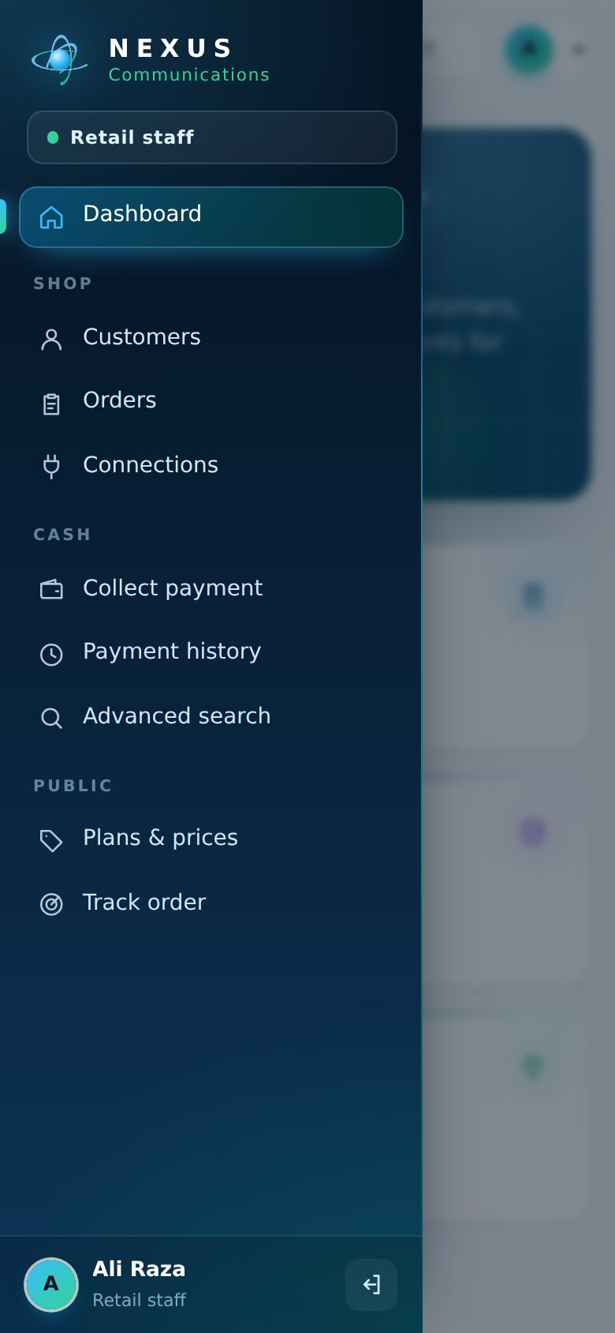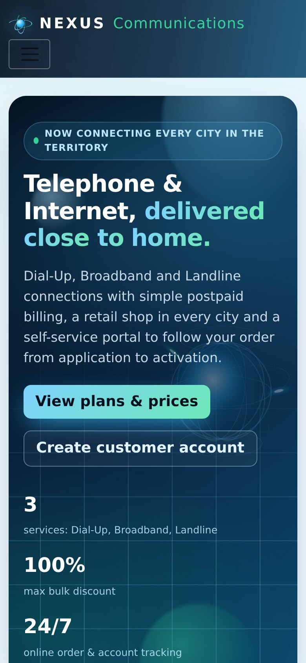
Figure 40. Phone: dashboard, sidebar drawer and home page

8. Testing
Testing combined manual checks with an automated browser run (Playwright, Chromium) that signs in as every role and performs the complete workflow through the real screens - the same screens shown in chapter 7. Negative tests check validation, security and the new overlays.

8.1 System test cases
Table 14. Test cases
ID | Test | Expected result | Result
TC-01 | Admin creates vendor, 3 products, a purchase and 3 employees (retail, technical, accounts) | Records saved, purchase increases stock | Pass
TC-02 | Retail staff registers 2 individual and 1 corporate customer | Customers and logins created | Pass
TC-03 | Corporate customer without company name | Error "Company name is required for a corporate customer" | Pass
TC-04 | Retail places Broadband and Telephone orders (one with quantity 3) | Order numbers B0000000001, T0000000001 ... generated | Pass
TC-05 | Visitor registers, logs in and places an order online | Order B0000000003 for the customer | Pass
TC-06 | Technical starts checks and records 5 feasibility results | Orders become Feasible | Pass
TC-07 | Multi-connection order provisioned with one serial number | Error: enter serials individually after provisioning | Pass
TC-08 | Technical provisions all feasible orders | 7 connections with 16-character account IDs; stock reduced | Pass
TC-09 | Accounts generates 4 bills (one back-dated) | Bills with plan fee, calls, deposit and 12.24 % tax; back-dated bill overdue | Pass
TC-10 | Retail collects more than the outstanding amount | Error "Payment exceeds the outstanding balance" | Pass
TC-11 | Retail collects a partial payment | Bill becomes Partially paid; history updated | Pass
TC-12 | Customer sends feedback | Feedback listed for Admin with rating | Pass
TC-13 | Login with a wrong password | "Invalid username or password." | Pass
TC-14 | Retail staff opens /Admin/Cities | Redirected to Access denied | Pass
TC-15 | Anonymous user opens /Accounts/Bills | Redirected to Login | Pass
TC-16 | Track an order number that does not exist | "No order was found for B9999999999" | Pass
TC-17 | Quick Track box with "ABC" / with "b0000000001" | Box shakes and stays / opens the order | Pass
TC-18 | New city with an existing code 001 | "A city with this code already exists." | Pass
TC-19 | New city with code "12A" | "City code must be exactly 3 digits" | Pass
TC-20 | Deactivate employee, then "Go back" in the confirm overlay | Nothing changes | Pass
TC-21 | Employee with a 3-character password | Minimum length 8 error | Pass
TC-22 | Registration with different password and confirmation | "Confirm password and Password do not match" | Pass
TC-23 | Customer opens another customer's order by URL | HTTP 404 - not shown | Pass
TC-24 | Technical suspends overdue connection, customer pays, Technical reactivates | Status Active -> Temporarily inactive -> Active | Pass

8.2 Unit testing checklist (development phase)
Checks recorded during development of the business services, kept here for completeness:
Table 15. Unit testing checklist
No. | Test | Result
1 | Order ID is 11 characters and starts with D, T or B | Pass
2 | Account ID is 16 characters with the correct city code | Pass
3 | Dial-Up order for a customer without landline creates two feasibility checks | Pass
4 | Dial-Up order with a Nexus landline creates one internet check | Pass
5 | Quantity 10 to 14 attaches the 25 % discount | Pass
6 | A connection cannot be created for a non-feasible order | Pass
7 | Stock reduces when equipment is issued | Pass
8 | Bill adds 12.24 % service tax | Pass
9 | Retail employee can collect only bills their shop may collect | Pass
10 | A permanently inactive connection cannot be reactivated | Pass
11 | Advanced search filters by name, type, date and contact number | Pass
12 | Customer can cancel an order before connection | Pass

Result
All 24 test cases passed on SQL Server 2022 with .NET 8.
System test cases TC-01 to TC-24 were run in this release; the schema was checked against the entity model: 19 tables, 5 migrations, 47 CHECK constraints.

9. Installation Guide

9.1 Requirements
- Windows 10 / 11 with .NET 8 SDK (dotnet --version shows 8.x).
- SQL Server 2019 / 2022 (Express, Developer or Standard) and SQL Server Management Studio.
- Visual Studio 2022 (optional) and Google Chrome.

9.2 Connect SQL Server
In SSMS choose Database Engine, Server name . (this computer), SQL Server Authentication, Login sa, Password aptech, Encryption *Mandatory* with Trust server certificate ticked, then Connect.
The project already contains this connection in appsettings.json:
appsettings.json
"DefaultConnection": "Server=.;Database=NexusServiceMarketingDb;User Id=sa;Password=aptech;MultipleActiveResultSets=true;TrustServerCertificate=True"
For SQL Express write Server=.\\SQLEXPRESS (the backslash is doubled inside JSON).

9.3 Create the database
Open PowerShell in the folder that contains NexusServiceMarketingSystem.csproj and run the commands one at a time:
Table 16. Commands
Step | Command | What it does
1 | dotnet tool install --global dotnet-ef --version 8.* | Installs the EF Core tool (first time only; use "update" if installed)
2 | dotnet ef dbcontext info | Shows the server it will use - Data source must be "."
3 | dotnet ef database update | Applies the 5 migrations: database, 19 tables, plans and discount bands
4 | dotnet run | Starts the website at http://localhost:5294

Without dotnet-ef: in SSMS run CREATE DATABASE NexusServiceMarketingDb;, select the new database, open Database/NexusServiceMarketingDb-schema.sql and press F5. The website also applies migrations automatically when it starts.

9.4 First login
Table 17. Default login
Role | Username | Password
Administrator (created automatically) | admin | Admin@123

After the first login: change the admin password, check the 5 starter cities and shops, create employees (Retail, Technical, Accounts) and start taking orders.

9.5 Troubleshooting
Table 18. Troubleshooting
Message | Solution
Login failed for user 'sa' | Check the password; in SSMS > Server properties > Security choose "SQL Server and Windows Authentication mode" and restart the SQL Server service.
A network-related or instance-specific error | Wrong server name - use "." or ".\SQLEXPRESS".
Database created but not visible in SSMS | Run "dotnet ef dbcontext info"; the Data source must be the same server SSMS is connected to. Refresh the Databases folder.
dotnet-ef is not recognized | Close and reopen the terminal after installing, or use the SQL script method.
Port already in use | Close the other running copy, or run: dotnet run --urls http://localhost:5300

10. User Guide

10.1 Getting around
- After login every user lands on their dashboard. The sidebar lists only the pages of that role; the current page is highlighted.
- Type an order number or account ID in the Track box at the top and press Enter (press / to jump to the box).
- Click any order number or account ID in a table to copy it.
- On a phone, open the menu with the button at the top left.

10.2 Administrator
- Master data > Cities: add each city with its unique 3-digit code.
- Retail shops: add at least one shop per city.
- Employees: create Retail (choose the shop), Technical and Accounts staff with their username and first password.
- Plans and Discount schemes: check prices; plans already used cannot be deleted, deactivate them instead.
- Stock > Vendors, Products, Purchases: keep modems and routers in stock (low-stock items show in red).
- Operations > Orders, Advanced search, Reports and Feedback to monitor the business.

10.3 Retail staff
- Customers > New customer for a walk-in customer (corporate customers need a company name).
- Orders > Place order: choose customer, service, plan, city, address and number of connections. For dial-up without a Nexus line, also choose a landline plan.
- Collect payment: open a bill, enter the amount (full or partial), method and reference.
- Connections and Payment history show everything handled by the shop.

10.4 Technical team
- Feasibility: press *Start checks* on a new order, then *Record result* for each check.
- For feasible orders press *Provision*: choose the modem / router, serial and (for landlines) phone numbers.
- Connections: change status, change plan or replace spoiled equipment.
- Overdue: suspend connections with overdue bills; reactivate them when the customer has paid.

10.5 Accounts
- Generate bill: choose the connection and period start, press *Show charges*, enter minutes and other usage, then *Generate bill*.
- Bills & payments: see outstanding amounts and record payments received at the office.

10.6 Customer
- Register on the website, then log in.
- Orders > New order to apply for a connection and follow its status.
- The dashboard shows the amount due and next due date; Bills lists every bill and payment.
- Upload documents and send feedback from the sidebar.

11. Developer Guide

11.1 Folder structure
Table 19. Project structure
Folder / file | Contents
Areas/<Role>/Controllers, Views | Admin, Retail, Technical, Accounts, Customer areas
Controllers, Views | Public pages: Home, Catalog, Track, Account, Search
Services/ | Workflows (orders, provisioning, billing, customers), Dashboard, Identifiers, Security, Documents
Data/ | AppDbContext, design-time factory, converters, seeders
Migrations/ | Five EF Core migrations and the model snapshot
Models/ | Entities (19), enums, view models, dashboard models, NexusIcons
Views/Shared/ | _Layout (app shell), _SideNav, Dashboard, partials
wwwroot/css | site.css (design tokens, public site, components), nexus-app.css (shell, dashboards, overlays)
wwwroot/js | site.js (loader, reveal, tilt, forms), nexus-app.js (sidebar, quick track, toasts, confirm, badges, counters)
Database/ | Full SQL script and Run-Migration.bat

11.2 Adding a feature
- Add or change the entity in Models/Entities and its configuration in AppDbContext.
- Create a migration: dotnet ef migrations add <Name> then dotnet ef database update.
- Put the rule in a service (never in the controller), register it in Program.cs.
- Add the controller action with [Authorize(Roles = ...)] and [ValidateAntiForgeryToken] on POST.
- Add the view; add a sidebar link in Views/Shared/_SideNav.cshtml.

12. Project Management

12.1 Task sheet
Table 20. Task sheet
No. | Task | Status
1 | Requirement analysis | Completed
2 | Database design and migrations | Completed
3 | Admin module | Completed
4 | Retail module | Completed
5 | Technical module | Completed
6 | Accounts module | Completed
7 | Customer portal and public tracking | Completed
8 | App shell, dashboards, motion and overlays | Completed
9 | Testing | Completed
10 | Documentation, presentation and submission | Completed

12.2 Project review and monitoring report
Table 21. Review and monitoring
Review | Progress | Issues and action
1st status | Database, migrations and Admin module ready | Database moved from LocalDB to SQL Server by changing the connection string
2nd status | All five role areas, billing, search, UI theme and documents ready | Empty city list fixed by starter data; plan change and order cancel added
Final | Sidebar app shell, live role dashboards, cut-overlay transitions, confirm overlays, documentation and presentation | Connection set to the local SQL Server (sa login); full workflow and negative tests passed

12.3 Final checklist
Table 22. Final checklist
Item | Done
Source code (ZIP) | Yes
Database scripts and migrations | Yes
Database backup (.bak) - SSMS > NexusServiceMarketingDb > Tasks > Back Up | Do before submitting
Login credentials documented | Yes
Project documentation (this document, Word and PDF) | Yes
Status report and feedback form (fill in your details) | Yes
Animated presentation | Yes

13. Conclusion and Future Enhancements
The Nexus Service Marketing System meets the problem statement: every order has a unique number and moves through feasibility, connection, billing and payment in one shared SQL Server database; every role has its own secure dashboard; and bills are calculated by the system with the required discount and tax rules. The new interface - sidebar shell, live dashboards, cut-overlay transitions and confirm overlays - makes the system modern and quick to use.

Future enhancements
- Online payments through a payment gateway and automatic receipts by e-mail / SMS.
- Call detail records imported from the exchange so bills calculate minutes automatically.
- Stock movement ledger and connection status history for full audit trails.
- Charts of monthly revenue and new connections per city on the admin dashboard.
- A mobile app for field technicians with photo upload at installation.

Demo logins used in this document
Admin: admin / Admin@123
Retail: ali.retail / Nexus@12345 - Technical: sara.tech / Nexus@12345 - Accounts: usman.accounts / Nexus@12345
Customers: ahmed.hassan, hina.javed / Customer@123 (created during testing; a fresh database contains only the admin)

