NEXUS SERVICE MARKETING SYSTEM
eProject - Complete Project Report
Item | Details
Project title | Nexus Service Marketing System
Technology | ASP.NET Core 8 MVC, Entity Framework Core 8, SQL Server (Express / LocalDB), Bootstrap 5
Student name | [Your name]
Enrollment no. | [Your enrollment number]
Batch / Group | [Batch] / [Group]
Centre | [Centre name]
Submission date | [DD/MMM/YYYY]

Certificate of Completion
This is to certify that the project titled "Nexus Service Marketing System" was designed, developed and tested by the student named on the cover page as part of the eProject learning programme. The project meets the requirements of the problem statement supplied by the eProjects team.
Student signature: ____________________ Mentor signature: ____________________

Table of Contents

1. Problem Definition
Nexus Communication is a telephone and internet service provider offering Dial-Up, Broadband and Landline connections through its office and retail shops across a territory. Customer records, orders, feasibility checks, equipment stock, vendors, bills and payments were handled on paper, which caused errors. The company needs an online application that keeps all these records automatically and gives separate logins to the Admin, Accounts, Technical and Retail staff and to customers.

Objectives
- Replace paper records with one SQL Server database.
- Give each role only the functions it needs (role-based security).
- Generate unique order IDs and account IDs automatically.
- Calculate bills with plan charges, deposit, discount and 12.24% service tax.
- Let customers and the public track orders and connections online.

2. Customer Requirement Specification
No. | Requirement (from the problem statement) | Where implemented
1 | Separate logins for Admin, Accounts, Technical, Retail employees and Customers | Role-based Areas, cookie login, hashed passwords
2 | Admin maintains employees, stock, vendors, retail shops, plans (insert, update, delete, search) | Admin area
3 | Order ID: 11 characters, first letter D / T / B, serial number (e.g. D0000000001) | IdentifierGenerator, DB check constraint
4 | Account ID: type letter + 3-digit city code + 12-digit serial (16 characters) | IdentifierGenerator, Cities.Code
5 | Only retail employees (and customers themselves) place orders | Retail and Customer areas
6 | Feasibility check: landline + internet for Dial-Up; internet only if customer already has a Nexus landline | OrderWorkflowService
7 | Technical staff update orders, create connections, make connections temporarily or permanently inactive, maintain equipment | Technical area
8 | Accounts generate bills; payment details updated by Accounts and Retail staff | Accounts and Retail areas, BillingService
9 | Bulk discount 10-14: 25%, 15-24: 50%, 25-49: 75%, 50+: 100% on advance and security deposit | DiscountSchemes, OrderWorkflowService
10 | Service tax 12.24% on the whole bill | BillingService
11 | Search order status by order ID and connection status (with due amount) by account ID | Public Track page
12 | Advanced search by ID, name, connection type, date / period, contact number | Admin > Advanced search
13 | Customer can see contact details, place an order, track orders, view bills | Customer area
14 | Address proofs, application forms and receipts filed by year and area | Customer Documents
15 | Customer feedback is collected; customers can change plan | Feedback page; Technical > Change plan
16 | Plan details with security deposits and call charges | Plans table (18 plans seeded)

Plan price list (seeded)
Type | Plan | Price | Security deposit
Dial-Up | Hourly 10 / 30 / 60 Hrs | 50 / 130 / 260 $ | 325 $
Dial-Up | Unlimited 28 Kbps monthly / quarterly | 75 / 150 $ | 325 $
Dial-Up | Unlimited 56 Kbps monthly / quarterly | 100 / 180 $ | 325 $
Broadband | Hourly 30 / 60 Hrs | 175 / 315 $ | 500 $
Broadband | Unlimited 64 Kbps monthly / quarterly | 225 / 400 $ | 500 $
Broadband | Unlimited 128 Kbps monthly / quarterly | 350 / 445 $ | 500 $
Landline | Local: yearly rental 75 $ (0.55/min), monthly 35 $ (0.75/min) | 75 / 35 $ | 250 $
Landline | STD monthly 125 $, half-yearly 420 $, yearly (price not given in spec) | 125 / 420 $ | 250 $

3. Project Plan
Phase | Work | Output
1. Analysis | Study problem statement, roles, rules | Requirement list
2. Design | ER diagram, tables, ID formats, screens | Database design, GUI standards
3. Database | EF Core entities, configurations, 4 migrations, seed data | 19 tables in SQL Server
4. Development | Five role areas, services for orders, connections, billing | Working website
5. UI design | Responsive theme, animations, validation messages | site.css, site.js
6. Testing | Unit testing and final checklists | Test results
7. Delivery | Documentation, database backup, source ZIP | Final submission

4. Entity-Relationship Diagram
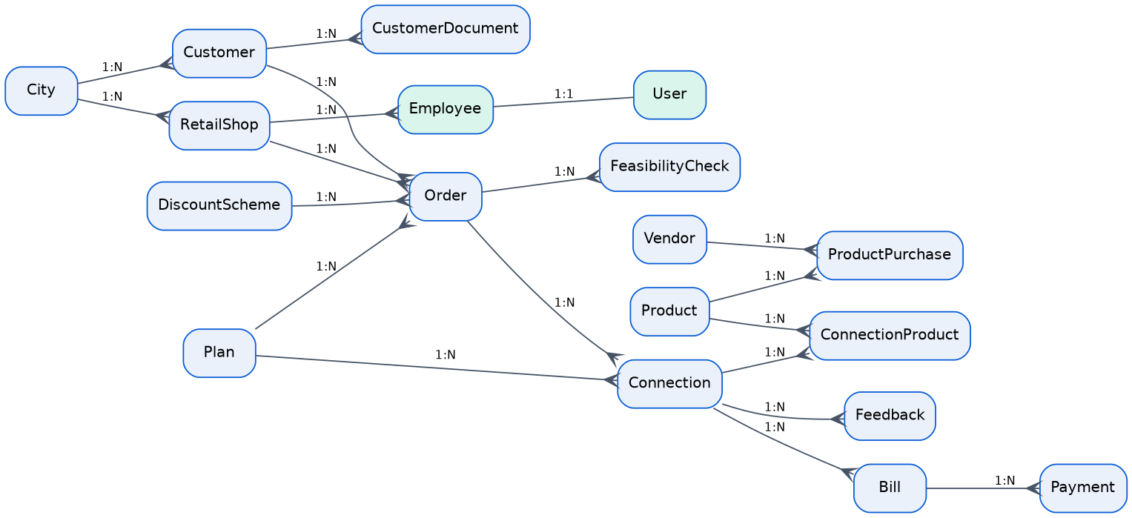

Tables (19)
Table | Purpose
Users, Employees | Staff logins and staff details (role: Admin, Accounts, Technical, RetailStaff)
Customers | Customer personal and contact details; customer login
Cities, RetailShops | Territory cities (3-digit code) and retail outlets
Plans, DiscountSchemes | Plan catalogue and bulk discount bands
Orders, FeasibilityChecks | Applications and their feasibility results
Connections, ConnectionProducts | Provided connections and the equipment issued
Vendors, Products, ProductPurchases | Equipment suppliers, stock and purchases
Bills, Payments | Postpaid bills and payments received
Feedbacks, CustomerDocuments | Customer feedback and filed documents
IdentifierCounters | Serial counters for order IDs and account IDs

5. Algorithms

5.1 Order placement
- Retail employee or customer selects connection type, plan, city, address and quantity.
- System checks the plan matches the type and the city is active.
- If quantity is 10 or more, the matching discount scheme is attached to the order.
- System takes the next serial for the type and creates the order ID (letter + 10 digits).
- Order status is set to Placed.

5.2 Feasibility check
- Technical employee opens a Placed order.
- Dial-Up: if the customer has an active Nexus landline, only an internet check is created; otherwise both landline and internet checks.
- Broadband: internet check. Telephone: landline check.
- For each check the employee records distance and, for internet, server availability.
- All checks feasible: order becomes Feasible. Any check not feasible: order becomes Not Feasible.

5.3 Connection creation
- Order must be Feasible. Equipment is chosen from stock (quantity is reduced).
- Security deposit = plan deposit, reduced by the discount percent when the scheme applies.
- Account ID = type letter + city code + 12-digit serial. Connection starts Active; order becomes Connected.

5.4 Bill generation
- Accounts employee selects connection and period, and enters usage (call) charges and equipment replacement charges.
- First bill: add security deposit and subtract the advance discount.
- SubTotal = plan charge + usage + deposit + replacement - discount.
- Service tax = 12.24% of SubTotal. Total = SubTotal + tax.
- Payments reduce the outstanding amount; status moves Issued, Partially Paid, Paid.

6. GUI Standards
Element | Standard
Colours | Primary blue #0B5ED7, dark blue #08306B, accent teal #00B3A4, light background #F3F6FB
Font | Segoe UI / system sans-serif, 16 px body
Layout | Bootstrap 5 grid, sticky top menu, role-based menu items, footer on every page
Buttons | Primary actions in blue, destructive actions in red outline with confirmation
Forms | Labels above fields, inline validation messages, double-submit protection
Feedback | Green alert for success (auto hides), red alert for errors
Motion | Page fade-in, hover lift on tiles, scroll reveal; disabled when the user prefers reduced motion
Money | US dollars, two decimals

7. Interface Design Document
Role | Main screens
Public | Home, Plans and prices, Track order / account, Login, Register
Admin | Cities, Retail shops, Employees, Plans, Discount schemes, Vendors, Products, Purchases, Customers, Orders, Advanced search, Reports, Feedback
Retail | Customers, Place order, Orders, Connections, Collect payment, Payment history
Technical | Feasibility, Connections (create, status, change plan), Equipment and stock
Accounts | Generate bill, Bills and payments
Customer | My orders (place, track, cancel), Connections, Bills, Documents, Profile, Feedback

8. Login Credentials and How to Run
Role | Username | Password
Admin (created automatically) | admin | Admin@123
Accounts / Technical / Retail | Created by Admin in Employees | Set by Admin
Customer | Self-registered or created by staff | Set at registration

Database server: .\SQLEXPRESS (SQL Server Express), database NexusServiceMarketingDb. Connection string is in appsettings.json.
- Install .NET 8 SDK and SQL Server Express.
- Run: dotnet ef database update (creates 19 tables and seeds 18 plans and 4 discount bands). The app also migrates itself at start-up.
- Run: dotnet run. On first start the Admin, 5 starter cities and 5 retail shops are created.
- Open the website and log in as admin. Change the admin password after the first login.

9. Task Sheet
No. | Task | Status
1 | Requirement analysis | Completed
2 | Database design and migrations | Completed
3 | Admin module | Completed
4 | Retail module | Completed
5 | Technical module | Completed
6 | Accounts module | Completed
7 | Customer portal and public tracking | Completed
8 | Theme, animations and validation | Completed
9 | Testing | Completed
10 | Documentation and submission | Completed

10. Project Review and Monitoring Report
Review | Progress | Issues and action
1st status | Database, migrations and Admin module ready | Database moved from LocalDB to SQL Express by changing the connection string
2nd and final status | All five role areas, billing, search, UI theme and documents ready | Empty city list fixed by adding starter data; plan change and order cancel added

11. Unit Testing Checklist
No. | Test | Result
1 | Login with wrong password shows an error | Pass
2 | Role cannot open another role's pages (access denied) | Pass
3 | Order ID is 11 characters and starts with D, T or B | Pass
4 | Account ID is 16 characters with the correct city code | Pass
5 | Dial-Up order for a customer without landline creates two feasibility checks | Pass
6 | Dial-Up order with Nexus landline creates one internet check | Pass
7 | Quantity 10 to 14 attaches the 25% discount | Pass
8 | Connection cannot be created for a non-feasible order | Pass
9 | Stock reduces when equipment is issued | Pass
10 | Bill adds 12.24% service tax | Pass
11 | Payment larger than the outstanding amount is rejected | Pass
12 | Retail employee can pay only at their own shop | Pass
13 | Permanently inactive connection cannot be reactivated | Pass
14 | Track page finds order and account IDs | Pass
15 | Advanced search filters by name, type, date and contact number | Pass
16 | Customer can cancel an order before connection | Pass

12. Final Checklist
Item | Done
Source code (ZIP) | Yes
Database scripts and migrations | Yes
Database backup (.bak) - create in SSMS before submitting | Do before submit
Login credentials documented | Yes
Project report (this document) | Yes
Status reports and feedback form | Yes
Presentation | Yes

Note: the specification gives no price for the yearly STD landline plan. It is seeded as inactive and the Admin must enter the price before activating it.

