COMET LEAP: Mini Buffett/Bezos-Style 30-Day Update Model
Reference-only visual timeline using abstract PNG art panels

Day 01 - Baseline + Truth Audit

Art reference panel for daily execution state and momentum

Day 02 - Single Daily Focus

Art reference panel for daily execution state and momentum

Day 03 - Local-Only Reliability

Art reference panel for daily execution state and momentum

Day 04 - Health + Recovery Rhythm

Art reference panel for daily execution state and momentum

Day 05 - Skill Stack Mapping

Art reference panel for daily execution state and momentum

Day 06 - Workflow Compression

Art reference panel for daily execution state and momentum

Day 07 - Decision Filter v1

Art reference panel for daily execution state and momentum

Day 08 - Confidence Scoring

Art reference panel for daily execution state and momentum

Day 09 - Output Proof Chain

Art reference panel for daily execution state and momentum

Day 10 - Loop Stabilization

Art reference panel for daily execution state and momentum

Day 11 - Audience Signal Pass

Art reference panel for daily execution state and momentum

Day 12 - Offer Clarity

Art reference panel for daily execution state and momentum

Day 13 - Artifact Packaging

Art reference panel for daily execution state and momentum

Day 14 - Feedback Intake

Art reference panel for daily execution state and momentum

Day 15 - Iteration Sprint

Art reference panel for daily execution state and momentum

Day 16 - Automation Guardrails
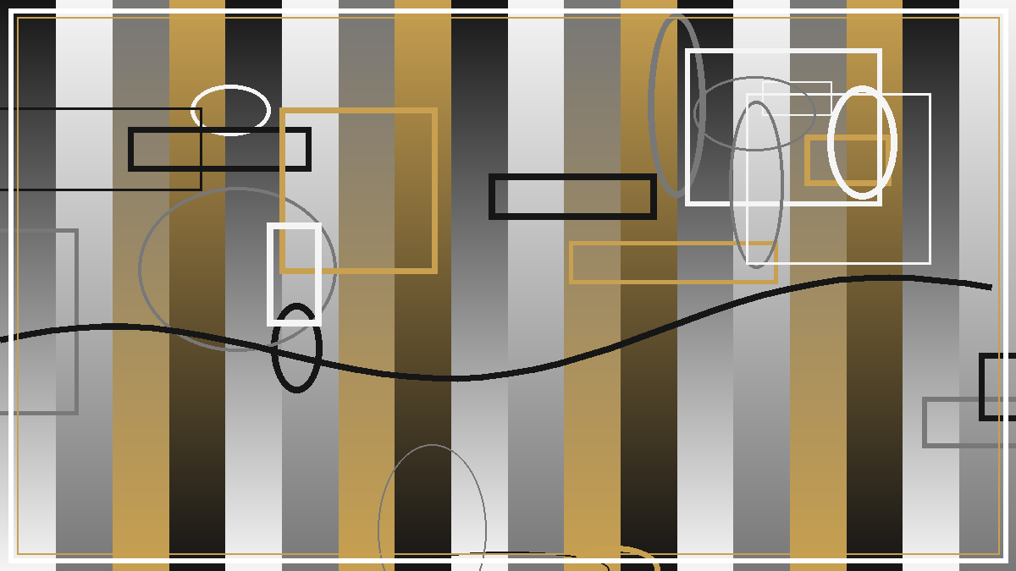
Art reference panel for daily execution state and momentum

Day 17 - Cost/Value Check

Art reference panel for daily execution state and momentum

Day 18 - Distribution Prep

Art reference panel for daily execution state and momentum

Day 19 - Case Study Build

Art reference panel for daily execution state and momentum

Day 20 - Partner Outreach

Art reference panel for daily execution state and momentum

Day 21 - Performance Review

Art reference panel for daily execution state and momentum

Day 22 - Bottleneck Removal

Art reference panel for daily execution state and momentum

Day 23 - System Simplification

Art reference panel for daily execution state and momentum

Day 24 - Trust Signal Upgrade

Art reference panel for daily execution state and momentum

Day 25 - Operator Resilience

Art reference panel for daily execution state and momentum

Day 26 - Scale Test Day

Art reference panel for daily execution state and momentum

Day 27 - Quality Hardening

Art reference panel for daily execution state and momentum

Day 28 - Narrative Alignment

Art reference panel for daily execution state and momentum

Day 29 - Launch Readiness

Art reference panel for daily execution state and momentum

Day 30 - 30-Day Convergence Review

Art reference panel for daily execution state and momentum

