NSGC 2026 Workshop: Hands-On Activity

These instructions were created for participants in the Human Pangenome Reference Consortium workshop at NSGC 2026. In this section we will learn how to use the UCSC Genome Browser, view HPRC data in the browser, and view large structural variation in HPRC assemblies from the perspective of the reference genome.

- Introduction to the UCSC Genome Browser

In this section, we will provide detailed instructions and screenshots to get everyone set up with the UCSC Genome Browser.

- Navigate to the UCSC Genome Browser
  - Open a web browser (like Chrome)
  - Navigate to https://genome.ucsc.edu/
  - Click Genome Browser to open the browser
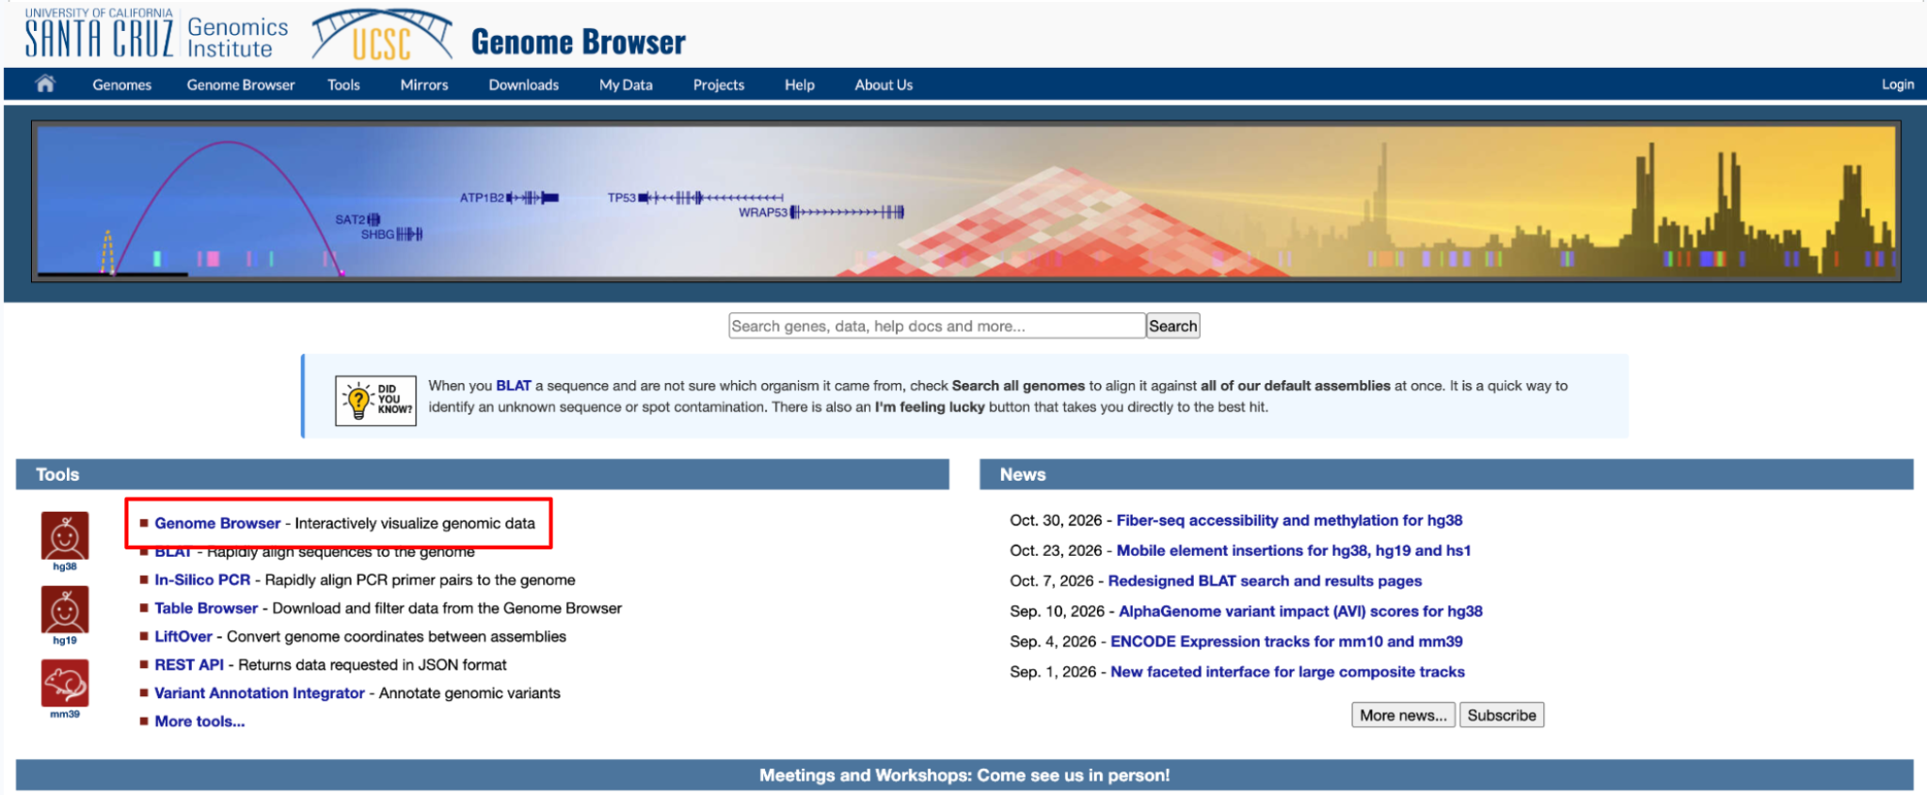

  - Click Go to select the default (human) reference assembly GRCh38
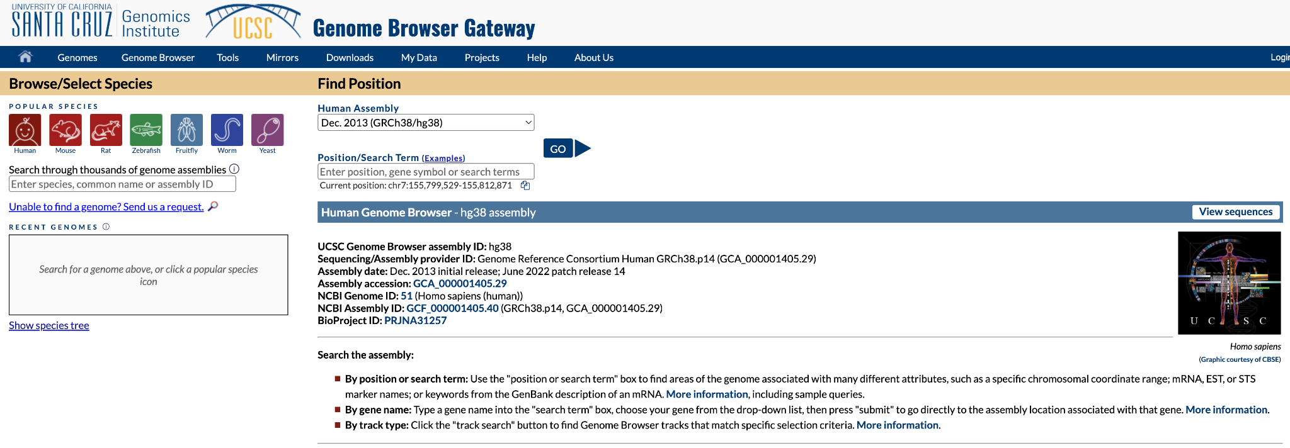

  - Click Hide all to remove all tracks
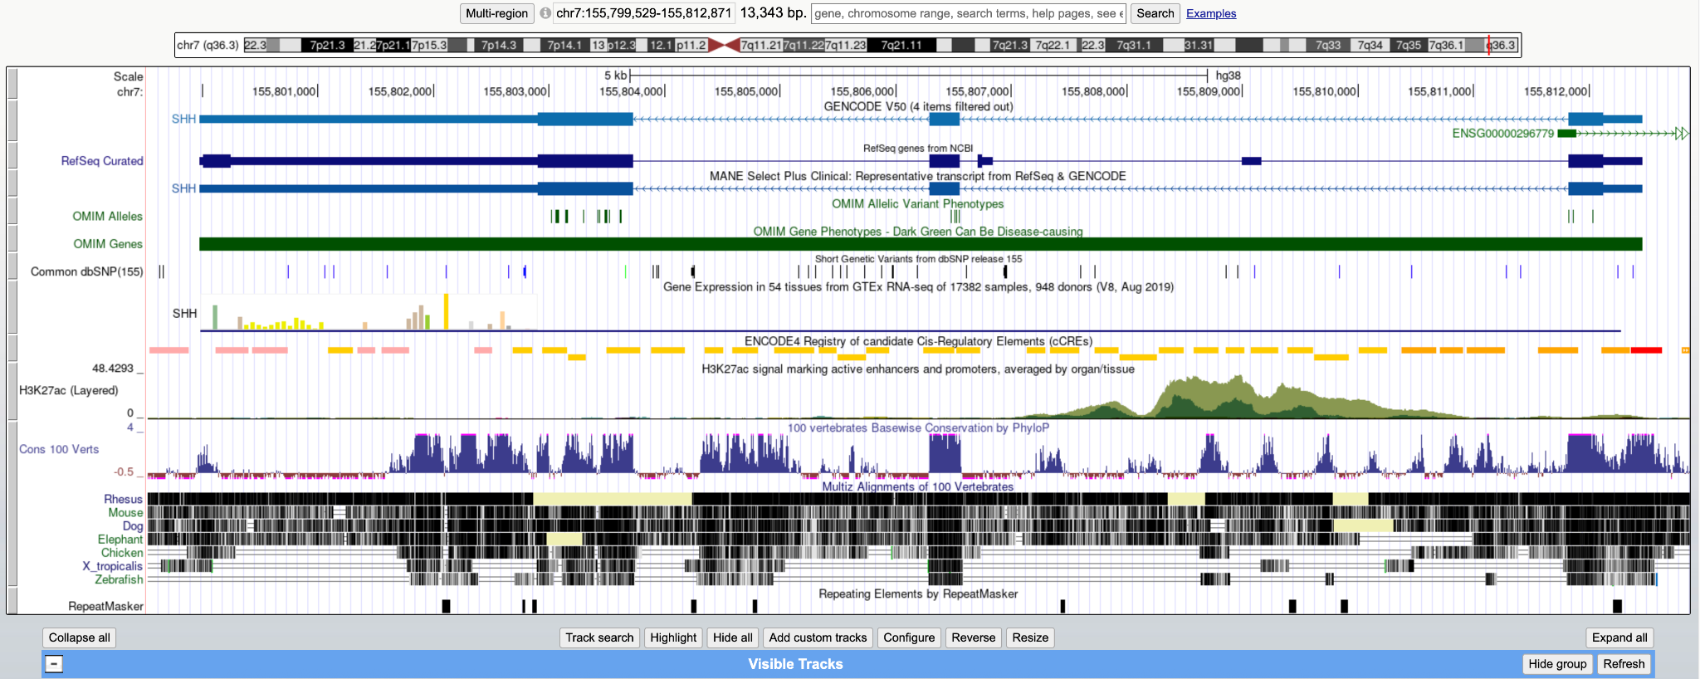

*Note: When you open the browser you see several “tracks”. Tracks are datasets such as genes, variants, or alignments shown on the genome. Each track can be displayed, hidden, or customized using the track configuration section (below).

  - To make genes visible, scroll down to the Genes and Gene Predictions track group and find GENCODE V50. Click the drop down, then select Pack. Click Refresh to update the browser.

- Familiarize yourself with the functionality of the browser
  - Navigate to TP53 by typing TP53 in the search bar, press Search
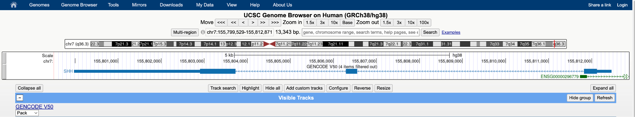

  - Try zooming in and out, moving side to side. Look through the tracks and open one or two that look interesting.

- Viewing Variation
- Add alignments of HPRC assemblies
  - Scroll down to the Human Pangenome - HPRC track group and click the dropdown for Multiple Alignment. Select Full, then press Refresh

- Look for variation in TP53
- Zoom in on a region of TP53 (or another gene of interest) until you see the base-level resolution like the example below.
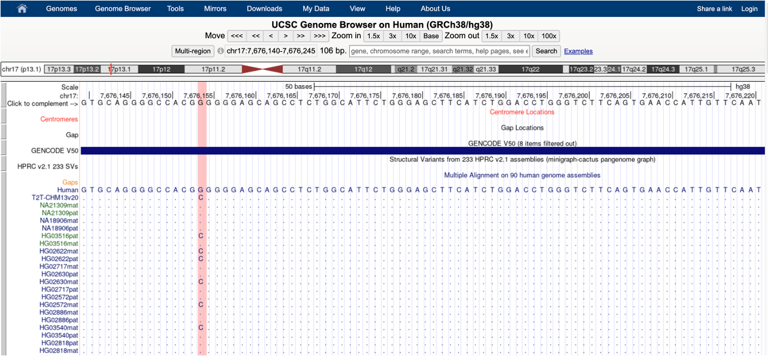

Check in: When we zoom in to the base level, we see the type of single-nucleotide variation we are used to viewing in a genome browser. When we are zoomed out, however, the HPRC alignments are black rectangles. What do the black rectangles represent? What does it mean when the rectangles are broken up?

- Viewing Large Variation
In this section, we will provide fewer detailed screenshots. The goal is for you to explore the Genome Browser independently, interpret the annotations, and discover the results for yourself.

- Navigate to the gene GSTM1
  - Zoom out (10X) to view the gene in its larger context
    - Do you see anything interesting at this zoom level?
  - Add the HPRC Structural Variant calls by navigating to the Variation track group, clicking on the Long-Read SVs text, finding HPRC v3.2 233 SVs. For that track alone, select Dense, then press Submit.
    - If you like, you can simplify the track by changing All LR SVs merged to Hide.

Check in: We can see that GTSM1 has some sort of large variation. What do you think is going on? What is the relationship between the missing regions in the HPRC alignments structural variants?
- The Amylase Locus
In this section, we will independently explore another interesting region: the amylase locus. The amylase locus on holds the genes for salivary amylase and pancreatic amylase, the enzymes that start breaking down starch. It is one of the most structurally variable regions in the human genome. The genes sit inside long, nearly identical segmental duplications, so the number of copies varies a lot between people.

- Navigate to the amylase locus (search for AMY1A)
- Zoom out (10X) to ensure that the entire locus (AMY2B → AMY1C) is visible
    - Notice that in this region the HPRC haplotypes are more variable in terms of where they align to GRCh38.
  - Add segmental duplications annotations by navigating to the Repeats track group, clicking the Segmental Dups dropdown, select Squish, and press Refresh.
    - Segmental duplications are long stretches of DNA that appear more than once in the genome with nearly identical sequence. Where do they fall relative to the AMY genes? (hint: zoom out)

Check in: The variation in the amylase locus looks to be complicated! We are seeing that the alignments of the HPRC2 assemblies to the reference don’t all break at one or two places on the genome, like they did in GTSM1. Instead, they break at multiple locations. What does this imply about the arrangement of the HPRC2 haplotypes as compared to GRCh38?

- Discussion
- TP53. If you’re looking for small variants in a patient’s Illumina reads, do you need a pangenome to analyze TP53? Why does the linear reference work well here?
- GSTM1. Now think about GSTM1, where about half of people are missing the gene that GRCh38 contains. What could go wrong when this patient’s reads are mapped to GRCh38? Would you need a pangenome to get this right, or could a well-known variant like this be handled another way?
- The amylase locus. Here we saw several common arrangements, but GRCh38 can show only one. Clinically important genes such as SMN1/SMN2, CYP2D6 and RHD face the same problem. Could you work out a patient’s arrangement from reads aligned to GRCh38 alone? What would you need instead?

