Instructions for the Pangenome Viewer Hands-on Activity

In this section we will view DNA sequencing reads aligned to linear and pangenome references. We will see examples where reads align poorly to a linear reference and this causes incorrect variant calls. This section uses a small app called the Pangenome Viewer that runs on your laptop and opens a web page showing DNA sequencing reads from one person, HG002, a public reference sample.

Prerequisites:
• A laptop running Windows, macOS or Linux.
• Python 3.
• A recent web browser (Chrome, Edge, Firefox or Safari).
• An internet connection. The viewer loads its display software and reference online.
• The pangenome_viewer folder, from the workshop GitHub page

I. Start the Viewer
1. Get the viewer folder
a. Download the pangenome_viewer zip file from the workshop GitHub page and unzip it.
2. Start the viewer with the launcher for your computer
a. macOS: double-click START_VIEWER_MACOS.command.
i. If macOS blocks it, Control-click the file, choose Open, then confirm Open.
ii. If it says the file is not executable, open Terminal in the folder and type bash START_VIEWER_MACOS.command. This happens when the zip was made on Windows.
b. Windows: double-click START_VIEWER_WINDOWS.bat.
c. Linux: open a terminal in the folder and type bash START_VIEWER_LINUX.sh.
3. Keep the Terminal (or command) window open
4. Your browser opens the viewer
a. If it does not open by itself, type this address in your browser: http://127.0.0.1:8080/index.html
b. If you are unable to see the browser, see Appendix A (Troubleshooting) or ask one of the instructors.

II. Get to Know the Viewer

- Familiarize yourself with the layout of the viewer
  - In the SNV view, two related genes are side by side
    - Each panel has two tracks: Pangenome (top) and Linear (bottom). They are the same reads from the same person, mapped to the two references.
    - The panels move together: drag or zoom one, and the other follows to the matching place in the partner gene.
- Familiarize yourself with the read pileups
a. The bar graph above each set of reads is the coverage. Click or hover on it to see the number.
b. Each grey bar is one read. A colored letter in a read is a base that differs from the reference (A green, C blue, G orange, T red). When many reads show the same color at one position, the coverage bar is colored too: this is a likely variant.
c. A black line through a read is a deletion; a purple mark is an insertion.
d. Pale (white-filled) reads have a low mapping quality (MAPQ): the mapper found more than one place that fits them about equally well.
e. Reads shown with red (or pink) fill are read pairs whose two ends are further apart than expected. In the SV view this points to a deletion between them. In the SNV view it usually means the read’s mate sits in the partner gene, about 20 kb away.
f. In the variant tracks of the SV view, the top bar is the call and the row under it is the genotype: cyan = homozygous (both copies), dark blue = heterozygous (one copy). Click it for details.
g. Click a read to see its details, including its mapping quality (MAPQ). In the SNV view the clicked read is also highlighted in red in all four tracks, so you can follow one read from the Linear track to where it lands in the Pangenome track, even in the other gene.

III. SNV Example 1: SIGLEC11 and SIGLEC16
Background. These two genes are nearly identical copies (they are part of a segmental duplication). With the linear reference, reads from one gene can be attracted to the other gene because their sequence matches it better.
SIGLEC16 encodes an immune receptor. The common allele in GRCh38 (haplotype A, about 80% of people) is a non-functional pseudogene. The functional allele (haplotype B, about 20%) is in the pangenome; compared with GRCh38 it carries a 4 bp insertion in exon 2. Annotation tools label it a frameshift, but it restores the 4 bases missing from the GRCh38 (pseudogene) allele: here the “frameshift” marks the working copy of the gene. HG002 is heterozygous: one copy of each.

- Click SNV, then SIGLEC11 vs SIGLEC16.
- Inspect the read coverage. This sample was sequenced to about 45-50 reads per position
  - First look at the alignments to the linear (bottom tracks) reference. Is the read coverage uneven? Or is it higher than expected in one gene and lower than expected in its partner?
  - Next inspect the read coverage from alignment to the pangenome (top tracks) reference. Does the coverage look even between the gene and its partner?
4. Variants in SIGLEC16
a. Compare the Pangenome and Linear tracks in the right panel. Find colored columns (SNVs) and insertions present with Pangenome but missing with Linear. Zoom out or drag to see more of the gene.
b. Across the gene, the pangenome calls 8 SNVs and the frameshift insertion correctly. With Linear, 7 SNVs and the insertion are missed and one SNV gets the wrong genotype.
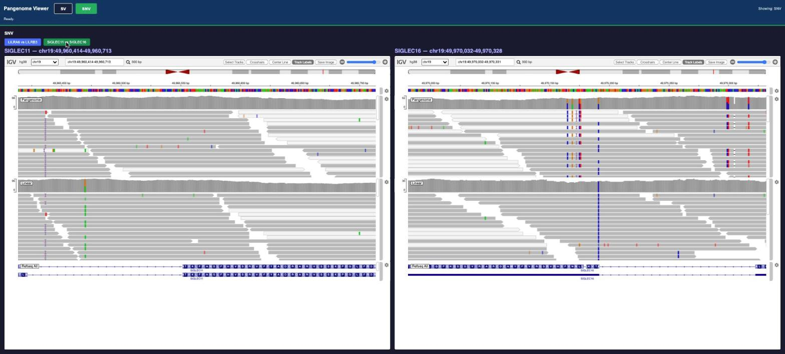
SIGLEC11 (left) and SIGLEC16 (right). Top track Pangenome, bottom track Linear. Note the coverage scale at the left of each track and the variant columns in SIGLEC16 with Pangenome.

Check in: We just saw that with the same reads, but different references we can get very different variant calls. Using the linear reference, reads from the functional SIGLEC16 copy were attracted to SIGLEC11. We also saw a difference in variant calls. With the linear reference this person's functional SIGLEC16 allele, including its frameshift, would not be reported.

Common Gotcha: A high mapping quality does not prove a read is in the right place, and a low one does not prove it is wrong. In these near-identical genes, compare coverage and variants rather than relying on MAPQ.

IV. SNV Example 2 (Your Turn): LILRA6 and LILRB3
Background. LILRB3 is an inhibitory receptor of immune cells, studied in acute myeloid leukemia and organ transplantation. Its partner LILRA6 is a 5.4 kb duplicated copy. A common alternative haplotype of LILRB3 (about 60% in the population) closely matches LILRA6. HG002 has two copies of this alternative haplotype (homozygous). Both are working, protein-coding genes (paralogs): this is not a gene and pseudogene pair.
1. Click SNV, then LILRA6 vs LILRB3.
2. Answer these questions using the things to look for above:
a. With Linear, what is the coverage in LILRA6 and in LILRB3? Which one is far from the expected 45–50?
b. With Pangenome, what happens to the coverage of each gene?
c. Do variants appear in LILRB3 with Pangenome that are not there with Linear? Look closely at position chr19:54,220,736. What could this change do to the protein?
d. Click a few Pangenome reads in LILRB3. What is their mapping quality, and does that mean the calls are wrong?
e. What would a report based on the linear reference have said about LILRB3 for this person?
f. Click a Linear read in LILRA6 that carries many colored bases. Where does the same read go with the Pangenome? With Linear, what are its mapping quality and its number of mismatches (NM, in the popup)?
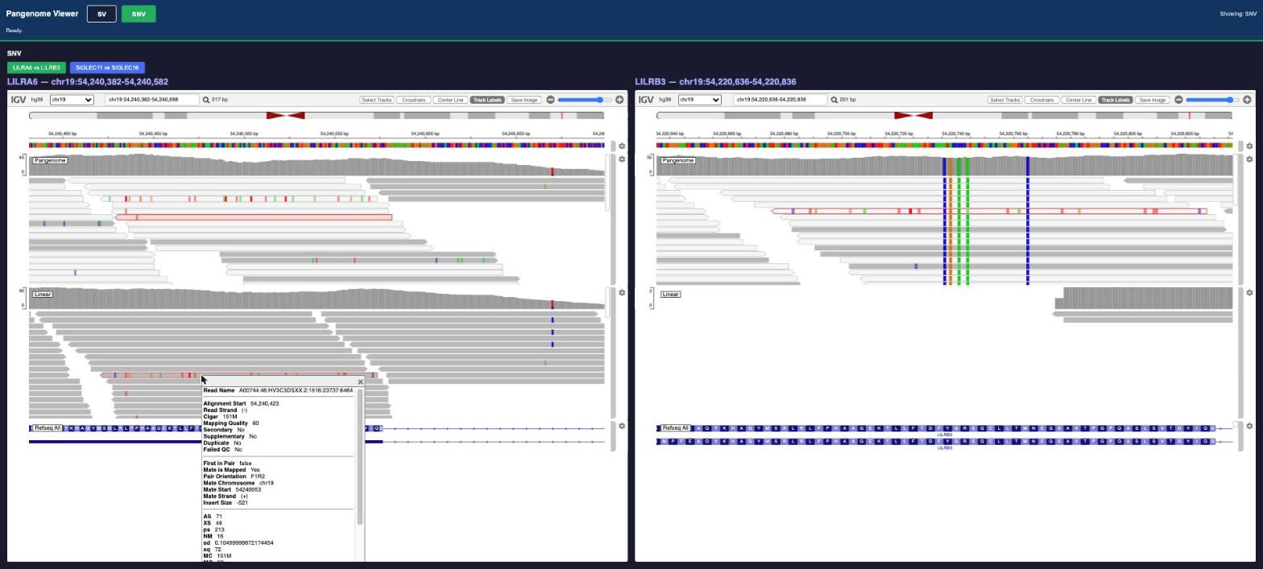
One read, two references. Linear (left, lower track): the clicked read sits in LILRA6 with mapping quality 60 but 16 mismatches. Pangenome (right, upper track): the same read, outlined in red, lands in LILRB3 on the 5 SNV columns.

Note: For answers to the questions above, see Appendix B.

V. SV Example 1: STK11
Background. STK11 is a tumor suppressor gene: its loss of function is linked to hereditary cancer predisposition and tumor development. A common 1,733 bp deletion lies in a VNTR in STK11 (gnomAD allele frequency about 49%). HG002 has it on both copies (homozygous).

Note that the SV examples are not about gene pairs. In this case we are viewing deletions inside a repeat called a VNTR. A VNTR (variable number tandem repeat) is a short sequence repeated many times in a row. With the linear reference, reads map to the correct region but cannot be placed at the right spot inside the repeat. With the pangenome they are placed at the right location within the VNTR, which lets the deletion be detected.

- Navigate to the STK11 example by clicking SV, then STK11.
- Note the differences in the SV view from the SNV view
  - The SV calls from each analysis are shown in the Linear SV variants and Pangenome SV variants tracks
  - Near-complete assemblies of each of HG002's two copies of the chromosome, aligned to the reference are shown in the HG002 Q100 hap1 and hap2 assembly tracks. A gap in the alignment shows where a true deletion is, and on which copy.
  - Read alignments are shown in the Linear alignments and Pangenome alignments tracks
  - Gene annotations are shown in the GENCODE v49 track
- View the structural variants tracks
  - Is there an SV call in the Linear and in the Pangenome variant tracks? Does it match the gap in the HG002 Q100 assembly tracks?
    - The linear analysis made no SV call here.
    - Pangenome SV variants shows a homozygous deletion (cyan genotype row) of 1,733 bp (chr19:1,195,603–1,197,335), exactly where the Q100 gap is.
- Linear alignments: zoom to the deleted stretch
a. Reads still cover it (about 22 reads per position) although it is deleted on both copies. Nearly all of them are faded: MAPQ 0, equally good places in the repeat.
b. Note that no Linear read support the (expected) deletion.
5. Pangenome alignments
a. About 40 reads span the deletion and show it as a black line. Red read pairs on each side also point to missing DNA.
b. Coverage in the deleted stretch drops to about 5, and far fewer reads are faded.
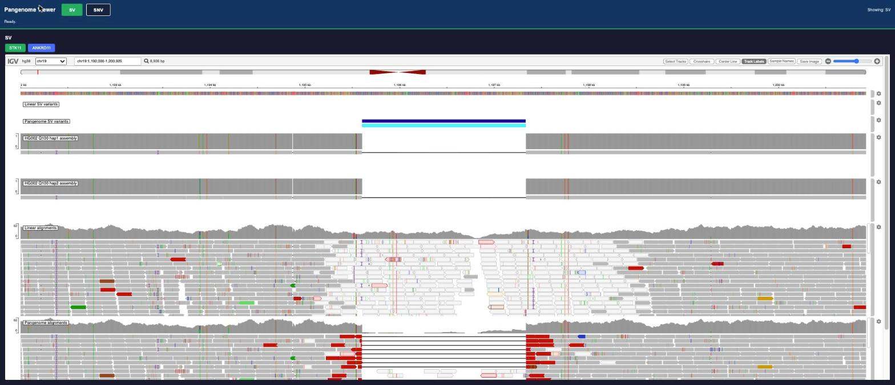
STK11. From the top: Linear SV variants (empty), Pangenome SV variants, HG002 Q100 hap1 and hap2 (the gap is the true deletion), Linear alignments (pale reads across the deletion), Pangenome alignments (black lines across the deletion). Scroll down for the GENCODE genes.

Check in:
In this example, the linear reference placed reads in the correct region but not at the right spo. We saw this as reads being placed in the region which we know from the HG002 Q100 assembly is deleted. The result was a missing call in the linear approach.
The pangenome, by comparison, includes haplotypes with the deletion. This allows for correct read placement, and we see the deletion as a black line spanning the middle of aligned reads. The pangenome approach was able to make the correct SV call.

VI. SV Example 2 (Your Turn): ANKRD11
Background. ANKRD11 is associated with KBG syndrome. A rare 61 bp deletion lies in a VNTR in ANKRD11. According to the HG002 Q100 assembly, HG002 has it on both copies.

1. Click SV, then ANKRD11.
2. Answer these questions:
a. Is there an SV call in the Linear and in the Pangenome variant track? Where, what kind and what size?
b. Does it match the HG002 Q100 hap1 and hap2 tracks?
c. In the Linear alignments, do reads cover the deleted stretch? Look at the colored bases in those reads.
d. In the Pangenome alignments, do reads show the deletion?

VII. Discuss
1. For each example, what changed between Linear and Pangenome: whether the variant was found, the gene it was assigned to, its zygosity?
2. What would change for counseling: classification, residual risk, carrier status, testing of relatives?
3. What to ask your laboratory: which reference and pipeline version, whether the pangenome workflow is validated, and the re-analysis policy. Reports should state the reference and pipeline version.

Appendix A. Troubleshooting
Problem | What to do
macOS blocks the launcher | Control-click START_VIEWER_MACOS.command, choose Open, confirm.
macOS: 'not executable' | In Terminal, in the folder: bash START_VIEWER_MACOS.command.
Python 3 missing | Accept the launcher's offer to install, or install from python.org, then start the launcher again. On a managed laptop, ask IT before the workshop.
'Port 8080 is already in use' | A viewer is already running. Close the older Terminal or command window, then start again.
Browser does not open | Open http://127.0.0.1:8080/index.html by hand.
ERR_CONNECTION_REFUSED | Check the launcher window is still open and says the server is running on 127.0.0.1 port 8080. Read any error in it. Start the launcher again.
No reads shown | Check the bams folder is next to index.html and that you used the launcher (not a double-click on index.html). Developer tools in the browser show any file that failed to load.
'Could not be loaded. Check the internet connection' | The viewer needs internet for IGV.js and the hg38 reference. Reconnect and reload the page.

Appendix B. Answers

SNV Example 2: LILRA6 and LILRB3
a. Linear: LILRA6 about 90 reads, LILRB3 about 1 (almost zero). All LILRB3 reads were attracted to LILRA6.
b. Pangenome: LILRA6 about 40, LILRB3 about 47: evenly shared, close to the expected depth.
c. Yes. 5 SNVs are called correctly in LILRB3 with the pangenome and missed with Linear. The one at chr19:54,220,736 is homozygous and creates a stop codon: premature truncation of LILRB3. The other 4 change an amino acid (missense). It is on a common haplotype and has no known clinical significance; population databases built on the linear reference can under-count it for the same mapping reason.
d. Almost all Pangenome reads in LILRB3 have MAPQ below 10 (about 95%), so they look faded. The variants are still true positives. Low MAPQ reflects how similar the two copies are, not a wrong placement. The confidently mapped (high MAPQ) Linear reads in LILRA6 were the wrong ones.
e. Nothing: no coverage, so no variant. A homozygous stop codon in LILRB3 would be missed.
f. It moves to LILRB3: its red outline appears in the Pangenome track of the right panel, on the 5 SNV columns. With Linear it had mapping quality 60 (the maximum) but 16 mismatches (NM 16) against LILRA6: a confident placement in the wrong gene.
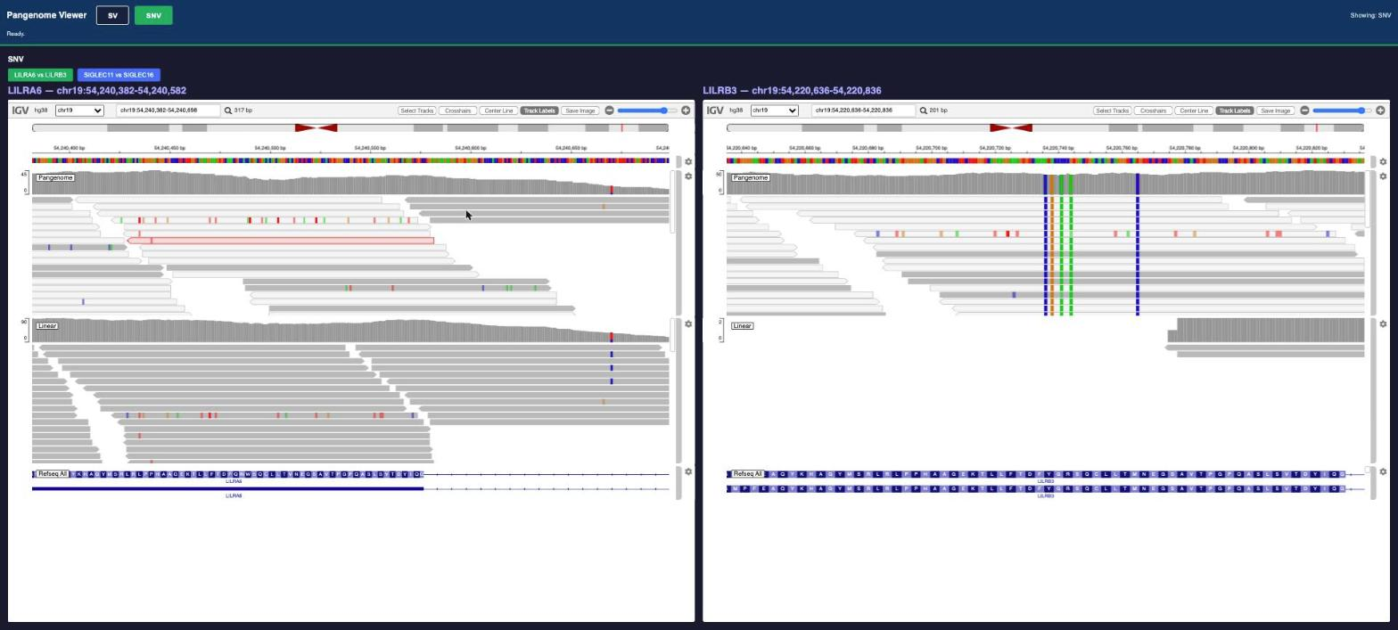
LILRA6 (left) and LILRB3 (right). Linear: about 90 reads in LILRA6, almost none in LILRB3. Pangenome: evenly shared, and the variant columns in LILRB3 appear.

SV Example 2: ANKRD11
a. Linear: no SV call. Pangenome: a homozygous 61 bp deletion (cyan genotype row) at chr16:89,398,327–89,398,387. (The linear small-variant caller can still call it, as a 41 bp and a 20 bp deletion.)
b. Yes, the deletion matches the gap in hap1 and hap2.
c. Yes, about 12 reads per position cover the deleted stretch with Linear. The mapper chose placements inside the repeat that are wrong but look acceptable, with few mismatches.
d. Yes, about 45 reads show the 61 bp deletion as a black line. Coverage in the deleted stretch falls to zero.
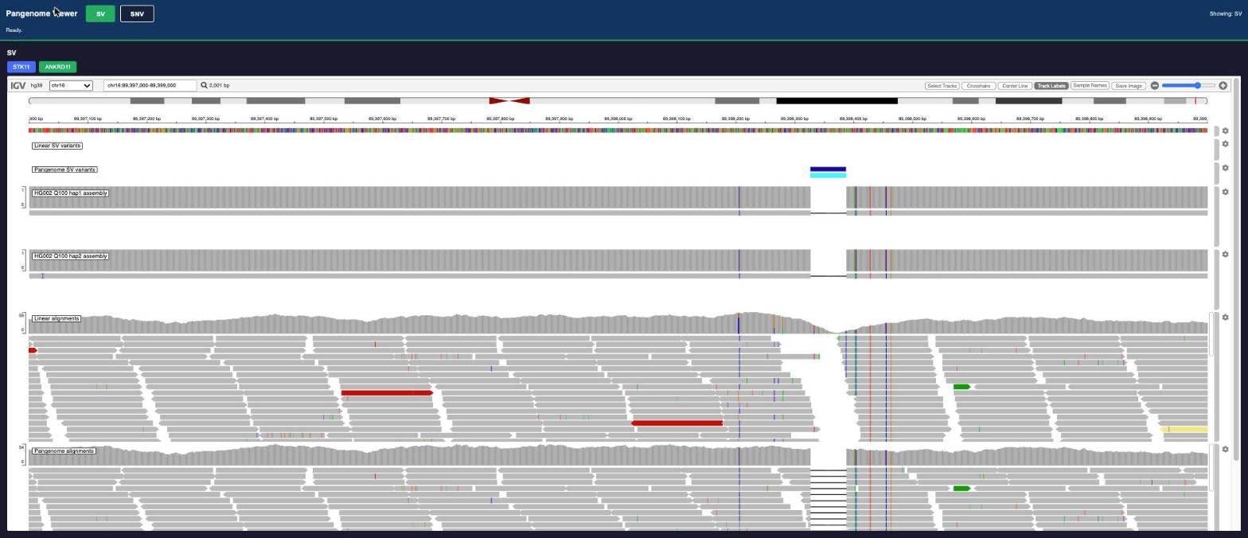
ANKRD11. Pangenome SV variants: the 61 bp deletion; HG002 Q100 hap1 and hap2: the gap on both copies; Pangenome alignments: black lines across the deletion.

Appendix C. Regions, Data and Software
Example | View / button | Region (GRCh38)
SIGLEC11 / SIGLEC16 | SNV / SIGLEC11 vs SIGLEC16 | SIGLEC11 chr19:49,960,414–49,960,713; SIGLEC16 chr19:49,970,032–49,970,328
LILRA6 / LILRB3 | SNV / LILRA6 vs LILRB3 | LILRA6 chr19:54,240,382–54,240,582; LILRB3 chr19:54,220,636–54,220,836
STK11 | SV / STK11 | chr19:1,192,000–1,201,000
ANKRD11 | SV / ANKRD11 | chr16:89,397,000–89,399,000

• Sample: HG002, public, about 45-50x whole-genome sequencing. Reads are mapped with DRAGEN to GRCh38 (Linear) and to the DRAGEN pangenome (Pangenome). Variant calls in the SV view are from DRAGEN 4.7 (pre-release).
• The SNV read files cover the full chr19:49,959,500–49,971,200 interval for the SIGLEC pair, so you can explore beyond the preset window.
• The answer key in the SV view is the HG002 Q100 assembly (hap1 and hap2).
• IGV.js 3.8.10 is loaded from jsDelivr with a fixed version and an integrity check. The hg38 reference is loaded by IGV; GENCODE v49 genes are packaged with the viewer (a two-transcript subset from UCSC). GENCODE is used instead of RefSeq because its longer STK11 transcript spans the whole STK11 region.
• Internal processing paths and command lines were removed from the file headers.

