NSGC 2026 Workshop: Hands-On Activity

These instructions were created for participants in the Human Pangenome Reference Consortium workshop at NSGC 2026. In this section we will learn how to use the UCSC Genome Browser, view HPRC data in the browser, and view large structural variation in HPRC assemblies from the perspective of the reference genome.

- Introduction to the UCSC Genome Browser

In this section, we will provide detailed instructions and screenshots to get everyone set up with the UCSC Genome Browser.

- Navigate to the UCSC Genome Browser
  - Open a web browser (like Chrome)
  - Navigate to https://genome.ucsc.edu/
  - Click Genome Browser to open the browser
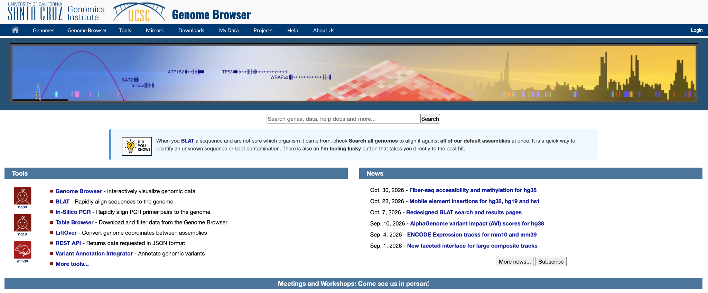

  - Click Go to select the default (human) reference assembly GRCh38
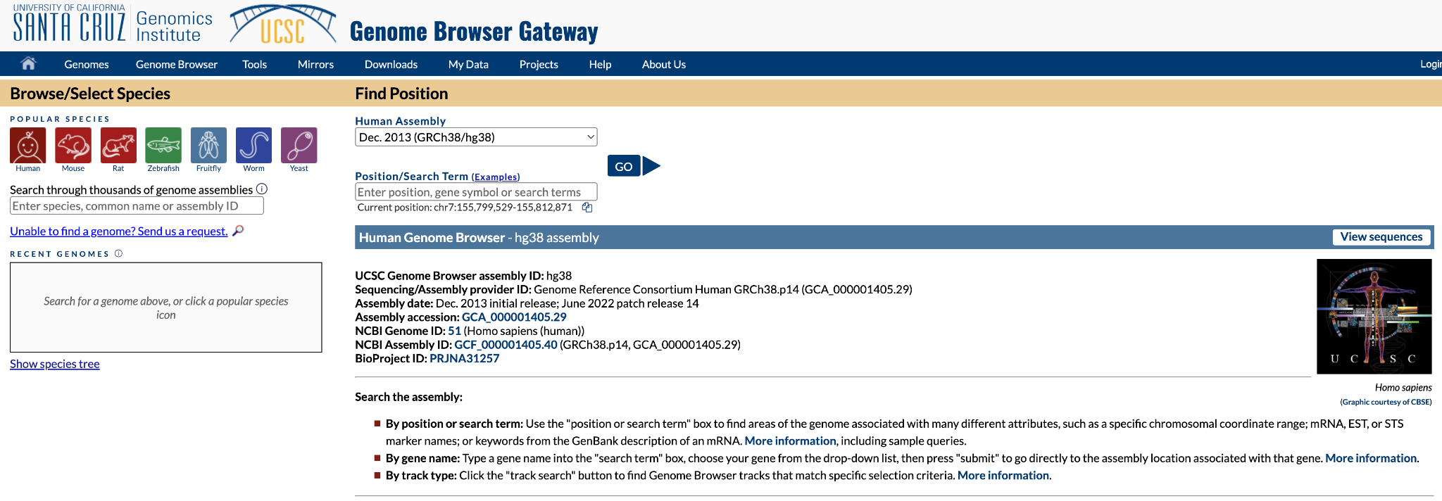

  - Click Hide all to remove all of the tracks
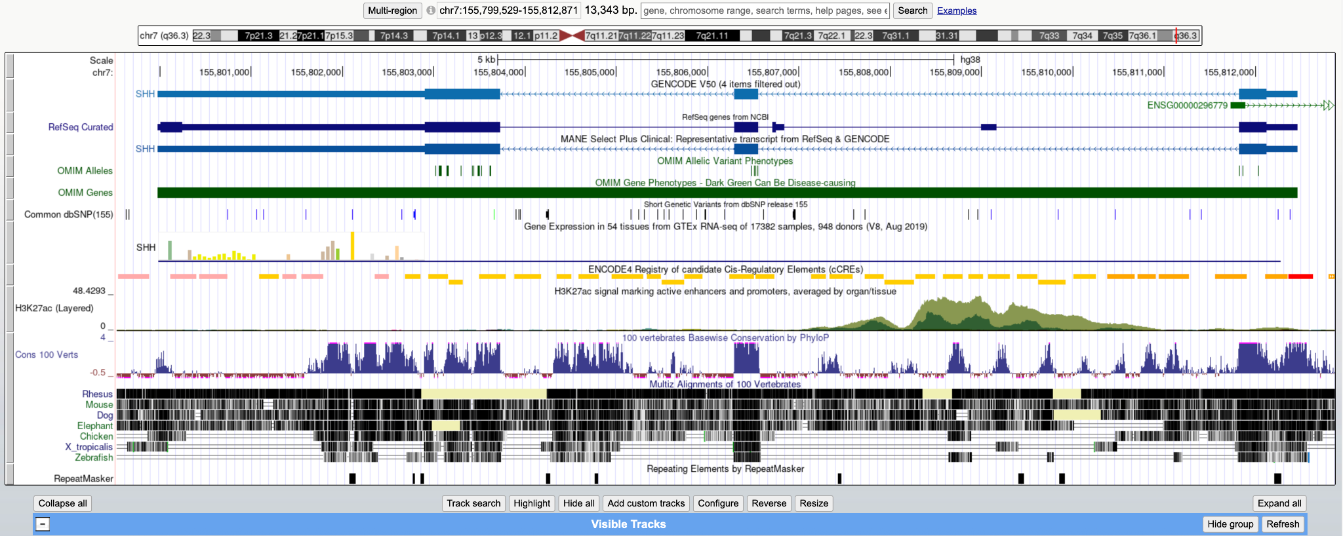

*Note: When you open the browser you see several “tracks”. Tracks are datasets such as genes, variants, or alignments shown on the genome. Each track can be displayed, hidden, or customized using the track configuration section (below).

  - To make genes visible, scroll down to the Genes and Gene Predictions track group and find GENCODE V50. Click the drop down, then select Pack. Click Refresh to update the browser.

- Familiarize yourself with the functionality of the browser
  - Navigate to TP53 by typing TP53 in to the search bar, press Search
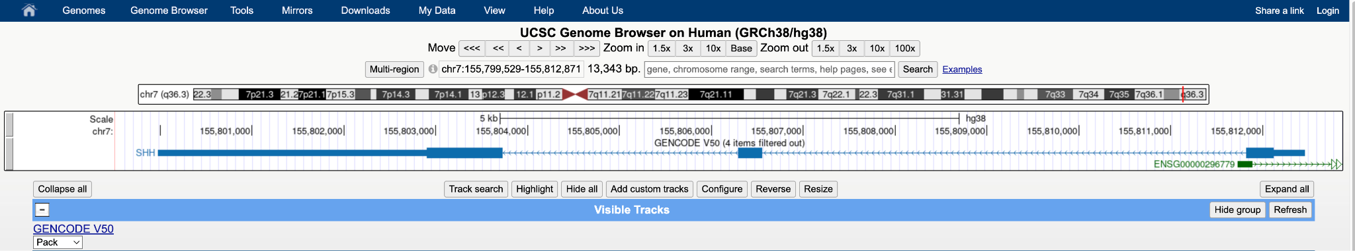

  - Try zooming in and out, moving side to side. Look through the tracks and open one or two that look interesting.

- Viewing Variation
- Add alignments of HPRC assemblies
  - Scroll down to the Human Pangenome - HPRC track group and click the dropdown for Multiple Alignment. Select Full, then press Refresh

- Look variation in TP53
- Zoom in on a region of TP53 (or another gene of interest) until you see the base-level resolution like the example below.
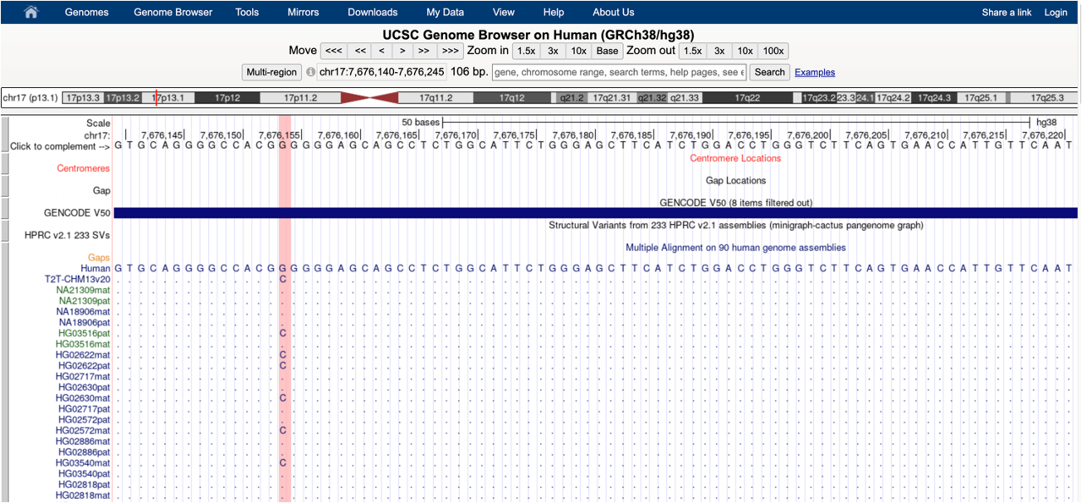

Check in: When we zoom in to the base level we see the type of single-nucleotide variation we are used to viewing in a genome browser. When we are zoomed out, however, the HPRC alignments are black rectangles. What do the black rectangles represent? What does it mean when the rectangles are broken up?

- Viewing Large Variation
In this section, we will provide fewer detailed screenshots. The goal is for you to explore the Genome Browser independently, interpret the annotations, and discover the results for yourself.

- Navigate to the gene GSTM1
  - Zoom out (10X) to view the gene in its larger context
    - Do you see anything interesting at this zoom level?
  - Add the HPRC Structural Variant calls by navigating to the Variation track group, clicking on the Long-Read SVs text, finding HPRC v3.2 233 SVs. For that track alone, select Dense, then press Submit.
    - If you like, you can simplify the track by changing All LR SVs merged to Hide.

Check in: We can see that GTSM1 has some sort of large variation. What do you think is going on? What is the relationship between the missing regions in the HPRC alignments structural variants?
- The Amylase Locus
In this section, we will independently explore another interesting region: the Amylase locus.

- Navigate to the aymlase locus (search for AMY1A)
- Zoom out (10X) to ensure that the entire locus (AMY2B → AMY1C) is visible
    - Notice that in this region the HPRC haplotypes are more variable in terms of where they align to GRCh38.
  - Add segmental duplications by navigating to the Repeats track group, clicking the Segmental Dups dropdown, select Squish, and press Refresh.
    - Zoom out again to see that the segmental duplications are concentrated around the amylase locus.
    - What do you think the segmental duplications represent? How are they involved in the haplotypic variation we are seeing?

Check in: The variation in the amylase locus looks to be complicated! In this region, do you think you can reconstruct what is happening in a patient sample’s genome using just GRCh38? In common analyses like mapping Illumina reads against the reference, would using GRCh38 alone “hide” any variation? What types?

