CAN THO UNIVERSITY
SCHOOL OF INFORMATION AND COMMUNICATION TECHNOLOGY
DEPARTMENT OF SOFTWARE ENGINEERING



FINAL REPORT
COURSE: CT219H - Application Programming with .NET
TOPIC: STUDENT MANAGEMENT

Student: | Supervisor:
Le Tran Hieu Nhan - B2308203 | Dr. Nguyen Cong Danh

Can Tho, 02/2026

I. SURVEY AND REQUIREMENTS ANALYSIS 1
1. Current Situation: 1
2. Requirements Analysis: 1
3. Functional Decomposition Diagram: 3
II. ANALYSIS AND DESIGN 4
I. Use Case Modeling 4
II. Use Case Specifications 6
III. Sequence Diagrams 24
III. DESIGN 34
I. Database Design 34
IV. CONCLUSION AND FUTURE DEVELOPMENT 42
A. Difficulties Encountered During Implementation 42
B. Achievements 42
C. References 43
D. Future Development 43

I. SURVEY AND REQUIREMENTS ANALYSIS

Current Situation:
Today, with the continuous development of computer science, many tasks that used to be performed manually, requiring considerable time and effort, are gradually being replaced by automated systems. These systems provide convenience for users and also help organizations operate in a more professional and efficient manner. From this practical demand, many software applications and tools have emerged to manage and process work on behalf of humans.
In educational management, as the number of students continues to increase, calculating scores and classifying students' academic performance at the end of each semester or school year requires more and more time and effort from academic staff and subject teachers. Therefore, developing a "Student Grading Management" software system for a school is essential in order to save time and effort for teachers and academic officers while also improving the accuracy of score calculation and student classification. This is a necessary and effective support tool that makes the work easier and saves significant time and effort.
Based on the practical needs above, I chose the topic "Student Grade Management" to manage student information and grades for the entire school.

2. Requirements Analysis:
- Problem Analysis: Building a "Grade Management" information system
A department requires the development of a student grade management system. The academic officer at the departmental office must enter grades from the grade sheets submitted by the subject divisions. The academic officer can print grade sheets and lists of students who did not pass (and must retake the exam or the course). Students can log in and view their own grades.
When students are admitted to the school, they submit their records to the Academic Affairs Office, which stores information about both students and teachers when they first join the school. The Academic Affairs Office is also responsible for assigning students to departments based on registration and assigning teachers to departments according to their specialties.
Input data sources include student information, teacher information, class assignment data, and teacher assignment data that have already been entered by the Academic Affairs Office (internal data source). However, since this is software, it cannot update information by itself, so teacher and student information must still be entered into the system. Therefore, the academic officer is responsible for entering student information, teacher information, assigning teachers according to their specialties, and assigning students to classes based on the records they submitted to the Academic Affairs Office. This leads to the functions of adding, editing, and deleting student and teacher records.
In many departments, the academic officer is usually the department secretary (and may also be a teacher teaching in that department). Therefore, the "academic officer" may be a teacher who has the right to add, edit, and delete student grades submitted by other teachers, or may simply be an office staff member responsible for recording grade sheets and being accountable for the entered grade information. Objectively, the academic officer should be a separate person who specializes in grade management to ensure fairness for students. Thus, within the scope of this project, the ICTV4 Group 4 considers the academic officer to be a staff member of the department responsible for managing student grades, with functions to add, edit, and delete grade records.
Teachers and students can log into the system to view their own information and student grades. Any mistakes made during data entry by the academic officer can be reported by students to the manager (academic officer). This leads to the functions of grade inquiry and personal information lookup. To log into the system, students, teachers, and academic officers all need appropriate access rights. This leads to the authorization function.
From the preliminary analysis above, the software system must include the following functions:
- Add, edit, and delete Students and Teachers.
- Add, edit, and delete grade records.
- Look up grades.
- Look up personal information.
- System authorization.
- User Requirements:
Clients: Teachers, Students
Teachers:
- Can view their own information, the classes assigned to them, student information, and student grades.
- For any data errors, teachers report them to the academic officer, who will correct and update them.
Students:
- Can view their own information, grades, and academic results.
Manager: Academic officer
* Includes the permissions of students and teachers. In addition, this role can view its own information; add, edit, and delete pupil, teacher, and student records; create classes; assign students to classes; and manage other teachers' information. Since this is essentially the main user, this role has almost full system permissions.
Administrator: the highest-privileged user who manages academic officers
- Has full authority but usually only uses the authorization system to grant and modify permissions.
- Manager Requirements:
The manager requires the software developer to build the software with the following functions:
  - Provide authorization for different types of users.
  - Support the entry of basic information for class teachers as well as academic officers.
  - Support entering student information upon admission.
  - Support assigning students to classes at the beginning of the school year.
  - Support entering student grades.
  - Support grade statistics and academic classification for students by class.
  - Look up student and teacher information.
  - User guide and support file
  - Contact information, software warranty policy, bug-fix updates, and further software development suited to real-world needs.

3. Functional Decomposition Diagram:

Figure 1. Functional Decomposition Diagram
- Grade management: the most general function of the system.
  - Student and teacher profile management: used to modify or add new information about students. This function can only be used by the manager (academic officer) or the system administrator.
  - Grade management: used to modify or add new exam scores for each student. This function can only be used by the manager (academic officer) or the system administrator.
    - Statistics and reporting: used to summarize student information by subject and course, and to print reports such as an individual student's transcript, retake grade sheets, and subject grade sheets.

II. ANALYSIS AND DESIGN

I. Use Case Modeling
1. General Use Case Diagram for All Actors

Figure 2: General Use Case Diagram
2. Use Case Diagram for the Manager Actor
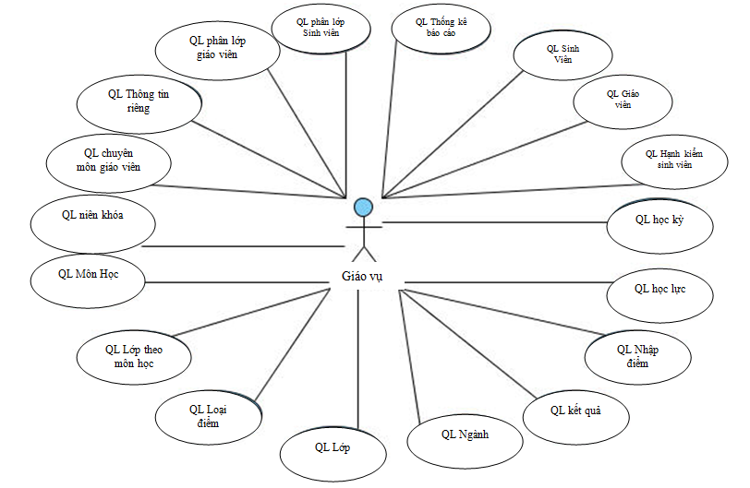
Figure 3: Use Case Diagram for the Manager Actor (Academic Officer)
- Use Case Diagram for the Teacher Actor:
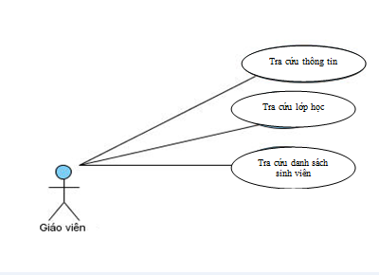
Figure 4: Use Case Diagram for the Teacher Actor (Client 1)
- Use Case Diagram for the Student Actor:
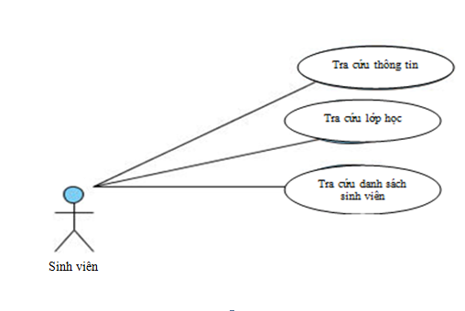
Figure 4: Use Case Diagram for the Student Actor (Client 2)

II. Use Case Specifications
1. Login Use Case Specification
Description: The user logs into the system.
Precondition: The system has not been logged into yet.
Main flow:
1. From the main interface, the user chooses to log into the system.
2. The system requires the user to enter login information (username and password).
3. The user enters the login information.
4. The user clicks the Log In button. [Exception a]
5. The system validates the login information. [Exception b]
6. The system notifies that the login is successful.
7. The use case ends.
Exception a: The user clicks the Cancel button.
a.4. The user clicks the Cancel button when they no longer wish to log in.
a.5. The use case ends.
Exception b: Invalid information.
b.5. The login information is invalid.
b.6. The system notifies that the login information is invalid and the login attempt is unsuccessful.
b.7. The use case ends.
Result: Login successful.
2. User Management Use Case Specification
Description: This function allows the administrator to manage user information, including adding, updating, and deleting user accounts.
Precondition: The user must be logged into the system with administrator privileges.
Main flow:
1. From the main interface, the user selects user management.
2. The system displays the user management interface.
a. Add user: The administrator wants to add a new user.
a.3. The administrator clicks the Add New button.
a.4. The system requests the information of the user to be added.
a.5. The administrator enters the information of the user to be added.
a.6. The administrator clicks Save. [Exception d]
a.7. The system validates the user information. [Exception e]
a.8. The user is added successfully, and the Add User use case ends.
Exception d: The administrator does not want to continue adding a new user.
d.6. The administrator clicks the Skip button.
d.7. The user is not added, and the Add User use case ends.
Exception e: Invalid user information.
e.7. The system reports that the user information to be added is invalid and asks the user to re-enter it.
e.8. Return to step a.5.
Result: A user is added to the system.
b. Update user: The administrator wants to update user information.
b.3. The administrator selects the user to be updated.
b.4. The administrator re-enters the user information.
b.5. The administrator clicks Save. [Exception f]
b.6. The system validates the user information. [Exception g]
b.7. The update is successful, and the Update User use case ends.
Exception f: The administrator no longer wants to update the user information.
f.5. The administrator clicks the Skip button.
f.6. The administrator no longer updates the user, and the Update User use case ends.
Exception g: Invalid user information.
g.6. The system reports that the user information is invalid and asks the user to re-enter it.
g.7. Return to step b.4.
Result: The information of a user in the system is updated.
c. Delete user: The administrator wants to delete a user.
c.3. The administrator selects the user to be deleted.
c.4. The administrator clicks the Delete button.
c.5. The system asks for confirmation of whether the deletion is really intended.
c.6. The administrator confirms the deletion. [Exception h]
c.7. The system checks the constraints. [Exception i]
c.8. The selected user is removed from the system, and the Delete User use case ends.
Exception h: The administrator confirms that they do not want to delete.
h.7. The Delete User use case ends without removing the user.
Exception i: There are constraints.
i.7. The system reports that there are constraints and the deletion cannot be performed; the Delete User use case ends.
Result: A user is removed from the system.

3. Change Password Use Case Specification
Description: This function allows the user to change the current password.
Precondition: The user must be logged into the system.
Main flow:
1. From the main interface, the user selects Change Password.
2. The system displays the Change Password interface.
3. The system requires the following information: old password, new password, and password confirmation.
4. The user enters the required information.
5. The user clicks the OK button. [Exception a]
6. The system validates the information. [Exception b]
7. The password is changed successfully.
Exception a: The user does not want to change the password.
a.5. The user chooses to cancel.
a.6. The Change Password use case ends.
Exception b: Invalid password.
b.6. The system reports an incorrect password and asks the user to re-enter the password information.
b.7. Return to step 4.
Result: Password changed successfully.

4. Academic Year Management Use Case Specification
Description: This function allows the manager to manage academic year, including adding, updating, and deleting academic year information.
Precondition: The user must be logged into the system with manager privileges.
Main flow:
1. From the main interface, the user selects academic year management.
2. The system displays the academic year management interface.
a. Add academic year: The user wants to add a new academic year.
a.3. The user clicks the Add New button.
a.4. The system requests the information of the academic year to be added.
a.5. The user enters the information of the academic year to be added.
a.6. The user clicks Save. [Exception d]
a.7. The system validates the academic year information. [Exception e]
a.8. Addition successful; the Add Academic Year use case ends.
Exception d: The user does not want to add a new academic year.
d.5. The user clicks the Skip button.
d.6. The user does not want to add the academic year anymore, and the Add Academic Year use case ends.
Exception e: Invalid academic year information.
e.7. The system reports that the academic year information to be added is invalid and asks the user to re-enter it.
e.8. Return to step a.5.
Result: An academic year is added to the system.
b. Update academic year: The user wants to update the information of the academic year.
b.3. The user selects the academic year to be updated.
b.4. The user re-enters the academic year information.
b.5. The user clicks Save. [Exception f]
b.6. The system validates the academic year information. [Exception g]
b.7. Update successful; the Update Academic Year use case ends.
Exception f: The user no longer wants to update the academic year information.
f.3. The user clicks the Skip button.
f.4. The Update Academic Year use case ends.
Exception g: Invalid academic year information.
g.5. The system reports that the academic year information is invalid and asks the user to re-enter it.
g.6. Return to step b.4.
Result: The information of an academic year in the system is updated.
c. Delete academic year: The user wants to delete the academic year.
c.3. The user selects the academic year to be deleted.
c.4. The user clicks the Delete button.
c.5. The system asks for confirmation of whether the deletion is really intended.
c.6. The user confirms the deletion. [Exception h]
c.7. The system checks the constraints. [Exception g]
c.8. The selected academic year is removed from the system, and the Delete Academic Year use case ends.
Exception h: The user does not want to delete the academic year.
h.6. The user confirms that they do not want to delete.
h.7. The Delete Academic Year use case ends without removing the academic year.
Exception g: There are constraints.
g.7. The system reports that there are constraints and the deletion cannot be performed; the Delete Academic Year use case ends.
Result: An academic year is removed from the system.

5. Semester Management Use Case Specification
Description: This function allows the manager to manage semester, including adding, updating, and deleting semester information.
Precondition: The user must be logged into the system with manager privileges.
Main flow:
1. From the main interface, the user selects semester management.
2. The system displays the semester management interface.
a. Add semester: The user wants to add a new semester.
a.3. The user clicks the Add New button.
a.4. The system requests the information of the semester to be added.
a.5. The user enters the information of the semester to be added.
a.6. The user clicks Save. [Exception d]
a.7. The system validates the semester information. [Exception e]
a.8. Addition successful; the Add Semester use case ends.
Exception d: The user does not want to add a new semester.
d.5. The user clicks the Skip button.
d.6. The user does not want to add the semester anymore, and the Add Semester use case ends.
Exception e: Invalid semester information.
e.7. The system reports that the semester information to be added is invalid and asks the user to re-enter it.
e.8. Return to step a.5.
Result: A semester is added to the system.
b. Update semester: The user wants to update the information of the semester.
b.3. The user selects the semester to be updated.
b.4. The user re-enters the semester information.
b.5. The user clicks Save. [Exception f]
b.6. The system validates the semester information. [Exception g]
b.7. Update successful; the Update Semester use case ends.
Exception f: The user no longer wants to update the semester information.
f.3. The user clicks the Skip button.
f.4. The Update Semester use case ends.
Exception g: Invalid semester information.
g.5. The system reports that the semester information is invalid and asks the user to re-enter it.
g.6. Return to step b.4.
Result: The information of a semester in the system is updated.
c. Delete semester: The user wants to delete the semester.
c.3. The user selects the semester to be deleted.
c.4. The user clicks the Delete button.
c.5. The system asks for confirmation of whether the deletion is really intended.
c.6. The user confirms the deletion. [Exception h]
c.7. The system checks the constraints. [Exception g]
c.8. The selected semester is removed from the system, and the Delete Semester use case ends.
Exception h: The user does not want to delete the semester.
h.6. The user confirms that they do not want to delete.
h.7. The Delete Semester use case ends without removing the semester.
Exception g: There are constraints.
g.7. The system reports that there are constraints and the deletion cannot be performed; the Delete Semester use case ends.
Result: A semester is removed from the system.
7. Class Management Use Case Specification
Description: This function allows the manager to manage class, including adding, updating, and deleting class information.
Precondition: The user must be logged into the system with manager privileges.
Main flow:
1. From the main interface, the user selects class management.
2. The system displays the class management interface.
a. Add class: The user wants to add a new class.
a.3. The user clicks the Add New button.
a.4. The system requests the information of the class to be added.
a.5. The user enters the information of the class to be added.
a.6. The user clicks Save. [Exception d]
a.7. The system validates the class information. [Exception e]
a.8. Addition successful; the Add Class use case ends.
Exception d: The user does not want to add a new class.
d.5. The user clicks the Skip button.
d.6. The user does not want to add the class anymore, and the Add Class use case ends.
Exception e: Invalid class information.
e.7. The system reports that the class information to be added is invalid and asks the user to re-enter it.
e.8. Return to step a.5.
Result: A class is added to the system.
b. Update class: The user wants to update the information of the class.
b.3. The user selects the class to be updated.
b.4. The user re-enters the class information.
b.5. The user clicks Save. [Exception f]
b.6. The system validates the class information. [Exception g]
b.7. Update successful; the Update Class use case ends.
Exception f: The user no longer wants to update the class information.
f.3. The user clicks the Skip button.
f.4. The Update Class use case ends.
Exception g: Invalid class information.
g.5. The system reports that the class information is invalid and asks the user to re-enter it.
g.6. Return to step b.4.
Result: The information of a class in the system is updated.
c. Delete class: The user wants to delete the class.
c.3. The user selects the class to be deleted.
c.4. The user clicks the Delete button.
c.5. The system asks for confirmation of whether the deletion is really intended.
c.6. The user confirms the deletion. [Exception h]
c.7. The system checks the constraints. [Exception g]
c.8. The selected class is removed from the system, and the Delete Class use case ends.
Exception h: The user does not want to delete the class.
h.6. The user confirms that they do not want to delete.
h.7. The Delete Class use case ends without removing the class.
Exception g: There are constraints.
g.7. The system reports that there are constraints and the deletion cannot be performed; the Delete Class use case ends.
Result: A class is removed from the system.
.
8. Subject Management Use Case Specification
Description: This function allows the manager to manage subject, including adding, updating, and deleting subject information.
Precondition: The user must be logged into the system with manager privileges.
Main flow:
1. From the main interface, the user selects subject management.
2. The system displays the subject management interface.
a. Add subject: The user wants to add a new subject.
a.3. The user clicks the Add New button.
a.4. The system requests the information of the subject to be added.
a.5. The user enters the information of the subject to be added.
a.6. The user clicks Save. [Exception d]
a.7. The system validates the subject information. [Exception e]
a.8. Addition successful; the Add Subject use case ends.
Exception d: The user does not want to add a new subject.
d.5. The user clicks the Skip button.
d.6. The user does not want to add the subject anymore, and the Add Subject use case ends.
Exception e: Invalid subject information.
e.7. The system reports that the subject information to be added is invalid and asks the user to re-enter it.
e.8. Return to step a.5.
Result: A subject is added to the system.
b. Update subject: The user wants to update the information of the subject.
b.3. The user selects the subject to be updated.
b.4. The user re-enters the subject information.
b.5. The user clicks Save. [Exception f]
b.6. The system validates the subject information. [Exception g]
b.7. Update successful; the Update Subject use case ends.
Exception f: The user no longer wants to update the subject information.
f.3. The user clicks the Skip button.
f.4. The Update Subject use case ends.
Exception g: Invalid subject information.
g.5. The system reports that the subject information is invalid and asks the user to re-enter it.
g.6. Return to step b.4.
Result: The information of a subject in the system is updated.
c. Delete subject: The user wants to delete the subject.
c.3. The user selects the subject to be deleted.
c.4. The user clicks the Delete button.
c.5. The system asks for confirmation of whether the deletion is really intended.
c.6. The user confirms the deletion. [Exception h]
c.7. The system checks the constraints. [Exception g]
c.8. The selected subject is removed from the system, and the Delete Subject use case ends.
Exception h: The user does not want to delete the subject.
h.6. The user confirms that they do not want to delete.
h.7. The Delete Subject use case ends without removing the subject.
Exception g: There are constraints.
g.7. The system reports that there are constraints and the deletion cannot be performed; the Delete Subject use case ends.
Result: A subject is removed from the system.
.
9. Teacher Management Use Case Specification
Description: This function allows the manager to manage teacher, including adding, updating, and deleting teacher information.
Precondition: The user must be logged into the system with manager privileges.
Main flow:
1. From the main interface, the user selects teacher management.
2. The system displays the teacher management interface.
a. Add teacher: The user wants to add a new teacher.
a.3. The user clicks the Add New button.
a.4. The system requests the information of the teacher to be added.
a.5. The user enters the information of the teacher to be added.
a.6. The user clicks Save. [Exception d]
a.7. The system validates the teacher information. [Exception e]
a.8. Addition successful; the Add Teacher use case ends.
Exception d: The user does not want to add a new teacher.
d.5. The user clicks the Skip button.
d.6. The user does not want to add the teacher anymore, and the Add Teacher use case ends.
Exception e: Invalid teacher information.
e.7. The system reports that the teacher information to be added is invalid and asks the user to re-enter it.
e.8. Return to step a.5.
Result: A teacher is added to the system.
b. Update teacher: The user wants to update the information of the teacher.
b.3. The user selects the teacher to be updated.
b.4. The user re-enters the teacher information.
b.5. The user clicks Save. [Exception f]
b.6. The system validates the teacher information. [Exception g]
b.7. Update successful; the Update Teacher use case ends.
Exception f: The user no longer wants to update the teacher information.
f.3. The user clicks the Skip button.
f.4. The Update Teacher use case ends.
Exception g: Invalid teacher information.
g.5. The system reports that the teacher information is invalid and asks the user to re-enter it.
g.6. Return to step b.4.
Result: The information of a teacher in the system is updated.
c. Delete teacher: The user wants to delete the teacher.
c.3. The user selects the teacher to be deleted.
c.4. The user clicks the Delete button.
c.5. The system asks for confirmation of whether the deletion is really intended.
c.6. The user confirms the deletion. [Exception h]
c.7. The system checks the constraints. [Exception g]
c.8. The selected teacher is removed from the system, and the Delete Teacher use case ends.
Exception h: The user does not want to delete the teacher.
h.6. The user confirms that they do not want to delete.
h.7. The Delete Teacher use case ends without removing the teacher.
Exception g: There are constraints.
g.7. The system reports that there are constraints and the deletion cannot be performed; the Delete Teacher use case ends.
Result: A teacher is removed from the system.

10. Student Management Use Case Specification
Description: This function allows the manager to manage student, including adding, updating, and deleting student information.
Precondition: The user must be logged into the system with manager privileges.
Main flow:
1. From the main interface, the user selects student management.
2. The system displays the student management interface.
a. Add student: The user wants to add a new student.
a.3. The user clicks the Add New button.
a.4. The system requests the information of the student to be added.
a.5. The user enters the information of the student to be added.
a.6. The user clicks Save. [Exception d]
a.7. The system validates the student information. [Exception e]
a.8. Addition successful; the Add Student use case ends.
Exception d: The user does not want to add a new student.
d.5. The user clicks the Skip button.
d.6. The user does not want to add the student anymore, and the Add Student use case ends.
Exception e: Invalid student information.
e.7. The system reports that the student information to be added is invalid and asks the user to re-enter it.
e.8. Return to step a.5.
Result: A student is added to the system.
b. Update student: The user wants to update the information of the student.
b.3. The user selects the student to be updated.
b.4. The user re-enters the student information.
b.5. The user clicks Save. [Exception f]
b.6. The system validates the student information. [Exception g]
b.7. Update successful; the Update Student use case ends.
Exception f: The user no longer wants to update the student information.
f.3. The user clicks the Skip button.
f.4. The Update Student use case ends.
Exception g: Invalid student information.
g.5. The system reports that the student information is invalid and asks the user to re-enter it.
g.6. Return to step b.4.
Result: The information of a student in the system is updated.
c. Delete student: The user wants to delete the student.
c.3. The user selects the student to be deleted.
c.4. The user clicks the Delete button.
c.5. The system asks for confirmation of whether the deletion is really intended.
c.6. The user confirms the deletion. [Exception h]
c.7. The system checks the constraints. [Exception g]
c.8. The selected student is removed from the system, and the Delete Student use case ends.
Exception h: The user does not want to delete the student.
h.6. The user confirms that they do not want to delete.
h.7. The Delete Student use case ends without removing the student.
Exception g: There are constraints.
g.7. The system reports that there are constraints and the deletion cannot be performed; the Delete Student use case ends.
Result: A student is removed from the system.

11. Academic Performance Management Use Case Specification
Description: This function allows the manager to manage academic performance, including adding, updating, and deleting academic performance information.
Precondition: The user must be logged into the system with manager privileges.
Main flow:
1. From the main interface, the user selects academic performance management.
2. The system displays the academic performance management interface.
a. Add academic performance record: The user wants to add a new academic performance record.
a.3. The user clicks the Add New button.
a.4. The system requests the information of the academic performance record to be added.
a.5. The user enters the information of the academic performance record to be added.
a.6. The user clicks Save. [Exception d]
a.7. The system validates the academic performance information. [Exception e]
a.8. Addition successful; the Add Academic Performance use case ends.
Exception d: The user does not want to add a new academic performance record.
d.5. The user clicks the Skip button.
d.6. The user does not want to add the academic performance record anymore, and the Add Academic Performance use case ends.
Exception e: Invalid academic performance information.
e.7. The system reports that the academic performance information to be added is invalid and asks the user to re-enter it.
e.8. Return to step a.5.
Result: An academic performance record is added to the system.
b. Update academic performance record: The user wants to update the information of the academic performance record.
b.3. The user selects the academic performance record to be updated.
b.4. The user re-enters the academic performance information.
b.5. The user clicks Save. [Exception f]
b.6. The system validates the academic performance information. [Exception g]
b.7. Update successful; the Update Academic Performance use case ends.
Exception f: The user no longer wants to update the academic performance information.
f.3. The user clicks the Skip button.
f.4. The Update Academic Performance use case ends.
Exception g: Invalid academic performance information.
g.5. The system reports that the academic performance information is invalid and asks the user to re-enter it.
g.6. Return to step b.4.
Result: The information of an academic performance record in the system is updated.
c. Delete academic performance record: The user wants to delete the academic performance record.
c.3. The user selects the academic performance record to be deleted.
c.4. The user clicks the Delete button.
c.5. The system asks for confirmation of whether the deletion is really intended.
c.6. The user confirms the deletion. [Exception h]
c.7. The system checks the constraints. [Exception g]
c.8. The selected academic performance record is removed from the system, and the Delete Academic Performance use case ends.
Exception h: The user does not want to delete the academic performance record.
h.6. The user confirms that they do not want to delete.
h.7. The Delete Academic Performance use case ends without removing the academic performance record.
Exception g: There are constraints.
g.7. The system reports that there are constraints and the deletion cannot be performed; the Delete Academic Performance use case ends.
Result: An academic performance record is removed from the system.

12. Grade Type Management Use Case Specification
Description: This function allows the manager to manage grade type, including adding, updating, and deleting grade type information.
Precondition: The user must be logged into the system with manager privileges.
Main flow:
1. From the main interface, the user selects grade type management.
2. The system displays the grade type management interface.
a. Add grade type: The user wants to add a new grade type.
a.3. The user clicks the Add New button.
a.4. The system requests the information of the grade type to be added.
a.5. The user enters the information of the grade type to be added.
a.6. The user clicks Save. [Exception d]
a.7. The system validates the grade type information. [Exception e]
a.8. Addition successful; the Add Grade Type use case ends.
Exception d: The user does not want to add a new grade type.
d.5. The user clicks the Skip button.
d.6. The user does not want to add the grade type anymore, and the Add Grade Type use case ends.
Exception e: Invalid grade type information.
e.7. The system reports that the grade type information to be added is invalid and asks the user to re-enter it.
e.8. Return to step a.5.
Result: A grade type is added to the system.
b. Update grade type: The user wants to update the information of the grade type.
b.3. The user selects the grade type to be updated.
b.4. The user re-enters the grade type information.
b.5. The user clicks Save. [Exception f]
b.6. The system validates the grade type information. [Exception g]
b.7. Update successful; the Update Grade Type use case ends.
Exception f: The user no longer wants to update the grade type information.
f.3. The user clicks the Skip button.
f.4. The Update Grade Type use case ends.
Exception g: Invalid grade type information.
g.5. The system reports that the grade type information is invalid and asks the user to re-enter it.
g.6. Return to step b.4.
Result: The information of a grade type in the system is updated.
c. Delete grade type: The user wants to delete the grade type.
c.3. The user selects the grade type to be deleted.
c.4. The user clicks the Delete button.
c.5. The system asks for confirmation of whether the deletion is really intended.
c.6. The user confirms the deletion. [Exception h]
c.7. The system checks the constraints. [Exception g]
c.8. The selected grade type is removed from the system, and the Delete Grade Type use case ends.
Exception h: The user does not want to delete the grade type.
h.6. The user confirms that they do not want to delete.
h.7. The Delete Grade Type use case ends without removing the grade type.
Exception g: There are constraints.
g.7. The system reports that there are constraints and the deletion cannot be performed; the Delete Grade Type use case ends.
Result: A grade type is removed from the system.

15. Teacher Specialization Management Use Case Specification
Description: This function allows the manager to manage teacher specialization, including adding, updating, and deleting teacher specialization information.
Precondition: The user must be logged into the system with manager privileges.
Main flow:
1. From the main interface, the user selects teacher specialization management.
2. The system displays the teacher specialization management interface.
a. Add specialization: The user wants to add a new specialization.
a.3. The user clicks the Add New button.
a.4. The system requests the information of the specialization to be added.
a.5. The user enters the information of the specialization to be added.
a.6. The user clicks Save. [Exception d]
a.7. The system validates the teacher specialization information. [Exception e]
a.8. Addition successful; the Add Specialization use case ends.
Exception d: The user does not want to add a new specialization.
d.5. The user clicks the Skip button.
d.6. The user does not want to add the specialization anymore, and the Add Specialization use case ends.
Exception e: Invalid teacher specialization information.
e.7. The system reports that the teacher specialization information to be added is invalid and asks the user to re-enter it.
e.8. Return to step a.5.
Result: A specialization is added to the system.
b. Update specialization: The user wants to update the information of the specialization.
b.3. The user selects the specialization to be updated.
b.4. The user re-enters the teacher specialization information.
b.5. The user clicks Save. [Exception f]
b.6. The system validates the teacher specialization information. [Exception g]
b.7. Update successful; the Update Specialization use case ends.
Exception f: The user no longer wants to update the teacher specialization information.
f.3. The user clicks the Skip button.
f.4. The Update Specialization use case ends.
Exception g: Invalid teacher specialization information.
g.5. The system reports that the teacher specialization information is invalid and asks the user to re-enter it.
g.6. Return to step b.4.
Result: The information of a specialization in the system is updated.
c. Delete specialization: The user wants to delete the specialization.
c.3. The user selects the specialization to be deleted.
c.4. The user clicks the Delete button.
c.5. The system asks for confirmation of whether the deletion is really intended.
c.6. The user confirms the deletion. [Exception h]
c.7. The system checks the constraints. [Exception g]
c.8. The selected specialization is removed from the system, and the Delete Specialization use case ends.
Exception h: The user does not want to delete the specialization.
h.6. The user confirms that they do not want to delete.
h.7. The Delete Specialization use case ends without removing the specialization.
Exception g: There are constraints.
g.7. The system reports that there are constraints and the deletion cannot be performed; the Delete Specialization use case ends.
Result: A specialization is removed from the system.

16. Course Class Management Use Case Specification
Description: This function allows the manager to manage course class, including adding, updating, and deleting course class information.
Precondition: The user must be logged into the system with manager privileges.
Main flow:
1. From the main interface, the user selects course class management.
2. The system displays the course class management interface.
a. Add course class: The user wants to add a new course class.
a.3. The user clicks the Add New button.
a.4. The system requests the information of the course class to be added.
a.5. The user enters the information of the course class to be added.
a.6. The user clicks Save. [Exception d]
a.7. The system validates the course class information. [Exception e]
a.8. Addition successful; the Add Course Class use case ends.
Exception d: The user does not want to add a new course class.
d.5. The user clicks the Skip button.
d.6. The user does not want to add the course class anymore, and the Add Course Class use case ends.
Exception e: Invalid course class information.
e.7. The system reports that the course class information to be added is invalid and asks the user to re-enter it.
e.8. Return to step a.5.
Result: A course class is added to the system.
b. Update course class: The user wants to update the information of the course class.
b.3. The user selects the course class to be updated.
b.4. The user re-enters the course class information.
b.5. The user clicks Save. [Exception f]
b.6. The system validates the course class information. [Exception g]
b.7. Update successful; the Update Course Class use case ends.
Exception f: The user no longer wants to update the course class information.
f.3. The user clicks the Skip button.
f.4. The Update Course Class use case ends.
Exception g: Invalid course class information.
g.5. The system reports that the course class information is invalid and asks the user to re-enter it.
g.6. Return to step b.4.
Result: The information of a course class in the system is updated.
c. Delete course class: The user wants to delete the course class.
c.3. The user selects the course class to be deleted.
c.4. The user clicks the Delete button.
c.5. The system asks for confirmation of whether the deletion is really intended.
c.6. The user confirms the deletion. [Exception h]
c.7. The system checks the constraints. [Exception g]
c.8. The selected course class is removed from the system, and the Delete Course Class use case ends.
Exception h: The user does not want to delete the course class.
h.6. The user confirms that they do not want to delete.
h.7. The Delete Course Class use case ends without removing the course class.
Exception g: There are constraints.
g.7. The system reports that there are constraints and the deletion cannot be performed; the Delete Course Class use case ends.
Result: A course class is removed from the system.

17. Grade Entry Use Case Specification
Description: This function allows the manager to manage grade entry, including adding, updating, and deleting grade entry information.
Precondition: The user must be logged into the system with manager privileges.
Main flow:
1. From the main interface, the user selects grade entry management.
2. The system displays the grade entry management interface.
a. Add grade: The user wants to add a new grade.
a.3. The user clicks the Add New button.
a.4. The system requests the information of the grade to be added.
a.5. The user enters the information of the grade to be added.
a.6. The user clicks Save. [Exception d]
a.7. The system validates the grade entry information. [Exception e]
a.8. Addition successful; the Add Grade use case ends.
Exception d: The user does not want to add a new grade.
d.5. The user clicks the Skip button.
d.6. The user does not want to add the grade anymore, and the Add Grade use case ends.
Exception e: Invalid grade entry information.
e.7. The system reports that the grade entry information to be added is invalid and asks the user to re-enter it.
e.8. Return to step a.5.
Result: A grade record is added to the system.
b. Update grade: The user wants to update the information of the grade.
b.3. The user selects the grade to be updated.
b.4. The user re-enters the grade entry information.
b.5. The user clicks Save. [Exception f]
b.6. The system validates the grade entry information. [Exception g]
b.7. Update successful; the Update Grade use case ends.
Exception f: The user no longer wants to update the grade entry information.
f.3. The user clicks the Skip button.
f.4. The Update Grade use case ends.
Exception g: Invalid grade entry information.
g.5. The system reports that the grade entry information is invalid and asks the user to re-enter it.
g.6. Return to step b.4.
Result: The information of a grade record in the system is updated.
c. Delete grade: The user wants to delete the grade.
c.3. The user selects the grade to be deleted.
c.4. The user clicks the Delete button.
c.5. The system asks for confirmation of whether the deletion is really intended.
c.6. The user confirms the deletion. [Exception h]
c.7. The system checks the constraints. [Exception g]
c.8. The selected grade is removed from the system, and the Delete Grade use case ends.
Exception h: The user does not want to delete the grade.
h.6. The user confirms that they do not want to delete.
h.7. The Delete Grade use case ends without removing the grade.
Exception g: There are constraints.
g.7. The system reports that there are constraints and the deletion cannot be performed; the Delete Grade use case ends.
Result: A grade record is removed from the system.

18. Assignment Use Case Specification
Description: This function allows the manager to manage assignment, including adding, updating, and deleting assignment information.
Precondition: The user must be logged into the system with manager privileges.
Main flow:
1. From the main interface, the user selects assignment management.
2. The system displays the assignment management interface.
a. Add assignment: The user wants to add a new assignment.
a.3. The user clicks the Add New button.
a.4. The system requests the information of the assignment to be added.
a.5. The user enters the information of the assignment to be added.
a.6. The user clicks Save. [Exception d]
a.7. The system validates the assignment information. [Exception e]
a.8. Addition successful; the Add Assignment use case ends.
Exception d: The user does not want to add a new assignment.
d.5. The user clicks the Skip button.
d.6. The user does not want to add the assignment anymore, and the Add Assignment use case ends.
Exception e: Invalid assignment information.
e.7. The system reports that the assignment information to be added is invalid and asks the user to re-enter it.
e.8. Return to step a.5.
Result: An assignment is added to the system.
b. Update assignment: The user wants to update the information of the assignment.
b.3. The user selects the assignment to be updated.
b.4. The user re-enters the assignment information.
b.5. The user clicks Save. [Exception f]
b.6. The system validates the assignment information. [Exception g]
b.7. Update successful; the Update Assignment use case ends.
Exception f: The user no longer wants to update the assignment information.
f.3. The user clicks the Skip button.
f.4. The Update Assignment use case ends.
Exception g: Invalid assignment information.
g.5. The system reports that the assignment information is invalid and asks the user to re-enter it.
g.6. Return to step b.4.
Result: The information of an assignment in the system is updated.
c. Delete assignment: The user wants to delete the assignment.
c.3. The user selects the assignment to be deleted.
c.4. The user clicks the Delete button.
c.5. The system asks for confirmation of whether the deletion is really intended.
c.6. The user confirms the deletion. [Exception h]
c.7. The system checks the constraints. [Exception g]
c.8. The selected assignment is removed from the system, and the Delete Assignment use case ends.
Exception h: The user does not want to delete the assignment.
h.6. The user confirms that they do not want to delete.
h.7. The Delete Assignment use case ends without removing the assignment.
Exception g: There are constraints.
g.7. The system reports that there are constraints and the deletion cannot be performed; the Delete Assignment use case ends.
Result: An assignment is removed from the system.

19. Class Assignment Use Case Specification
Description: This function allows the manager to manage class assignment, including adding, updating, and deleting class assignment information.
Precondition: The user must be logged into the system with manager privileges.
Main flow:
1. From the main interface, the user selects class assignment management.
2. The system displays the class assignment management interface.
a. Add class assignment: The user wants to add a new class assignment.
a.3. The user clicks the Add New button.
a.4. The system requests the information of the class assignment to be added.
a.5. The user enters the information of the class assignment to be added.
a.6. The user clicks Save. [Exception d]
a.7. The system validates the class assignment information. [Exception e]
a.8. Addition successful; the Add Class Assignment use case ends.
Exception d: The user does not want to add a new class assignment.
d.5. The user clicks the Skip button.
d.6. The user does not want to add the class assignment anymore, and the Add Class Assignment use case ends.
Exception e: Invalid class assignment information.
e.7. The system reports that the class assignment information to be added is invalid and asks the user to re-enter it.
e.8. Return to step a.5.
Result: A class assignment is added to the system.
b. Update class assignment: The user wants to update the information of the class assignment.
b.3. The user selects the class assignment to be updated.
b.4. The user re-enters the class assignment information.
b.5. The user clicks Save. [Exception f]
b.6. The system validates the class assignment information. [Exception g]
b.7. Update successful; the Update Class Assignment use case ends.
Exception f: The user no longer wants to update the class assignment information.
f.3. The user clicks the Skip button.
f.4. The Update Class Assignment use case ends.
Exception g: Invalid class assignment information.
g.5. The system reports that the class assignment information is invalid and asks the user to re-enter it.
g.6. Return to step b.4.
Result: The information of a class assignment in the system is updated.
c. Delete class assignment: The user wants to delete the class assignment.
c.3. The user selects the class assignment to be deleted.
c.4. The user clicks the Delete button.
c.5. The system asks for confirmation of whether the deletion is really intended.
c.6. The user confirms the deletion. [Exception h]
c.7. The system checks the constraints. [Exception g]
c.8. The selected class assignment is removed from the system, and the Delete Class Assignment use case ends.
Exception h: The user does not want to delete the class assignment.
h.6. The user confirms that they do not want to delete.
h.7. The Delete Class Assignment use case ends without removing the class assignment.
Exception g: There are constraints.
g.7. The system reports that there are constraints and the deletion cannot be performed; the Delete Class Assignment use case ends.
Result: A class assignment is removed from the system.

20. Statistics Use Case Specification
Description: This function allows the manager to compile student results.
Precondition: The user must be logged into the system with manager privileges.
Main flow:
1. From the main interface, the user selects Statistics.
2. The system displays the Statistics interface.
3. The user selects the information to be summarized.
4. The user clicks the View button. [Exception a]
5. The Statistics use case ends.
Exception a: The user does not want to generate statistics.
a.4. The user stops the statistical operation.
a.5. The Statistics use case ends.
Result: The list of statistical results is displayed.

21. Search Use Case Specification
Description: This function allows the user to search for student or teacher information.
Precondition: The user must be logged into the system.
Main flow:
1. From the main interface, the user selects Search.
2. The system displays the Search interface.
3. The user enters the search information and clicks the OK button. [Exception a]
4. The system returns the search results.
Exception a: The user does not want to continue searching.
a.3. The user stops the search operation.
a.4. The Search use case ends.
Result: Search results are displayed.

III. Sequence Diagrams
1. Sequence Diagram for the Login Use Case
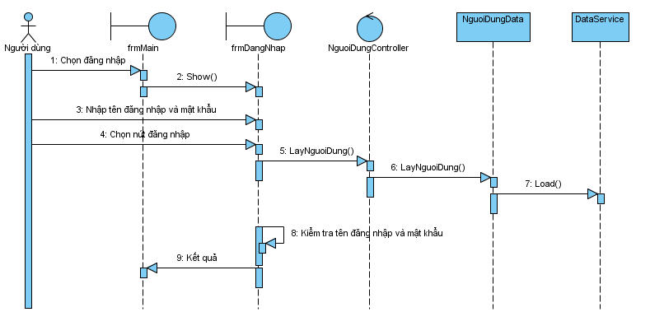
Sequence Diagram for the Login Use Case
2. Sequence Diagram for the User Management Use Case
2.1 Add User
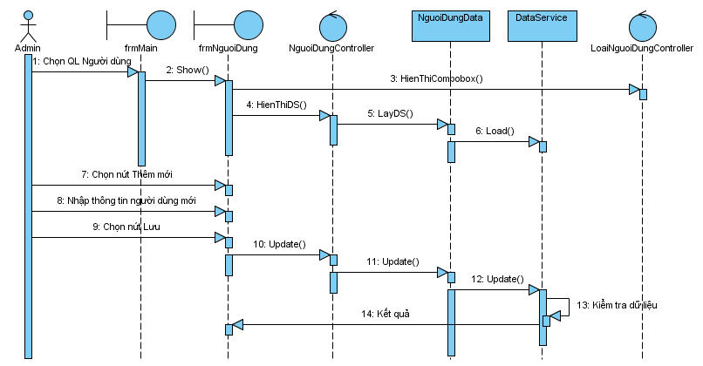
Sequence Diagram for the Add User Use Case
2.2 Delete User
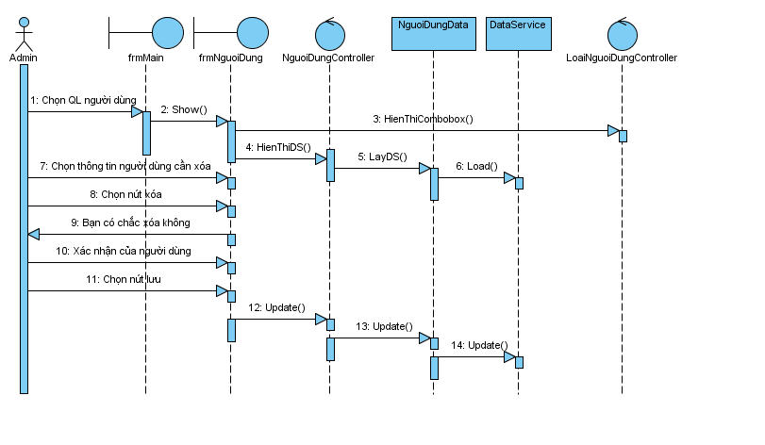
Sequence Diagram for the Delete User Use Case
2.3 Edit User
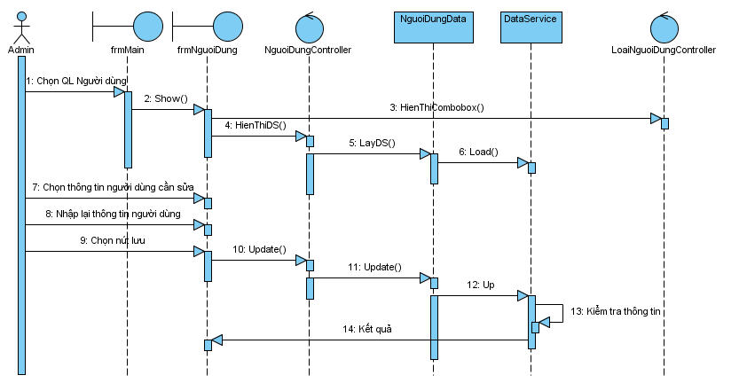
Sequence Diagram for the Edit User Use Case
3. Sequence Diagram for the Change Password Use Case
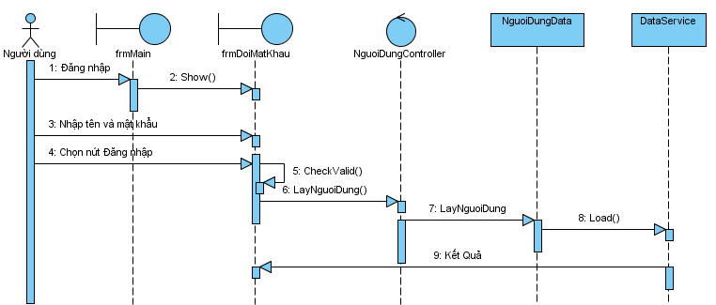
Sequence Diagram for the Change Password Use Case
4. Sequence Diagram for the Academic Year Management Use Case
4.1 Add Academic Year
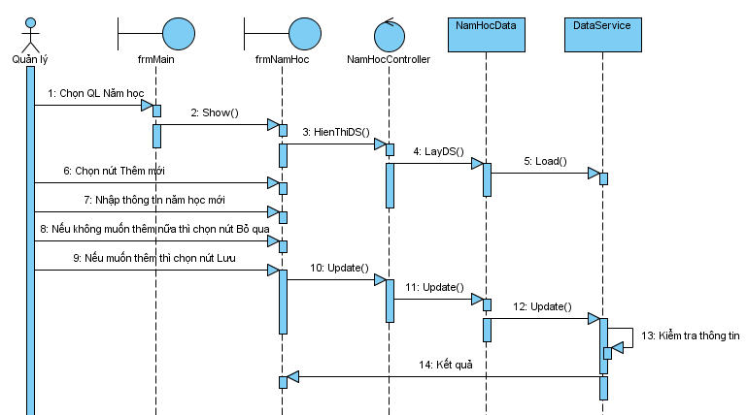
Sequence Diagram for the Add Academic Year Use Case
4.2 Delete Academic Year
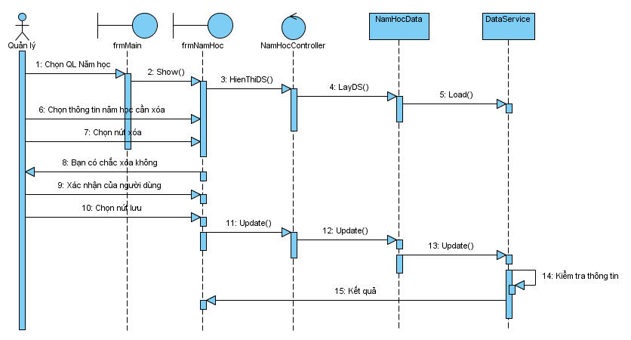
Sequence Diagram for the Delete Academic Year Use Case
4.3 Edit Academic Year
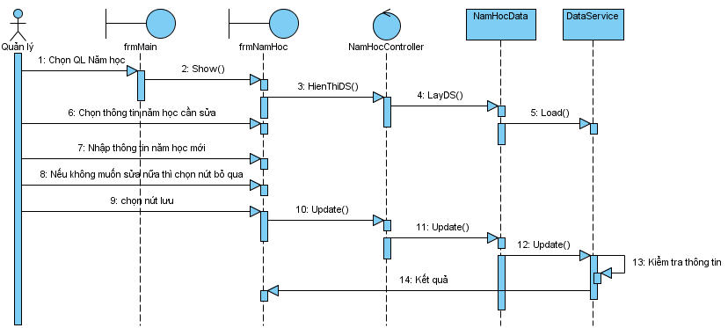
Sequence Diagram for the Edit Academic Year Use Case
5. Sequence Diagram for the Student Management Use Case
5.1 Add Student
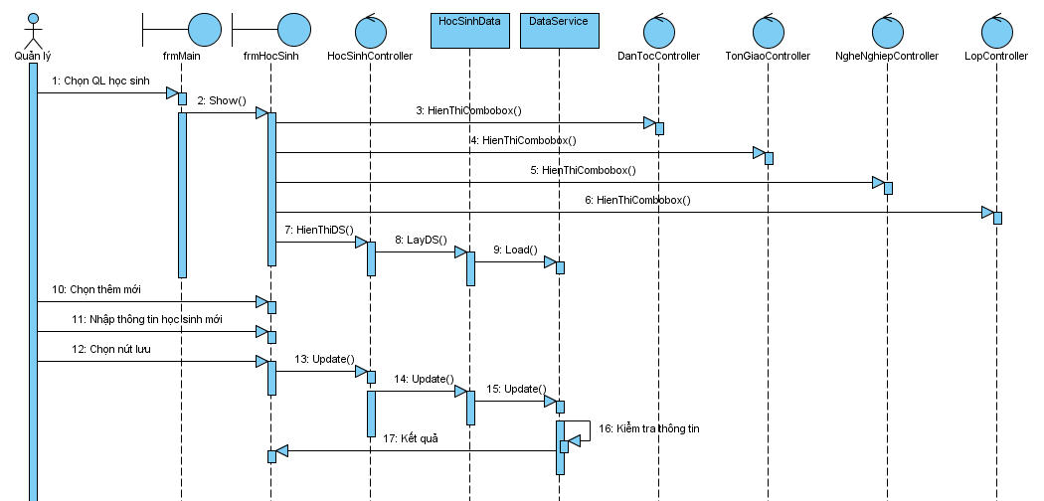
Sequence Diagram for the Add Student Use Case
5.2 Delete Student

Sequence Diagram for the Delete Student Use Case
5.3 Edit Student
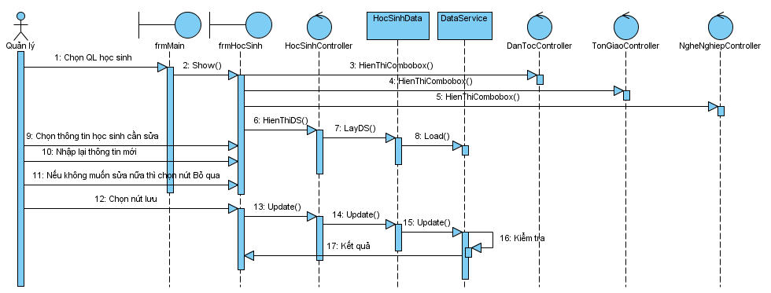
Sequence Diagram for the Edit Student Use Case

6. Sequence Diagram for the Assignment Use Case
6.1 Add Assignment
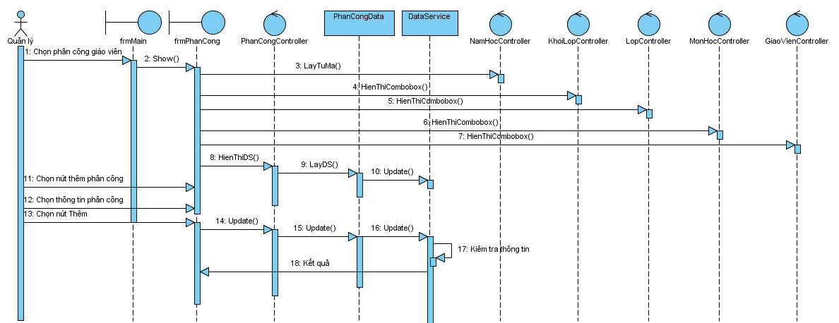
Sequence Diagram for the Add Assignment Use Case
6.2 Delete Assignment
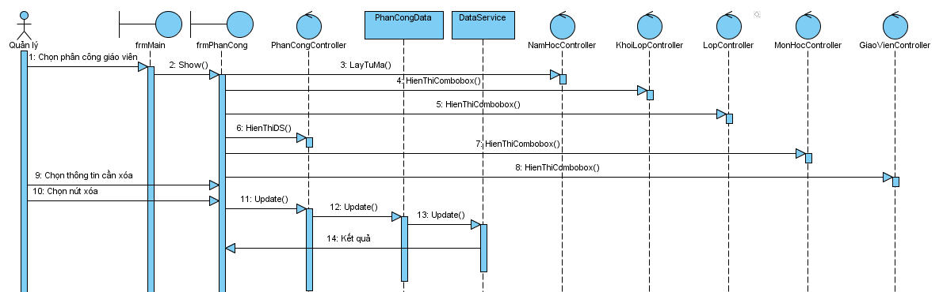

Sequence Diagram for the Delete Assignment Use Case
6.3 Edit Assignment
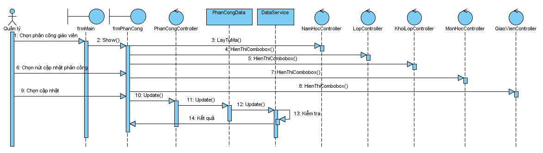
Sequence Diagram for the Edit Assignment Use Case
7. Sequence Diagram for the Class Assignment Use Case
7.1 Add Class Assignment
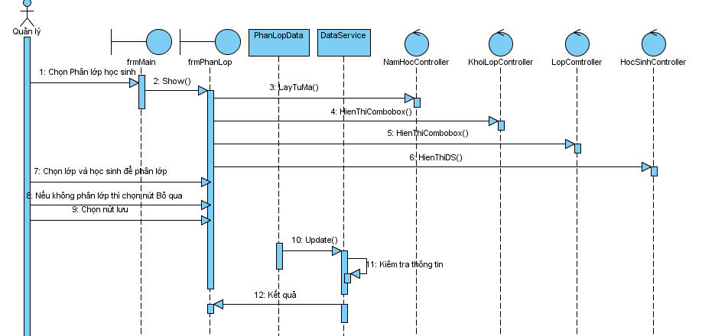
Sequence Diagram for the Add Class Assignment Use Case
7.2 Delete Class Assignment
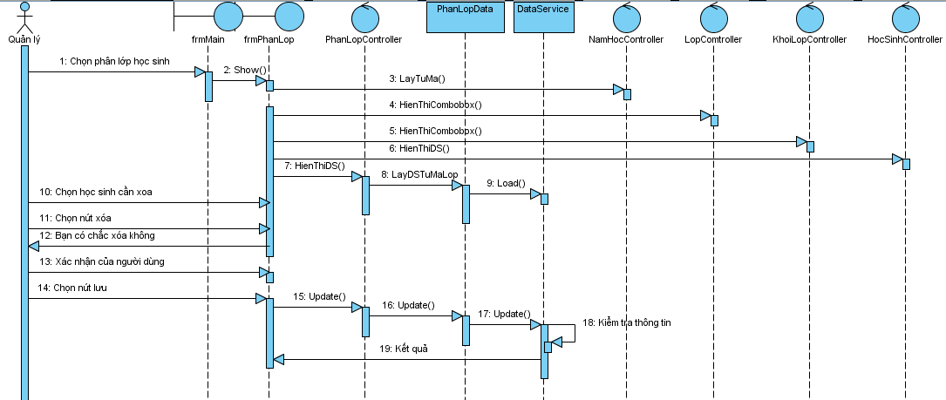
Sequence Diagram for the Delete Class Assignment Use Case
7.3 Edit Class Assignment
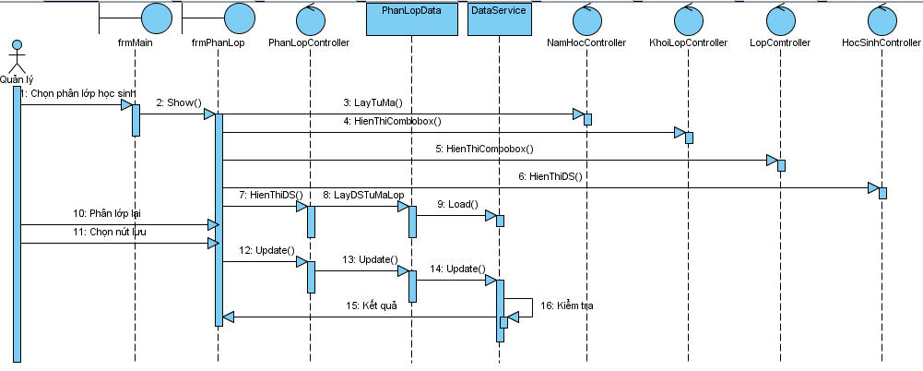
Sequence Diagram for the Edit Class Assignment Use Case

8. Sequence Diagram for the Grade Entry Use Case
8.1 Add Grade
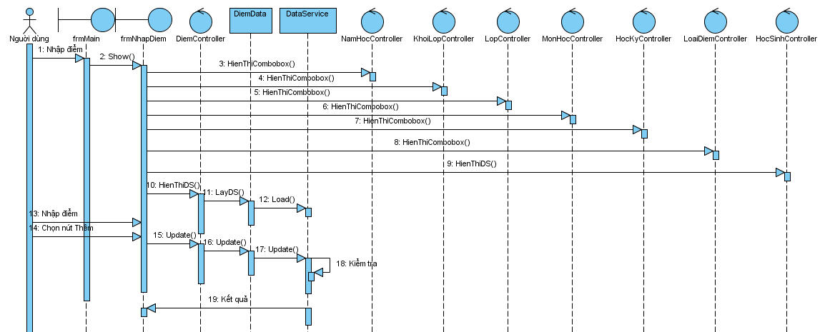
Sequence Diagram for the Add Grade Use Case
8.2 Delete Grade
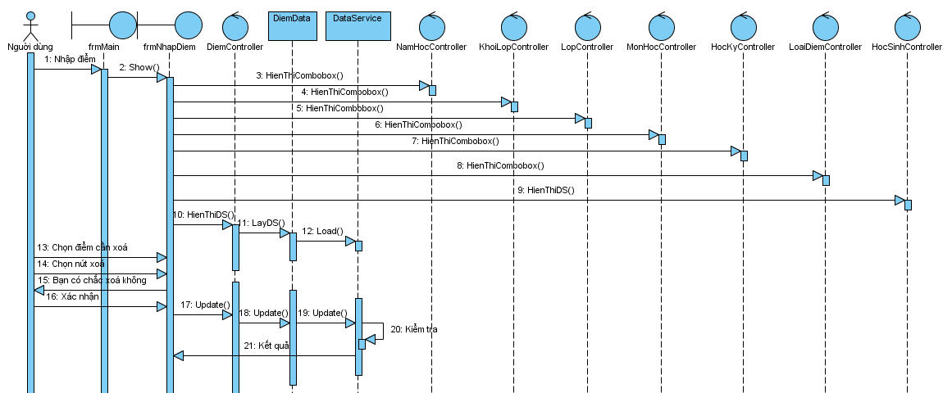
Sequence Diagram for the Delete Grade Use Case
8.3 Edit Grade
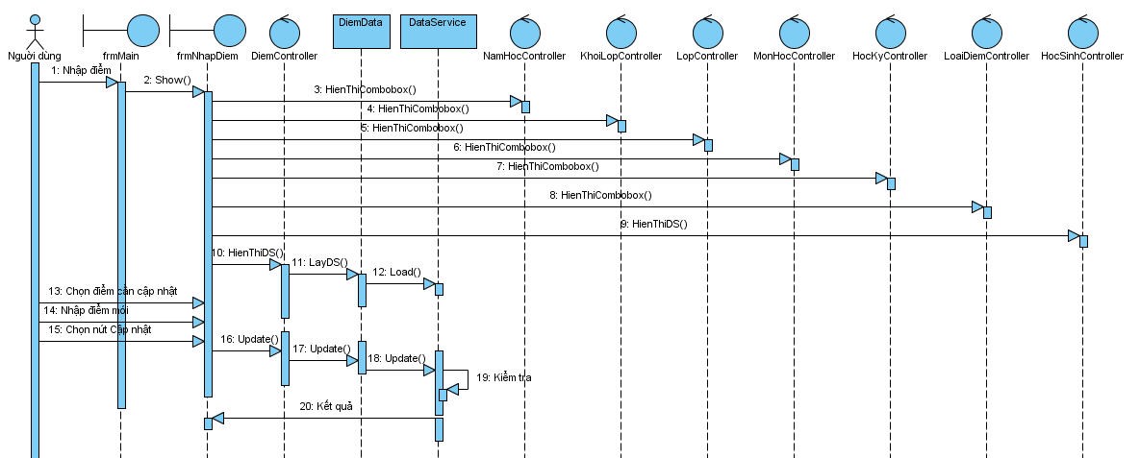
Sequence Diagram for the Edit Grade Use Case
9. Sequence Diagram for the Search Student Use Case
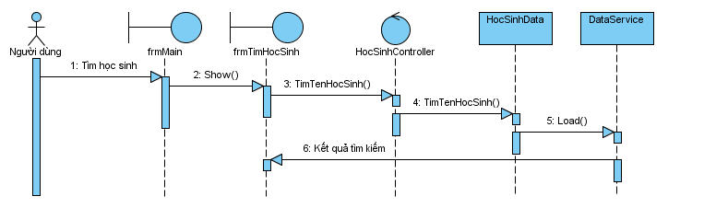
Sequence Diagram for the Search Student Use Case

III. DESIGN

I. Database Design
1. Data Tables:
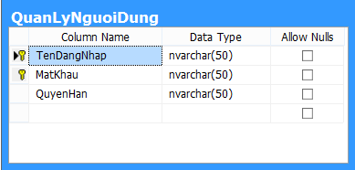

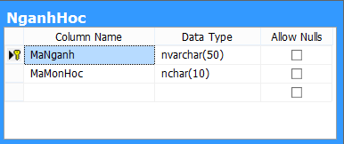

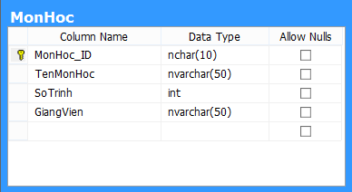

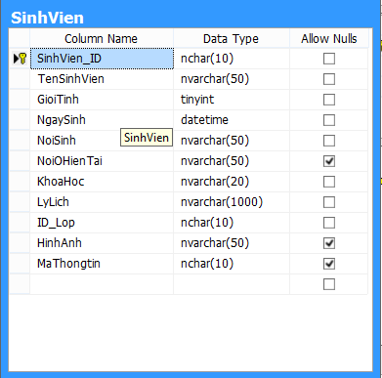

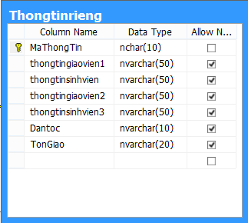

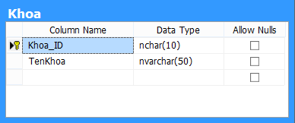

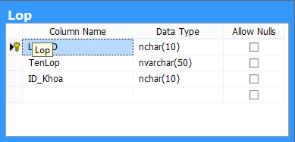

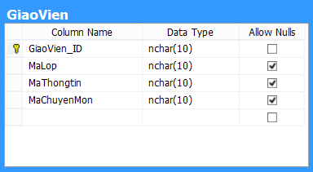

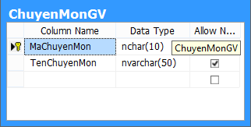

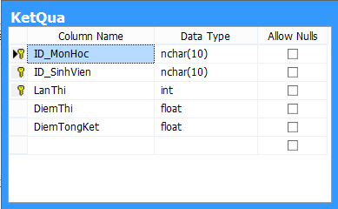
2. Relationships Between Tables
III. IMPLEMENTATION:
- Selected Language and Database:
Selected language: C#
Supporting software: Microsoft Visual Studio 10, SQL Server 2008, DotNetBar, and other drawing tools.
- Main Interfaces:
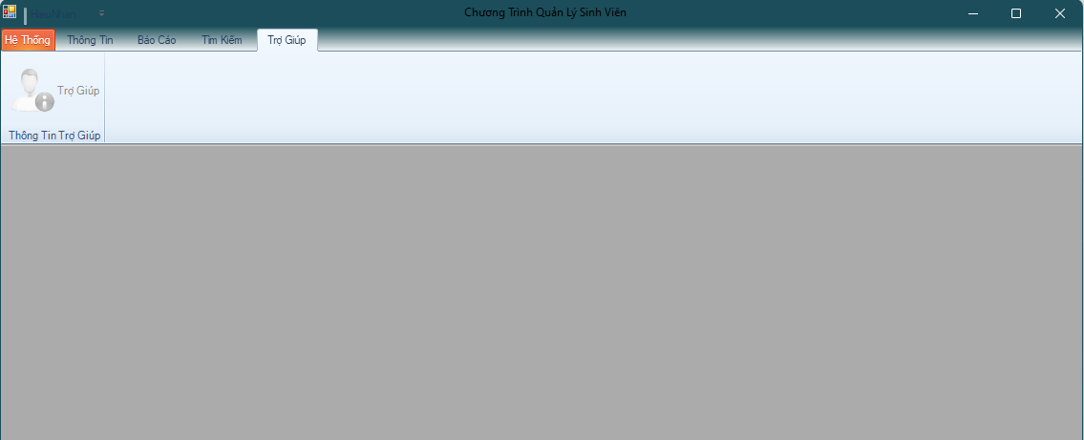
Screen displayed when the system starts

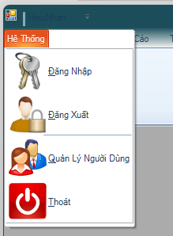
Toolbar for login, logout, and user management

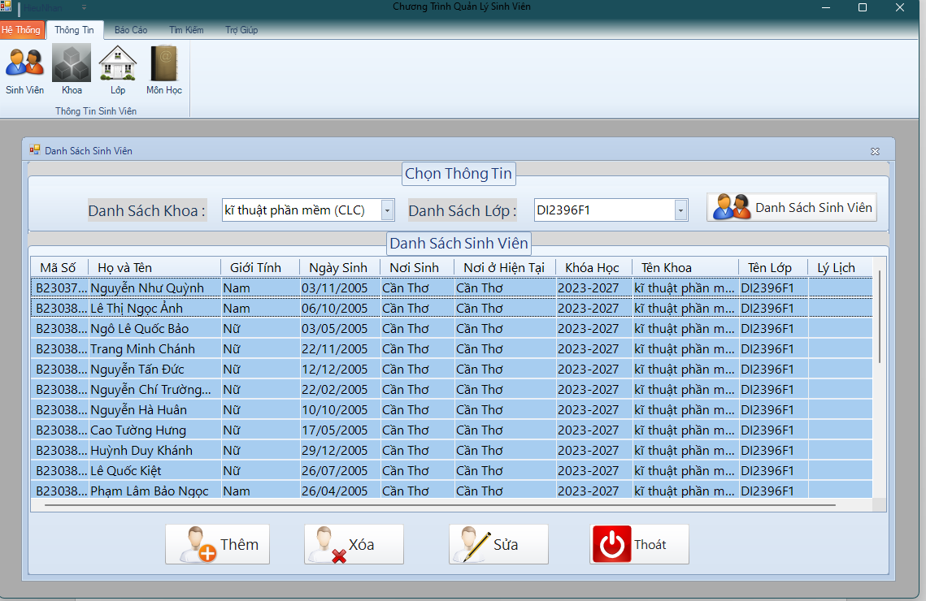
Student display form

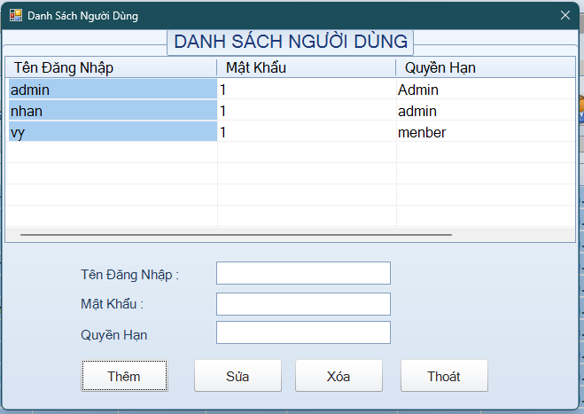
User list form
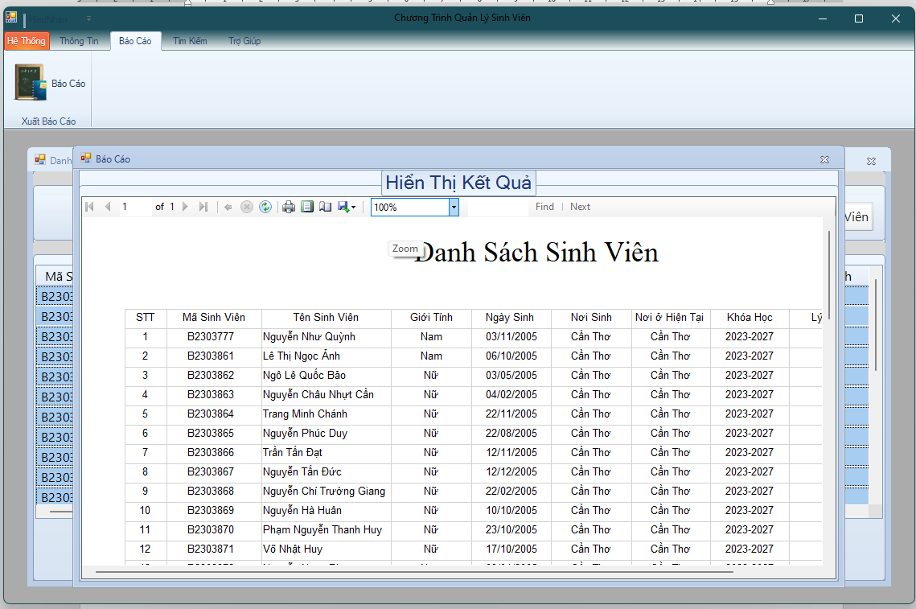
Results display form
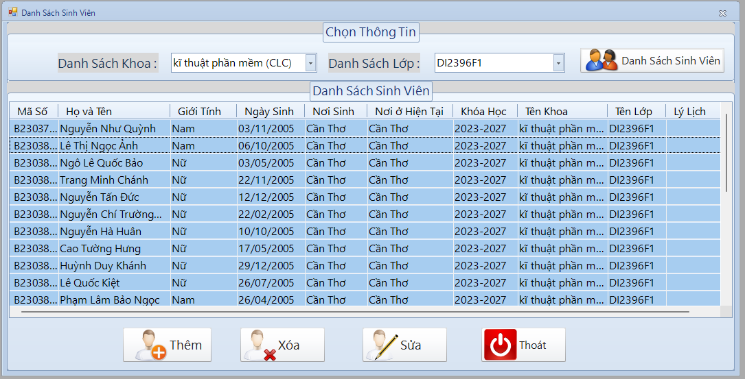
Form displaying the student list, with add, edit, and delete functions

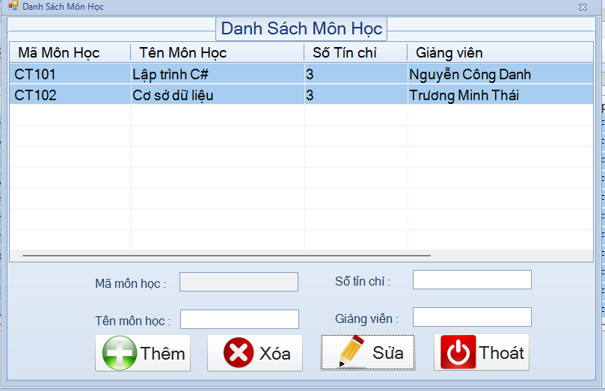
Form displaying the subject list, with add, edit, and delete functions
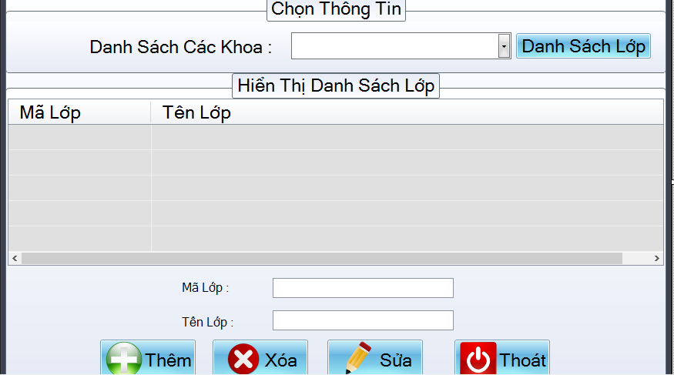
Form displaying the class list, with add, edit, and delete functions
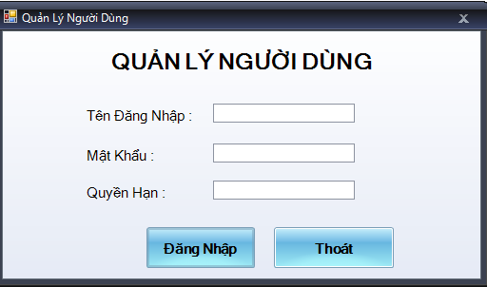
Admin login form
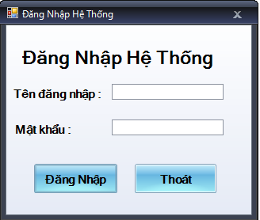
User login form
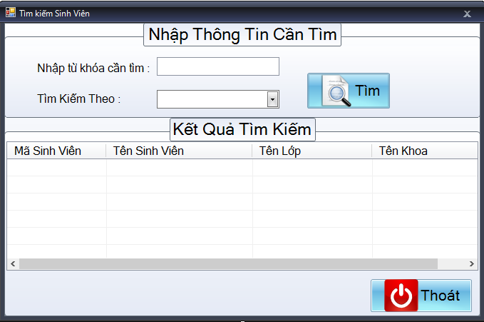
Search form

IV. CONCLUSION AND FUTURE DEVELOPMENT

A. Difficulties Encountered During Implementation
During the implementation of the project, I encountered several difficulties as follows:
- The project required both system analysis, database design, and interface programming, so the workload was quite heavy for a single person.
- Combining analysis, design, and programming required consistency to avoid discrepancies between the theoretical model and the actual implementation.
- During database construction and foreign key constraint setup, I encountered many errors related to relationships between tables and had to review and revise them multiple times to ensure stable system operation.
- The tools used, such as SQL Server 2008, Visual Studio 2010, and DotNetBar, are older versions, so the available reference materials were limited, requiring a great deal of study and experimentation to complete the functions.
Although I encountered many difficulties, through self-study and practice I gained valuable experience during the system development process.

B. Achievements
After completing the project, I achieved the following results:
- Built and designed the database in SQL Server 20018 according to the relational model (ERD).
- Analyzed and built system models such as Use Case diagrams, ER models, sequence diagrams, and more.
- Designed and programmed several main modules of the system using Visual Studio 2010 combined with DotNetBar, including:
  - Student management
  - Class management
  - Teacher management
  - Subject management
  - Academic results management
  - User login and authorization
- Connected the database to the application and processed data through SQL queries.
Through this project, I strengthened my knowledge of:
- Information system analysis and design
- Relational database design
- Windows Forms application programming
- Data processing with SQL Server

C. References
- Reference materials and online articles related to SQL Server, C#, and Windows Forms.
- Textbooks on Information System Analysis and Design from various universities.
- NET Technology Programmer textbook, Module 1, Module 2, Module 1

D. Future Development
In the future, the system can be further developed and expanded with functions such as:
- Upgrading the user interface to a more modern design.
- Developing advanced reporting functions (exporting Excel and PDF files).
- Adding advanced search and statistics functions.
- Upgrading the system to a web platform or a cross-platform application.
- Improving security (password encryption and more detailed authorization).

