|  |  |
| --- | --- |
| **Schneider Electric** |  |

|  |  |  |  |  |  |  |  |
| --- | --- | --- | --- | --- | --- | --- | --- |
| Project: | | PWP 2023 | | | | **Function** : | |
| title**:** | | PWP 2023 | | | | Nb of pages: 5 | |
| **File name: Low sales P3 order options** | | | | | | Revision level: A1 | |
| **content:** | | | | **Withdrawal File**   * **P3U10 application** * **Distance protection in P3L30** * **1A order options for P3x3x series (slot 8)** | | | |
| **issued to:** | | | | **To: Franck Bureau**  **Copies to: Araceli Monje** | | | |
| **Response** | | | | | | | |
|  | | | | | | | |
|  |  | |  | |  | |  |
|  |  | |  | |  | |  |
|  |  | |  | |  | |  |
| V1 | 8 May 2023 | | Pekka Hämäläinen | |  | | Origin |
| **rev.** | **date** | | **Written by** | | **Checked by** | | **Status** |

A**Table of contents**

1 why the withdrawal of this product offer 3

2 general objectives 7

2.1 Objective and reasons of the withdrawal of the offer 7

2.2 Commercial policy 7

2.3 Commercial Constraints 7

3 scope of the withdrawal 7

4 Description of the substitution solution 9

5 Management of the customer communication 9

6 Customer argumentation support 9

7 Class Assignment and Schedule 9

8 service solution 9

9 management of special offers 10

10 pricing policy update 10

11 FAQ 10

# why the withdrawal of this product offer

In conjunction with the Easergy P3’s range name changes to PowerLogic P3 we have decided to optimize the P3 offering range. Drivers to such functionality removal is the low sales and lately introduced other products to cover same functionalities. The Offer Marketing has decided to withdraw the functionalities out from commercial availability.

* Easergy P3U10 relay model
* Distance protection in P3L30
* Dedicated 1A input for the P3x3x relay as the other 5/1A module does the same

Discontinuation of the above functionalities will be referenced as “P3 simplification” later in this document.

Sales quantities are as per the following tables

**Sales statistics – P3U10**

|  |
| --- |
|  |
| Figure: Annual quantity of Easergy P3U10 relay since 2018 |

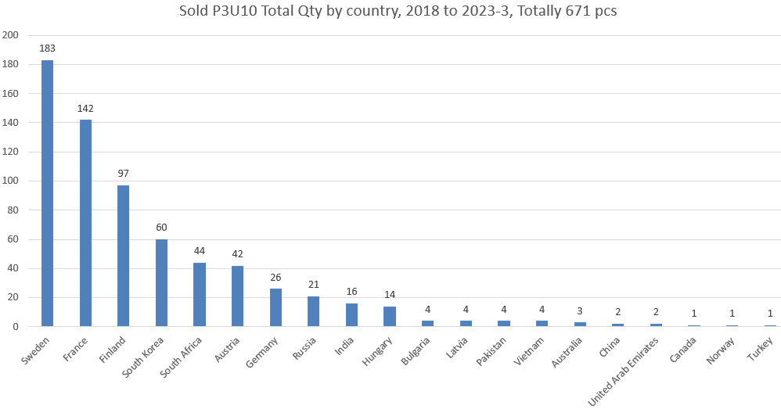

Figure: P3U10 quantities by country since 2018

|  |  |
| --- | --- |
|  |  |
| Figure: P3U10 quantities by ordering reference since 2018 | Figure: P3U10 quantities by terminal type since 2018 |

**Sales statistics - Distance protection in P3L30**

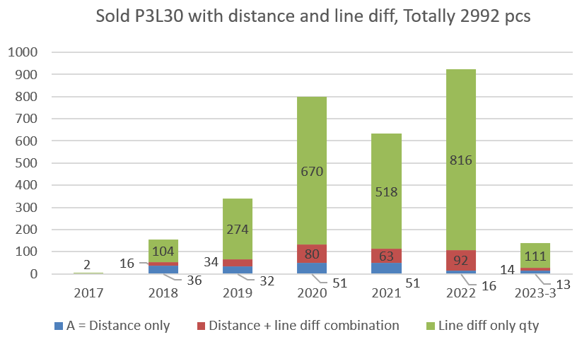

**Figure:** P3L30 quantities by protection application since 2017. “*Distance only*” is accurate data but “*Distance + line diff combination*” is an assumption as there is no way to distinguish how often distance is used together with line differential. Above table assumes that distance is used in 10% in the line differential applications (red section in the graph).

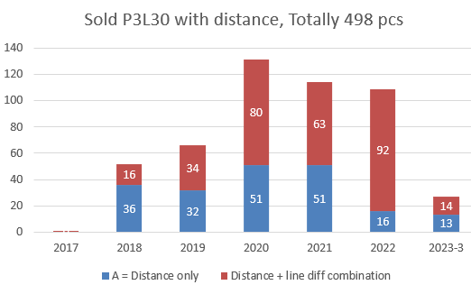

**Figure:** Detailed view of the distance feature use in P3L30. Note the comment in the previous graph.

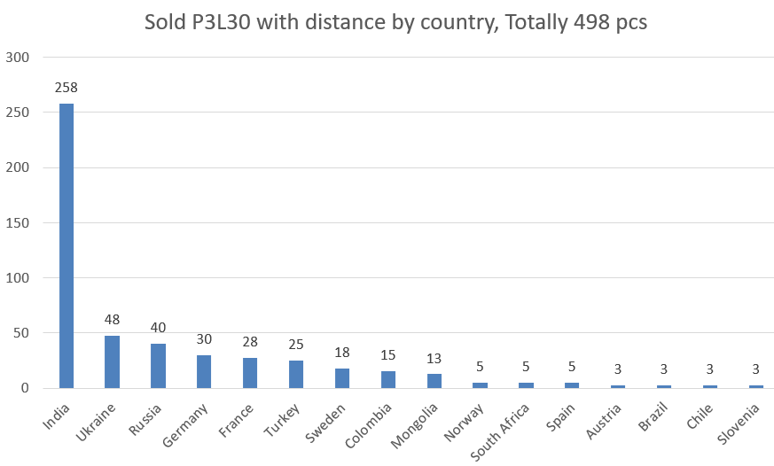

**Figure:** Quantity of the distance protection used in P3L30 by country.

**Sales statistics - Dedicated 1A input for the P3x3x relay**

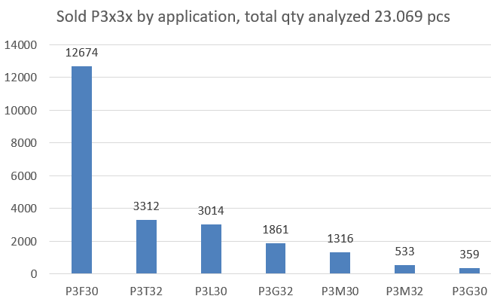

**Figure:** Quantity split of the product Easergy P3 application. Quantity analyzed since 2018 to 2023-3.

|  |  |
| --- | --- |
| **Figure:** Quantity split of different analog input ranges for slot 8 in P3x3x. | **Figure:** Quantity split of different analog input ranges for slot 8 in P3x3x |

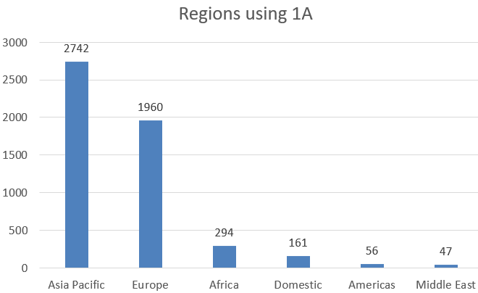

**Figure:** Regional split (as per Vamp’s data base structure) of the 1A input use in P3x3x.

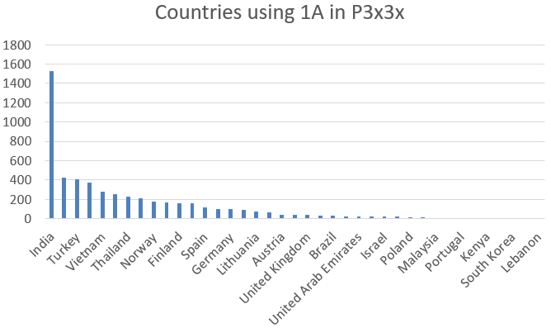

**Figure:** Country split of the 1A input use in P3x3x.

# general objectives

## Objective and reasons of the withdrawal of the offer

The scope of the withdrawal consists of above referenced functionalities in Easergy P3.

## Commercial policy

The sales and deliveries of the P3 simplification products will terminate at the same moment once the PowerLogic P3 range naming become in use. This is expected within Q4 / 2023. After this moment the HW and HW is not supported to new products anymore.

## Commercial Constraints

The P3 simplification products have relatively small impact to total sales of P3 range.

Completely obsoleted P3U10 application represents less than 1.5% of the total P3Ux sales. There is 1:1 similar product using P3U20 relay. The later model contains one option card more hence the price is slightly more. The difference between P3U10 compared to cheapest P3U20 model is less than 30 €

Discontinuation of the distance features impacts to 1,7% of the P3x3x quantities. For distance also LoB has alternative relays to cover the same functionality.

Regarding termination of the 1A input in slot 8 for P3x3x does not have practical impact because there is another order option which can do both 5/1A in the same HW.

Above referenced features will be removed from all assets during the range naming conversion to PowerLogic P3.

# scope of the withdrawal

The following models are under the scope of this withdrawal.

**Easergy P3U10 relay model**

Protection relay P3U10 will completely be discontinued.

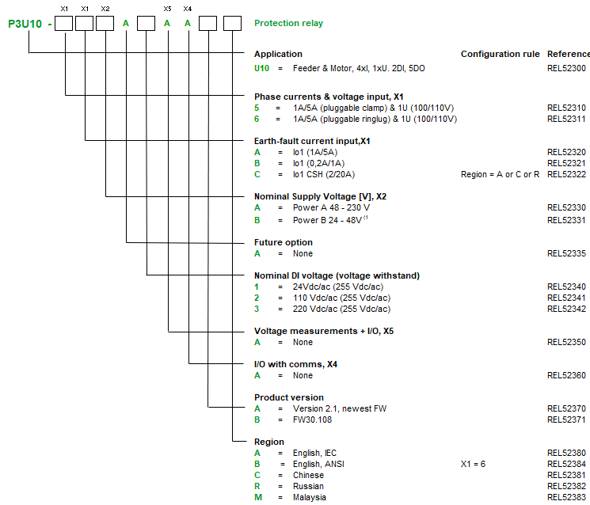

**Distance protection in P3L30**

To remove distance from P3L30 order option A = Distance protection relay will be removed from the product selection. Also the contents to S and T options will be modified accordingly.

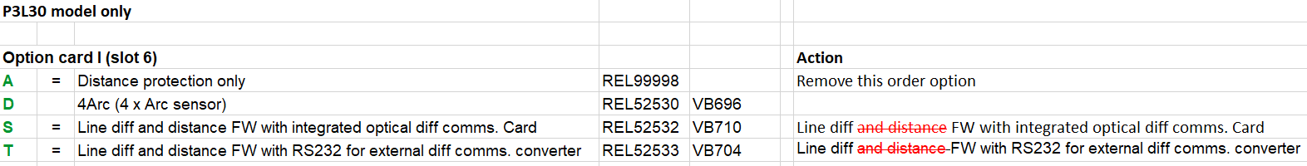

**Dedicated 1A input for the P3x3x relay**

Order options F, O, 2 and 6 will be discontinued.

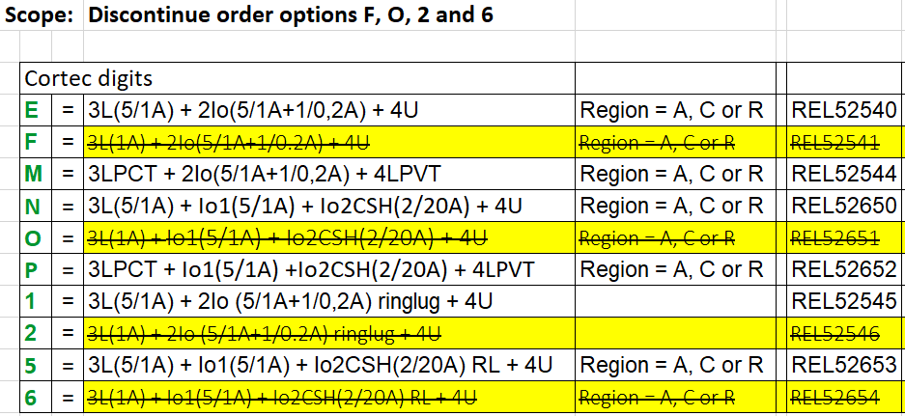

# Description of the substitution solution

|  |  |
| --- | --- |
| **Under PWP 2023** | **Replacement** |
| Easergy P3U10 | PowerLogic P3U20 |
| Distance protection in P3L30:   * Order options at slot 6: A, S and T | Easergy MiCOM P439 for stand-alone distance protection.  Should the application consist of both distance and line differential then use Easergy MiCOM P54x relay |
| Dedicated 1A input for the P3x3x relay:   * Oder options F, O, 2 and 6 | Use combined 5/1A input for P3x3x relay:   * Order options E, N, 1 and 5 |

# Management of the customer communication

The dedicated obsolescence notice shall be communicated to countries within June 2023. Also make announcement in the LoB’s appropriate webinars touching product withdrawal communications.

# Customer argumentation support

Easergy P3 has been developed with a strong focus on simplicity at every stage of the product’s life-cycle to increase ease of use and gain efficiency, many innovative features and complete set of digital tools has been released to serve this purpose. To proof this, align with corporate management guidance, and improve simplicity the range naming is a right moment to remove less important function out from P3.

# Class Assignment and Schedule

The schedule is based on the PWP-2023 schedule.

# service solution

For P3U10 the service model is P3U20.

Regarding the distance

* Option 1: Easergy Micom P439
* Option 2: Connect LoB and check P3L30 replacement product availability

The 1A order option has alternative reference. User must adjust setting scaling during the repair commissioning. Require dedicated instructions from customer care.

# management of special offers

Should the country have homologated 1A order option then they have to negotiate using combined 5/1A option.

# pricing policy update

No immediate change to be applied in the pricing policy of the offer that is under the scope of this withdrawal file and of the offer that will be the replacement. List prices will remain the same as before.

# FAQ

n/a