**Matrix Multiplication Application**

This application consists of 3 Projects:

1. Matrix Client – This is a ASP.NET Web Application (.NET framework 4.5)
2. Matrix Multiplication – ASP.NET Web API MVC Application (.Net Core 2.0)
3. Matrix Calculation – Class Library Project (.NET framework 4.5)
4. Matrix Multiplication Algorithm
5. **Matrix Client**

To run the project simply set multiple startup projects.  
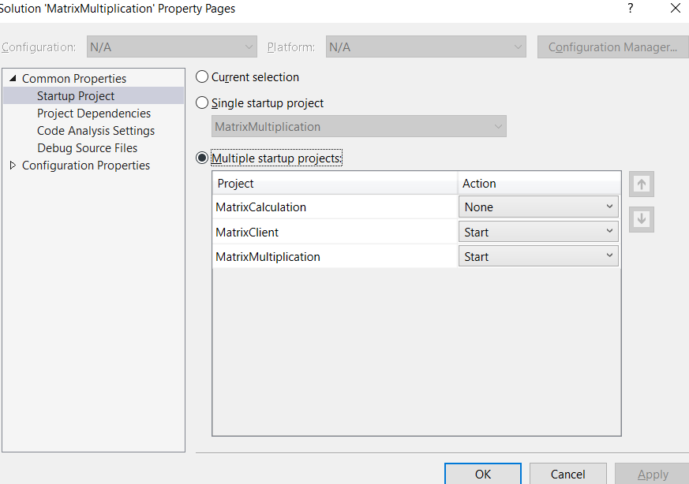

Web Page is simple. Enter Data set size and press validate to get result.  
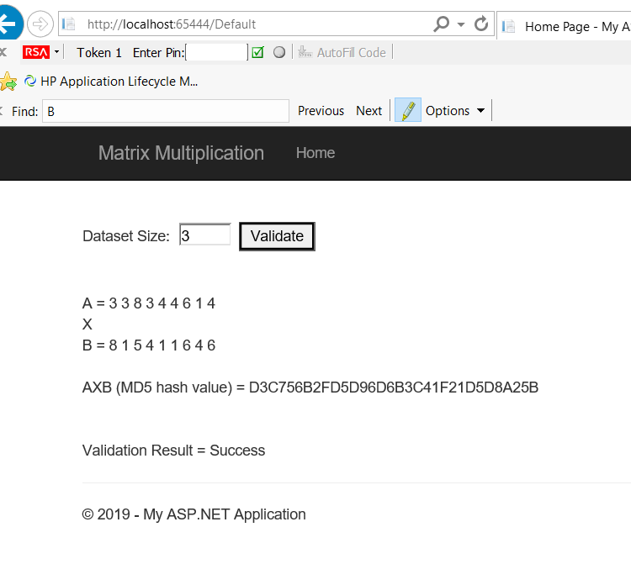

This Project has following methods in default.aspx file:

InitMatrix(), GetDataset(), CalculateResult() and ParseMatrix()

1. **Matrix Multiplication**

This project has the Numbers Controller and Model classes FileAccess and Numbers. I save size, random generated Matrixes in File on server side web API this can be in a database or cached but cache option is not recommended.

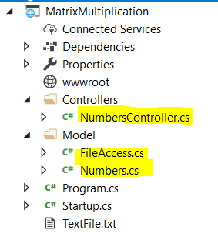

1. **Matric Calculation**

Because the requirement is such that both client and server need to generate the Matrix multiplication result I have put the logic in a class library that both client and server can share to remove code duplication

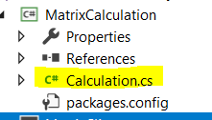

This class library has 2 methods:

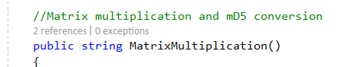

and



**Matrix Multiplication Algorithm**

I have used Mathnet.Numerics nuget package for matrix multiplication. Performance is good upto 200 dataset size but at 1000 performance is not good. I can work on improving performance if given more time.