Event Cruncher Stylus (ECS) – Application Overview

Overview
The Event Cruncher Stylus (ECS) is a web-based platform designed to support the creation, organization, and exploration of narrative historical scenes.
The application allows users to construct structured narratives using a cube-based interface that represents key contextual dimensions of an event:
- Who
- What
- When
- Where
- Why
- How
Each cube face represents a different contextual category, allowing users to attach files, descriptions, and metadata to construct a complete representation of a historical or narrative event.
The system integrates user authentication through the University of Florida authentication service, ensuring that only authorized students and researchers can access the platform.

System Architecture
The application follows a three-tier web architecture consisting of:
- Client Layer (Frontend)
- Application Layer (Backend)
- Data Layer (Database)

Client Layer
The frontend is implemented using React and provides the interactive user interface.
Responsibilities include:
- Rendering the cube-based narrative interface
- Managing user interactions
- Sending API requests to the backend
- Displaying uploaded content and generated scenes
The frontend communicates with the backend through REST API calls.

Application Layer
The backend server is built using Node.js with Express.js.
This server acts as the central controller of the application and is responsible for:
- Processing API requests from the frontend
- Handling authentication through UF SAML
- Managing user sessions
- Reading and writing cube data
- Processing file uploads
- Coordinating AI-based scene generation

Authentication
Authentication is handled through SAML integration with the University of Florida authentication system (UF Auth).
This ensures that only verified UF students and faculty members can access the system.
Authentication workflow:
- User attempts to log into ECS.
- The application redirects the user to the UF SAML authentication service.
- The user logs in using their university credentials.
- UF Auth verifies the identity and returns a SAML assertion.
- The backend validates the assertion and creates a user session.
This authentication model ensures secure access while leveraging the university’s existing identity infrastructure.

Data Layer
All application data is stored in a MySQL relational database.
The database stores information related to:
- User profiles
- Cube scenes
- Scene metadata
- Uploaded file references
- Cube face content
Each scene can contain multiple cube faces, and each face can contain multiple uploaded files or textual descriptions.

File Storage
The system supports uploading and attaching media files to cube faces, including:
- Images
- Audio
- Video
- Documents
Uploaded files are stored in server storage and referenced in the MySQL database through file metadata.

Technology Stack
- React
- Express.js
- SAML
- MySQL

Software Architecture Diagram
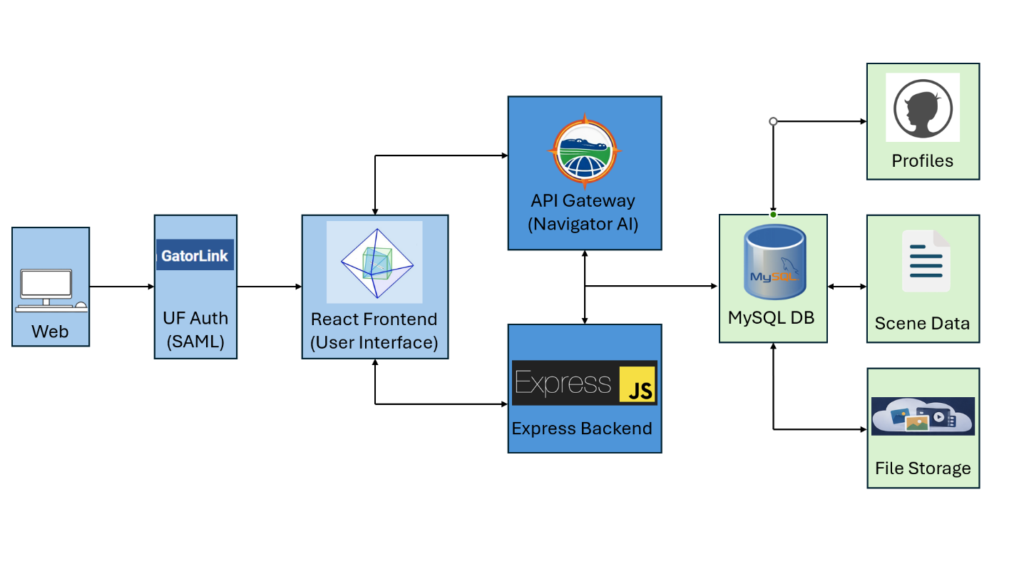

Feature & Functionality Overview

1. Language Translation
The application supports three display languages, selectable from the Landing Page dropdown or persisted across sessions via browser detection:
- English (default)
- German (Deutsch)
- Mandarin Chinese (普通话)
All UI labels, cube face names (Who, What, When, Where, Why, How), button text, placeholder copy, navigation links, instructions, and footer text are fully translated. Changing the language also regenerates the 3D cube face textures so labels update in real time.

2. Short Description
Each of the six 5W1H cube faces has an associated Short Description — a concise summary intended to contextualize that face's content. Accessed by clicking the top-right quadrant of a face when a face is selected on the Cosmos page.
- View / Edit: Opens a modal showing the current short description text for that face.
- Save: Persists the text to the database (face_descriptions table, short_description column).
- File Attachments: Files can be uploaded and associated with the short description; they appear as linked items inside the modal.
- Lock / Unlock: Admin users can lock a short description so that non-admin users cannot edit it or trigger the AI generator for it.

3. Long Description
Each cube face also supports a Long Description — a more detailed, narrative-form explanation of that face's content. Accessed by clicking the bottom-left quadrant of a face.
- View / Edit: Opens a modal with a larger text area for richer content.
- Save: Persists to the database (long_description column).
- File Attachments: Same file-attach capability as the Short Description modal.
- Lock / Unlock: Admin-only lock that blocks non-admin users from editing or generating AI content for the long description.

4. AI Generator — Short and Long Descriptions
Both Short and Long Description modals include an AI generation assistant:
- Short Description AI: Opens the AI Short Description modal. The user provides a query/prompt; the system sends the current face context and prompt to the Anthropic API (/api/anthropic) and streams a generated suggestion back in the modal.
- Long Description AI: Same flow for the Long Description, supporting multi-turn prompting and longer-form generated content.
- Apply: A one-click button copies the AI-generated text into the description text area so the user can review and save it.
- Locked State: If an admin has locked the description for that face, the AI modal is replaced with an “AI Generator Locked” notice, preventing generation for non-admin users.
- Interaction Logging: All AI queries and applied responses are recorded in the interaction log.

5. Lock / Unlock Functionality
Locking is a per-face, per-description-type toggle available only to admin users (admin / userId = 1 depending on context).
Target | Lock Field | Effect When Locked
Short Description | is_locked | Non-admins see read-only text; AI generator disabled
Long Description | long_desc_locked | Non-admins see read-only text; AI generator disabled
- Lock state is visually indicated in the description modal by a Locked / Unlocked pill button.
- Lock state is stored in the database and persists across sessions.
- Non-admin users attempting to open the AI generator when locked see an “AI Generator Locked by Admin” notice modal.

6. Interaction Log
A persistent, in-session activity record that tracks user actions throughout the application.
Logged event types include:
- Session start
- Face selected
- Face text added
- File uploaded to a face
- Short/long description viewed
- Short/long description saved
- Short/long description lock toggled
- AI short/long query submitted
- AI response applied
Storage:
- The log is kept in memory (interactionLogRef) and serialized to localStorage as ecs_interaction_log, so it survives page refreshes within the same browser session.
Export:
- The interaction log is automatically included as interaction-log.txt in the ZIP download.
- It is formatted with timestamps and human-readable action descriptions.

7. Interactive Workspace
The primary editing area for each cube face.
Features include:
- Text Input: A multi-line textarea for entering the face’s 5W1H content.
- Bullet Points: A toolbar button inserts a bullet character (•) at the current cursor position.
- Numbered Lists: A toolbar button inserts an incrementing number prefix.
- Smart Enter Key: When the cursor is inside a bullet or numbered line, pressing Enter automatically continues the same formatting on the next line.
- File Insertion: A file upload input allows attaching one or more files to the current face.
- Saved vs. Pending Files: Unsaved files display with an “(unsaved)” indicator.
- Save Button: Persists both text and confirmed file uploads to the database simultaneously.

8. File Upload — All Formats
Files can be attached to any cube face workspace, short description, or long description.
Capabilities:
- Accepted types: Any file format the browser file picker allows.
- Navigator AI supports .zip, .xlsx, .csv, .jpg, .png, .pdf, .txt, .doc, .docx.
- Storage: Files are stored as binary data in the avfiles or desc_files database tables.
- Download: Saved files are downloadable via linked URLs.
- Delete: Saved files can be removed and synced to the server immediately.
- Multiple files: Multiple files can be uploaded in a single operation.

9. Hover Tooltips on Icons
Interactive UI elements display descriptive hover tooltips.
Examples include:
- Quadrant hover tooltips in Cosmos
- Button tooltips with descriptive title text
- Persistent quadrant labels:
  - Q1 WORKSPACE
  - Q2 SHORT DESC
  - Q3 LONG DESC
  - Q4 5W1H LLM
- Toolbar icon hover descriptions

10. Share Link — Simulations and Evaluations
Users can generate a shareable link containing a snapshot of their 5W1H face data.
Workflow:
- User clicks “Share Simulation”.
- App posts face data to /api/simulation-tokens.
- A share modal displays a generated URL with a “Copy Link” button.
- Other logged-in users opening the link can access:
  - Textual Simulation
  - Video Visual
  - Consistency Evaluator

11. Video Visual Simulation
Creates an AI-generated animated video presentation of the 5W1H content.
Features:
- Triggered through “Video Visual”
- Uses /api/generate-video
- VideoPlayer component supports:
  - Scene durations
  - Background colors
  - Layered text elements
  - Fade/slide/scale animations
  - Scrubber timeline
  - Play/pause controls

12. Textual Simulation
Generates a written narrative analysis of the 5W1H data.
The simulation result contains:
- Scenario: Narrative generated from face data
- Gaps: Missing or weak dimensions
- Variations: Alternative interpretations or scenarios

13. Consistency Evaluation (Wobble Evaluator)
AI-powered consistency analysis of the 5W1H entries.
Evaluation modes:
- Direct
- Clues
- Socratic
Domains:
- General
- Legal
- Medical
- Scientific
- Journalistic
Outputs include:
- Wobble badge:
  - SILENT
  - SHIMMER
  - WOBBLE
- Tier consistency bars
- Tier diagnoses
- Written feedback
- Overall assessment
- Animated Mini Octahedron visualization

14. Spreadsheet View
Displays all face data in a tabular modal view.
Features:
- Triggered by the XLSX toolbar button
- Faces displayed as columns
- Rows show text content and attached file names
- Uses the xlsx library

15. Download — ZIP Archive
Exports all workspace data into a downloadable ZIP file.
The ZIP contains:
- ECS-Data.xlsx
- All uploaded files
- interaction-log.txt
Libraries used:
- JSZip
- file-saver

16. Top-Left Logo Button — Return to Start Page
The ECS logo in the top-left corner links back to the Start Page (/), acting as the application’s home/reset button.

17. Top-Right Dropdown Menu
A hamburger menu provides navigation links to:
- Start Page
- Landing Page
- Login
- Create Account
- Navigator AI
The menu is globally accessible across pages.

18. Navigator AI — Chat Interface
A dedicated AI chat interface at /levels/Navigator.
Features:
- Multi-turn conversations
- Markdown rendering with react-markdown
- Multiple file attachments
- File deduplication
- Loading state indicator
- Error handling
- Auto-scroll
- Introductory hint text
- Requests sent via /api/navigator-chat

19. ECS Sector Analysis (5W1H LLM Processor)
The fourth quadrant (Q4) opens an AI-driven analysis modal.
Capabilities:
- Streams AI-generated analysis from Anthropic API
- Evaluates internal and cross-face consistency
- Provides editor guidance and consistency questions
- Renders markdown responses inline

20. Validation Modal
AI-powered validation available on Tetrahedral Level and Cosmos.
Checks include:
- Length adequacy
- Content validity
- Cross-face consistency
- Suggestions for improvement
Results display as color-coded status badges.

21. Criteria Instructions (CI Modal)
Admin-only feature for defining per-face guidance.
Features:
- Admins can edit instructions
- Users view read-only instructions
- Stored in the criteria database table
- Accessible from CubicLevel and TetrahedralLevel

22. 3D Interactive Cube / Octahedron Visualization
Core 3D UI experience across level pages.
Features:
- Interactive cube and octahedron visualizations
- Drag-to-rotate
- Zoom controls
- Face selection and highlighting
- Dynamic language-based textures
- Opacity adjustments based on camera angle

23. User Authentication
Login:
- Username/password authentication
- bcrypt verification
- Failed login popup
- Session persistence through localStorage
Create Account:
- Strong-password validation
- Password confirmation
- Duplicate username detection
- Automatic avdata row creation
Persistent Session:
- localStorage maintains authentication state.

24. Application Flow Summary
DisplayPage (/)
- Animated splash screen with START button
LandingPage (/landing-page)
- Language selector
- Login/Create Account links
Login (/login)
- Redirects to Cosmos
CreateAccount (/create-account)
- Redirects to Cosmos
Cosmos (/levels/cosmos)
- Workspace (Q1)
- Short Description (Q2)
- Long Description (Q3)
- 5W1H Processor (Q4)
- Consistency Evaluator
- Textual Simulation
- Video Visual
- Share Link
- Spreadsheet View
- ZIP Download
- Navigator AI
Navigator AI (/levels/Navigator)
- Multi-turn AI chat with file uploads

25. Technology Stack
Layer | Technology
Frontend | React 18, React Router 6
3D Graphics | Three.js
Internationalization | i18next (EN / DE / ZH)
AI Backend | Anthropic API (via Express proxy)
File Export | JSZip, file-saver, xlsx
Database | MySQL
File Upload | Multer
Authentication | bcryptjs

