**Table of Contents / Index**

**Beauty in Poetry 3**

1.1.1 Read the expression in the bubble. 3

(A) Questions 3

**The Bizhu Festival 4**

2.1.1 Discuss the following questions in pairs. 4

(B) Questions. 4

**Language and Power 5**

3.1.1 Look at the illustrations below and guess who the people are. 5

(C) Questions. 5

**Paraphrasing and Rephrasing 7**

4.1.1 See the graph and read the text given below. 7

(D) Questions. 7

**Writing Cohesively 9**

5.1.1 Look at the picture, and discuss in groups 9

(E) Question. 9

**Introducing Someone Formally 11**

6.1.1 Look at the illustrations below 11

(F) Questions. 11

**A Hole in the Fence 13**

7.1.1 Look at the following personal timeline 13

(G) Questions. 13

**Life in the Woods 15**

8.1.1 Write answers to the following questions individually, 15

(G) Questions. 15

**Writing Differently 17**

9.1.1 Look at the following illustrations. 17

**Success is Counted Sweetest 19**

10.1.1 Look at the illustrations given below 19

(I) Questions. 19

**The Merchant of Venice 21**

11.1.1 Read the riddles given below 21

(J) Questions. 21

**Appendix 23**

1. Beauty in poetry 23

2. The Bizhu Festival 24

3. Language and Power 25

# Beauty in Poetry

## 1.1.1 Read the expression in the bubble.

Then, in pairs/groups ask and answer the questions that follow. Later, share your responses with the whole class.

### (A) Questions

a. Have you ever been compared with anyone or to anything like Riana?

b. Whom/what have you been compared to?

c. Why did s/he compare you with that thing/person?

d. How did you feel then?

e. Do you think that comparing one thing to another similar thing helps us to understand something/someone better? If yes, how?

# The Bizhu Festival

## 2.1.1 Discuss the following questions in pairs.

And then, share your answers with the class.

a) Did you interview anyone for any reason?

b) Did someone interview you for any purpose?

c) What was the topic of the interview?

d) What were the questions that had been asked there?

e) What were the responses?

f) Did you share any information about the interview with anyone? If yes, what did you say?

### (B) Questions.

a) Did you interview anyone for any reason?

b) Did someone interview you for any purpose?

c) What was the topic of the interview?

# Language and Power

## 3.1.1 Look at the illustrations below and guess who the people are.

1. Who started the conversations?

2. Who controlled the conversations?

3. Who gave decisions?

4. Who asked direct questions?

5. Who replied with minimum words?

### (C) Questions.

a) Which group of people are more senior and respected in society?

b) What are the features of the language they use? Please mention two or three.

c) Do you think that the choice of words in sentences and the way someone speaks

during a conversation determines/demonstrates his/her position or status in that

particular situation? If yes, explain with an example.

# Paraphrasing and Rephrasing

## 4.1.1 See the graph and read the text given below.

Then, in pairs/ groups,discuss the main ideas of these texts.

1) Now, present the arranged information in front of the class.

2) It’s time to write a text individually reflecting on your experience of doing the

activities.

3) Then, paraphrase the text using all the paraphrasing techniques.

### (D) Questions.

a) Now, check you have written all the information as it is in the graph, chart or table.

Also check, you have used your language.

b) Finally, submit a copy of your text to the teacher.

# Writing Cohesively

## 5.1.1 Look at the picture, and discuss in groups

of 4-6 to identify one of the attractive places in your area that may be a place of tourist attraction.

1) Write the name of your area/village/district and the name of a place that may be a

place of tourist attraction

2) Give a short description of the place

3) Write at least 2-3 three reasons to explain why people should visit the place

### (E) Question.

a. What is the text about?

b. How many ideas are there in the text? What are they?

c. Are the ideas connected to each other? If yes, how are they connected?

d. How many paragraphs are there in the text?

# Introducing Someone Formally

## 6.1.1 Look at the illustrations below

and read the sentences written inthem. In groups, discuss the questions that follow.

1) How many types of writing can you see?

2) What are they called?

3) How often do you read and write them?

4) Why do we write them?

### (F) Questions.

a. How do you address your Head Teacher when you write an application to him

or her?

b. Which words/phrases do you use to address your friend/cousin when you write

a letter/email?

c. How is your writing to your teachers different (using words/phrases, tone,

addressing, etc.) from your writing to family members?

# A Hole in the Fence

## 7.1.1 Look at the following personal timeline

of Shaoli Farzana. Then,complete yours with your information.

1) Do all the actions in the timeline happen at a particular time or at different times?

If your answer is ‘at different times’, what are they?

2) How have you expressed different times in your sentences?

3) Do you think these time-indicating words in your timeline (recently, now, next

year) help you to decide the form of verbs in the sentences? If yes, explain with an

example.

### (G) Questions.

a) Which parts of speech are the base form of gerund, participle and infinitive?

b) What are the parts of speech they act like in a sentence?

c) Have you found any similarities and differences among these three grammar points

(Gerund, Participles and Infinitives)? If yes, what are they? Write them in the

following grid.

# Life in the Woods

## 8.1.1 Write answers to the following questions individually,

and then share your responses in pairs/groups.

1) Have you ever noticed things like the sky, birds, rivers, trees, ants and school bells

closely?

2) What comes to your mind when you think of them?

3) How do you describe your feelings about them? You can write your feelings in the

following way. One is given as an example.

### (G) Questions.

a) Have you ever experienced a situation like this?

b) Is there any similarity between the given situation and your experience of such a

day?

c) Which words/phrases can you compare the day with?

# Writing Differently

## 9.1.1 Look at the following illustrations.

Imagine what is happening there.

1) What are the children doing? Where are they?

2) How will you describe the place the children are in?

3) Discuss the importance of using a library.

(H) Questions.

a) What are the themes (subject matter) of the three texts?

b) How are they different from each other?

c) Do you know what these three different texts are called?

# Success is Counted Sweetest

## 10.1.1 Look at the illustrations given below

and the texts they follow. Then,ask and answer the following questions in pairs/groups. Later, share your answers with the whole class.

1. Who are the people in the picture?

2. How do they contribute to society?

3. Do you think they are achievers (successful)? Explain your answer.

### (I) Questions.

a) What are the ways (arranging a seminar, staging a play, making posters, etc.) in

which you can do the project?

b) What are the advantages and disadvantages of each way?

c) Do all of them have the same potential?

# The Merchant of Venice

## 11.1.1 Read the riddles given below

and solve them in pairs/groups. Give you a score for each correct answer.

1). With whom do you share your happiness or sadness besides your family?

2) Why are friends special to you?

3) To you, what are the essential qualities of friendship?

### (J) Questions.

a) What do you like about this story?

b) What are the qualities of a friend that you have found in them?

c) Have you learnt anything from the story? If yes, what is it?

# Appendix

## 1. Beauty in poetry

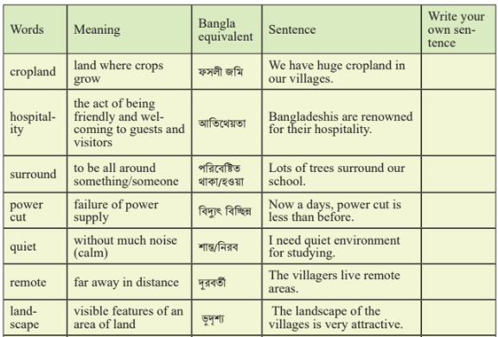

## 2. The Bizhu Festival

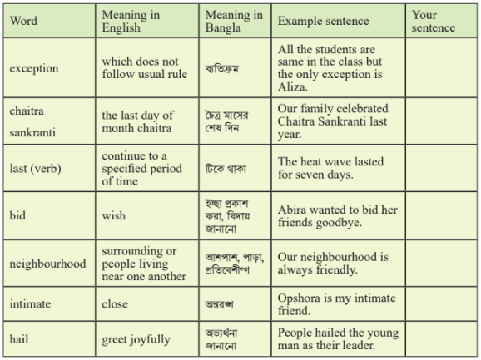

## 3. Language and Power

