NEA Report
Task 2
Humayrah Siddique
19/09/2018

Contents
Analysis 4
Decomposition 4
Specification Requirement 6
Importance of Testing 8
Design 9
Flowchart/Pseudocode 9
Data/Structure Table 15
Testing For Robustness 19
Test Table 19
Development 22
Iterative Testing 22
25
25
27
Resources Used 29
Testing 30
Final Testing 30
Evaluation 33

Analysis

Decomposition
The main parts of this program are-
- Allows two players to enter their details, which are then authenticated to ensure that they are authorised players.
- Play the game.
  - Five turns where two players roll two 6-sided dice and gain/lose points depending on what they rolled.
- Displays the score and player name of the top 5 winning scores from the external file.
I chose these to be the main parts in my program to focus on because it will help me make my code streamlined and easy to write. Without these fundamental components the program will not resemble the task sheet. For example, neglecting the “Only authorised players are allowed to play the game.” portion will mean that anyone can play the game and potentially exploit it. Therefore, I prioritised the login system.
The game part I left very vague because I can worry about the little rules as I go along but the main features of the game is that it’s turn based, 5rounds, and involves rolling 2 6-sided dice. Without these features the game wouldn’t resemble the intended game at all, so I thought to put these at the front of my program.
Finally, I prioritised the leader board system because it encourages the user to play the game due to the added competitiveness. While this is a program, it is going to be used by real people and so I need to take into consideration components, like user interface and robustness, to make people want to play my game and make it easy to follow.
Looking at the task, I know that file handling, use of the random module, and iteration is going to be used. File handling with the user base and leader board, the random module will have to be used when rolling the dice as real dice won’t be used and all the player can do is watch. And iteration will be used to emulate the 5 rounds, as well as in the login section to make sure only authorised people can log in.
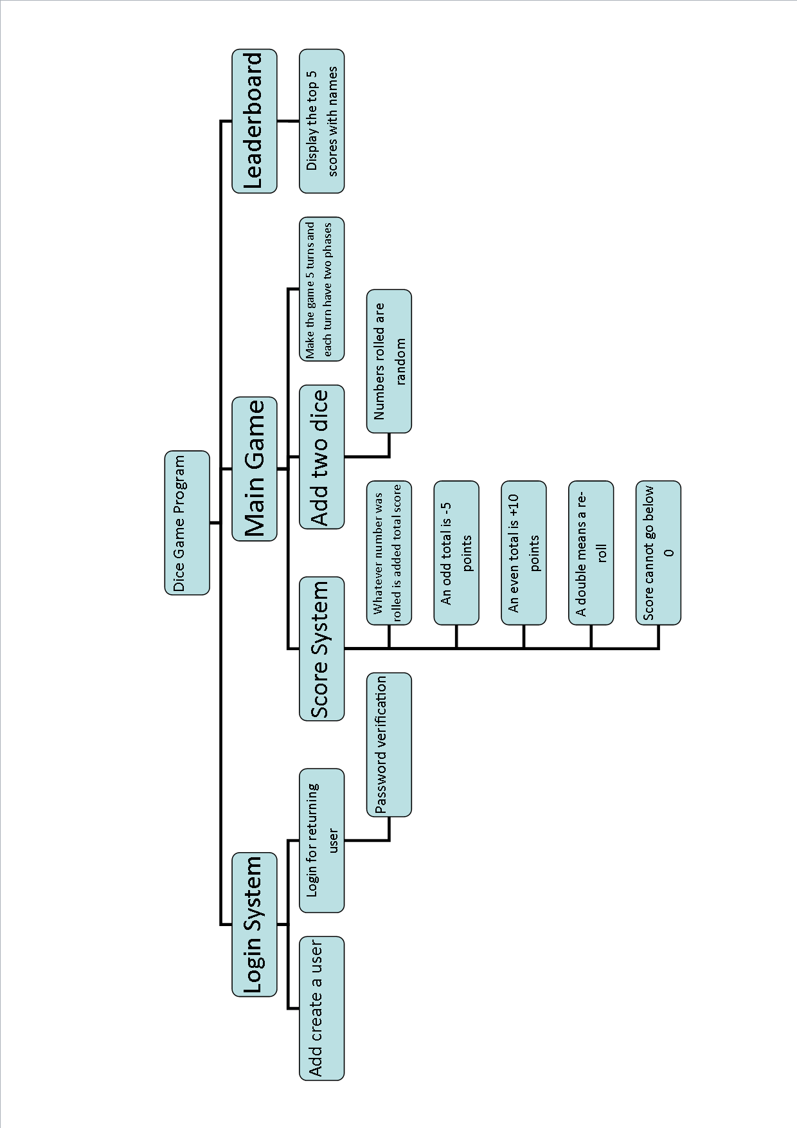

Specification Requirement
The program should be able to:
- Allow authorised players to play the game.
  - If the user is new, allow them to create a username and password [using IF statements]
    - Username and password must only contain characters, can be lowercase and uppercase
  - If not, then allow player to enter name and password
  - Check name and password is valid against file system [using a conditional WHILE statement while login != True]
  - If not, then request the user to log in again until it is correct
  - Print out the first player and repeat for the second player [a FOR loop set until 2 for the two players]
- Allow each player to roll two six-sided dice.
  - The first user should press enter, where the code will then output the two randomly generated numbers from the “roll” [using the RANDOM module]
    - Any input given must continue the program rather than interact with anything else
    - ADVANCED FEATURE: if I have time, I can add specific commands. For example, if the wrong person rolled because they assumed it was their turn, they write “reroll” instead of just pressing enter and the turn will restart.
  - The number should only be between 1-6, and this number shouldn’t be the same for both dice every time, rather the event of a double should be a coincidence [separate the two die variables and roll for each rather than at once, but OUTPUT should be at once]
  - If the two six-sided dice are the same, then a third die should be rolled which is also 1-6
- Modify the points depending on the roll and output the total score for each player after every round.
  - +10 for an even roll [using IF statements]
  - -5 for an odd roll
  - On a double roll third die after the modification
  - This third die number should be added directly to the total score of whoever rolled it
- Do this for 5 rounds.
  - Have round numbers to make sure you have played 5 rounds [use a FOR loop for 5]
- If both players have the same score after the 5 rounds, an endless loop of rolling one die will occur until one person rolls a higher number than someone else.
  - Endless loop meaning WHILE
  - Constantly compare the two values in an IF statement
- After this, the winner is calculated and outputted.
- Stores the winner’s score and name into an external file.
  - File handling will need to be used, multiple people means a LIST will need to be used when reading from it.
- Displays the “leader board” which will have the top 5 scores loaded externally.
  - Simply read from the file
I will know that these 8 requirements have been met by doing the following:
- By “authorised”, this means that the user has been registered into a database and the information they write into the program matches to the information in the database. I can do this with a username password system, where if Katarina wants someone to become an authorised player, she can sign them up with a name as an identifier and a password as an authenticator. Then when they want to play the game, they can enter their details and if allowed onto the program, they are “authorised”.
- To ensure that each player gets to roll two six-sided dice in a round, I will first need to incorporate one die, where it has 6 sides that are rolled randomly as there is no human skill involved in this virtual game. I then need to make sure the two dice can be rolled at the same time, and then allow both players to do it in the same round. By using outputs, I can find out if both players have rolled two six-sided dice in each round.
- To make sure I know that the points have been successfully modified depending on the roll, I can keep track of the totals in the final program and see if the score has added 5 for an even number, subtracted 10 for an odd number, and added by the specific amount in the event of a double. It is crucial I test each instance separately and together as I could have coded errors in the system separately or they do not work together.
- To know that I can play 5 rounds I can simply add a round counter at the start of every turn or count them myself.
- The draw system can be checked to see if it works after the 5 rounds, as this is initiated after the computer has calculated the final scores to be equal. Once this is done, I need to use a conditional while loop to ensure that only after the two players roll different amounts, the one with the higher amount wins.
- I can check to see if I have output the player correctly by cross referencing what the computer has said with what I have personally calculated throughout the game, using testing.
- Finally, the leader board system can be checked if done correctly as it will display the top 5 results in descending order, name and points. It will be the final output of the system and shouldn’t have any errors in ordering the scores and putting the right people to those scores. It should also consider the game just played.

Importance of Testing
will you know when you are done testing. Modular analysis rather than whole program analysis “for login I added passwords and names so everyone knows who they are they are distinct.”
I need to test:
- If an authorised user can log in.
- If when an unauthorised user tries to log in is either signed up or blocked out.
- If the correct names are associated with the players.
- If the player handling is consistent throughout the program.
- When the player inputs enter, if the dice are rolled and the numbers 1-6 are being output.
- When the two dice have been rolled, if the total points are correctly calculated.
- If the double is rolled, a third die is rolled.
- If both users can do this process within a single turn.
- If the outputs at the end of each round are correct mathematically.
- If the program only allows 5 rounds, no more no less.
- If the program correctly outputs the winner.
- If the name and score is saved externally.
- If the program can display the leader board from an external file.
- If the leader board is correct.
To make this program suited for the real world, the UI needs to be friendly. This means all text will need to have good grammar and understandable words rather than technical vocabulary. People may mistype their logins in, so it’s good to have a loop that will allow them to try again. The game needs to be spaced out properly with headers so the user knows what part of the program they are in. E.g Player One’s Turn, Total Score at the end of Round 4, etc.

Design

Flowchart/Pseudocode
import random
import time
FUNCTION open_file(filename, state):
RETURN open(filename + ".txt", state)
ENDFUNCTION

FUNCTION is_odd(number):
IF int(number) % 2 = 0:
odd <- False
ELSE:
odd <- True
ENDIF
RETURN odd
ENDFUNCTION

FUNCTION sort(numbers):
while True:
hasSorted <- False
selectedIndex <- 0
for i in range(1, len(numbers)):
IF numbers[selectedIndex][0] < numbers[i][0]:
numbers[i-1], numbers[i] <- numbers[i], numbers[i-1]
hasSorted <- True
ENDIF
selectedIndex <- i
ENDFOR
IF not hasSorted:
RETURN numbers
ENDIF
ENDFUNCTION

ENDWHILE
FUNCTION login_program():
num_players <- 0
while num_players = 0:
num_players <- int(input("How many people are playing? "))
ENDWHILE
players <- []
OUTPUT "\n\nOk, " + str(num_players) + " are playing. We now need each of you to log in.\n"
while len(players) < num_players:
OUTPUT "[User " + str(len(players) + 1) + "]"
new_user <- input("\nAre you a new User? Y OR N: ").capitalize()
IF new_user = "Y":
username <- input("Username: ")
name <- input("Name: ")
password <- input("Password: ")
while name.isalpha() != True:
name <- input("\nName must be letters only. Re-type name: ")
ENDWHILE
with open(username + ".txt", "w") as file:
file.write(name + "\n" + password)
OUTPUT "\nNow Log In: \n"
ENDIF
username <- input("Username: ")
password <- input("Password: ")
login <- False
try:
file <- open_file(username, "r")
except FileNotFoundError:
OUTPUT "File doesn't exist. Restarting..."
time.sleep(0.5)
login_program()
file <- open_file(username, "r")
for line in file:
IF password = line:
login <- True
ENDIF
ENDFOR
file <- open_file(username, "r")
IF login = True:
OUTPUT "Welcome " + file.readline()
players.append(username)
ELSEIF login = False:
OUTPUT "Login failed. Restarting..."
time.sleep(0.5)
login_program()
ENDIF
file.close()
ENDWHILE
OUTPUT "\n"
OUTPUT players
RETURN players
ENDFUNCTION

FUNCTION whole_program():
players <- login_program()
#Game
score <- [0]*len(players)
turns <- 0
while turns < 5:
for i in range(len(players)):
dice_1 <- random.randint(1,6)
dice_2 <- random.randint(1,6)
roll <- dice_1 + dice_2
OUTPUT "Round " + str(turns+1)
OUTPUT "It's " + str(players[i]) + "'s turn. Press Enter to Roll."
input()
OUTPUT players[i] + " rolled a " + str(dice_1) + " AND a " + str(dice_2) + "."
OUTPUT "Roll Total <- " + str(roll)
IF dice_1 = dice_2:
OUTPUT "You a rolled a double, press Enter to roll again."
input()
dice_3 <- random.randint(1,6)
OUTPUT players[i] + " rolled a " + str(dice_3)
score[i] += dice_3
ENDIF
IF is_odd(roll) = False:
score[i] += 10
ELSEIF is_odd(roll) = True:
IF score[i] - 5 >= 0:
score[i] -= 5
ELSE:
score[i] <- 0
ENDIF
ENDIF
OUTPUT players[i] + "'s score: " + str(score[i]) + "."
input()
ENDFOR
turns += 1
ENDWHILE
while score[0] = score[1]:
OUTPUT "\nThe final scores seem to be a tie."
for i in range(len(players)):
tie_dice <- random.randint(1,6)
score[i] += tie_dice
OUTPUT players[i] + "'s turn. Press Enter to roll: "
input()
OUTPUT players[i] + " has rolled a " + str(tie_dice) + "."
OUTPUT "\n" + players[i] + "'s total: " + str(score[i]) + "."
IF players[i] = 0:
IF score[i] > score[i+1]:
OUTPUT players[i] + " is in the lead with " + str(score[i]) + "points."
ELSEIF score[i] < score[i+1]:
OUTPUT players[i+1] + " is in the lead with " + str(score[i+1]) + "points."
ELSEIF score[i] = score[i+1]:
OUTPUT "Still a tie."
ENDIF
ELSEIF players[i] = 1:
IF score[i] > score[i-1]:
OUTPUT players[i] + " is in the lead with " + str(score[i]) + "points."
ELSEIF score[i] < score[i-1]:
OUTPUT players[i-1] + " is in the lead with " + str(score[i-1]) + "points."
ELSEIF score[i] = score[i-1]:
OUTPUT "Still a tie."
ENDIF
ENDIF
ENDWHILE
ENDFOR
max_score <- 0
for a in range(len(players)):
IF score[a] > max_score:
max_score <- score[a]
max_score_name <- players[a]
ENDIF
ENDFOR
OUTPUT "The winner is " + max_score_name + " with " + str(max_score) + " points."
with open("leaderboard.txt", "a") as file:
file.write(str(max_score) + ", " + max_score_name + "\n")
with open("leaderboard.txt", "r") as file:
data <- file.readlines()
sort(data)
OUTPUT "Top 5 scores:"
for i in range(5):
OUTPUT data[i]
ENDFUNCTION

ENDFOR
whole_program().
function (

Data/Structure Table
Name | Data Type | Purpose | Scope | Rules
number | Integer | This is the number that will be checked in the subroutine | Is_odd subroutine [Local] | Any number that fits into a double dice roll (so from 2-12)
Odd | Boolean | If True, it means the number is odd | Global | Has to return False if a number is divisible is 2
hasSorted | Boolean | When no passes are made in the bubble sort, this becomes True to indicate the sorting is over. | Sort subroutine [Local]
numbers | list | Numbers that are being sorted | global | Has to be integers in the list.
selectedIndex | Integer | Changes which index in the score list are being looked at to compare to the next number. | Sort subroutine [Local] | Cannot be smaller than 0, cannot be larger than the total number of items In a list.
num_players | Integer | Total number of players | Login subroutine [Local] | For the purposes of the program it has to be two.
players | List, string | Player names | Login subroutine [Local] | Can hold the usernames of the players
New_user | String | Determine whether to run register or login program | Login subroutine [Local] | Has to be capital, either “Y” or “N”.
Username | String | The name assigned to the player for the final score and duration of the game. Will allow them to play multiple times with the same name. | Login subroutine [Local] | Can be letters or numbers, as long as it can be used in a file name.
Password | string | Just for the user to know. | Login subroutine [Local] | Ideally, you wouldn’t want anyone else to know it so it should be censored.
name | String | Name of the user to play the game with and register with at the end of the game. | Login subroutine [Local]
login | Boolean | Checks if the inputs given for login and password match any in the database. If not then the login is false. If true it allows the user to log in. | Login subroutine [Local]
file | string | It tries to open the file with the same username as the one entered by the user. Because I am saving each file according to the username, being unable to open the file means the username doesn’t exist. | Login subroutine [Local] | Must be the same as the username to open.
line | string | Allows the current line being read by the ‘for’ loop to be handled. This is used to check line by line if the password exists in the file. | Login subroutine [Local]
players | List (string) | Players holds the names of player one and two so when handling whose turns it is and where to allocate the points (do other functions), the program won’t have to be confused. | global | Cannot exceed 2 for the program. Cannot be less than 2.
score | List (integers) | Holds the current score of each other player individually. Kind of like having two separate variables but makes it easier to code as I only have to call a specific index rather than a new variable. | Main program subroutine | Can never go below 0.
turns | integer | Amount of turns in the game. Will be set to 5 to allow the 5 turns as per the program requirements, but can be easily modified to match whatever turns you want. | Main program subroutine | Cannot be any more or less than 5.
Dice_1 | integer | The first dice to be rolled. Will be randomised. | Main program subroutine | Has to be between 1-6.
Dice_2 | integer | The second dice to be rolled. it’s separate so that two different numbers can be randomised, rather than the same one. | Main program subroutine | Has to be between 1-6.
Dice_3 | integer | This dice is only used if dice 1 and 2 are equal. It follows the rule that a third dice must be rolled in the event of a tie, but once again I want it to be separate so the same number isn’t rolled. | Main program subroutine | Has to be between 1-6.
roll | integer | The total of the two dice. Whether it’s odd or even determines what will happen to the total score. | Main program subroutine | Has to be between 2-12
Tie_dice | integer | At the end of the game, if both scores are equal this die will be used to determine the winner. | Main program subroutine | Has to be between 1-6.
Max_score | integer | This will hold the user with the final top score in the instance of the game. | Main program subroutine
data | List (integer) | This is the data that will be read into the sort function to be sorted and put into the program. Like a bridge between the file and the code. | Main program subroutine | Formatted as name, score.

Testing For Robustness
To make my program robust, I am going to implement checks like the “FileNotFoundError” so my program doesn’t crash if the user’s file isn’t found. because there could still be another file that actually has the username. I am also planning to make the program’s UI more friendly by adding space between the words, making them full sentences rather than commands (E.g “Welcome to the game!” as opposed to “Game:”). I am going to add spacing between the different phases in the game and make sure that they are clear, as well as making it clear when user input is needed.
To test these functions out, I will make dummy users interact with the game, as well as have other students play my game to see if it’s easy to follow for someone who doesn’t know anything about my code.

Test Table
Test Number | Test Purpose | Input Data | Type of Test (normal, boundary, erroneous, robust) | Expected Result
SUBROUTINE OPENFILE
1 | To get a file open in the program | A file that exists in the system i.e “user.txt” | normal | For the file to be usable by the program.
SUBROUTINE ODD CHECKER
1 | To see if the program will notice an odd number. | An odd number e.g 1 | normal | For it to return True.
2 | To see if the program will notice an even number. | An even number e.g 2 | normal | For the program to return False.
3 | The same as above but with more complex numbers. | A large odd number like 651465468546541 | normal | For the program to return True.
4 | The same as above but with more complex numbers. | A large even number like 54864786352 | normal | For the program to return False.
SUBROUTINE SORT DATA
1 | To see if the numbers in a list are sorted. | A list that has numbers in a muddled order. | normal | For the numbers to be in descending order.
2 | To see how the sort algorithm handles duplicate numbers. People can get the same numbers in the real game. | A list that isn’t in the correct order, and has multiple of the same number. | boundary | For the numbers to be in the descending order and for the duplicates to be next to each other.
SUBROUTINE LOGIN PROGRAM
1 | To see if 2 people can play the game successfully | Two players sign up correctly | normal | To be logged in ready to play the game
2 | To see if 2 returning people can play the game successfully | Two players log in correctly | normal | To be logged in ready to play the game
3 | The program should be able to restart if the person tries to log in with a username that doesn’t exist. | User a file name that doesn’t exist in the directory. | errorneous | The program should restart. (even if player one logged in successfully and player two made the mistake)
4 | The program has to expect either an accidental mistyping of a password or program misuse. | An existing username, but the incorrect password. | errorneous | The program should restart. (even if player one logged in successfully and player two made the mistake)
SUBROUTINE MAIN GAME
1 | I want to get a full roll. Two randomised numbers. | One of the players “roll” | normal | 2 numbers ranging from 1-6 each.
2 | To test if the correct procedure is followed if a double is rolled. | Two of the same number is rolled (through multiple tries using the random function) | boundary | The program will ask for a third die to be rolled by the correct user who rolled the double.
3 | To test if the correct procedure is followed if an odd number is rolled. | Two numbers that add up to an odd total. (e.g 1 and 2) | normal | 5 points should be removed from the total score (of the corresponding player).
4 | To test if the correct procedure is followed if an even number is rolled. | Two numbers that add up to an even total. (e.g 4 and 6) | normal | 10 points should be added to the total score (of the corresponding player)..
5 | To see if the game will run with no errors (logic or syntax). | Hold enter until 3 chevrons (>>>) indicating no more code appear. | robust | The code should run with no red error messages.
6 | Find out if both users get to roll in the same turn. | Skip through the first person’s turn (pressing enter) | normal | The second user should be asked to roll before the turn counter goes through.
7 | See if 5 rounds will run. | Hold enter keeping track of the turn counter | Normal | The game should display rounds 1-5.
8 | To make sure a score never goes below 0. | Constantly roll odd numbers (no random) | normal | The score should always go to 0.
9 | See if the correct winner is displayed. | Have two scores, one being larger than the other. (e.g player one = 4 and player two = 5) | normal | Player two should win.
19 | Check if the tie game is playable. | Have the two final scores be the same. | normal | The tie game is initiated.

Development

Iterative Testing
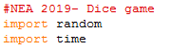
Importing the modules that I will be using. While the random module is needed, the time module is only so that the user has time to read what’s going on.
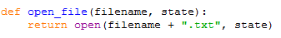
This is a simple function that returns whatever file and state is called to be used in the program. I have it separated because I use file handling a lot and it’s easier to just do what I want with a file rather than opening and closing it constantly. Also the withopen function only allows you to manipulate a file within the code, so the function should allow me to do more.

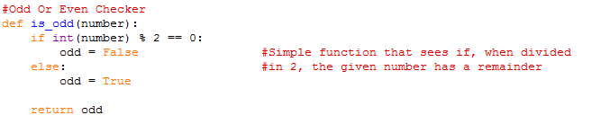
This function tries to divide a given number by 2. If there is no remainder (0), then the number is treated as odd = False and sent back to the program. If there is a remainder, it is treated as false and so retuned as odd = True.

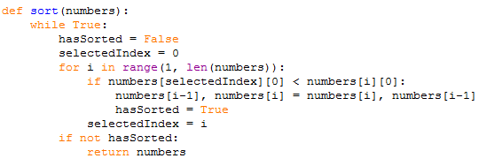

“While True” starts the while loop on infinite so that I can check the list as many times as I want until the condition is met. I reset the” hasSorted” to “False” so the program knows that every time the list is gone through it’s with the notion that the list isn’t sorted. When the if “not hasSorted” (so “hasSorted” isn’t “False”) then the numbers are given.
As for the actual swapping, the numbers are taken in index form as my file saves as score as SCORE, NAME. So having it as a line will be “score, name” and so can’t be compared. Instead I store it as “score” “name”, so not only can it be sorted, but also the name moves along with the number so it can be shown at the end. “I” refers to the place in the list, “i-1” being one before it (as I am doing it in descending order). I would change the < operand to > to make ascending.

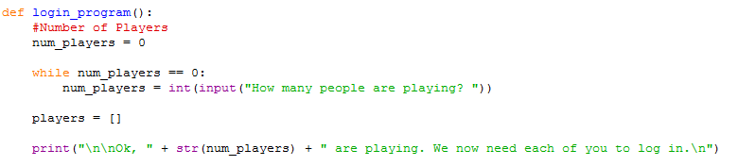
This simply sets up the number of players. Initially my code was made for two people only but I decided to open it up for multiple players. “Players” is in a list so that I can switch between players easily rather than handling two separate variables. It prevents me splitting them up while coding and I don’t have to track the two variables separately.

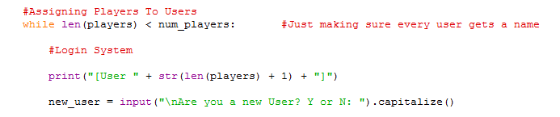
While the number of people playing (complete with name) is less than the number specified at the beginning, it will then run the login or register portion (accordingly).

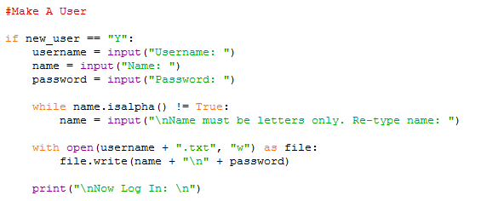
The register has been chosen, so now any username, name and password is chosen. ”while name.isaplha()” just makes sure the name is all alphabetic. It then writes to a new file, where the username is the filename and the name and password are stored in separate lines. It then skips straight to logging in.

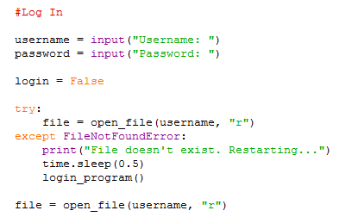
Username and password is entered by the user. As the file hasn’t been checked yet login is set to False. When the program has checked the username exists, the login is then set to True.
The try/except FIleNotFoundError means that I know this error will be encountered when the username exists, except instead of letting my code crash, it will simply restart the code and try again. It’s to prevent a frequent crash that I know will occur.

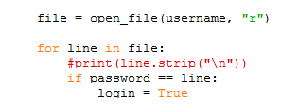
A simple for loop which, once opened the file that responds to the username, checks line by line to find a password match. If this is true, then the rest of the code is skipped to either the next player or (if it is the last player) skips to the game.

This time the login is False after checking each and every line of the responding file, and so it is assumed the password was not a match. Because this login process is put into a subroutine it is easy to restart, and I put a time function there so the user knows that an error occurred in the login specifically, allowing them to ask the admin for assistance.
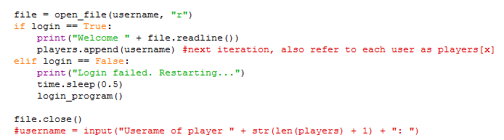

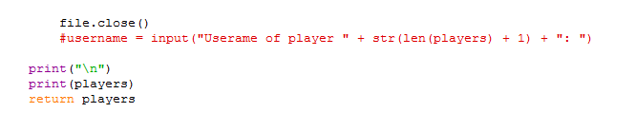
End of subroutine just prints all the players and their names so the user has confirmation that this is the setup they are getting. “Players” is returned as this is the only variable that will be used in the main program after the whole login process.

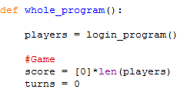
Loads the login function as this is the one function that will be called in my main program. Once this is done, the game begins with the scores set up for the specific players.

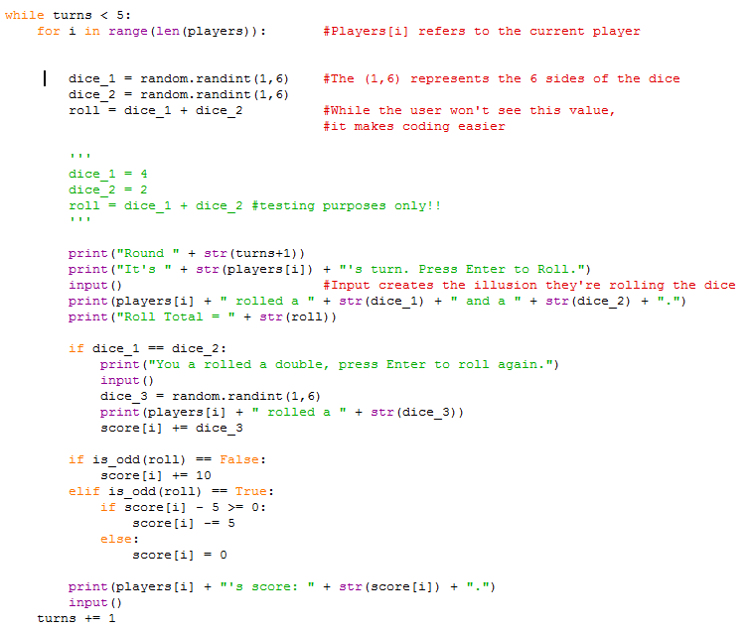
This is the whole game. “While turns < 5” just allows you to change how many turns you want in the game. “for I in range(..)” means that this rolling process will happen for as many players as needed. In this case it will be two. The two dice, plus the roll is done before hand so the program is easier to manage and I can split up the doing portion and the portion the user is going to see.
I take inputs so user can read at their own pace and it feels like when they press enter they roll the die.
The if statements check out certain conditions like the double roll and the odd or even total. They modify the points of the correct user accordingly.

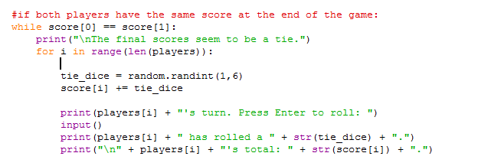
This only occurs when both [0] and [1] (the two players) have the same final score. It rolls a tie dice until the two players get different scores to avoid breaking. Then whenever the rolls are different the loop ends.

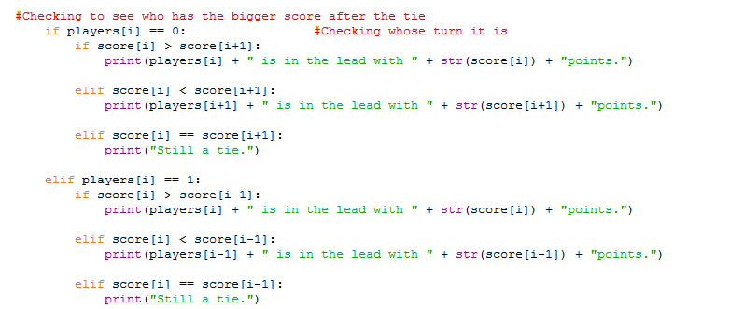
A long if statement that will print whoever won the game depending on their score. The last one will say that it is still a tie and then restart the tie die game.

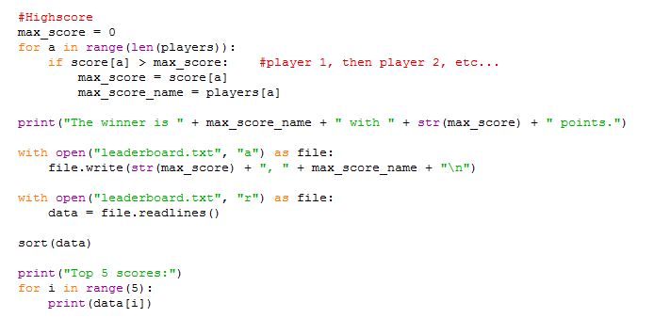
This is where the winner and their score is saved externally to a file, after which the top 5 scores will be printed to the user.

This one function call will start the whole program.

Resources Used
Lists :: w3 schools,
OCR pseudocode guide,
Mod/Div :: (https://www.w3resource.com/python-exercises/python-basic-exercise-21.php),
How to Append List :: Learning To Program In Python - 05 Lists

Testing

Final Testing
Test Number | Test Purpose | Input Data | Type of Test (normal, boundary, erroneous, robust) | Expected Result | Pass or Fail?
SUBROUTINE OPENFILE
1 | To get a file open in the program | A file that exists in the system i.e “user.txt” | normal | For the file to be usable by the program. | P
SUBROUTINE ODD CHECKER
1 | To see if the program will notice an odd number. | An odd number e.g 1 | normal | For it to return True. | P
2 | To see if the program will notice an even number. | An even number e.g 2 | normal | For the program to return False. | P
3 | The same as above but with more complex numbers. | A large odd number like 651465468546541 | normal | For the program to return True. | P
4 | The same as above but with more complex numbers. | A large even number like 54864786352 | normal | For the program to return False. | P
SUBROUTINE SORT DATA
1 | To see if the numbers in a list are sorted. | A list that has numbers in a muddled order. | normal | For the numbers to be in descending order. | P
2 | To see how the sort algorithm handles duplicate numbers. People can get the same numbers in the real game. | A list that isn’t in the correct order, and has multiple of the same number. | boundary | For the numbers to be in the descending order and for the duplicates to be next to each other. | P
SUBROUTINE LOGIN PROGRAM
1 | To see if 2 people can play the game successfully | Two players sign up correctly | normal | To be logged in ready to play the game | P
2 | To see if 2 returning people can play the game successfully | Two players log in correctly | normal | To be logged in ready to play the game | P
3 | The program should be able to restart if the person tries to log in with a username that doesn’t exist. | User a file name that doesn’t exist in the directory. | errorneous | The program should restart. (even if player one logged in successfully and player two made the mistake) | P
4 | The program has to expect either an accidental mistyping of a password or program misuse. | An existing username, but the incorrect password. | errorneous | The program should restart. (even if player one logged in successfully and player two made the mistake) | P
SUBROUTINE MAIN GAME
1 | I want to get a full roll. Two randomised numbers. | One of the players “roll” | normal | 2 numbers ranging from 1-6 each. | P
2 | To test if the correct procedure is followed if a double is rolled. | Two of the same number is rolled (through multiple tries using the random function) | boundary | The program will ask for a third die to be rolled by the correct user who rolled the double. | P
3 | To test if the correct procedure is followed if an odd number is rolled. | Two numbers that add up to an odd total. (e.g 1 and 2) | normal | 5 points should be removed from the total score (of the corresponding player). | P
4 | To test if the correct procedure is followed if an even number is rolled. | Two numbers that add up to an even total. (e.g 4 and 6) | normal | 10 points should be added to the total score (of the corresponding player).. | P
5 | To see if the game will run with no errors (logic or syntax). | Hold enter until 3 chevrons (>>>) indicating no more code appear. | robust | The code should run with no red error messages. | P
6 | Find out if both users get to roll in the same turn. | Skip through the first person’s turn (pressing enter) | normal | The second user should be asked to roll before the turn counter goes through. | P
7 | See if 5 rounds will run. | Hold enter keeping track of the turn counter | Normal | The game should display rounds 1-5. | P
8 | To make sure a score never goes below 0. | Constantly roll odd numbers (no random) | normal | The score should always go to 0. | P
9 | See if the correct winner is displayed. | Have two scores, one being larger than the other. (e.g player one = 4 and player two = 5) | normal | Player two should win. | P
10 | Check if the tie game is playable. | Have the two final scores be the same. | normal | The tie game is initiated. | P

Evaluation
My system meets all the requirements for this project. However, my program can be easily abused in that if someone were to make an account, they can misuse the program however they wish as there is no difference between admin and regular user. This means they have access to everything the code has to offer, including other people’s logins.
In terms of robustness I can add many checks and validations the login process such as password requirements, username requirements, and censor the password when typed to streamline my database for easy navigation and to help with security.
My user interface could be improved by using Python’s format feature, but this will be added nearer to the end of the development cycle as that is a beautification feature and so less important than robustness. If I were to do it again I would try and shorten my code by adding more subroutines to make processes faster. I could also use a different type of sort for the leader board. I could store the files differently – rather than in multiple files it could all be in one database.
What I think I did well in my code is the readability as there are comments and spacing which makes my code easy to follow. I utilise subroutines and different loops to make my code efficient. The use of two dimensional arrays is also something I’m proud of because I don’t frequently use them and so this was a learning experience for me.

