Rethinking Sequence Assembly

Omar Rosado Ramírez Humberto Ortiz-Zuazaga

May 10, 2015

Abstract

In bio-informatics, Sequence Assembly faces few problems, the most persistent one being the “bad read problem”, which creates “extra” reads that make the newly constructed DNA strand bad. In this study, we create an assembler that inserts artificial errors into a fixed strand, sequences and assembles it, and then creates a graph representation of the DNA strand, which is used to characterize the created errors.

1 Intro

Sequence Assembly has become the crown jewel of bio-informatics. It is the process which takes a known or unknown strand of DNA that has been sequenced into smaller strands, called reads, and assembles it back together. It relies on programs called sequencers and assemblers to do exactly that, sequence the DNA and assemble the DNA. Sounds simple enough, but the problem in sequence assembly is that the assemblers made cant reconstruct the original DNA strand exactly nor to an approximate we may call useful.

2 Prior Work

Along our study, we compared ideas to those of two papers, [1] and [2], which make a similar approach to the problem. [1] approaches the problem by making a list of reads, which they call solid reads and weak reads. Using a method called spectral alignment, they are able to remove a large amount of the errors and increase the “good” reads, but still fail at obtaining what they want. Another path they take is called Error Correction, which takes the size of a sequences and eliminates the parts which are 2 times larger than the errors predicted. This approach eliminates approximately 80%
of the errors, but its not good enough. [2] makes a dictionary with the most repeated reads and discards the less repeated ones. Simple enough, more efficient than [1], but not quite what is needed. The goal is to obtain at least less than 1% of errors. In this study, we present the possible solution.

3 Our Work

In this study, we present Copperhead, the possible and most simple way out of the sequence assembly problem.

3 .1 Our tools

Copperhead is made in a Python environment, along with the libraries networkX, GraphViz, and find_euler_path. To make the graphs below, we used the open-source graph plotting program, Gephi.

3.2 The Copperhead Assembler

The Copperhead assembler creates an artificial strand of DNA which is used to simulate the whole “sequence assembly”. To simulate, we insert a small amount artificial errors in the strand, each represented with the letter x. The strand is then sequenced into reads of any range(we use 15 to get good coverage) and after, the strand is sequenced again into kmers. The kmers are the ones who present problems when it comes to assembly, so it's here that the real work begins. Like in [2], we take each kmer and place it in a dictionary. The difference with Copperhead is that, as it counts each kmer, the number of times it appears is stored in the dictionary also. The program then proceeds to eliminate the kmers that least appear, which are most likely errors. In this case, they are errors due to the amount of x's that appear, which are very small. During this process, a low percentage of good kmers is lost due to the unlikelihood of them appearing very few times(less than 3, in our case). If a real DNA strand where used, the same process would take place, probably with better results(**to be explained further on). After the least appearing kmers are eliminated, the program creates a graph representation [figure 1] of the strand using NetworkX.
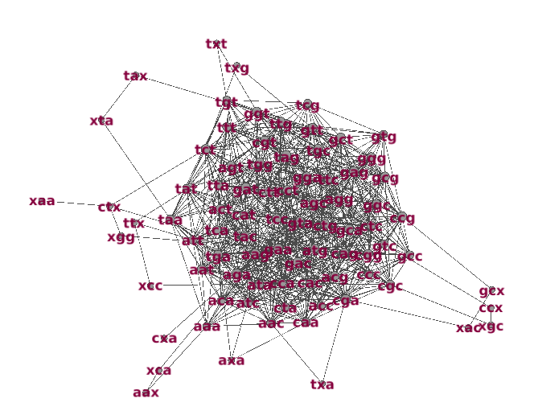
Figure 1. This graph was created using Gephi. The graph is made to only show every unique kmer(or node, using networkX speak). It shows the kmers that least appear(ones with x's) outside of the main strand. This means that they connect few times with few kmers, hence they appearing in few quantities.

The program uses the created graph to look for an Eulerian path( visit every node[kmer] once each). This process is used to solidify the fact that at the end we actually have the “whole” DNA strand. The module used to find the Eulerian path is called find_euler_path, which is documented in [3].

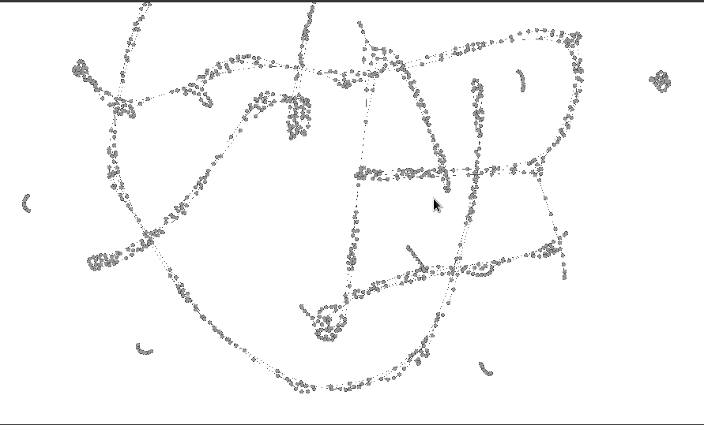
Figure 2. This graph shows the strand in a more indulging way. The DNA strand is seen like the average Joe would imagine it, a long piece of connected “objects”. The graph is not completely connected due to the existence of errors. The small pieces detached from the long strands are errors(each read contains an error).

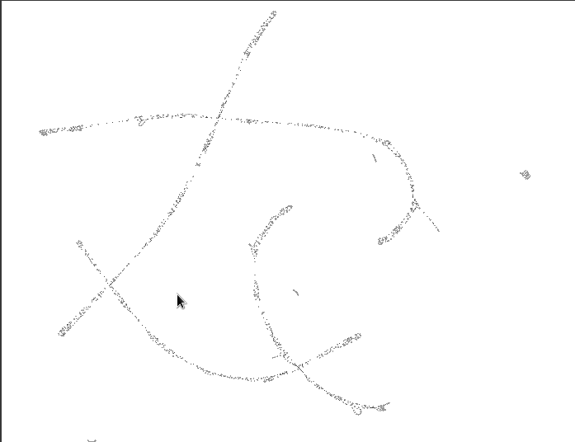
Figure 3. Here, the strands are clear and seen from afar. While the longest one contains no errors, the rest contains a piece which contains errors, including the small ones mentioned already(full of errors).

The next graph [figure 4] is one of the small strands up close.

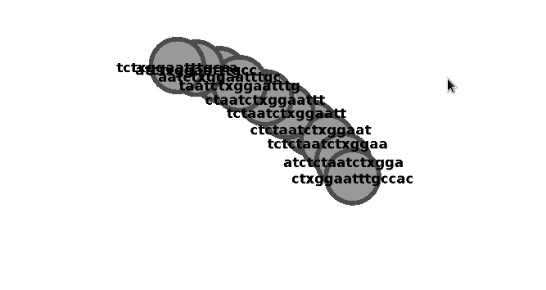

Figure 4. In this strand, every kmer has an x. [ignore the cursor]

Since the strands contain errors, an Eulerian path is never found. As mentioned earlier, if a real DNA strand where used, better results would come up due to the fact that there is a small amount of errors in our fixed strand(x's). Since there are no errors in a real DNA strand, the result of its process through Copperhead will most likely be excellent. The final step taken is the assembly and comparison to the original strand, which is not fully defined. The Copperhead Assembler can be found in our repository at: http://github.com/longSh0t/CopperHeadAssembler/COPPERHEAD2000.py

4 Future Work

The next step for Copperhead is to eliminate the artificial DNA strand and experiment with actual DNA. To this moment, Copperhead has only used artificial DNA strands for every experiment. In the future, graph comparisons of real and artificial DNA will lead us to conclusions (or possibly, but not hopefully, to square one!) that will make sequence assembly seem a lot less close to the impossible.
5 Conclusion

In sequence assembly, detecting bad reads and eliminating them is the main goal. Copperhead's purpose is to be as simple as possible; an approach to sequence assembly that is both efficient and simple to understand(for new-comers mostly). Although the same problem persists, sequence assembly only gets easier. With the artificial error simulation, the strand assembly has become, in part, “another complex python project”. Now, it's only a matter of time, wisdom and patience until Copperhead is ready to crack it.

6 Acknowledgments

This paper and experiment would have not been possible without my colleague Ricardo Lopez Torres and his mad thinking skills and my mentor Humberto Ortiz-Zuazaga for his 80's techno-wizard wisdom and infinite knowledge. I would also like to thank every computer science professor in the University of Puerto Rico, Rio Piedras Campus. Without their dedication and great mentoring, this study and many others would not have been possible. Thank you all.

References

[1] Pavel A. Pevzner, Haixu Tang, and Michael S. Waterman . An Eulerian Path Approach to DNA Fragment Assembly. http://www.pnas.org/content/98/17/9748 , 2001.

[2] Manfred G. Grabherr, Brian J. Hass, Moran Yassour. Trinity: Reconstructing A Full-length Transcriptone Without A Genome From RNA-Seq Data. http://dx.doi.org/10.1038/nbt.1883 , 2011.

[3] Edwardo S. Rivera, Humberto Ortiz-Zuazaga. A General Implementation Of Eulerian Path. http://dx.doi.org/10.6084/m9.figshare.1424492 , 2015.

