Active learning for low-band-gap three-dimensional metal–organic frameworks: prospective DFT validation of a chemically audited hypothetical catalogue
Carlos H. Guerrero Navarroª, Maryam Ghotbi^{b}, Perla B. Balbuena^{a,b,c,*}
ª Department of Chemical Engineering, Texas A&M University, College Station, Texas 77843, United States
^{b} Department of Chemistry, Texas A&M University, College Station, Texas 77843, United States
^{c} Department of Materials Science and Engineering, Texas A&M University, College Station, Texas 77843, United States
* Corresponding author: balbuena@tamu.edu

Abstract
Three-dimensional metal–organic frameworks (MOFs) with small band gaps are rare, and screening hypothetical frameworks for them with density functional theory (DFT) is costly. We report an active-learning workflow coupling a chemically audited catalogue of 131 hypothetical three-dimensional frameworks, assembled with PORMAKE from charge-balanced M(II) carboxylate nodes and dicarboxylate linkers on five nets, with an ExtraTrees ensemble trained on 20,372 QMOF band gaps and a lower-confidence-bound acquisition with diversity terms. Three batches were validated prospectively with spin-polarised PBE-D3(BJ) calculations after CHGNet pre-relaxation: 18 of 27 frameworks gave accepted labels; the rest collapsed, sheared or did not converge, and are reported. All 13 open-shell frameworks (Fe, Co, Cu) have PBE gaps below 1 eV, eight below 0.5 eV. The prospective error of the surrogate is 0.23 eV for these but 0.96 eV for the closed-shell Zn₄O frameworks, which it underpredicts systematically; retraining changes little. A retrospective benchmark on QMOF confirms this: at equal DFT budget the acquisition finds three to four times more low-gap frameworks than random selection, while the model error barely moves. Band-edge projections show that the metal fixes the gap in the open-shell families, where both band edges are metal d states, whereas in Zn₄O frameworks both edges are linker states and amine or pyridine substituents lower the gap by up to 1 eV. Periodic GFN1-xTB on CHGNet geometries reproduces the closed-shell labels within 0.23 eV without training data, a cheap check where the surrogate is weakest, but fails for open-shell metals. Code, data and VASP outputs are open.
Keywords: metal–organic frameworks; active learning; band gap; density functional theory; hypothetical materials; extended tight binding; QMOF

1. Introduction
Metal–organic frameworks (MOFs) combine permanent porosity with a modular chemistry of inorganic nodes and organic linkers [1]. Electrically conductive MOFs would add charge transport to this toolbox for sensing, energy storage and electrocatalysis, but they remain a small subset of the known frameworks and are dominated by two-dimensional honeycomb lattices built from π-conjugated, redox-active linkers [2–4]. Three-dimensional conductive frameworks are much rarer, because the carboxylate linkages that make most three-dimensional MOFs robust also interrupt the orbital overlap needed for band transport [5–7]. A small electronic band gap is a necessary, although not sufficient, condition for conductivity, and it is the property that can be screened at scale with semilocal density functional theory (DFT) [8].
Data-driven screening of MOF band gaps rests largely on the QMOF database, which provides PBE band gaps for more than twenty thousand experimentally derived structures, together with hybrid-functional gaps for a subset [9,10]. Models trained on QMOF, from tabular regressors to graph networks and pre-trained transformers [11–13], reach mean absolute errors (MAE) of about 0.3–0.4 eV on held-out QMOF structures. Hypothetical frameworks, however, are rarely drawn from the same distribution: topology-based generators such as PORMAKE can assemble trillions of frameworks from building-block libraries [14], and their densities, pore sizes and metal contents often fall outside the QMOF range. How well a QMOF-trained surrogate transfers to such frameworks can only be established prospectively, by computing the frameworks it selects.
Active learning offers a disciplined way to spend a limited DFT budget: a surrogate proposes candidates, their labels are computed, and the model is retrained [15]. Multi-objective acquisition functions that balance predicted value, uncertainty and diversity have been formalised for materials design [16], and active learning has been used in MOF research to build machine-learned potentials [17], to steer adsorption simulations [18] and, most relevant here, to choose the most informative training structures for property prediction on existing databases [19]. What is less common is a discovery-oriented loop on hypothetical three-dimensional frameworks in which every DFT outcome, including the frameworks that fall apart, is reported, and in which the gain of the loop is separated into finding low-gap frameworks and improving the model.
A complementary route is to replace the data-driven surrogate by a cheap physics-based estimate. The semi-empirical tight-binding method GFN1-xTB [20] optimises MOF geometries reliably under periodic boundary conditions [21,22], and tight-binding electronic structure has been benchmarked against DFT for two-dimensional frameworks [23]. Jose and Walsh recently showed that periodic GFN1-xTB reproduces PBE band gaps of 4,941 QMOF structures with an MAE of 0.37 eV, fails for frameworks with Cr–Ni and Cu(II) centres, and provides a useful low-fidelity input for Δ-learning of hybrid-functional gaps [24,25]. Whether this transfers to hypothetical frameworks that lie outside QMOF, and how it compares with a data-driven surrogate there, has not been tested.
Here we build a chemically audited catalogue of hypothetical three-dimensional frameworks, screen it with a QMOF-trained ExtraTrees ensemble and a lower-confidence-bound acquisition function, and validate three batches with spin-polarised PBE-D3(BJ) calculations (Fig. 1). We report four results. First, the loop works as a discovery tool: all 13 open-shell frameworks that survived DFT have PBE gaps below 1 eV, and a retrospective benchmark on QMOF quantifies the gain over random selection. Second, the surrogate is accurate for open-shell 3d frameworks but underpredicts closed-shell Zn₄O frameworks by about 1 eV, a transfer failure that 18 new labels do not repair. Third, band-edge projections explain the chemistry: in the open-shell families both band edges are metal d states and the metal fixes the gap, whereas in Zn₄O frameworks both edges lie on the linker and substituents tune the gap. Fourth, periodic GFN1-xTB on machine-learned geometries is an inexpensive, training-free check exactly where the surrogate is weakest, and fails exactly where the surrogate is strongest. Throughout, PBE gaps are used as labels because they are the quantity available in QMOF; their relation to hybrid-functional gaps is discussed explicitly.
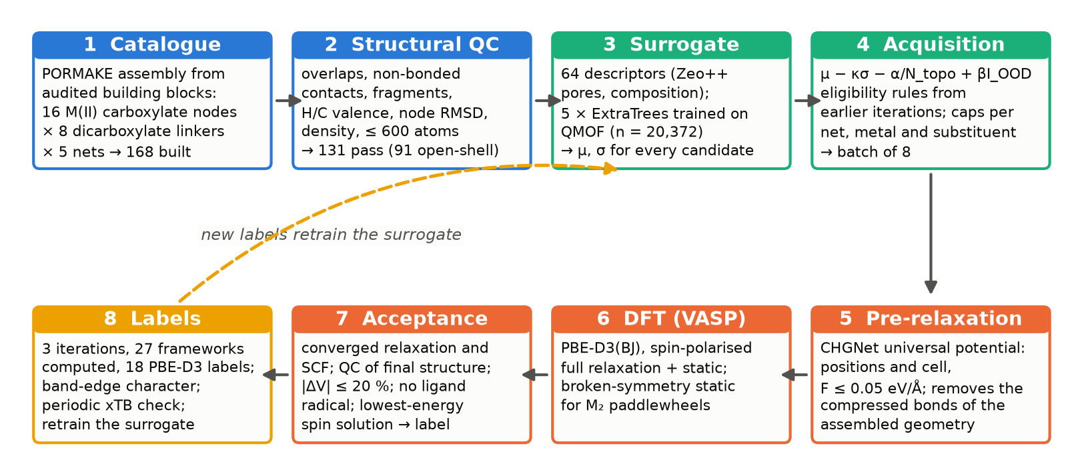
Figure 1. Workflow. A PORMAKE catalogue built from audited building blocks (1) is filtered by structural quality control (2) and scored by an ExtraTrees ensemble trained on QMOF (3). An acquisition function with diversity caps and eligibility rules selects each DFT batch (4), which is pre-relaxed with CHGNet (5), computed with VASP (6) and filtered by acceptance rules (7). Accepted labels (8) retrain the surrogate and are analysed for band-edge character; periodic GFN1-xTB is used as an independent check. All numbers refer to this work.

2. Methods

2.1 Building blocks and catalogue
Frameworks were assembled with PORMAKE 0.2.3 [14], which places node and edge building blocks on the vertices and edges of a topological net and relaxes the cell to match them. The PORMAKE library contains 648 nodes and 219 edges without chemical annotation, so every building block was audited first: composition, number of connection points, presence and number of carboxylate groups, extra oxygen atoms (oxo, hydroxo) and the metal oxidation state implied by charge balance with dianionic dicarboxylate linkers (Table S1). Only metal nodes whose connection points are all carboxylates and whose implied oxidation state is +2 were retained, so that every assembled framework is a neutral M(II) dicarboxylate. Sixteen such nodes cover five families: trinuclear M₃(CO₂)₆ (pcu; M = Mn, Fe, Co, Zn, Mg), the Zn₄O(CO₂)₆ cluster of MOF-5 (pcu), M₂(CO₂)₄ paddlewheels (nbo and cds; M = Mn, Fe, Co, Cu, Zn), tetrahedrally connected M₂(CO₂)₄ units (dia; M = Co, Ni, Zn) and the eight-connected M₄(CO₂)₈ cluster (bcu; M = Fe, Co). The edges are carboxylate-free spacers, so the assembled linkers are 1,4-benzenedicarboxylate (BDC), 2-amino-BDC, 2,3,5,6-tetrafluoro-BDC, pyridine-2,5-dicarboxylate, 4,4′-biphenyldicarboxylate (BPDC), octafluoro-BPDC, and the phenylpyridine and bipyridine dicarboxylates (Table S2). The metal label of every framework is read from its building block, not from a name.
Every node–linker–net combination was built (168 frameworks) and passed through a structural quality control (QC) that rejects any framework with a pair of atoms closer than 0.70 Å, a heavy–heavy or H–H pair closer than 1.00 Å, a non-bonded contact shorter than 0.8 times the sum of covalent radii, more than one connected component or an isolated atom, an H atom without exactly one neighbour or a C atom with an organic coordination number outside 2–4, a composition different from the sum of its building blocks, a density outside 0.20–3.0 g cm⁻³, a cell length below 5 Å, more than 600 atoms, or a node root-mean-square deviation above 0.30 Å after placement. Thirty-seven frameworks failed, most often for low density or short heavy-atom contacts (Table S3); the catalogue holds 131 frameworks, 91 with an open-shell 3d metal and 40 closed-shell (Zn, Mg) references (Table S4). The generator reproduces the compositions of MOF-5, IRMOF-3 and IRMOF-10 (Table S5).

2.2 Descriptors and surrogate model
Each framework is described by 64 tabular descriptors (feature set C, Table S7): eight geometric quantities, among them the pore-limiting and largest-cavity diameters from a high-accuracy Voronoi decomposition in Zeo++ [26], 22 composition aggregates such as the metal fraction, the carbon-to-atom ratio and the number of open-shell 3d metals, and the fractions of 34 common elements. QMOF structures were featurised identically. The surrogate was chosen from a benchmark of eleven regressors on five feature sets, trained on 80 % of the 20,372 QMOF entries with a PBE gap and evaluated on the remaining 20 %, stratified by the 1 eV threshold (Table S6). ExtraTrees [27,28] on feature set C gave the lowest error without PBE-derived inputs (R² = 0.75, MAE = 0.39 eV, Spearman ρ = 0.86, ROC AUC = 0.95 for the 1 eV classification; Fig. S1); adding categorical descriptors (set D) did not help, and PBE-derived auxiliary quantities (set E) were excluded as leakage. Gradient-boosting [29–31] and random-forest [32] models were within 0.02 eV. SHAP values [33] rank the open-shell flag, the transition-metal flag and the open-shell fraction as the three dominant descriptors (Fig. S2).
For active learning, five ExtraTrees regressors (300 trees, max_features = sqrt, min_samples_leaf = 2; Table S8) with different seeds form an ensemble in the spirit of deep ensembles [34]. The prediction μ(x) is the mean of the five members. Because the five means of fully grown tree ensembles differ by only 0.03 eV on average, the uncertainty σ(x) is defined as the standard deviation over all 1,500 trees of the five members, which is 0.5 eV on average for the catalogue and tracks the prospective errors (Section 3.4). A framework is flagged out of distribution (I_{OOD} = 1) when its density, pore-limiting diameter, number of atoms, metal fraction or carbon-to-atom ratio lies outside the 5–95 % range of QMOF; 89 of the 131 frameworks carry the flag.

2.3 Acquisition and batch selection
Candidates are ranked by a lower-confidence-bound score extended with a topology-novelty reward and the out-of-distribution penalty,
score(x) = μ(x) − κ σ(x) − α / max(1, N_{topo}(x)) + β I_{OOD}(x), (1)
where N_{topo}(x) is the number of accepted labels already available in the net of x, and κ = 1.0, α = 0.3 and β = 0.5 [16,35]. The lowest scores are taken subject to diversity caps per net, metal and substituent, so that a batch samples several families rather than the single most promising one. In iteration 0 the caps were two per net and two per metal, and two closed-shell frameworks, MOF-5 and the Zn₂ paddlewheel cds framework, were added as references; iteration 0 therefore comprised 11 frameworks. Iterations 1 and 2 selected eight frameworks each from the candidates not yet computed, with caps of four per net, two per metal and four per substituent, and with eligibility rules learned from the previous iteration: node families or node–net–metal combinations whose frameworks had collapsed in DFT were excluded, and frameworks were limited to 160 atoms (Table S9). The caps are reached by the open-shell candidates after six picks, so the last two slots of iterations 1 and 2 went to Zn₄O frameworks, which served as closed-shell protocol checks and, as it turned out, as the most informative test of transferability. The parameters were fixed before any DFT result was known and were not tuned afterwards.

2.4 Pre-relaxation and DFT
As-assembled PORMAKE geometries contain compressed bonds at the node–linker junction (C–C down to 1.1 Å, N–H 0.86 Å), which in a first attempt produced initial forces of 10–35 eV Å⁻¹, electronic convergence failures and relaxations that advanced by only a few ionic steps per day. From iteration 1 onward, and for the restarts of iteration 0, every framework was therefore pre-relaxed (positions and cell, FIRE, forces below 0.05 eV Å⁻¹) with the universal machine-learned potential CHGNet 0.3.0 [36] before DFT. The pre-relaxed geometry is only a starting point; every label comes from the DFT relaxation described next.
DFT calculations used VASP 6.3.2 [37] with the projector augmented-wave method [38,39], the PBE functional [40] and the D3(BJ) dispersion correction [41,42], a 520 eV plane-wave cutoff and Γ-centred k-meshes with n_{i} = round(25 Å / a_{i}) divisions (Γ only for relaxations of cells with all lattice vectors above 12 Å). All calculations were spin polarised with a high-spin ferromagnetic initial guess (5, 4, 3, 2 and 1 μ_{B} for Mn, Fe, Co, Ni and Cu) and ALGO = All for Fe, Co and Ni, for which the default algorithm failed to converge. Positions and cell were relaxed (ISIF = 3) to forces below 0.05 eV Å⁻¹; a relaxation was considered converged only when a restarted run reported convergence again, which guards against the false convergence of a single long run. A static calculation with EDIFF = 10⁻⁶ eV and LORBIT = 11 followed. For every M₂ paddlewheel framework a second static calculation was started from a broken-symmetry guess with opposite moments on the two metals of each isolated M₂ unit (ISYM = 0) [43], and the lower-energy converged solution provided the label. Complete parameters are given in Table S10.
A band gap was accepted as a label only if the relaxation and the static self-consistent field converged, the relaxed structure passed the same QC as the catalogue, no non-metal atom carried a moment above 0.3 μ_{B}, and the framework had not collapsed, defined as a volume change beyond ±20 % or a cell-angle change beyond 10° relative to the generated structure; intact soft frameworks contracted by up to 14 % under PBE-D3. Five relaxations that had not met the force criterion at the end of their second walltime, but whose largest force was below 0.25 eV Å⁻¹ and whose gap had been stable to within 0.05 eV over the last 50 ionic steps (four in iteration 0, with residual forces of 0.08–0.22 eV Å⁻¹, and one in iteration 1, 0.11 eV Å⁻¹), were stopped by hand and their static calculations run on the last geometry; they are marked in Table S11. One relaxation whose last electronic step missed the energy threshold by 10⁻⁵ eV was accepted because the converged static calculation on the same geometry gave forces below 0.05 eV Å⁻¹. Band gaps are the difference between the lowest unoccupied and highest occupied eigenvalues over all k-points and both spins. Band-edge character was obtained from the site- and orbital-projected eigenvalues within 0.25 eV of the valence-band maximum (VBM) and conduction-band minimum (CBM), summed over k-points and spins and assigned to four site groups: metal, μ₄-oxide, carboxylate O, and the C, H, N and F atoms of the linker backbone. Structures were handled with pymatgen and ASE [44,45].

2.5 Periodic GFN1-xTB
GFN1-xTB [20] band gaps were computed with tblite 0.4 [46] under periodic boundary conditions at the Γ point, with an electronic temperature of 500 K and the number of unpaired electrons fixed at the high-spin count of the 3d metals; the Hamiltonian is spin restricted, as in Jose and Walsh [24]. Γ-point calculations on an n₁ × n₂ × n₃ supercell, equivalent to a Γ-centred k-mesh of the unit cell, changed the gaps by at most 0.12 eV. Two reference sets were computed: a random subset of 2,000 QMOF structures, once as periodic crystals and once as the finite clusters that an earlier version of this work had used, and the 131 catalogue frameworks at their as-assembled, CHGNet-relaxed and, where available, DFT-relaxed geometries. For the Zn₄O labels the Mulliken populations [47] of the frontier orbitals were assigned to the same four site groups as the DFT band edges.

2.6 Retrospective benchmark
To estimate what the acquisition buys at this DFT budget, the prospective protocol was replayed on QMOF, where labels are free. The surrogate was trained on the QMOF structures inside the 5–95 % range of the five out-of-distribution descriptors; the candidate pool consisted of out-of-range QMOF structures with the catalogue's chemistry (one metal from Mn, Fe, Co, Ni, Cu, Zn or Mg, and otherwise only C, H, N, O and F), 150 per repeat. Batches of 11, 6 and 6 structures, then further batches of 6 up to 53 labels, were selected by six strategies (random, greedy, lower confidence bound, the acquisition of this work with and without retraining, and pure uncertainty sampling), their QMOF gaps were revealed, and the model was retrained; 20 repeats were run. Metrics are the number of labelled structures with gaps below 0.5 and 1 eV, the recall of the ten lowest gaps in the pool, and the MAE on a fixed external out-of-distribution test set.

3. Results and discussion

3.1 Catalogue and surrogate predictions
The 131 frameworks span 48–432 atoms per cell, densities of 0.20–1.22 g cm⁻³, pore-limiting diameters of 4.3–17.7 Å and largest-cavity diameters of 7.0–24.7 Å. Compared with QMOF the catalogue is lighter, more open and slightly richer in metal (Fig. 2); 68 % of the frameworks are flagged out of distribution on at least one descriptor, mostly for low density and large pores. This is deliberate: the design targets open three-dimensional nets with open-shell nodes, which QMOF contains only sparsely, and the prospective validation measures whether the surrogate survives the shift.
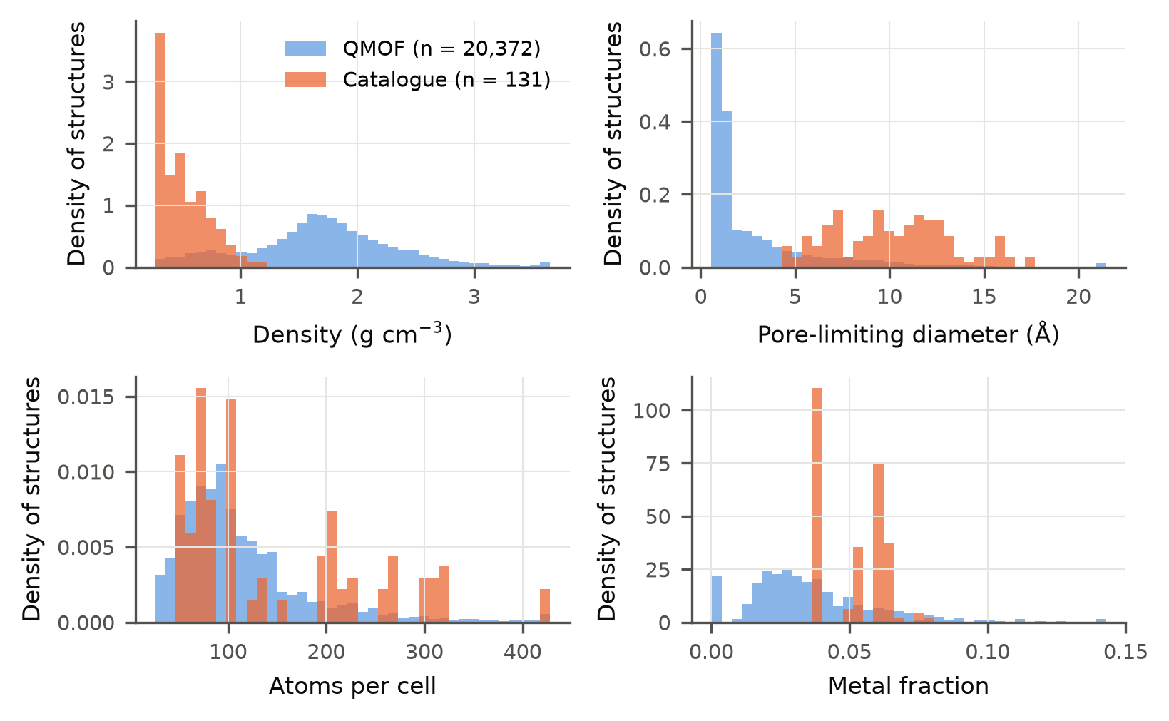
Figure 2. Distributions of four descriptors for the 131 catalogue frameworks and for the 20,372 QMOF structures used for training: framework density, pore-limiting diameter, atoms per cell and metal fraction (normalised histograms). The out-of-distribution flag of Section 2.2 uses the 5 % and 95 % percentiles of the QMOF distributions.
The initial surrogate, trained on QMOF only, predicts PBE gaps below 1 eV for 82 of the 131 frameworks (Fig. 3, Fig. S3, Fig. S4). Its predictions are organised by the metal: the closed-shell Zn and Mg families lie at 1.4–2.5 eV, and every open-shell family lies between 0.4 and 1.2 eV, with Co and Fe below Mn, Cu and Ni. Paired comparisons that change one design axis at a time (Table S7 and results/surrogate in the repository) quantify the trends the model has learned from QMOF: replacing Zn by Co, Fe, Mn, Ni or Cu in the same node, net and linker lowers μ by 1.1–1.4 eV; the substituents lower it by 0.03 (F₄) to 0.27 eV (bipyridine) relative to H; the long BPDC linker raises it by 0.07 eV; and the cds net lies 0.3 eV below nbo for the same paddlewheel. These are properties of the surrogate, and Sections 3.3 and 3.4 test them against DFT.
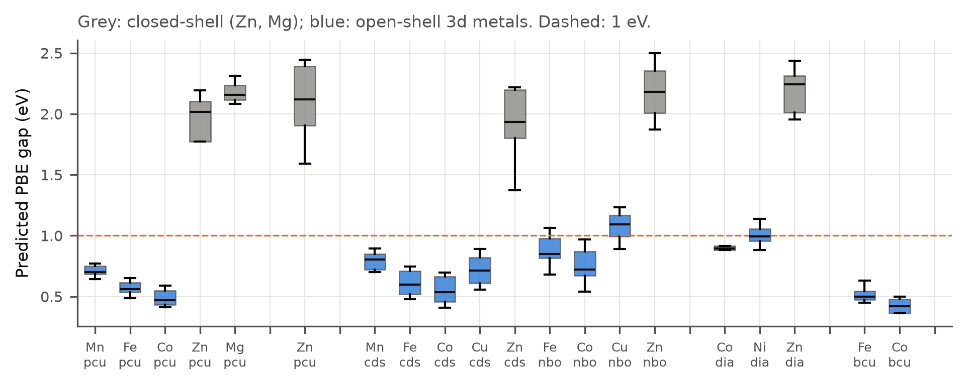
Figure 3. Predicted PBE gap μ of the initial surrogate (trained on QMOF only) for the 131 catalogue frameworks, grouped by net and metal. Grey, closed-shell Zn and Mg frameworks; blue, open-shell 3d frameworks; the dashed line marks 1 eV. Boxes span the interquartile range over linkers.

3.2 Three iterations of DFT validation
Twenty-seven frameworks were computed in three iterations for a total of 24,600 core-hours (Table 1, Table 2, Table S15). Eighteen gave accepted labels; nine did not, and their fate is part of the result (Table S13). Five frameworks collapsed or sheared: the two trinuclear Mn₃ pcu frameworks lost about half of their volume, the Mn₂ cds and Fe₄ bcu frameworks of iteration 1 lost 21–25 %, and the Zn₂ paddlewheel cds framework sheared by 25°. In all five the node geometry that PORMAKE assembles is not the one PBE-D3 prefers once the metal is placed; the Mn₂ ‘paddlewheel’ node, for instance, has a Mn–Mn distance of 4.0 Å rather than the 2.6–2.8 Å of the Cu and Co paddlewheels. The M₃(CO₂)₆ family was excluded after iteration 0, so its Fe and Co members remain untested. The remaining four failures were a dia Ni framework whose self-consistent field did not converge in 24 h, an nbo Co framework whose relaxation became unstable, a Cu₂ framework with a long pyridine linker whose static calculation did not converge from either spin guess, and an Fe₂ framework with the amine linker whose relaxation was still lowering its energy at the walltime. These outcomes defined the eligibility rules of the following iterations, and they cost 11,900 core-hours, half of the total, two thirds of it in the 24 h relaxations of iteration 0 that preceded the CHGNet pre-relaxation. No Mn framework survived, so the open-shell results concern Fe, Co and Cu.
Table 1. The 18 accepted PBE-D3(BJ) labels, ordered by family and gap. μ ± σ is the prediction of the surrogate that selected the framework. "Spin state" is the converged state of the run that provided the label (FM, high-spin ferromagnetic; AFM, antiferromagnetic broken-symmetry solution; NM, non-magnetic low-spin solution); VBM / CBM gives the site group with the largest projected weight within 0.25 eV of each band edge (O_{carb}, carboxylate oxygen). Complete data, including spin-solution energies and the QMOF gaps of MOF-5 and IRMOF-3, are in Table S11 and Table S12.
Framework | Formula (cell) | Atoms | Iter. | μ ± σ before DFT (eV) | PBE-D3 gap (eV) | Spin state | VBM / CBM
Zn₄O pcu, NH₂-BDC (IRMOF-3) | C₂₄H₁₅N₃O₁₃Zn₄ | 59 | 1 | 1.92 ± 0.52 | 2.51 | closed shell | linker / linker
Zn₄O pcu, N₂-ring-BPDC | C₃₆H₁₈N₆O₁₃Zn₄ | 77 | 1 | 1.60 ± 0.51 | 2.75 | closed shell | linker / linker
Zn₄O pcu, N-ring-BPDC | C₃₉H₂₁N₃O₁₃Zn₄ | 80 | 2 | 1.90 ± 0.54 | 3.03 | closed shell | linker / linker
Zn₄O pcu, N-ring-BDC | C₂₁H₉N₃O₁₃Zn₄ | 50 | 2 | 2.34 ± 0.58 | 3.11 | closed shell | linker / linker
Zn₄O pcu, BDC (MOF-5) | C₂₄H₁₂O₁₃Zn₄ | 53 | 0 | 2.38 ± 0.43 | 3.52 | closed shell | O_{carb} / linker
Co₄ bcu, NH₂-BDC | C₆₄H₄₀Co₈N₈O₃₂ | 152 | 2 | 0.35 ± 0.18 | 0.33 | FM | metal / metal
Co₄ bcu, N-ring-BDC | C₅₆H₂₄Co₈N₈O₃₂ | 128 | 1 | 0.38 ± 0.28 | 0.37 | FM | metal / metal
Co₄ bcu, BDC | C₆₄H₃₂Co₈O₃₂ | 136 | 2 | 0.39 ± 0.26 | 0.38 | FM | metal / metal
Co₄ bcu, F₄-BDC | C₆₄Co₈F₃₂O₃₂ | 136 | 0 | 0.47 ± 0.43 | 0.53 | FM | metal / metal
Fe₄ bcu, F₄-BDC | C₆₄F₃₂Fe₈O₃₂ | 136 | 0 | 0.58 ± 0.48 | 0.01 | FM | metal / metal
Fe₄ bcu, NH₂-BDC | C₆₄H₄₀Fe₈N₈O₃₂ | 152 | 0 | 0.46 ± 0.31 | 0.07 | FM | metal / metal
Cu₂ cds, F₄-BDC | C₃₂Cu₄F₁₆O₁₆ | 68 | 1 | 0.60 ± 0.38 | 0.34 | AFM | metal / metal
Cu₂ cds, NH₂-BDC | C₃₂H₂₀Cu₄N₄O₁₆ | 76 | 0 | 0.56 ± 0.29 | 0.69 | AFM | linker / metal
Cu₂ cds, F₈-BPDC | C₅₆Cu₄F₃₂O₁₆ | 108 | 2 | 0.70 ± 0.58 | 0.89 | AFM | O_{carb} / metal
Cu₂ cds, N-ring-BDC | C₂₈H₁₂Cu₄N₄O₁₆ | 64 | 0 | 0.58 ± 0.37 | 0.90 | AFM | O_{carb} / metal
Co₂ cds, F₄-BDC | C₃₂Co₄F₁₆O₁₆ | 68 | 1 | 0.48 ± 0.33 | 0.67 | NM (low spin) | metal / metal
Fe₂ cds, N-ring-BDC | C₂₈H₁₂Fe₄N₄O₁₆ | 64 | 2 | 0.51 ± 0.31 | 0.04 | FM | metal / metal
Fe₂ cds, F₄-BDC | C₃₂F₁₆Fe₄O₁₆ | 68 | 1 | 0.44 ± 0.36 | 0.05 | FM | metal / metal

Table 2. Prospective evaluation of the surrogate by iteration. "Labels in training" is the number of DFT labels added to QMOF when the batch was selected; MAE and bias refer to the accepted labels of each batch, predicted by the model that selected them; "within 2σ" counts labels inside twice the predicted uncertainty.
Iteration | Labels in training | Submitted | Accepted | Collapsed / sheared | Other failures | MAE (eV) | Bias (eV) | Within 2σ | Gap < 1 eV | Gap < 0.5 eV | Core-hours
0 | 0 | 11 | 6 | 3 | 2 | 0.44 | -0.12 | 5/6 | 5 | 2 | 16,081
1 | 6 | 8 | 6 | 2 | 0 | 0.43 | -0.21 | 5/6 | 4 | 3 | 4,782
2 | 11 | 8 | 6 | 0 | 2 | 0.43 | -0.27 | 5/6 | 4 | 3 | 3,741
All |  | 27 | 18 | 5 | 4 | 0.43 | -0.20 | 15/18 | 13 | 8 | 24,604
Over all 18 labels: open-shell 3d frameworks MAE 0.23 eV (bias +0.09 eV, n = 13, all 13 within 2σ); closed-shell Zn₄O frameworks MAE 0.96 eV (bias −0.96 eV, n = 5, two within 2σ). Core-hours are from the SLURM logs (Grace, 48-core nodes, iteration 0; FASTER, 64-core nodes, iterations 1–2) and include the failed frameworks.
Two of the labels are known materials and calibrate the protocol. MOF-5 gives 3.52 eV, within the 3.47–3.55 eV range of its three QMOF entries [9,48], and IRMOF-3 gives 2.51 eV against 2.32–2.37 eV in QMOF, a difference of about 0.15 eV that is within the spread expected from the different starting geometries and the dispersion correction. The spin solutions matter for the paddlewheels (Table S12). For all four Cu₂ frameworks the broken-symmetry start converged to an antiferromagnetically coupled Cu₂ unit, as in HKUST-1 [49], 0.02–0.45 eV below the ferromagnetic solution, and opened the gap from 0.23–0.27 eV to 0.34–0.90 eV; the ferromagnetic label would have placed all four in the "quasi-metallic" range. For the Co₂ paddlewheel the broken-symmetry start relaxed to a non-magnetic low-spin state 0.26 eV below the high-spin solution, with a gap of 0.67 eV instead of 0.14 eV, a preference for low spin that PBE is known to exaggerate. For the Fe₂ paddlewheels the high-spin ferromagnetic state was lowest by at least 0.8 eV. Every open-shell label in Table 1 is therefore the lowest-energy solution among the spin states tried, and the range of gaps across spin solutions is reported for each framework.

3.3 Chemistry of the labels: the metal sets the gap, the linker tunes it where the edges allow
Fig. 4 arranges the labels by family and Fig. 5 shows the character of the two band edges (Table S14). The 13 open-shell frameworks all have PBE gaps below 1 eV, eight below 0.5 eV, and within each family the gap depends weakly on the linker. The four Co₄ bcu frameworks span 0.33–0.53 eV across the H, NH₂, pyridine and F₄ linkers, the two Fe₄ bcu and the two Fe₂ cds frameworks are nearly gapless (0.01–0.07 eV) with F₄, NH₂ or pyridine linkers alike, and the band edges of all of them, as well as of the low-spin Co₂ framework, are metal d states on both sides (0.70–0.92 of the projected weight at the VBM, 0.84–0.92 at the CBM). The gap of these frameworks is a d–d gap of the minority-spin manifold (Fig. 6), set by the ligand field of the carboxylate node and by the metal, and the linker backbone contributes about 0.1 or less of the weight at either edge. This is the DFT counterpart of the surrogate's metal effect, and it explains why the substituent effects the model learned from QMOF are small.
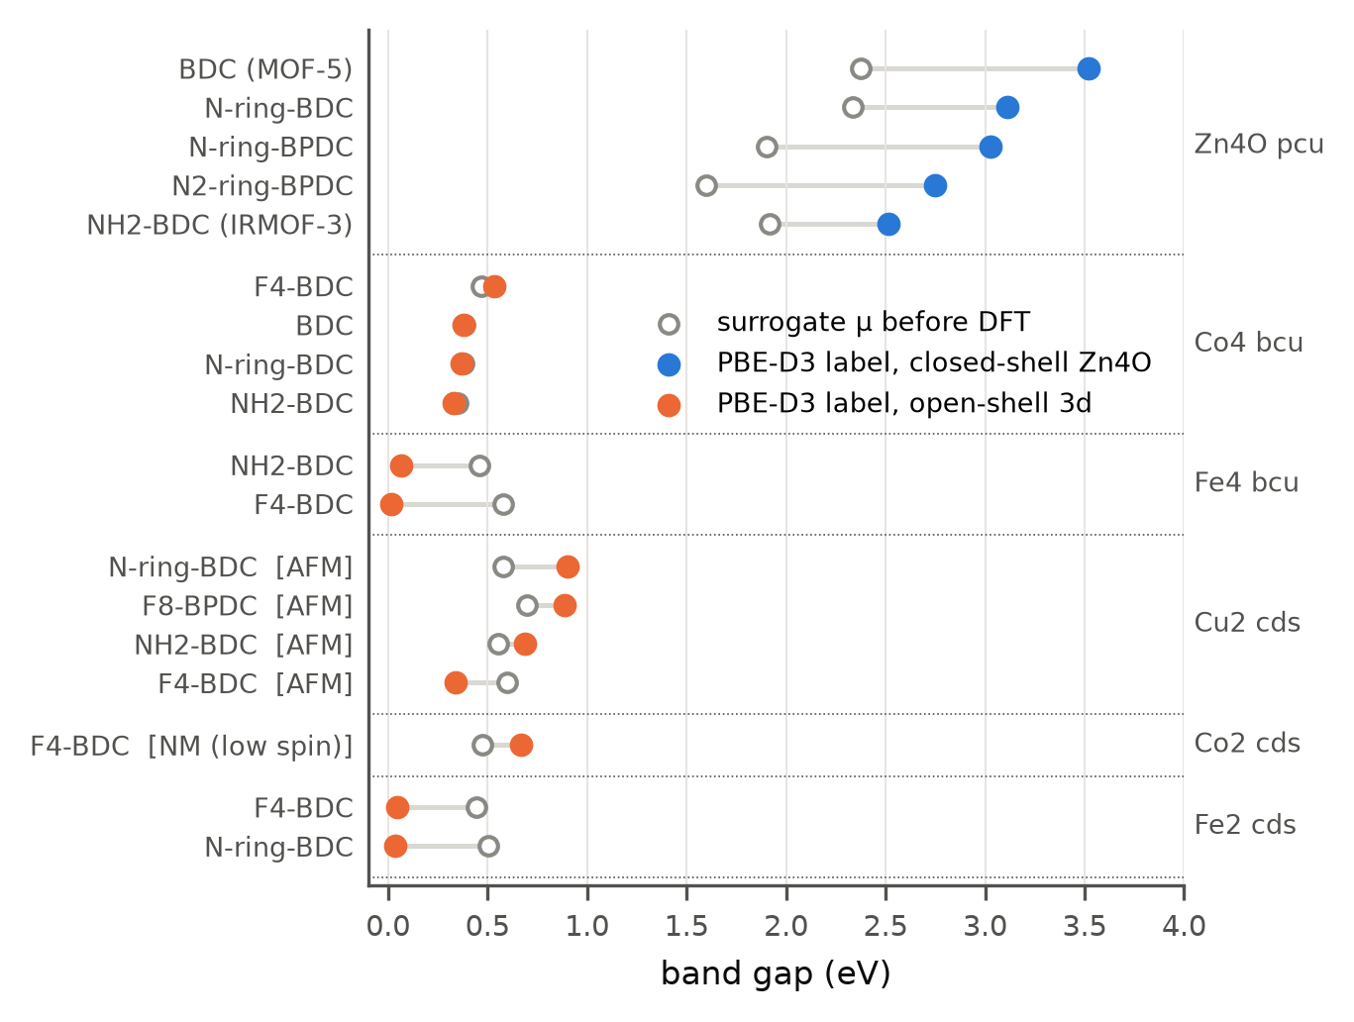
Figure 4. PBE-D3(BJ) band gaps of the 18 accepted labels (filled circles; blue, closed-shell Zn₄O; orange, open-shell 3d) and the prediction μ of the surrogate that selected each framework (open circles), grouped by node family and net. Brackets mark the converged spin state of the paddlewheel labels.
The Cu₂ cds frameworks are the one open-shell family in which the linker reaches the band edges. Their CBM is the Cu d_{x²−y²}–carboxylate O antibonding state in all four cases (0.58–0.60 Cu, 0.34–0.36 O), but the VBM changes with the substituent: it is a mixed Cu d / carboxylate O state for the F₄, F₈ and pyridine linkers (gaps 0.34, 0.89 and 0.90 eV) and a linker state for 2-amino-BDC (0.82 of the weight on the backbone, gap 0.69 eV), where the amine lone pair rises above the Cu d manifold, as it does in amino-functionalised Zn and Ti frameworks [50,51].
The Zn₄O frameworks are the mirror image. Zn contributes 3 % or less to either edge of the four substituted frameworks and 13 % to the VBM of MOF-5; the CBM is the π-antibonding state of the aromatic linker in all five (0.68–0.80 of the weight, the rest on the carboxylate O), and the VBM is a linker state for the four substituted linkers (0.86–0.96) but a carboxylate O state in MOF-5 itself (0.44 carboxylate O, 0.33 linker, 0.10 μ₄-O), in agreement with earlier calculations [48]. The substituents therefore act directly on the gap: the amine raises the VBM most (IRMOF-3, 2.51 eV), followed by the bipyridine (2.75 eV) and the pyridine linkers (3.03 and 3.11 eV), against 3.52 eV for MOF-5. The same substituents move the open-shell gaps by 0.2 eV at most. The design rule that follows is simple and testable: the metal node decides whether a three-dimensional carboxylate framework falls below 1 eV at the PBE level, and linker functionalisation is a handle only when the band edges are organic, which is the case for closed-shell nodes and for the amine-functionalised Cu paddlewheel.
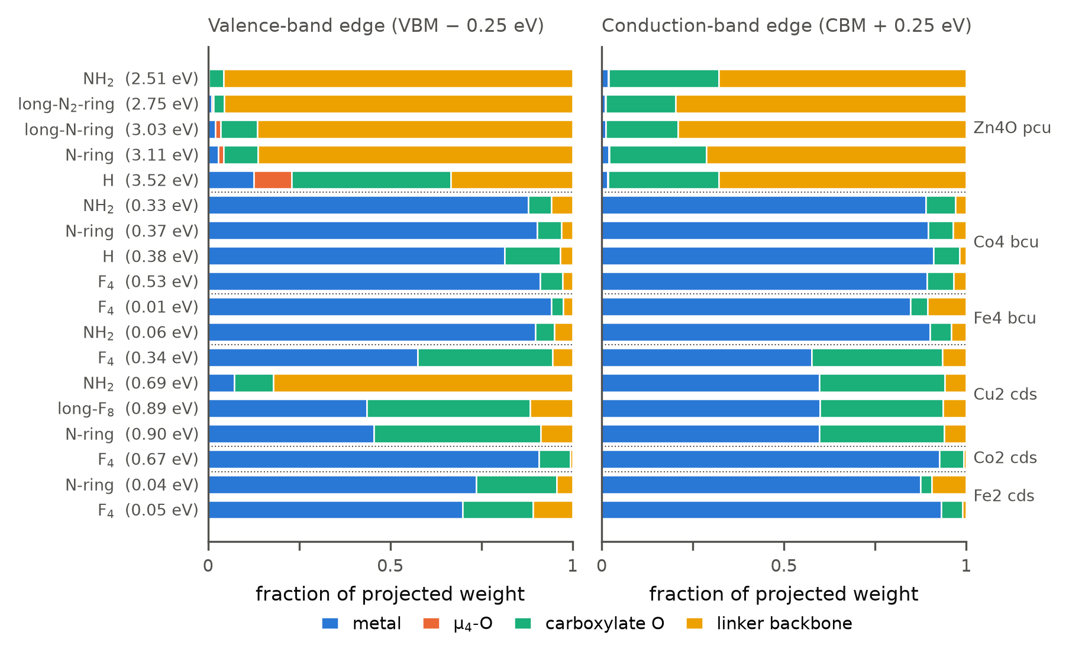
Figure 5. Band-edge character of the 18 labels from the site-projected eigenvalues within 0.25 eV of the VBM (left) and CBM (right), both spins, k-weighted and normalised to the projected weight: metal (all orbitals), μ₄-O, carboxylate O and linker backbone (C, H, N, F). Frameworks are ordered as in Table 1; the gap is given in parentheses.
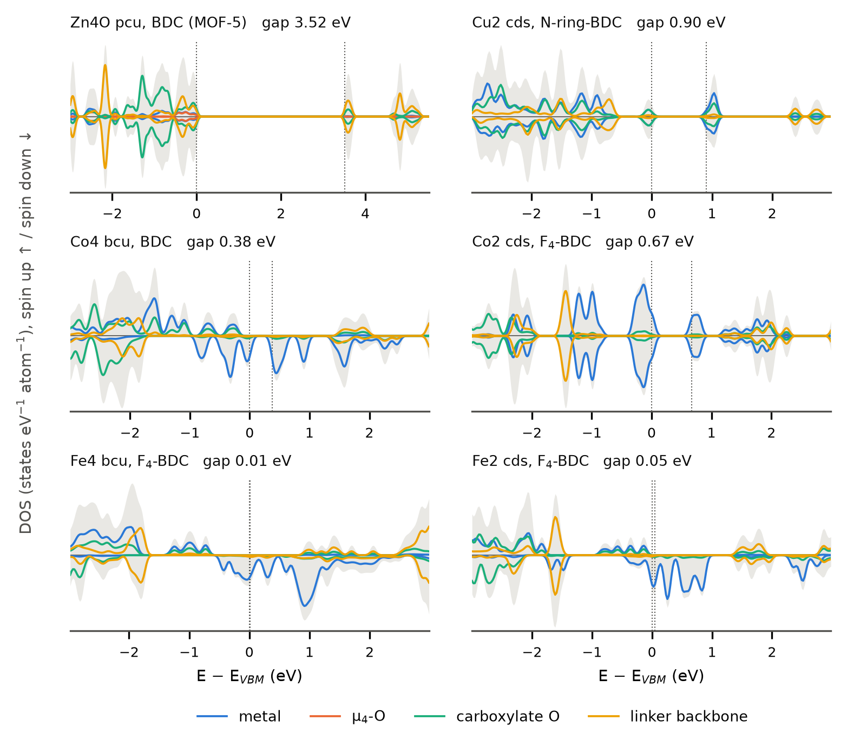
Figure 6. Spin-resolved density of states (spin up positive, spin down negative; 0.05 eV Gaussian broadening) of one framework per family, relative to the VBM, with the projections onto the four site groups of Fig. 5; the grey area is the total DOS and the dotted lines mark the VBM and CBM. In the Co and Fe frameworks the gap opens inside the minority-spin d manifold; in MOF-5 and the Cu₂ framework the edges involve the carboxylate O and linker states. All 18 frameworks are shown in Fig. S5.

3.4 What the surrogate got right and wrong, and what the labels changed
Fig. 7 compares every label with the prediction of the model that selected it. For the open-shell frameworks the surrogate is accurate: MAE 0.23 eV, bias +0.09 eV, all 13 within 2σ, and the ranking of families (Fe below Co below Cu) correct. Its one systematic error there is the Fe frameworks, predicted at 0.44–0.58 eV and computed at 0.01–0.07 eV, which PBE without a Hubbard correction renders nearly metallic. For the Zn₄O frameworks the surrogate fails in the same direction five times: predictions of 1.6–2.4 eV against labels of 2.5–3.5 eV, MAE 0.96 eV, with only two of five labels within 2σ. The closed-shell Zn₄O frameworks are the most out-of-distribution members of the catalogue (density 0.3–0.6 g cm⁻³, pore-limiting diameters of 8.5–14.5 Å), and the tree ensemble, which cannot extrapolate, regresses them towards the QMOF mean. The MAE per batch, 0.44, 0.43 and 0.43 eV, is flat across the three iterations because each batch mixed four to five open-shell frameworks with one to two Zn₄O references.
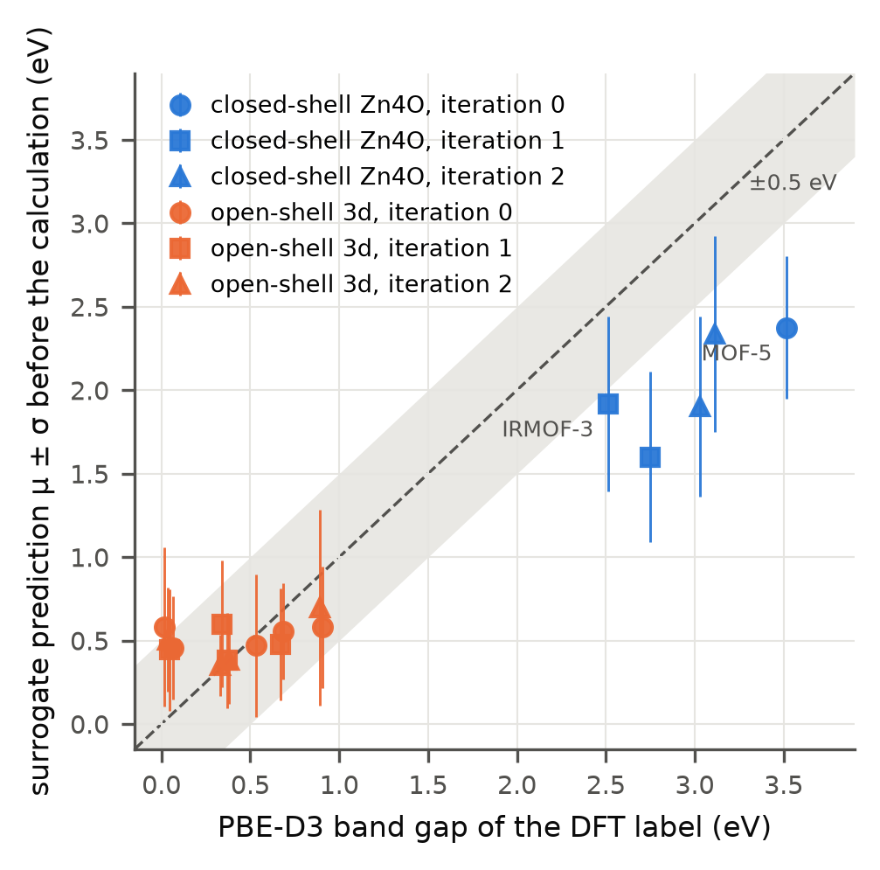
Figure 7. Prospective parity plot: the prediction μ ± σ of the surrogate that selected each framework against its accepted PBE-D3(BJ) label. Circles, squares and triangles are iterations 0, 1 and 2; blue, closed-shell Zn₄O; orange, open-shell 3d. The grey band is ±0.5 eV.
Retraining on the labels did not repair this. With all 18 labels added to the 20,372 QMOF entries, the catalogue predictions move by 0.07 eV on average; the Zn₄O predictions rise by 0.35 eV, to an in-sample error that is still 0.47 eV, and the paired substituent, metal and net trends of Section 3.1 are unchanged. Eighteen points cannot reweight a forest grown on twenty thousand, and nothing in the workflow claimed they would: the acquisition function rewards low predicted gaps and uncertainty, not model improvement. The retrospective benchmark on QMOF makes this separation explicit (Fig. 8, Table S19). At the budget of this work, 23 labels, the acquisition of this work has found 12.5 ± 2.9 structures with gaps below 0.5 eV against 3.6 ± 1.8 for random selection, and recovers 59 % of the ten lowest gaps in the pool against 16 %; the pure-exploitation and lower-confidence-bound variants perform the same within noise, and pure uncertainty sampling finds almost nothing. Over the same 23 labels the MAE on an external out-of-distribution test set improves by 6 meV, and by 16 meV after 53 labels, indistinguishable from random labelling. The loop is a discovery tool, and that is how its value should be stated: at equal DFT cost it returned three to four times more low-gap frameworks than an unguided choice would have, while leaving the surrogate essentially as it was.
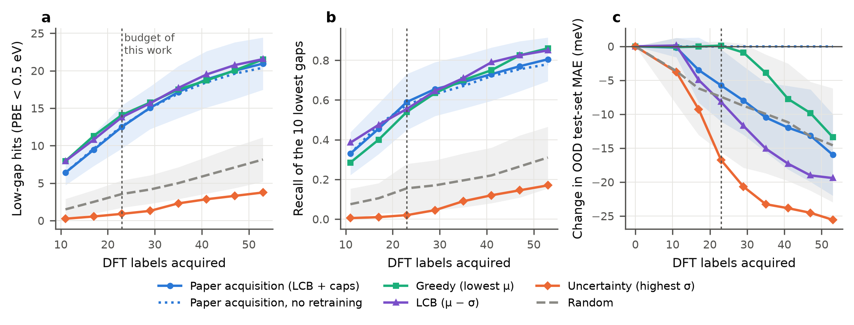
Figure 8. Retrospective active-learning benchmark on QMOF (20 repeats, pools of 150 out-of-distribution structures with the catalogue's chemistry). (a) Labelled structures with PBE gap below 0.5 eV and (b) recall of the ten lowest gaps in the pool versus labels acquired, for six selection strategies; shaded bands are one standard deviation for the acquisition of this work and for random selection. (c) Change of the MAE on a fixed external out-of-distribution test set. The dotted line marks the 23 labels of the prospective campaign.

3.5 Periodic GFN1-xTB as a training-free check
On the 2,000-structure QMOF subset, periodic GFN1-xTB reproduces the PBE gaps of closed-shell frameworks with an MAE of 0.40 eV and a Spearman correlation of 0.90 (n = 791), but not those of open-shell 3d frameworks (MAE 0.73 eV, ρ = 0.29, n = 1,205), in line with Jose and Walsh [24] (Table S16, Fig. S6). The finite-cluster treatment, which cuts the framework into a neutral fragment, collapses 98 % of the gaps below 0.1 eV irrespective of the chemistry; an earlier version of this work had drawn the conclusion that GFN1-xTB is unusable for MOF band gaps from such clusters, and we report the comparison so that the artefact is not repeated. Against hybrid HSE06 gaps the periodic xTB values are 1.3–1.5 eV too low, as PBE itself is.
The useful result is on the generated frameworks (Table 3, Fig. 9). At the DFT geometry, GFN1-xTB reproduces the five Zn₄O labels with an MAE of 0.14 eV, where the surrogate erred by 0.96 eV, and it does so without any training data. At the CHGNet geometry, which is available for every candidate at a cost of seconds to minutes, the MAE is 0.23 eV; at the as-assembled PORMAKE geometry it is 0.43 eV, because the compressed bonds of the raw assembly distort the frontier orbitals. The frontier orbitals of xTB also agree with the DFT band edges in character: for all five Zn₄O frameworks the dominant site group at the HOMO and at the LUMO is the same in both methods, and the linker fraction of the HOMO follows the same order across linkers (Table S18). For the 13 open-shell labels the picture reverses: the spin-restricted xTB gaps have an MAE of 0.52 eV and no rank correlation with the labels, and across the catalogue the xTB and surrogate predictions correlate for the closed-shell frameworks (ρ = 0.59) but not for the open-shell ones (ρ = 0.16). The two estimates are complementary, and the practical rule is to run periodic xTB on CHGNet geometries for every closed-shell candidate before trusting a QMOF-trained surrogate on it, at a cost that is negligible against a single DFT relaxation.
Table 3. Mean absolute error and bias (eV) of the surrogate and of periodic GFN1-xTB at three geometries against the accepted PBE-D3(BJ) labels, by electronic group. The k-mesh supercell row covers the labels whose static k-mesh supercell has at most 700 atoms; the CHGNet row covers the frameworks that had a CHGNet geometry. Per-framework values are in Table S17.
Estimate | Closed-shell Zn₄O: MAE (bias) | Open-shell 3d: MAE (bias)
Surrogate μ before DFT | 0.96 (-0.96), n = 5 | 0.23 (+0.09), n = 13
GFN1-xTB, DFT geometry (Γ) | 0.14 (-0.07), n = 5 | 0.52 (+0.14), n = 13
GFN1-xTB, DFT geometry, k-mesh supercell | 0.17 (-0.08), n = 3 | 0.78 (+0.12), n = 7
GFN1-xTB, CHGNet geometry | 0.23 (-0.22), n = 5 | 0.53 (+0.11), n = 12
GFN1-xTB, as-assembled geometry | 0.43 (-0.30), n = 5 | 0.61 (+0.29), n = 13

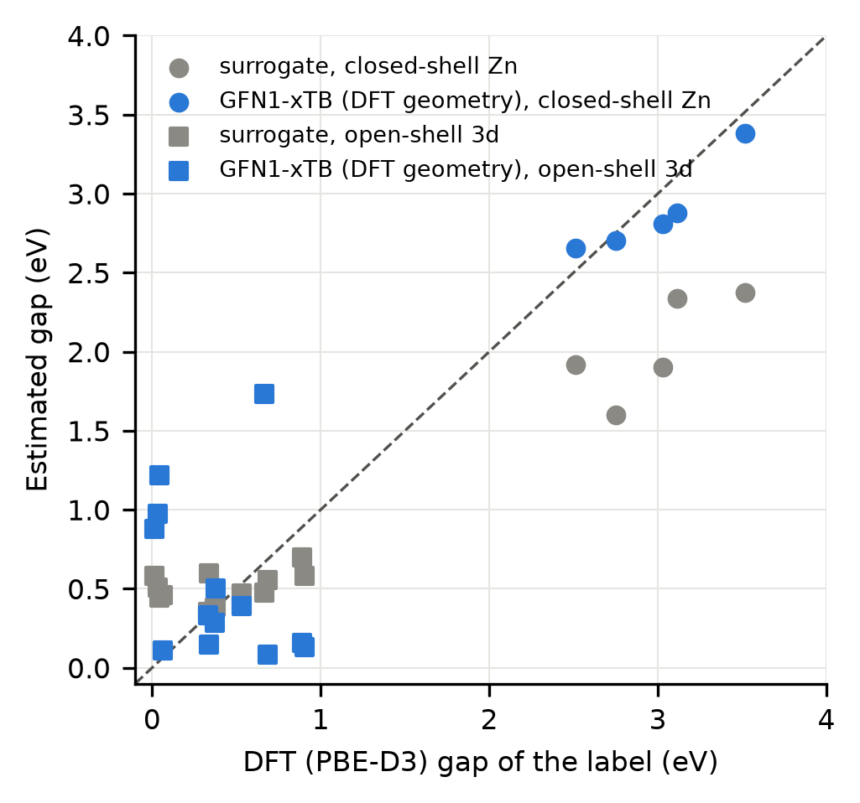
Figure 9. Surrogate prediction (grey) and periodic GFN1-xTB gap at the DFT geometry (blue) against the accepted PBE-D3(BJ) label for the 18 frameworks; circles, closed-shell Zn₄O; squares, open-shell 3d.

3.6 Limitations
Three limitations bound the conclusions. First, PBE underestimates band gaps and, for open-shell 3d metals without a Hubbard correction, can close them spuriously [52]; the gaps reported here are PBE labels on the QMOF scale, not predictions of measured gaps. The 10,800 QMOF structures with both PBE and HSE06 gaps make the consequence concrete (Table S20, Fig. S7): for open-shell 3d frameworks the HSE06 gap exceeds the PBE gap by 2.2 eV at the median, and only 2 % of the frameworks with a PBE gap below 1 eV keep an HSE06 gap below 1 eV (15 % below 2 eV), against 16 % and 42 % for the other frameworks. A low PBE gap in an open-shell framework is therefore a flag for hybrid-functional follow-up [53], which the low-gap Fe and Co frameworks of Table 1 merit. Second, the labels depend on the spin solution, and only two to three solutions were tried per framework; the Co₂ low-spin and the Cu₂ antiferromagnetic labels show that the choice changes the gap by up to 0.5 eV. Third, the statistics are small, 18 labels from a catalogue of 131, and the catalogue covers five nets and 16 nodes; the failure of eight generated node geometries under DFT, in particular of every Mn framework, shows that catalogue size is not the binding constraint, chemical realism of the building blocks is. Apart from MOF-5, IRMOF-3 and IRMOF-10, which the generator reproduces and which are in CoRE MOF [54], the frameworks are hypothetical; their thermodynamic stability and synthesizability were not assessed.

4. Conclusions
A QMOF-trained ExtraTrees surrogate, coupled to a lower-confidence-bound acquisition with diversity caps and to a DFT protocol with machine-learned pre-relaxation, broken-symmetry spin states and explicit acceptance rules, selected 27 hypothetical three-dimensional MOFs of which 18 gave PBE-D3(BJ) labels. All 13 open-shell frameworks have PBE gaps below 1 eV, which the surrogate predicted to 0.23 eV; the five Zn₄O frameworks were underpredicted by 0.96 eV and the error did not shrink on retraining, a transfer failure that a retrospective benchmark on QMOF confirms: at this budget the loop finds three to four times more low-gap frameworks than random selection but does not improve the model. The band-edge analysis gives the chemical reason and the design rule: in Fe, Co and low-spin Co frameworks both edges are metal d states and the metal fixes a d–d gap that the linker barely moves, whereas in Zn₄O frameworks both edges are organic and amine or pyridine linkers lower the gap by up to 1 eV, with the Cu₂ paddlewheel in between. Periodic GFN1-xTB on CHGNet geometries reproduces the closed-shell labels within 0.23 eV without training and is the natural check for a data-driven surrogate on hypothetical closed-shell frameworks; for open-shell metals it is not. The catalogue, the labels with every failed framework, and the analysis code are released so that the next loop can start from them rather than from QMOF alone.

CRediT authorship contribution statement
Carlos H. Guerrero Navarro: Conceptualization, Methodology, Software, Investigation, Formal analysis, Data curation, Visualization, Writing – original draft. Maryam Ghotbi: Validation, Writing – review & editing. Perla B. Balbuena: Conceptualization, Supervision, Resources, Funding acquisition, Writing – review & editing.

Declaration of competing interest
The authors declare that they have no known competing financial interests or personal relationships that could have appeared to influence the work reported in this paper.

Data availability
The code, the building-block audit, the catalogue (CIF files, QC tables, descriptors), the surrogate predictions and acquisition rankings of every iteration, the DFT summary tables (dft_results.csv, spin_solutions.csv, compute_log.csv), the band-edge and xTB tables and the scripts that produce every figure are available at https://github.com/humbertogn-coder/MOF_3D_Generator [55]. The raw VASP inputs and outputs (POSCAR, CONTCAR, OSZICAR, OUTCAR, vasprun.xml, DOSCAR; POTCAR files excluded under the VASP licence) and the GFN1-xTB results are deposited on Zenodo [56]. QMOF is available from its original repository [9] and is not redistributed. All random seeds are fixed and the trained models are rebuilt deterministically by the scripts.

Declaration of generative AI and AI-assisted technologies in the writing process
During the preparation of this work the authors used Claude (Anthropic) to assist with code review, data analysis scripts and language editing of the manuscript. After using this tool, the authors reviewed and edited the content as needed and take full responsibility for the content of the published article. All data figures were generated by the scripts in the repository from the underlying data; Fig. 1 is a schematic drawn with matplotlib.

Acknowledgements
This work acknowledges support from the Texas A&M Semiconductor Institute (TSI) and the National Science Foundation under Award No. 2345874. Portions of this research were conducted with the advanced computing resources provided by Texas A&M High Performance Research Computing (Grace and FASTER clusters). The funding sources had no role in the study design, the analysis or the decision to publish.

Supplementary material
Supplementary material to this article (Tables S1–S20 and Figures S1–S7) is available online.

References
[1] H. Furukawa, K.E. Cordova, M. O'Keeffe, O.M. Yaghi, The chemistry and applications of metal-organic frameworks, Science 341 (2013) 1230444.
[2] L. Sun, M.G. Campbell, M. Dincă, Electrically conductive porous metal–organic frameworks, Angew. Chem. Int. Ed. 55 (2016) 3566–3579.
[3] L.S. Xie, G. Skorupskii, M. Dincă, Electrically conductive metal–organic frameworks, Chem. Rev. 120 (2020) 8536–8580.
[4] R.W. Day, D.K. Bediako, M. Rezaee, L.R. Parent, G. Skorupskii, M.Q. Arguilla, C.H. Hendon, I. Stassen, N.C. Gianneschi, P. Kim, M. Dincă, Single crystals of electrically conductive two-dimensional metal–organic frameworks: structural and electrical transport properties, ACS Cent. Sci. 5 (2019) 1959–1964.
[5] L.S. Xie, L. Sun, R. Wan, S.S. Park, J.A. DeGayner, C.H. Hendon, M. Dincă, Tunable mixed-valence doping toward record electrical conductivity in a three-dimensional metal–organic framework, J. Am. Chem. Soc. 140 (2018) 7411–7414.
[6] C.H. Hendon, A.J. Rieth, M.D. Korzyński, M. Dincă, Grand challenges and future opportunities for metal–organic frameworks, ACS Cent. Sci. 3 (2017) 554–563.
[7] E.M. Johnson, S. Ilic, A.J. Morris, Design strategies for enhanced conductivity in metal–organic frameworks, ACS Cent. Sci. 7 (2021) 445–453.
[8] F. Zanca, L.T. Glasby, S. Chong, S. Chen, J. Kim, D. Fairen-Jimenez, B. Monserrat, P.Z. Moghadam, Computational techniques for characterisation of electrically conductive MOFs: quantum calculations and machine learning approaches, J. Mater. Chem. C 9 (2021) 13584–13599.
[9] A.S. Rosen, S.M. Iyer, D. Ray, Z. Yao, A. Aspuru-Guzik, L. Gagliardi, J.M. Notestein, R.Q. Snurr, Machine learning the quantum-chemical properties of metal–organic frameworks for accelerated materials discovery, Matter 4 (2021) 1578–1597.
[10] A.S. Rosen, V. Fung, P. Huck, C.T. O'Donnell, M.K. Horton, D.G. Truhlar, K.A. Persson, J.M. Notestein, R.Q. Snurr, High-throughput predictions of metal–organic framework electronic properties: theoretical challenges, graph neural networks, and data exploration, npj Comput. Mater. 8 (2022) 112.
[11] Z. Cao, R. Magar, Y. Wang, A. Barati Farimani, MOFormer: self-supervised transformer model for metal–organic framework property prediction, J. Am. Chem. Soc. 145 (2023) 2958–2967.
[12] Y. Kang, H. Park, B. Smit, J. Kim, A multi-modal pre-training transformer for universal transfer learning in metal–organic frameworks, Nat. Mach. Intell. 5 (2023) 309–318.
[13] J. Park, H. Kim, Y. Kang, Y. Lim, J. Kim, From data to discovery: recent trends of machine learning in metal–organic frameworks, JACS Au 4 (2024) 3727–3743.
[14] S. Lee, B. Kim, H. Cho, H. Lee, S.Y. Lee, E.S. Cho, J. Kim, Computational screening of trillions of metal–organic frameworks for high-performance methane storage, ACS Appl. Mater. Interfaces 13 (2021) 23647–23654.
[15] T. Lookman, P.V. Balachandran, D. Xue, R. Yuan, Active learning in materials science with emphasis on adaptive sampling using uncertainties for targeted design, npj Comput. Mater. 5 (2019) 21.
[16] K.M. Jablonka, G.M. Jothiappan, S. Wang, B. Smit, B. Yoo, Bias free multiobjective active learning for materials design and discovery, Nat. Commun. 12 (2021) 2312.
[17] A. Sharma, S. Sanvito, Quantum-accurate machine learning potentials for metal-organic frameworks using temperature driven active learning, npj Comput. Mater. 10 (2024) 237.
[18] K. Mukherjee, A.W. Dowling, Y.J. Colón, Sequential design of adsorption simulations in metal–organic frameworks, Mol. Syst. Des. Eng. 7 (2022) 248–259.
[19] A. Jose, E. Devijver, N. Jakse, R. Poloni, Informative training data for efficient property prediction in metal–organic frameworks by active learning, J. Am. Chem. Soc. 146 (2024) 6134–6144.
[20] S. Grimme, C. Bannwarth, P. Shushkov, A robust and accurate tight-binding quantum chemical method for structures, vibrational frequencies, and noncovalent interactions of large molecular systems parametrized for all spd-block elements (Z = 1–86), J. Chem. Theory Comput. 13 (2017) 1989–2009.
[21] M. Nurhuda, C.C. Perry, M.A. Addicoat, Performance of GFN1-xTB for periodic optimization of metal organic frameworks, Phys. Chem. Chem. Phys. 24 (2022) 10906–10914.
[22] M. Pokora, J. Goclon, J. Margraf, C. Panosetti, A. Samtsevych, P. Paneth, Low-cost periodic calculations of metal-organic frameworks: a GFN1-xTB perspective, ChemPhysChem 26 (2025) e202500081.
[23] M. Mahmoudi Gahrouei, N. Vlastos, R. D'Souza, E.C. Odogwu, L. de Sousa Oliveira, Benchmark investigation of SCC-DFTB against standard and hybrid DFT to model electronic properties in two-dimensional MOFs for thermoelectric applications, J. Chem. Theory Comput. 20 (2024) 3976–3992.
[24] A. Jose, A. Walsh, GFN1-xTB-assisted machine learning for electronic structure screening of metal–organic frameworks, J. Chem. Theory Comput. 22 (2026) 8531–8540.
[25] H. Park, T. Li, A. Jose, S.-J. Shin, A. Walsh, Data-driven design of metal-organic frameworks for photoelectrochemical reactions, ACS Energy Lett. (2026), in press.
[26] T.F. Willems, C.H. Rycroft, M. Kazi, J.C. Meza, M. Haranczyk, Algorithms and tools for high-throughput geometry-based analysis of crystalline porous materials, Microporous Mesoporous Mater. 149 (2012) 134–141.
[27] P. Geurts, D. Ernst, L. Wehenkel, Extremely randomized trees, Mach. Learn. 63 (2006) 3–42.
[28] F. Pedregosa, G. Varoquaux, A. Gramfort, V. Michel, B. Thirion, O. Grisel, M. Blondel, P. Prettenhofer, R. Weiss, V. Dubourg, J. Vanderplas, A. Passos, D. Cournapeau, M. Brucher, M. Perrot, É. Duchesnay, Scikit-learn: machine learning in Python, J. Mach. Learn. Res. 12 (2011) 2825–2830.
[29] J.H. Friedman, Greedy function approximation: a gradient boosting machine, Ann. Stat. 29 (2001) 1189–1232.
[30] T. Chen, C. Guestrin, XGBoost: a scalable tree boosting system, in: Proceedings of the 22nd ACM SIGKDD International Conference on Knowledge Discovery and Data Mining, ACM, San Francisco, 2016, pp. 785–794.
[31] G. Ke, Q. Meng, T. Finley, T. Wang, W. Chen, W. Ma, Q. Ye, T.-Y. Liu, LightGBM: a highly efficient gradient boosting decision tree, in: Advances in Neural Information Processing Systems 30, Curran Associates, Long Beach, 2017, pp. 3149–3157.
[32] L. Breiman, Random forests, Mach. Learn. 45 (2001) 5–32.
[33] S.M. Lundberg, S.-I. Lee, A unified approach to interpreting model predictions, in: Advances in Neural Information Processing Systems 30, Curran Associates, Long Beach, 2017, pp. 4765–4774.
[34] B. Lakshminarayanan, A. Pritzel, C. Blundell, Simple and scalable predictive uncertainty estimation using deep ensembles, in: Advances in Neural Information Processing Systems 30, Curran Associates, Long Beach, 2017, pp. 6402–6413.
[35] N. Srinivas, A. Krause, S.M. Kakade, M. Seeger, Gaussian process optimization in the bandit setting: no regret and experimental design, in: Proceedings of the 27th International Conference on Machine Learning, Omnipress, Haifa, 2010, pp. 1015–1022.
[36] B. Deng, P. Zhong, K. Jun, J. Riebesell, K. Han, C.J. Bartel, G. Ceder, CHGNet as a pretrained universal neural network potential for charge-informed atomistic modelling, Nat. Mach. Intell. 5 (2023) 1031–1041.
[37] G. Kresse, J. Furthmüller, Efficient iterative schemes for ab initio total-energy calculations using a plane-wave basis set, Phys. Rev. B 54 (1996) 11169–11186.
[38] P.E. Blöchl, Projector augmented-wave method, Phys. Rev. B 50 (1994) 17953–17979.
[39] G. Kresse, D. Joubert, From ultrasoft pseudopotentials to the projector augmented-wave method, Phys. Rev. B 59 (1999) 1758–1775.
[40] J.P. Perdew, K. Burke, M. Ernzerhof, Generalized gradient approximation made simple, Phys. Rev. Lett. 77 (1996) 3865–3868.
[41] S. Grimme, J. Antony, S. Ehrlich, H. Krieg, A consistent and accurate ab initio parametrization of density functional dispersion correction (DFT-D) for the 94 elements H–Pu, J. Chem. Phys. 132 (2010) 154104.
[42] S. Grimme, S. Ehrlich, L. Goerigk, Effect of the damping function in dispersion corrected density functional theory, J. Comput. Chem. 32 (2011) 1456–1465.
[43] L. Noodleman, Valence bond description of antiferromagnetic coupling in transition metal dimers, J. Chem. Phys. 74 (1981) 5737–5743.
[44] S.P. Ong, W.D. Richards, A. Jain, G. Hautier, M. Kocher, S. Cholia, D. Gunter, V.L. Chevrier, K.A. Persson, G. Ceder, Python Materials Genomics (pymatgen): a robust, open-source Python library for materials analysis, Comput. Mater. Sci. 68 (2013) 314–319.
[45] A.H. Larsen, J.J. Mortensen, J. Blomqvist, I.E. Castelli, R. Christensen, M. Dułak, J. Friis, M.N. Groves, B. Hammer, C. Hargus, E.D. Hermes, P.C. Jennings, P.B. Jensen, J. Kermode, J.R. Kitchin, E.L. Kolsbjerg, J. Kubal, K. Kaasbjerg, S. Lysgaard, J.B. Maronsson, T. Maxson, T. Olsen, L. Pastewka, A. Peterson, C. Rostgaard, J. Schiøtz, O. Schütt, M. Strange, K.S. Thygesen, T. Vegge, L. Vilhelmsen, M. Walter, Z. Zeng, K.W. Jacobsen, The atomic simulation environment—a Python library for working with atoms, J. Phys.: Condens. Matter 29 (2017) 273002.
[46] S. Ehlert, M. Müller, S. Grimme, tblite: light-weight tight-binding framework, version 0.4, https://github.com/tblite/tblite (accessed October 2026).
[47] R.S. Mulliken, Electronic population analysis on LCAO–MO molecular wave functions. I, J. Chem. Phys. 23 (1955) 1833–1840.
[48] M. Fuentes-Cabrera, D.M. Nicholson, B.G. Sumpter, M. Widom, Electronic structure and properties of isoreticular metal-organic frameworks: the case of M-IRMOF1 (M = Zn, Cd, Be, Mg, and Ca), J. Chem. Phys. 123 (2005) 124713.
[49] X.X. Zhang, S.S.-Y. Chui, I.D. Williams, Cooperative magnetic behavior in the coordination polymers [Cu₃(btc)₂L₃] (L = H₂O, pyridine), J. Appl. Phys. 87 (2000) 6007–6009.
[50] J. Gascon, M.D. Hernández-Alonso, A.R. Almeida, G.P.M. van Klink, F. Kapteijn, G. Mul, Isoreticular MOFs as efficient photocatalysts with tunable band gap: an operando FTIR study of the photoinduced oxidation of propylene, ChemSusChem 1 (2008) 981–983.
[51] C.H. Hendon, D. Tiana, M. Fontecave, C. Sanchez, L. D'arras, C. Sassoye, L. Rozes, C. Mellot-Draznieks, A. Walsh, Engineering the optical response of the titanium-MIL-125 metal–organic framework through ligand functionalization, J. Am. Chem. Soc. 135 (2013) 10942–10945.
[52] J.P. Perdew, M. Levy, Physical content of the exact Kohn-Sham orbital energies: band gaps and derivative discontinuities, Phys. Rev. Lett. 51 (1983) 1884–1887.
[53] A.V. Krukau, O.A. Vydrov, A.F. Izmaylov, G.E. Scuseria, Influence of the exchange screening parameter on the performance of screened hybrid functionals, J. Chem. Phys. 125 (2006) 224106.
[54] Y.G. Chung, E. Haldoupis, B.J. Bucior, M. Haranczyk, S. Lee, H. Zhang, K.D. Vogiatzis, M. Milisavljevic, S. Ling, J.S. Camp, B. Slater, J.I. Siepmann, D.S. Sholl, R.Q. Snurr, Advances, updates, and analytics for the computation-ready, experimental metal–organic framework database: CoRE MOF 2019, J. Chem. Eng. Data 64 (2019) 5985–5998.
[55] C.H. Guerrero Navarro, MOF_3D_Generator: active learning for low-band-gap 3D MOFs, GitHub repository, https://github.com/humbertogn-coder/MOF_3D_Generator (2026).
[56] C.H. Guerrero Navarro, M. Ghotbi, P.B. Balbuena, Active learning for low-band-gap 3D metal–organic frameworks: code, catalogue, DFT outputs and analysis tables, Zenodo (2026). https://doi.org/10.5281/zenodo.XXXXXXX (DOI to be minted on acceptance).

