Supporting Information
Active learning for low-band-gap three-dimensional metal–organic frameworks: prospective DFT validation of a chemically audited hypothetical catalogue
Carlos H. Guerrero Navarroª, Maryam Ghotbi^{b}, Perla B. Balbuena^{a,b,c,*}
ª Department of Chemical Engineering, Texas A&M University, College Station, Texas 77843, United States
^{b} Department of Chemistry, Texas A&M University, College Station, Texas 77843, United States
^{c} Department of Materials Science and Engineering, Texas A&M University, College Station, Texas 77843, United States
* Corresponding author: balbuena@tamu.edu
All tables and figures in this document are produced by the scripts of the public repository (https://github.com/humbertogn-coder/MOF_3D_Generator) from the data files deposited with the article; the script that produces each item is named in its caption.

S1. Building blocks, quality control and catalogue
The PORMAKE 0.2.3 library was audited with scripts/01_audit_pormake_bbs.py: 648 nodes (528 containing a metal, 298 with carboxylate connection points only) and 219 edges. Nodes were retained when all connection points are carboxylates and the oxidation state implied by charge balance with dianionic dicarboxylates is +2 (Table S1). The edges are carboxylate-free spacers; the carboxylate groups belong to the node, so the assembled linker is the spacer plus two carboxylates (Table S2). Every node–linker–net combination was built with scripts/02_generate_catalogue.py and filtered by the QC rules of Section 2.1 of the main text (Table S3); the composition of the resulting catalogue is given in Table S4. The generator reproduces the compositions of three known frameworks (Table S5).
Table S1. Metal nodes used in the catalogue (scripts/01_audit_pormake_bbs.py, data/pormake_audit/nodes.csv). Composition as in the PORMAKE building block; every connection point is a carboxylate and the implied metal oxidation state is +2.
PORMAKE node | Composition | Family | Metal | Nets | Frameworks passing QC
N317 | Co₂(CO₂)₄ paddlewheel | M₂(CO₂)₄-paddlewheel | Co | cds, nbo | 14
N409 | Cu₂(CO₂)₄ paddlewheel | M₂(CO₂)₄-paddlewheel | Cu | cds, nbo | 14
N355 | Fe₂(CO₂)₄ paddlewheel | M₂(CO₂)₄-paddlewheel | Fe | cds, nbo | 14
N288 | Mn₂(CO₂)₄ paddlewheel | M₂(CO₂)₄-paddlewheel | Mn | cds | 8
N153 | Zn₂(CO₂)₄ paddlewheel | M₂(CO₂)₄-paddlewheel | Zn | cds, nbo | 16
N398 | Co₂(CO₂)₄ | M₂(CO₂)₄-tetrahedral | Co | dia | 5
N649 | Ni₂(CO₂)₄ | M₂(CO₂)₄-tetrahedral | Ni | dia | 5
N256 | Zn₂(CO₂)₄ | M₂(CO₂)₄-tetrahedral | Zn | dia | 5
N491 | Co₃(CO₂)₆ | M₃(CO₂)₆ | Co | pcu | 6
N334 | Fe₃(CO₂)₆ | M₃(CO₂)₆ | Fe | pcu | 5
N406 | Mg₃(CO₂)₆ (closed-shell s-block reference) | M₃(CO₂)₆ | Mg | pcu | 7
N548 | Mn₃(CO₂)₆ | M₃(CO₂)₆ | Mn | pcu | 5
N382 | Zn₃(CO₂)₆ | M₃(CO₂)₆ | Zn | pcu | 4
N35 | Co₄(CO₂)₈ | M₄(CO₂)₈ | Co | bcu | 7
N350 | Fe₄(CO₂)₈ | M₄(CO₂)₈ | Fe | bcu | 8
N16 | Zn₄O(CO₂)₆ | Zn₄O(CO₂)₆ | Zn | pcu | 8

Table S2. Edge building blocks and the dicarboxylate linkers they form once joined to two carboxylate nodes. "BDC-type" linkers have one aromatic ring, "BPDC-type" linkers two.
PORMAKE edge | Assembled dicarboxylate linker | Label | Frameworks passing QC
E107 | phenylpyridine dicarboxylate | BPDC-type, Nring1 | 14
E14 | 1,4-benzenedicarboxylate (BDC) | BDC-type, H | 20
E145 | octafluoro-BPDC | BPDC-type, F₈ | 15
E166 | pyridine-2,5-dicarboxylate | BDC-type, Nring1 | 19
E228 | 2,3,5,6-tetrafluoro-BDC | BDC-type, F₄ | 18
E34 | 4,4'-biphenyldicarboxylate (BPDC) | BPDC-type, H | 14
E35 | bipyridine dicarboxylate | BPDC-type, Nring2 | 14
E72 | 2-amino-BDC | BDC-type, NH₂ | 17

Table S3. Structural quality-control criteria and the number of the 37 rejected frameworks that fail each one (a framework can fail several; data/catalogue/catalogue.csv). The remaining criteria of Section 2.1 (composition, cell length, atom count, node RMSD) rejected no framework.
QC criterion | Frameworks failing it (of 37 rejected)
density outside 0.20–3.0 g cm⁻³ | 18
heavy–heavy or H–H pair closer than 1.00 Å | 16
more than one connected component | 8
H atom without exactly one neighbour | 5
C atom with organic coordination number outside 2–4 | 5
non-bonded contact shorter than 0.8 × Σ r_{cov} | 3
any pair closer than 0.70 Å | 17

Table S4. Composition of the catalogue after quality control: number of frameworks per node family, net and metal (data/catalogue/passed.csv). Each cell counts up to eight linkers.
Node family | Net | Co | Cu | Fe | Mg | Mn | Ni | Zn | Total
M₂(CO₂)₄-paddlewheel | cds | 8 | 8 | 8 | – | 8 | – | 8 | 40
M₂(CO₂)₄-paddlewheel | nbo | 6 | 6 | 6 | – | – | – | 8 | 26
M₂(CO₂)₄-tetrahedral | dia | 5 | – | – | – | – | 5 | 5 | 15
M₃(CO₂)₆ | pcu | 6 | – | 5 | 7 | 5 | – | 4 | 27
M₄(CO₂)₈ | bcu | 7 | – | 8 | – | – | – | – | 15
Zn₄O(CO₂)₆ | pcu | – | – | – | – | – | – | 8 | 8

Table S5. Reproduction of known frameworks by the generator (results/validation_known_mofs.csv). The QMOF values are averages over the QMOF entries with the same composition; the generated frameworks are less dense because PORMAKE places the building blocks on an idealised net.
Known MOF | Formula (cell) | Composition reproduced | Passes QC | Density built (g cm⁻³) | Density QMOF | QMOF PBE gap (eV) | QMOF entries
MOF-5 (IRMOF-1) | C₂₄H₁₂O₁₃Zn₄ | yes | yes | 0.55 | 0.78 | 3.52 | 3
IRMOF-10 | C₄₂H₂₄O₁₃Zn₄ | yes | yes | 0.29 | 0.32 | 3.13 | 1
IRMOF-3 | C₂₄H₁₅N₃O₁₃Zn₄ | yes | yes | 0.64 | 0.71 | 2.35 | 3

S2. Surrogate model
Eleven regressors and the matching classifiers were trained on 80 % of the 20,372 QMOF entries with a PBE gap and evaluated on the remaining 20 % (scripts/00_qmof_benchmark.py; split stratified by gap < 1 eV, random_state = 42). Table S6 reports feature set C; Table S7 reports the ExtraTrees results for all five feature sets; Table S8 lists the hyperparameters. Fig. S1 shows the parity plot of the selected model on the hold-out set, Fig. S2 its SHAP feature importances, Fig. S3 the mean prediction of the initial surrogate by metal and substituent, and Fig. S4 the acquisition landscape of iteration 0.
Table S6. Benchmark on feature set C (64 descriptors), QMOF hold-out set of 4,075 structures. Regression metrics refer to the PBE gap; classification metrics to the 1 eV threshold (positive class: gap < 1 eV). "Dummy" predicts the training mean (regression) or the majority class.
Regressor | R² | MAE (eV) | RMSE (eV) | Spearman ρ | Classifier | ROC AUC | F₁
Ridge | 0.60 | 0.54 | 0.72 | 0.77 | LogisticRegression | 0.91 | 0.74
ElasticNet | 0.60 | 0.54 | 0.72 | 0.77 | LogisticRegression | 0.91 | 0.74
KNN | 0.69 | 0.45 | 0.63 | 0.82 | KNN | 0.93 | 0.76
SVR_RBF | 0.69 | 0.44 | 0.63 | 0.83 | SVC_RBF | 0.93 | 0.77
RandomForest | 0.74 | 0.41 | 0.57 | 0.86 | RandomForest | 0.95 | 0.80
ExtraTrees | 0.75 | 0.39 | 0.56 | 0.86 | ExtraTrees | 0.95 | 0.81
GradientBoosting | 0.68 | 0.48 | 0.65 | 0.81 | GradientBoosting | 0.93 | 0.78
HistGradientBoosting | 0.71 | 0.44 | 0.61 | 0.83 | HistGradientBoosting | 0.94 | 0.77
MLP | 0.70 | 0.45 | 0.62 | 0.83 | MLP | 0.93 | 0.77
XGBoost | 0.75 | 0.41 | 0.57 | 0.86 | XGBoost | 0.94 | 0.80
LightGBM | 0.74 | 0.41 | 0.58 | 0.85 | LightGBM | 0.94 | 0.80
DummyMean | -0.00 | 0.94 | 1.13 | – | DummyMostFrequent | 0.50 | 0.00

Table S7. Feature sets and the hold-out performance of ExtraTrees on each (regression R² and MAE; ROC AUC of the matching classifier). Set C was selected; set E uses PBE-derived inputs that are not available for hypothetical frameworks.
Set | Features | Content | R² (ET) | MAE (eV) | ROC AUC
A | 8 | n_atoms, density, PLD, LCD, cell volume, LCD − PLD, LCD/PLD, volume per atom | 0.13 | 0.85 | 0.68
B | 30 | A + aggregate composition (metal counts and fractions, open-shell 3d flag and fraction, C/N/O/H per atom, ratios, heteroatom fraction, mean and std of Z and electronegativity) | 0.72 | 0.43 | 0.93
C | 64 | B + fractions of 34 common elements (selected) | 0.75 | 0.39 | 0.95
D | 64 + 4 | C + categorical topology, primary metal, crystal system and node SMILES (one-hot) | 0.75 | 0.40 | 0.95
E | 68 + 4 | D + four PBE-derived quantities per atom (energy, vdW, electronic, |magmom|); reference only, leakage | 0.77 | 0.39 | 0.95

Table S8. Hyperparameters of the surrogate and of the active-learning ensemble (scripts/05_train_predict.py, src/mofal/surrogate.py).
Parameter | Value | Note
Regressor | ExtraTreesRegressor (scikit-learn 1.9) | feature set C, 64 descriptors
n_estimators | 300 | per ensemble member
max_features | sqrt
min_samples_leaf | 2
Ensemble | 5 members, seeds 42, 123, 456, 789, 2024 | μ = mean of member means
Uncertainty σ | standard deviation over the 1,500 trees of the five members | spread of member means (0.03 eV) also reported
Benchmark split | 80/20, stratified by gap < 1 eV, random_state = 42 | same split for all models and feature sets
Missing values | median imputation
OOD flag | density, PLD, n_atoms, metal fraction or C per atom outside the 5–95 % range of QMOF | 89 of 131 frameworks flagged

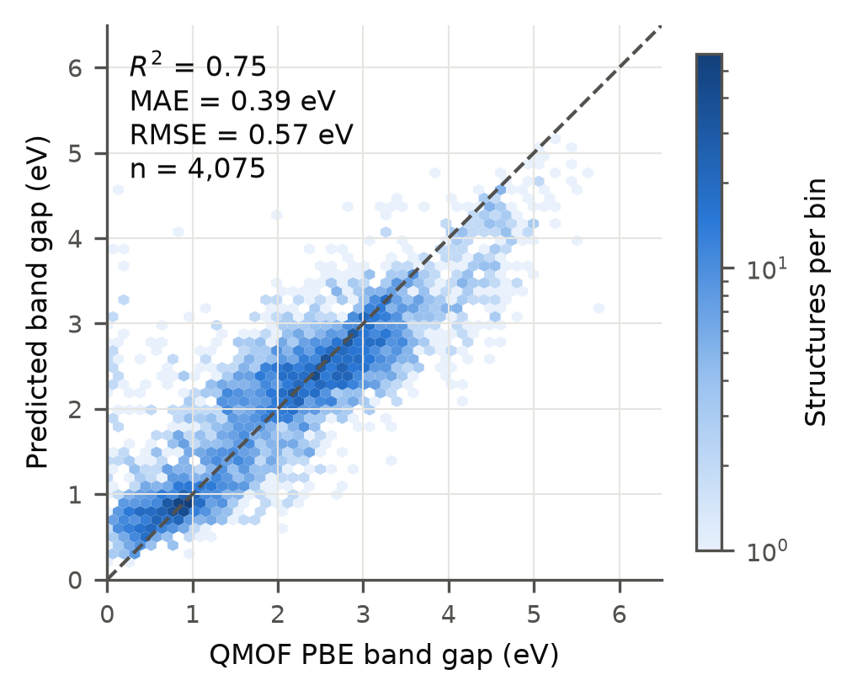
Figure S1. Parity plot of the ExtraTrees regressor (feature set C) on the QMOF hold-out set (scripts/11_make_figures.py). Colour, point density on a logarithmic scale; dashed line, y = x.
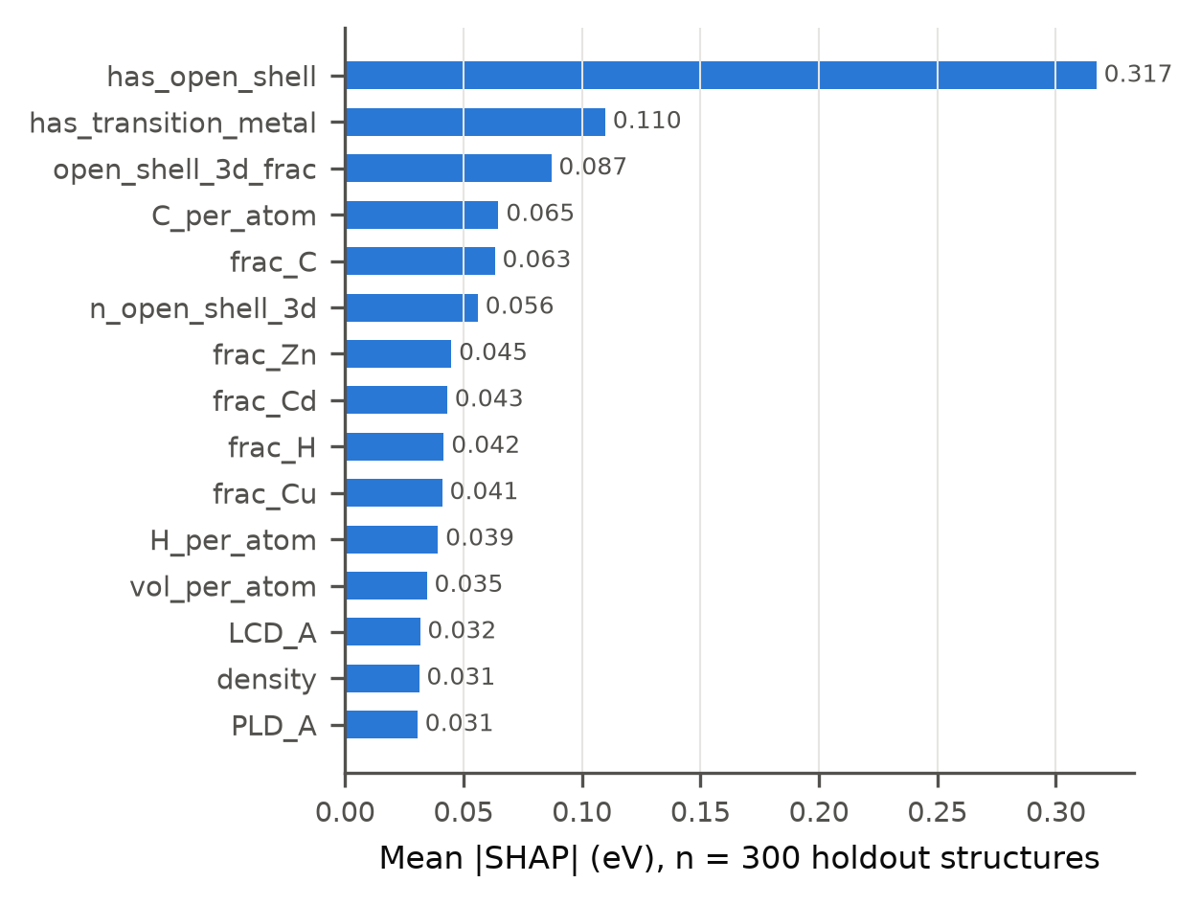
Figure S2. Mean absolute SHAP value (eV) of the twenty most important descriptors of the ExtraTrees surrogate on a 300-structure sample of the QMOF hold-out set (scripts/11_make_figures.py; results/surrogate/shap_mean_abs.csv).
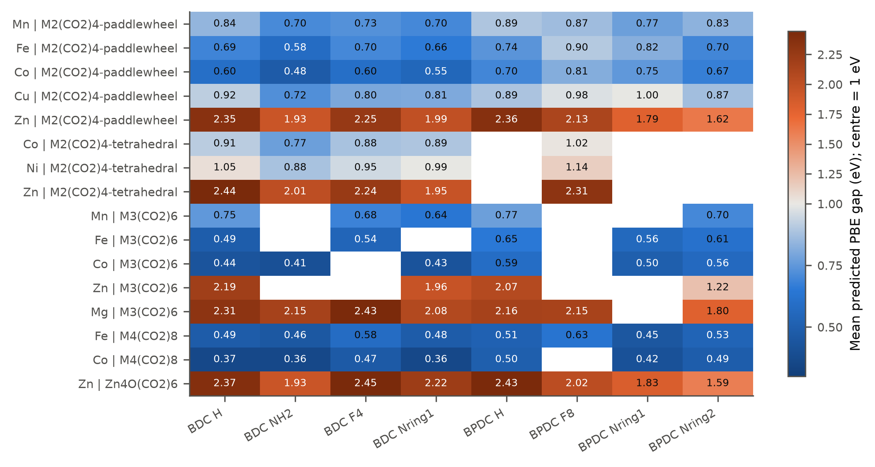
Figure S3. Mean predicted PBE gap of the initial surrogate for the 131 catalogue frameworks by metal and linker substituent, averaged over nets (scripts/11_make_figures.py). Empty cells are combinations absent from the catalogue.
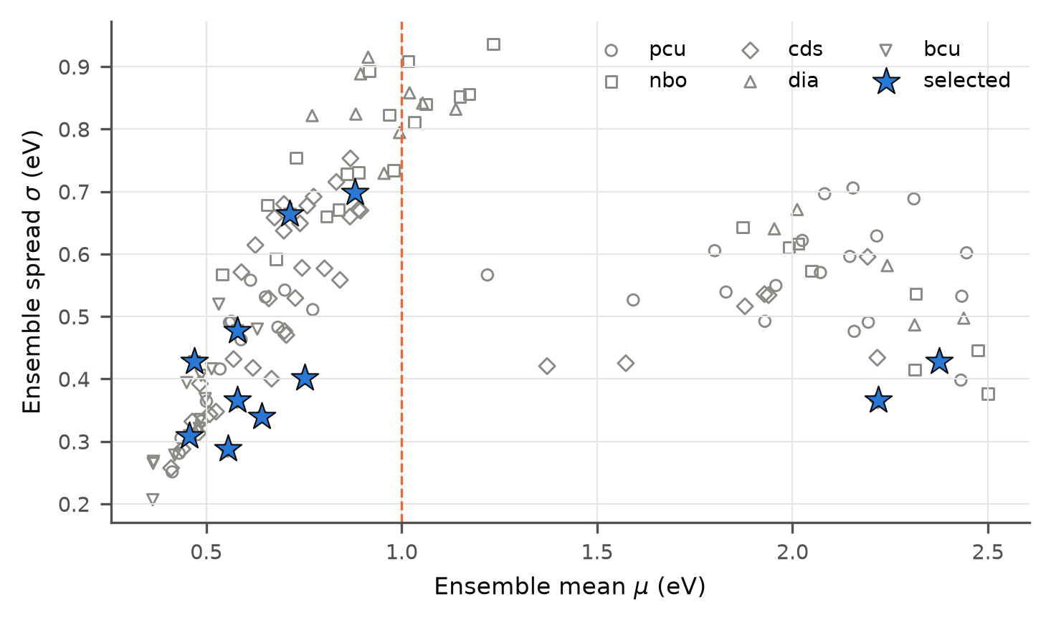
Figure S4. Acquisition landscape of iteration 0: predicted gap μ against uncertainty σ for the 131 frameworks, coloured by net; stars mark the eleven frameworks sent to DFT (scripts/11_make_figures.py; data/al/iter0/acquisition_ranking.csv).

S3. Acquisition and batch selection
Table S9. Batch selection per iteration (scripts/06_select_batch.py; data/al/iter<k>/selection_rules.json). "Eligible candidates" are the frameworks not yet computed that satisfy the eligibility rules; the caps are applied in score order. Iteration 0 added two closed-shell references to nine frameworks chosen by score.
Iteration | Labels in training | Eligible candidates | Batch | Diversity caps | Eligibility rules | Forced | κ / α / β
0 | 0 | 131 | 11 | 2 per net, 2 per metal | none | MOF-5, Zn₂ cds (closed-shell references) | 1.0 / 0.3 / 0.5
1 | 6 | 42 | 8 | 4 per net, 2 per metal, 4 per substituent | family M₃(CO₂)₆; paddlewheel:cds:Zn; ≤ 160 atoms | Mn₂ cds F₄-BDC (anchor of the metal series) | 1.0 / 0.3 / 0.5
2 | 11 | 26 | 8 | 4 per net, 2 per metal, 4 per substituent | family M₃(CO₂)₆; paddlewheel:cds:Zn; paddlewheel:cds:Mn; M₄(CO₂)₈:bcu:Fe; ≤ 160 atoms | none | 1.0 / 0.3 / 0.5

S4. DFT protocol and results
Table S10 lists the VASP parameters. Table S11 gives the complete record of the 18 accepted labels, Table S12 every spin solution computed, Table S13 the nine frameworks without a label, Table S14 the band-edge projections on all site groups and Table S15 the computational cost per iteration. Fig. S5 shows the spin-resolved density of states of all 18 labelled frameworks.
Table S10. VASP 6.3.2 parameters (src/mofal/vasp.py). PAW data sets: Mn_pv, Fe_pv, Ni_pv, Cu_pv, Mg_pv, Co, Zn, C, H, N, O, F from potpaw_PBE.52. A relaxation is accepted as converged when a restarted round reports "reached required accuracy" again.
Parameter | Relaxation | Static | Broken-symmetry static
Functional / dispersion | PBE + D3(BJ) | PBE + D3(BJ) | PBE + D3(BJ)
PAW set | potpaw_PBE.52 | potpaw_PBE.52 | potpaw_PBE.52
ENCUT (eV) | 520 | 520 | 520
EDIFF (eV) | 1 × 10⁻⁵ | 1 × 10⁻⁶ | 1 × 10⁻⁶
NELM | 120 | 300 | 300
ISPIN / MAGMOM | 2 / high-spin FM | 2 / high-spin FM | 2 / ±max(HS, 2) per M₂ unit
ISYM | default | default | 0
LMAXMIX | 4 | 4 | 4
ALGO | Normal (All for Fe, Co, Ni) | Normal (All for Fe, Co, Ni) | Normal (All for Fe, Co, Ni)
ISMEAR / SIGMA | 0 / 0.01 | −5 if ≥ 4 k-points and ALGO ≠ All, else 0 / 0.01 | as static
IBRION / ISIF / NSW | 2 / 3 / 600 | −1 / – / 0 | −1 / – / 0
EDIFFG (eV Å⁻¹) | −0.05 | – | –
k-points | Γ if all a_{i} ≥ 12 Å, else Γ-centred n_{i} = round(25 Å / a_{i}) | Γ-centred n_{i} = round(25 Å / a_{i}) | as static
LORBIT / NEDOS | – | 11 / 3001 | 11 / 3001
KPAR | 2 if ≥ 2 k-points | 2 if ≥ 2 k-points | 2 if ≥ 2 k-points

Table S11. Complete record of the 18 accepted labels (results/final/table_labels.csv). "Start of label run": initial magnetic moments of the static calculation that provided the label (fm, high-spin ferromagnetic; afmbs, broken-symmetry start in the same folder; afm2, broken-symmetry sibling run of iteration 0). ΔE is the energy of that solution relative to the ferromagnetic-start solution; M_{tot} the total moment; F_{max} the largest residual force of the relaxation; ΔV the volume change relative to the generated structure; VB and CB metal d the metal d fraction of the projected weight within 0.25 eV of the band edges; QMOF PBE the mean QMOF gap of the known framework; core-h the core-hours spent on the framework including restarts.
Framework | Iter. | Gap (eV) | Direct | Start of label run | ΔE vs FM start (eV) | M_{tot} (μ_{B}) | Relax. stopped | F_{max} (eV Å⁻¹) | ΔV (%) | VB metal d | CB metal d | QMOF PBE (eV) | Core-h
Zn₄O pcu, NH₂-BDC | 1 | 2.514 | no | – | – | 0.0 | no | 0.048 | 4.1 | 0.00 | 0.01 | 2.35 | 24
Zn₄O pcu, N₂-ring-BPDC | 1 | 2.750 | yes | – | – | -0.0 | no | 0.046 | -11.3 | 0.01 | 0.01 | – | 94
Zn₄O pcu, N-ring-BPDC | 2 | 3.029 | yes | – | – | -0.0 | no | 0.049 | 0.0 | 0.02 | 0.01 | – | 90
Zn₄O pcu, N-ring-BDC | 2 | 3.114 | no | – | – | -0.0 | no | 0.049 | 5.6 | 0.02 | 0.01 | – | 21
Zn₄O pcu, BDC | 0 | 3.518 | no | – | – | 0.0 | no | 0.027 | -5.8 | 0.11 | 0.01 | 3.52 | 191
Co₄ bcu, NH₂-BDC | 2 | 0.332 | no | – | – | 24.0 | no | 0.050 | -7.0 | 0.88 | 0.89 | – | 828
Co₄ bcu, N-ring-BDC | 1 | 0.372 | no | – | – | 24.0 | no | 0.043 | -14.5 | 0.90 | 0.89 | – | 634
Co₄ bcu, BDC | 2 | 0.379 | yes | – | – | 24.0 | no | 0.048 | -10.3 | 0.81 | 0.90 | – | 556
Co₄ bcu, F₄-BDC | 0 | 0.533 | no | – | – | 22.0 | yes | 0.128 | -8.5 | 0.91 | 0.89 | – | 1,815
Fe₄ bcu, F₄-BDC | 0 | 0.014 | no | – | – | 32.0 | yes | 0.224 | 1.4 | 0.92 | 0.84 | – | 1,849
Fe₄ bcu, NH₂-BDC | 0 | 0.065 | no | – | – | 32.0 | yes | 0.172 | -7.3 | 0.89 | 0.90 | – | 1,775
Cu₂ cds, F₄-BDC | 1 | 0.339 | no | afmbs-start | -0.01 | -0.0 | no | 0.029 | -0.3 | 0.57 | 0.58 | – | 616
Cu₂ cds, NH₂-BDC | 0 | 0.687 | no | afm2-start | -0.43 | 0.0 | yes | 0.082 | 0.7 | 0.07 | 0.60 | – | 1,774
Cu₂ cds, F₈-BPDC | 2 | 0.890 | yes | afmbs-start | -0.45 | 0.0 | no | 0.044 | 5.1 | 0.43 | 0.60 | – | 345
Cu₂ cds, N-ring-BDC | 0 | 0.904 | yes | afm2-start | -0.41 | 0.0 | no | 0.028 | 3.3 | 0.46 | 0.60 | – | 613
Co₂ cds, F₄-BDC | 1 | 0.668 | no | afmbs-start | -0.26 | -0.0 | yes | 0.105 | -0.3 | 0.91 | 0.89 | – | 816
Fe₂ cds, N-ring-BDC | 2 | 0.035 | yes | fm-start | 0.00 | 16.0 | no | 0.046 | 10.9 | 0.73 | 0.87 | – | 375
Fe₂ cds, F₄-BDC | 1 | 0.046 | yes | fm-start | 0.00 | 16.0 | no | 0.049 | 5.8 | 0.70 | 0.92 | – | 294

Table S12. All spin solutions computed for the paddlewheel frameworks (data/dft/spin_solutions.csv). E, total energy; ΔE, energy relative to the ferromagnetic-start solution of the same framework; Σ|m_{M}|, sum of the absolute metal moments; M_{tot}, total moment; "label" marks the solution used as the training label (lowest energy among the converged solutions). Solutions whose SCF did not converge are listed but not compared.
Framework | Initial moments | E (eV) | ΔE (eV) | Gap (eV) | Σ|m_{M}| (μ_{B}) | M_{tot} (μ_{B}) | State | SCF conv.
Cu₂ cds, NH₂-BDC | fm | -522.641 | +0.000 | 0.226 | 0.00 | -0.00 | NM (low spin) | yes
Cu₂ cds, NH₂-BDC | afm | -522.641 | +0.000 | 0.226 | 0.00 | -0.00 | NM (low spin) | yes
Cu₂ cds, NH₂-BDC | afm2 | -523.072 | -0.432 | 0.687 | 2.12 | 0.00 | AFM | yes | label
Cu₂ cds, N-ring-BDC | fm | -453.482 | +0.000 | 0.257 | 0.00 | -0.00 | NM (low spin) | yes
Cu₂ cds, N-ring-BDC | afm | -453.798 | -0.316 | 0.527 | 2.21 | 2.00 | FM | yes
Cu₂ cds, N-ring-BDC | afm2 | -453.897 | -0.415 | 0.904 | 2.12 | 0.00 | AFM | yes | label
Co₂ cds, F₄-BDC | fm | -488.426 | +0.000 | 0.142 | 3.94 | 4.00 | FM | yes
Co₂ cds, F₄-BDC | afmbs | -488.687 | -0.261 | 0.668 | 0.03 | -0.00 | NM (low spin) | yes | label
Cu₂ cds, F₄-BDC | fm | -473.409 | +0.000 | 0.272 | 1.07 | -0.00 | AFM | yes
Cu₂ cds, F₄-BDC | afmbs | -473.425 | -0.015 | 0.339 | 1.08 | -0.00 | AFM | yes | label
Fe₂ cds, F₄-BDC | fm | -493.639 | +0.000 | 0.046 | 14.24 | 16.00 | FM | yes | label
Fe₂ cds, F₄-BDC | afmbs | -492.800 | +0.840 | 0.078 | 14.01 | 0.00 | AFM | yes
Cu₂ cds, F₈-BPDC | fm | -751.346 | +0.000 | 0.249 | 0.00 | 0.00 | NM (low spin) | yes
Cu₂ cds, F₈-BPDC | afmbs | -751.800 | -0.454 | 0.890 | 2.15 | 0.00 | AFM | yes | label
Cu₂ cds, N-ring-BPDC (no label) | fm | -745.664 | +0.000 | 0.022 | 1.60 | 1.68 | FM | no
Cu₂ cds, N-ring-BPDC (no label) | afmbs | -731.769 | +13.896 | 0.623 | 2.22 | -2.00 | FM | yes
Fe₂ cds, N-ring-BDC | fm | -474.073 | +0.000 | 0.035 | 14.15 | 16.00 | FM | yes | label
Fe₂ cds, N-ring-BDC | afmbs | -472.759 | +1.314 | 0.058 | 13.31 | -0.00 | AFM | no

Table S13. Frameworks computed without obtaining a label (results/final/table_excluded.csv). μ ± σ is the prediction of the surrogate that selected the framework; ΔV and Δangle are measured on the last available geometry; the core-hours include every attempt.
Framework | Iter. | Atoms | μ ± σ (eV) | Outcome | ΔV (%) | Δangle (°) | Ionic steps | Core-h
Zn₂ cds, BDC | 0 | 68 | 2.22 ± 0.37 | collapse/shear | -15 | 25 | 22 | 1,152
Ni₂ dia, NH₂-BDC | 0 | 304 | 0.88 ± 0.70 | SCF not converged (relaxation) | 1 | 0 | 8 | 2,304
Co₂ nbo, F₄-BDC | 0 | 204 | 0.71 ± 0.66 | unstable relaxation | 1 | 0 | 1 | 2,304
Mn₃ pcu, BDC | 0 | 51 | 0.75 ± 0.40 | collapse/shear | -51 | – | – | 1,152
Mn₃ pcu, N-ring-BDC | 0 | 48 | 0.64 ± 0.34 | collapse/shear | -49 | 23 | 25 | 1,152
Fe₄ bcu, BDC | 1 | 136 | 0.37 ± 0.30 | collapse/shear | -25 | – | – | 1,536
Mn₂ cds, F₄-BDC | 1 | 68 | 0.68 ± 0.51 | collapse/shear | -21 | 9 | 126 | 768
Cu₂ cds, N-ring-BPDC | 2 | 104 | 0.78 ± 0.69 | SCF not converged (static) | -0 | 1 | 9 | 758
Fe₂ cds, NH₂-BDC | 2 | 76 | 0.42 ± 0.27 | relaxation unfinished | 6 | 2 | 235 | 768

Table S14. Band-edge character of the 18 labels: fraction of the site- and orbital-projected weight within 0.25 eV of the VBM and CBM (both spins, k-weighted) on the metal (all orbitals and d only), the μ₄-oxide, the carboxylate O and the linker backbone (scripts/17_band_edge_character.py).
Framework | Gap (eV) | VB metal | VB metal d | VB μ₄-O | VB O_{carb} | VB linker | CB metal | CB metal d | CB μ₄-O | CB O_{carb} | CB linker
Zn₄O pcu, NH₂ | 2.51 | 0.00 | 0.00 | 0.00 | 0.04 | 0.96 | 0.02 | 0.01 | 0.00 | 0.30 | 0.68
Zn₄O pcu, long-N₂-ring | 2.75 | 0.01 | 0.01 | 0.01 | 0.03 | 0.96 | 0.01 | 0.01 | 0.00 | 0.19 | 0.80
Zn₄O pcu, long-N-ring | 3.03 | 0.02 | 0.02 | 0.01 | 0.10 | 0.86 | 0.01 | 0.01 | 0.00 | 0.20 | 0.79
Zn₄O pcu, N-ring | 3.11 | 0.03 | 0.02 | 0.02 | 0.09 | 0.86 | 0.02 | 0.01 | 0.00 | 0.27 | 0.71
Zn₄O pcu, H | 3.52 | 0.13 | 0.11 | 0.10 | 0.44 | 0.33 | 0.02 | 0.01 | 0.00 | 0.30 | 0.68
Co₄ bcu, NH₂ | 0.33 | 0.88 | 0.88 | 0.00 | 0.06 | 0.06 | 0.89 | 0.89 | 0.00 | 0.08 | 0.03
Co₄ bcu, N-ring | 0.37 | 0.90 | 0.90 | 0.00 | 0.07 | 0.03 | 0.90 | 0.89 | 0.00 | 0.07 | 0.04
Co₄ bcu, H | 0.38 | 0.81 | 0.81 | 0.00 | 0.15 | 0.03 | 0.91 | 0.90 | 0.00 | 0.07 | 0.02
Co₄ bcu, F₄ | 0.53 | 0.91 | 0.91 | 0.00 | 0.06 | 0.03 | 0.89 | 0.89 | 0.00 | 0.07 | 0.03
Fe₄ bcu, F₄ | 0.01 | 0.94 | 0.92 | 0.00 | 0.03 | 0.03 | 0.85 | 0.84 | 0.00 | 0.05 | 0.10
Fe₄ bcu, NH₂ | 0.06 | 0.90 | 0.89 | 0.00 | 0.05 | 0.05 | 0.90 | 0.90 | 0.00 | 0.06 | 0.04
Cu₂ cds, F₄ | 0.34 | 0.57 | 0.57 | 0.00 | 0.37 | 0.05 | 0.58 | 0.58 | 0.00 | 0.36 | 0.07
Cu₂ cds, NH₂ | 0.69 | 0.07 | 0.07 | 0.00 | 0.11 | 0.82 | 0.60 | 0.60 | 0.00 | 0.34 | 0.06
Cu₂ cds, long-F₈ | 0.89 | 0.44 | 0.44 | 0.00 | 0.45 | 0.12 | 0.60 | 0.60 | 0.00 | 0.34 | 0.06
Cu₂ cds, N-ring | 0.90 | 0.46 | 0.46 | 0.00 | 0.46 | 0.09 | 0.60 | 0.60 | 0.00 | 0.34 | 0.06
Co₂ cds, F₄ | 0.67 | 0.91 | 0.91 | 0.00 | 0.09 | 0.01 | 0.93 | 0.89 | 0.00 | 0.07 | 0.01
Fe₂ cds, N-ring | 0.04 | 0.74 | 0.74 | 0.00 | 0.22 | 0.04 | 0.88 | 0.87 | 0.00 | 0.03 | 0.09
Fe₂ cds, F₄ | 0.05 | 0.70 | 0.70 | 0.00 | 0.19 | 0.11 | 0.93 | 0.92 | 0.00 | 0.06 | 0.01

Table S15. Computational cost per iteration from the SLURM logs (data/dft/compute_log.csv): number of jobs, wall-clock hours and core-hours (wall-clock × cores per node). Jobs that reached the walltime are counted at their limit.
Iteration | Cluster (cores per node) | Jobs | Wall-clock hours | Core-hours
0 | FASTER (64) | 5 | 4 | 268
0 | Grace (48) | 23 | 329 | 15,813
1 | FASTER (64) | 9 | 75 | 4,782
2 | FASTER (64) | 8 | 58 | 3,741
All |  | 45 | 466 | 24,604

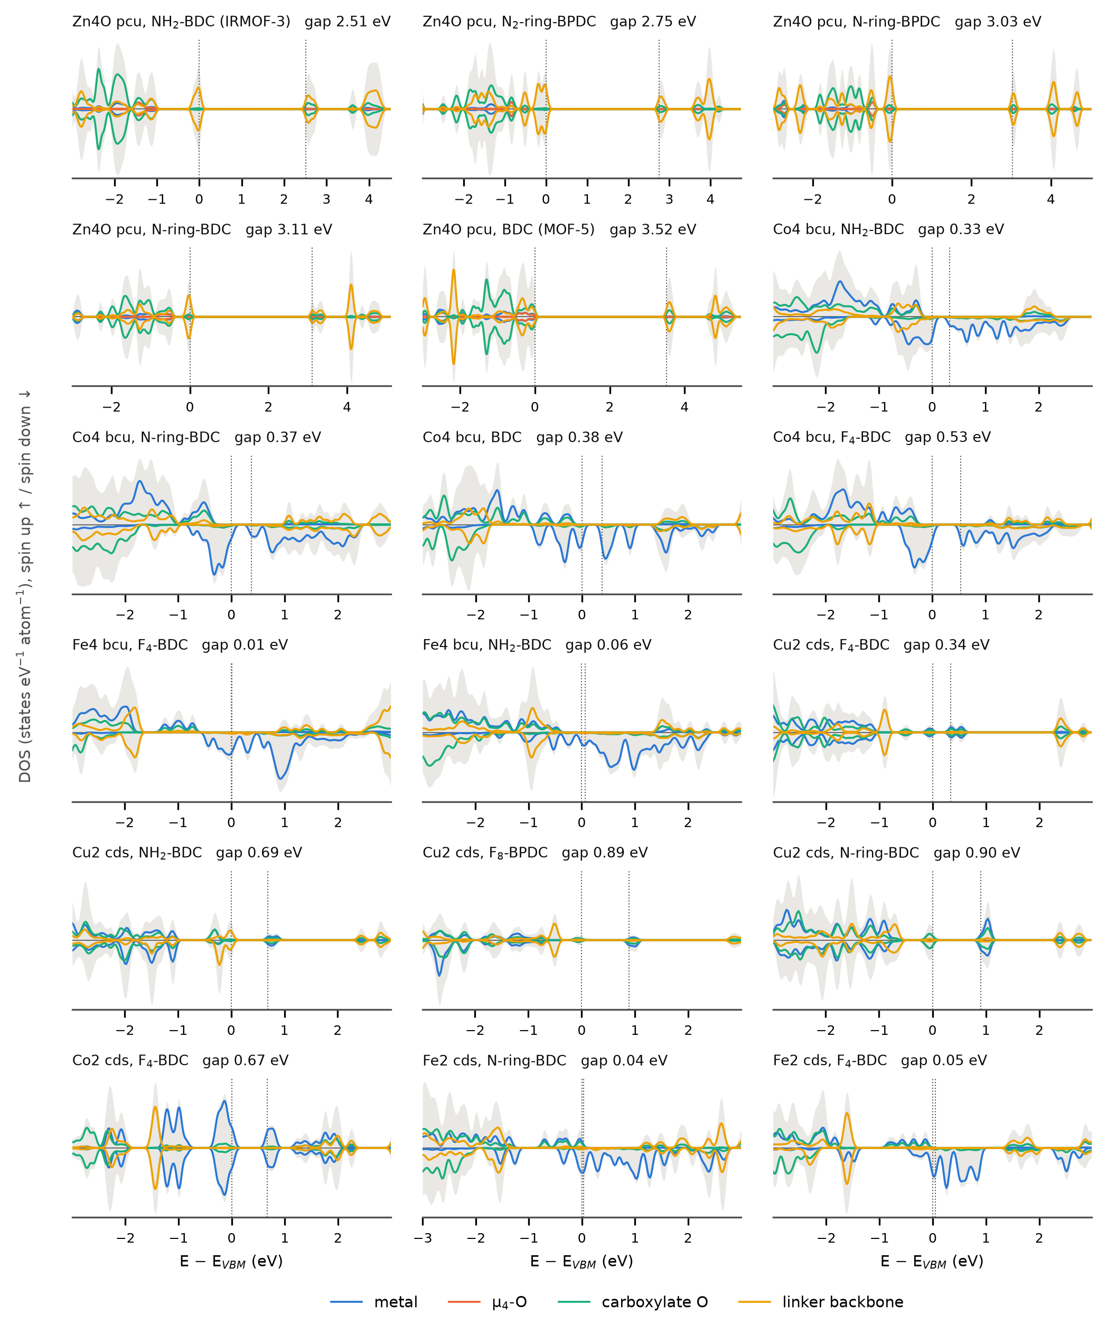
Figure S5. Spin-resolved density of states (spin up positive, spin down negative; Gaussian broadening 0.05 eV) of the 18 labelled frameworks relative to the VBM, with projections on the four site groups (scripts/19_dos_figures.py). Grey, total DOS; dotted lines, VBM and CBM.

S5. Periodic GFN1-xTB
Table S16 summarises GFN1-xTB against the PBE and HSE06 gaps of a random subset of 2,000 QMOF structures, computed as periodic crystals and as finite clusters (Fig. S6; scripts/13_xtb_validation.py and 14_xtb_analysis.py). Table S17 lists the xTB gaps of the 18 labelled frameworks at three geometries (scripts/16_xtb_candidates.py) and Table S18 compares the character of the xTB frontier orbitals with the DFT band edges of the Zn₄O frameworks (scripts/17_band_edge_character.py).
Table S16. GFN1-xTB band gaps of the QMOF subset against PBE and, where available, HSE06 reference gaps, for periodic and finite-cluster treatments and by electronic group (results/xtb/xtb_summary.csv). The last column is the ROC AUC of the xTB gap as a classifier of reference gaps below 1 eV.
Group | Treatment | Reference | n | MAE (eV) | Bias (eV) | Spearman ρ | xTB gap < 0.1 eV (%) | ROC AUC (ref. < 1 eV)
all | cluster | PBE | 1828 | 1.22 | -1.22 | 0.06 | 97.6 | 0.53
all | cluster | HSE06 | 853 | 3.42 | -3.42 | 0.09 | 97.1 | 0.52
all | periodic | PBE | 1998 | 0.60 | +0.37 | 0.62 | 6.7 | 0.83
all | periodic | HSE06 | 854 | 1.60 | -1.44 | 0.58 | 4.3 | 0.72
closed-shell | cluster | PBE | 755 | 2.15 | -2.15 | 0.19 | 97.5 | 0.59
closed-shell | cluster | HSE06 | 314 | 4.49 | -4.49 | 0.19 | 96.2 | 0.61
closed-shell | periodic | PBE | 791 | 0.40 | +0.10 | 0.90 | 3.9 | 0.91
closed-shell | periodic | HSE06 | 313 | 1.40 | -1.34 | 0.95 | 3.2 | 0.95
open-shell 3d | cluster | PBE | 1072 | 0.57 | -0.57 | -0.01 | 97.7 | 0.51
open-shell 3d | cluster | HSE06 | 538 | 2.81 | -2.81 | -0.02 | 97.6 | 0.47
open-shell 3d | periodic | PBE | 1205 | 0.73 | +0.54 | 0.29 | 8.5 | 0.70
open-shell 3d | periodic | HSE06 | 540 | 1.72 | -1.50 | -0.01 | 5.0 | 0.48

Table S17. Periodic GFN1-xTB gaps (eV) of the 18 labelled frameworks at the DFT-relaxed geometry (Γ point and, where the supercell has at most 700 atoms, the supercell equivalent to the static k-mesh), at the CHGNet geometry and at the as-assembled PORMAKE geometry, with the PBE-D3(BJ) label and the surrogate prediction (results/xtb_candidates/xtb_vs_dft_vs_surrogate.csv).
Framework | PBE-D3 label (eV) | Surrogate μ (eV) | xTB, DFT geom. (Γ) | xTB, DFT geom., k-mesh | xTB, CHGNet geom. | xTB, as assembled
Co₄ bcu, F₄-BDC | 0.53 | 0.47 | 0.39 | – | 0.31 | 1.10
Fe₄ bcu, F₄-BDC | 0.01 | 0.58 | 0.88 | – | 0.90 | 0.90
Fe₄ bcu, NH₂-BDC | 0.07 | 0.46 | 0.11 | – | 0.21 | 0.86
Cu₂ cds, NH₂-BDC | 0.69 | 0.56 | 0.10 | 0.08 | 0.13 | 0.14
Cu₂ cds, N-ring-BDC | 0.90 | 0.58 | 0.15 | 0.13 | – | 0.18
Zn₄O pcu, BDC | 3.52 | 2.38 | 3.50 | 3.38 | 3.36 | 2.87
Co₄ bcu, N-ring-BDC | 0.37 | 0.38 | 0.28 | – | 0.17 | 1.02
Co₂ cds, F₄-BDC | 0.67 | 0.48 | 1.74 | 1.73 | 1.33 | 1.17
Cu₂ cds, F₄-BDC | 0.34 | 0.60 | 0.19 | 0.15 | 0.05 | 0.24
Fe₂ cds, F₄-BDC | 0.05 | 0.44 | 1.22 | 1.22 | 1.07 | 0.48
Zn₄O pcu, N₂-ring-BPDC | 2.75 | 1.60 | 2.70 | – | 2.52 | 2.04
Zn₄O pcu, NH₂-BDC | 2.51 | 1.92 | 2.68 | 2.66 | 2.52 | 2.82
Co₄ bcu, BDC | 0.38 | 0.39 | 0.50 | – | 0.06 | 1.11
Co₄ bcu, NH₂-BDC | 0.33 | 0.35 | 0.33 | – | 0.11 | 0.91
Cu₂ cds, F₈-BPDC | 0.89 | 0.70 | 0.15 | 0.16 | 0.16 | 0.19
Fe₂ cds, N-ring-BDC | 0.04 | 0.51 | 0.98 | 0.97 | 1.14 | 0.78
Zn₄O pcu, N-ring-BPDC | 3.03 | 1.90 | 2.81 | – | 2.71 | 2.76
Zn₄O pcu, N-ring-BDC | 3.11 | 2.34 | 2.89 | 2.88 | 2.69 | 2.91

Table S18. Character of the frontier orbitals of the Zn₄O frameworks: fraction of the DFT projected weight within 0.25 eV of the band edges (DFT) and of the GFN1-xTB Mulliken population of the orbitals within 0.25 eV of the HOMO and LUMO (xTB) on the linker backbone, the carboxylate O and the μ₄-oxide; the metal fraction is below 0.03 in all cases (results/band_edges/xtb_vs_dft_band_edges.csv).
Zn₄O framework | Gap DFT | Gap xTB | VB linker DFT | VB linker xTB | VB O_{carb} DFT | VB O_{carb} xTB | VB μ₄-O DFT | VB μ₄-O xTB | CB linker DFT | CB linker xTB | CB O_{carb} DFT | CB O_{carb} xTB
NH₂ | 2.51 | 2.68 | 0.96 | 0.98 | 0.04 | 0.02 | 0.00 | 0.00 | 0.68 | 0.82 | 0.30 | 0.17
long-N₂-ring | 2.75 | 2.70 | 0.96 | 0.94 | 0.03 | 0.04 | 0.01 | 0.02 | 0.80 | 0.90 | 0.19 | 0.10
long-N-ring | 3.03 | 2.81 | 0.86 | 0.91 | 0.10 | 0.06 | 0.01 | 0.03 | 0.79 | 0.90 | 0.20 | 0.10
N-ring | 3.11 | 2.89 | 0.86 | 0.89 | 0.09 | 0.10 | 0.02 | 0.00 | 0.71 | 0.85 | 0.27 | 0.15
H | 3.52 | 3.50 | 0.34 | 0.48 | 0.44 | 0.32 | 0.10 | 0.20 | 0.68 | 0.82 | 0.30 | 0.17

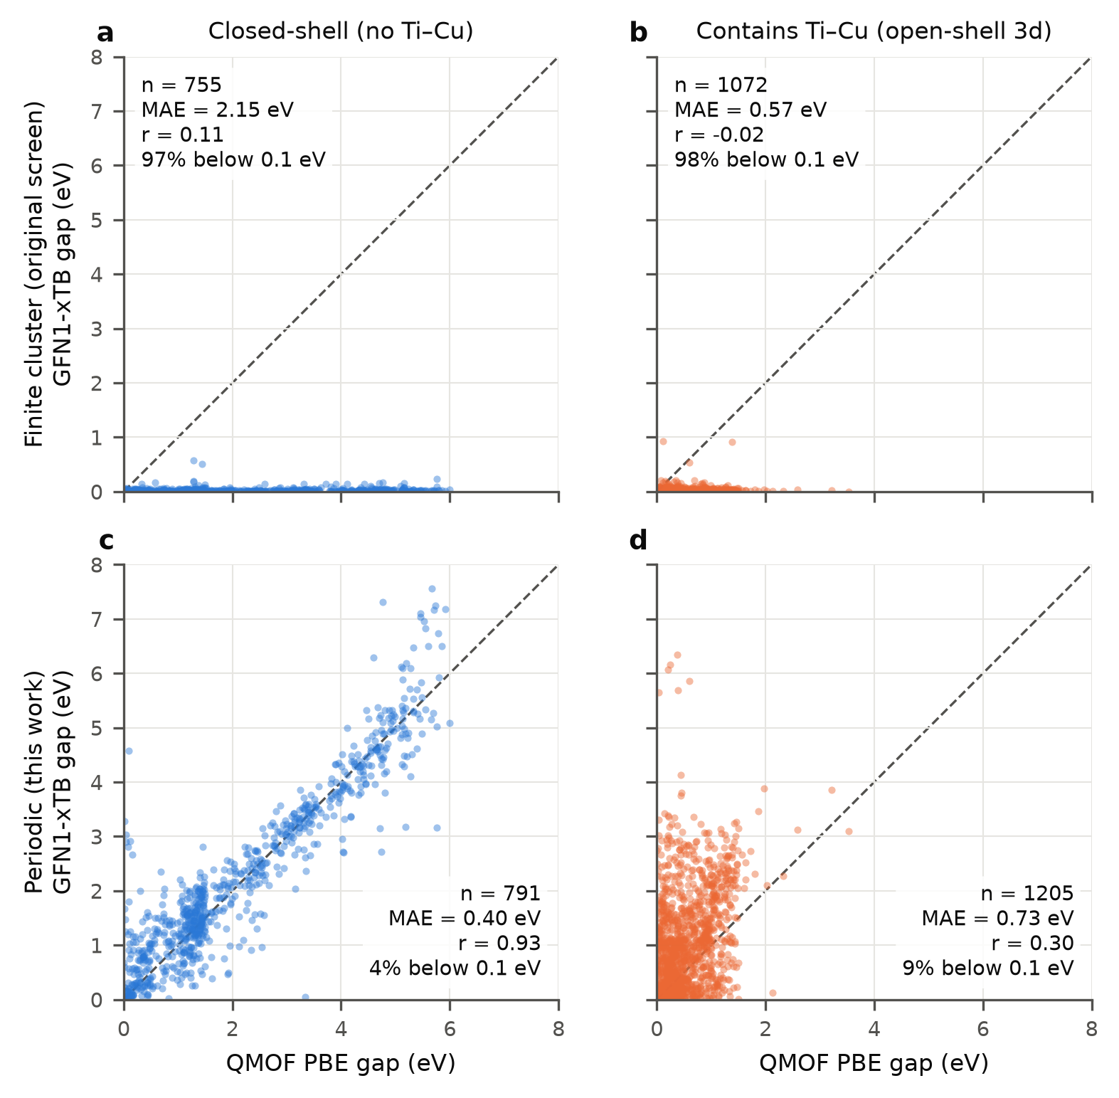
Figure S6. GFN1-xTB gaps of the QMOF subset against the PBE reference for the periodic and the finite-cluster treatment, by electronic group (scripts/14_xtb_analysis.py). The cluster treatment collapses the gaps regardless of chemistry.

S6. Retrospective active-learning benchmark
Table S19. Retrospective benchmark on QMOF after 23 labels (the budget of this work) and after 53 labels: mean ± standard deviation over 20 repeats of the number of labelled structures with PBE gap below 0.5 eV, the number below 1 eV, the recall of the ten lowest gaps in the pool of 150, and the MAE on a fixed external out-of-distribution test set, overall and for gaps below 1 eV (scripts/15_retrospective_al.py; results/retro_al/retro_al_headline.csv). The expected number of hits below 0.5 eV for random selection is 4.0 at 23 labels and 9.1 at 53.
Labels | Strategy | Hits < 0.5 eV | Hits < 1 eV | Recall of 10 lowest | OOD test MAE (eV) | OOD test MAE, gap < 1 eV
23 | random | 3.5 ± 1.8 | 7.9 | 0.15 | 0.455 | 0.399
23 | greedy (lowest μ) | 14.1 ± 2.7 | 22.2 | 0.54 | 0.462 | 0.393
23 | LCB (μ − σ) | 13.8 ± 2.5 | 20.6 | 0.56 | 0.454 | 0.394
23 | this work (LCB + novelty + caps) | 12.5 ± 2.9 | 19.9 | 0.59 | 0.456 | 0.392
23 | this work, no retraining | 12.6 ± 2.9 | 19.4 | 0.57 | 0.462 | 0.396
23 | uncertainty (highest σ) | 0.9 ± 0.9 | 1.7 | 0.02 | 0.445 | 0.403
53 | random | 8.2 ± 3.0 | 17.9 | 0.31 | 0.448 | 0.401
53 | greedy (lowest μ) | 21.5 ± 3.4 | 42.7 | 0.86 | 0.449 | 0.390
53 | LCB (μ − σ) | 21.6 ± 3.5 | 41.6 | 0.85 | 0.443 | 0.391
53 | this work (LCB + novelty + caps) | 20.9 ± 3.5 | 38.7 | 0.81 | 0.446 | 0.391
53 | this work, no retraining | 20.4 ± 3.8 | 37.5 | 0.78 | 0.462 | 0.396
53 | uncertainty (highest σ) | 3.8 ± 1.6 | 7.8 | 0.17 | 0.437 | 0.409

S7. PBE and HSE06 band gaps in QMOF
For the 10,810 QMOF structures that have both a PBE and an HSE06 gap, Table S20 and Fig. S7 compare the two by electronic group and by primary metal (scripts/12_qmof_pbe_vs_hse06.py). The relevant quantity for this work is the fraction of structures with a PBE gap below 1 eV that keep a small HSE06 gap.
Table S20. PBE and HSE06 band gaps in QMOF by electronic group and primary metal (results/qmof_pbe_vs_hse06/). "Open-shell 3d" means a primary metal from Ti to Cu. The last two columns give the percentage of structures with PBE gap below 1 eV whose HSE06 gap is below 1 and 2 eV.
QMOF subset (primary metal) | n | Median PBE (eV) | Median HSE06 (eV) | Median HSE06 − PBE (eV) | n with PBE < 1 eV | of which HSE06 < 1 eV (%) | of which HSE06 < 2 eV (%)
open-shell 3d (Ti-Cu) | 2927 | 0.89 | 3.24 | 2.22 | 1901 | 2.3 | 14.8
other | 7883 | 2.80 | 4.04 | 1.24 | 189 | 16.4 | 41.8
Mn | 379 | 0.92 | 2.99 | 2.11 | 208 | 1.9 | 28.9
Fe | 112 | 0.98 | 3.09 | 1.81 | 57 | 1.8 | 12.3
Co | 406 | 0.72 | 3.57 | 2.79 | 296 | 1.7 | 5.1
Ni | 243 | 1.13 | 3.71 | 2.54 | 87 | 0.0 | 4.6
Cu | 1713 | 0.88 | 3.15 | 2.15 | 1215 | 2.6 | 15.6
Zn | 1668 | 2.81 | 4.08 | 1.24 | 15 | 13.3 | 60.0
Mg | 79 | 3.28 | 4.58 | 1.33 | 0 | – | –

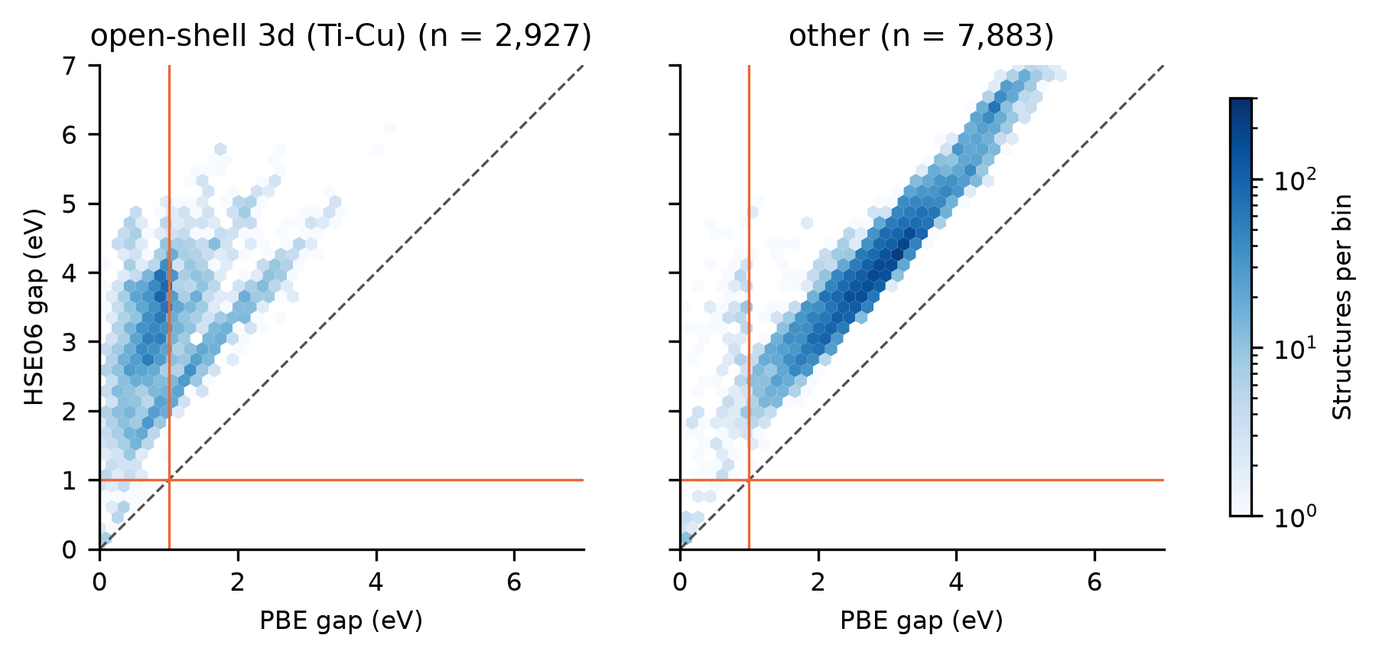
Figure S7. HSE06 against PBE band gaps for the QMOF structures that have both, by electronic group (scripts/12_qmof_pbe_vs_hse06.py).

