From a classic battery model to lithium-SPAN with a physics-informed neural network
Summary of results for the advisor meeting
PINN-DFN project, Balbuena group, Texas A&M University · Carlos Guerrero · October 2026

In short
We trained a physics-informed neural network (PINN) on the classic lithium-ion battery model and checked it where the answer is known; we then moved it to the lithium-SPAN cell model, checked it against that model's own paper, tested it on independent data from another publication, and finally used it to learn about SPAN chemistry. The main results:
- Classic model (graphite | NMC, LG M50 cell). The PINN reproduces the reference simulator to 0.23-0.24 mV and recovers battery parameters and the aging state from one discharge curve within about 0.6 % and 1.6 % (synthetic data).
- Li-SPAN model. Our own copy of the published model reproduces the authors' curves (16 / 18 mV), and the PINN reproduces our model to 0.26 mV at 0.1 C and 0.18 mV at 1 C (average of three independent trainings), including the sulfur species inside the electrode.
- Inverse problem. From two synthetic discharge curves (0.1 C and 1 C, with noise) the PINN finds eight parameters of the model within 2 % (most within about 0.3 %).
- Independent data (SPAN500, Wang et al., Nature Materials 2026, a paper our group co-authored; different electrolyte). The model fits the measured curve to 8.9-10 mV, less than the change of the same cell between two consecutive cycles (54 mV).
- Chemistry. In the Simanjuntak cell most of the voltage lost at 1 C is contact resistance (344 of 470 mV), and the lost capacity is an unfinished third reduction step. For SPAN500 the tool measures the first-cycle activation, and across SPAN300, SPAN320 and SPAN500 how the reduction potentials and the active sulfur change with the synthesis temperature.
The detailed equations, error metrics and numerical settings of every step will be in the manuscript and its supplementary information; this document explains what each result means.

1. Background

1.1 Why lithium-SPAN, and why a model
Lithium-sulfur batteries promise more energy per kilogram than lithium-ion batteries, because sulfur is light and can take up two electrons per atom. Their weak point is that, in most electrolytes, the sulfur dissolves as polysulfide molecules that travel to the lithium anode and are lost (the shuttle). In sulfurized polyacrylonitrile (SPAN) the sulfur is chemically bound to a carbon-nitrogen polymer backbone. In carbonate electrolytes it reacts without dissolving, so the shuttle largely disappears and the cell can cycle for hundreds of cycles. Our group, together with collaborators at Brookhaven National Laboratory and other institutions, studies how the SPAN structure controls this behavior (Wang et al., Nature Materials 2026).
A continuum model of the cell turns the chemistry into equations that predict the voltage during a discharge, the concentration of each species inside the electrode, and how these change with the current. Such a model lets us ask why a cell behaves as it does and which material property we should change.

1.2 The classic battery model (DFN) and the PINN
The Doyle-Fuller-Newman (DFN) model is the standard physics model of a lithium-ion cell. It treats the cell as three thin layers (negative electrode, separator, positive electrode) and follows five effects at the same time (Figure 1).
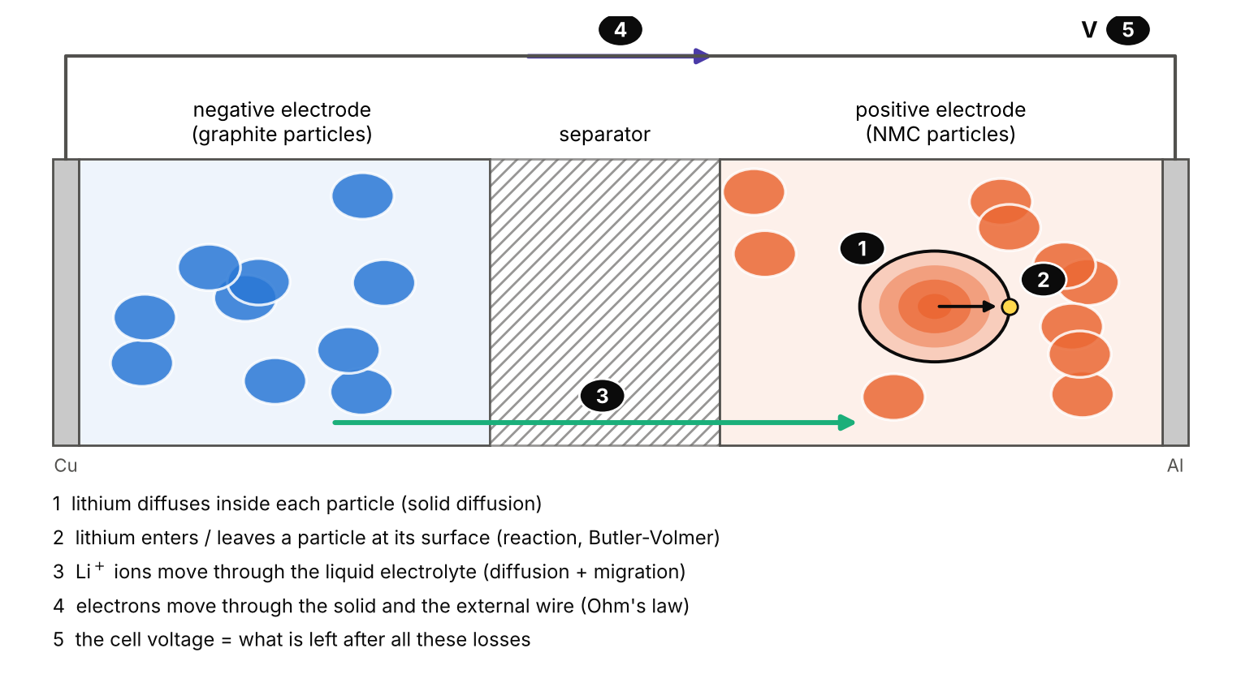
Figure 1. What the classic DFN model describes (drawing, not to scale). Every effect costs some voltage; the cell voltage is what is left.
A PINN is a neural network that is trained to obey these equations instead of copying data: at thousands of random points in the cell and in time, the network's answer is put into the equations, and the training reduces how badly they are violated. The same network can be used in two directions. In the forward problem the parameters are known and the network predicts the voltage (and everything inside the cell). In the inverse problem the voltage is measured and some parameters are unknown: they become extra numbers that the training adjusts until the network obeys the equations and matches the data.
How we checked it. With synthetic data, i.e. voltage curves computed with PyBaMM (the standard open-source battery simulator), where the exact answer is known. The cell is the LG M50, a commercial 5 Ah graphite | NMC cell whose parameters were measured by Chen et al. (2020): forward problem, inverse problem (three parameters of a new cell) and aged cells (lithium and active material lost after 200 cycles, from PyBaMM's degradation models).
Be careful: LG M50: real parameters, simulated curves
The LG M50 tests use the parameters measured on the real cell, but all voltage curves (also for the aged cells) were computed with PyBaMM. We have not yet fitted measured LG M50 curves; the first measured data in this project are the Li-SPAN ones (chapter 3).

1.3 The Li-SPAN model of Simanjuntak et al. (2024)
The first continuum model of a Li-SPAN cell was published by Simanjuntak, Danner, Wang, Buchmeiser and Latz (Electrochimica Acta 497, 144571, 2024). In it, the sulfur sits in short chains of four atoms (S₄) that bridge the polymer backbone. During discharge each chain is reduced in three steps, one after the other (Figure 2). Each step adds two electrons per chain and happens at its own voltage (near 2.2, 1.9 and 1.66 V), which is why the model's discharge curve has three sloping segments (measured SPAN curves are smoother). Steps 2 and 3 also release sulfide (S²⁻), which meets Li⁺ from the electrolyte and precipitates as solid Li₂S.
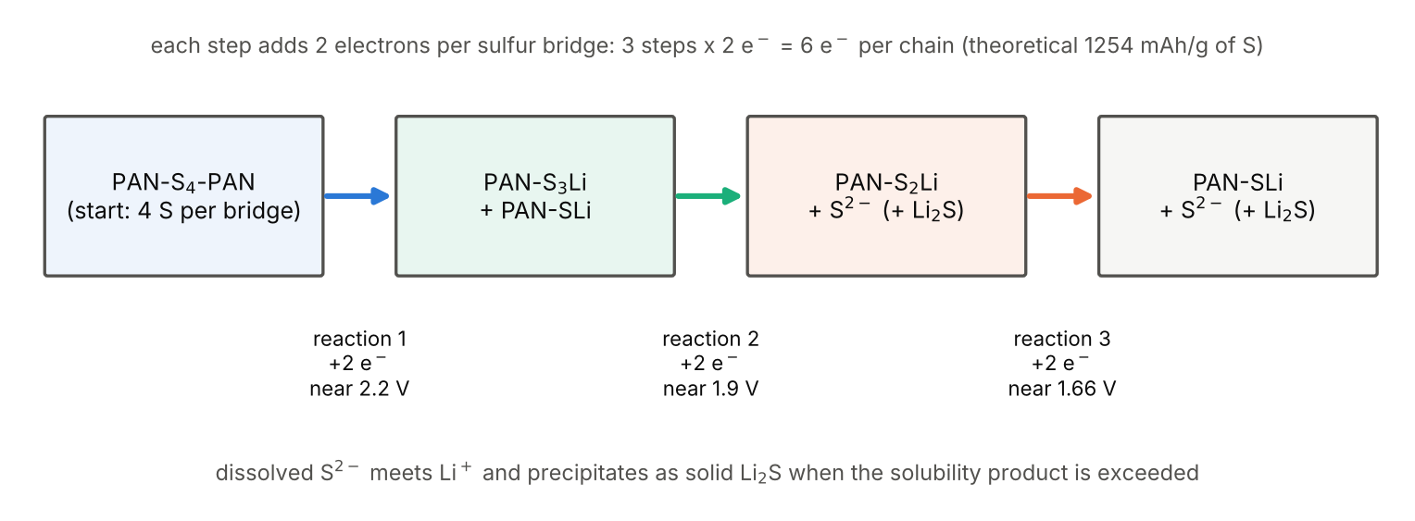
Figure 2. The reaction mechanism of the Li-SPAN model (drawing). Three steps of two electrons each give the theoretical capacity of 1254 mAh per gram of sulfur.
Figure 3 shows the cell as this model sees it: a lithium-metal foil, a thick glass-fibre separator and a porous SPAN electrode.
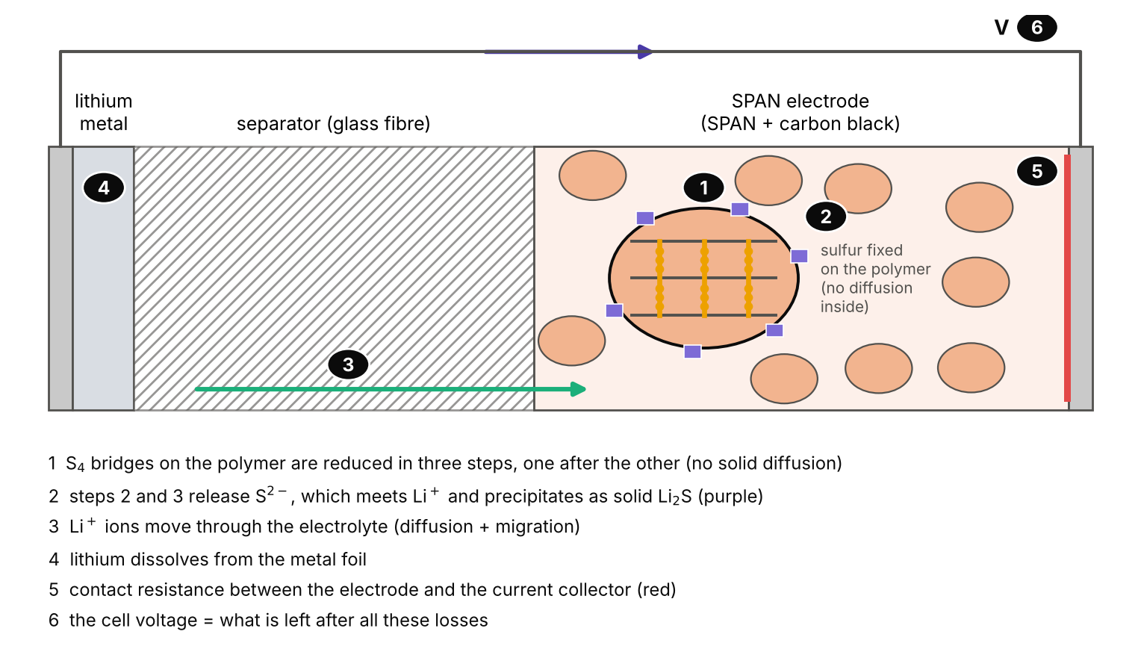
Figure 3. The Li-SPAN cell as described by the Simanjuntak model (drawing, not to scale).
Compared with the classic DFN, the Li-SPAN model is simpler in one way (nothing diffuses inside the solid: the sulfur is fixed on the polymer) and more complex in another (three reactions in sequence and a solid product that grows). Figure 4 compares the two and lists what the Li-SPAN model leaves out. These are its limitations, and they explain most of the differences we see when we compare it with real cells.
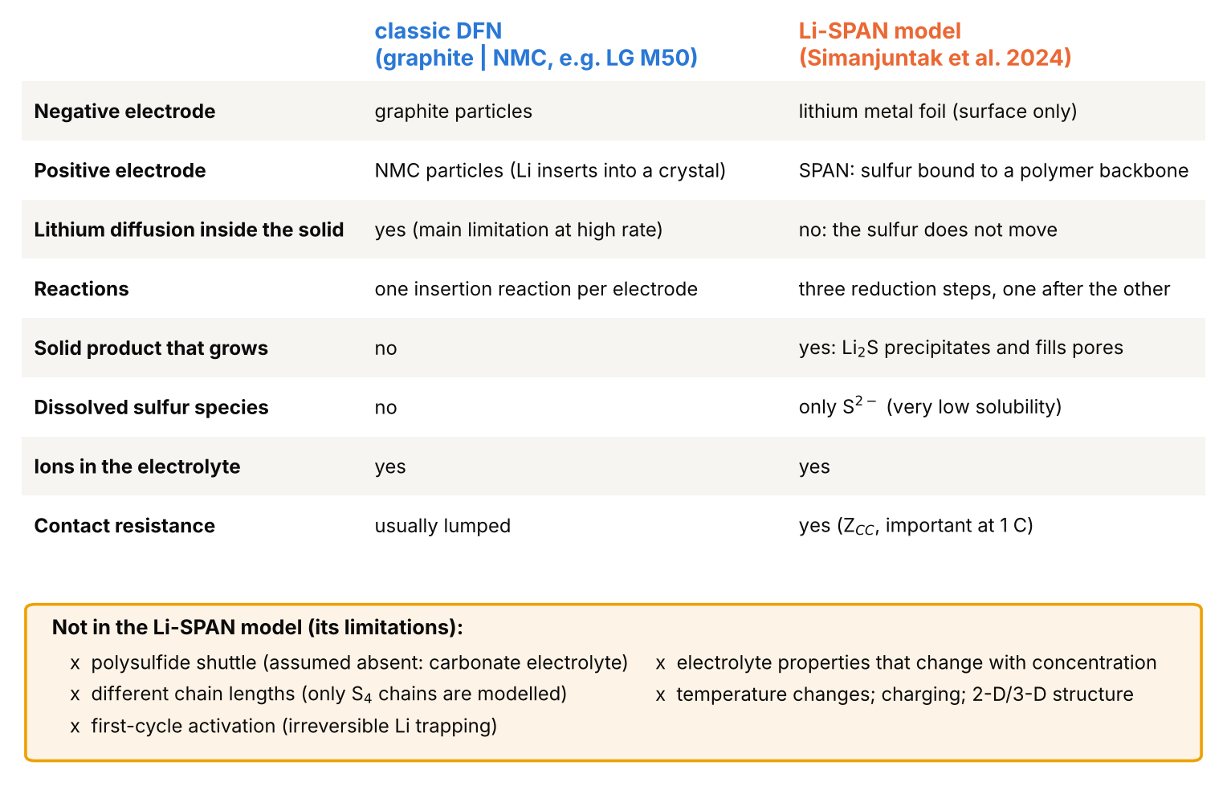
Figure 4. What each model includes, and what the Li-SPAN model does not include.

2. What we did
Figure 5 shows the seven steps of the project. Blue: the classic model; orange: the Li-SPAN model with the data of its own paper; green: the Li-SPAN model with independent data, and its use to learn about the chemistry.
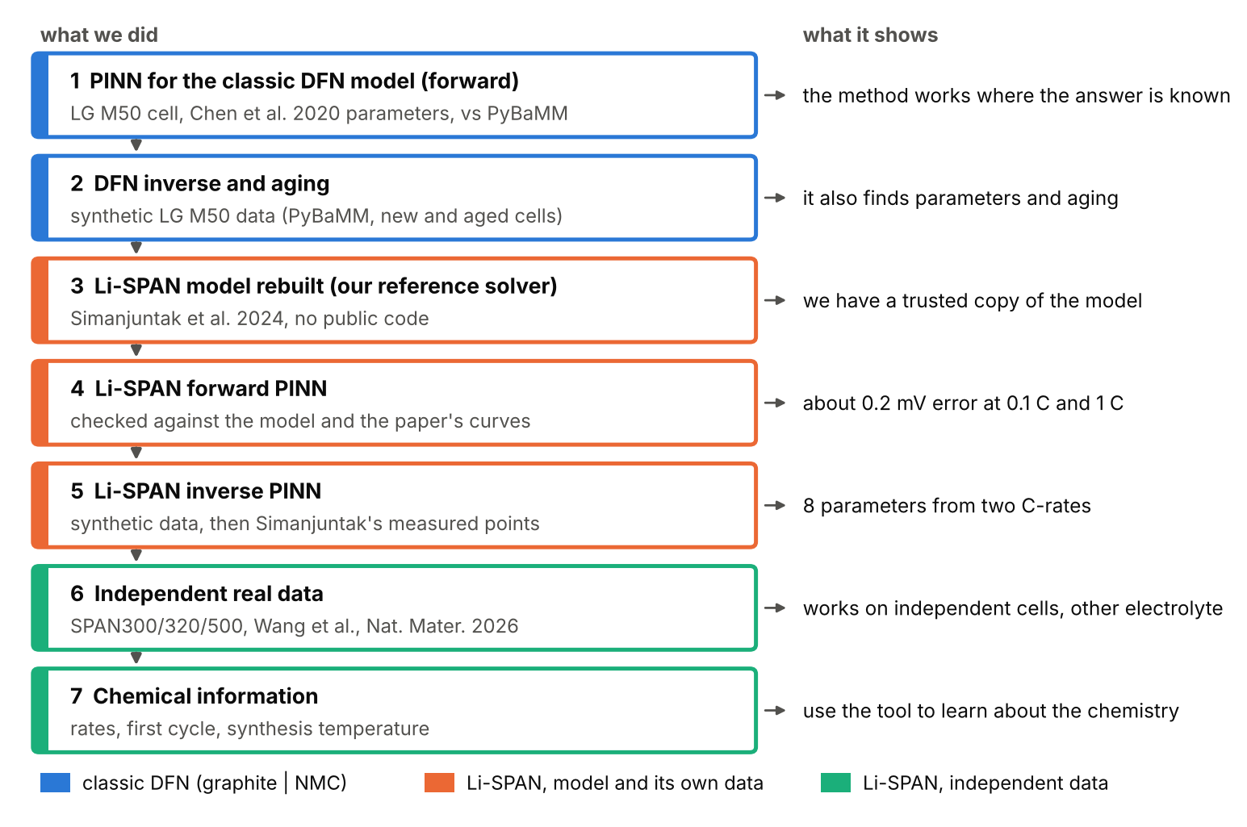
Figure 5. The steps of the project, in order (drawing).

Why start with the classic DFN, and not directly with Li-SPAN?
Because a new tool must first be checked where the answer is known (Figure 6):
- A trusted reference exists for the DFN. PyBaMM solves the DFN model reliably, so when the PINN disagrees, the PINN is wrong. For Li-SPAN no public simulator existed; we had to write our own. Starting there would have meant two unknowns at once: is the PINN wrong, or our implementation of the model?
- We learned how to train this kind of network. The DFN taught us the design rules: build into the network everything the physics fixes exactly, balance the different equations during training, add global conservation checks, and use two discharge rates for the inverse problem. A first attempt without these rules (September 2026) never got below 23 mV; with them the Li-SPAN PINN reached below 1 mV within days.
- Credibility. The graphite | NMC DFN is the usual test case for PINNs in battery modeling. Reproducing it is what makes the new result (Li-SPAN) believable.
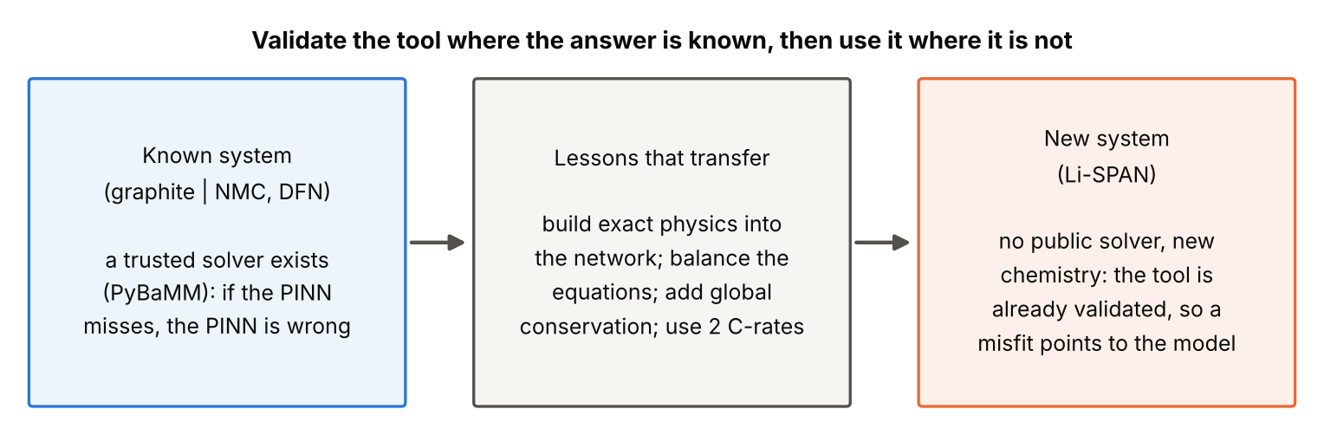
Figure 6. Why the classic model came first (drawing).

3. Results
Each figure is explained in three parts: what is plotted, what it shows, and why the small differences exist. Unless stated otherwise, error means the difference between the PINN and the reference simulator, averaged over the discharge (root mean square), in millivolts. For comparison, a good battery tester measures the voltage with a noise of about 1 mV.

3.1 Classic DFN: the PINN reproduces the reference simulator
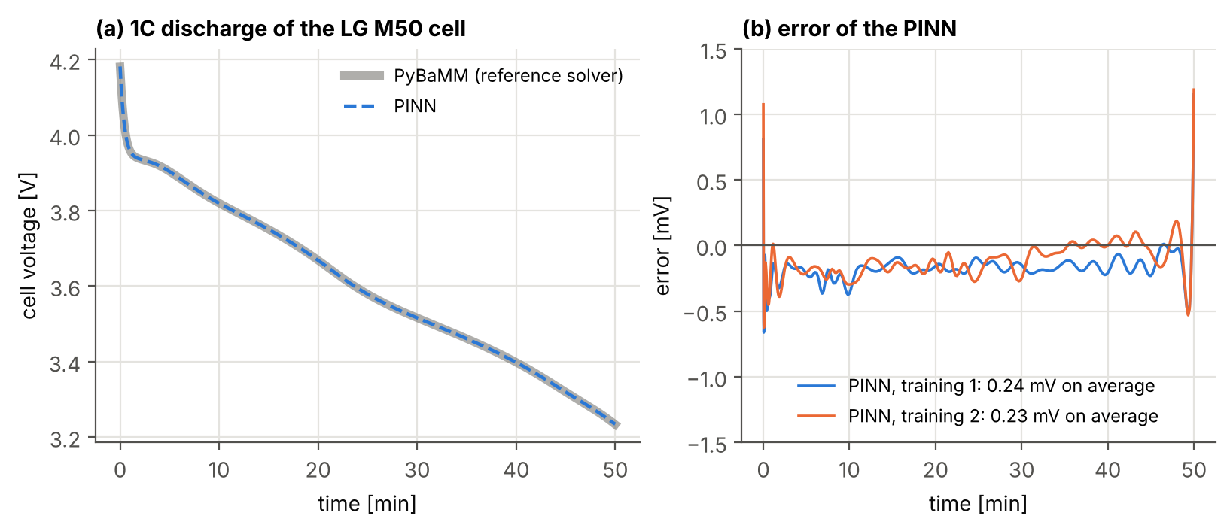
Figure 7. LG M50 cell (parameters of Chen et al. 2020), 1C discharge (5 A). Reference: PyBaMM.
How to read it: (a) Cell voltage during the first 50 minutes of the discharge: thick grey = PyBaMM, dashed blue = PINN. (b) Error (PINN minus PyBaMM) for two trainings started from different random numbers.
What it shows
The two curves lie on top of each other: the error is 0.24 and 0.23 mV on average, about a quarter of the noise of a battery tester. It is largest in the first seconds and the last minute, where the voltage changes fastest.

3.2 Classic DFN: parameters and aging from one discharge
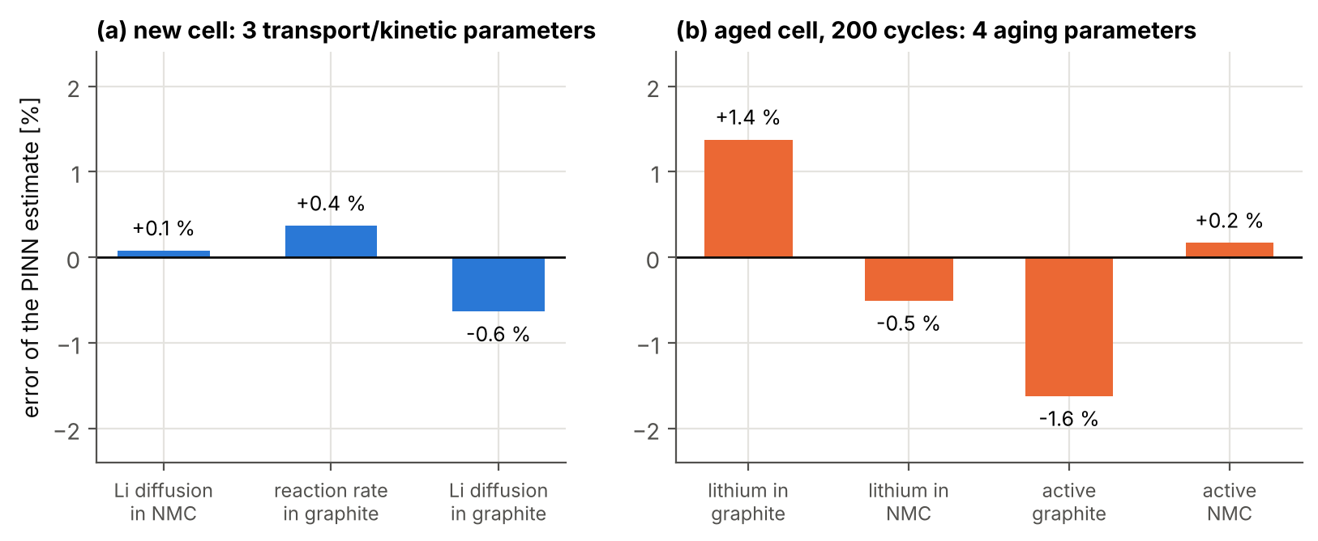
Figure 8. Inverse problem with synthetic LG M50 data. (a) New cell: three parameters from one noisy 1C discharge. (b) Cell after 200 cycles (PyBaMM degradation models): how much lithium and active material are left in each electrode.
How to read it: Each bar is the error of one parameter found by the PINN, in percent of its true value (zero = perfect).
What it shows
The errors are at most about 0.6 % for the new cell and 1.6 % for the aged cell. The PINN reads not only material parameters but also how much lithium and active material are left in each electrode of an aged cell, from a single discharge curve. The two largest errors of (b) (lithium in graphite +1.4 %, active graphite -1.6 %) belong to a pair that changes the voltage in almost the same way; a slow discharge should separate them.

3.3 Our Li-SPAN model reproduces the published curves
No code of the Simanjuntak model is public, so we wrote our own simulator (a finite-volume solver). Before using it as the reference for the PINN we compared it with the paper.
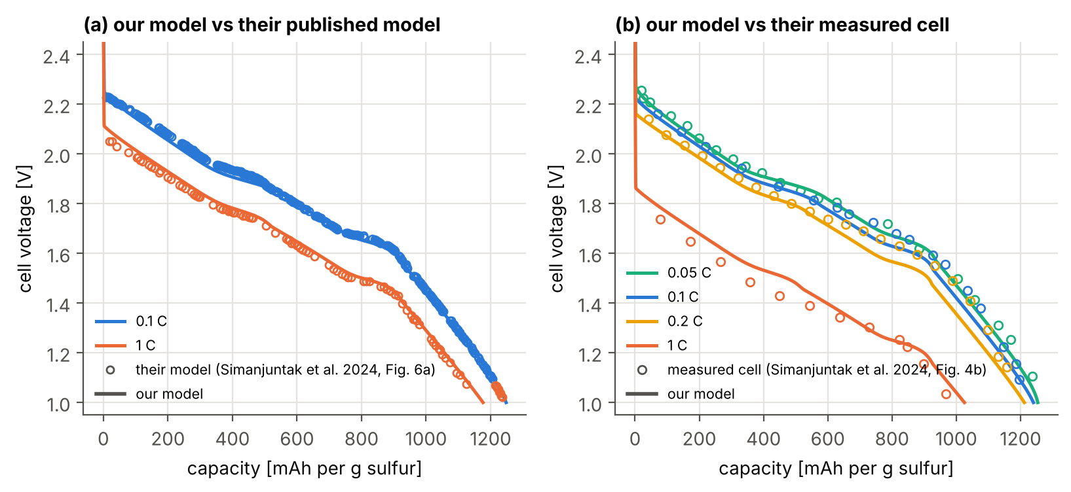
Figure 9. (a) Circles: simulated curves from Simanjuntak et al. 2024 (their Fig. 6a); lines: our model. (b) Circles: their measured cell (their Fig. 4b) at four rates; lines: our model.
How to read it: x: capacity delivered per gram of sulfur; y: cell voltage. Circles are read (digitized) from the figures of the paper; lines are our simulator.
What it shows
(a) Our model differs from theirs by 16 mV (0.1 C) and 18 mV (1 C) on average. (b) With the parameters printed in the paper, the model follows the trend of the measured cell (higher rate, lower voltage and capacity) but misses the points by 27-57 mV: it is below them at the slow rates and above them at 1 C, where the measured cell loses more voltage (the paper attributes this to the contact resistance). Fitting the parameters to these points (inverse PINN, chapter 4) brings the misfit to 16-23 mV.
Why the differences: the curves were read from a printed figure (a few mV), and the paper does not give some inputs (for example how the electrolyte properties change with concentration). We had to choose these in eight places, and every choice is documented.

3.4 The Li-SPAN PINN reproduces the model
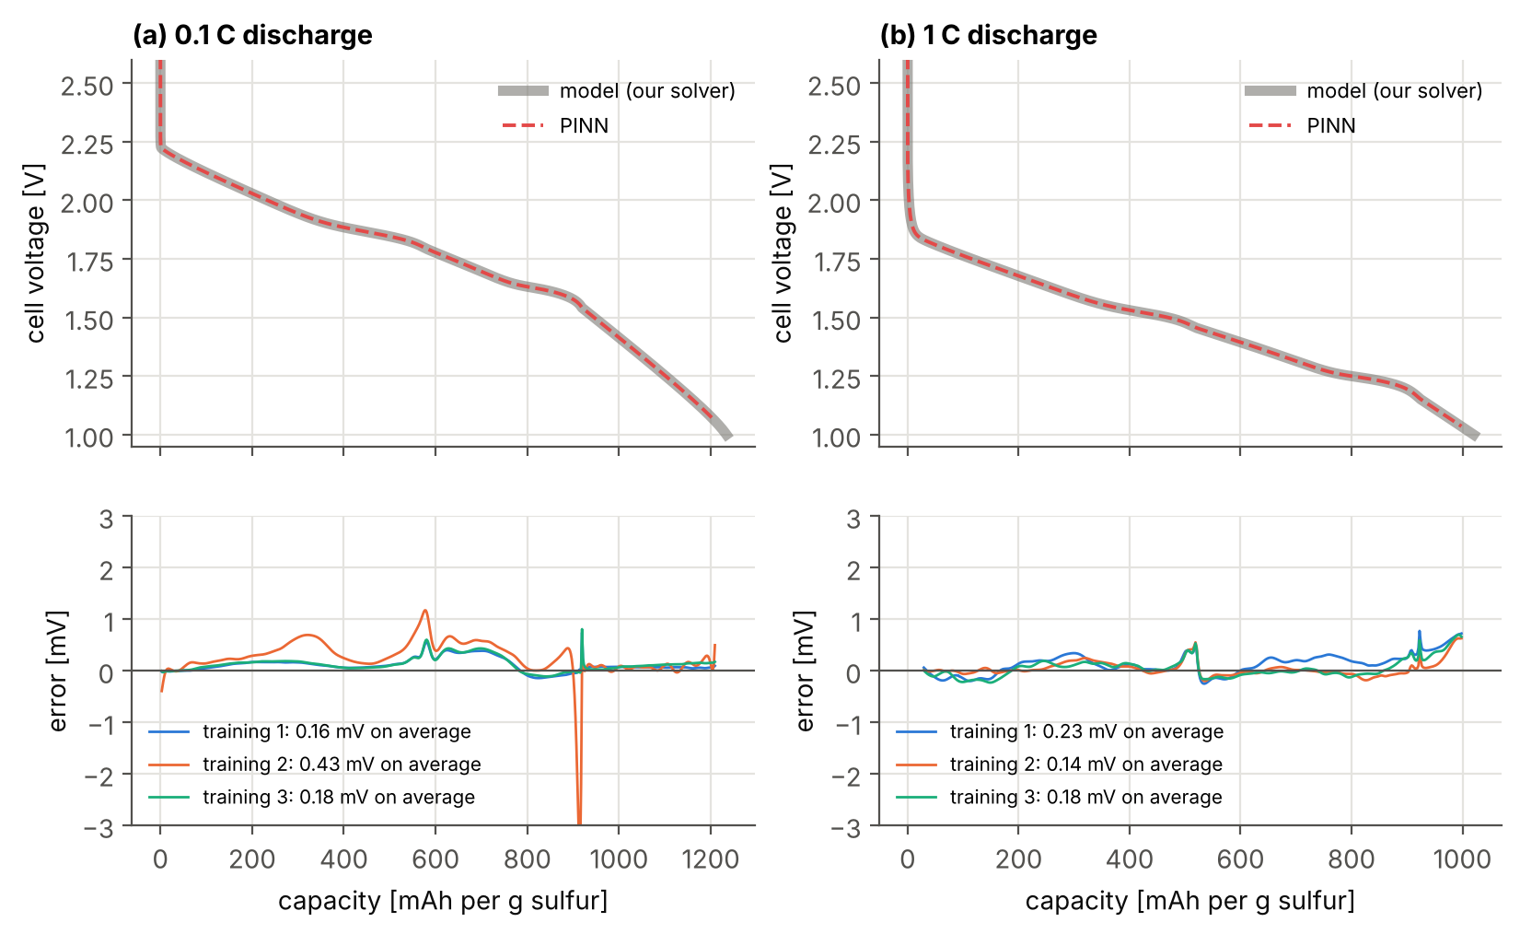
Figure 10. Li-SPAN PINN against our model at 0.1 C and 1 C (three trainings each, all started from random numbers).
How to read it: Top: cell voltage; thick grey = our model, dashed red = PINN. Bottom: error for each of the three trainings.
What it shows
The error is 0.16, 0.43 and 0.18 mV at 0.1 C and 0.23, 0.14 and 0.18 mV at 1 C (averages 0.26 and 0.18 mV). It stays roughly constant along the whole discharge, below 1 mV almost everywhere. Three trainings with the same recipe give a similar quality, so the result is reproducible and not luck.
Why the small bumps: they sit where one reduction step ends and the next begins and the curve bends sharply; networks find sharp bends hardest. One training has a narrow 3.5 mV spike at the start of the third step (about 915 mAh/g).

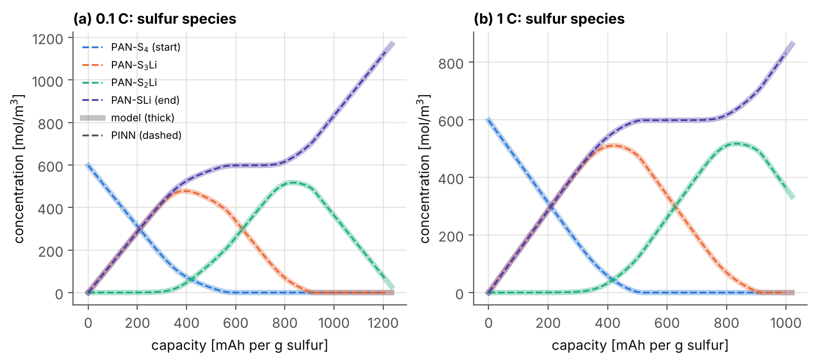
Figure 11. Concentration of the four sulfur states during the discharge (average over the electrode): thick = our model, dashed = PINN.
What it shows
The PINN gets the chemistry inside the electrode right, not only the voltage: the four sulfur states agree within about 1 mol/m³ (out of 598). The curves show the mechanism of Figure 2: PAN-S₄ is used up first, PAN-S₃Li rises and falls, PAN-S₂Li rises and falls, and PAN-SLi (the end product) grows. At 1 C the green PAN-S₂Li curve does not return to zero: the discharge stops before step 3 is finished (chapter 4).

3.5 Inverse problem: which parameters are easy to find
Test: discharge curves computed with our model at 0.1 C and 1 C, plus 1 mV of random noise, and a starting guess far from the truth (rate constants ×2, ×0.5, ×1.5, etc.). Two ways of training: Adam only (the standard training, 7000 steps) and Adam + LM (the same plus a Newton-type correction of the parameters, Levenberg-Marquardt, every 250 steps).
Table 1. Eight parameters found from two synthetic discharge curves (0.1 C and 1 C, 1 mV noise). Noise limit: the typical error (one standard deviation) that this amount of noise causes even for the best possible method; a single test can land closer or further.
Parameter | What it is | Unit | True | Start | Adam only | Adam + LM | Error (Adam + LM) | Noise limit
k_{0,1} | how fast step 1 runs | mol m⁻² s⁻¹ | 2.950×10⁻⁸ | 5.900×10⁻⁸ | 3.239×10⁻⁸ | 3.008×10⁻⁸ | +1.96 % | 1.02 %
k_{0,2} | how fast step 2 runs | mol m⁻² s⁻¹ | 2.390×10⁻⁸ | 1.195×10⁻⁸ | 2.339×10⁻⁸ | 2.383×10⁻⁸ | -0.31 % | 0.71 %
k_{0,3} | how fast step 3 runs | mol m⁻² s⁻¹ | 2.340×10⁻⁸ | 3.510×10⁻⁸ | 2.354×10⁻⁸ | 2.347×10⁻⁸ | +0.31 % | 0.72 %
b₁ | how much the step-1 voltage drops as the step progresses | V | 0.3000 | 0.3300 | 0.2969 | 0.2996 | -0.14 % | 0.16 %
b₂ | same for step 2 | V | 0.2800 | 0.2520 | 0.2784 | 0.2802 | +0.05 % | 0.20 %
b₃ | same for step 3 | V | 0.6200 | 0.6820 | 0.6204 | 0.6204 | +0.06 % | 0.11 %
U_{0,1} | voltage at which step 1 starts | V | 2.2000 | 2.2200 | 2.1963 | 2.1990 | -1.0 mV | 0.4 mV
Z_{CC} | contact resistance electrode / collector | Ω m² | 0.0250 | 0.0375 | 0.0251 | 0.0250 | +0.09 % | 0.09 %

What it shows
Easiest: the voltage slopes b and the contact resistance Z_{CC} (errors 0.05-0.14 % and 0.09 %). Hardest: the reaction rates k₀ (0.3-2 %), because a slower reaction and a larger contact resistance lower the voltage in a similar way; only the combination of a slow and a fast discharge separates them. With Adam alone the rate of step 1 was still 10 % off after 7000 steps; with the LM correction every parameter is within 2 % of the truth and within 2.3 noise limits.

3.6 Independent real data: SPAN500 (Wang et al., Nature Materials 2026)
These are published data from a paper our group co-authored: a SPAN made at 500 °C, in a coin cell with an ether electrolyte (the Simanjuntak model was built for a carbonate electrolyte), discharged at C/10, cycles 1-3. The sulfur content and the electrode thickness are not reported, so we first fit an effective sulfur content with our simulator (it sets the current of the cell per gram of sulfur); the PINN then finds the voltages and slopes of the three steps.
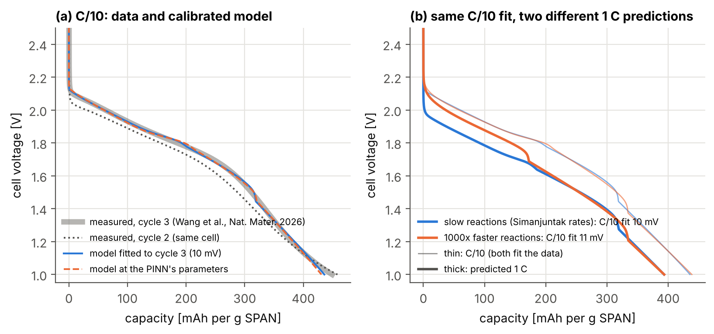
Figure 12. SPAN500 at C/10 (data from Wang et al., Nature Materials 2026, source data of Fig. 4a).
How to read it: (a) x: capacity per gram of SPAN (as in the paper). Thick grey = measured, cycle 3; dotted = cycle 2 of the same cell; blue = our model fitted to cycle 3 with our simulator; dashed orange = our model run with the parameters found by the PINN.
(b) Thin lines: two C/10 fits that assume slow reactions (the Simanjuntak rates) or 1000 times faster reactions; thick lines: what each fit predicts for a 1 C discharge.
What it shows
(a) The model reproduces cycle 3 to 10 mV on average. With the PINN's parameters the error is 8.9 mV, against 8.2 mV for the best possible parameters on the same part of the curve: the PINN finds practically the best answer. The same cell changes by 54 mV between cycles 2 and 3, so the remaining error is smaller than the cell's own variation. The effective sulfur content is 38 wt% (the paper gives 40-50 wt% for typical SPAN).
(b) Both assumptions fit C/10 equally well, but their 1 C predictions differ by up to 135 mV. One discharge rate cannot tell how fast the reactions are; one 1 C discharge of the same cell would decide.
Why the error: the model's three steps make small kinks (near 200 and 320 mAh/g) that the real cell does not have. The model assumes identical S₄ chains, while SPAN500 has a mixture of short chains (the Nature Materials finding), and it was built for a different electrolyte. The fitted values are therefore effective parameters of this cell.

4. Using the tool: what it tells us about the chemistry
Once the model has been calibrated by the inverse PINN, it shows things that are hard to measure directly: what happens inside the electrode and which process costs the voltage. Every result in this chapter is limited by the assumptions of the model (Figure 4); where possible we compare it with what the two papers report.

4.1 What limits the Simanjuntak cell at higher rate?
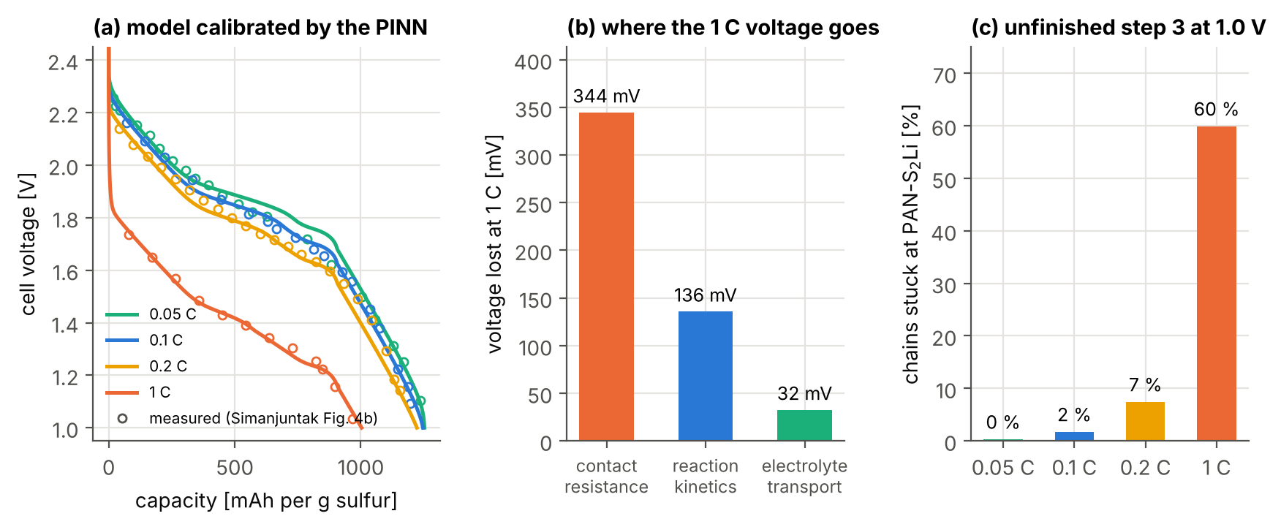
Figure 13. Simanjuntak cell, model calibrated by the inverse PINN on the measured points of their Fig. 4b (0.1 C and 1 C).
How to read it: (a) Lines: the calibrated model at four rates; circles: the measured cell (data from Simanjuntak et al. 2024, Fig. 4b). (b) Voltage lost at 1 C compared with a very slow discharge (0.05 C), split by removing one loss at a time from the model. (c) Share of the sulfur chains still in the PAN-S₂Li state when the cell reaches its 1.0 V cut-off.
What it shows
Most of the 1 C loss is not chemistry. At 1 C the cell loses about 470 mV compared with 0.05 C. About 344 mV of it is the contact resistance between the electrode and the current collector (the PINN found Z_{CC} = 0.034 Ω m²; the paper quotes 0.035 as its best agreement in the text and uses 0.025 in its table), 136 mV is the speed of the SPAN reactions and only 32 mV is ion transport in the electrolyte. (The three parts add up to more than the total because they overlap.)
The capacity lost at 1 C is the third reduction step. The capacity falls from 1253 to 1003 mAh per g of sulfur. At the cut-off, 60 % of the chains are still PAN-S₂Li: the cell runs out of voltage before step 3 (PAN-S₂Li → PAN-SLi + Li₂S) can finish. Without the contact resistance the model would deliver 1201 mAh/g; with 100 times faster reactions 1143; with a perfect electrolyte only 1022.
The electrode works evenly. Li₂S forms almost uniformly across the electrode (2 % difference between front and back at 1 C) and the salt concentration changes by at most 13 %.

What the literature says. Simanjuntak et al., changing parameters by hand, concluded that the large overpotential at high current comes from the contact resistance and not from the SPAN kinetics, and that ion transport is not limiting in their highly porous electrodes. Our calibration agrees that the contact resistance dominates and transport is minor, but gives the reactions a visible share; the unfinished third step is new, more chemical information. These numbers come from about 30 digitized points and a model that misses them by about 18 mV, so the contact resistance is firmly determined and the other shares are trends. For this electrode design, a better contact with the collector would help at 1 C more than faster SPAN chemistry. (The PINN's own fields agree with our simulator at these parameters within 0.15-0.31 mV and 1.1 mol/m³.)
For sections 4.2 and 4.3 the inverse PINN was run on 5 more measured curves with the same method as in section 3.6 (allowing larger parameter steps, because these curves need larger shifts). On every one it reached a misfit within 1.0 mV of the best possible fit with our simulator (8.6-11.6 mV), with step potentials within 26 mV of it. As in section 3.6, the effective sulfur content is fitted with our simulator and the PINN finds the step potentials and slopes.

4.2 SPAN500: what changes in the first cycle?
SPAN loses about a fifth of its capacity in the first cycle (Nature Materials: about 20 %, explained by lithium that replaces residual protons at the edges of the SPAN domains and stays trapped). For SPAN500 the measured capacity falls from 627 (cycle 1) to 458 and 449 mAh/g (cycles 2 and 3), and the first-cycle Coulombic efficiency is 74 %. We calibrated the model separately on each of the three discharges.
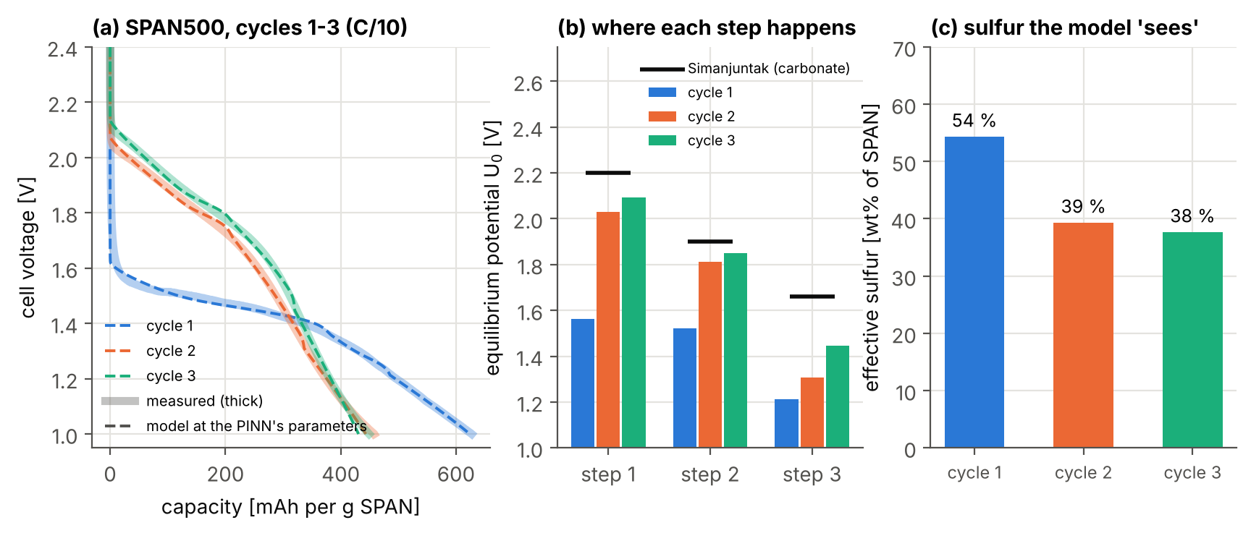
Figure 14. SPAN500, cycles 1-3 at C/10 (data from Wang et al., Nature Materials 2026, source data of Fig. 4a), each calibrated separately.
How to read it: (a) Thick = measured discharge of each cycle; dashed = calibrated model. (b) Equilibrium potential of each reduction step found for each cycle (bars), with the values of the Simanjuntak model for a carbonate electrolyte (black marks). (c) Effective sulfur content the model needs to reproduce the capacity of each cycle.
What it shows
The first discharge happens at a much lower voltage. The model places steps 1, 2 and 3 470, 291 and 92 mV lower in cycle 1 than in cycle 2; the largest shift is in step 1, at the beginning of the discharge. From cycle 2 to cycle 3 steps 1 and 2 move up by only 63 and 40 mV, while step 3 keeps rising (139 mV): after the first discharge the material is activated, and its end of discharge is still settling.
The first discharge needs more 'sulfur'. The effective sulfur content goes from 54 wt% (cycle 1) to 39 and 38 wt%. The model has no term for lithium that is trapped, so it reads the extra first-cycle capacity as extra active sulfur. This number follows the capacity, so it is a consistency check rather than a new measurement: the 28 % drop is close to the 26 % first-cycle loss implied by the Coulombic efficiency (74 %), and of the same order as the ~20 % of sulfur in S=C environments that the Nature Materials paper estimates from the SPAN structure.

Be careful: what the model can and cannot say here
The model describes the first cycle with effective values (lower potentials and more 'sulfur'). It measures how large the activation is and in which part of the discharge it happens, but the mechanism comes from the structural measurements of the Nature Materials paper.

4.3 SPAN300, SPAN320, SPAN500: what does the synthesis temperature change?
The Nature Materials paper shows that a higher synthesis temperature shortens the sulfur chains in SPAN, and that the discharge plateau and the capacity become lower (long chains such as S₈ or S₆²⁻ reduce near 2.4 V, short chains such as S₄²⁻ near 2.1 V). We calibrated the model on the second-cycle discharge of each material.
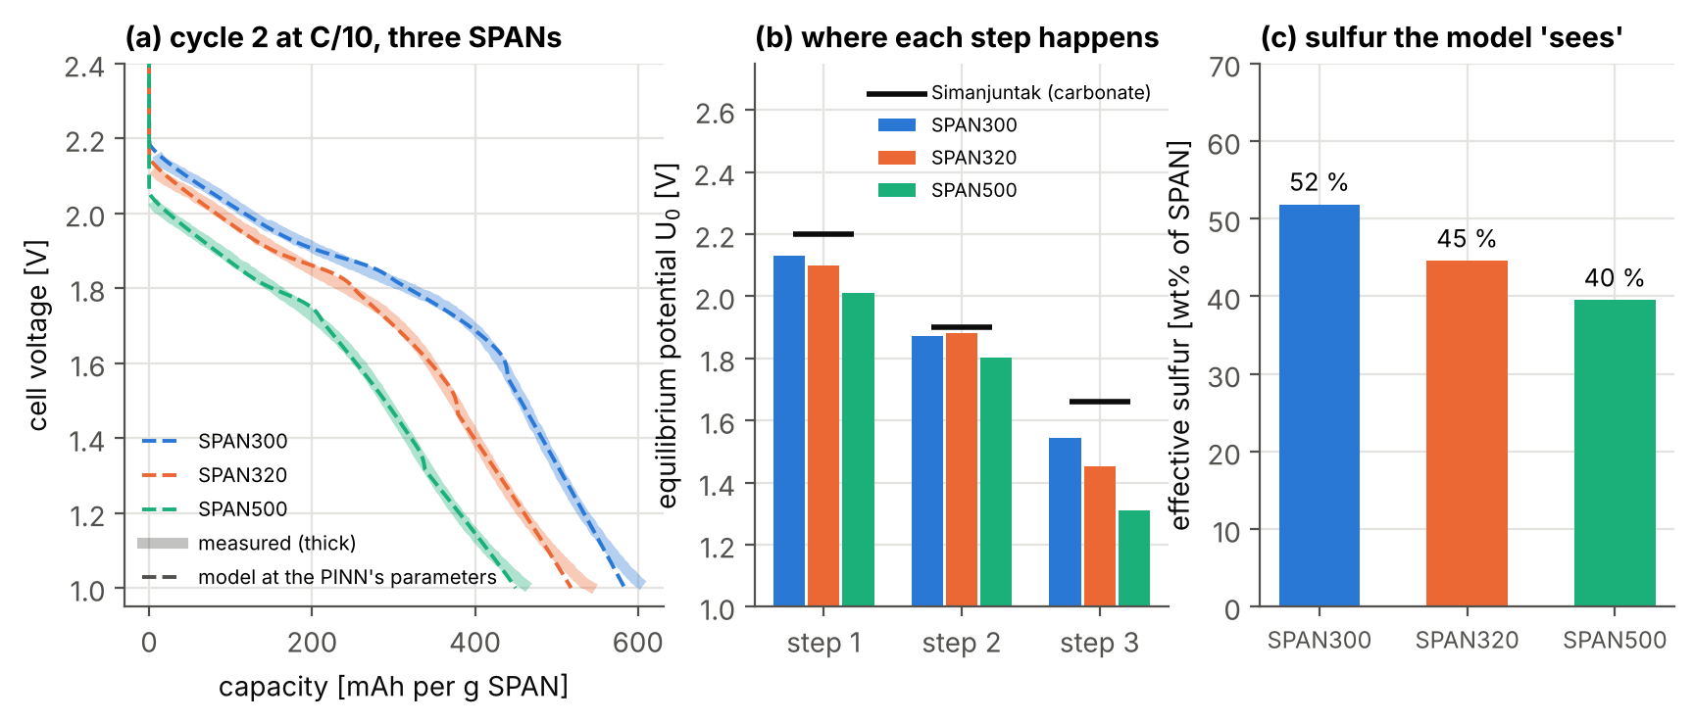
Figure 15. SPAN made at 300, 320 and 500 °C, second discharge at C/10 (data from Wang et al., Nature Materials 2026, digitized from Supplementary Fig. 21).
How to read it: (a) Thick = measured; dashed = calibrated model. (b) Equilibrium potential of each step for each material, with the Simanjuntak values (black marks). (c) Effective sulfur content.
What it shows
From SPAN300 to SPAN500 all three steps move down. The steps of SPAN500 sit 118, 68 and 234 mV below those of SPAN300; the largest shift is in step 3, the end of the discharge. This puts numbers, step by step, on the lower plateau that the paper links to shorter chains.
Less sulfur takes part. The effective sulfur content is 52 wt% (SPAN300), 45 wt% (SPAN320) and 40 wt% (SPAN500). The model thus separates two effects that the paper discusses together ("shorter sulfur chains and/or lower sulfur content"): where the steps happen (the potentials) and how much sulfur takes part (the effective content). It cannot tell whether the missing sulfur is absent or present but inactive.

Be careful: digitized curves, one rate, effective parameters
The three curves were read from a figure (about 6 mV and 2 mAh/g per pixel). As a digitization check, the SPAN500 curve of this figure and the source-data curve of section 4.2 give step potentials within 20 mV. All three materials are fitted with the same S₄-chain model, so the parameters are effective values that describe the differences between materials, not the real chain lengths.

5. Analysis and conclusions

5.1 The chain of evidence
Each step was checked against something trusted before the next one used it: the DFN PINN against PyBaMM (0.23-0.24 mV), our Li-SPAN model against the published curves (16 / 18 mV), the Li-SPAN PINN against our model (0.26 / 0.18 mV), and the inverse PINN against known synthetic answers (within 2 %), against the authors' estimate on their measured cell (Z_{CC} 0.034 vs 0.025-0.035 Ω m²) and against the best possible fit on independent SPAN500 data (8.9 vs 8.2 mV). The errors form a clear hierarchy: PINN vs model about 0.2 mV, the numerical simplifications of our benchmark 0.01-5 mV (manuscript), model vs real cells 8-20 mV. The PINN is never the limiting part; what we can say about a real cell is limited by the model and the data.

5.2 What we learned about the chemistry
- Simanjuntak cell at 1 C: the voltage loss is mostly contact resistance (344 of 470 mV) and the capacity loss is an unfinished third reduction step; Li₂S forms evenly. The main conclusion agrees with the original paper; the split between the losses is a trend.
- SPAN500, first cycle: the first discharge happens 92-470 mV lower than the second (most at its beginning), and its extra capacity appears as extra 'sulfur', close to the measured first-cycle loss.
- SPAN300 to SPAN500: all three reduction steps move down by 68-234 mV and the effective sulfur content falls from 52 to 40 wt%, separating the chain-length and sulfur-content effects.
- Experiments: one C/10 curve fixes the equilibrium properties but not the reaction speed; one more discharge rate of the same cell is the most valuable next measurement.

5.3 Limitations
- The model: identical S₄ chains, a carbonate electrolyte with constant properties, no polysulfide shuttle, no first-cycle chemistry, constant temperature, discharge only. Parameters fitted to SPAN500 or to other electrolytes are effective values.
- The data: some curves were read from published figures; the Nature Materials cells were measured at one rate, and their sulfur content and electrode thickness are not reported; the LG M50 curves are simulated.
- The method: training a PINN takes about two hours, while our classic solver computes one Li-SPAN discharge in a few seconds (see the box below).
Key idea: why a PINN if the classic solver is faster?
For a one-dimensional cell the classic solver is faster, both for one simulation and for a parameter fit (about 140 simulations of a few seconds), and the manuscript will say so. The PINN is worth it because one tool gives the solution, the fit to data and every field inside the cell; because it suits cases where each classical simulation is expensive (2-D/3-D electrodes, microstructures) or where the unknown is a whole function; and because a parametric PINN (parameters as inputs) is trained once and then fits new data in seconds. This work shows that the method is accurate and reliable on a new, multi-reaction chemistry; the last two points are the next steps.

5.4 Next steps
(1) Write the manuscript for the Journal of The Electrochemical Society, with the mathematical details, error metrics and checks of every step there and in the supplementary information. (2) Obtain discharge curves of one SPAN cell at two or more rates, with its sulfur content and electrode thickness, to calibrate the SPAN kinetics (for SPAN500, a single 1 C discharge would decide between the two assumptions of section 3.6). (3) Later: fit measured LG M50 curves, and build a parametric PINN for fast fitting of many cells.

