A PINN for a Lithium-SPAN Cell Model
Results, analysis and limitations: a summary for the advisor review before writing the manuscript
Project: PINN-DFN, Li-SPAN part (Balbuena group, Department of Chemical Engineering, Texas A&M University)
Project lead: Carlos Guerrero
Status of the work: October 9, 2026 (paper steps 1-5 completed)
Written in the plain language of the student guide (October 2026). All numbers and figures are generated from the project repository (DFN_PINN_Project) by scripts/paper_build.py; see the Appendices.
Contents

(If the table of contents is empty, right-click it in Word and choose 'Update field'.)

Executive summary
This document summarizes, explains and analyzes the results of the Li-SPAN part of the PINN-DFN project, so that they can be presented to our advisor and she can decide whether we start writing the manuscript for the Journal of The Electrochemical Society (JES). It uses the same plain language as the student guide (October 2026): every method is explained with an analogy first, then with the equation, then with what we found. It does not repeat the background of the guide (batteries, the DFN model, neural networks); read chapters 2-4 of the guide if those are new to you.

What we did, in five sentences
- We rebuilt the published Li-SPAN cell model (Simanjuntak et al. 2024) as a finite-volume (FV) solver, fixed its ambiguities, and checked it against the paper.
- A physics-informed neural network (PINN) trained from scratch reproduces the FV voltage to 0.26 mV rms at 0.1 C and 0.18 mV at 1 C (mean of three seeds).
- One C-rate cannot separate the kinetics from the contact resistance; 0.1 C + 1 C determine eight parameters to about 1 %.
- The inverse PINN recovers them within 2 Cramer-Rao bounds of an ideal estimator, and its small bias is predicted by its own forward error.
- On two measured data sets the model fits to 8-20 mV, limited by the model; for this 1-D cell the PINN is about 1000 times slower than the FV solver.
Table 1. The project in seven questions.
Question | Answer | Evidence
Is our reference model a faithful copy of the published one? | Yes, after eight documented closures; 16 / 18 mV rms from the paper's curves at 0.1 / 1 C | Figure 2, Table 2
Can a PINN solve the Li-SPAN model accurately? | Yes: 0.14-0.44 mV rms, all six runs below 0.5 mV | Figure 3, Table 5
Is it reproducible? | Yes: three seeds per rate from random initialization; one seed has a narrow 3.5 mV spike at a phase transition | Table 5
Which parameters can a voltage curve reveal? | Eight (k_{0,1-3}, b₁₋₃, U_{0,1}, Z_{CC}) with two C-rates; transport and Li₂S parameters no | Figure 5
Does the inverse PINN work? | Yes, as well as an ideal estimator up to a bias that we can predict | Figure 6, Table 7
Does it work on real data? | The fits are as good as the model allows (8-20 mV); the real-data cases are demonstrations with clear limits | Figure 7, Table 8
Is the PINN faster than a classical solver? | No (seconds vs hours). Its value is methodological | Figure 8

Key idea: is the current work enough to start writing?
Yes, for the decision to start writing: every result the paper needs exists, is reproducible from saved files, and a first full draft of the manuscript already exists (paper/manuscript/). Before submission we still need (i) the literature positioning and reference list, (ii) an agreed framing of the cost result, and (iii) the supplementary material. Two optional items would make the paper stronger: confirmation of our model closures by the original authors, and multi-rate measurements of a SPAN cell from our group. Chapter 9 gives the full checklist.

Be careful: what this work does NOT claim
It does not propose a new SPAN model, it does not claim that the PINN is faster than a finite-volume solver, and it does not claim that the parameters fitted to the SPAN500 data are material properties valid at other rates. These limits are part of the message, not a weakness to hide (chapter 8).

1. Context and goal

1.1 Why lithium-SPAN, and why a model
Lithium-sulfur batteries promise more energy per kilogram than lithium-ion batteries, because sulfur is light and can take up two electrons per atom. Their weak point is that, in most electrolytes, the sulfur dissolves as polysulfide molecules that travel to the lithium anode and are lost (the shuttle). In sulfurized polyacrylonitrile (SPAN) the sulfur is chemically bound to a carbon-nitrogen polymer backbone. In carbonate electrolytes it reacts without dissolving, so the shuttle largely disappears and the cell can cycle for hundreds of cycles. Our group, together with collaborators at Brookhaven National Laboratory and other institutions, studies how the SPAN structure controls this behavior (Wang et al., Nature Materials 2026).
A continuum model of the cell turns the chemistry into equations that predict the voltage during a discharge, the concentration of each species inside the electrode, and how these change with the current. Such a model lets us ask why a cell behaves as it does and which material property we should change. The first continuum model of a Li-SPAN cell was published by Simanjuntak, Danner, Wang, Buchmeiser and Latz (Electrochimica Acta 497, 144571, 2024). Our project uses that model as its physics.

1.2 The Simanjuntak model in one page
The cathode contains SPAN in which sulfur sits in short chains of four atoms (S₄) bound to the polymer. During discharge each chain is reduced in three sequential steps, each transferring two electrons per S₄ chain:
- step 1: S₄ → S₃Li + SLi (the chain is cut);
- step 2: S₃Li → S₂Li + released sulfide S²⁻;
- step 3: S₂Li → SLi + released sulfide S²⁻;
- the released S²⁻ meets Li⁺ in the electrolyte and precipitates as solid Li₂S.
There is no diffusion inside the solid (the sulfur does not move), so at every point of the electrode the four sulfur species just change in time according to the three reaction rates r₁, r₂, r₃:
(1)
Each rate follows a Butler-Volmer law. Its driving force is the difference between the electrode potential and an equilibrium potential U that decreases linearly as the step progresses (the slope b_{m} was fitted by the authors to measured open-circuit voltages):
(2)
Here Δφ is the potential difference between solid and electrolyte, ζ_{m} is how far step m has progressed, and δ_{m} switches the backward (oxidation) term on or off. The electrolyte (1 M LiPF₆ in carbonate) is described by Nernst-Planck transport, the lithium metal anode by its own Butler-Volmer law, and the cell voltage is what the cathode current collector sees minus a contact-resistance drop:
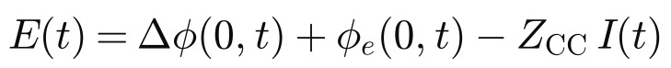 (3)
Analogy: a three-stage assembly line
Picture a factory where each sulfur chain passes three workstations in order. Station 1 cuts the chain, station 2 and station 3 each remove one more piece. Each station works faster when the 'pressure' (the electrode potential) is higher than the station's own threshold (U), and each station's threshold drops as it runs out of work. The cell voltage is the pressure the factory needs to keep all stations busy at the speed the customer (the current) demands. The three plateaus of a SPAN discharge curve are the three stations taking turns.

1.3 What a PINN is
A physics-informed neural network is trained on the model equations instead of data: its outputs (concentrations, potentials) must satisfy the equations at thousands of random points. When the equation errors (residuals) are near zero, the network is a solution of the model; the same network can then be asked to match measured data with some parameters left free (the inverse problem). Chapter 4 of the student guide explains this in detail.

1.4 Goal of the paper
The paper we want to write is a short, correct methods paper for JES, whose readers are modelers in the Newman tradition. It should show four things and state their limits:
- a faithful, documented numerical reference of the Li-SPAN model (the published model is ambiguous in several places);
- a PINN that reproduces that reference to a fraction of a millivolt, with the design choices that made it possible;
- what discharge curves can and cannot tell us about the parameters, and an inverse PINN that is as accurate as an ideal estimator;
- two applications to measured curves, and an honest comparison of the computing cost.
Scope agreed on October 7: Li-SPAN only (no Li-S); real data limited to what is available (the digitized Simanjuntak Fig. 4b points and the SPAN500 data of our Nat. Mater. 2026 paper); a first full draft of the manuscript now exists, with every number generated from saved results.
Key idea: why this matters for the group
A validated Li-SPAN model plus a tool that reads parameters from voltage curves is the bridge between our atomistic and structural studies of SPAN (what the material is) and the performance of a cell (what the material does).

Be careful: our model is the published model, not a new one
Everything in this work rests on the physics of Simanjuntak et al. Where we had to make choices (section 2.1) we say so and quantify them. A reviewer may ask whether the authors agree with our reading; contacting T. Danner (DLR) is listed as an optional step in chapter 9.

2. Methodology
The work followed six phases (Figure 1). Each phase produced a tool that the next one needed: the reference model is the ruler for the PINN, the PINN is the engine of the inverse problem, the identifiability study says which parameters the inverse problem can hope to find, and the measured data test everything against reality. This chapter explains the tools; chapter 3 tells the story of the phases and the problems we met; chapter 4 gives the results.
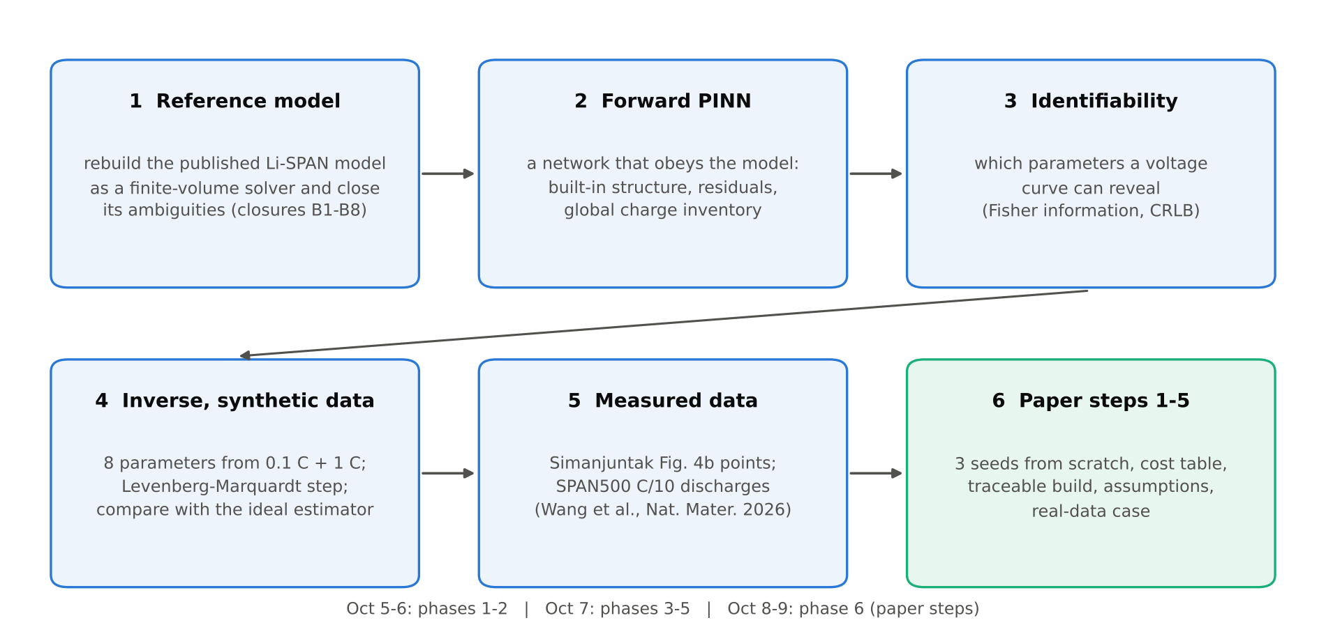
Figure 1. The six phases of the Li-SPAN work (drawing). Blue: research phases; green: the five consolidation steps agreed for the paper (reproducibility, cost, traceability, assumptions, real-data case).

2.1 The reference model: a finite-volume solver
PyBaMM, the standard open-source battery simulator, has no Li-SPAN model, so we wrote our own. The electrode and the separator are cut into small volumes (40 in the cathode and 20 in the separator for the PINN benchmark and the synthetic data; 20 and 10 for the comparison with the paper, the fits, the identifiability study and SPAN500); inside each volume the species and potentials are averaged, and the equations become a large set of ordinary differential equations in time, solved with a stiff integrator (backward differentiation formula, tolerance 10⁻⁶). This is called a finite-volume (FV) method. One full discharge takes about 4-5 s at 0.1 C and 5-7 s at 1 C on one processor core (coarse and fine grid).
Analogy: the ruler
Before you can say that a new measuring tape is accurate, you need a ruler you trust. The FV solver is our ruler: we checked it against the paper's curves (chapter 4.1), against a different grid (20 / 10 and 40 / 20 volumes give voltages within 0.1 mV), and against conservation of charge and sulfur. Every PINN number in this document is a comparison with this ruler.

Closures: where the paper had to be interpreted
Reproducing the published curves was not possible with the equations and table values exactly as printed. In eight places we had to choose (Table 2). The three that matter most: we count all three steps in the electric current (the printed definition omits step 1, which carries a third of the capacity); we use effective rate constants fitted to the paper's curves (the printed values make the voltage almost independent of the current, unlike the paper's own Fig. 6a); and we treat step 3 as irreversible during discharge (switching on the printed backward terms of steps 2 and 3 together changes the voltage by 53 mV rms, against 2.7 mV for step 2 alone, and contradicts the paper's species curves).
Table 2. Closures of the published model (details: docs/PAPER_ASSUMPTIONS.md, docs/LI_SPAN_MODEL_FORMULATION.md section 5.2).
# | Choice | Why
B1 | faradaic current includes step 1 | step 1 carries one third of the capacity (paper Fig. 5a)
B2 | effective rate constants fitted to paper Fig. 6a | printed values give no rate dependence; 16 / 18 mV rms after the fit
B3 | step 3 irreversible during discharge | literal model (steps 2 and 3 reversible): 53 mV rms change and wrong species curves
B4 | S²⁻ reference concentrations (0.01 and 10⁻⁵ mol m⁻³) | needed for the open-circuit break points; a 10x change moves V by ≤ 0.01 mV
B5 | ion diffusivities from the salt diffusivity and t₊ | the printed formula swaps t₊ and 1 - t₊
B6 | a permanent Li₂S nucleation seed (10⁻⁵) | without it Li₂S never nucleates
B7 | capacity normalized by the sulfur implied by the model (0.767 mg cm⁻²) | reproduces the paper's axes (text says 0.6)
B8 | contact resistance 0.025 Ω m² (Table 2) | the text quotes 0.035; Fig. 4b matches 0.025

2.2 The PINN: build the physics in, penalize the rest
The main lesson of the whole project (DFN and Li-SPAN) is that a PINN works well when everything the physics fixes exactly is built into the network's structure, and only the remaining equations are left as residuals to be minimized. For Li-SPAN this meant four built-in features:
- Ordered reaction extents. The network outputs three positive numbers P_{m} at each point; from them we build the fraction of each step that is still to be done, e_{m}, and the extents ξ_{m} (equation below). By construction the steps happen in order (step 3 can never be ahead of step 2), start at zero and never exceed one, so sulfur is conserved exactly.
- Exact current. A second network decides where in the electrode the reaction happens, but its output is normalized so that the total reaction rate always equals the current the cycler imposes.
- Exact kinetics. The potential difference Δφ is not a network output; at each point it is computed by solving the Butler-Volmer equation for the rate the network asks for (a small root-finding step inside the network).
- Exact initial state for the electrolyte, and the anode reaction built into the electrolyte potential.
(4)
What is left (the extent equations, Ohm's law in solid and electrolyte, the salt balance and its boundary conditions) becomes the loss function, a weighted sum of the mean squared residuals of each group; the weights adapt during training so that no group dominates:
(5)

The global charge inventory
One extra residual turned out to be decisive. Every electron that leaves through the external circuit corresponds to one step of the reaction somewhere in the electrode, so the integral of the extents over the electrode must equal the charge passed:
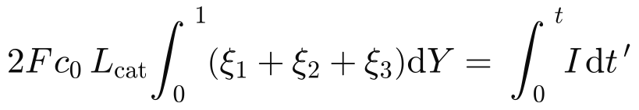 (6)
This equation follows from the extent equations, so in theory it adds nothing. In practice the extent equations are satisfied only up to a small mean error, and over a ten-hour discharge that error accumulates into a few mol m⁻³ of missing or extra product, which in the last plateau shows up directly as millivolts of voltage error. Adding the inventory as its own residual removed this drift (0.1 C error from about 1 mV to about 0.2 mV).
Analogy: the bank statement
You can track your money by recording every purchase (the extent equations). Small rounding errors in each entry add up over a year. The bank statement (the charge passed, which we know exactly) lets you check the total at any time. The inventory residual is that monthly check.

Training recipe
Four networks of 4 layers × 96 neurons, 30 000 optimization steps (Adam, learning rate decreasing from 10⁻³ to 10⁻⁵), new random collocation points at every step, the inventory residual switched on after 10 000 steps (switched on from the start, it fights the extent equations before they are learned), one CPU thread. The same recipe is used for both C-rates and for all seeds.

2.3 Identifiability: which parameters can a voltage curve reveal?
Before trying to estimate parameters, we asked which ones the data can determine at all. For each parameter θ_{i} we compute, with the FV solver, how much the voltage curve changes when θ_{i} changes slightly (the sensitivity S). From the sensitivities and the measurement noise σ we build the Fisher information matrix F; its inverse gives the Cramer-Rao lower bound (CRLB), the smallest standard error any unbiased method can achieve with that data:
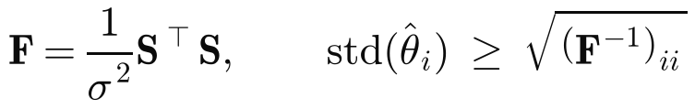 (7)
Analogy: two people pushing a car
If two people push a stuck car from the same side, you can measure how far the car moved, but not who pushed harder: only their sum is visible. Two parameters with the same effect on the voltage are like that, and the Fisher matrix detects it (their bounds become huge and their correlation close to ±1). Pushing from different angles (a second C-rate) separates them.

2.4 The inverse problem and the ideal estimator
For the inverse problem one PINN per C-rate is trained, all sharing the same unknown parameters. Plain gradient descent on network weights and parameters together turned out to be very slow, because the parameters are correlated (they sit in a long narrow valley of the misfit). The fix is a Levenberg-Marquardt (LM) step on the parameters every 250 training steps, with the networks frozen for that step:
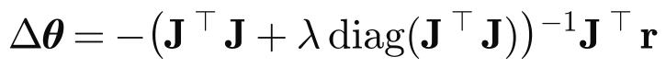 (8)
Here r is the vector of data residuals, J its derivative with respect to the parameters and λ a damping factor. For measured data, which the model cannot match exactly, a trust-region version keeps the networks physics-only and accepts a parameter step only if the misfit really decreases after the networks re-adjust.
Noise makes even a perfect method miss the true parameters, so we judge the PINN against the ideal estimator: a least-squares fit with the FV solver itself on exactly the same noisy data. When the two differ, a linear error model predicts the difference from the PINN's forward error e (PINN minus FV voltage at the same parameters):
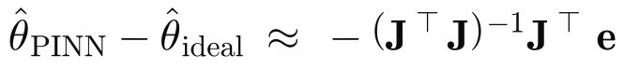 (9)

2.5 Real data used
Two measured data sets were used (details in section 4.6): the experimental points of Simanjuntak et al. Fig. 4b at 0.05-1 C, digitized from the figure (we fit 0.1 + 1 C and predict 0.05 and 0.2 C), and the C/10 discharges of the SPAN500 coin cell of Wang et al. (Nat. Mater. 2026), our group's own data, at a single rate and without reported sulfur content.

2.6 Reproducibility and traceability
Because the paper must be correct, we followed four rules: (1) the final recipe is trained from scratch with three seeds per C-rate and the spread is reported, not the best run; (2) no number is typed by hand: scripts/paper_build.py regenerates every figure, table and number from saved results, fingerprints every input file, and fills the placeholders of the manuscript; (3) the build re-evaluates the saved networks instead of copying numbers from training logs; (4) failed runs are kept with a note explaining why they stopped.
Key idea: these rules found real errors
When the build re-evaluated a saved 1 C network it reported 257 mV instead of 0.12 mV: the code that reads a run's protocol back from its configuration silently fell back to the 0.1 C current. The same bug had made a resumed 1 C training run train at the wrong current; that run was kept with a note and repeated. The traceable numbers also caught three wrong values in our own notes (section 3.2). Without these rules they would have reached the manuscript.

3. Phases of the work

3.1 Timeline
The Li-SPAN work started after the DFN part of the project (a PINN for the lithium-ion DFN model of the LG M50 cell, with 0.23-0.25 mV accuracy, three-parameter inverse problems within 0.1-0.6 % and an aging study; see the student guide, chapters 5-6). The DFN part gave us the design rules (build the physics in; balance the residual groups) that the Li-SPAN work reused; the second-order parameter step for correlated parameters was developed during the Li-SPAN work itself.
Table 3. Phases of the Li-SPAN work (October 2026).
Phase | When | What was produced | Main outcome
1 Reference model | Oct 5-6 | FV solver, digitized paper curves, closures B1-B8 | 16 / 18 mV rms from the paper at 0.1 / 1 C; capacities within 3.1 %
2 Forward PINN | Oct 6-7 | PINN with built-in structure; charge inventory; separator scaling | first 24 mV, then 1 mV, then 0.2 mV (0.1 C) and 0.12 mV (1 C), warm-started
3 Identifiability | Oct 7 | sensitivities of 17 parameters at 4 C-rates | 8 parameters identifiable with 0.1 C + 1 C; others invisible or confounded
4 Inverse (synthetic) | Oct 7 | multi-rate inverse PINN with LM step | 8 parameters within 2.3 standard errors of the truth
5 Measured data | Oct 7 | fits to Simanjuntak Fig. 4b (FV and PINN) | 18 mV model-form error; contact resistance 0.033 Ω m² (paper 0.035)
6 Paper steps 1-5 | Oct 8-9 | 3 seeds from scratch; cost table; traceable build; assumption checks; SPAN500 case | 0.26 / 0.18 mV mean; this document

3.2 Problems found and how they were solved
Much of the value of the project is in the problems it ran into, because each one is a lesson for anybody who builds a PINN for a battery model. We list them honestly, including our own mistakes; the negative results are part of what the paper will report.
Table 4. Problems met during the Li-SPAN work and their solutions.
Problem | Symptom | Fix | Effect
step 2 reversible is stiff for a PINN | backward rate 20x the demand from a tiny representation error | PINN benchmark treats step 2 as irreversible (quantified) | 2.7 mV change at 0.1 C, 0.1 mV at 1 C
single-precision cancellation in 1 - ξ | residuals stuck, 150 mV voltage error | species computed from the remaining fractions e_{m} | residuals down 100x in 500 steps
extents drift over the 10 h discharge | error wanders between 0.7 and 1.5 mV | global charge-inventory residual | 0.1 C error about 0.2 mV
separator salt residual on the wrong scale | 1 C separator salt gradient about 10 % too small; a residual that looked converged was a 25 % error of the separator dynamics | separator residual scaled with (1 - t₊) I / (F L_{sep}), its own transient scale | 1 C error 1.97 → 0.12 mV
inverse: Adam crawls along correlated parameters | k_{0,1} still 10 % off after 7000 steps | Levenberg-Marquardt step on the parameters | within 1-2 % after 750 steps
real data: data bend the physics | PINN reports 14 mV, FV at its parameters 20 mV | physics-only fields + trust region | physics-consistent, 1.8 mV above the FV optimum
protocol bug (ours) | the saved protocol was read back with the wrong key: a resumed 1 C run and one re-evaluation silently used the 0.1 C current | protocol read with both key names, error otherwise; run repeated | exposed by the re-evaluation (257 mV instead of 0.12 mV); invalid run kept with a note
finite-difference step too small (ours) | least-squares fits slow or stalled | absolute 1 % / 1 mV steps | SPAN500 fit 12.2 → 10.0 mV; Fig. 4b fit unchanged (18.4 mV)
SPAN500 PINN: data window, warm start, bounds | trust-region steps rejected or stuck | window before the cut-off; re-adaptation stage; wider bounds | 8.9 mV vs 8.2 mV for the FV optimum

Be careful: three wrong numbers in our own notes
Building the paper numbers from the saved files showed three values in our working notes that were wrong: the bounds of the transport parameters with four C-rates are 15-72 %, not 70-190 %; the largest salt-concentration change at 1 C is 13.5 %, not 3 %; and the two SPAN500 kinetic hypotheses differ at 1 C by up to 135 mV, not 95 mV (95 mV is the value at 50 mAh g⁻¹). All three are corrected everywhere; none changes a conclusion.

Key idea: why we tell this
A reviewer trusts a paper more when it shows how it checked itself. The traceable build is not bureaucracy: in two days it exposed one code bug (and the invalid training run it caused) and three wrong numbers.

A practical note: the computations ran on a two-core cloud machine that was reset several times when the session was idle, so all long jobs were made resumable; training costs are reported as CPU time per step (measured time per step × number of steps), which is less sensitive to such interruptions.

4. Results
All numbers in this chapter are produced by scripts/paper_build.py from saved results (paper/numbers.json), and every figure is a figure of the draft manuscript. Errors are given as root-mean-square (rms) differences over the discharge, from 100 s after the current is switched on to 98 % of the discharge, and as the maximum difference over the same window:
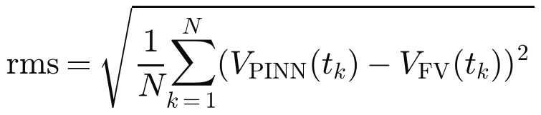 (10)

4.1 The reference model reproduces the published curves
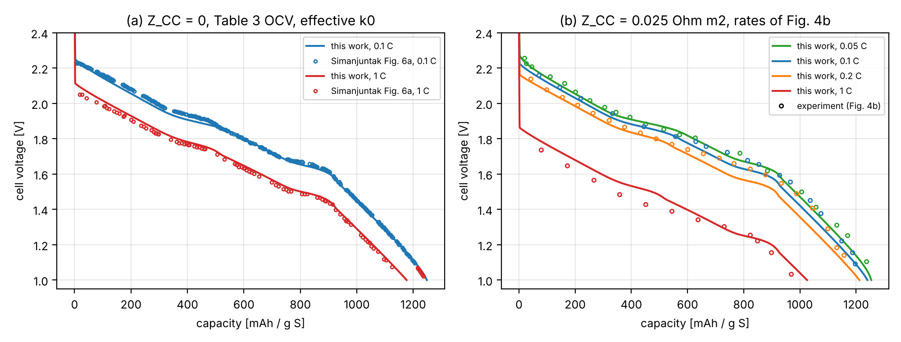
Figure 2. (a) Our FV solver (lines) and the curves of Simanjuntak et al. Fig. 6a (circles) at 0.1 C and 1 C without contact resistance. (b) The FV solver at the four C-rates of their Fig. 4b, with their experimental points (circles).
With the effective rate constants and the closures of Table 2, the FV solver reproduces the published model curves to 16.0 mV rms at 0.1 C and 18.4 mV rms at 1 C (largest deviations 32 and 45 mV). The delivered capacities at 0.05, 0.1, 0.2 and 1 C (1254, 1240, 1212 and 1025 mAh g_{S}⁻¹) agree with the paper within 3.1 %, and the evolution of the four sulfur species and of Li₂S follows their Fig. 5a (not shown here). The remaining difference is expected: the paper uses concentration-dependent electrolyte properties that it does not give, and we digitized the curves from the figure.
Key idea: 4.1 in one line
We have a trustworthy numerical copy of the published model, with every interpretation documented.

4.2 The PINN solves the model to a fraction of a millivolt
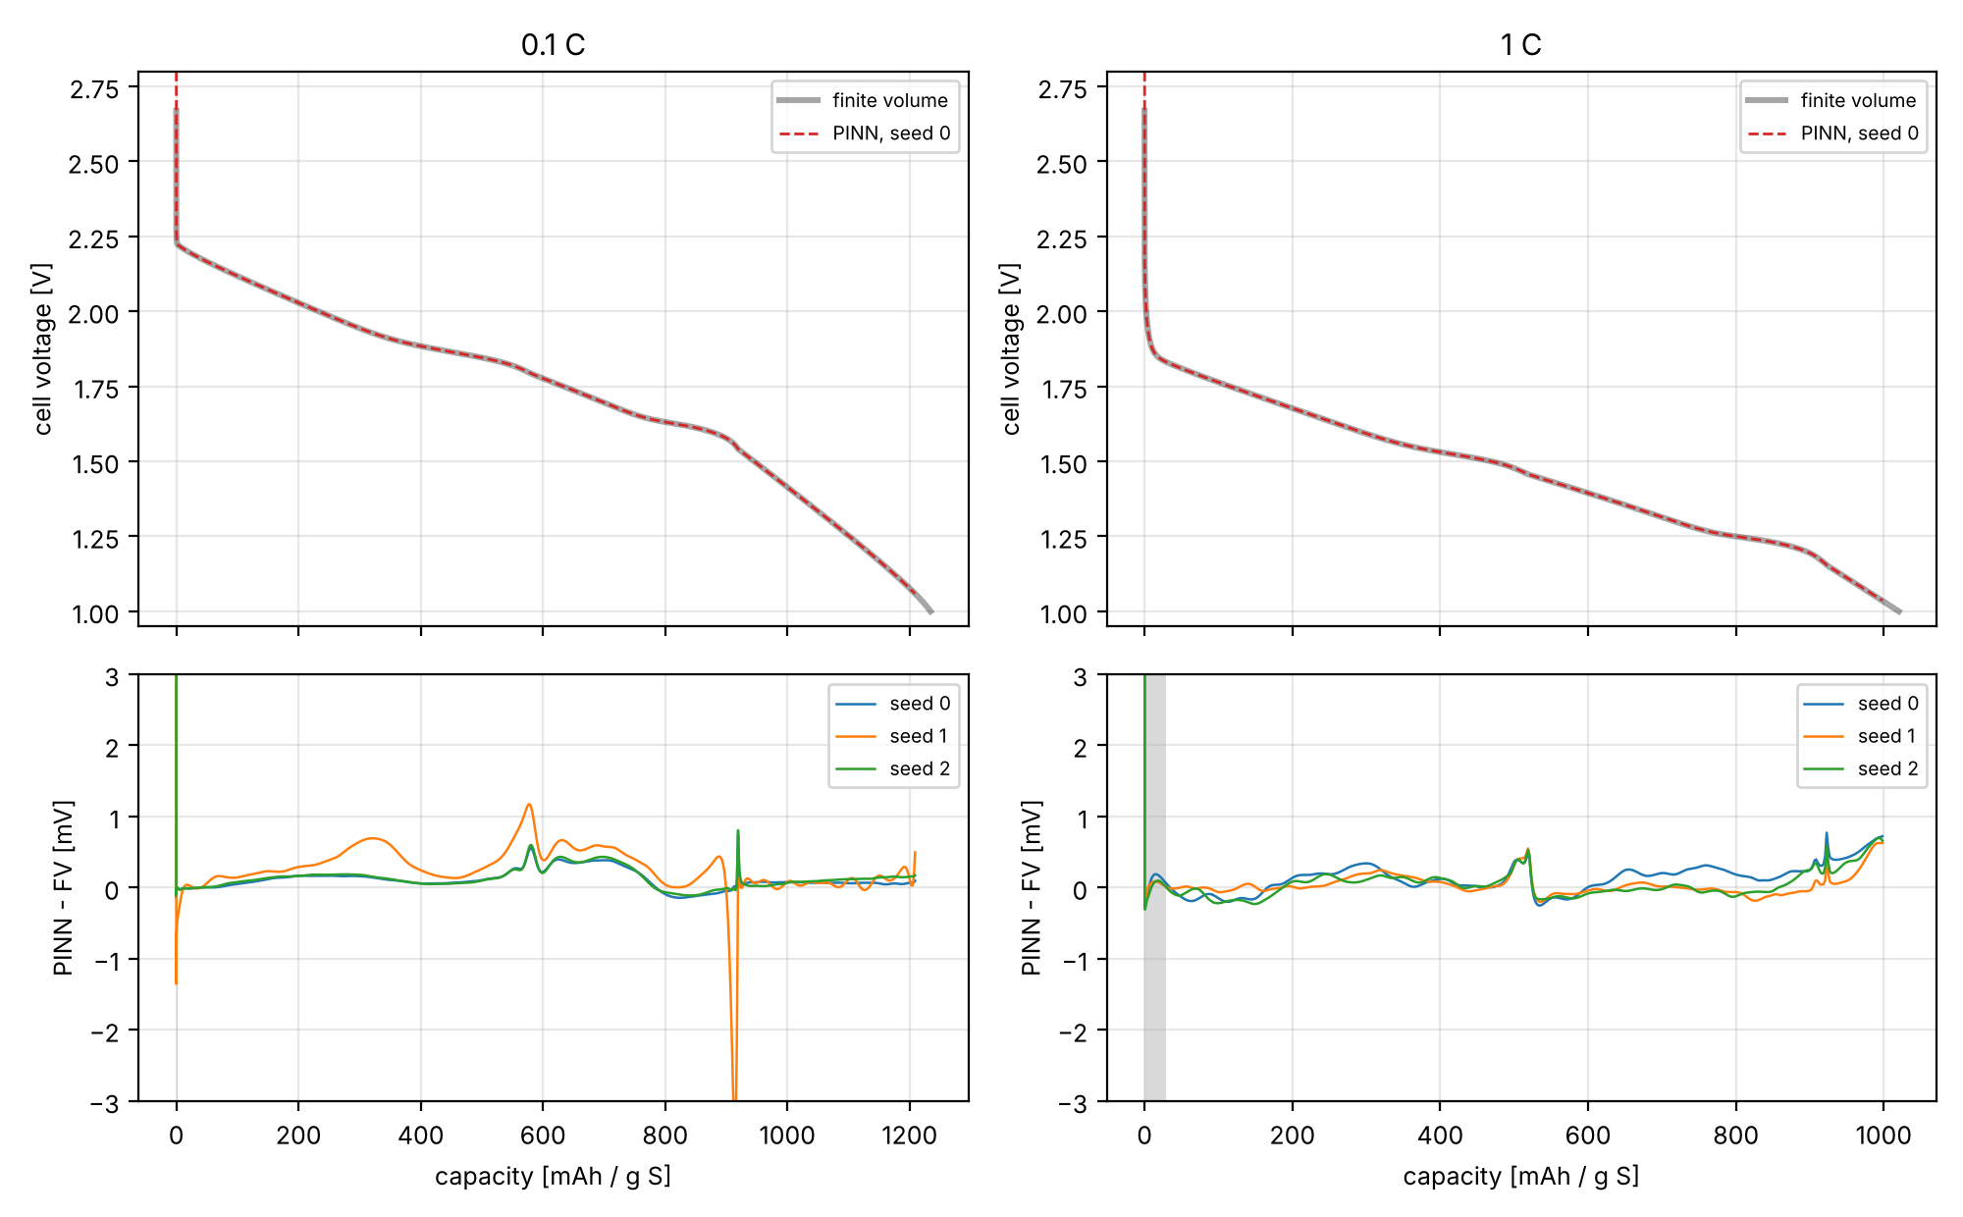
Figure 3. Top: cell voltage from the FV solver (thick grey) and the PINN (seed 0, dashed red) at 0.1 C and 1 C. Bottom: PINN minus FV for the three seeds. The grey band marks the first 100 s (30 s current ramp and its transient), excluded from the error statistics.
Table 5. Forward accuracy of the final recipe, trained from scratch, three seeds per C-rate (PINN vs FV).
C-rate | Seed | V rms [mV] | V max [mV] | SPAN species rms [mol m⁻³] | Electrolyte rms / max [mol m⁻³]
0.1 C | 0 | 0.164 | 0.74 | 0.12-0.56 | 0.04 / 0.10
0.1 C | 1 | 0.435 | 3.54 | 0.38-0.94 | 0.05 / 0.11
0.1 C | 2 | 0.177 | 0.81 | 0.12-0.57 | 0.04 / 0.12
1 C | 0 | 0.225 | 0.77 | 0.19-0.51 | 1.51 / 7.8
1 C | 1 | 0.137 | 0.63 | 0.16-0.47 | 0.87 / 7.0
1 C | 2 | 0.179 | 0.70 | 0.15-0.45 | 1.14 / 7.0
mean |  | 0.26 (0.1 C), 0.18 (1 C)

All six runs reproduce the FV voltage to better than 0.5 mV rms (0.14-0.44 mV). The evaluated voltage window spans 1.16 V at 0.1 C and 0.80 V at 1 C, so this is an error of about 0.01-0.04 % of the voltage range, well below the millivolt-level noise of a typical battery cycler. One run (0.1 C, seed 1) has a narrow spike of 3.5 mV exactly where the third plateau starts (around 915 mAh g⁻¹), where the open-circuit potential changes slope abruptly; without that spike its error is 0.35 mV rms. The other five runs stay below 0.81 mV everywhere.
The internal states are also right (Figure 4): the four sulfur species agree within 1 mol m⁻³ out of 598, the Li₂S volume fraction within 10⁻⁵, and the electrolyte concentration within 0.05 mol m⁻³ at 0.1 C and 0.9-1.5 mol m⁻³ rms at 1 C (out of 1000; the 1 C electrolyte is the hardest field, with a maximum error of about 7-8 mol m⁻³).
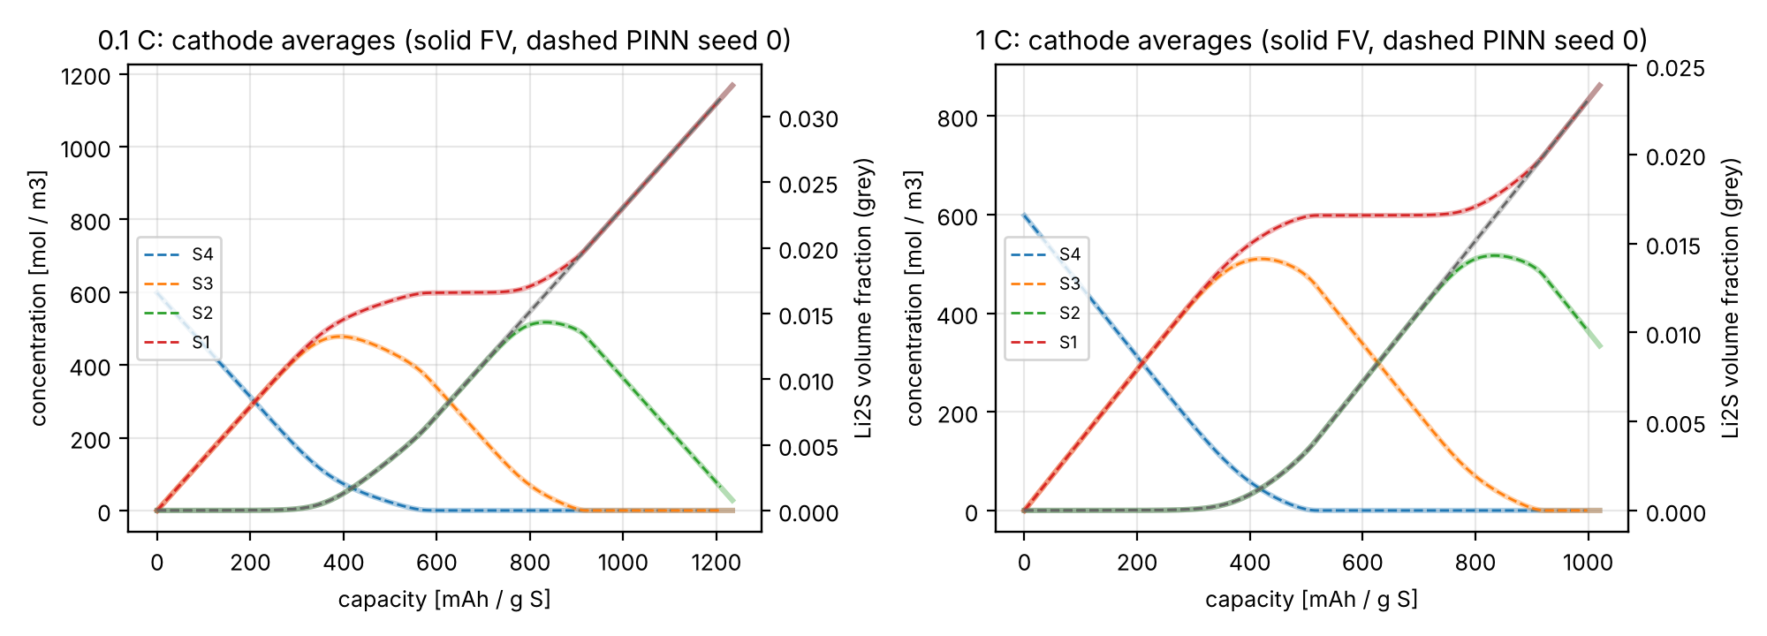
Figure 4. Cathode-averaged concentrations of the four sulfur species (left axis) and Li₂S volume fraction (grey, right axis): FV (solid, light) and PINN seed 0 (dashed).
At 0.1 C the error first falls below 1 mV after 12 500 of the 30 000 steps (seed 0), and all three seeds stay below 1 mV from step 17 500 on; at 1 C it falls below 1 mV after 15 000-17 500 steps. Earlier results (0.21 / 0.12 mV) came from networks that continued previous runs; the numbers above are from random initialization and are the ones the paper will report.
Analogy: three students, one exam
Training the same network three times with different random starting points is like giving the same exam to three students with the same preparation. If all three pass with similar grades, the method (not luck) is responsible. Here all six passed (below 0.5 mV); one student made a single slip on one question (the 3.5 mV spike).

For the slides
Figure 3 plus the mean row of Table 5: 'PINN vs reference: 0.26 mV (0.1 C) and 0.18 mV (1 C), three seeds, from scratch'.

4.3 How much do our modeling choices matter?
The PINN is compared with the FV solution of exactly the same equations. That benchmark differs from the FV reference of section 4.1 in a few numerical choices (step 2 irreversible, no double-layer charging, a 30 s current ramp), and the reference itself relies on assumptions inherited from the paper (constant electrolyte properties, 25 °C). We quantified every one by changing it alone and recomputing the discharge (Table 6; the curves are Figure S1 of the draft).
Table 6. Effect of each modeling choice on the voltage (vs the PINN benchmark).
Choice changed | 0.1 C: rms / max [mV] | 1 C: rms / max [mV]
step 2 reversible (as in the FV reference) | 2.66 / 5.63 | 0.12 / 0.30
all three steps reversible (literal printed model) | 52.7 / 190 | not computed (solver too stiff)
double layer as in the paper (c_{DL} = 0.1 F m⁻²) | 4.58 / 11.7 (+6 mAh g⁻¹) | 3.37 / 9.9 (+5 mAh g⁻¹)
1 s instead of 30 s current ramp | 0.01 / 0.20 | 0.06 / 0.95
coarser grid (20 / 10 volumes) | 0.01 / 0.01 | 0.08 / 0.09
contact resistance 0.035 instead of 0.025 Ω m² | 10.0 (constant shift) | 100 (constant shift)
S²⁻ reference concentrations × 10 | ≤ 0.01 | ≤ 0.01
electrolyte conductivity -10 % | 0.32 / 0.33 | 3.04 / 3.19
salt diffusivity -20 % | 0.12 / 0.19 | 0.96 / 1.66
temperature +10 K (no Arrhenius) | 0.78 / 2.91 | 2.93 / 3.49

The only benchmark simplification above 3 mV rms is the double layer (4.6 / 3.4 mV rms): with the large SPAN surface area the electrode stores about 160 C m⁻² capacitively, adding about 6 mAh g⁻¹ and shifting the plateau transitions by up to 12 mV. Treating step 2 as irreversible changes the voltage by 2.7 mV rms, but up to 5.6 mV at the plateau transitions. The choices span 0.01-5 mV rms: most are larger than the PINN error (0.14-0.44 mV), a few (grid, ramp, S²⁻ references) are smaller, and all are well below the model-experiment misfit (18 mV), except two that are not benchmark simplifications: the contact resistance quoted in the paper's text (a constant shift of 10 / 100 mV) and the literal printed model. The PINN accuracy is therefore a statement about the equations, not about the cell. Closure B3 is essential: the literal model, with the backward terms of steps 2 and 3 switched on, differs by 53 mV rms.

4.4 What a discharge curve can reveal
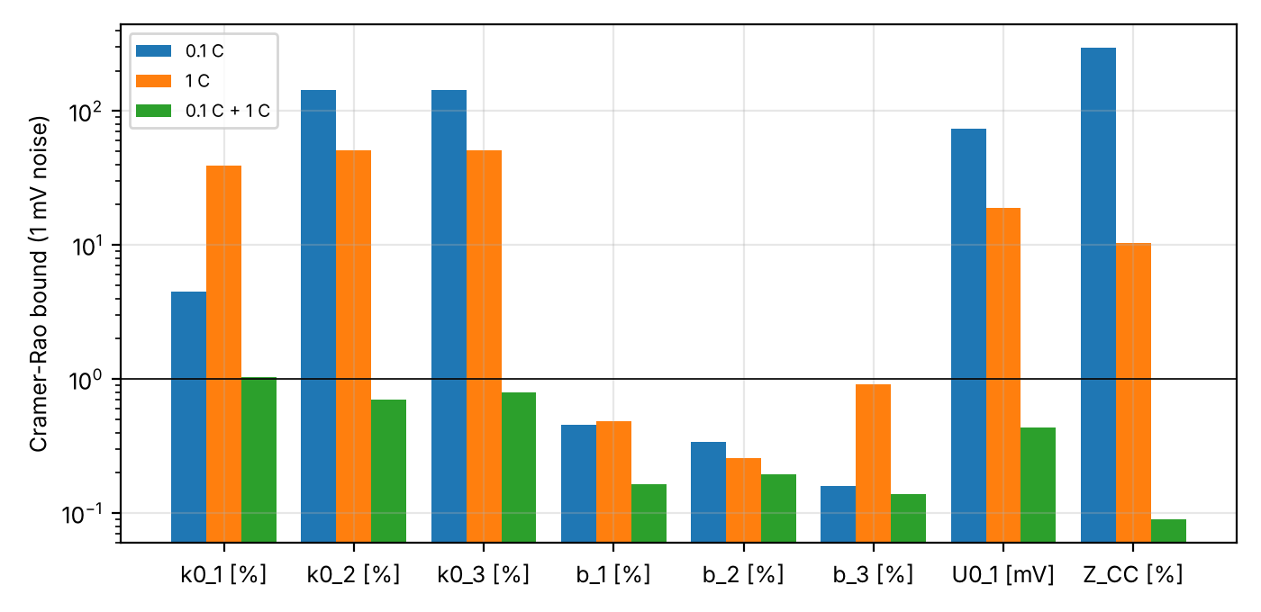
Figure 5. Cramer-Rao lower bounds (smallest achievable standard error, 1 mV noise) of the eight parameters of the inverse problem, from 0.1 C alone, 1 C alone and both together. Logarithmic scale; the line marks 1 %.
Figure 5 answers the question 'what can we hope to measure?'. Three findings decide the design of the inverse problem:
- With one C-rate, the kinetics, the first equilibrium potential and the contact resistance cannot be separated. At 0.1 C the bound of k_{0,2} is 144 % and that of Z_{CC} 296 %: they all shift the voltage almost uniformly. Even at 0.1 C alone the open-circuit slopes b_{m} are well determined (below 0.5 %).
- Two C-rates solve it. The ohmic drop grows linearly with the current, the kinetic overpotential with its logarithm, so 0.1 C and 1 C together bound all eight parameters to 1.04 % or better (Z_{CC} 0.09 %, U_{0,1} 0.44 mV).
- Some parameters are invisible. The electrolyte conductivity, transference number and solid conductivity act through an ohmic-like drop that looks like Z_{CC} (correlation 0.94; bounds 15-72 % even with four C-rates), and the Li₂S kinetics move the voltage by less than 0.1 mV per e-fold change. They must be taken from independent measurements.
A fourth, exact result explains why U_{0,2} and U_{0,3} are not in the list: for a step that only runs forward (Tafel regime), the rate depends on the product of the rate constant and an exponential of the equilibrium potential, so multiplying k₀ by 1000 is exactly the same as raising U₀ by 0.355 V:
(11)
Key idea: 4.4 in one line
One discharge rate tells you the open-circuit shape; you need at least two rates to measure the kinetics, and some properties no discharge curve will ever reveal.

4.5 The inverse PINN is as good as an ideal estimator
The test: synthetic discharge curves at 0.1 C and 1 C (FV solver, true parameters = nominal, 1 mV random noise, 112 and 90 points), and a deliberately bad starting guess: k₀ × 2 / 0.5 / 1.5, b × 1.1 / 0.9 / 1.1, U_{0,1} + 20 mV and Z_{CC} × 1.5 (84 mV initial misfit).
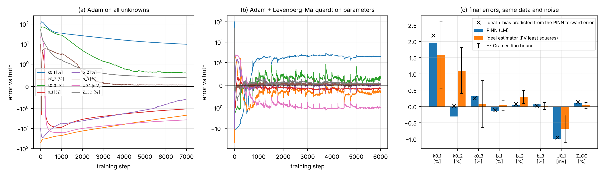
Figure 6. (a) Parameter errors during training with Adam only; (b) with the Levenberg-Marquardt step every 250 steps; (c) final errors of the PINN (blue) and of the ideal estimator on the same data (orange) with its Cramer-Rao bound, and the PINN result predicted from its forward error (crosses).
With Adam alone the parameters crawl along the correlated directions and are still 9.8 % off in k_{0,1} after 7000 steps (Figure 6a). With the LM step the first parameter update brings the misfit from 84 mV to 2.6 mV, and after 750 steps all parameters are within 1-2 % (Figure 6b). Table 7 compares the final PINN estimates with the ideal estimator.
Table 7. Eight-parameter inverse from 0.1 C + 1 C synthetic data: errors with respect to the true values.
Parameter | Initial | PINN + LM | Ideal (FV) estimator | CRLB | PINN - ideal: actual / predicted
k_{0,1} [%] | +100 | +1.96 | +1.58 | 1.02 | +0.37 / +0.60
k_{0,2} [%] | -50 | -0.31 | +1.10 | 0.71 | -1.41 / -1.08
k_{0,3} [%] | +50 | +0.31 | +0.07 | 0.72 | +0.23 / +0.18
b₁ [%] | +10 | -0.14 | +0.03 | 0.16 | -0.17 / -0.15
b₂ [%] | -10 | +0.05 | +0.30 | 0.20 | -0.24 / -0.22
b₃ [%] | +10 | +0.06 | +0.02 | 0.11 | +0.05 / +0.01
U_{0,1} [mV] | +20 | -0.99 | -0.69 | 0.43 | -0.31 / -0.27
Z_{CC} [%] | +50 | +0.09 | +0.04 | 0.09 | +0.06 / +0.09

Even the ideal estimator misses the truth (k_{0,1} by 1.6 %) because of the noise, so it is the right yardstick. The CRLB column is computed for the actual data points of this test (for example 1.02 % for k_{0,1}); Figure 5 uses the 100-point design of the identifiability study (1.04 %). The PINN differs from the ideal estimator by at most 2.0 Cramer-Rao bounds (k_{0,2}; median 0.7), and the difference is predictable: the PINN voltage at its final parameters differs from the FV voltage by 0.15 mV (0.1 C) and 0.71 mV (1 C), and propagating this forward error through the sensitivities reproduces the PINN-minus-ideal differences parameter by parameter (last column). The inverse PINN is the ideal estimator plus the bias of its own forward error, mostly from the 1 C electrolyte.
Analogy: a slightly bent ruler
If your ruler is bent by a known small amount, every measurement you make with it is off by a predictable amount. The PINN is that ruler: its tiny voltage error (0.15-0.7 mV) bends the parameter estimates by a predictable amount (up to 1.4 % in k_{0,2}). Knowing the bend, you can correct for it or straighten the ruler.

4.6 Measured data
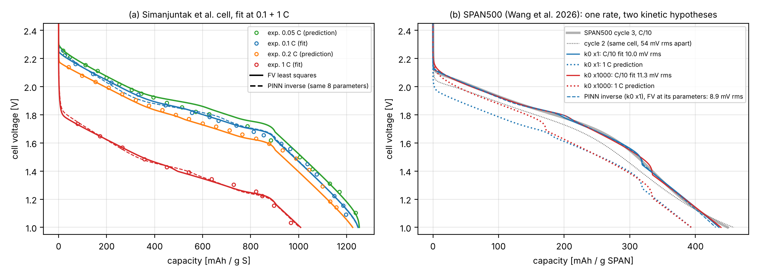
Figure 7. (a) Simanjuntak et al. cell: experimental points (circles), FV least-squares fit (solid) and PINN inverse (dashed, FV model run at the PINN's parameters), fitted at 0.1 + 1 C, predicted at 0.05 and 0.2 C. (b) SPAN500 cell (Wang et al. 2026): C/10 cycle 3 (thick grey) and cycle 2 (dotted), fits with two kinetic hypotheses (solid) and their 1 C predictions (dotted), and the PINN inverse (dashed).

Simanjuntak et al. cell (Fig. 4b points)
Fitting the same eight parameters to the digitized experimental points at 0.1 C and 1 C reduces the misfit from 50 / 46 mV (nominal model) to 19.8 / 16.1 mV (18.4 mV overall) and improves the predictions at the two rates not used in the fit from 31 / 61 mV to 29.8 / 31.1 mV (Table 8). The contact resistance comes out as 0.033 Ω m², close to the 0.035 that the authors themselves quote as their best value. The other parameters are loosely determined (different starts give different parameters with the same misfit), because the remaining 18 mV is a model-form error, not noise. The PINN inverse lands in the same valley: the FV model at its parameters misses the data by 22.7 / 15.8 mV (20.2 mV overall, 1.8 mV above the FV optimum), with Z_{CC} = 0.034 Ω m².

SPAN500 (Nature Materials 2026)
These are our own group's data, but they were not measured for modeling: one C-rate (C/10), a different electrolyte (ether instead of carbonate), a coin cell, and no reported sulfur content or electrode thickness. We kept the Simanjuntak geometry and transport (at about 1 A m⁻² they contribute less than 1 mV), took the series resistance from the high-frequency end of the published impedance spectrum, and fitted the effective sulfur fraction together with the open-circuit parameters U_{0,1-3} and b₁₋₃.
- The third discharge is reproduced to 10.0 mV rms (nominal model: 80 mV), with an effective sulfur fraction of 0.38 g S per g SPAN, close to the 40-50 wt% the paper gives for typical SPAN.
- But the same cell changes by 54 mV rms between cycles 2 and 3, and the fitted model misses cycle 2 by 55 mV. The calibration describes one cycle, not the material.
- With all three rate constants raised a thousandfold the fit is as good (11.3 mV; the fit compensates by lowering U_{0,2} and U_{0,3} by 0.35 and 0.43 V, as the equation of section 4.4 predicts), but the two calibrations predict 1 C curves that differ by up to 135 mV in the first plateau. One C-rate cannot fix the kinetics, exactly as section 4.4 predicted.
- The PINN inverse on the same data (same sulfur fraction, data up to 413 mAh g⁻¹ so that the window stops before the end-of-discharge collapse) reaches parameters where the FV model misses the data by 8.9 mV, against 8.2 mV for the FV optimum on the same window.
Table 8. Fits to measured data.
Data | Model / method | Misfit [mV rms] | Notes
Simanjuntak 0.1 C / 1 C (fitted) | FV least squares | 19.8 / 16.1 | Z_{CC} = 0.033 Ω m²
Simanjuntak 0.05 C / 0.2 C (predicted) | FV least squares | 29.8 / 31.1 | nominal model 31 / 61
Simanjuntak 0.1 C / 1 C (fitted) | PINN inverse (FV at its parameters) | 22.7 / 15.8 | Z_{CC} = 0.034 Ω m²
SPAN500 cycle 3, C/10 | FV, paper kinetics | 10.0 | w_{S} = 0.376; cycle 2: 55 mV
SPAN500 cycle 3, C/10 | FV, kinetics × 1000 | 11.3 | 1 C prediction differs by up to 135 mV
SPAN500 cycle 3, Q ≤ 413 mAh g⁻¹ | PINN inverse vs FV optimum | 8.9 vs 8.2 | same valley

Be careful: what the real-data results mean
On real data the limit is the model, not the PINN: 8-20 mV of misfit is the price of the model's simplifications (and, for SPAN500, of using a carbonate-electrolyte model with S₄ chains for a short-chain SPAN in an ether electrolyte). The fitted parameters are therefore effective values. The real-data cases demonstrate the workflow and its limits; they are not a calibration of SPAN500.

4.7 Computing cost
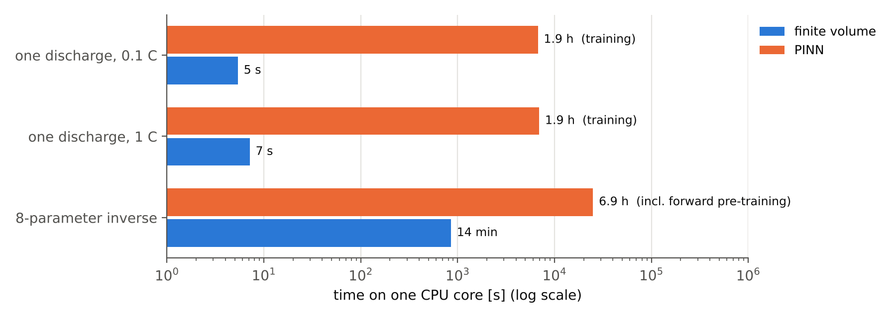
Figure 8. Computing time on one CPU core (log scale). FV: finite-volume solver. PINN: training of the final recipe (CPU time from measured time per step) and, for the inverse, the logged time of the inverse runs plus the forward training they start from.
An FV discharge takes 4-7 s; training the PINN takes 1.9 h of CPU time, about a thousand times more. Once trained, the PINN returns a whole discharge curve in about 60 ms, but only for the parameters and current it was trained for. For the eight-parameter inverse, the FV least-squares fit needs 68 discharges per C-rate (14 min), the PINN route about 1.9 h on top of about 5 h of forward training. For this one-dimensional model the PINN is therefore not a faster solver, and the paper will say so. Its value lies elsewhere (chapter 5).
For the slides
Figure 8 with one sentence: 'For a 1-D cell a stiff solver takes seconds; the PINN is a different tool, not a faster one'.

5. Analysis and discussion

5.1 What the results mean together
Read one after the other, the results tell a single story with three levels of error, each roughly an order of magnitude smaller than the one above:
Table 9. The hierarchy of errors in this work.
Level | Size | What it is | Where
model vs experiment | 8-20 mV (fits), about 30 mV (predictions) | the physics of the model is simpler than the cell | 4.6
modeling choices | 0.01-5 mV (12 mV max) | closures, double layer, ramp, constant properties | 4.3
PINN vs model | 0.14-0.44 mV | the network's numerical error | 4.2

This hierarchy is the central argument of the paper. Because the PINN error is about an order of magnitude below the typical modeling choice, and the modeling choices are well below the model-experiment misfit, the PINN does not limit anything we can say about the cell. Every conclusion about real data is a conclusion about the model, and every improvement must come from the physics (or from better data), not from a better network.
Analogy: a microscope that is better than the sample
If your microscope resolves details ten times finer than the scratches on your slide, buying a better microscope will not help you see the cell; cleaning the slide will. Our PINN is the microscope, the model is the slide.

5.2 Strengths
- Accuracy and reproducibility from scratch. Six independent trainings, all below 0.5 mV, with the same recipe at two C-rates whose physics is quite different (at 1 C the electrolyte matters, at 0.1 C it does not).
- Design rules that transfer. Building the reaction ordering, the current and the kinetics into the network, and adding global inventories, worked for both the DFN and the Li-SPAN model; each fix is tied to a specific, diagnosed failure (table of section 3.2), which makes the paper useful to others.
- An honest yardstick for inverse problems. Comparing with the ideal estimator on the same data, and predicting the difference from the forward error, is stronger than the usual 'we recovered the true parameters within x %'. It separates what the noise allows from what the method loses.
- Identifiability first. The Fisher analysis explained in advance why one C-rate is not enough and which parameters must be measured independently; the SPAN500 case then showed exactly that behavior on real data.
- Traceability. Every number is generated from saved files with fingerprints; this already caught one invalid run and three wrong notes.

5.3 Weaknesses and how the paper deals with them
- The PINN is slower than the FV solver (about 1000x for a forward solve). We state it plainly and argue the value of the method elsewhere: uniform treatment of forward and inverse problems, a differentiable model with gradients for free, and a path to settings where meshes are expensive (not tested here).
- The real-data cases are limited. The Simanjuntak points are digitized; the SPAN500 data are one C-rate, a different electrolyte and a different chain structure. We present them as demonstrations with explicit limits rather than as calibrations.
- The benchmark is our reading of the published model. The closures are documented and quantified; a confirmation from the original authors would remove the doubt (optional step, chapter 9).
- One seed has a 3.5 mV spike at a phase transition. It is reported, located and explained (abrupt change of the open-circuit slope); the rms error of that run is still 0.44 mV.

5.4 Where a PINN is worth its cost
For a single forward simulation of a one-dimensional cell, never. The PINN becomes interesting when (i) the same object must solve the model, absorb data and return gradients with respect to parameters, as in our inverse problems; (ii) many evaluations of a fixed model are needed after a one-time training (60 ms per discharge curve once trained); or (iii) the geometry or coupling makes mesh-based solvers expensive (two- or three-dimensional electrodes, parametric networks that take the parameters as inputs). Points (ii) and (iii) are outlook, not results of this work.
Key idea: the honest message
A carefully designed PINN can solve a multi-reaction conversion-cathode model to sub-millivolt accuracy and invert it as well as an ideal estimator; on a 1-D cell it is a methodological tool, not a speed-up; and for Li-SPAN the bottleneck is the model and the data, not the solver.

6. Conclusions
- The Li-SPAN model of Simanjuntak et al. reproduces its published curves only with documented closures (faradaic current of step 1, effective rate constants in the Tafel regime, step 3 irreversible during discharge); with them our FV reference matches the published curves to 16 / 18 mV rms.
- A PINN with the reaction ordering, the current balance and the kinetics built in, plus a global charge-inventory residual, reproduces the reference to 0.26 mV (0.1 C) and 0.18 mV (1 C) rms, mean of three seeds trained from scratch.
- One discharge rate cannot separate kinetics from contact resistance and open-circuit parameters; 0.1 C and 1 C together determine eight parameters to about 1 % or better; transport and Li₂S parameters are practically invisible in discharge curves.
- With a Levenberg-Marquardt step on the parameters, the multi-rate inverse PINN reaches the accuracy of an ideal least-squares estimator up to a bias of at most 2 Cramer-Rao bounds, which is predicted by the PINN's own forward error.
- On measured data the misfit (8-20 mV) is a model-form error; for SPAN500 it is smaller than the change between consecutive cycles, and the kinetics cannot be calibrated from one C-rate.
- For this 1-D model the PINN costs about a thousand times more CPU time than the FV solver; its value is methodological.

7. The paper: message, structure and status

7.1 What is new (to be confirmed by the literature review)
To our knowledge (this must be checked against the literature before submission, chapter 9): (i) no PINN has been published for a SPAN or other multi-reaction conversion-cathode continuum model; (ii) the published Li-SPAN model has not been independently re-implemented with its ambiguities documented; (iii) inverse PINNs for battery models are usually judged against the true parameters, not against an ideal estimator with a predictive bias model.

7.2 Structure and status of the draft
The draft (paper/manuscript/manuscript.md) has all sections: introduction; model and closures (the closure table, Table 2 of this document, still has to be added); FV reference (Fig. 1); PINN formulation; identifiability and inverse method; results on forward accuracy (Figs. 2-3, Table 2), identifiability (Fig. 4), synthetic inverse (Fig. 5, Table 3), measured data (Fig. 6, Table 5) and cost (Table 4); conclusions; supplementary assumption checks (Fig. S1, Table S1). It has about 3400 words (roughly 7-8 journal pages with the figures), is written in Markdown with LaTeX equations for easy conversion to the JES template, and its 61 placeholders (55 distinct numbers) are all filled automatically from the saved results. The reference list is still incomplete.
Be careful: decisions the advisor should make
(1) Is the framing 'methods paper with an honest cost statement' acceptable, or should the paper emphasize the identifiability and inverse results more and the PINN less? (2) Is the SPAN500 case worth including with its limits, or should it move to the supplementary material until multi-rate data exist? (3) Authorship and the role of the DFN results (main text, supplementary, or a separate paper).

8. Limitations
A reviewer will ask about these points, and the paper should state them before anyone asks.

8.1 Limitations of the physics
- Inherited model assumptions. One-dimensional cell, constant temperature (25 °C assumed; the paper does not state it), constant 1 M electrolyte properties (the concentration-dependent correlations the paper cites are not given; at 1 C the salt concentration changes by up to 13.5 %, which we bracketed: ≤ 3 mV), sulfur in S₄ chains with three sequential steps, open-circuit potentials linear in the extent, no polysulfide shuttle, discharge only.
- Our closures. Eight interpretations of the published model (Table 2). They reproduce the published curves to 16-18 mV, but only the authors' implementation could confirm them.
- Benchmark simplifications for the PINN. Step 2 irreversible, no double layer, 30 s current ramp, the dissolved S²⁻ represented implicitly. Each is quantified (Table 6); the double layer (4.6 mV rms, up to 12 mV) is the only one above 3 mV rms (step 2 irreversible: 2.7 mV rms, up to 5.6 mV, at 0.1 C).

8.2 Limitations of the data
- Simanjuntak Fig. 4b: digitized points (about 5 mV accuracy), 12-22 per rate, from a figure; the measured cell's sulfur loading is inconsistent with the model (0.6 vs 0.767 mg cm⁻²).
- SPAN500: one C-rate, ether electrolyte, unknown sulfur content and electrode thickness, short-chain SPAN (the model assumes S₄ chains), large cycle-to-cycle change (54 mV). The fitted values are effective parameters for one cycle.
- No multi-rate measurements of our own: the identifiability study shows that this is what limits a kinetic calibration.

8.3 Limitations of the method
- Cost: hours of training for what a stiff solver does in seconds (1-D).
- Seed sensitivity: rms errors 0.14-0.44 mV across seeds; one 3.5 mV spike at a phase transition.
- Real-data inverse: the trust-region PINN stops 0.7-1.8 mV (misfit) above the FV optimum, because its parameter step ignores how the fields respond to the parameters; a parametric PINN or implicit differentiation would fix it (future work).
- Window: the PINN cannot represent the voltage collapse after the cell is empty, so its data window must stop before the end of discharge (98 % of the discharge time; for SPAN500, 95 % of the capacity).
- Computing platform: a two-core cloud machine; timings measured in two separate sessions differed by 4-13 % (for example 3.9 vs 4.4 s for one FV discharge).
Key idea: none of these blocks the paper
Every limitation is either quantified in the results (physics, benchmark, seeds, cost) or is a scope statement (data, platform). The paper becomes stronger, not weaker, by listing them.

9. Is the current work enough?
Short answer: yes, it is enough for the advisor to approve the writing of the manuscript, and a first full draft already exists. It is not yet enough to submit: three items are missing and two optional items would strengthen the paper. The checklist below separates them.
Table 10. Readiness checklist for the manuscript.
Item | Status | Needed for
Reference model + validation | done | paper
Forward PINN, three seeds per rate, from scratch | done | paper
Identifiability (Fisher / CRLB) | done | paper
Synthetic inverse + ideal estimator + error model | done | paper
Measured-data cases (Simanjuntak, SPAN500) | done, with stated limits | paper
Cost comparison | done | paper
Assumptions quantified | done | paper / supplementary
Traceable build of all figures and numbers | done | paper (and reviewers)
Draft manuscript (all sections) | done (draft 1) | paper
Literature review, novelty statement, reference list | to do (needs the advisor and the group's references) | submission
Agreed framing of the cost result and of the SPAN500 case | to decide with the advisor (chapter 7) | submission
Supplementary information (full equations, Table S1) | to assemble (content exists in the repository docs) | submission
Confirmation of the closures by the original authors (T. Danner, DLR) | optional | stronger paper
Multi-rate discharge data of a SPAN cell from our group | optional | much stronger real-data case

If the advisor agrees, the remaining work is mostly writing: about one to two weeks for the literature section, the supplementary information and the conversion to the JES template, plus whatever time the optional items take. The optional multi-rate data are the single most valuable addition: with two C-rates of one cell, the SPAN500-type calibration would become a real kinetic calibration (section 4.4 shows exactly which parameters it would determine).
Be careful: one thing that must not happen
No number may be typed into the manuscript by hand. If a value changes (for example after a new run), rebuild with python scripts/paper_build.py and every figure, table and number updates together.

10. Suggested presentation for the advisor meeting
A 15-20 minute presentation, about 12 slides. Each line gives the slide's message and the figure or table of this document to use.
Table 11. Slide outline.
# | Slide message | Material
1 | Title: PINN for a Li-SPAN cell model: accuracy, identifiability, parameter estimation | -
2 | Why: SPAN cells, continuum models, forward and inverse problems | chapter 1
3 | The Simanjuntak model in one picture: three steps, Li₂S, electrolyte | eqs. of 1.2; analogy box
4 | What we did: six phases | Figure 1
5 | Reference model reproduces the paper (16 / 18 mV) with documented closures | Figure 2, Table 2
6 | PINN design: build the physics in; the charge inventory | eqs. of 2.2; bank-statement analogy
7 | Forward accuracy: 0.26 / 0.18 mV, three seeds from scratch | Figure 3, Table 5
8 | What a curve reveals: one rate is not enough | Figure 5
9 | Inverse: as good as the ideal estimator; the bias is predictable | Figure 6c, Table 7
10 | Real data: the model is the limit (Simanjuntak, SPAN500) | Figure 7, Table 8
11 | Cost and honest message | Figure 8; section 5.4
12 | Is it enough? Checklist and decisions needed | Table 10; chapter 7 caution box

For the slides
Keep one message per slide and put the number on the slide (for example '0.26 mV, 3 seeds'). Put the error-hierarchy table of chapter 5 on the conclusion slide: it answers most questions before they are asked.

Appendices

A. Key numbers
Table 12. Key numbers (all generated by scripts/paper_build.py).
Quantity | Value | Source file
FV vs paper Fig. 6a, rms (0.1 / 1 C) | 16.0 / 18.4 mV | paper/numbers.json
PINN vs FV, rms, three seeds (0.1 C) | 0.164 / 0.435 / 0.177 mV (mean 0.26) | lispan_final_0.1C_seed{0,1,2}
PINN vs FV, rms, three seeds (1 C) | 0.225 / 0.137 / 0.179 mV (mean 0.18) | lispan_final_1C_seed{0,1,2}
CRLB with 0.1 + 1 C (largest of 8) | 1.04 % (k_{0,1}) | results/lispan/identifiability
CRLB at 0.1 C alone: k_{0,2} / Z_{CC} | 144 % / 296 % | results/lispan/identifiability
Inverse: PINN vs ideal estimator | max 2.0 CRLB, median 0.7 | paper/numbers.json (LM inverse run vs fit_0.1+1C_nominal.json)
PINN forward error at its estimate (0.1 / 1 C) | 0.15 / 0.71 mV | results/paper/inverse_error_model.json
Simanjuntak Fig. 4b fit (overall; Z_{CC}) | 18.4 mV; 0.033 Ω m² | fit_0.1+1C_fdabs.json
SPAN500 fit; cycle-to-cycle change | 10.0 mV; 54 mV | results/lispan/span500
SPAN500 1 C predictions, largest difference | 135 mV | paper/numbers.json
SPAN500 PINN vs FV optimum (same window) | 8.9 vs 8.2 mV | lispan_inv_span500_c3_paper_wS_b5; fit_cycle3_pinnwindow.json

Files: the draft is in paper/manuscript/, figures and tables in paper/figures/ and paper/tables/, every number with its source in paper/numbers.json, input fingerprints in paper/MANIFEST.json; assumptions in docs/PAPER_ASSUMPTIONS.md; the full technical record in docs/LI_SPAN_MODEL_FORMULATION.md; the sources of this document in report/results_summary/. Everything is rebuilt with python scripts/paper_build.py.

