**Project Proposal**

A Game built by C++

_Spirit in Campus_

CSC3002

October 6, 2024

Table of Contents

ToC

Proposal information 2

Intro: Why we choose this topic – Game & C++ 2

Related work 2

Where our ideas originate from 2

Where to obtain additional resources 2

Our work 2

Schedule 3

Team 3

Introduction of Our Game – Spirit in Campus 3

The Storyline 3

Abstract 3

The setting of Character 4

How they affect Mechanism 4

Project 5

Project Goal 5

Developing schedule 6

Peroration 6

# Proposal information

## Intro: Why we choose this topic – Game & C++

In a world where gaming reigns supreme, our team members indulge in their passion for various games during our leisure time. This project knows no thematic bounds; the only rule is to harness the power of C++. With its incredible capabilities, we seize this opportunity to craft our very own game. Having felt the thrill of playing, we’re now ready to dive headfirst into the exhilarating journey of game development!

## Related work

### Where our ideas originate from

Initially, we aimed to create a single game, but the complexities of 3D development often rely on powerful engines like Unity or Unreal, which either aren’t built with C++ or have steep learning curves (yes, we're looking at you, Unreal). So, we shifted our focus to 2D games. Drawing inspiration from titles like "Soul Knight," "Katana Zero," "Hyper Light Drifter," "Hades," and "Hollow Knight," we discovered that independent 2D games often share common gameplay elements while boasting unique styles. Our goal is to hone our C++ skills while crafting a 2D game that reflects our own artistic vision and offers engaging gameplay!

### Where to obtain additional resources

We plan to learn and gather resources while developing the game. So far, our collected resources include:

[GeneraRecord](https://record.generative.fm/browse)  
[Music](https://soundimage.org/action-4/)  
[IndieSpirit|indienovaIndieGames](https://indienova.com/)  
[GameAssetsMarket](https://www.gamedevmarket.net/)  
SDL tutorial:  
<https://tjumyk.github.io/sdl-tutorial-cn/contents.html>  
<https://space.bilibili.com/25864506>

In the future, we will also refer to GitHub and CSDN to address specific issues.

## Our work

Refer to Introduction of Our Game – Spirit in Campus

Overall architecture is the mechanism of game.

Individual component is design of character, storyline, maps/levels.

Highlights: create a polished work within a manageable workload, allowing us as beginners to gain valuable experience throughout this project.

## Schedule

Refer to Developing schedule

## Team

Like CAI (Team Leader): Coordination, Planning, Assistant Programmer, Art

Shiyuan LIU: Planning, Assistant Programmer, Art

Chichao WANG: Lead Programmer: Map

Ziyang XU: Lead Programmer: Characters

Runkai ZHAO: Assistant Programmer

# Introduction of Our Game – Spirit in Campus

## The Storyline

### Abstract

The student guy/girl (TBD) fainted in the hospital due to a head injury, while its spirit somehow went back to school. To manage to get back to its body, the spirit wandered around the campus to collect spirit fragile to make it more capable of going back to its own body. During the journey of going back to its body, we have *friends* to help and *Ghostbusters* to try to catch you.

TBD version 2: The student loves studies and spends his heart on it. It makes it a cripple to a certain degree. A spirit that is not whole does not fit in an entire body.

_____________________story line influence map/level design_________________________

Intro slides: Preliminary summary.

Map design: TBA (to be arranged)

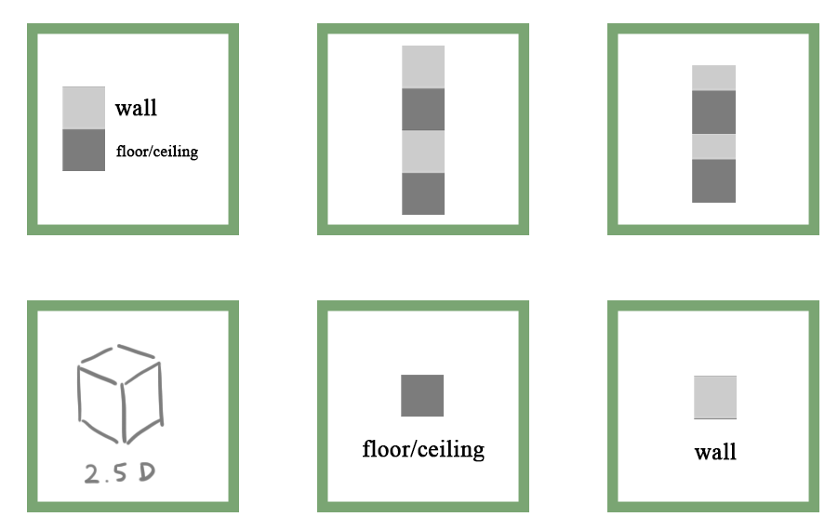c.r Like Cai

* Library; Teaching building (BCD), College. With [1,3] type map. As the main map of the game.
* In some level we use [2,2], [2,3] for better illustration.

## The setting of Character

**Ghostly Powers: A Playful Overview**

**Perception:** As a ghost, you possess a unique awareness of your surroundings. You can sense certain objects that are ripe for possession (how exciting!). Your local perception allows you to know exactly what's happening around you—there's never a dull moment when you’re floating about!

**Possession:** You can inhabit specific items, turning them into your personal vessels. It’s like stepping into a cozy new home, where you control everything as if you’ve always belonged there.

**Phasing:** Want to explore? You can seamlessly pass through certain walls, making barriers just a minor inconvenience.

**Flowing:** You thrive in the shadows! You prefer the comfort of darkness, where movement feels effortless and oh-so-smooth.

**Slow Motion:** Time dances differently for you. Between the worlds of the living and the departed, your experience of time can slow down, allowing for those exquisitely detailed moments (when the mood strikes).

Dive into the fun of being a ghost!

## How they affect Mechanism

**Senses**

* **Feeling the Entities**: When players press Tab, nearby interactive objects will be highlighted.
* **Examples**: Clues, controllable people, or items.

**Possession**

* **Controlling an Entity**: Players can use the properties of possessed objects to achieve their goals.
* **Disguise and Manipulation**: Possess a person for disguise or an object to intimidate or use its abilities.

**Intangibility**

* **A Way to Move**: Press Space to temporarily phase out of the map and enter a hovering state.
* **Target Visualization**: The screen will show possible target spaces to move to.
* **Switching Spaces**: While in this state, press Tab to change your target space.
* **Reaching the Target**: Release Space to arrive at your chosen location.

**Flow**

* **Movement Dynamics**: The ghost controlled by the player can’t roam freely in light for long.
* **Using Shadows**: Utilize people’s shadows—jumping into one for a sneaky surprise!
* **Moving Through Pipes**: Navigate up and down floors by moving through pipes

# Project

## Project Goal

* + **Gameplay**
    - Character controls should feel responsive and intuitive.
    - A complete storyline that effectively conveys a theme.
    - Interesting level design.
  + **Team Roles**
    - **Division of Labor**
      * Programmer 1: Responsible for character control and attributes, as well as the UI system.
      * Programmer 2: Responsible for scene interactions and level design.
      * Artist 1: Character design, supporting Programmer 1.
      * Artist 2: Scene design, supporting Programmer 2.
      * Coordinator: In addition to overseeing the project, responsible for monitoring progress and selecting sound effects.
    - **Communication**
      * Weekly team meetings every weekend.
      * Discussion on level design.
      * Detailed plot discussions.
    - **Project Outcomes**
      * Practical experience in project development.
      * Learning to use the SDL library and other necessary libraries.
      * Gaining experience in developing game-related software.
    - Learning to use Git for version control.
    - Problem decomposition skills.
    - Release our game.

## Developing schedule

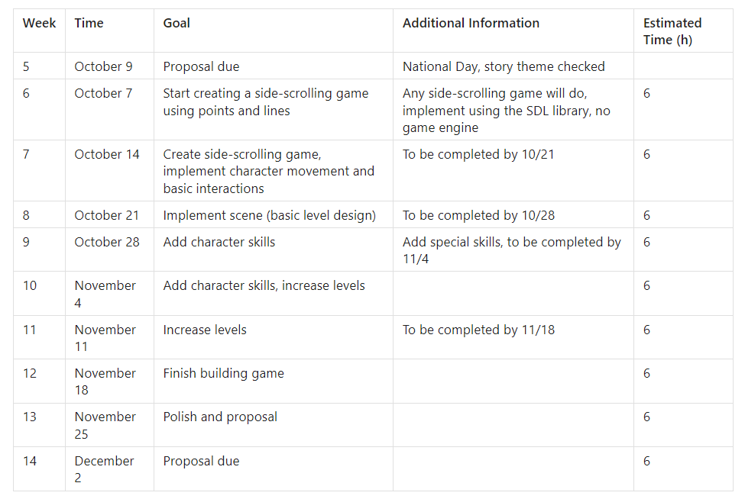

# Peroration

This is the end of the project proposal.

As we embark on this game making journey together, I want to express my gratitude for each team member's dedication in advance. I'm confident that our collaborative efforts will lead to a successful project.

Good luck to us and enjoy game making!