**Project Proposal**

A Game built by C++

_Spirit in Campus_

CSC3002

October 6, 2024

Contents

目录

Introduction of Our Game – Spirit in Campus 2

Why we choose this topic – Game & C++ 2

Related work 2

Where our ideas originate from 2

Where to obtain additional resources 2

Our work 2

Schedule 2

Team member 3

The Storyline 3

Abstract 3

The setting of Character 4

中文版本 4

English version 4

How it affect Mechanism 4

中文版本 5

English version 5

Project 6

Project Goal 6

Developing schedule 6

Suggestion 7

**时间以及统筹**： 7

**版本控制**： 7

**.技术实现** 7

# Proposal information

## Intro: Why we choose this topic – Game & C++

我们的组员在娱乐时间都或多或多少喜欢玩不同的游戏，这次的project并没有限制主题，只是限制了语言使用是C++，而C++拥有强大的功能。所以我们想借这次机会做出自己的游戏。我们体验过玩游戏时什么感觉，这次我们将会直接体验游戏的制作过程

In a world where gaming reigns supreme, our team members indulge in their passion for various games during our leisure time. This project knows no thematic bounds; the only rule is to harness the power of C++. With its incredible capabilities, we seize this opportunity to craft our very own game. Having felt the thrill of playing, we’re now ready to dive headfirst into the exhilarating journey of game development!

## Related work

### Where our ideas originate from

我们最初只是打算制作一款游戏，因为3D游戏大多需要借助诸如unity或unreal等强力引擎，而这些引擎要么不是C++开发，要么是学习难度太大（没错，就是unreal）。所以我们打算制作2D游戏。于是参考了诸如元气骑士，武士零，hyper drifter，hades，空洞骑士等游戏——如我们所料，独立2D游戏玩法有共同点，而且多数具有自己强烈的风格。而我们打算练习使用C++的同时，制作有我们自己的风格，有一定可玩性的的2D游戏。

Initially, we aimed to create a single game, but the complexities of 3D development often rely on powerful engines like Unity or Unreal, which either aren’t built with C++ or have steep learning curves (yes, we're looking at you, Unreal). So, we shifted our focus to 2D games. Drawing inspiration from titles like "Soul Knight," "Katana Zero," "Hyper Light Drifter," "Hades," and "Hollow Knight," we discovered that independent 2D games often share common gameplay elements while boasting unique styles. Our goal is to hone our C++ skills while crafting a 2D game that reflects our own artistic vision and offers engaging gameplay!

### Where to obtain additional resources

我们打算在制作游戏的同时去学习，搜集资源。目前搜集成果有：

[Generative.fm - Record](<https://record.generative.fm/browse>)

[音乐]https://soundimage.org/action-4/

[独立精神 | indienova 独立游戏](https://indienova.com/)

[Game Assets for Indie Developers | GameDev Market](<https://www.gamedevmarket.net/>)

SDL tutorial:

https://tjumyk.github.io/sdl-tutorial-cn/contents.html

<https://space.bilibili.com/25864506>

当然未来会参考GitHub和CSDN去解决具体问题。

## Our work

参考project部分

Overall architecture is the mechanism of game.

Individual component is design of character, storyline, maps/levels.

Highlights: create a polished work within a manageable workload, allowing us as beginners to gain valuable experience throughout this project.

## Schedule

参考project部分

## Team

蔡礼珂（组长）：统筹，策划，副程序，美工

刘诗远：策划，副程序，美工

王驰超：主程序：地图

许子阳：主程序：人物

赵润楷：副程序：交互

Rico CAI (Team Leader): Coordination, Planning, Assistant Programmer, Art

Ryth LIU: Planning, Assistant Programmer, Art

Mike WANG: Lead Programmer: Map

Nerdles XU: Lead Programmer: Characters

Fatmmouse ZHAO: Assistant Programmer

# Introduction of Our Game – Spirit in Campus

## The Storyline

### Abstract

The student guy/girl (TBD) fainted in the hospital due to a head injury, while its spirit somehow went back to school. To manage to get back to its body, the spirit wandered around the campus to collect spirit fragile to make it more capable of going back to its own body. During the journey of going back to its body, we have *friends* to help and *Ghostbusters* to try to catch you.

TBD version 2: The student loves studies and spends his heart on it. It makes it a cripple to a certain degree. A spirit that is not whole does not fit in an entire body.

_____________________story line influence map/level design_________________________

Intro slides: Preliminary summary.

Map design: TBA (to be arranged)

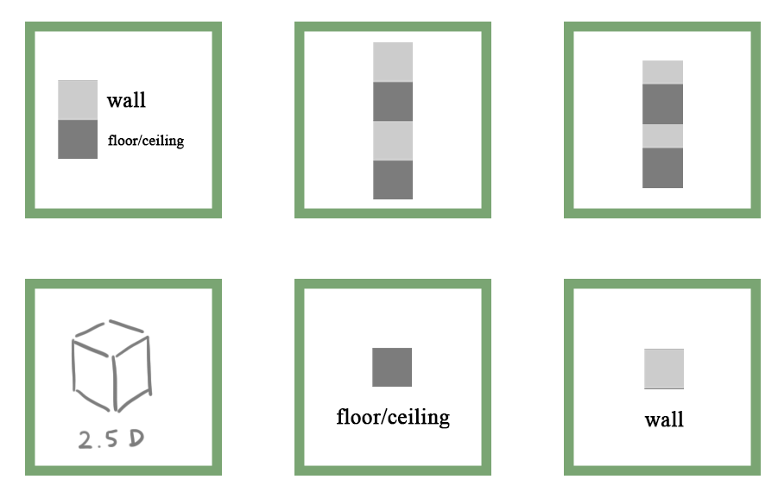c.r Like Cai

* Library; Teaching building (BCD), College. With [1,3] type map. As the main map of the game.
* In some level we use [2,2], [2,3] for better illustration.

## The setting of Character

### 中文版本

幽灵的能力概况

**感知：** 作为一只幽灵，你对周围环境有着独特的敏感度。你可以感受到一些物品适合附身（天呀！）。你的局域感知让你能准确知道周围发生了什么，太酷了，做鬼也风流。

**附身：** 你可以进入特定的物品，将它们变成你的容器。而你可以像物品本来的意识一样控制着他。

**穿墙：** 想要探索？你可以轻松穿过某些墙壁，让障碍变得微不足道。

**流动：** 你在阴影中畅游！阳光会让你感到难受。你喜欢黑暗的安逸，那里移动感觉轻松自如。

**慢动作：** 时间在你这里舞动得与众不同。在生与死的交界处，你的时间感可以变得缓慢，捕捉那些细腻而美妙的瞬间（也许不是那么美妙）。

快来体验做幽灵的乐趣吧！(TBD)

### English version

**Ghostly Powers: A Playful Overview**

**Perception:** As a ghost, you possess a unique awareness of your surroundings. You can sense certain objects that are ripe for possession (how exciting!). Your local perception allows you to know exactly what's happening around you—there's never a dull moment when you’re floating about!

**Possession:** You can inhabit specific items, turning them into your personal vessels. It’s like stepping into a cozy new home, where you control everything as if you’ve always belonged there.

**Phasing:** Want to explore? You can seamlessly pass through certain walls, making barriers just a minor inconvenience.

**Flowing:** You thrive in the shadows! You prefer the comfort of darkness, where movement feels effortless and oh-so-smooth.

**Slow Motion:** Time dances differently for you. Between the worlds of the living and the departed, your experience of time can slow down, allowing for those exquisitely detailed moments (when the mood strikes).

Dive into the fun of being a ghost!

## How it affect Mechanism

玩法待定，慢动作暂时不加入。

### 中文版本

**感知** -> 感受周围的存在

* 玩家按下 Tab 键时，周围可互动的物品将高亮显示。
* 示例：线索、可控制的人或物品。

**附身** -> 控制一个实体

* 玩家可以利用被附身物品的特性来达成目标。
* 附身于人身上进行伪装；附身于物品来恐吓或利用其属性。

**无形** -> 一种移动方式

* 按下空格键可以暂时脱离地图，进入悬浮状态。
* 屏幕上会显示可以移动到的目标空间。
* 在此状态下按下 Tab 键可实现空间切换。
* 松开空格键即可到达目标空间。

**流动** -> 一种移动方式

* 玩家控制的幽灵不能在光线下长时间自由活动。
* 你可以利用人的影子，来一场“影子跳水”！背后一凉，真是刺激！
* 还可以利用管道上下楼，畅享灵动的幽灵之旅

### English version

**Senses**

* **Feeling the Entities**: When players press Tab, nearby interactive objects will be highlighted.
* **Examples**: Clues, controllable people, or items.

**Possession**

* **Controlling an Entity**: Players can use the properties of possessed objects to achieve their goals.
* **Disguise and Manipulation**: Possess a person for disguise or an object to intimidate or use its abilities.

**Intangibility**

* **A Way to Move**: Press Space to temporarily phase out of the map and enter a hovering state.
* **Target Visualization**: The screen will show possible target spaces to move to.
* **Switching Spaces**: While in this state, press Tab to change your target space.
* **Reaching the Target**: Release Space to arrive at your chosen location.

**Flow**

* **Movement Dynamics**: The ghost controlled by the player can’t roam freely in light for long.
* **Using Shadows**: Utilize people’s shadows—jumping into one for a sneaky surprise!
* **Moving Through Pipes**: Navigate up and down floors by moving through pipes

# Project

## Project Goal

* 游戏性
  + 角色的控制手感要好
  + 故事线完整，最好能讲好一个故事，展现一个主题
  + 关卡设计有趣
* 人员分工
  + 分工合理
    - 程序1：负责实现人物控制，角色特性。UI系统。
    - 程序2：负责实现场景交互，关卡设计。
    - 美术1：人物设计，辅助程序1
    - 美术2：场景设计，辅助程序2
    - 统筹：除了统筹工作，监督进度，负责音效选择。
  + 交流顺畅
    - 每周周末一次组会
    - 交流关卡设计
    - 细化剧情讨论
  + 项目收获
    - 实践一次项目开发
    - 学会使用SDL库以及其他需要的库
    - 收获开发游戏类软件的经验
    - 学会使用git进行版本控制
    - Problem decomposition
    - 发布自己的游戏

## Developing schedule

|  |  |  |  |  |
| --- | --- | --- | --- | --- |
| week | time | goal | additional information | 预计用时（h） |
| 5 | 10月9日 | proposal due | National Day, story theme checked |  |
| 6 | 10月7日 | 开始独立用点和线制作横板 | *任意一个横板游戏都行, 不用游戏引擎，用SDL库实现 | 6 |
| 7 | 10月14日 | 用点和线制作横板，人物移动，基本交互实现 | 10/21前完成 | 6 |
| 8 | 10月21日 | 场景（基础关卡设计）实现 | 10/28前完成 | 6 |
| 9 | 10月28日 | 添加人物技能 | 添加特殊的技能11/4前完成 | 6 |
| 10 | 11月4日 | 添加人物技能，增加关卡 |  | 6 |
| 11 | 11月11日 | 增加关卡 | 11/18日前完成 | 6 |
| 12 | 11月18日 | finish building game |  | 6 |
| 13 | 11月25日 | polish and proposal |  | 6 |
| 14 | 12月2日 | proposal due |  | 6 |

## Suggestion

### **时间以及统筹**：

- **时间预留**：每周6小时的开发时间对初学者可能会显得有些紧凑，尤其是在前期实现基本交互和关卡设计时。可以考虑在前几个星期多预留一些缓冲时间，以应对可能的学习曲线和技术问题。

- **时间管理**：使用甘特图或任务管理工具（如Trello）来可视化进度，确保每个成员明确自己的任务和截止日期。

- **分阶段评估**：在第8周和第11周，建议进行一次阶段性评估，检查当前进度，确保每个人的任务都在轨道上。

- **沟通记录**：定期记录会议内容和决策，确保所有成员都在同一页面上。

- **定期更新**：除了每周的组会，可以建立一个线上文档（如Google Docs）供成员实时更新自己的工作进展，促进透明度。

### **版本控制**：

- **Git的使用**：确保团队成员在一开始就熟悉Git的使用，包括分支管理和合并代码的基本操作。可以在第一周进行一个简单的Git工作坊。

### **.技术实现**

- **逐步实现**：在每个开发阶段，确保基础功能的实现。例如，在角色控制方面，先实现基本的移动，再逐步加入其他技能。

- **模块化设计**：将游戏功能模块化，使得每个成员都能独立完成各自的任务，减少代码冲突。

- **早期测试**：建议在每个关卡的初步完成后，进行内部测试，收集反馈。可以邀请其他同学试玩，获取不同的视角和建议。