VCF v9 Deployment — Working Guide
HumbledGeeks Lab | AFF A300 + UCS B200 M4 | Domain: humbledgeeks.com

Host Assignment
Deploying with 7 of 8 hosts. dc3-hst-esxi01 is temporarily offline (SSD install) and will be added to the Workload Domain once back online.

Management Domain — 4 Hosts (vSAN)
Hostname | FQDN | IP
dc3-hst-esxi02 | dc3-hst-esxi02.humbledgeeks.com | 10.103.16.52
dc3-hst-esxi03 | dc3-hst-esxi03.humbledgeeks.com | 10.103.16.53
dc3-hst-esxi04 | dc3-hst-esxi04.humbledgeeks.com | 10.103.16.54
dc3-hst-esxi05 | dc3-hst-esxi05.humbledgeeks.com | 10.103.16.55

VI Workload Domain — 3 Hosts
Hostname | FQDN | IP
dc3-hst-esxi06 | dc3-hst-esxi06.humbledgeeks.com | 10.103.16.56
dc3-hst-esxi07 | dc3-hst-esxi07.humbledgeeks.com | 10.103.16.57
dc3-hst-esxi08 | dc3-hst-esxi08.humbledgeeks.com | 10.103.16.58

NOTE: dc3-hst-esxi01 (10.103.16.51) will be added to the Workload Domain after the SSD install is complete, bringing it to 4 hosts.

Hostname | FQDN | Status
dc3-hst-esxi01 | dc3-hst-esxi01.humbledgeeks.com | Offline — SSD install in progress. Add to Workload Domain when ready.

Environment Reference
Component | FQDN / Name | IP | Status
DNS Server |  | 10.103.20.11 | Done
SDDC Manager | dc3-srv-sddc.humbledgeeks.com | 10.103.16.19 | Done — deployed
vCenter | hg-vcf-mgmt1.humbledgeeks.com | 10.103.16.20 | DNS done
NSX Manager A | hg-vcf-nsx-a.humbledgeeks.com | 10.103.16.25 | DNS done
NSX Manager B | hg-vcf-nsx-b.humbledgeeks.com | 10.103.16.26 | DNS done
NSX Manager C | hg-vcf-nsx-c.humbledgeeks.com | 10.103.16.27 | DNS done
Jump Server (Apache) | TBD | TBD | Apache — pending setup
ESXi01 (offline) | dc3-hst-esxi01.humbledgeeks.com | 10.103.16.51 | SSD install
ESXi02 — Mgmt | dc3-hst-esxi02.humbledgeeks.com | 10.103.16.52 | Ready
ESXi03 — Mgmt | dc3-hst-esxi03.humbledgeeks.com | 10.103.16.53 | Ready
ESXi04 — Mgmt | dc3-hst-esxi04.humbledgeeks.com | 10.103.16.54 | Ready
ESXi05 — Mgmt | dc3-hst-esxi05.humbledgeeks.com | 10.103.16.55 | Ready
ESXi06 — Workload | dc3-hst-esxi06.humbledgeeks.com | 10.103.16.56 | Ready
ESXi07 — Workload | dc3-hst-esxi07.humbledgeeks.com | 10.103.16.57 | Ready
ESXi08 — Workload | dc3-hst-esxi08.humbledgeeks.com | 10.103.16.58 | Ready

Phase 1 — Download VCF Bundles from Broadcom
NOTE: The SDDC Manager OVA you already deployed is the management appliance. The bundles below are what SDDC Manager pulls from the depot to deploy vCenter, NSX, and configure ESXi hosts during bringup. These are two separate things.

1.1 Log Into the Broadcom Support Portal
A free Broadcom account gives access to VCF evaluation downloads. No partner or support contract required.
- Go to https://support.broadcom.com and sign in (create a free account if needed).
- Navigate to: My Dashboard → Software → VMware Cloud Foundation
- If VCF is not listed: Product Downloads → All Products → search "VMware Cloud Foundation"
- Select VCF 9.0.2.0
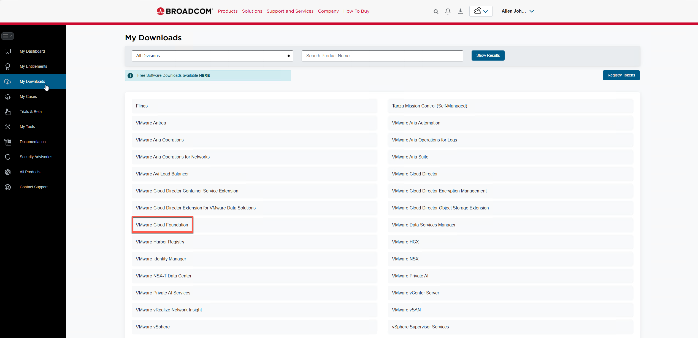
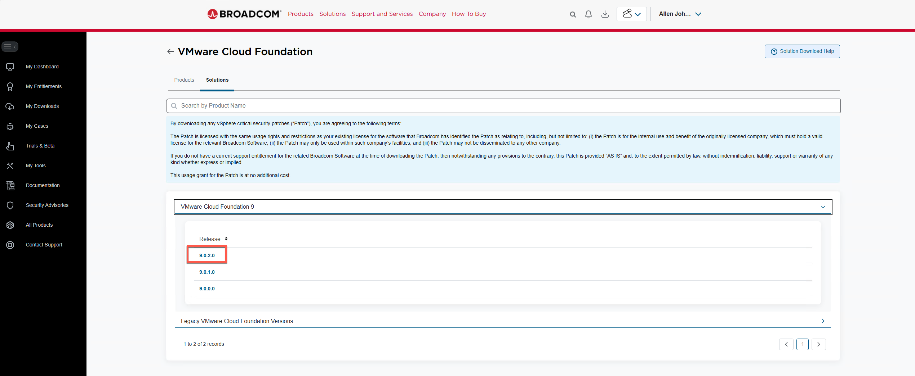
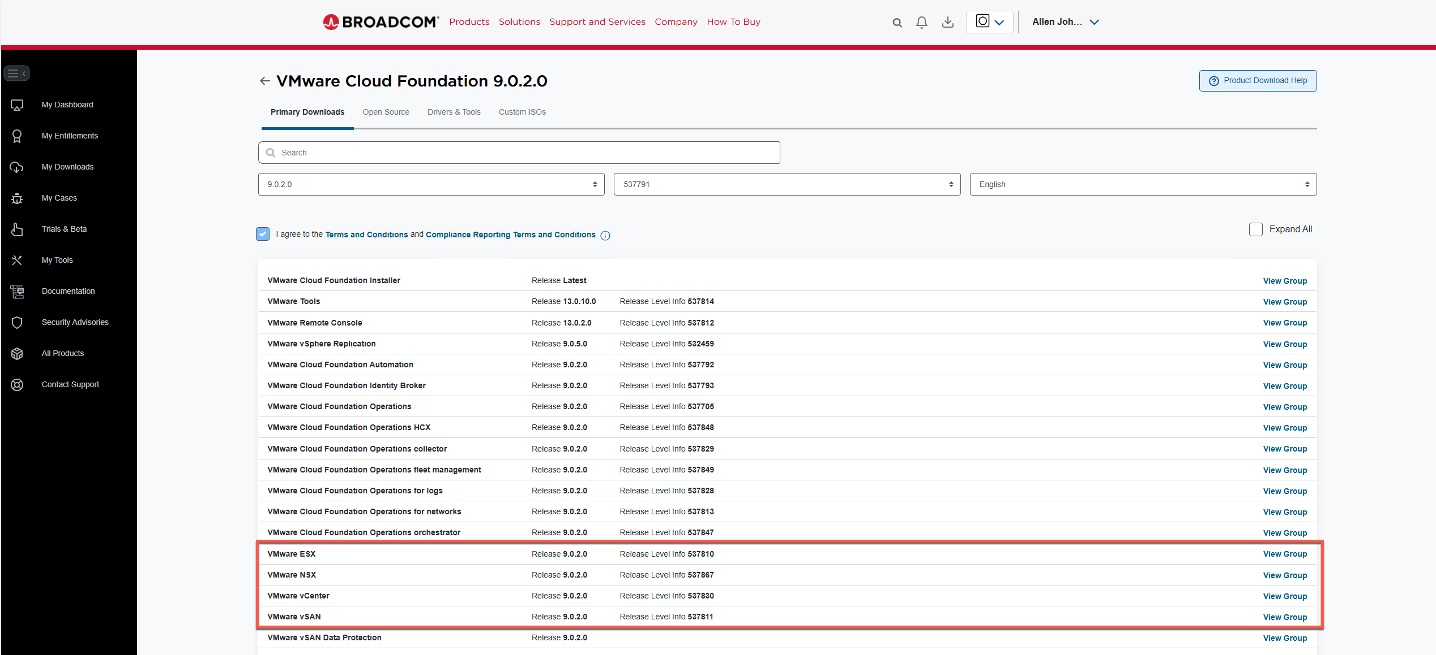

[SCREENSHOT] Broadcom Support Portal — VCF 9.0.2.0 download page showing full bundle list

1.2 Download the Required Depot Bundles
These five bundles are all you need to deploy VCF and get the Management and Workload Domains up and running. The Ops, Automation, and Fleet components can be added later once VCF is stable.
Product | File to Download | Approx. Size | Done?
VMware Cloud Foundation Installer | VCF Installer bundle (.zip) | ~1 GB | [ ]
VMware ESX | ESX Depot / Update Bundle (.zip) | ~500 MB | [ ]
VMware vCenter | vCenter Appliance Update Bundle (.zip) | ~8.65 GB | [ ]
VMware NSX | NSX Offline / Update Bundle (.zip) | ~6–8 GB | [ ]
VMware vSAN | vSAN Update Bundle (.zip) | ~1 GB | [ ]

TIP: Total download is roughly 15–18 GB. Always choose the Update Bundle or Depot Bundle (.zip) — not the standalone Appliance ISO and not the Patch ISO.

1.3 Post-Bringup Add-Ons (Download Later)
These components are optional and can be deployed after VCF bringup is complete. Do not download them now — focus on getting VCF up first.
Product | Approx. Size | Notes
VCF Operations | ~5 GB | Aria Operations — deploy post-bringup
VCF Operations collector | ~2 GB | Deploy after Operations
VCF Operations fleet management | ~2 GB | Fleet management add-on
VCF Operations for logs | ~2 GB | Log analytics
VCF Automation | ~23 GB | Aria Automation — large, deploy when needed
VCF Identity Broker | ~1 GB | Required if deploying Automation
VCF Operations HCX | varies | Only if doing HCX migrations
VMware vSphere Replication | varies | DR replication — post-bringup

[SCREENSHOT] Broadcom Portal — vCenter download page with Update Bundle (.zip) selected
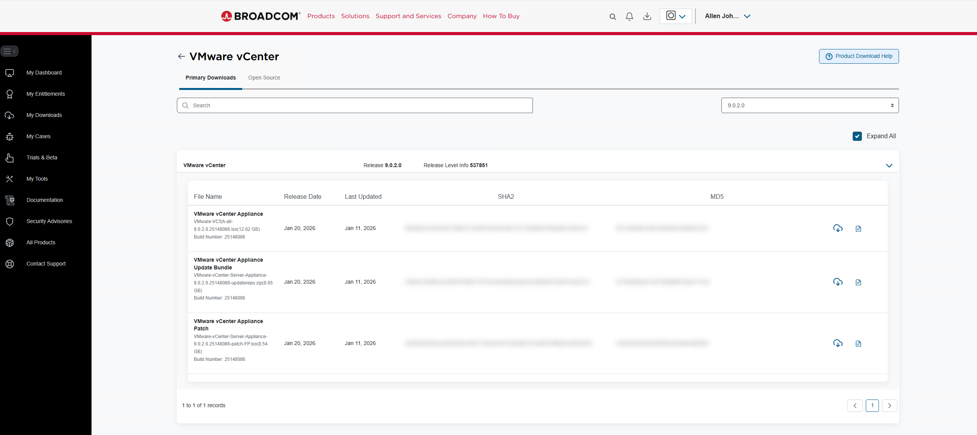

[SCREENSHOT] Broadcom Portal — ESX download page with Depot Bundle selected
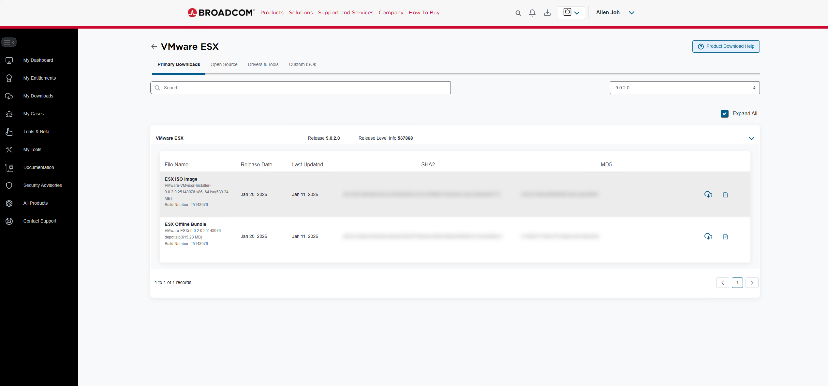

[SCREENSHOT] Broadcom Portal — NSX download page with Offline Bundle selected
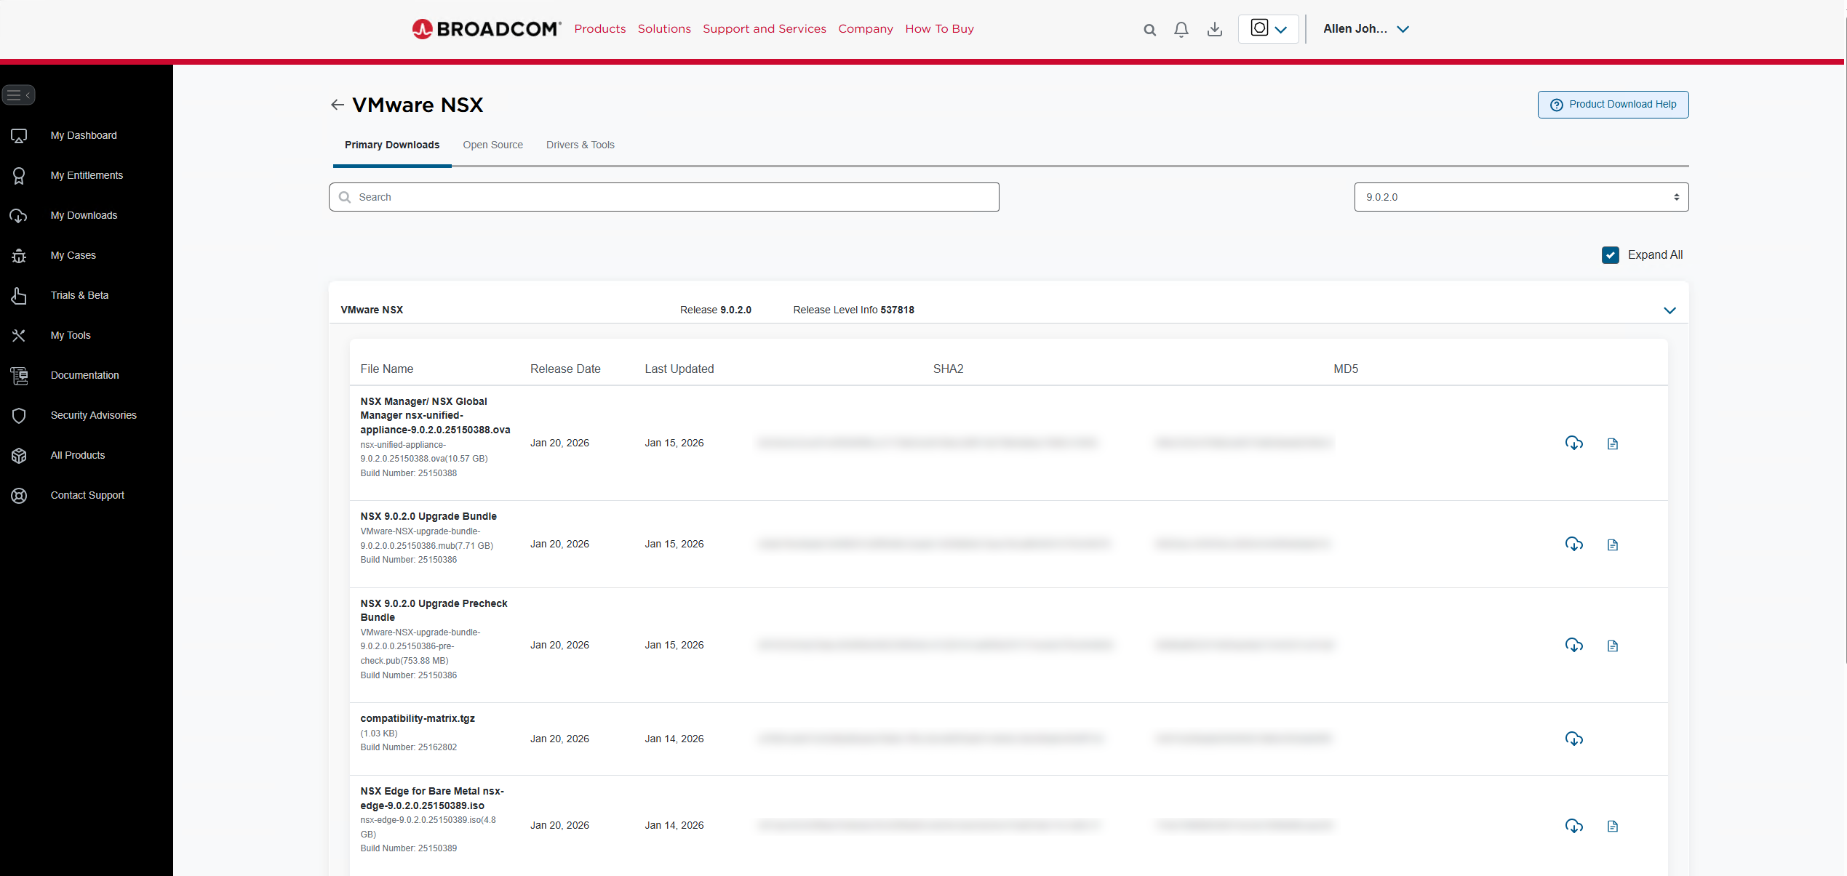

[SCREENSHOT] C:\vcf-offline folder — all 5 required bundle files downloaded and present
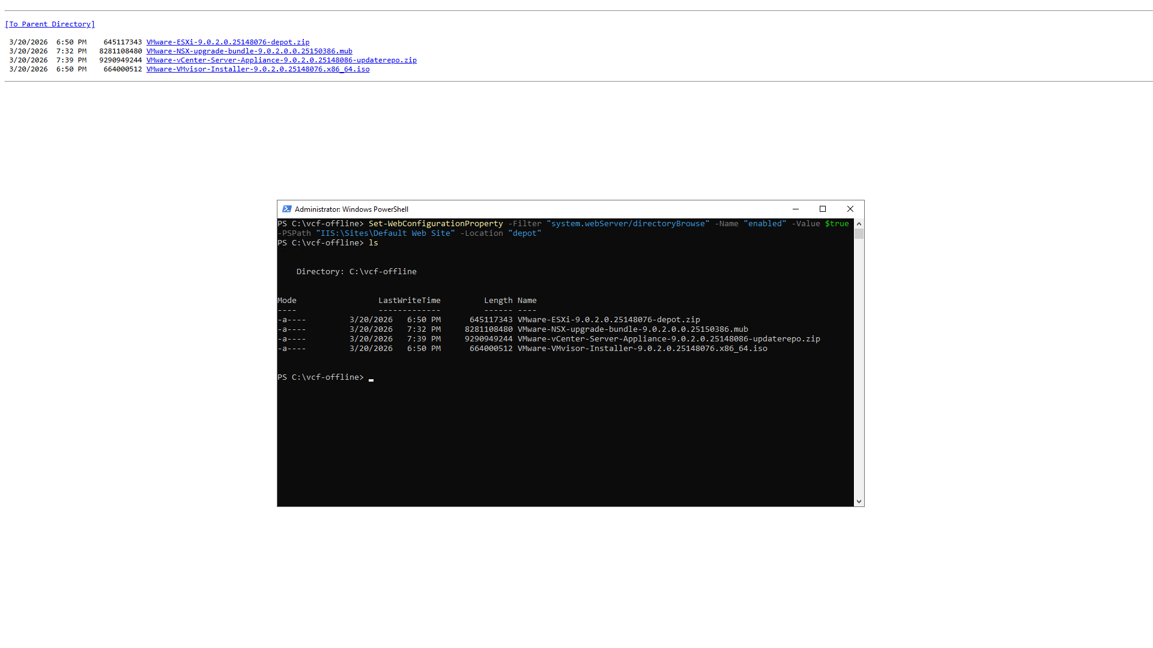

Phase 2 — Configure the Offline Depot on the Jump Server (Apache)

The jump server runs Ubuntu 24.04 LTS with Apache HTTP Server acting as a simple file depot. SDDC Manager connects to this server during bringup to pull the VCF bundles. This replaces IIS and works on any management network VM with a static IP.

2.1 Deploy the Jump Server VM (Ubuntu 24.04 LTS)
Provision a small Ubuntu 24.04 LTS VM on your management infrastructure:
- 2 vCPU | 4 GB RAM | 20 GB OS disk
- Static IP on the management network — e.g. hg-jump-01.humbledgeeks.com / 10.103.16.30
- Storage sized for all bundles — 20 GB minimum (the 5 required bundles total ~18 GB)

[SCREENSHOT] vCenter — Ubuntu 24.04 LTS VM powered on, static IP confirmed

2.2 Install Apache
SSH into the jump server and install Apache:
sudo apt update && sudo apt upgrade -y sudo apt install apache2 -y sudo systemctl enable --now apache2

[SCREENSHOT] Terminal — apache2 installed, systemctl status apache2 showing active (running)

2.3 Create the Depot Directory
Create the directory Apache will serve and set the correct ownership:
sudo mkdir -p /var/www/html/depot sudo chown -R www-data:www-data /var/www/html/depot

2.4 Transfer the Bundle Files
Copy the 5 bundle .zip files downloaded in Phase 1 to the depot directory. Use SCP from Windows (OpenSSH) or any transfer method available on your network:
# From a Windows machine with OpenSSH: scp C:\vcf-offline\*.zip ubuntu@10.103.16.30:/tmp/ # On the jump server — move to the Apache web root: sudo mv /tmp/*.zip /var/www/html/depot/ sudo chown www-data:www-data /var/www/html/depot/*.zip sudo chmod 644 /var/www/html/depot/*.zip

[SCREENSHOT] Terminal — ls /var/www/html/depot/ showing all 5 bundle .zip files present

2.5 Enable Directory Listing
SDDC Manager must be able to browse and enumerate the depot directory. Create an Apache config to enable directory listing:
sudo bash -c 'cat > /etc/apache2/conf-available/depot.conf << EOF <Directory /var/www/html/depot> Options +Indexes AllowOverride None Require all granted </Directory> EOF' sudo a2enconf depot sudo systemctl reload apache2

[SCREENSHOT] Terminal — a2enconf depot output, apache2 reloaded with no errors

2.6 Open the Firewall
Allow HTTP traffic through the Ubuntu firewall:
sudo ufw allow 80/tcp sudo ufw reload sudo ufw status

2.7 Test the Depot URL
Open a browser on any machine on the management network and navigate to:
http://hg-jump-01.humbledgeeks.com/depot/
You should see a directory listing of all 5 bundle .zip files. If you see a blank page or 403 error, recheck Step 2.5 — directory listing may not be enabled.

[SCREENSHOT] Browser — http://hg-jump-01.humbledgeeks.com/depot/ showing directory listing of all 5 bundle files

TIP: If you do not yet have a DNS A record for the jump server, use the raw IP: http://10.103.16.30/depot/ You can add the DNS record after Phase 3.

TIP: If you do not yet have a DNS A record for the jump server, use the raw IP: http://10.103.16.30/depot/ You can add the DNS record after Phase 3.

[SCREENSHOT] Browser — http://hg-jump-01.humbledgeeks.com/depot/ showing directory listing of all 5 bundle files

You should see a directory listing of all 5 bundle .zip files. If the page is blank or returns a 403, check Step 2.5 — directory listing may not be enabled.
http://hg-jump-01.humbledgeeks.com/depot/
Open a browser on any machine on the management network and navigate to:

2.7 Test the Depot URL

sudo ufw allow 80/tcp sudo ufw reload sudo ufw status
Allow HTTP traffic through the Ubuntu firewall:

2.6 Open the Firewall

[SCREENSHOT] Terminal — a2enconf depot output, apache2 reloaded successfully with no errors

sudo bash -c 'cat > /etc/apache2/conf-available/depot.conf << EOF <Directory /var/www/html/depot> Options +Indexes AllowOverride None Require all granted </Directory> EOF' sudo a2enconf depot sudo systemctl reload apache2
SDDC Manager must be able to enumerate the depot directory. Enable directory listing in Apache:

2.5 Enable Directory Listing

[SCREENSHOT] Terminal — ls /var/www/html/depot/ showing all 5 bundle .zip files present

# From a Windows machine with OpenSSH (run in PowerShell or CMD): scp C:\vcf-offline\*.zip ubuntu@10.103.16.30:/tmp/ # On the jump server — move bundles to the web root: sudo mv /tmp/*.zip /var/www/html/depot/ sudo chown www-data:www-data /var/www/html/depot/*.zip sudo chmod 644 /var/www/html/depot/*.zip
Copy the 5 bundle .zip files downloaded in Phase 1 to the depot directory on the jump server. Use SCP or any file transfer method available on your network:

2.4 Transfer the Bundle Files

sudo mkdir -p /var/www/html/depot sudo chown -R www-data:www-data /var/www/html/depot
Create the directory Apache will serve and set correct ownership:

2.3 Create the Depot Directory

[SCREENSHOT] Terminal — apache2 installed, systemctl status apache2 showing active (running)

sudo apt update && sudo apt upgrade -y sudo apt install apache2 -y sudo systemctl enable --now apache2
SSH into the jump server and install Apache:

2.2 Install Apache

[SCREENSHOT] vCenter — Ubuntu 24.04 LTS VM deployed and powered on, static IP confirmed

- Static IP on the management network — e.g. hg-jump-01.humbledgeeks.com / 10.103.16.30
- 2 vCPU | 4 GB RAM | 20 GB OS disk | Additional storage large enough for all bundles (~20 GB minimum)
Provision a small Ubuntu 24.04 LTS VM on your management infrastructure with the following specs:

2.1 Deploy the Jump Server VM (Ubuntu 24.04 LTS)

The jump server runs Ubuntu 24.04 LTS with Apache HTTP Server acting as a simple file depot. SDDC Manager connects to this server during bringup to download the VCF bundles. This replaces IIS and works on any management network VM or physical server with a static IP.

Phase 3 — DNS Verification
ALREADY DONE: A records already exist for: dc3-srv-sddc, hg-vcf-mgmt1, hg-vcf-nsx-a/b/c, hg-vcf-aria, hg-vcf-ops, hg-vcf-fleet, hg-vcf-opscollector, dc3-hst-esxi02 through dc3-hst-esxi08.

3.1 Records Still Needed
Host | Record Needed | Done?
Jump Server | A record + PTR (optional but recommended) | [ ]
dc3-hst-esxi01.humbledgeeks.com | A record + PTR (add now, host ready later) | [ ]
All VCF components | Confirm PTR reverse DNS records exist for each | [ ]

WARNING: PTR (reverse DNS) records are required. SDDC Manager performs reverse lookups during pre-checks. A host that resolves forward but not in reverse will fail validation.

3.2 Validate DNS Before Opening the Bringup Wizard
# Forward lookups — VCF components
nslookup dc3-srv-sddc.humbledgeeks.com
nslookup hg-vcf-mgmt1.humbledgeeks.com
nslookup hg-vcf-nsx-a.humbledgeeks.com
nslookup hg-vcf-nsx-b.humbledgeeks.com
nslookup hg-vcf-nsx-c.humbledgeeks.com
# Forward lookups — ESXi hosts
nslookup dc3-hst-esxi02.humbledgeeks.com
nslookup dc3-hst-esxi03.humbledgeeks.com
nslookup dc3-hst-esxi04.humbledgeeks.com
nslookup dc3-hst-esxi05.humbledgeeks.com
nslookup dc3-hst-esxi06.humbledgeeks.com
nslookup dc3-hst-esxi07.humbledgeeks.com
nslookup dc3-hst-esxi08.humbledgeeks.com
# Reverse lookups
nslookup 10.103.16.19
nslookup 10.103.16.20
nslookup 10.103.16.25
nslookup 10.103.16.52
# Confirm depot is reachable
curl -I http://<jump-server-ip>/depot/
[SCREENSHOT] Terminal — nslookup results showing clean forward and reverse resolution for all components

WARNING: Do not proceed to Phase 4 until all forward and reverse lookups resolve correctly.

Phase 4 — Configure the Depot in SDDC Manager
ALREADY DONE: SDDC Manager deployed: dc3-srv-sddc.humbledgeeks.com / 10.103.16.19

4.1 Log Into SDDC Manager
Open a browser and navigate to: https://dc3-srv-sddc.humbledgeeks.com
[SCREENSHOT] SDDC Manager — Login screen
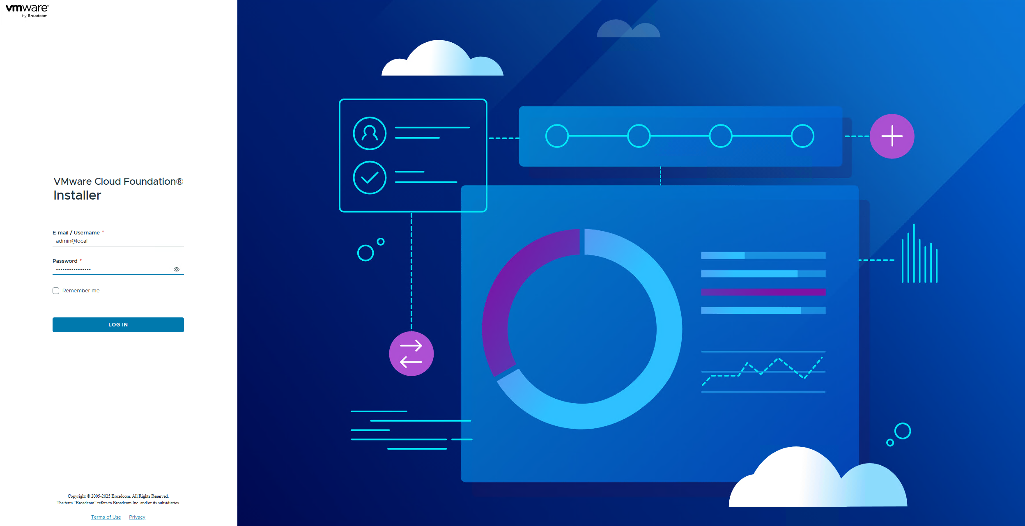

[SCREENSHOT] SDDC Manager — Dashboard after login
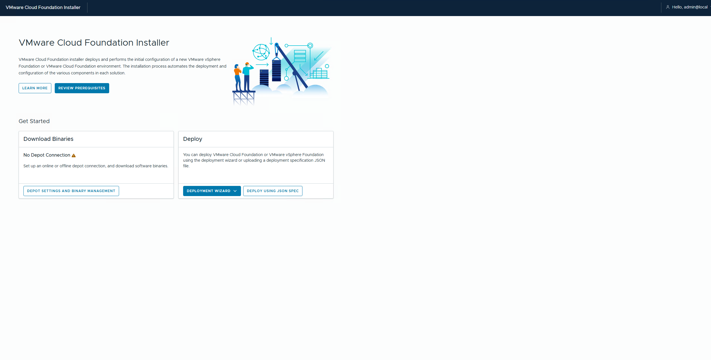

4.2 Configure Offline Depot
- Navigate to: Administration → Depot Settings
- Select: Offline Depot
- Enter depot URL: http://<jump-server-ip>/depot/
- Click Validate — wait for SDDC Manager to enumerate the available bundles
- Click Save once validation passes
[SCREENSHOT] SDDC Manager — Depot Settings — Offline Depot URL entered
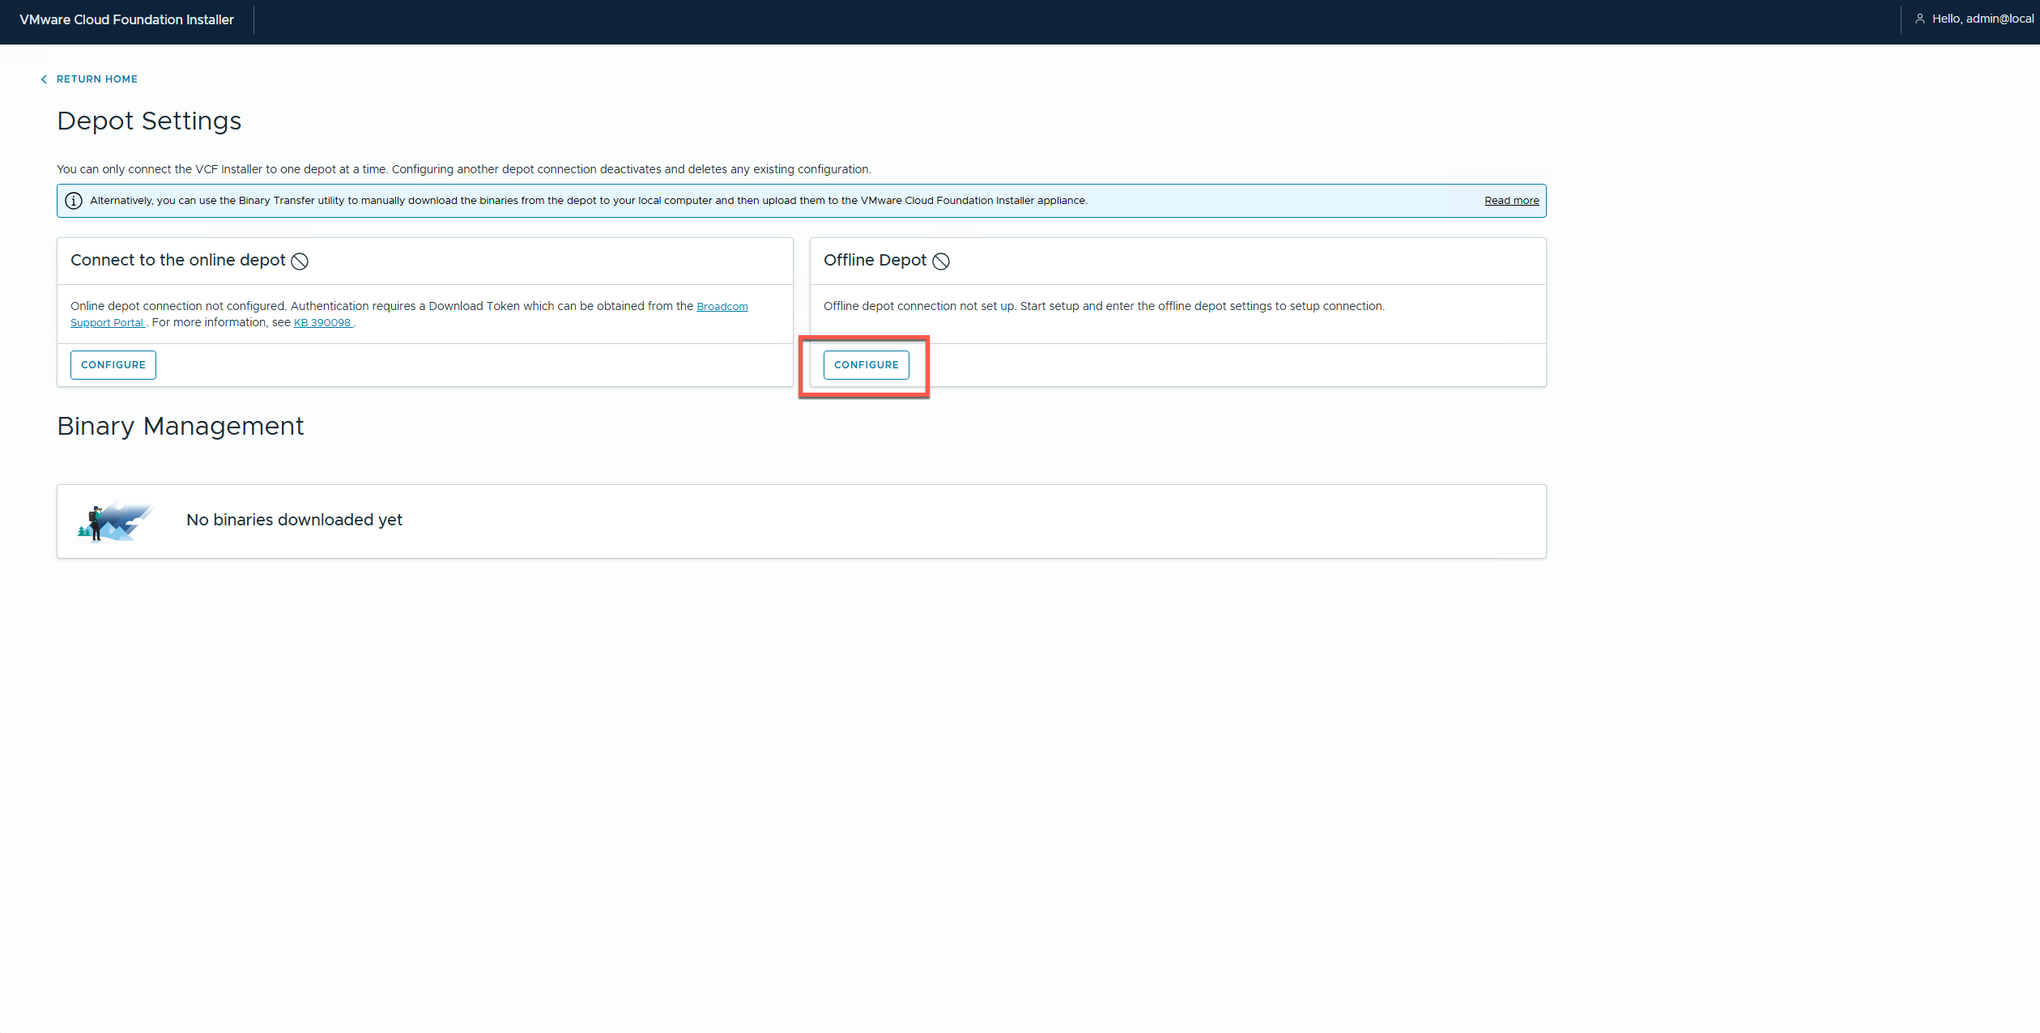
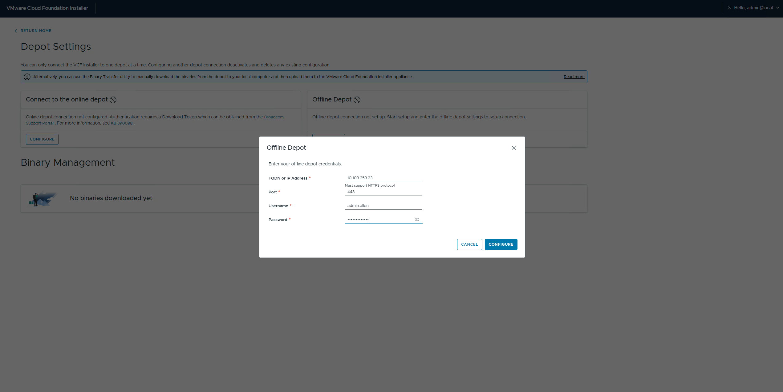

[SCREENSHOT] SDDC Manager — Depot validation succeeded

[SCREENSHOT] SDDC Manager — All 5 bundles listed and available after offline depot validated

4.3 Alternative — Online Depot (Broadcom API Token)
NOTE: Use this section to demonstrate the online depot path for the blog post.

- Log into https://support.broadcom.com
- Navigate to: My Dashboard → API Tokens → Generate Token
- Copy the token — displayed only once
- In SDDC Manager: Administration → Depot Settings → Online Depot
- Paste the token and click Connect
- Wait for the bundle manifest to sync
[SCREENSHOT] Broadcom Support Portal — API Token generation page

[SCREENSHOT] SDDC Manager — Online Depot connected and bundle manifest synced

Phase 5 — VCF Bringup
WARNING: Bringup takes 2–4 hours on B200 M4 hardware. Do not restart any component during bringup.

5.1 Start Bringup and Run Pre-Checks
SDDC Manager validates all hosts, network reachability, and hardware compatibility. CPU and hardware warnings are expected on B200 M4 blades. Resolve any red failures before proceeding — yellow warnings are acceptable.
[SCREENSHOT] SDDC Manager — Bringup wizard — host and network entry screen

[SCREENSHOT] SDDC Manager — Pre-check results, all hosts validated

5.2 Management Domain Host Assignment
When the wizard prompts for Management Domain hosts, enter these four:
Hostname | FQDN | IP
dc3-hst-esxi02 | dc3-hst-esxi02.humbledgeeks.com | 10.103.16.52
dc3-hst-esxi03 | dc3-hst-esxi03.humbledgeeks.com | 10.103.16.53
dc3-hst-esxi04 | dc3-hst-esxi04.humbledgeeks.com | 10.103.16.54
dc3-hst-esxi05 | dc3-hst-esxi05.humbledgeeks.com | 10.103.16.55

NOTE: Do not include esxi01 (offline) or the workload hosts at this stage.

5.3 Handle CPU Compatibility Check
If SDDC Manager blocks on CPU compatibility for the B200 M4 blades, SSH in and bypass:
ssh admin@dc3-srv-sddc.humbledgeeks.com
vcf-bringup --config /path/to/bringup.json --skip-cpu-compatibility-check

5.4 Monitor Bringup Progress
SDDC Manager shows a task timeline as each component deploys. If a task fails, click the log link on that task for details.
[SCREENSHOT] SDDC Manager — Bringup task timeline in progress

[SCREENSHOT] SDDC Manager — Bringup complete, Management Domain healthy

5.5 Post-Bringup Verification Checklist
[ ] SDDC Manager dashboard — Management Domain shows green
[ ] vCenter accessible: https://hg-vcf-mgmt1.humbledgeeks.com
[ ] NSX Manager accessible: https://hg-vcf-nsx-a.humbledgeeks.com
[ ] All 4 Management Domain ESXi hosts visible in vCenter cluster
[ ] SDDC Manager Inventory shows all 4 hosts enrolled
[SCREENSHOT] SDDC Manager — Final dashboard, Management Domain all green

[SCREENSHOT] vCenter — Management cluster showing esxi02 through esxi05

Phase 6 — Deploy VI Workload Domain
With the Management Domain healthy, deploy the VI Workload Domain using the remaining 3 hosts. esxi01 can be added later once the SSD install is complete.

6.1 Create the Workload Domain
- In SDDC Manager, navigate to: Workload Domains → Add Domain
- Select domain type: VI (Virtual Infrastructure)
- Enter a domain name (e.g. vcf-workload-01)
- Add the three workload hosts:
Hostname | FQDN | IP
dc3-hst-esxi06 | dc3-hst-esxi06.humbledgeeks.com | 10.103.16.56
dc3-hst-esxi07 | dc3-hst-esxi07.humbledgeeks.com | 10.103.16.57
dc3-hst-esxi08 | dc3-hst-esxi08.humbledgeeks.com | 10.103.16.58

[SCREENSHOT] SDDC Manager — Add Workload Domain wizard with esxi06–08 entered

[SCREENSHOT] SDDC Manager — Workload Domain deployment in progress

[SCREENSHOT] SDDC Manager — Workload Domain healthy, all 3 hosts enrolled

6.2 Adding ESXi01 After SSD Install
Once dc3-hst-esxi01.humbledgeeks.com (10.103.16.51) is back online:
- Confirm DNS A and PTR records exist for dc3-hst-esxi01.humbledgeeks.com
- Verify the host is reachable and ESXi is healthy
- In SDDC Manager: Workload Domains → vcf-workload-01 → Hosts → Add Host
- Enter hostname: dc3-hst-esxi01.humbledgeeks.com and IP: 10.103.16.51
- SDDC Manager will validate and commission the host into the domain
[SCREENSHOT] SDDC Manager — esxi01 added to Workload Domain, 4 hosts total

Working Notes
__________________________________________________________________________________________
__________________________________________________________________________________________
__________________________________________________________________________________________
__________________________________________________________________________________________
__________________________________________________________________________________________
__________________________________________________________________________________________
__________________________________________________________________________________________
__________________________________________________________________________________________
__________________________________________________________________________________________
__________________________________________________________________________________________
__________________________________________________________________________________________
__________________________________________________________________________________________
__________________________________________________________________________________________
__________________________________________________________________________________________
__________________________________________________________________________________________
__________________________________________________________________________________________
__________________________________________________________________________________________
__________________________________________________________________________________________
__________________________________________________________________________________________
__________________________________________________________________________________________
__________________________________________________________________________________________
__________________________________________________________________________________________
__________________________________________________________________________________________
__________________________________________________________________________________________

