VCF v9 Deployment
Working Guide
HumbledGeeks Lab • AFF A300 + UCS B200 M4 • Domain: humbledgeeks.com

Host Assignment
Deploying with 7 of 8 hosts. dc3-hst-esxi01 is temporarily offline (SSD install) and will be added to the Workload Domain once back online.

Management Domain — 4 Hosts (vSAN)
Hostname | FQDN | IP
dc3-hst-esxi02 | dc3-hst-esxi02.humbledgeeks.com | 10.103.16.52
dc3-hst-esxi03 | dc3-hst-esxi03.humbledgeeks.com | 10.103.16.53
dc3-hst-esxi04 | dc3-hst-esxi04.humbledgeeks.com | 10.103.16.54
dc3-hst-esxi05 | dc3-hst-esxi05.humbledgeeks.com | 10.103.16.55

VI Workload Domain — 3 Hosts
Hostname | FQDN | IP
dc3-hst-esxi06 | dc3-hst-esxi06.humbledgeeks.com | 10.103.16.56
dc3-hst-esxi07 | dc3-hst-esxi07.humbledgeeks.com | 10.103.16.57
dc3-hst-esxi08 | dc3-hst-esxi08.humbledgeeks.com | 10.103.16.58

NOTE: dc3-hst-esxi01 (10.103.16.51) will be added to the Workload Domain after the SSD install is complete, bringing it to 4 hosts.

Environment Reference
Component | FQDN / Name | IP | Status
DNS Server |  | 10.103.20.11 | Done
SDDC Manager | dc3-srv-sddc.humbledgeeks.com | 10.103.16.19 | Done — deployed
vCenter | hg-vcf-mgmt1.humbledgeeks.com | 10.103.16.20 | DNS done
NSX Manager A | hg-vcf-nsx-a.humbledgeeks.com | 10.103.16.25 | DNS done
NSX Manager B | hg-vcf-nsx-b.humbledgeeks.com | 10.103.16.26 | DNS done
NSX Manager C | hg-vcf-nsx-c.humbledgeeks.com | 10.103.16.27 | DNS done
dc3-app-web1 (Apache) | dc3-app-web1.humbledgeeks.com | 10.103.16.245 | Pending setup
ESXi01 (offline) | dc3-hst-esxi01.humbledgeeks.com | 10.103.16.51 | SSD install
ESXi02 — Mgmt | dc3-hst-esxi02.humbledgeeks.com | 10.103.16.52 | Ready
ESXi03 — Mgmt | dc3-hst-esxi03.humbledgeeks.com | 10.103.16.53 | Ready
ESXi04 — Mgmt | dc3-hst-esxi04.humbledgeeks.com | 10.103.16.54 | Ready
ESXi05 — Mgmt | dc3-hst-esxi05.humbledgeeks.com | 10.103.16.55 | Ready
ESXi06 — Workload | dc3-hst-esxi06.humbledgeeks.com | 10.103.16.56 | Ready
ESXi07 — Workload | dc3-hst-esxi07.humbledgeeks.com | 10.103.16.57 | Ready
ESXi08 — Workload | dc3-hst-esxi08.humbledgeeks.com | 10.103.16.58 | Ready

Phase 1 — Download VCF Bundles from Broadcom
NOTE: The SDDC Manager OVA you already deployed is the management appliance. The bundles below are what SDDC Manager pulls from the depot to deploy vCenter, NSX, and configure ESXi hosts during bringup. These are two separate things.

1.1 Log Into the Broadcom Support Portal
A free Broadcom account gives access to VCF evaluation downloads. No partner or support contract required.

1. Go to https://support.broadcom.com and sign in (create a free account if needed).
2. Navigate to: My Dashboard → Software → VMware Cloud Foundation
3. If VCF is not listed: Product Downloads → All Products → search "VMware Cloud Foundation"
4. Select VCF 9.0.2.0

📷 Broadcom Support Portal — VCF 9.0.2.0 download page showing full bundle list
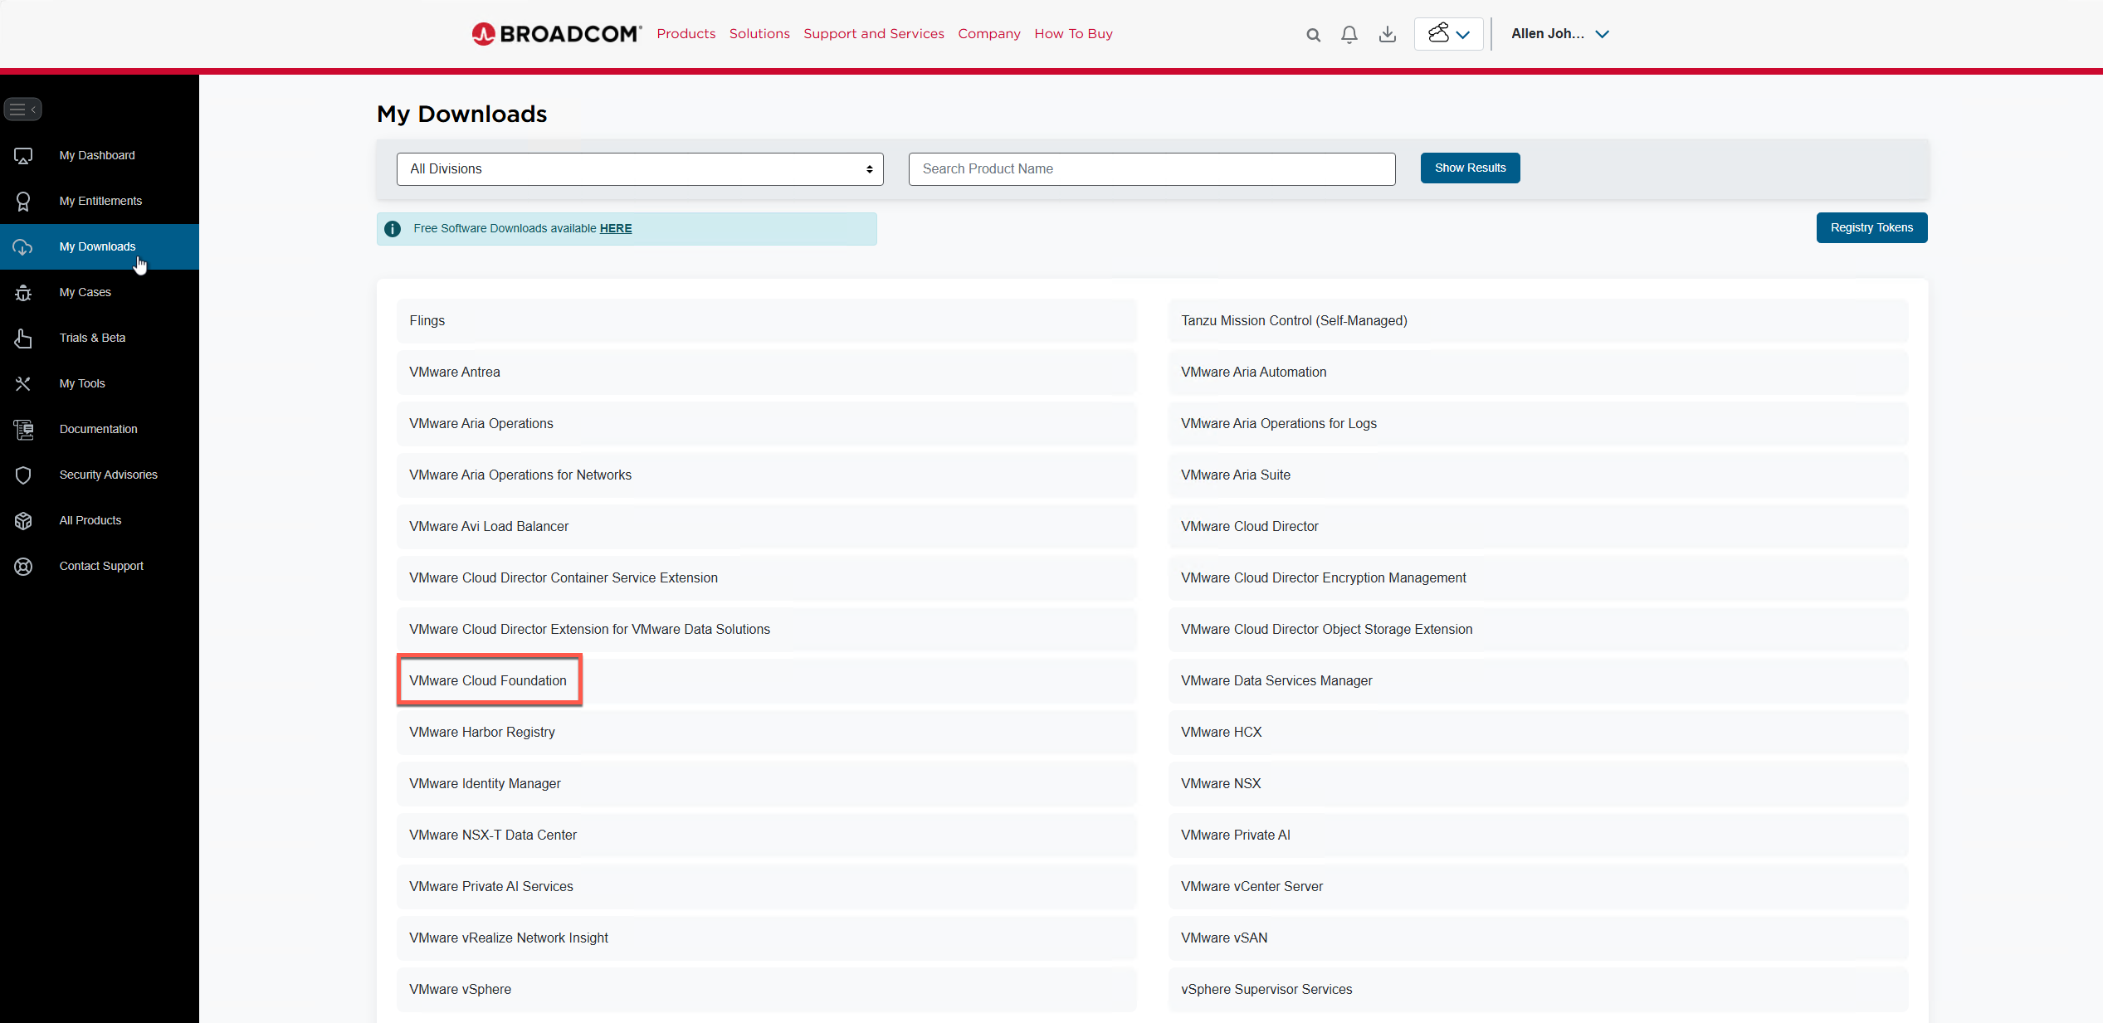
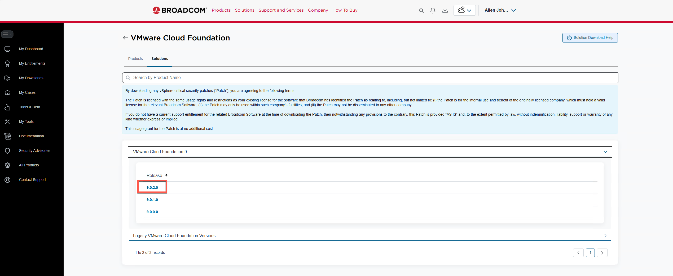
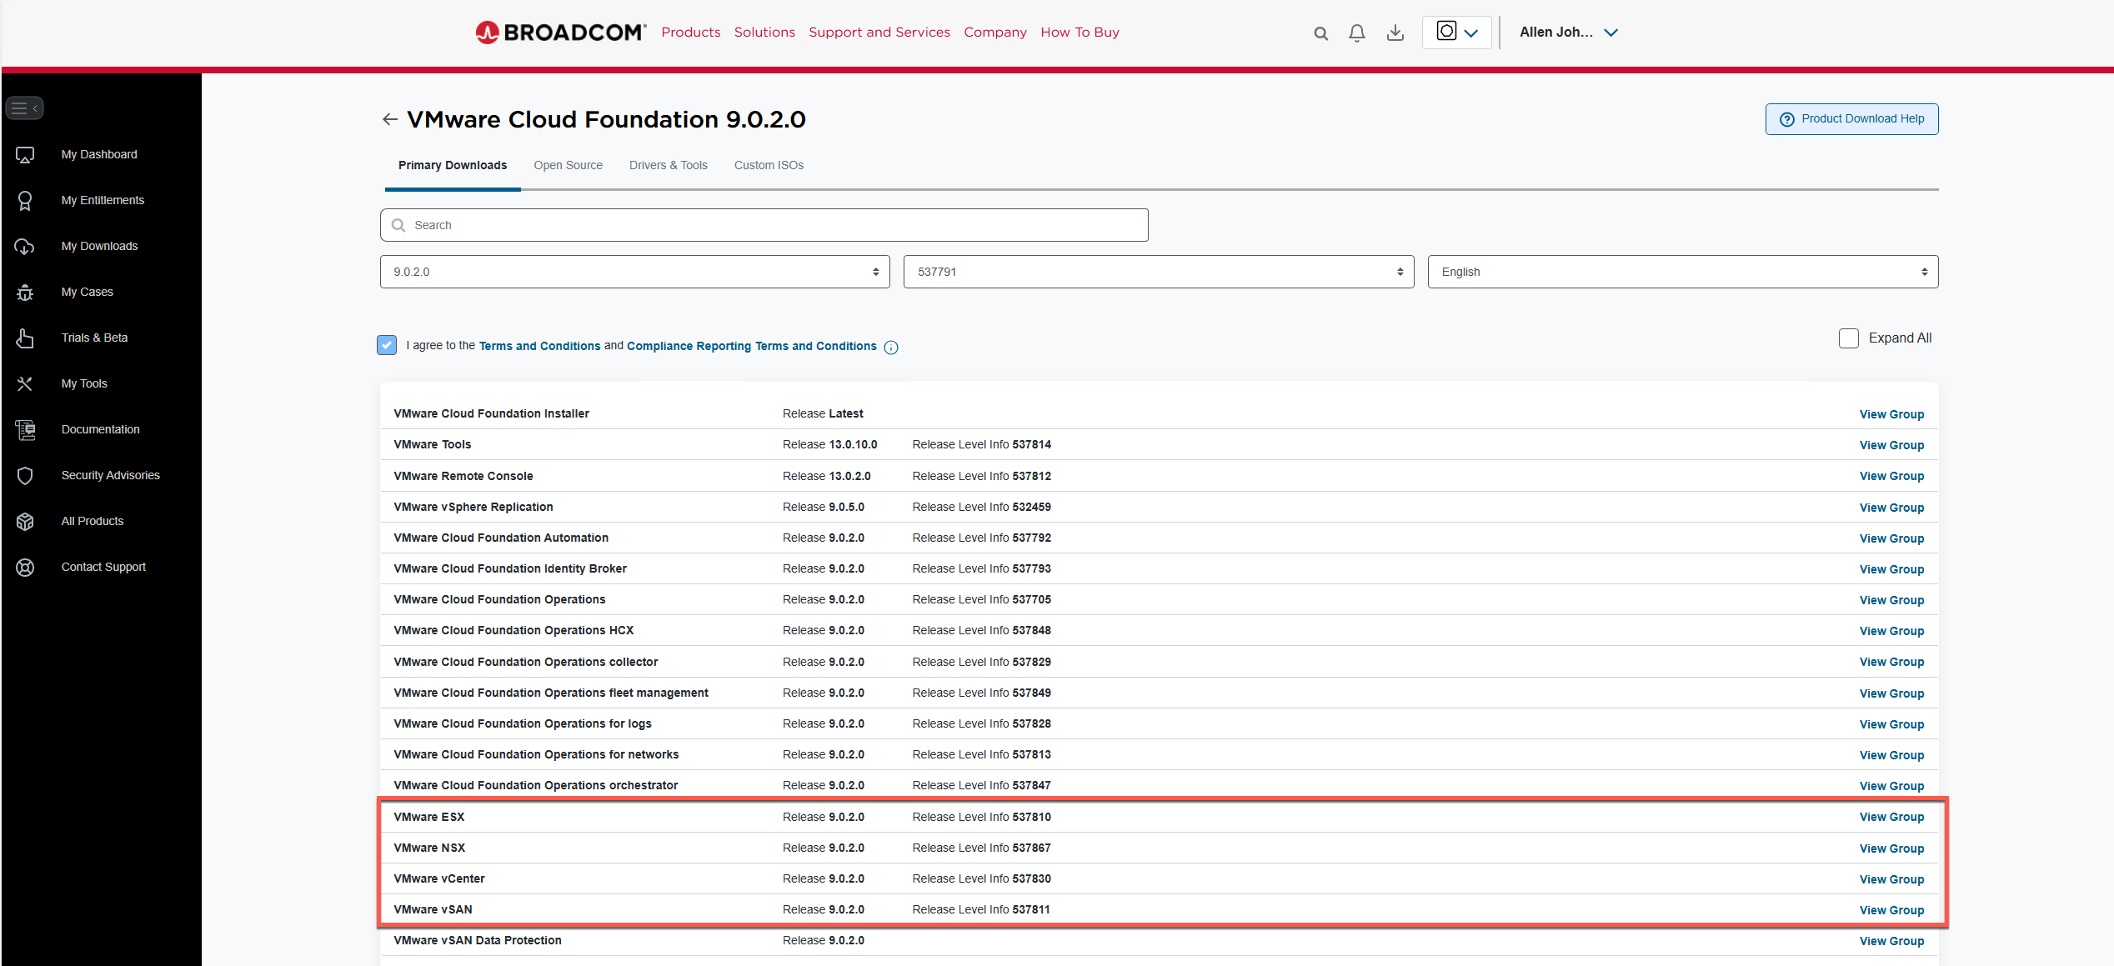

1.2 Download the Required Depot Bundles
Download ALL files listed below for each component. The VCF Installer looks for specific filenames in specific COMP subdirectories — missing a file will cause a BundleNotFoundException during Binary Management.

Component | File(s) to Download | Size | Done?
ESX_HOST | VMware-ESXi-9.0.2.0.25148076-depot.zip  VMware-VMvisor-Installer-9.0.2.0.25148076.x86_64.iso | ~615 MB  ~634 MB | [ ]
VCENTER | VMware-VCSA-all-9.0.2.0.25148086.iso ← REQUIRED for fresh install  VMware-vCenter-Server-Appliance-9.0.2.0.25148086-updaterepo.zip | ~10–12 GB  ~8.7 GB | [ ]
NSX_T_MANAGER | VMware-NSX-upgrade-bundle-9.0.2.0.0.25150386.mub  nsx-unified-appliance-9.0.2.0.25150388.ova | ~7.8 GB  ~varies | [ ]
SDDC_MANAGER_VCF | VCF-SDDC-Manager-Appliance-9.0.2.0.25151285.ova | ~2.1 GB | [ ]
VRSLCM | VCF-OPS-Lifecycle-Manager-Appliance-9.0.2.0.25137839.ova  VCF-OPS-Lifecycle-Manager-9.0.2.0.25137839.patch | ~1.5 GB  ~1.6 GB | [ ]
VRLI | Operations-Logs-Appliance-9.0.2.0.25137850.pak | ~1.0 GB | [ ]
VROPS | Operations-Upgrade-9.0.2.0.25137843.pak | ~5.2 GB | [ ]
VCF_OPS_CLOUD_PROXY | Operations-Cloud-Proxy-9.0.2.0.25137840.ova | ~2.8 GB | [ ]

CRITICAL: The VMware-VCSA-all-9.0.2.0.25148086.iso is required for a fresh vCenter deployment. Do NOT download only the updaterepo.zip — the VCF Installer will fail with BundleNotFoundException without the full ISO. Total download is approximately 40+ GB.

📷 Broadcom Portal — vCenter download page with Update Bundle (.zip) selected
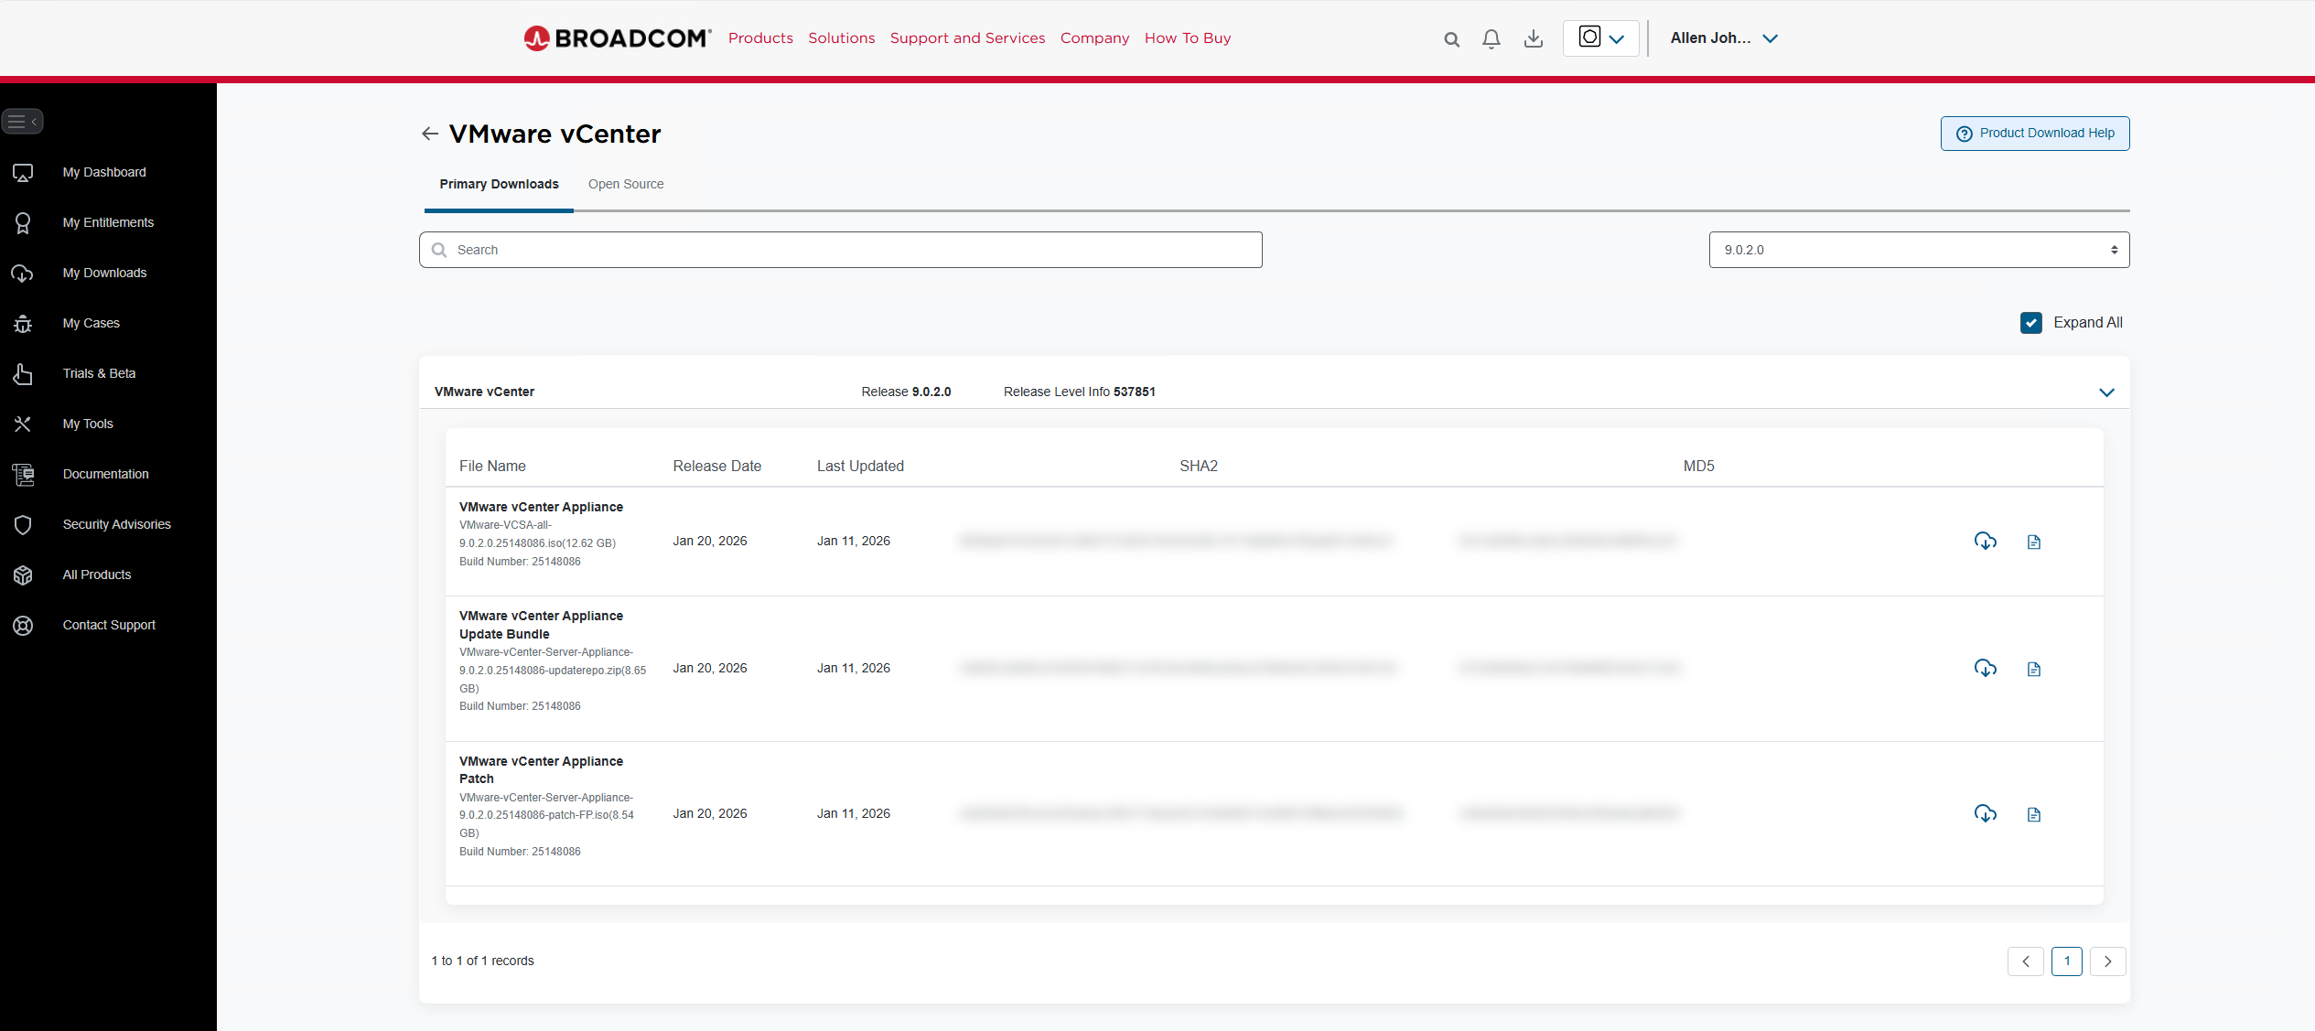

📷 Broadcom Portal — ESX download page with Depot Bundle selected
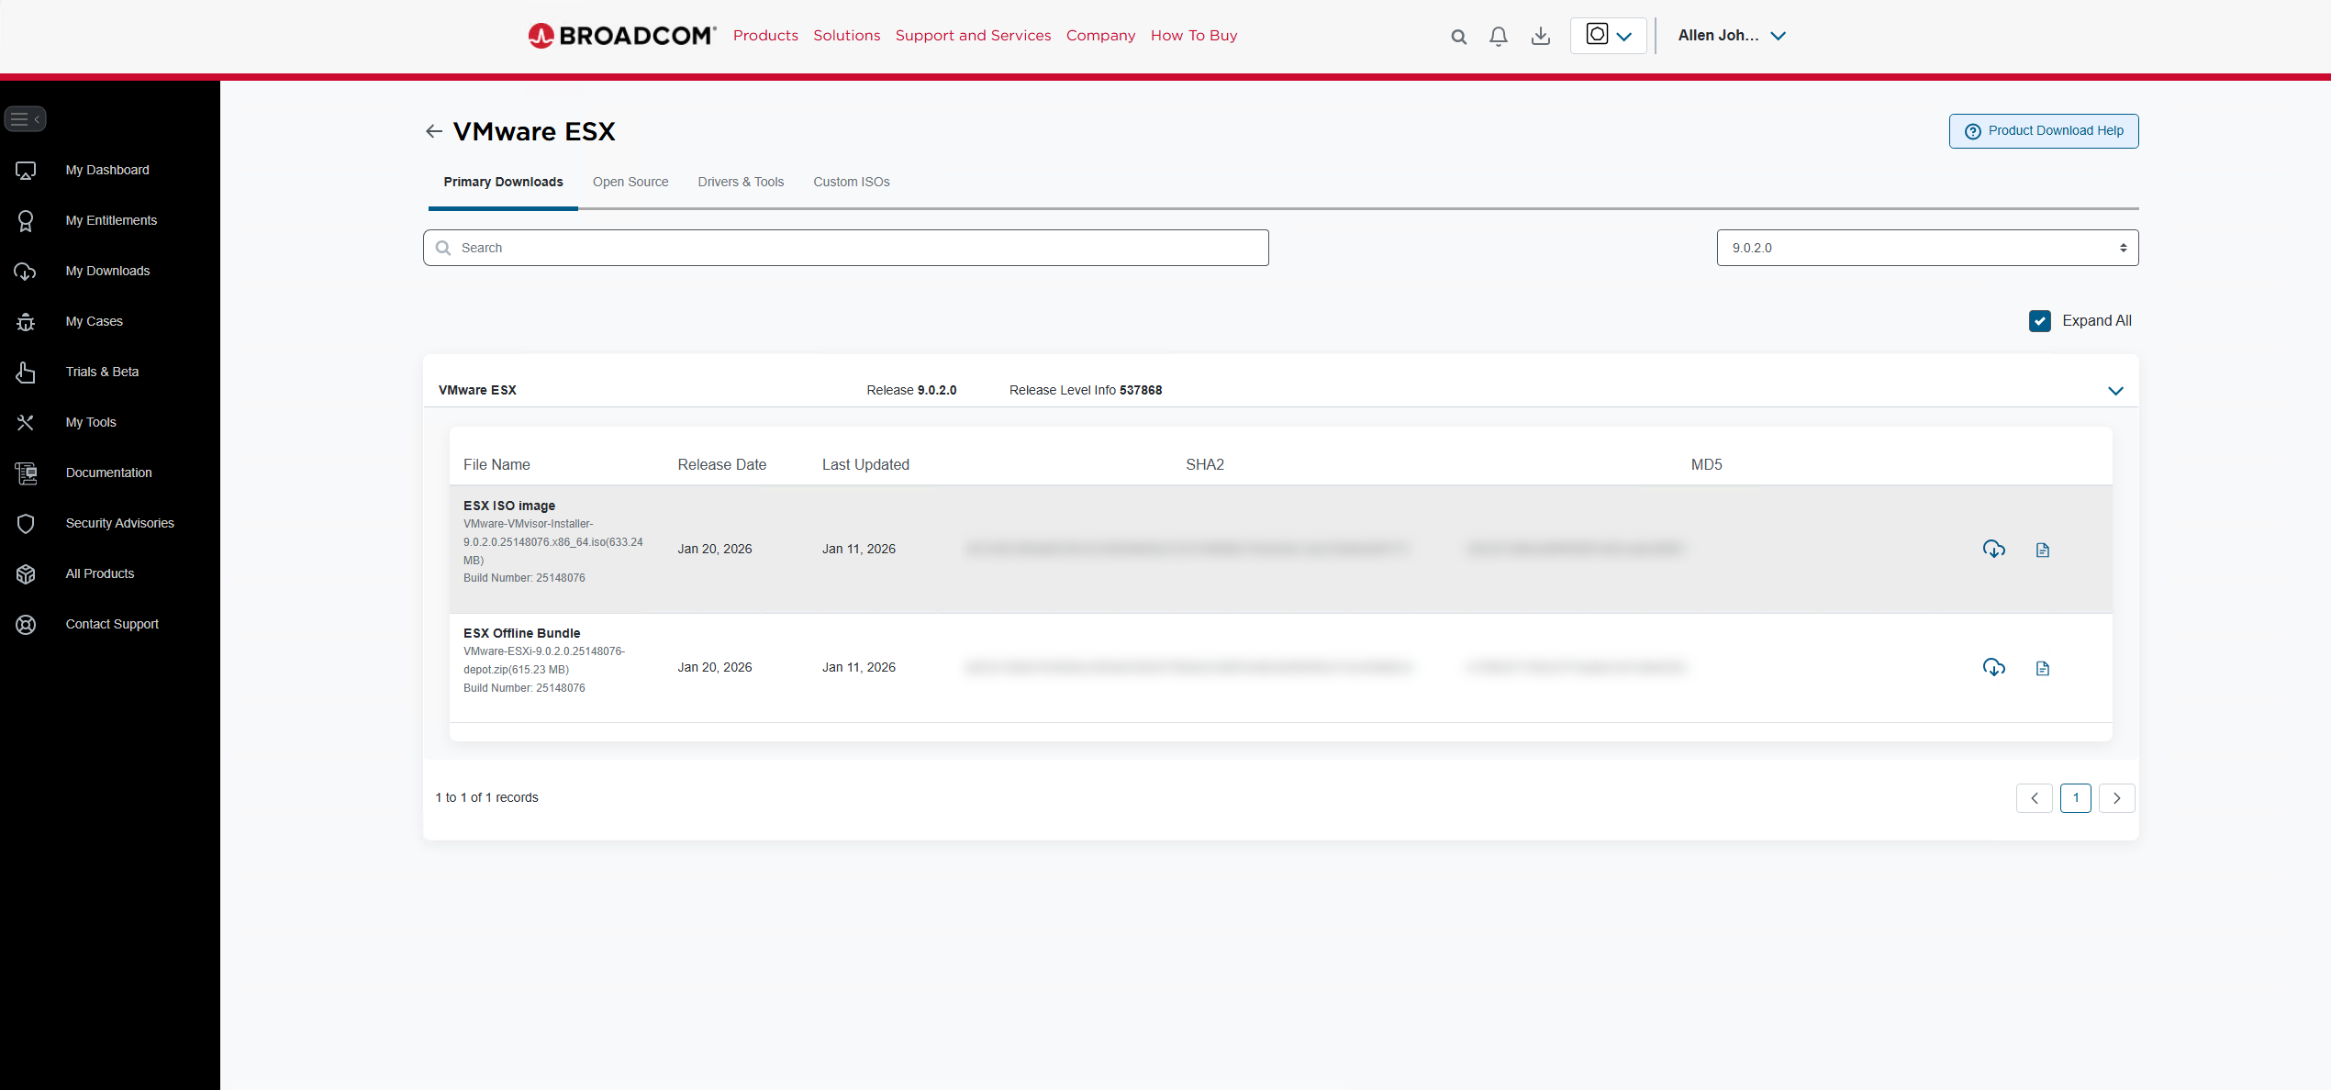

📷 Broadcom Portal — NSX download page with Offline Bundle selected
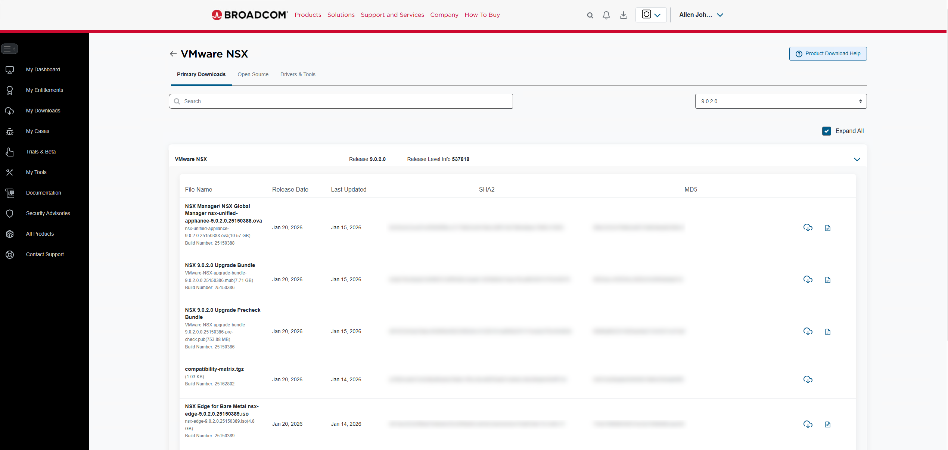

📷 C:\vcf-offline folder — all 5 required bundle files downloaded and present
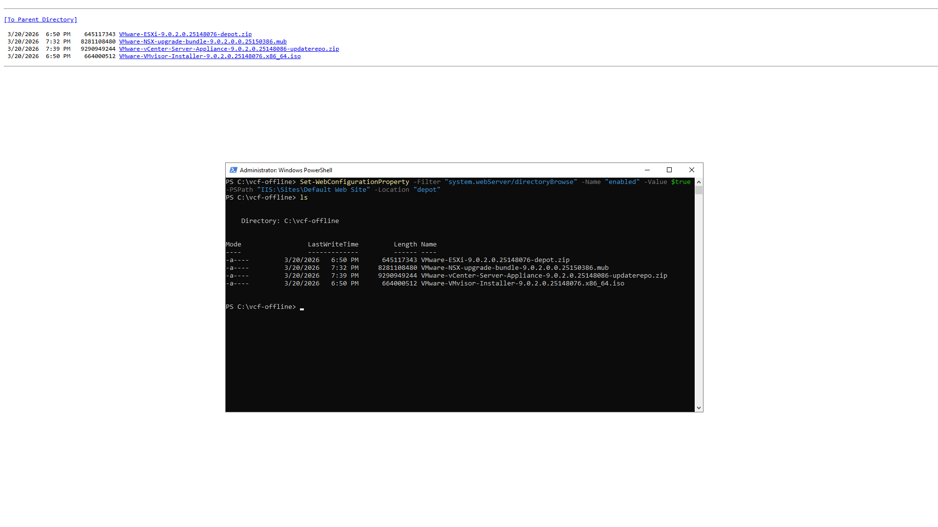

1.3 Post-Bringup Add-Ons (Download Later)
These components are optional and can be deployed after VCF bringup is complete. Do not download them now — focus on getting VCF up first.

Product | Approx. Size | Notes
VCF Operations | ~5 GB | Aria Operations — deploy post-bringup
VCF Operations Collector | ~2 GB | Deploy after Operations
VCF Operations Fleet Management | ~2 GB | Fleet management add-on
VCF Operations for Logs | ~2 GB | Log analytics
VCF Automation | ~23 GB | Aria Automation — large, deploy when needed
VCF Identity Broker | ~1 GB | Required if deploying Automation
VCF Operations HCX | varies | Only if doing HCX migrations
VMware vSphere Replication | varies | DR replication — post-bringup

Phase 2 — Configure the Offline Depot on dc3-app-web1 (Ubuntu + Apache)
The depot server runs Ubuntu 24.04 LTS with Apache HTTP Server acting as a simple file server. The VCF Installer connects to this server to pull the VCF bundles during bringup.

IMPORTANT — Three lessons learned the hard way:
1. The VCF Installer prepends /PROD/ to all depot paths. Set DocumentRoot to /var/www/html/depot (not /depot/PROD) and place your bundles inside a PROD subfolder.
2. Do NOT configure Basic Auth on Apache — the VCF Installer does not support it and will return a '400 Bad Request' error.
3. Disable the Apache default-ssl.conf site — it overrides your custom depot-ssl.conf on port 443.

2.1 Deploy the dc3-app-web1 VM (Ubuntu 24.04 LTS)
Provision a small Ubuntu 24.04 LTS VM on your management infrastructure with the following specs:
• 2 vCPU | 4 GB RAM | 20 GB OS disk
• Additional storage large enough for all bundles (~20 GB minimum for the 5 required bundles)
• Static IP on the management network — dc3-app-web1.humbledgeeks.com / 10.103.16.245

📷 vCenter — Ubuntu 24.04 LTS VM deployed and powered on, static IP confirmed

2.2 Update and Install Apache
SSH into dc3-app-web1 and run the following:

sudo apt update && sudo apt upgrade -y
sudo apt install apache2 -y
sudo systemctl enable --now apache2
sudo systemctl status apache2

Confirm Apache is active (running) before continuing.

📷 Terminal — apache2 installed, systemctl status apache2 showing active (running)

2.3 Enable the SSL Module
The VCF Installer requires HTTPS (port 443). Enable the SSL module then immediately disable the default SSL site — leaving default-ssl enabled will override your custom depot config:

sudo a2enmod ssl
sudo systemctl restart apache2
sudo a2dissite default-ssl
sudo systemctl reload apache2

WARNING: Do NOT run 'sudo a2ensite default-ssl'. If you already enabled it, run 'sudo a2dissite default-ssl' before continuing — it listens on *:443 and overrides the depot config.

2.4 Generate a Self-Signed SSL Certificate
Generate a self-signed certificate valid for 10 years. The VCF Installer accepts self-signed certs:

sudo openssl req -x509 -nodes -days 3650 -newkey rsa:2048 \
-keyout /etc/ssl/private/depot-selfsigned.key \
-out /etc/ssl/certs/depot-selfsigned.crt \
-subj "/CN=dc3-app-web1.humbledgeeks.com/O=HumbledGeeks/C=US"

📷 Terminal — openssl cert generation output showing certificate written

2.5 Create the Depot Directory Structure
The VCF Installer constructs binary download paths as /COMP/{COMPONENT_TYPE}/{filename}. With DocumentRoot set to /var/www/html/depot/PROD, each component type needs its own subdirectory. Create the full structure up front:

sudo mkdir -p /var/www/html/depot/PROD/COMP/ESX_HOST
sudo mkdir -p /var/www/html/depot/PROD/COMP/VCENTER
sudo mkdir -p /var/www/html/depot/PROD/COMP/NSX_T_MANAGER
sudo mkdir -p /var/www/html/depot/PROD/COMP/SDDC_MANAGER_VCF
sudo mkdir -p /var/www/html/depot/PROD/COMP/VRSLCM
sudo mkdir -p /var/www/html/depot/PROD/COMP/VRLI
sudo mkdir -p /var/www/html/depot/PROD/COMP/VROPS
sudo mkdir -p /var/www/html/depot/PROD/COMP/VCF_OPS_CLOUD_PROXY
sudo chown -R www-data:www-data /var/www/html/depot

NOTE: DocumentRoot is /var/www/html/depot/PROD — the VCF Installer requests /COMP/{TYPE}/{file}, which maps to /var/www/html/depot/PROD/COMP/{TYPE}/{file}. Do NOT place files directly in the depot root or PROD root — they will not be found.

2.6 Configure HTTP and HTTPS Virtual Hosts
Create configs for both HTTP (port 80) and HTTPS (port 443). Both use the same DocumentRoot. Do NOT add Basic Auth — the VCF Installer does not support it:

HTTP (000-default.conf):

sudo bash -c 'cat > /etc/apache2/sites-available/000-default.conf << EOF
<VirtualHost *:80>
ServerName dc3-app-web1.humbledgeeks.com
DocumentRoot /var/www/html/depot
<Directory /var/www/html/depot>
Options +Indexes
AllowOverride None
Require all granted
</Directory>
</VirtualHost>
EOF'

HTTPS (depot-ssl.conf):

sudo bash -c 'cat > /etc/apache2/sites-available/depot-ssl.conf << EOF
<VirtualHost *:443>
ServerName dc3-app-web1.humbledgeeks.com
SSLEngine on
SSLCertificateFile /etc/ssl/certs/depot-selfsigned.crt
SSLCertificateKeyFile /etc/ssl/private/depot-selfsigned.key
DocumentRoot /var/www/html/depot
<Directory /var/www/html/depot>
Options +Indexes
AllowOverride None
Require all granted
</Directory>
</VirtualHost>
EOF'

sudo a2ensite depot-ssl
sudo cp /etc/apache2/sites-available/000-default.conf /etc/apache2/sites-enabled/000-default.conf
sudo cp /etc/apache2/sites-available/depot-ssl.conf /etc/apache2/sites-enabled/depot-ssl.conf
sudo systemctl reload apache2

📷 Terminal — a2ensite depot-ssl output, apache2 reloaded with no errors

2.7 Transfer the Bundle Files
Use WinSCP (connect as ubuntu-admin@10.103.16.245) or SCP to upload each file into its correct COMP subdirectory. Each file MUST be in the matching directory or the VCF Installer will fail with BundleNotFoundException:

File | Destination on Depot Server
VMware-ESXi-9.0.2.0.*.zip  VMware-VMvisor-Installer-9.0.2.0.*.iso | /var/www/html/depot/PROD/COMP/ESX_HOST/
VMware-VCSA-all-9.0.2.0.*.iso  VMware-vCenter-*-updaterepo.zip | /var/www/html/depot/PROD/COMP/VCENTER/
VMware-NSX-upgrade-bundle-*.mub  nsx-unified-appliance-*.ova | /var/www/html/depot/PROD/COMP/NSX_T_MANAGER/
VCF-SDDC-Manager-Appliance-*.ova | /var/www/html/depot/PROD/COMP/SDDC_MANAGER_VCF/
VCF-OPS-Lifecycle-Manager-*.patch  VCF-OPS-Lifecycle-Manager-Appliance-*.ova | /var/www/html/depot/PROD/COMP/VRSLCM/
Operations-Logs-Appliance-*.pak | /var/www/html/depot/PROD/COMP/VRLI/
Operations-Upgrade-*.pak | /var/www/html/depot/PROD/COMP/VROPS/
Operations-Cloud-Proxy-*.ova | /var/www/html/depot/PROD/COMP/VCF_OPS_CLOUD_PROXY/

After all files are transferred, fix permissions:

sudo chown -R www-data:www-data /var/www/html/depot/
sudo chmod -R 755 /var/www/html/depot/PROD/COMP/

# Verify structure
find /var/www/html/depot/PROD/COMP/ -type f | sort

TIP: Do NOT place files in /var/www/html/depot/ root or /depot/PROD/ root — they will not be discovered. Every file must be inside its COMP/{TYPE}/ subdirectory.

📷 Terminal — find /var/www/html/depot/PROD/COMP/ showing all files in correct subdirectories

2.8 Open the Firewall
Allow both HTTP and HTTPS through the Ubuntu firewall:

sudo ufw allow 80/tcp
sudo ufw allow 443/tcp
sudo ufw reload
sudo ufw status

2.9 Verify the Depot is Accessible
Test the exact path the VCF Installer will request — it always prepends /PROD/ to depot paths:

# Test HTTP
curl -s http://10.103.16.245/PROD/metadata/productVersionCatalog/v1/productVersionCatalog.json | head -c 100

# Test HTTPS (use -k to accept self-signed cert)
curl -sk https://10.103.16.245/PROD/metadata/productVersionCatalog/v1/productVersionCatalog.json | head -c 100

Both commands should return JSON starting with {"version": 1...}. If you get a 404, check that the PROD folder structure exists and DocumentRoot is set to /var/www/html/depot.

TIP: You can also browse to https://dc3-app-web1.humbledgeeks.com/PROD/ in a browser to confirm the directory listing. Accept the self-signed certificate warning.

📷 Browser — https://dc3-app-web1.humbledgeeks.com/PROD/ showing directory listing of bundle files

Phase 3 — DNS Verification
ALREADY DONE: A records already exist for: dc3-srv-sddc, hg-vcf-mgmt1, hg-vcf-nsx-a/b/c, hg-vcf-aria, hg-vcf-ops, hg-vcf-fleet, hg-vcf-opscollector, dc3-hst-esxi02 through dc3-hst-esxi08.

3.1 Records Still Needed
Host | Record Needed | Done?
dc3-app-web1 | A record + PTR (optional but recommended) | [ ]
dc3-hst-esxi01.humbledgeeks.com | A record + PTR (add now, host ready later) | [ ]
All VCF components | Confirm PTR reverse DNS records exist for each | [ ]

WARNING: PTR (reverse DNS) records are required. SDDC Manager performs reverse lookups during pre-checks. A host that resolves forward but not in reverse will fail validation.

3.2 Validate DNS Before Opening the Bringup Wizard
Run the following nslookup commands from any machine on the management network:

# Forward lookups — VCF components
nslookup dc3-srv-sddc.humbledgeeks.com
nslookup hg-vcf-mgmt1.humbledgeeks.com
nslookup hg-vcf-nsx-a.humbledgeeks.com
nslookup hg-vcf-nsx-b.humbledgeeks.com
nslookup hg-vcf-nsx-c.humbledgeeks.com

# Forward lookups — ESXi hosts
nslookup dc3-hst-esxi02.humbledgeeks.com
nslookup dc3-hst-esxi03.humbledgeeks.com
nslookup dc3-hst-esxi04.humbledgeeks.com
nslookup dc3-hst-esxi05.humbledgeeks.com
nslookup dc3-hst-esxi06.humbledgeeks.com
nslookup dc3-hst-esxi07.humbledgeeks.com
nslookup dc3-hst-esxi08.humbledgeeks.com

# Reverse lookups
nslookup 10.103.16.19
nslookup 10.103.16.20
nslookup 10.103.16.25
nslookup 10.103.16.52

# Confirm depot is reachable (use -k to accept self-signed cert)
curl -Ik https://10.103.16.245/depot/

📷 Terminal — nslookup results showing clean forward and reverse resolution for all components

WARNING: Do not proceed to Phase 4 until all forward and reverse lookups resolve correctly.

Phase 4 — Configure the Depot in SDDC Manager
ALREADY DONE: SDDC Manager deployed: dc3-srv-sddc.humbledgeeks.com / 10.103.16.19

4.1 Log Into SDDC Manager
Open a browser and navigate to:
https://dc3-srv-sddc.humbledgeeks.com

📷 SDDC Manager — Login screen
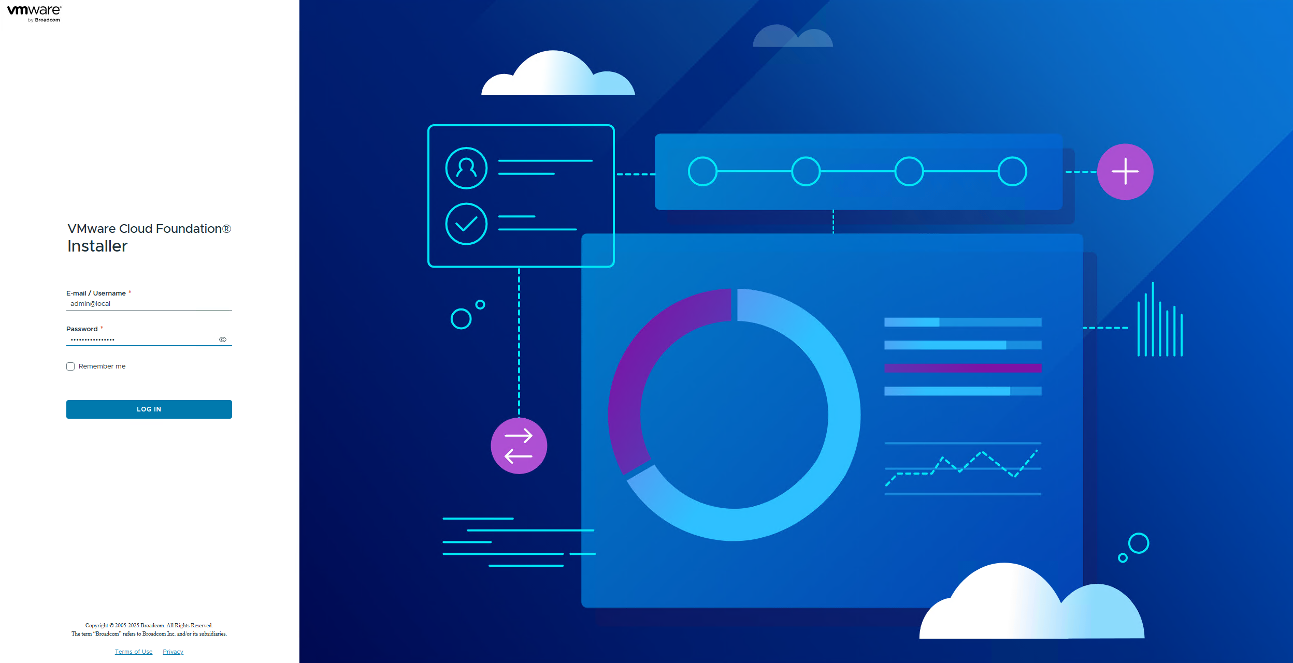

📷 SDDC Manager — Dashboard after login
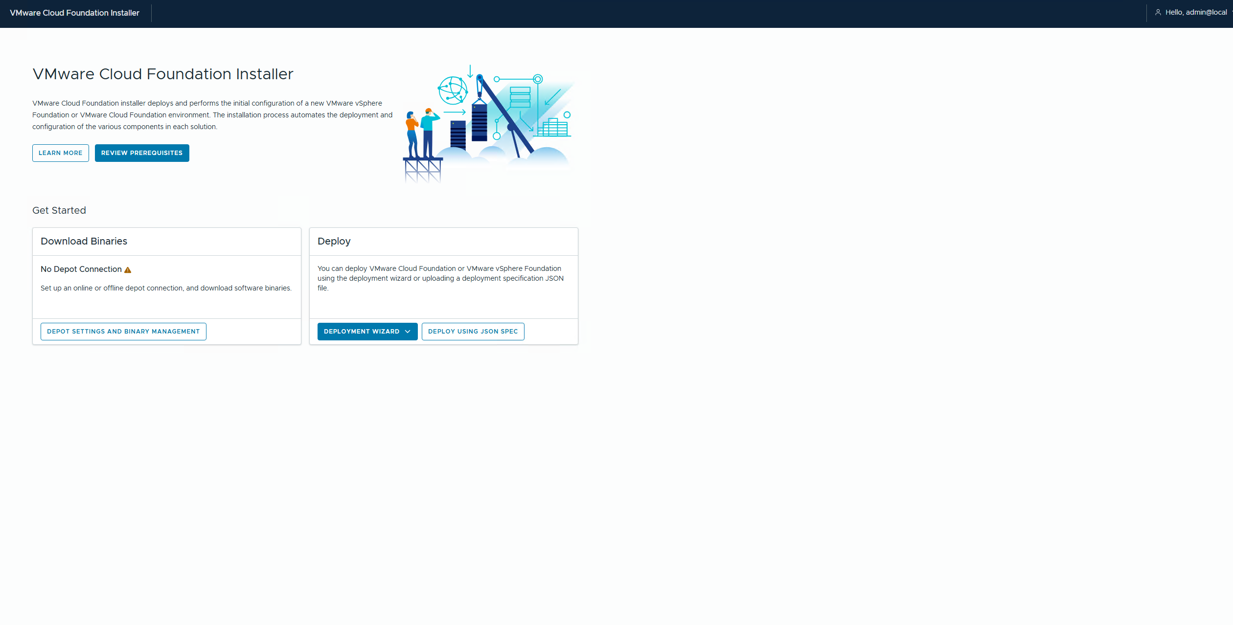

4.2 Configure Offline Depot
1. Navigate to: Administration → Depot Settings
2. Select: Offline Depot
3. Enter FQDN or IP: dc3-app-web1.humbledgeeks.com | Port: 443 (HTTPS required)
4. Username / Password: enter any value — the server does not enforce authentication
4. Click Validate — wait for SDDC Manager to enumerate the available bundles
5. Click Save once validation passes

📷 SDDC Manager — Depot Settings — Offline Depot URL entered
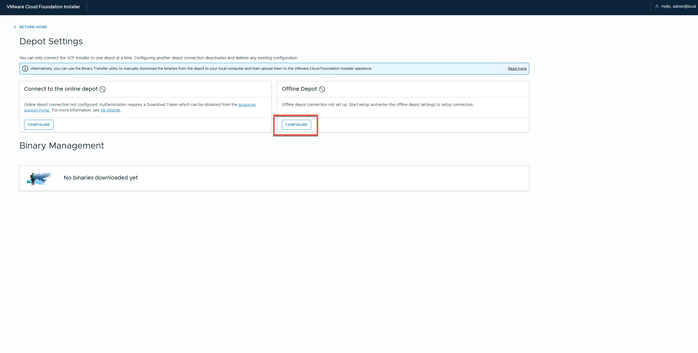

📷 SDDC Manager — Depot validation succeeded
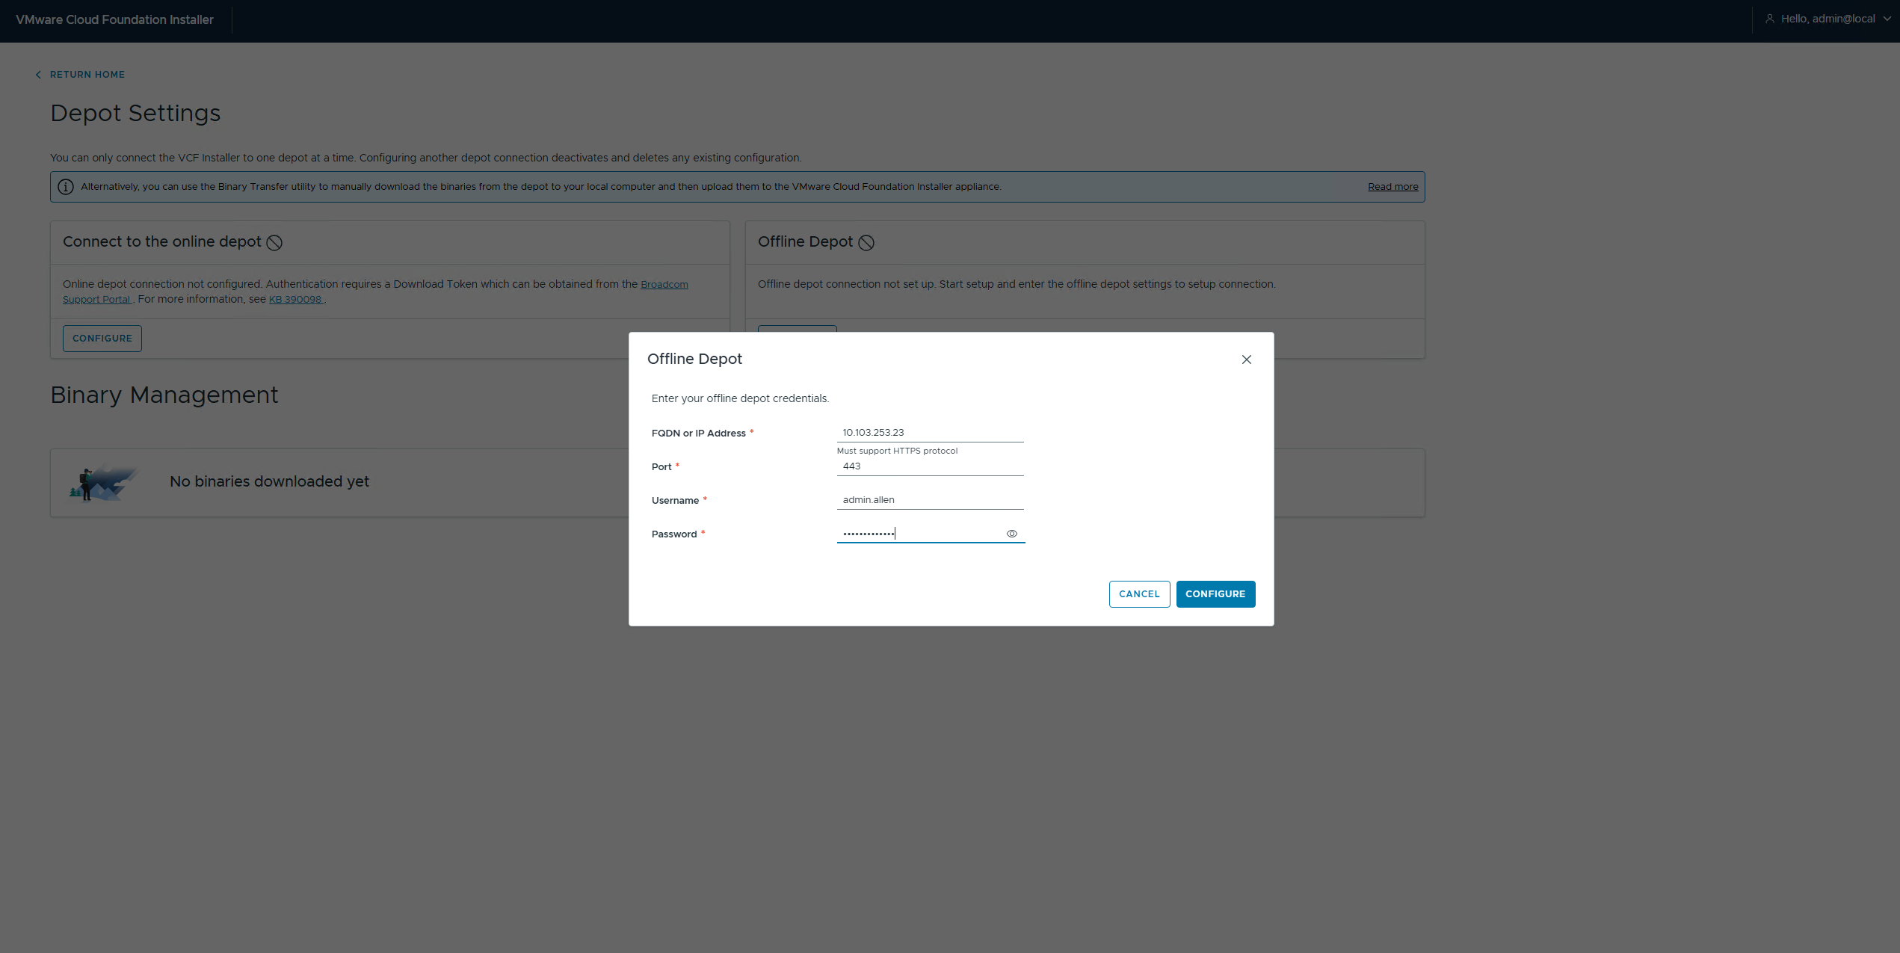

📷 SDDC Manager — All 5 bundles listed and available after offline depot validated

4.3 Alternative — Online Depot (Broadcom API Token)
NOTE: Use this section to demonstrate the online depot path for the blog post.

1. Log into https://support.broadcom.com
2. Navigate to: My Dashboard → API Tokens → Generate Token
3. Copy the token — displayed only once
4. In SDDC Manager: Administration → Depot Settings → Online Depot
5. Paste the token and click Connect
6. Wait for the bundle manifest to sync

📷 Broadcom Support Portal — API Token generation page

📷 SDDC Manager — Online Depot connected and bundle manifest synced

Phase 5 — VCF Bringup
WARNING: Bringup takes 2–4 hours on B200 M4 hardware. Do not restart any component during bringup.

5.1 Start Bringup and Run Pre-Checks
SDDC Manager validates all hosts, network reachability, and hardware compatibility. CPU and hardware warnings are expected on B200 M4 blades. Resolve any red failures before proceeding — yellow warnings are acceptable.

📷 SDDC Manager — Bringup wizard — host and network entry screen

📷 SDDC Manager — Pre-check results, all hosts validated

5.2 Management Domain Host Assignment
When the wizard prompts for Management Domain hosts, enter these four:

Hostname | FQDN | IP
dc3-hst-esxi02 | dc3-hst-esxi02.humbledgeeks.com | 10.103.16.52
dc3-hst-esxi03 | dc3-hst-esxi03.humbledgeeks.com | 10.103.16.53
dc3-hst-esxi04 | dc3-hst-esxi04.humbledgeeks.com | 10.103.16.54
dc3-hst-esxi05 | dc3-hst-esxi05.humbledgeeks.com | 10.103.16.55

NOTE: Do not include esxi01 (offline) or the workload hosts at this stage.

5.3 Handle CPU Compatibility Check
If SDDC Manager blocks on CPU compatibility for the B200 M4 blades, SSH in and bypass:

ssh admin@dc3-srv-sddc.humbledgeeks.com
vcf-bringup --config /path/to/bringup.json --skip-cpu-compatibility-check

5.4 Monitor Bringup Progress
SDDC Manager shows a task timeline as each component deploys. If a task fails, click the log link on that task for details.

📷 SDDC Manager — Bringup task timeline in progress

📷 SDDC Manager — Bringup complete, Management Domain healthy

5.5 Post-Bringup Verification Checklist
• [ ] SDDC Manager dashboard — Management Domain shows green
• [ ] vCenter accessible: https://hg-vcf-mgmt1.humbledgeeks.com
• [ ] NSX Manager accessible: https://hg-vcf-nsx-a.humbledgeeks.com
• [ ] All 4 Management Domain ESXi hosts visible in vCenter cluster
• [ ] SDDC Manager Inventory shows all 4 hosts enrolled

📷 SDDC Manager — Final dashboard, Management Domain all green

📷 vCenter — Management cluster showing esxi02 through esxi05

Phase 6 — Deploy VI Workload Domain
With the Management Domain healthy, deploy the VI Workload Domain using the remaining 3 hosts. esxi01 can be added later once the SSD install is complete.

6.1 Create the Workload Domain
1. In SDDC Manager, navigate to: Workload Domains → Add Domain
2. Select domain type: VI (Virtual Infrastructure)
3. Enter a domain name (e.g. vcf-workload-01)
4. Add the three workload hosts:

Hostname | FQDN | IP
dc3-hst-esxi06 | dc3-hst-esxi06.humbledgeeks.com | 10.103.16.56
dc3-hst-esxi07 | dc3-hst-esxi07.humbledgeeks.com | 10.103.16.57
dc3-hst-esxi08 | dc3-hst-esxi08.humbledgeeks.com | 10.103.16.58

📷 SDDC Manager — Add Workload Domain wizard with esxi06–08 entered

📷 SDDC Manager — Workload Domain deployment in progress

📷 SDDC Manager — Workload Domain healthy, all 3 hosts enrolled

6.2 Adding ESXi01 After SSD Install
Once dc3-hst-esxi01.humbledgeeks.com (10.103.16.51) is back online:

1. Confirm DNS A and PTR records exist for dc3-hst-esxi01.humbledgeeks.com
2. Verify the host is reachable and ESXi is healthy
3. In SDDC Manager: Workload Domains → vcf-workload-01 → Hosts → Add Host
4. Enter hostname: dc3-hst-esxi01.humbledgeeks.com and IP: 10.103.16.51
5. SDDC Manager will validate and commission the host into the domain

📷 SDDC Manager — esxi01 added to Workload Domain, 4 hosts total

Working Notes

