 Private Auction Opportunity! 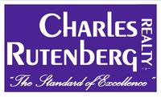

Attention Flippers, Investors, First Time Homeowners……
Opportunity is Knock, Knock, Knocking!!!

This Beautiful Home MUST BE SOLD!!!
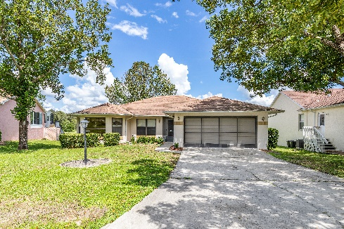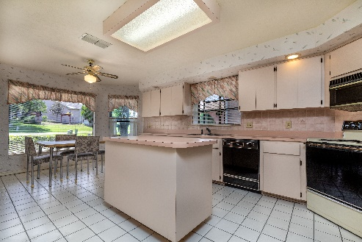
781 West Colbert Ct
Beverly Hills, FL 34465

3 Bedroom, 2 Bathroom, 2 Car Garage with Green space views adjacent to great golf including Black Diamond and Twisted Oaks Golf Club.

- The 2377 sq ft home has 1761 sq ft heated/ac.
- Located in the quiet neighborhood of Oakwood Village this property is ready for some updates and a new family.
- Split level floor plan features a spacious Master Bedroom with a nice Double Sink Master Bath featuring a separate Garden Bath and Shower.
- An Eat in kitchen that features a powered Island perfect for the gourmet chef.
- No neighbors in the back and a sloping backyard that compliments the warm and cozy feel of this residential gem.
- Built in 1989 the property is block construction with a shingle roof and sound construction.
- Homeowners Association is required, and the fee is $65 Annually.
- Minimum Bid is $125,000.00
- 10% Buyers Premium is in effect.

Property is scheduled for Auction October 10th, however, is indeed subject to prior sale.

Contact: Chris Bohr 813-765-6057
Chris@BohrSellsHomes.com

Or Jeff Burchard 727-560-5333

