**PROGRAMMING ASSIGNMENT 2- SHORT CIRCUIT EVALUATION**

**Name:** Humesh Reddy Venkatapuram

**Aggie ID:** 800810540

**Problem Description:** Testing several languages to see if the language implementation has Short Circuit Evaluation in the **AND** Boolean construct.

# Summary table:

|  |  |
| --- | --- |
| **Language** | **Short Circuit Experiment result with AND operator** |
| **ADA** | **and**: No Short-circuit  **and then**: Short-circuit happens [In ADA, and then is the short circuit form of the and operator] |
| **K-shell** | **&&**: Short-circuit happens |
| **PHP** | **&&/and**: Short-circuit happens |
| **PERL** | **&&/and**: Short-circuit happens |

**Output:** Below are the code and their respective output in screenshot form.

**CODE FOR ADA PROGRAM:**

with Text_IO;

use Text_IO;

procedure prog_ada is

i : Integer;

function f return Boolean is

begin

Put_line ("I have been evaluated");

return true;

end f;

begin

i := 1;

if i = 0 and f then

Put_line ("True");

else

Put_line ("False");

end if;

end prog_ada;

**OUTPUT FOR THE ABOVE CODE:**

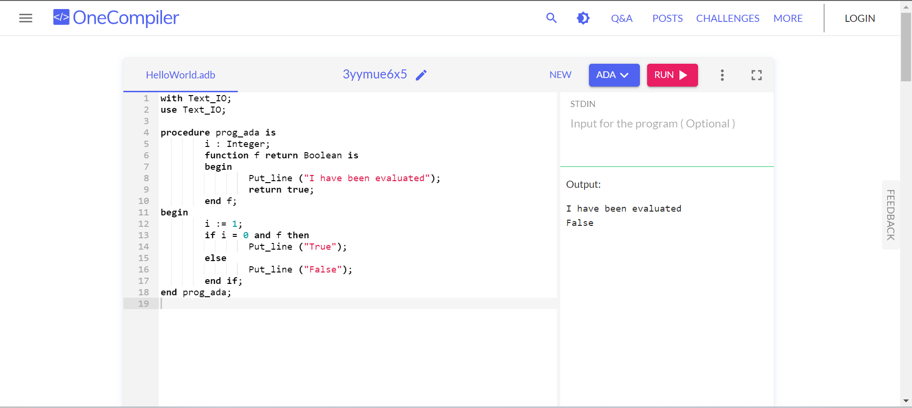

The output of the ADA program is seen in the screenshot above.

**CODE FOR K-SHELL PROGRAM:**

function f {

print "<p>I have been evaluated</p>"

return 1

}

i=1

if (( i == 0 && f )); then

echo "True"

else

echo "False"

fi

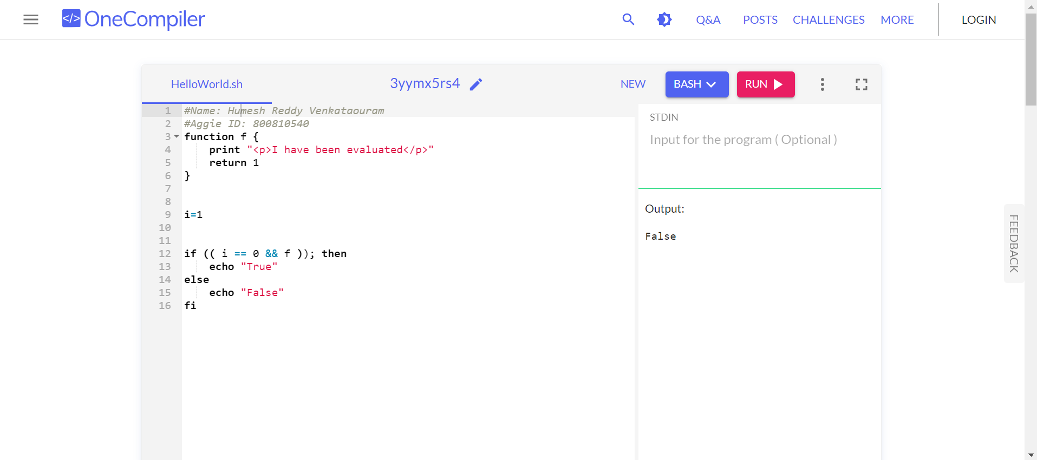

The output of the K-SHELL program is seen in the screenshot above.

**CODE FOR PHP PROGRAM:**

<?php

function f () {

echo '<p>I have been evaluated</p>';

return 1;

}

$i = 1;

if ( $i == 0 && f() )

echo 'True';

else

echo 'False';

?>

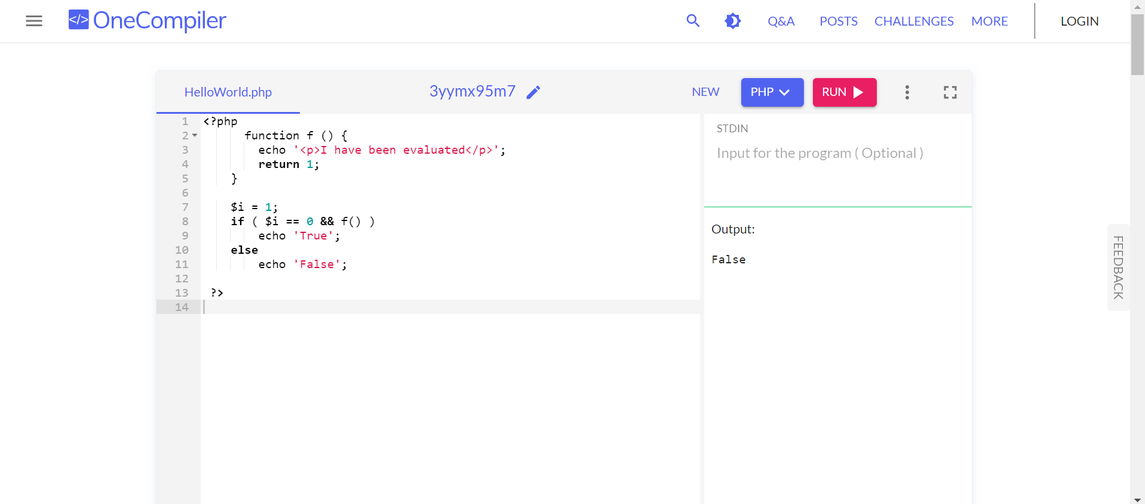

The output of the PHP program is seen in the screenshot above.

**CODE FOR PERL PROGRAM:**

use strict;

use warnings;

sub f {

print ("I have been evaluated\n");

return 1;

}

my $i = 1;

if ( $i == 0 && f() ) {

print("True\n");

} else {

print("False\n");

}

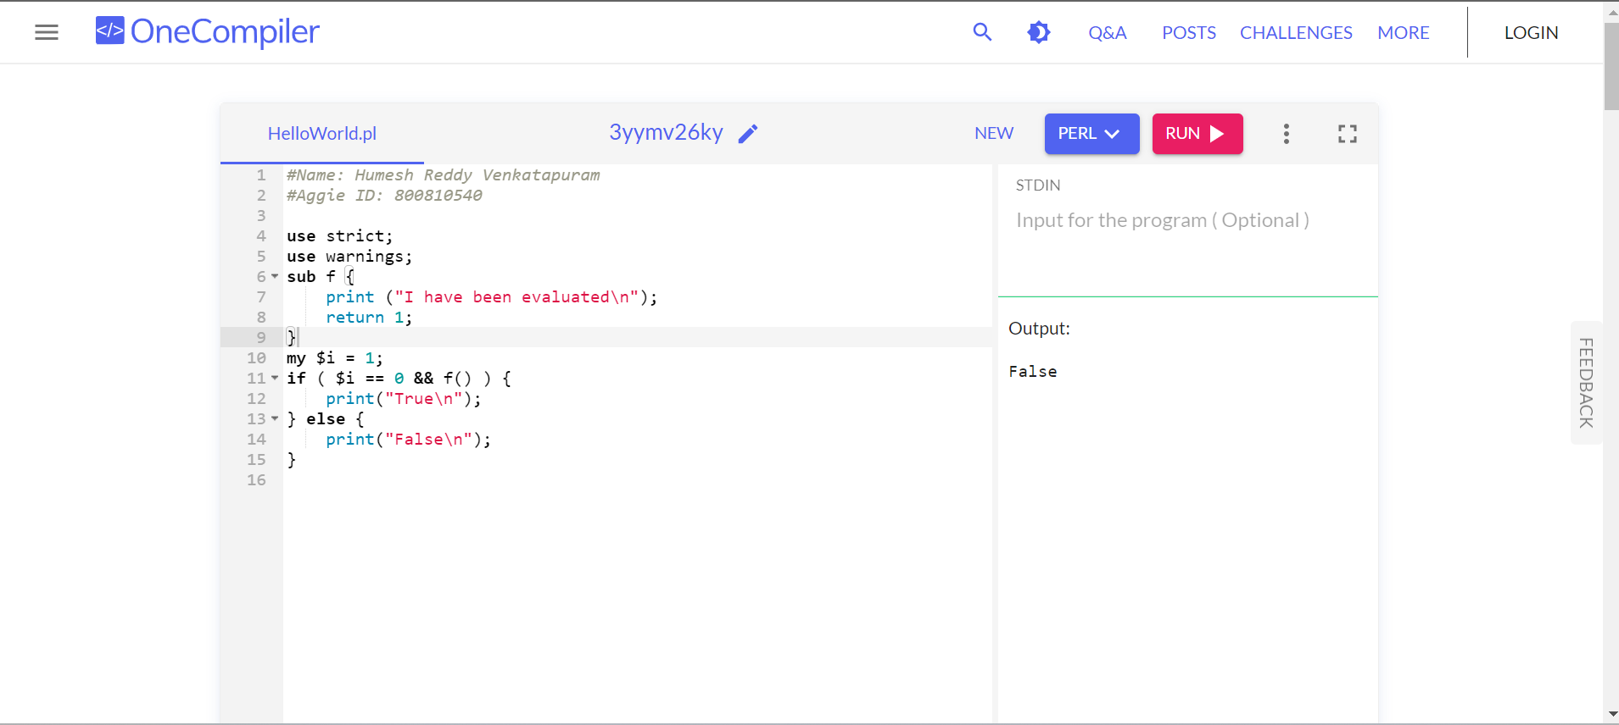

The output of the PERL program is seen in the screenshot above.