Name: Humesh Reddy Venkatapuram

Date: 03/22/2023

**PA 4: File conversion -- remove control blocking data from backups**

**PROBLEM DESCRIPTION:** You are working on a project where you are given data that has been through a "backup" program which, at times, adds extraneous data. You discover that the data added has a pattern. The pattern is the corrupt data ALWAYS starts with a CONTROL-C and always ends in a CONTROL-B, and that at most 4 carriage returns are introduced with such an event. You also discover that after the CONTROL-C, there may be more Control-C characters as part of the extraneous data.

**PYTHON CODE:**

# Name: Humesh Reddy Venkatapuram

# Assignment No: 4

# Problem Description: File conversion -- remove control blocking data from backups

# Language: Python

import sys

def main():

    # Taking in the input file

    input_file = open('control-char.txt', 'r')

    # Storing in output file

    output_file = open('pythonOutput.txt', 'w')

    # Declaring variables to tell precisely if the control is inside ^C and outside ^B

    inC = False

    outC = False

    # Reading the input file

    line = input_file.read()

    # The for loop is used to convert characters to decimal values and compater to ETX==3 (^C)

    #in decimal and STX==2 (^B) in decimal.

    #The character between ETX and STX is not printed

    for i in line:

        if not line:

            break

        # Setting condition after ^C occurs

        if ord(i) == 3 and inC == False:

            inC = True

            outC = False

        # Getting conditions after ^B occurs

        if ord(i) == 2 and inC == True:

            inC = False

            outC = True

        # Printing the file, except the part in between ^C and ^B

        if inC == False and outC == False:

            # print (i, end = "")

            # output.write(i)

            sys.stdout.write(i)

            output_file.write(i)

        if outC == True:

            outC = False

    input_file.close()

    output_file.close()

if __name__ == "__main__":

  main()

**OUTPUT:**

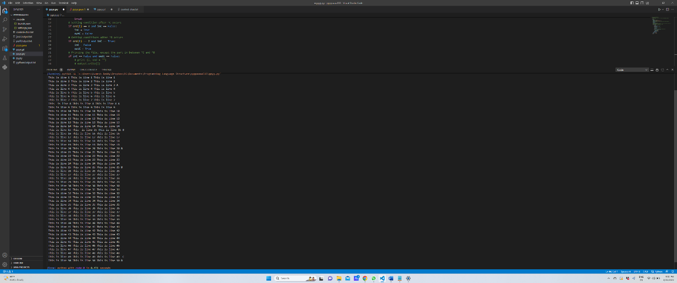

**JAVA CODE:**

// Name: Humesh Reddy Venkatapuram

// Assignment No: 4

// Problem Description: File conversion -- remove control blocking data from backups

// Language: Java

import java. io.*;

import java. util.*;

public class ppyy {

/**

 * @param args

 */

public static void main( String[] args ) {

try {

    // Taking in the input file

FileReader input = new FileReader ("control-char.txt") ;

Scanner s = new Scanner (input);

// Storing in output file

FileWriter output = new FileWriter ("javaOutput.txt") ;

//Declaring variables to tell precisely if the control is inside ^C and outside ^B

boolean inC = false;

boolean out = false;

String line;

while ( s.hasNextLine() ) {

// Reading the input file

line = s.nextLine();

int length = line. length() ;

// The for loop is used to convert characters to decimal values and compater to ETX==3 (^C)

    //in decimal and STX==2 (^B) in decimal.

    //The character between ETX and STX is not printed

for ( int i=0; i<length; i++ ) {

// Setting condition after ^C occurs

if ( (int) line.charAt (i) == 3 && inC == false ) {

inC = true;

out = false;

}

// Getting conditions after ^B occurs

if ( (int) line.charAt (i) == 2 && inC == true ) {

inC = false;

out = true;

}

// Printing the file, except the part in between ^C and ^B

if ( inC == false && out == false ) {

System.out.print (line.charAt(i));

output.write(line.charAt(i));

}

if ( out == true ) {

out = false;

}

}

if (inC == false) {

System.out.println();

output.write("\n");

}

}

input. close () ;

output.close();

} catch ( IOException e ) {

e.printStackTrace();

System.exit(1);

}

}

}

**OUTPUT:**

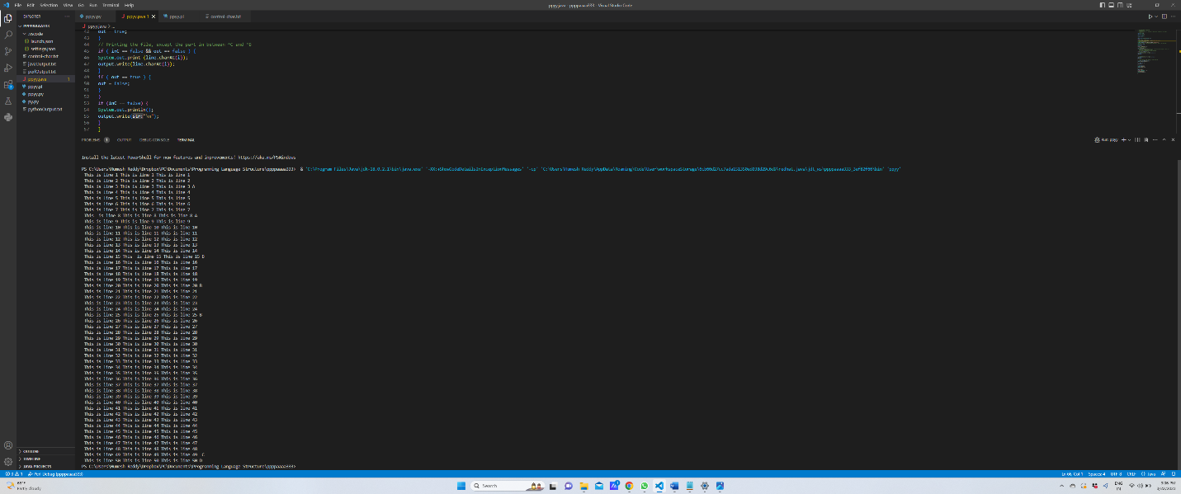

**PERL CODE:**

# Name: Humesh Reddy Venkatapuram

# Assignment No: 4

# Problem Description: File conversion -- remove control blocking data from backups

# Language: Perl

use strict;

use warnings;

my $input = 'control-char.txt';

open (FH, '<', $input) or die $!;

open (FW,'>', "perlOutput.txt") or die $!;

my $inC = 1; # False

my $outC = 1; # False

# Reading the input file

my $line = <FH>;

# The for loop is used to convert characters to decimal value and

# compater to ETX == 3 (^C) in decimal and STX == 2 (^B) in decimal.

# The character between ETX and STX is not printed

while ( $line ) {

my $str = $line;

# using split() function

my @spl = split('', $str);

# displaying result using foreach loop

foreach my $i (@spl) {

if (ord($i)== 3 and $inC == 1) {

$inC = 0;

$outC = 1;

}

# Getting conditions after ^B occurs

if (ord($i) == 2 and $inC == 0) {

$inC = 1;

$outC = 0;

}

# Printing the file, except the part in between ^C and ^B

if ($inC == 1 and $outC == 1){

print $i;

$a = $i;

print FW $a;

}

if ($outC == 0) {

$outC = 1;

}

}

$line = <FH>;

}

close(FW) or die $!;

close (FH) or die $!;

**OUTPUT:**

