

**T.C.  
AKDENİZ UNİVERSİTY  
Computer Engineering Department  
DATABASE MANAGEMENT SYSTEM**



**HOSPITAL MANAGEMENT SYSTEM**

***GROUP-16***

***Arzu Dabanıyastı (20180808032)***

***Aslı Türkoğlu (20180808012)***

***Ceyda Elmas (20180808037)***

***Melike Tekin (20190808031)***

***Hümeyra Köseoğlu (20180808015)***

**OUR PROJECT**

The place and importance of hospitals in the health system is increasing. Hospitals are institutions that use advanced technology, have high costs and employ specialist personnel. The increase in the resources allocated to hospitals and the increase in the health expectations of the society have made it necessary to manage these institutions with a modern management approach. Based on this necessity, we developed the hospital management system project with the aim of obtaining information, using the most appropriate tools in data entry and management, data transfer and information exchange between all units and employees of the hospital. We have created a more functional system compared to other hospital management systems.

**Unnormalized Set of Data**

* appointmentID
* appointmentDate
* appointmentTime
* appointmentStatus
* prescriptionSerialNo
* testID
* testName
* testDate
* testResult
* diagnosisID
* diagnosisName
* clinicName
* adminTRID
* adminName
* adminSurname
* adminEmail
* adminPassword
* doctorTRID
* doctorName
* doctorSurname
* doctorEmail
* doctorGender
* doctorBranch
* doctorPosition
* doctorPhone
* doctorPassword
* patientTRID
* patientName
* patientSurname
* patientGender
* patientDOB
* patientEmail
* patientPhone
* patientAddress
* patientPassword

**E-R Diagram for 3NF Database**

**SQL TABLES**

Admin Table

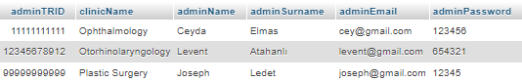

Appointment Table

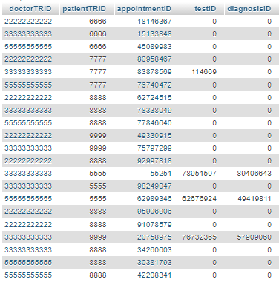

Diagnosis Table

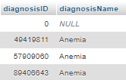

Doctor Table

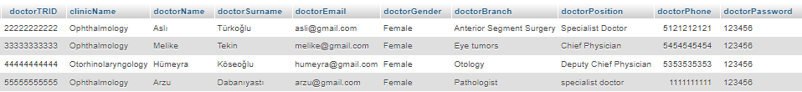

Patient Table

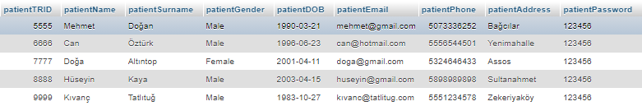

Test Table



Hospital Relation Table



**CUSTOMER REQUEST**

**A LIST OF ALL DOCTORS THAT HAVE SEEN A CERTAIN PATIENT**

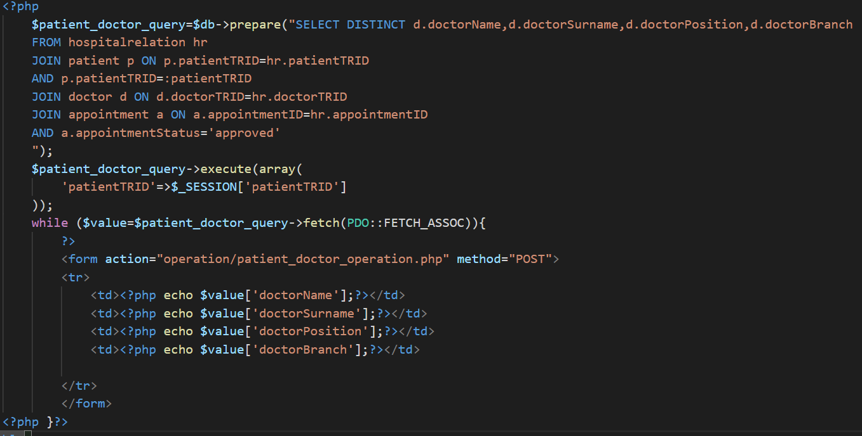**A WAY TO CHANGE THE DATE OF AN APPOINTMENT**

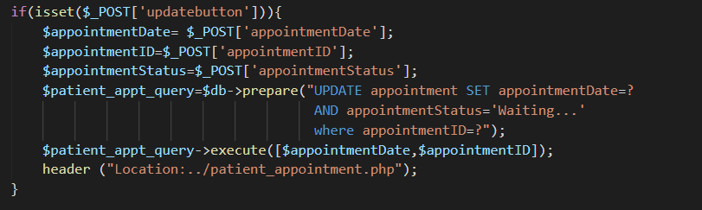

**A WAY TO REMOVE AN APPOINTMENT FROM THE SYSTEM**

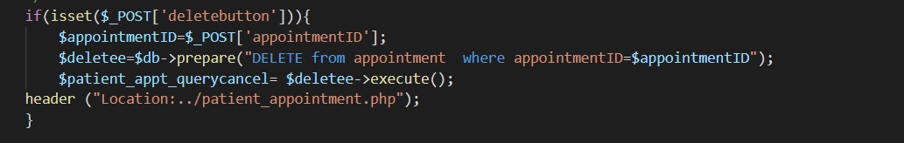

**A LIST OF ALL PATIENTS AND THE NUMBER OF APPOINTMENTS THEY HAVE HAD IN THE PAST YEAR**

metin içeren bir resim

Açıklama otomatik olarak oluşturuldu

**A WAY TO REMOVE A DOCTOR FROM THE SYSTEM**

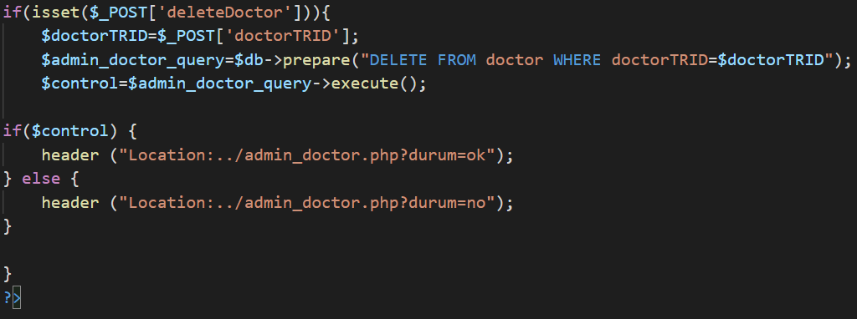

**A WAY TO ADD A NEW DOCTOR TO THE DATABASE**

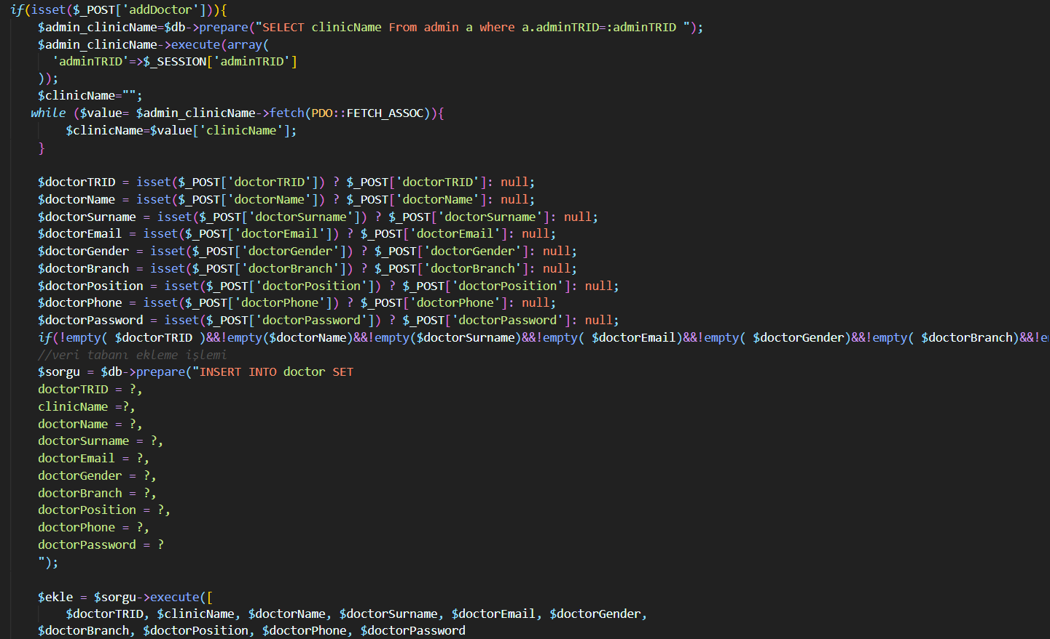

**OUR PRESENTATION VIDEO:**

<https://www.youtube.com/watch?v=xSPAyyIatuU&list=PLvDxSeHydswsS4Bwl1zGBqE9CQq3x9LDb&index=59&ab_channel=JosephLedetJosephLedet>

**OUR PRESENTATION QUESTIONS AND ANSWERS VIDEO:**

<https://www.youtube.com/watch?v=2lYhDDhS53M&list=PLvDxSeHydswsS4Bwl1zGBqE9CQq3x9LDb&index=58&ab_channel=JosephLedetJosephLedet>

**FINALLY:**

We used HTML, CSS and JAVASCRIPT for the interface part of our project. We wrote PHP codes to connect MYSQL and the interface. After our first report, we added the features requested by the customer to our system and according to the feedback, we fixed the deficiencies in our first report in the final report.