

Hosted Challenge App

Data Analytics and Artificial Intelligence Tools 2 (Gpo 101)

Names and IDs:

Humberto Gonzalez Escamilla - A00837328

November 30, 2025
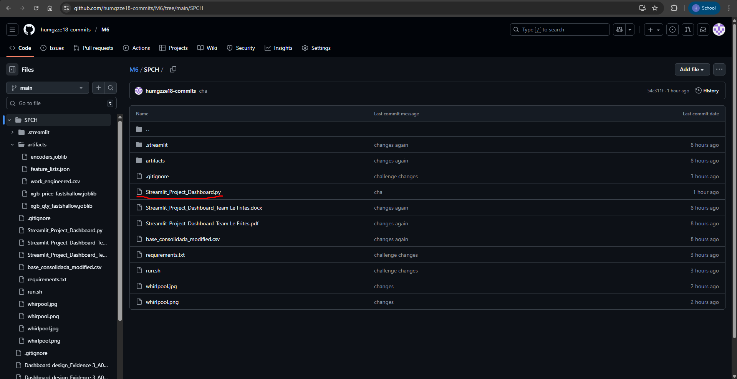
Screenshot of my GitHub Repository and the link to access it.
Link: https://github.com/humgzze18-commits/M6/tree/main/SPCH

