Curtis Humm

ECE 497

Hw07

|  |  |  |  |
| --- | --- | --- | --- |
| **Trial** | **Min** | **Max** | **Average** |
| **Kernel Module** | 490us | 500us | 495us |
| **Mmap** | 10ns | 3.29us | 1.65us |
| **Interrupts** | 95.8ms | 100ms | 97.9ms |

Figure One: Listings of the Min/Max/Average

Images Taken

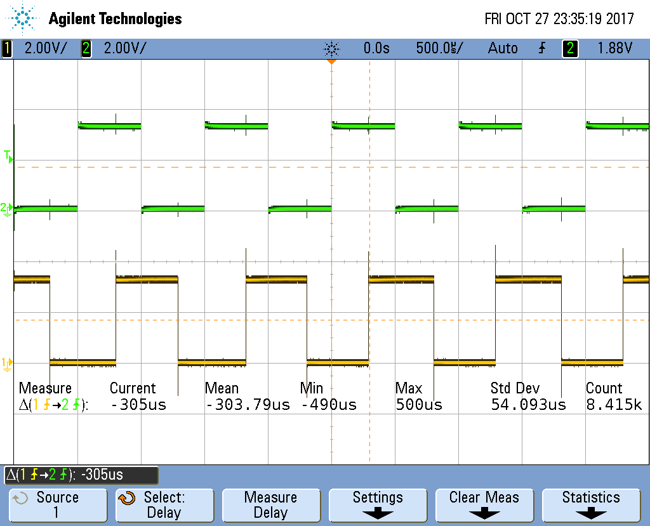

Figure Two: Kernel Module

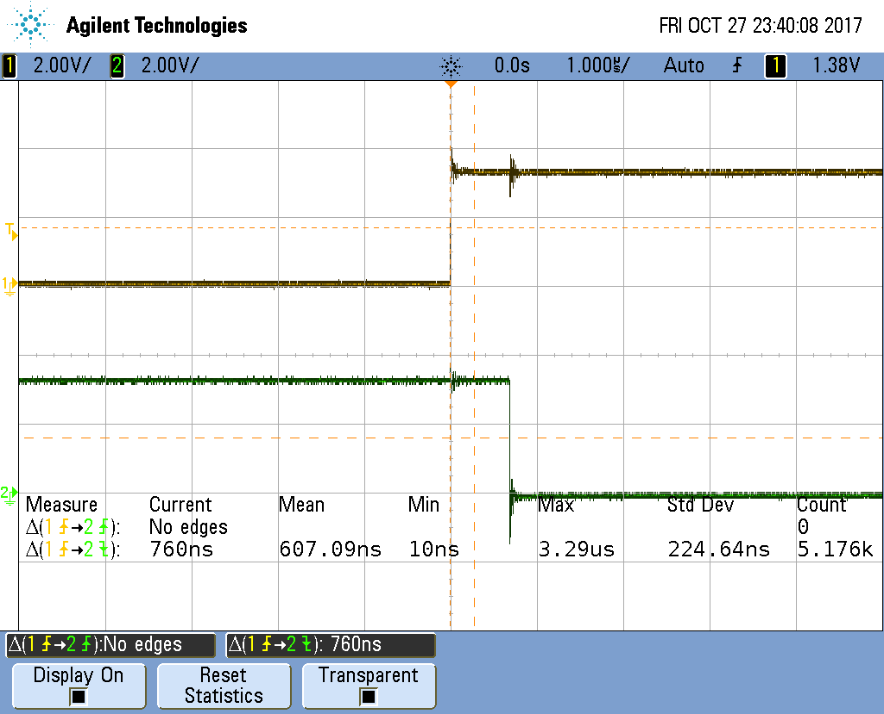

Figure Three: Mmap

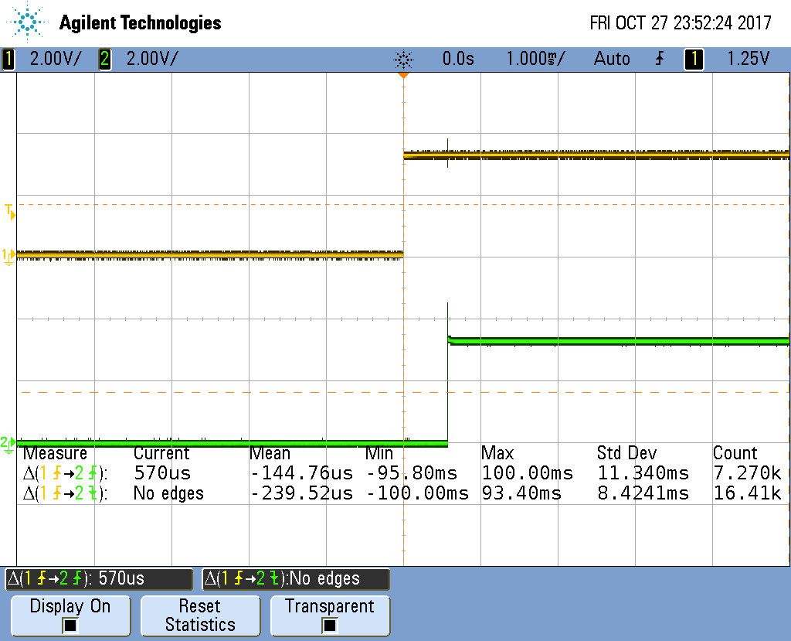

Figure Four: Interrupts

Throughout the trials, the interrupts proved to have the slowest reaction time, which makes sense as after an interrupt is fired code has to be processed and run, vs mmap and kernel which work directly to purpose. In this vein, it is logical that mmap is the fastest of the lot, as it directly connect input to output without requiring the use of computational logic. I found the wide variance in speed to be interesting however, but in the end it made sense. Kernel and Interrupts work with code in regular clock cycles, rather than the speed of electrical transfer.