TASK ROUND

BLOCKCHAIN

CHEF-CHAIN

* OVERVIEW

**What It Is:**

**A blockchain-powered meal kit e-commerce and crowdsourcing platform** where users can:

1. **Order meal kits** with transparent ingredient sourcing.
2. **Submit recipes** and earn rewards when their recipes are selected for production.
3. **Vote on community recipes** to shape the platform's offerings.
4. **Track sustainability metrics** for meal kits, fostering eco-friendly choices.

**Key Selling Points:**

1. **Transparency and Trust**:  
   Blockchain tracks the supply chain, ensuring ingredient authenticity and fair voting processes.
2. **Community Engagement**:  
   Crowdsourcing allows users to actively influence the meal kit diversity.

* **Reward Ecosystem**:  
  Recipe-Creators and voters are rewarded with tokens, driving loyalty and participation.

1. **Eco-Conscious Focus**:  
   Ingredient traceability and sustainability reporting attract environmentally conscious users.
2. **Unique Recipes**:  
   The platform becomes a hub for creative, community-curated recipes turned into real products.

**Platform's Dual Identity:**

1. **E-Commerce Side**:
   * A streamlined experience for users to browse and order meal kits with full transparency.
   * Integration of ingredient tracking via blockchain (origin, certifications, carbon footprint).
2. **Crowdsourcing Side**:
   * A vibrant community space where users contribute, vote on, and engage with recipes.
   * Blockchain ensures fairness in recipe selection and transparent royalty payouts to creators.

**REAL WORLD PROBLEM IT IS ADDRESSING TO :**

| **Problem** | **Explanation** | **Proposed Solution** |
| --- | --- | --- |
| **Lack of Ingredient Transparency** | **Consumers are unaware of the origins and quality of ingredients in meal kits.** | **Blockchain records the source, certifications, and transport details of each ingredient for verification.** |
| **Unverified Sustainability Claims** | **Companies make unverifiable eco-friendly claims, leaving consumers doubtful.** | **Blockchain ensures transparency of sustainability metrics, enabling informed and eco-conscious choices.** |
| **Inefficient Community Engagement** | **Limited avenues for food lovers to contribute ideas or engage with meal kit brands.** | **Crowdsourcing recipes allows users to submit, vote, and see their recipes turned into real products.** |
| **Quality Assurance in Logistics** | **Perishable goods may be damaged due to mishandling or improper transport.** | **IoT sensors monitor conditions like temperature and humidity, logging data on the blockchain for accuracy.** |
|  | | |

* **How blockchain technology can address the problem:**

**1. Ingredient Transparency**

**Problem:** Customers lack visibility into the source and quality of ingredients.

**Blockchain Solution:**

* Blockchain creates a tamper-proof ledger where every ingredient's journey (farm-to-table) is recorded.
* Smart contracts automate the process of logging and verifying supplier-provided details, such as certifications and quality checks.
* Customer Interaction: A QR code on meal kits links to the blockchain record, allowing users to see the origin, certifications, and transport history of ingredients.

Technical Aspect:

* Each supply chain event (e.g., packaging, transport) is a transaction on the blockchain, stored as an immutable record.

**2. Sustainability Verification**

**Problem:** Companies make unverifiable sustainability claims**.**

**Blockchain Solution:**

* Verifiable proof of sustainability is logged on the blockchain, including certifications likeorganic or fair trade.
* Carbon footprint and transport impact data are calculated and linked to the blockchain record for each meal kit.
* Customers can make informed choices by accessing transparent, verifiable sustainability metrics.

Technical Aspect:

* Blockchain’s decentralized nature ensures no single entity can alter sustainability data. Smart contracts enforce compliance with predefined eco-friendly criteria.

**3. Community Engagement through Recipe Crowdsourcing**

**Problem:** Food enthusiasts lack platforms to contribute and monetize their ideas.

Blockchain Solution:

* Users submit recipes, which are stored on the blockchain for transparency.
* Smart contracts manage voting, ensuring that each vote is recorded securely and cannot be altered.
* Winning recipe creators are rewarded with tokens or monetary benefits via automated payouts.

Technical Aspect:

* Voting is managed using decentralized apps (dApps), ensuring fairness.
* Rewards are distributed through a token-based incentive system managed on the blockchain.

**4. Quality Assurance in Logistics**

**Problem:** Perishables often degrade during transport due to poor monitoring.

**Blockchain Solution:**

* IoT sensors monitor transport conditions (temperature, humidity).
* Sensor data is logged on the blockchain in real-time, ensuring tamper-proof tracking of conditions.
* Customers can verify transport quality by accessing the blockchain record for their meal kit.
* IoT devices send data to a middleware system, which interacts with blockchain nodes.
* Smart contracts trigger alerts if conditions deviate from acceptable thresholds.

**Why Blockchain Is Ideal**

1. **Immutability**: Prevents tampering with ingredient, transport, or voting data.
2. **Decentralization:** Builds trust by removing reliance on a single central authority**.**
3. **Automation**: Smart contracts eliminate manual intervention for rewards, quality alerts, or payment processing**.**
4. **Transparency:** Offers consumers and stakeholders real-time access to accurate dat**a.**

**High-level architecture (smart contracts, frontend/backend):**

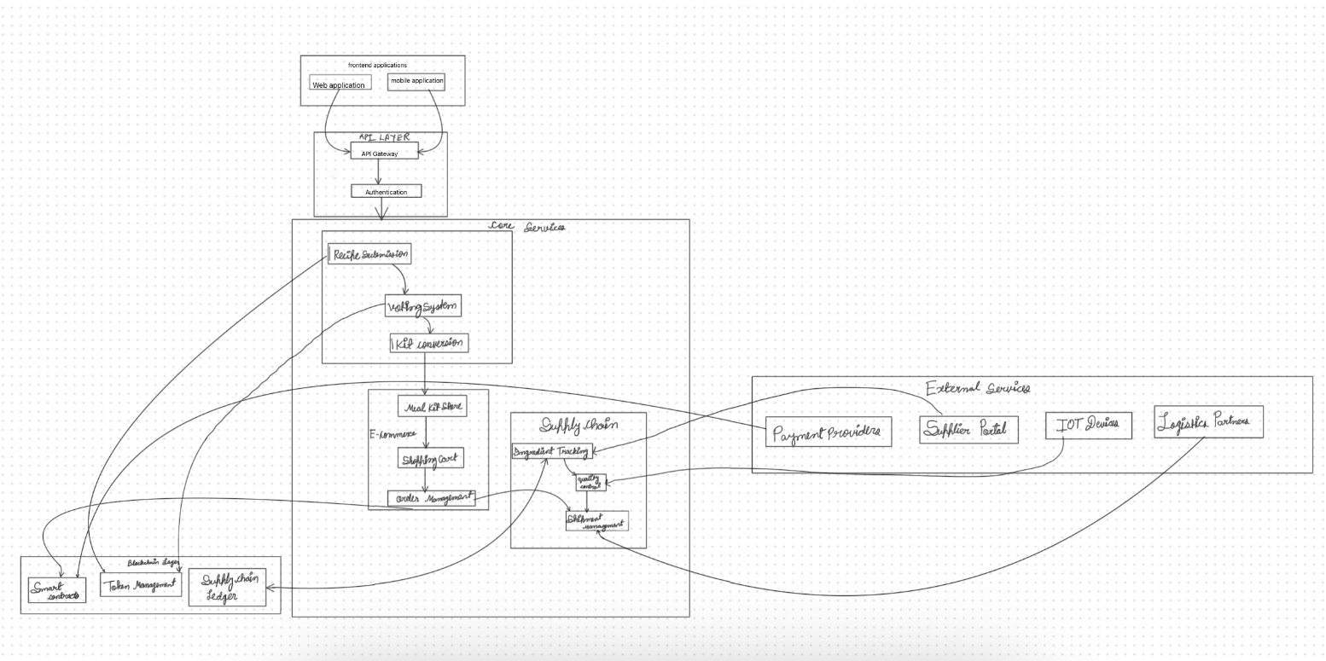

**Frontend**

**Frontend**

* **Frameworks**: React.js, Next.js for dynamic and responsive user interfaces.
* **Libraries**: Web3.js or Ethers.js for blockchain interaction.
* **Styling**: Tailwind CSS or Bootstrap for sleek designs.

**Backend**

* **Frameworks**: Node.js/Express.js for APIs and server-side logic.
* **Database**:
  + Relational: PostgreSQL for user and order data.
  + Decentralized: IPFS for immutable certification and recipe storage.

**Blockchain**

* **Network**: Ethereum or Polygon for public-facing functionality, Hyperledger for private supply chain data.
* **Smart Contracts**: Written in Solidity.

**IoT Integration**

* **Hardware**: Temperature and humidity sensors.
* **Middleware**: MQTT broker to transmit data to the blockchain.

**User workflow:**

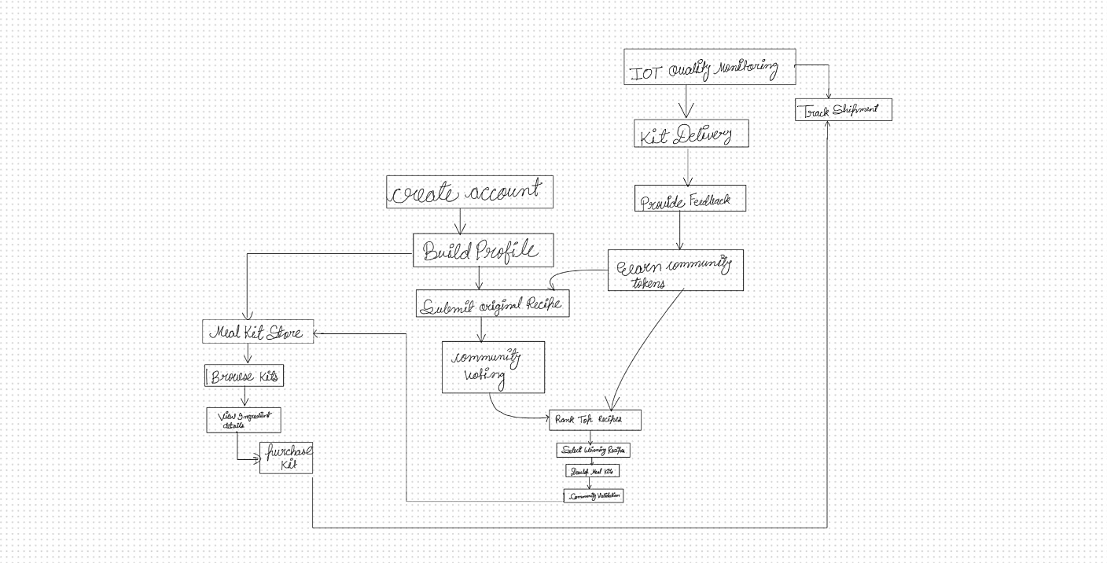

**Scenario 1: User Orders a Meal Kit and Earns Tokens**

**Step 1: User Browses the Platform**

* **Activity**: A user logs into the platform to explore meal kits. They view ingredient details, including sourcing and freshness data.
* **Blockchain Role**:
  + Ingredient information is fetched from the blockchain ledger.
  + The user scans a **QR code** on one kit, which shows:
    - Ingredient source (e.g., "Farm: Green Valley, CA").
    - Transport conditions (e.g., "Temperature maintained: 4°C").
    - Certifications (e.g., "Organic, Non-GMO").

**Step 2: User Places an Order**

* **Activity**: The user selects a meal kit and proceeds to checkout.
* **Blockchain Role**:
  + **Smart Contract for Tokens**:
    - If the user pays with tokens, the contract deducts the required amount from their balance.
* Payment data and order confirmation are logged immutably.

**Scenario: User Posts a Recipe and Earns Tokens**

**Step 1: User Submits a Recipe**

* **Activity:  
  A user, divyanshi, creates a recipe for "cabbage dumplings" and submits it on the platform through the web or mobile app.**
  + **She includes:**
    - **A detailed list of ingredients and quantities.**
    - **Step-by-step instructions.**
    - **A photo or video of the prepared dish.**
* **Blockchain Role:**
  + **Smart Contract for Recipe Submission:**
    - **The recipe is hashed (for immutability) and stored on the blockchain.**
    - **Divyanshi’s wallet address is linked to the recipe to ensure attribution.**
* **Reward:  
  divyanshi earns base tokens (e.g., 10 tokens) for submitting the recipe.**

**Step 2: Community Voting on the Recipe**

* **Activity:  
  The recipe is displayed on the platform for the community to vote.**
  + **Users can upvote or comment on Emma’s recipe.**
  + **Voting is open for a defined period (e.g., 2 weeks).**
* **Blockchain Role:**
  + **Smart Contract for Voting:**
    - **Votes are recorded on-chain to ensure transparency and prevent fraudulent activity (e.g., duplicate voting).**
* **Reward**:
  + Divyanshi earns **bonus tokens** based on the number of upvotes her recipe receives (e.g., 1 token per upvote).
  + Top-voted recipes might also qualify for additional rewards.

**Step 3: Recipe Selected for a Meal Kit**

* **Activity**:  
  Divyanshi’s recipe becomes a crowd favorite and is selected to be turned into a meal kit by the platform.
* **Blockchain Role**:
  + **Smart Contract for Selection**:
    - The smart contract triggers an additional reward when a recipe achieves a "Top 10" status or is converted into a meal kit.
  + Example Workflow:
    - RecipeHash and votes are evaluated.
    - Winning recipes are flagged, and their creators receive tokens.
* **Reward**:
  + Divyanshi receives **premium tokens** for her recipe’s conversion into a meal kit.

**Step 4: Users Purchase the Meal Kit**

* **Activity**:  
  Other users purchase the "cabbage dumplings " meal kit from the platform.
  + A percentage of the revenue from these purchases is allocated to Emma as a **royalty reward**.
* **Blockchain Role**:
  + **Smart Contract for Royalties**:
    - Tracks sales of the meal kit.
    - Automatically transfers a fixed percentage of the revenue as tokens to divyanshi’s wallet.
* **Reward**:

Emma earns **royalty tokens** for every meal kit sold.