Project Description
Matthew Nassar¹, Markus Ullsperger², Hans Kirschner², Ali Hummos³
¹Carney Institute for Brain Science, Brown University, Providence RI, USA
²Institute of Psychology, Otto-von-Guericke University, Magdeburg D-39106, Germany
³Brain and Cognitive Sciences, Massachusetts Institute of Technology, Massachusetts MA, USA

Specific Aims

Humans monitor and adjust behavior in accordance with changing demands of the environment. Doing so effectively requires both proactively inferring the type and intensity of control likely required in a given situation based on recent history, and reacting to quickly engage the necessary control mechanisms when expectations are violated. This requires the brain to combine information over multiple timescales to implement control mechanisms that are both efficient and flexible. While a handful of computational models propose mechanisms for this multi-timescale integration of control, they do so only in narrow settings, falling short of a more general computational theory of control allocation.

Here we propose to obtain such a theory by defining control not in terms of task variables, but in terms of the recruitment of latent abstractions that adaptively bias information processing according to online goals. This idea builds from recent work showing that recurrent neural networks (RNNs) that alternate between learning and inference processes can discover latent abstractions that afford improved generalization and behavioral flexibility. Here we propose to test the idea that inference over these latent abstractions is a task-general controller that can explain behavioral and neural hallmarks of cognitive control in humans.

We draw on our experience in computational neuroscience and cognitive control to understand how the brain combines information across timescales to instantaneously adjust behavior. First, we leverage a large existing response conflict task EEG dataset (n = 1300) to test whether “inference” in our model can explain behavioral adjustments and their neural signatures. Second, we collect empirical data to test whether model predictions generalize to novel control demands and tasks. Third, we test whether causal perturbations of the posterior medial frontal cortex (pMFC), which is thought to play a primary role in cognitive control adjustments, maps to computational perturbations of the inference process in our model ⁴⁵.

Aim 1: Determine computational mechanisms of control allocation across timescales. We will leverage a large response conflict task EEG dataset (Flanker task; n=1300) to constrain models of cognitive control dynamics. A set of trained RNNs will perform the task allowing us to examine how their accuracy, response times, and internal dynamics map onto behavioral and EEG measures from humans. The set of RNNs will include 1) a base model RNN no latent units, 2) RNNs that perform inference over theoretically motivated latent units, 3) an RNN that discovers latent abstractions from scratch. Models will be compared to human data to determine if and how inference over latent embeddings explains multi-timescale control behavior and its underlying dynamics, as measured by beta-power lateralization (BPL). This work will reveal the latent variables over which inference can emulate human control and its neural dynamics.

Aim 2: Test model-predictions in a novel task framework for generalization. We will use the RNN model developed in aim 1 to make testable predictions for control behaviors and their underlying dynamics in novel task contexts and in distinct cognitive tasks. Human participants and trained RNNs will perform variations of the flanker task (different congruency probability and flanker/stimulus onset asynchrony). We will also test performance on a color discrimination task embedded in a random dot motion stimulus with varying levels of motion/response congruency. Model behavior and dynamics will be compared to participant behavior and BPL (measured with EEG) to determine whether control variables learned in one cognitive control task generalize to novel conditions and/or to a different cognitive task.

Aim 3: Testing the necessity of pMFC with causal interventions. We will use low-intensity transcranial focused ultrasound stimulation (TUS) to causally modulate neural activity in pMFC. Based on previous research strongly suggesting an involvement of the pMFC in cognitive control functions and tracking task and reinforcement history, we will investigate the necessity of this brain region for the estimation of control demand and within trial adjustments in the decision process. We will perform several perturbations of the inference system in our RNN models and compare the resulting behavioral changes to those obtained when TUS is applied to pMFC in human participants performing a flanker task.

1 Overview & Significance
Humans adapt flexibly to their environment to achieve goals efficiently and to avoid harmful outcomes through a process referred to as cognitive control. Employing cognitive control efficiently requires inferring the type and intensity of control that will likely be required in a given situation and deploying it proactively. At the same time, when expectations are violated, one needs to quickly adjust to emerging changes on the spot. This poses an interesting question as to how the brain combines information over multiple timescales to control instantaneous behavioral adjustments. This process is critically important to normal brain function, and disorders that impair it seriously deteriorate quality of life, either through erratic and perseverative behaviors reflecting a lack of control, or through disabling compulsions and checking behaviors reflecting a hyperactive and misdirected control system ²⁷.

Despite general agreement that cognitive control is an important function performed by the brain, there is no consensus on what, exactly, the neural mechanisms of cognitive control are, or even whether different controlled processes are executed through a common mechanism. Much of the debate centered on attempts to explain the activation of brain activity in posterior medial frontal cortical (pMFC) regions that are typically activated in tasks and conditions that demand controlled processing and performance monitoring ^{1,31,32,33,45,64,68,73,82}. Theories convergently assume that pMFC activity indicates the necessity, magnitude and perhaps even the type of adaptation needed for goal achievement and action outcome optimization, but it is debated what signals are represented and how they facilitate adaptation. Most widely accepted theories are based on principles of reinforcement learning and response conflict monitoring. For example, in the response conflict monitoring theory ⁶ neurons in the pMFC are positioned as conflict detectors that are assumed to recruit cognitive control processes and fast erroneous responses are a special case of high response conflict ¹¹. While on correct trials involving response conflict the conflict is maximal before the response, on errors resulting from (prematurely) executing the incorrect response tendency the response conflict is largest after the response ⁸⁸. Neuroimaging studies have shown that the pMFC represents experienced response conflict ⁸² and conflict prediction ^{32,41}, yet the validity and mechanistic details of conflict monitoring theory have been hotly debated, in particular challenging the idea that all error signaling that modulates behavior is reflected in a unitary conflict signal ^{8,9,10,33,35,77,89}. There is also active debate over whether control signals in pMFC are task specific, domain general, or both. Using human single neuron recordings in pMFC, Fu et al., 2022 demonstrated remarkable similarity in the timing, magnitude, and overall dynamics of neurons in two different conflict tasks, suggesting that neural populations encode a domain-general performance monitoring signal abstracted away from task-specific requirements, and idea that has also been supported by laminar recordings in human pMFC⁸⁴. However, the same study also provided evidence for domain-specific performance monitoring signals in pMFC, with a subset of neurons signaling errors and conflict exclusively for either a Stroop task or multisource interference task ³².

While the debate about mechanisms of control has unfolded over decades, inspired a large number of publications ^{1,6,7,36,73,74,88}, yielded a large number of theories ^{45,82}, and even spawned an entire series of specialized conferences (e.g., International Symposium on Motivational and Cognitive Control (MCC2000-2023)), we still lack a single coherent and validated theory that explains what control is, why it is necessary under some conditions and not others, and how it is implemented in the brain. Here we propose one such coherent theory and a set of experiments designed to refine, test, and possibly validate it.

Our ideas build on an existing theory that the function of control is to reduce overlap in neural network representations under conditions in which that overlap would lead to impaired performance ^{6,16,56,57}. Overlapping representations can be helpful for learning in correlated environments where, for example, nearby lines are similarly oriented, since such overlapping representations allow learning to be generalized beyond the exact instance of a stimulus that was observed to other related stimuli ^{26,34}. However, this benefit of generalization comes at a cost; such overlapping representations can make it difficult to perform specific tasks, namely those that require distinguishing between correlated factors that have had similar impacts on outcomes (e.g. action-outcomes) in training data. A prominent model of cognitive control solves this problem by amplifying task specific features (i.e. observed color in a Stroop task) so as to minimize their downstream representation in overlapping representations ^{16,57}. Related work has suggested that the need for such task-specific control signals might be anticipated based on prior experience through a learning process that plays out over a longer timescale, for example a series of incongruent trials in a Stroop task ⁶. While this line of theory has been compelling in its ability to explain core psychology results in cognitive control, it is limited in a number of ways. It has typically been applied to tasks where the control processes are somewhat transparent (e.g. The Stroop task) and where there is a relatively limited space of features that affect to what extent control is necessary (i.e. congruent/incongruent trials) as well as the types of control that might be useful. In such cases, control signals have typically been designed specifically for the task at hand, rather than being learned or discovered.

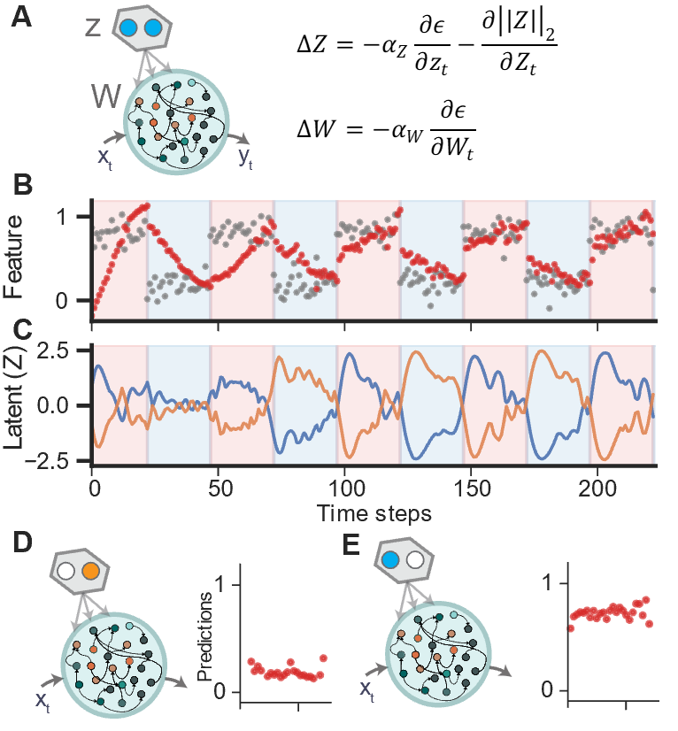
Here we propose an extension of this basic theory that solves the core shortcomings of existing instantiations. Previous work has shown that artificial neural networks, when trained on data with natural correlation structures, develop overlapping representations of the form that make control signals useful ^{56,57,63}. To date no model has been proposed to learn and execute the emerging control problems. The problem of inferring the control structure from experience involves segmenting experience into discrete tasks, which requires the agent to reason about their temporal experience beyond the current trial. Recent work from member of our research team, Ali Hummos, addressed the question of how neural systems might self-organize around the latent structure of the environment ^{37,69}. More specifically, the method starts by equipping RNNs with a small latent embedding to represent current task demands. Then by alternating task learning (updating the neural synaptic weights to learn) and task inference (updating the latent embedding to infer the appropriate task), the system emulates the ‘Expectation-Maximization’ clustering algorithm. The algorithm can discover relevant task demands from data, and as such might discover the relevant control knob to facilitate rapid behavioral improvement for a given task. However, while features of the model align to the problem of cognitive control, the model has never been applied to standard problems or tasks typically studied in cognitive control research.
Fig. 1: RNN embeddings can serve as control representations. A) Neural network contains synaptic weights W and embedding units Z. The network receives sensory input x and produces output y leading to error ϵ. Both Z and W are updated to reduce error. B) Model predictions (red) come to match observed data (gray) over time. C) Latent Z values becomes tuned to block structure over training, after which manipulating Z can drive the network to produce either one of the learned behaviors, providing a task specific cognitive controller (D, E) .

In this proposal we will test this overarching theory through three specific aims. In aim 1 will develop a core set of RNN models to examine what latent embeddings when adaptively controlled would improve flanker task performance and the fit to within and across trial dynamics in human behavior and EEG data. In Aim 2 we will test whether different task changes that require the need for controlled processing can all be subserved by the same controllers (i.e. embedding space) or whether new controllers must be learned for each new control requirement. Furthermore, we will examine the degree to which control policies optimized for one task (from Aim 1) generalize to a different task (Aim 2). Finally, in Aim 3, we will test the effects of perturbations to the control system in our trained RNN and examine whether these effects match those produced by perturbation of the pMFC in humans performing a cognitive control task.

2 Innovation
Our work innovates in several ways. First, we build on a recently developed model that solved a critical problem in continual learning with RNNs. Solving this problem is critical for the human brain since people are forced to learn one experience at a time. We propose that the brain leverages temporal experience to discover latent structure in the environment, and doing inference over this latent structure to achieve flexible and goal-congruent behaviors. The novel model we use can similarly discover latent embeddings that enable a single recurrent neural network to solve multiple tasks presented serially – without any explicit labeling of tasks or randomization of training samples ^{37,69} (Fig 1). Thus, our work innovates by addressing one of the most critical problems faced by the brain using a novel solution demonstrated in a machine learning setting, and here, extended as a model of cognitive flexibility and cognitive control. Second, our work innovates by exploiting a massive dataset previously collected by PIs Ullsperger and Kirschner to characterize the behavioral manifestations of multi-demand control and its underlying neural dynamics. The dataset contains behavioral and EEG data from more than a thousand participants who completed a flanker task that manipulated the demand for control in multiple ways. Behavioral characterizations of this data have revealed a rich behavioral fingerprint of control that includes influences of both recent task and performance history as well as of ongoing active control demands ^{29,30,43} (Fig 2 and 3). Furthermore, characterization of EEG data has provided a signature of the neural dynamics underlying this dynamic control allocation, in particular through lateralized beta activity that provides a time-resolved window into the dynamics underlying successes and failures of cognitive control ^{30,43} (Fig 4 and 5). Finally, our work innovates by using transcranial focused ultrasound stimulation (TUS) to perturb neural function in a spatially targeted manner, thereby enabling us to test the causal role of pMFC in executing control functions.

3 Approach and preliminary data
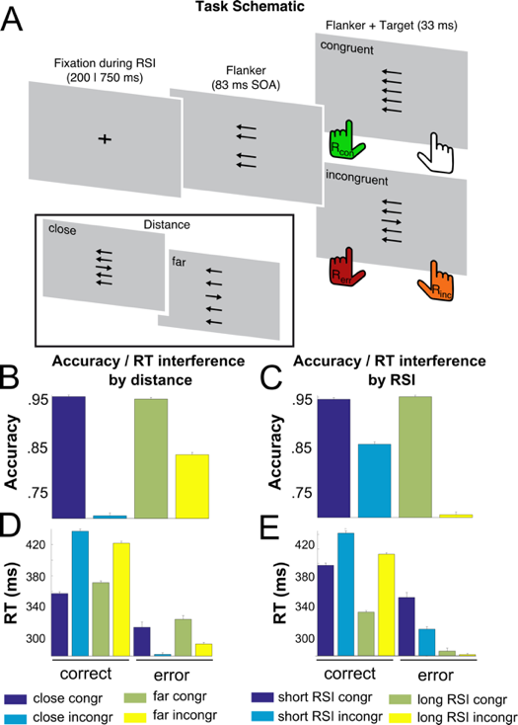
To identify the computational mechanisms underlying cognitive control, test their generality across control demands and tasks, and examine the causal role of pMFC in executing them, we will combine computational modeling with empirical studies through three specific Aims. In the first Aim, we will leverage computational modeling to better understand the “controllers” that best explain human behavior and their underlying neural signatures in a previously administered flanker task. In the second Aim, we will combine modeling with an empirical study to test if and how control representations generalize to new task demands in a flanker task and to new tasks (evidence accumulation conflict task). Finally, in the third Aim we will perturb pMFC, a region implicated in the allocation of control, and examine its effects on control behaviors and their computational and neural underpinnings.

Aim 1: Determine computational mechanisms of control allocation across timescales
In the first Aim, we will attempt to test our theory that cognitive control can be effectively modeled through embedding updates in an RNN with a capacity for continual learning. This process will involve constructing a base RNN capable of performing a modified flanker task (Fig 2A), and then extending that model to include latent embeddings that can be updated through an inference process, that we propose is analogous to the one used by the brain to implement cognitive control. We will test several candidate “embeddings”, which in our view, might serve as potential controllers, and examine which of these embeddings leads to synthetic dynamics and behavior best matched to human EEG and behavioral data, respectively. Finally, we will use a procedure pioneered by research team member Ali Hummos to “discover” a latent embedding from the task data itself allowing us to examine what controllers are learned and whether they account for human behavior and its neural dynamics.

All models will undergo a multi-stage training process to first encourage overlapping representations that are efficient for learning and generalizing, and second enable the model to perform a specific cognitive control task, the flanker task, for which we have a large existing dataset (N = 1300, EEG and behavior). RNNs will initially be trained on a large class of tasks requiring detection of “patches of arrows” presented in a vertical space. The inputs to the RNN will correspond to directional arrow detectors “tuned” to each location in vertical space, as well as additional input neurons that provide the RNN with information about which of several such tasks it is currently required to perform ⁸⁷. Tasks will correspond to the location of the arrow that the model is asked to provide a directional (left/right) discrimination. The key aspect of pre-training is that on each “trial” the RNN will be presented with an array of arrows that is spatially correlated, such that arrows in neighboring locations tend to be pointed in the same direction. Based on previous work ^{26,34,39,87}, we anticipate that this pretraining procedure will lead the RNN models to develop overlapping representations of the stimulus space, such that units in the RNN that are sensitive to a rightward arrow presented at one position in the array, will also be sensitive to rightward arrows presented at nearby positions in the array.
Fig. 2 Task and behaviour from Fischer et al., 2018. (A) In the flanker task either congruent or incongruent flankers (four surrounding arrows) in close or far proximity to the central target (inset) are presented on each trial. Congruent stimuli usually yield faster responses (green) compared to incongruent stimuli, which lead to delayed responses (orange) or induce errors (red). Stimulus incongruence increases RT and decreases accuracy, while interacting with the flanker distance (B, D) and response stimulus interval (RSI; C,E) to modulate both speed and accuracy.

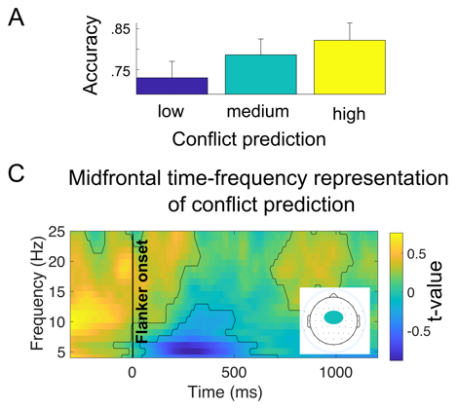
After pretraining, all models will be trained to perform the target task, which requires discriminating the direction of a target arrow in the presence of either congruent or incongruent flanking arrows (“flankers”; Fig 2A). The task provides a unique opportunity to link our RNNs to human behavior and the neural signals that underlie it, since we previously collected behavioral and EEG data from a large sample of 1300 young healthy adults who performed the task as part of an (ongoing) genetic association study. The flanker task (Fig. 2A) was designed to study cognitive control processes ^{30,43}, and includes 50% congruent trials (target and flanker arrows indicate the same direction) and 50% incongruent trials (distracting flanker arrows induce a response tendency opposite to the target-induced correct response). The task also includes manipulations of flanker-target distance (near, far) and the interval between response and next stimulus, both of which have previously been shown to influence the interfering effects of distractors and behavioral control adjustments ^{21,23}.
Fig. 3 Behavioural and neural correlates of conflict expectations. Higher conflict expectation is associated with increased accuracy (A) on incongruent trials, and increased midfrontal theta to beta band activity in the pre stimulus interval (B).

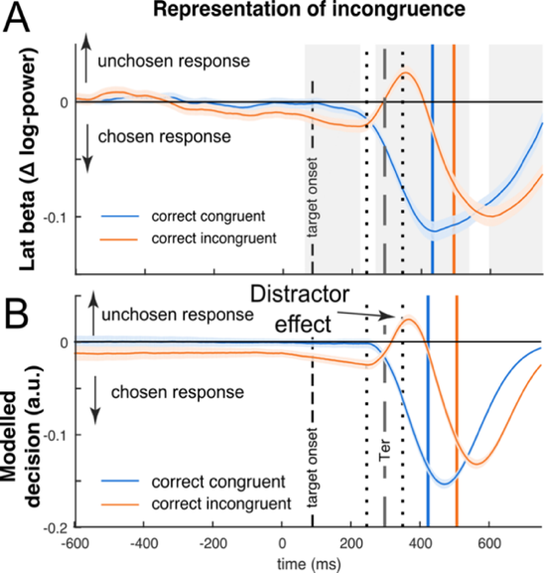
Participant behavior in the task reflected effects of flanker interference, the interval between last response and next stimulus (RSI), and flanker distance (Fig 2B-E). Error commission in this task triggered adjustments including increased reaction times (post-error slowing), post-error increase in accuracy (PIA), and decrease in the RT increase caused by distractors. Model-based assessments of control demand expectations were reflected in reaction time and accuracy adjustments and in midfrontal theta band (4-8hz) activity (Fig 3), likely originating in mPFC to recruit cognitive control ^{12,18,19,20,61}. These data suggest that participants are implementing control over multiple timescales and that pMFC is likely involved in this process ^{34,43}.

Comparison of a multistage drift diffusion model (DDM) and lateralized beta frequency power over motor cortex in the same dataset provide unique insights into within trial control dynamics underlying task behavior ^{6,10}. Beta power lateralization (BPL) is composed of the activity-difference recorded over contralateral and ipsilateral motor cortices and reflects the relative evidence of decisions in action space ^{2,8}. BPL time courses and DDM simulations shows remarkable similarity and suggest that participants are initially influenced toward the response favored by flankers and on correct incongruent trials this initial influence is overcome by a stronger late signal pushing in the opposite direction ^{6,10} (Fig 4). Post-error adaptations are for instance reflected in suppression of distracting evidence ⁶ (Fig 5A). BPL around the response decreased with increasing RTs consistent with a collapsing decision bound ¹⁰ (Fig 5C). The latter observations suggest that BPL peak, coinciding with the motor response, may serve as a neural proxy for the decision threshold.
Fig. 4 Stimulus related beta power and simulated decision variables form Fischer et al., 2018 and Kirschner et al., 2024. Beta power lateralization is composed of the activity-difference recorded over contralateral and ipsilateral motor cortices and reflects the relative evidence of decisions in action space ^{15,40}. (A,B) Comparison of distractor effects on BPL (A) and modelled decision signal in a multistage DDM during stimulus processing (B). Distractor effects were seen at similar times on incongruent (red) compared to congruent trials (blue). Distractors pushed BPL and decision variable away from the correct response. Notably, many features of the time-course and dynamics of BPL are closely predicted by the diffusion variable of the DDM. The vertical blue and orange lines in reflect mean RT per condition.

Taken together, our previous work demonstrates that our existing data set lends itself particularly well to study computational mechanisms of control allocation across timescales and that BPL can be utilized a neural proxy to validated model predictions. A key goal of aim 1 is to test whether and through which mechanisms RNN behavioral data matches these behavioral and neural signatures of cognitive control processes.

Pretrained RNNs will be fine-tuned to perform the flanker task and then used to generate synthetic dynamics and behavior for all task conditions. The exact training will differ slightly across the RNN model set. The base RNN will be trained on the exact task conditions performed by humans, by providing target and flanker information as inputs with times matched to that in the human task, and outputs corresponding to left or right response options. Trials will be broken into discrete timesteps corresponding to 10 msec bins and inputs will be fed to the RNN at the same timepoint in which humans would observe them, meaning that the flankers will be provided first followed by the target information after an 83 msec delay. Weights within the RNN and those mapping RNN units to output will be updated using backpropagation through time to maximize rewards. We lower rewards late in the trial by a discount factor to encourage models to respond faster ⁷⁸.

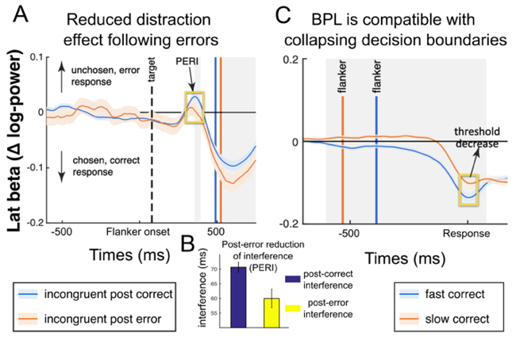
RNN models will differ in their latent embedding space. The base model will not include any latent embedding projections, and thus only be capable of learning through weight adjustments. We will also construct models with theoretically motivated embedding representations that could possibly serve as controllers to modulate how information flows through the RNN toward the output. Each unit in the set of embedding units will have randomly weighted projections into the RNN. Embedding values will be provided as input to the model during the flanker task “fine tuning” from a set of theoretically motivated embeddings that include: 1) congruent/incongruent trial type, 2) short/long inter-trial interval, 3) left/right target direction, 4) distractor distance, as well as all combinations of these embeddings. Training the RNN with such candidate control variables encourages the models to learn computations that are explicitly responsive to those control variables. So, for example, following this training, one could adjust the value of the embedding units to control the RNN behavior, according to the meaning associated with the embedding units during training. After this “fine tuning”, we will test the RNN behavior on task trials and allow the activity of the embedding units to be adjusted dynamically through feedback from trial stimuli and rewards, i.e. through gradient descent updates absent (in base model) ³⁹.

The updates of embedding unit activations can be thought of as an inference process, whereby the network “infers” the underlying latent state, and indeed such updates can be used to infer the generative mean of an underlying latent variable (Fig 1). However, this inference also affects how information flows through the RNN, since a change in the latent embedding units will alter which units in the network are suprathreshold, and thereby sensitive to incoming information, either from inputs or other RNN units. Thus, a change in which latent embedding unit is active can alter the subnetwork through which inputs are interpreted and translated into outputs, thereby affording a mechanism that could enable broad tuning favoring generalization in one regime, and more specialized representation limiting interference in another. However, the utility of separating processing into different subnetworks like this depends on the task and what is represented in the latent embedding units. Thus, a primary goal of the theoretically motivated embeddings is to determine which embeddings enable behavioral improvements, and to ask whether these embeddings lead to control behaviors and dynamics well-matched to those of human participants.
Fig. 5 Within-trial adjustments in neural decision signals and behaviour in Fischer et al., 2018 and Kirschner et al., 2024. Post-error reduction of interference (PERI) is seen in the beta signal (A) and in the behaviour (B). This highlights BPL’s ability to track trial-wise adaptations in cognitive control. (C) Beta power lateralization around the response decreased with increasing RTs. This is in line with predictions of the DDM with collapsing decision thresholds, a process wherein the decision boundary reduces over time. These results suggest that peak BPL around the response may serve as a neural proxy for the decision threshold.

We will also train a final set of RNNs that learn what to represent in their latent embeddings directly from the data ^{37,69}. The goal of this set of models is to examine what sort of controllers would emerge if an embedding space with fixed size were available for use in partitioning the RNN into subnetworks. For example, it would clearly not be useful to divide the RNN into subnetworks according to the arrow direction of one of the flankers, however, one could imagine it might be useful to have different subnetworks to solve congruent and incongruent trials, since these trials differ in the degree to which flanking arrows could be used to determine the correct response. Our approach to learning latent embeddings from data will follow Hummos ³⁷, but in short: traditional RNNs are trained on tasks by updating their weights, a model for slow incremental synaptic plasticity or ‘task learning’. In addition, we will update the embedding units Z also to lower output error as a model of ‘task inference’, or rapidly neural activity-based adjustments to meet current task demands. Initially, those embedding units have no meaning associated with them, and updating them will have little effect on RNN processing. However, the dynamics of the system emulate an Expectation-Maximization clustering algorithm. Embedding units converge to representing latent variables that impose a useful clustering over task trials (Fig 1).

After training, all models will perform the same flanker task administered to human participants. Model weights will be frozen but embedding units will continue to evolve their activity according to gradients. Embedding units will be adjusted dynamically every time step. For example, as soon as the flankers and the target appear, gradient descent in the embedding units might retrieve a representation of ‘incongruent trial’, if it is a latent variable the RNN learned to represent incongruent trials during training.

Human and RNN behavioral data, including both choice and reaction time, will be analyzed with regressions to determine how task variables on the current trial and from recent trial history, impact behavior. Furthermore, behavioral data will be fit with a joint RL-DDM model capable of describing both within trial and across trial control effects in terms of reinforcement (i.e., the degree to which recent incongruent trials drive up expectations that control will be necessary) and drift diffusion (i.e., changes in the rate of drift toward the correct boundary or degree of separation between correct and incorrect boundaries). Finally, each RNN provides action output reflecting its moment-to-moment decision variable and a decision time output, which signals when the RNN is ready to output a response and receive feedback reward.

We will compare behavior of trained models without latent embeddings to those containing either theoretically motivated or data-driven latent embeddings to test the overarching hypothesis that incorporating updates of latent embedding space can improve the efficiency (i.e. reward rate) in recurrent neural networks. We will then compare the behavior of the models to that of human participants to test if and how latent embeddings can explain signatures of control both within and across trials. Similarly, we will examine within-trial model dynamics and compare them to EEG recordings from human participants, in order to understand how latent embeddings affect dynamics and to test which embeddings might best account for dynamic signatures of human control.

H1.1: Latent embeddings of conflict facilitate efficient learning in RNNs. We propose that latent embeddings provide an efficient strategy to navigate the tradeoff between faster learning with overlapping representations versus more accurate performance under conflict with reduced interference. Thus, we predict that “fine tuned” models that update embeddings related to congruency will show improved task performance, in terms of average reward rate in the flanker task, over those that rely exclusively on weights or those that represent embeddings of more specific variables (e.g., inter-trial interval). To test our overarching idea in a broader way, we will also test the performance of trained models in a continual learning framework using a set of tasks that were held out from the initial training to evaluate the generality of learning beyond the specific training environment. We predict that models with data-driven embeddings will outperform both the basic RNN and those using theoretically motivated embedding spaces on both of these metrics, and that investigation of the learned embeddings will reveal units sensitive to trial congruency.

H1.2: Latent embeddings enable RNNs to capture behavioral signatures of control. We propose that the brain does inference over latent states of the current trial and uses these inferences to dynamically control information flow. We thus predict that this mechanism will enable the RNNs to produce hallmarks of human behavior. Our previous analyses of human behavior in the flanker task have revealed a number of primary behavioral features: 1) increased accuracy and decreased RT for congruent trials, 2) increased accuracy and decreased RT for shorter preparation time [RSI], 3) decreased accuracy and increased RT for incongruent trials with near (as opposed to far) flankers, and 4) decreased congruency effects on behavior following an error trial. We predict that basic RNNs trained as described above will show basic congruency (1) and near/far (3) effects, but that models that include latent embeddings representing conflict will recapitulate the full behavioral signature of control in human participants, with carryover effects in the latent embedding from one trial to the next giving rise to preparation time effects (2) and the update of latent embedding activities after errors driving post-error behavioral modification (4). We predict that the model set capable of explaining human behavior will include those that learned embeddings directly from the task data, as we predict that such models will learn an embedding space that is highly sensitive to conflict.

H1.3: Dynamics in RNNs with latent conflict embeddings match beta-lateralization EEG signals. EEG data collected simultaneous with human flanker task behavior provides insight into within trial control dynamics underlying task behavior. Specifically, lateralized beta frequency power over motor cortex shows temporal dynamics suggesting that 1) participants are initially influenced toward the response favored by flankers and on correct incongruent trials this initial influence is overcome by a stronger late signal pushing in the opposite direction ^{30,43} 2), the magnitude of initial flanker signaling is reduced after errors ³⁰, and 3) beta lateralization diverges rapidly late in the trial consistent with a collapsing decision bound ⁴³. We will examine the difference between RNN output activities in favor of left/right options to examine its within trial dynamics. We predict that basic RNNs will show basic pattern of effects (1) but that models with latent conflict embeddings will additionally adjust dynamics from trial-to-trial (2) due to error-induced latent state updating. We predict that models with data-driven embeddings will learn embeddings that explicitly represent time within trial leading them to additionally explain dynamics consistent with a collapsing decision bound (3).

H1.4: Medial prefrontal theta will correlate with magnitude of updates to latent embedding units. Midfrontal theta (MFT) activity is thought index cognitive control across a wide range of tasks ¹². Here we propose that control is implemented through adjustment of latent embedding units that control how information flows through the RNN. Thus, we predict that trial-to-trial variability in the absolute magnitude of latent embedding activity adjustments in models best matching behavior will correlate closely with the dynamics of MFT, as measured in EEG from human subjects.

H1.5: Individual differences in control are related to a behavioral fingerprint of inference strength. We will manipulate the strength of inference in best fitting RNNs by modulating the proportion by which gradients are used to update activations in the latent embedding units (inference learning rate) and examining how this change affects a range of measurable behaviors (error rate, RT congruency effects, post error slowing). We will then measure control differences across individuals in our dataset by subjecting a wide array of behavioral and EEG task measures thought to relate to control (e.g., error rate, congruency differences in RT, post-error slowing, ERN magnitude, congruency differences in MFT) to a principal components analysis. This analysis will be performed on a subset of the overall dataset and validated in a held out set in order to evaluate which components reliably track together across individuals. We will test the prediction that the component explaining the most variance in human behavior matches the dimension of behavior that is affected by alterning the inference learning rate in the RNN model, which would result in scaling of overall latent embedding activity adjustments.

Preliminary data. Our preliminary RNN data shows a proof-of-concept that our RNNs trained with task-relevant latent embeddings can generalize to novel task conditions (Fig 6). Our preliminary behavioral and EEG data shows that individuals performing the flanker task were sensitive to task manipulations and that they modulated control according to both within across trial factors. EEG data further suggests that participants initially accumulated information about the flankers, and that on “correct” trials, this spurious accumulation was overridden by rapid accumulation of target information (Fig 4).

Potential pitfalls/alternative outcomes. It is possible that no model in our initial set of RNNs will match the full pattern of behavioral results. Indeed, a primary strength of our proposal is that it builds on a rich dataset revealing an intricate tapestry of nuanced patterns of control behavior, that in turn provides strong constraints for modeling. In the case that no model in the set can explain the full repertoire of control behaviors and dynamics we will perform targeted analyses to determine the mapping between model components and specific behavioral results. These analyses will likely include cognitive models as an intermediate, including an RL-DDM model that we have previously fit to the flanker task data and can capture basic pattern of results. Through a systematic exploration of how training protocols, embedding feature spaces, and hyperparameters in our RNN model set affect intuitive parameters in the cognitive model, and how these parameters map onto specific behavioral elements, we will examine a wider range of models that might be consistent with our overarching hypothesis. We see this iterative process of model fitting and model critique as a primary advantage of the computational modeling endeavor, in that it enables rapid epistemological progress even when results are not as predicted, ensuring that knowledge will be gained, irrespective of whether the initial theories and assumptions are all correct ⁵⁸.

Aim 2: Test model-predictions in a novel task framework for generalization.
Our first Aim will examine whether and how control adjustments RNN embeddings can explain behavioral and neural cognitive control phenomenon in a previously developed flanker task. However, success at this endeavor would still leave open an important question: do the “control knobs” that explain cognitive control depend on task conditions, or even tasks themselves? For example, we might identify an embedding space over which our model could reproduce control structure within the flanker task data examined in Aim 1, but there are no guarantees that this embedding space would make accurate predictions for a new set of experimental manipulations (for example, the proportion of congruent/incongruent trials). Beyond this, it would leave open the question of whether the learned control representations from one task might be “reused” in another task, thereby providing a general mechanism for control. Together, these two questions can be thought of as asking whether control representations in our model are capable of “near” and “far” transfer.

We will address these questions in Aim 2 through additional computational modeling in combination with a new set of empirical studies conducted in humans. The modeling approach will involve two distinct steps: first we will test predictions from the models developed in Aim 1, focusing primarily on those that offered the best explanations of our existing human data, for a variant of the flanker task that includes dynamic changes in the underlying probability of congruency as well as an additional manipulation of the timing between the onset of flankers and target stimulus. The second modeling step will involve extending the model slightly and retraining it to perform two very different control tasks, the first being the extended flanker task, and the second being a dot-motion conflict task.

To develop model predictions for near-transfer we will use the fully trained model set developed in Aim 1 to make predictions for a novel variant of the flanker task. The novel variant will include the same stimuli and trial structure, but will use a fixed inter-trial interval and flanker distance. Instead, the novel task will include two additional task manipulations. First, we will manipulate the time between flanker onset and target onset, such that some trials show the target simultaneous with the flankers, whereas other trials show the target up to 150 msec after the onset of the flanker stimuli. Second, we will manipulate the trial structure such that the average level of congruency changes in blocks of 10-40 trials through discrete transitions at which time the proportion of congruent trials is sampled from a uniform distribution ranging from 20% to 80%. Performance of the models will be characterized in terms of average reward rate through exhaustive simulations. Simulated choices and response times from the various RNNs will be analyzed through regression analyses to measure the effects of manipulations on both of these factors, as well as by fitting a model previously developed by our team that combines an RL component that captures trial-to-trial control adjustments and a drift-diffusion component that captures within trial dynamics. We will also characterize the within-trial dynamics of the RNNs, as measured through the difference in subthreshold output activations favoring right versus left responses, separately for each task condition. These descriptive measures will serve as predictions for a “near-transfer” empirical study that will also be conducted as part of this Aim.

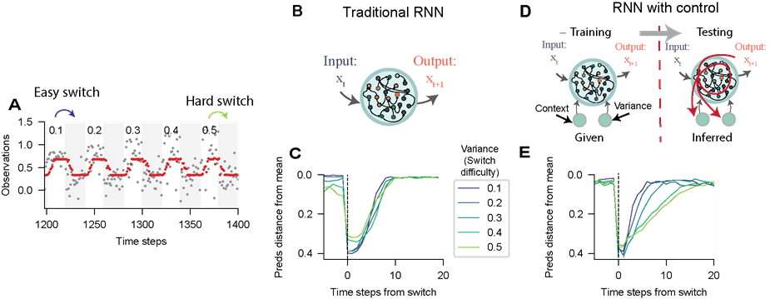
To address far transfer, we first introduce a second cognitive control task. The task will require participants to fixate centrally on a field of dots with both color (blue-yellow) and motion (left-right) coherences (overall strength of motion/color information) that are manipulated from trial-to-trial. Participants will be instructed to identify the dominant color in the stimulus and signal their decision through a left- or right-handed response. The mapping between color and correct response will be signaled to the participant through a set of colored targets (blue/yellow) appearing on the left and right side of the motion stimulus. The mapping will vary across trials with the blue and yellow targets equally likely to be associated with rightward/leftward responses. Successful task performance thus requires participants to combine information about the dominant color of the stimulus (e.g., blue) with a cue (e.g., blue circle appearing on left side of screen) in order to produce the correct response (left button press). Motion in this task is completely incidental and unrelated to performance, however, previous work including work by our research team has shown that participants are both slower and less accurate when motion information (leftward/rightward) is incongruent with the correct response option ^{22,65,66}. Furthermore, these congruency effects are reduced on trials following errors ²², suggesting that, like in the flanker task, participants are undergoing trial-to-trial adjustments of control in accordance with ongoing performance demands ^{65,66,73}. Thus, it is conceivable that the brain, and our models of it, might use a single control policy across the two tasks.

With respect to models, we will test this idea by first extending the model set developed in Aim 1 to allow for performance of the color-motion control task (CMCT). We will equip the model with additional inputs that, in the presence of color or motion stimulus, reflect momentary evidence (i.e., normal random variable with unit variance and mean reflecting coherence) and color-side cues (+1/-1 for blue/yellow stimulus in each of two location units). The extended model will be retrained, like in Aim 1, using naturalistic stimulus correlations to promote default response biases. In this case, we will train in a continual learning framework, alternating between training on the arrow discrimination task described previously, and motion and color discrimination tasks in which motion and color are always presented congruently. Models will then be fine-tuned in alternation on the novel flanker and CMCT tasks. We will characterize model performance, sensitivity of choice and response time to task manipulations in both tasks, computational parameters of best fitting RL-DDM models, and within trial RNN dynamics as described above. These descriptive measures will serve as predictions for a “far-transfer” empirical study that is also part of this Aim.
Fig. 6. RNNs explicitly trained with control variables in embedding units can dynamically adjust amount of control even in novel task conditions. Networks were trained on to predict a sequence of observations, but then tested on a novel aspect of the task, the dynamics of inferring a block switch. (A) We created a series of easy to hard switches, by parameterizing the variance of observations in the block to switch from (variance ranging from 0.1 for easy switches to 0.5 for hard switches) and maintained a constant mean and variance for the data in the block to switch to. The difficulty of detecting the switch increases with the variance of the block to switch from. (B) A traditional RNN (C) failed to modulate its switch rate according to difficulty. (D) A schematic demonstrating the training of an RNN with control variables. A 4-neuron embedding that received context information and input noise level (variance) as a proxy for context uncertainty and sensory signal uncertainty in human experiments. During testing, these were not provided and were instead inferred from the input observations. The embedding units were updated along their gradients, indicating whether their activations needed to increase or decrease to better account for current observations. (E) The RNN with control aptly adjust switching speed according to the current variance, demonstrating switching rate proportional to the difficulty of the context switch, paralleling animal behavior in similar task requiring decisions under uncertainty.

To test the predictions of our model, we will conduct a relatively large scale (N=260) behavioral EEG study in humans. This sample size will allow us to reliably assess the dynamics of beta-lateralization including the magnitude of flanker related accumulation and collapsing decision boundaries as we measured in our previous large EEG dataset ⁴³. Participants will perform both the novel flanker task (45 minutes) and, after a short break, the CMCT task (45 minutes), while EEG is continuously recorded. The primary site for data collection will be Magdeburg (N=200), however, a smaller dataset will be collected at Brown (N=60) to evaluate cross-site reliability of primary findings. All exploratory analyses will be first performed on the Magdeburg dataset and subsequently validated in the Brown dataset. Human behavioral data will be analyzed similarly to the model data, and compared to the model predictions in order to test the generalization of predictions made by different models in the set. EEG data will be preprocessed and lateralized beta, MFT, and error related negativity (ERN) signals will be extracted using methods we have reported previously ^{3,29,67}. Model behavior and dynamics will be compared to human behavior and EEG data to test the following specific hypotheses:

H2.1: Models that include conflict in embedding structure will perform better in changing environments. We hypothesize that conflict signals optimize a tradeoff between generalizations that are useful for learning and task-specific processing necessary to implement arbitrary tasks. Thus we predict that models with conflict signals that reflect and respond to congruency will more rapidly calibrate behavior in the face of experimental changes in congruency probability.

H2.2: Models that include conflict in embedding structure will successfully predict human behavior in a novel flanker task. Models that have embeddings that respond to conflict, either by design (theoretically motivated embeddings) or through data driven training, will predict smaller congruency effects when congruency is more common, an effect we hypothesize will also emerge in human participant data. We predict that such models learn to use conflict control signals to select a subnetwork of the RNN that relies more selectively on the target stimulus. Thus, we also predict that the same models will be sensitive to flanker/target latency, with higher latencies corresponding to lower accuracies and longer response times. Critically, we hypothesize that these effects will be reduced in blocks with increased control demands (low proportion congruent, indicating a non-trivial transfer of control (i.e., congruency to timing) that we predict will also emerge in human participant data.

H2.3: Models that include conflict in embedding structure will successfully predict neural dynamics in a novel flanker task. We hypothesize that conflict embeddings will control the degree to which task-general representations contribute to choice dynamics. Thus, we predict that increased activity in the conflict units will reduce accumulation of evidence for the incorrect response after onset of flankers but before onset of targets. We hypothesize that models with conflict-sensitive embeddings will update them proactively, thereby leading to modulation according to our task manipulation of congruency proportion, and that the exact timing of these dynamics will depend on the task manipulation of the target and flankers. We predict that all of these effects on within-trial choice dynamics in the RNN will be mirrored in beta-lateralization of human participants performing the novel flanker task.

H2.4: Models that learn embeddings from scratch will develop representations of congruency that persist across tasks. We will examine what control representations are learned in the embedding units of models where embeddings are learned directly from the data, which in this case will come from two different tasks presented in a continual learning framework. We predict that in models with a relatively small number of control units, task-general conflict embeddings will be learned that respond to incongruency in either the flanker or the CMCT task. We predict that these representations will promote cross-task conflict effects, whereby observing an incongruent trial on the flanker task will minimize subsequent-trial congruency effects in the CMCT task.

H2.5: Models with generalized conflict embeddings will predict human behavior in the CMCT task. We predict that models that develop generalized conflict embeddings will produce slower and less accurate responses on incongruent trials in the CMCT task, and that these effects will be reduced following an error trial, since activity in conflict units should be updated through inference in response to such errors. We predict that these effects will match empirical data from human participants qualitatively and quantitatively.

H2.6: Models with generalized conflict embeddings will predict neural dynamics in the CMCT task. We predict that models that develop generalized conflict embeddings will display dynamics that depend on color and motion coherence in a manner that depends on time within trial as well as previous trial outcome (error/correct). We predict that this will be mirrored in human subject beta-lateralization signals. Furthermore, we predict that trial-to-trial mPFC theta signals, which are thought to provide a biomarker for ongoing control processing ¹², will be closely correlated with trial-to-trial variability in the activation of conflict sensitive embedding units. We further predict that the specific models that show the strongest correlation between embedding unit activation and mPFC theta will also provide the best match to behavioral fingerprints of control.

Preliminary data. The success of this Aim will build on previous computational work from our team showing the ability of our RNN framework to capture behavior across multiple tasks in a continual learning framework ³⁷. More specific to our proposal, we ran the following experiment. We trained the base RNN model to match its output predictions to the distribution of the data points it observes (training data points = 1000), and then tested its performance on a novel aspect of the task that was not trained specifically: the dynamics of block switch inference (only 10 switch data points in the training set). We see that while the base RNN failed to modulate its inference based on the difficulty of the switch, an RNN trained with an embedding receiving mean and variance input succeeds (Fig 6). These findings are analogous to human and other animals behavior where their context switch inference is modulated by sensory uncertainty ^{54,70}. Moreover, there is previous behavioral work demonstrating conflict effects in tasks similar to our proposed CMCT ^{22,65,66}, and EEG data supporting the ability of beta-lateralization to capture dynamics in an evidence accumulation task ⁶⁷.

Potential pitfalls/alternative outcomes. While we predict that models with data-driven embeddings will discover task-general congruency/conflict representations, we may find that such representations only emerge under a highly constrained set of conditions. For example, it may be that such cross-task embeddings only emerge if the embedding space is extremely small, limiting the possibility for task-specific embeddings. Alternately, we might find that these representations only emerge under very specific training regimes, or only when action and/or input spaces of the tasks are overlapping in specific ways. While these results would, in some sense, limit the ability of our model to generalize arbitrarily to different settings, they would also provide critically important datapoints useful for understanding when and why shared versus individuated control representations develop. Such computational findings would inspire additional human experiments to examine whether these principles dictating shared versus individuated control are also features of human cognitive control.

Aim 3.: Testing the necessity of pMFC for cognitive control mechanisms with causal modulation.
While correlative approaches such as EEG, fMRI and invasive electrophysiological recordings strongly suggest an involvement of the pMFC in cognitive control functions, evidence for the necessity of this brain region for these functions is limited. One reason for this limitation is that isolated, specific and focal lesions in human pMFC are rare, such that clinical neuropsychological studies are confined to studies in single cases or small groups, often with large lesions ^{17,28,52,53,79,81}. Moreover, the pMFC is rather vaguely defined based on neuroimaging results and comprises the anterior midcingulate cortex (aMCC), pre-supplementary motor area (pre-SMA) and adjacent medial Brodmann area 8 in the dorsomedial prefrontal cortex (dmPFC). In the literature, the terms dorsal anterior cingulate cortex (dACC, a term deviating from Vogt’s nomenclature) and (anterior) rostral cingulate zone (RCZa) are often used nearly synonymously to aMCC ⁶². The aMCC is a cytoarchtectonically defined subregion of pMFC located around the middle portion of the cingulate sulcus and is thought to play a crucial role in cognitive control ^{43,73}. However, replicable mapping of functional representations in the pMFC onto its anatomical subregions has been difficult. In human fMRI research, substantial interindividual variability of pMFC anatomy may be a major reason for the inability to differentiate clear functional boundaries. Therefore, non-invasive stimulation methods applicable in humans are vital to probe the causal involvement of pMFC subregions in cognitive control functions. Therefore, non-invasive stimulation methods applicable in humans are vital to probe the causal involvement of pMFC subregions in cognitive control functions. The novel method of low-intensity transcranial focused ultrasound stimulation (TUS) has recently received interest as a novel non-invasive technique that uses acoustic energy to influence neuronal activity in both cortical and deep brain regions with very high spatial specificity in the order of millimeters ²⁴. It is believed that TUS induces neuromodulation by mechanically interacting with cells as the ultrasound wave passes through the target area ^{14,90}. Recent reviews that assess the safety of this method ^{5,50,61} suggest that it is ripe for systematic use to map the causal contributions of network nodes to functions such as cognitive control. Indeed, recently evidence in humas has shown that theta burst TUS can induce increased cortical excitability for up to 90 minutes in the human motor cortex ⁹¹. Moreover, it has been shown that functional connectivity of the human aMCC increased following an offline TUS protocol and that TUS-mediated neuroplasticity lasts at least 50 minutes post-stimulation ⁸⁶. However, there is still a debate as to what extent and in which direction TUS shifts of the inhibition/excitation balance in the target location ²⁴. In addition, no study has yet investigated the effect of TUS-mediated aMCC effects on cognitive control functions. Here, we test whether TUS-mediated changes in neuroplasticity in the aMCC, resemble behaviors predicted by our model when the inference process is computationally “manipulated”. The Ullsperger lab has recently acquired a TUS system including neuronavigation tools (used to create a virtual map of the brain using T1-weighted MRI scans, allowing accurate localization and targeting of specific brain regions). In one pilot study directly related to this proposal, we used a flanker task with the same stimuli and trial structure as in Aim1, but with a fixed inter-trial interval and flanker distance. For each participant, the maximal error-related fMRI activity within the aMCC was selected as the individual target for TUS. Individual MRI-based skull models served to determine the parameters for sonication. Directly after either a sham stimulation or TUS of aMCC, an active control region in the posterior cingulate cortex (PCC), participants performed the flanker task again. Via acoustic measurements and simulations, we were able validate that we effectively and safely targeted this deep cortical region (Fig. 7). Preliminary data (n=19) shows that TUS over aMCC significantly increased accuracy compared to sham. These preliminary findings are consistent with aMCC playing a role in implementing control and TUS having an activating influence on it.

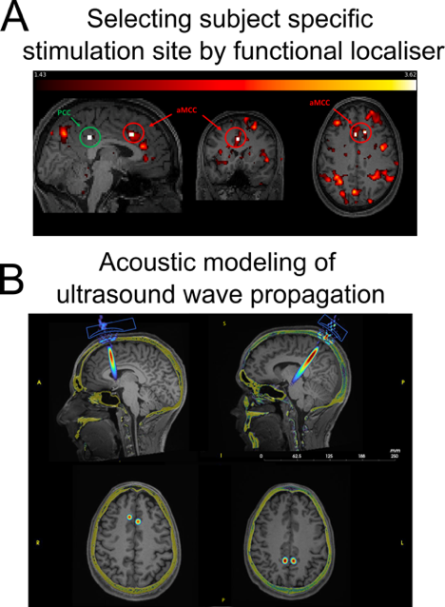
We will generate testable predictions for TUS using our set of trained RNN models on the flanker task. As described above, we propose that inference over embedding unit activations can provide a task-general account of cognitive control. Thus, reducing the degree to which embedding units are adjusted according to gradients on each timestep provides a way to turn predicted control dynamics up or down. Intuitively, a slower rate favors stable embedding units activity that is integrated from several recent trials, whereas a high update rate, favors rapid adaptation to trial demands. However, we will also consider other possible perturbations of the model, that might also be consistent with our overarching hypothesis but would reflect slightly different roles of the aMCC. First, we will consider deviations from optimal adjustments that directly follow gradients. Specifically, we will consider the possibility that updates to the embedding units include multivariate noise that can be either increased or decreased to simulate possible effects of our manipulation. In this case, the perturbation of the model would not affect the overall amplitude control adjustments, but instead, their precision. Next, we will consider a multiplicative scaling of the overall magnitude of embedding activations. This probes the default RNN behaviour without control on one end, or strong control which also introduces rigidity in the embedding space as the gradient-based updates or feedback would require many updates to switch the embedding activity to match changes in task demands.

After generating predictions, we will measure behavior and EEG with TUS of either aMCC or a different control region in human participants performing the novel flanker task used in Aim 2, in which the probability of incongruent/congruent trials is manipulated systematically. The experimental methodology will be as follows: based on individual fMRI scans during the novel flanker task, we will determine individual target locations within the pMFC for each participant. Specifically, the voxel with maximum activity for detecting errors versus correct task performance will be identified. In addition, structural MRI scans will be collected (T1) to create individual skull and head models. Using the software k-Plan and k-Wave, we will determine individual sonication trajectories. Stimulation parameters will be selected such that thermal and mechanical (acoustic) effects are kept within the safety limits ². In three sessions in counterbalanced order, young healthy participants (N=35) will receive either active TUS of the aMCC, TUS of an active control region (e.g. posterior cingulate cortex, PCC, or the lateral ventricle, where sonication of CSF should have no effect on neuronal activity) or a sham stimulation, respectively. The sample size is based on power calculations suggesting that 30 participants are needed for reliable modulations of neural cognitive control signals ⁷⁶ and compensating for potential dropouts. In addition, this sample size is significantly exceeding previous human TUS studies ^{72,86}. Correct targeting will be ensured using neuronavigation. Session blinding will be supported by bone-conduction headphones masking acoustic effects of the stimulation duty cycle that could be heard by the participants and potentially exert variable salience effects ⁸⁰. Bilateral stimulation will be applied offline (before the task) with a fundamental frequency of 250 kHz (4 element transducer) in a 5 Hz protocol (SD=120s; 1/PRF=0.2s; PD=0.03s ramp) with ISPPA of 30W/cm², ISPTA4.5W/cm² and 60 mm focus. Simulations were performed and revealed that the applied intensity is within the safety limits. These simulations will be repeated for every individual head model based on anatomical MRIs. Directly after TUS application, participants will perform the novel flanker task, while EEG is recorded.
Fig 7. TUS will be used to temporally perturb aMCC, a subregion of pMFC. (A) Unpublished data showing conflict contrast in flanker task for an individual subject. Masks for TUS (white squares) were created by obtaining the local maximum of the aMCC region. Control masks were created for PCC, a region with no activation for the contrast of interest. (B) Acoustic modeling of ultrasound wave propagation is used to target aMCC and PCC and to ensure safety for selection of subject-specific stimulation parameters.

As described previously, human and RNN choice and reaction time data will be analyzed with regressions and fit with a joint RL-DDM model capable of describing both within trial and across trial control effects. For model fitting, we will use the large dataset from Aim 2 to constrain the free parameters in fits to the TUS data through hierarchical modeling. Moreover, we examine within-trial model dynamics and compare it to EEG recordings from human participants. We will use the results from the model perturbations to interpret the effects of TUS-mediated aMCC in order to test the following sub-hypotheses:

H3.1 TUS will modulate the integration window of previously experienced conflict. Based on the evidence suggesting that the aMCC is crucial to track trends in the environment ^{4,13,47,51,55,71,75,85} and integrating information over longer time scales ⁴², we propose that TUS to this region will affect the degree to which recent incongruent trials drive up expectations that control will be necessary. Based on work suggesting that TUS will promote increased excitation relative to inhibition ⁹¹, we anticipate that TUS will have a facilitating effect on these trial-by-trial adjustments, and that this same behavioral result will emerge from RNN models in which inference over latent embeddings is increased. Effects of the modulated integration window will be reflected in parameter changes in a joint RL-DDM model describing both within trial and across trial control effects in terms of reinforcement (i.e., the degree to which recent incongruent trials drive up expectations that control will be necessary) and drift diffusion (i.e., changes in the rate of drift toward the correct boundary or degree of separation between correct and incorrect boundaries). Specifically, we expect 1) adaptive changes in the learning rate adjustments based on new information and 2) proactive increase of separation between correct and incorrect boundaries in the DDM.

H3.2: TUS will modulate cognitive control dynamics and specific RNN latent manipulations will recover similar dynamics in the model. Based on our preliminary data showing increased accuracy in a Flanker task after TUS of aMCC, and evidence showing that functional connectivity of the human aMCC increased following an offline TUS protocol ⁸⁶, we propose that TUS of aMCC will reduce interference and facilitate post error adjustments. Specifically, we hypothesize (1) increased accuracy and decreased RT on incongruent trials and (2) decreased congruency effects on behavior following an error trial. Further, we predict that these behavioral effects will be accompanied by reduced distractor effects evident in beta lateralization EEG signals and increased midfrontal theta (MFT) activity as a proxy for increased recruitment of cognitive control ¹². Finaly, we anticipate that this same behavioral pattern will emerge from RNN models in which inference over latent embeddings is increased.

Preliminary data supporting our ability to execute Aim 3. Our ability to execute this aim is supported by preliminary data from our team demonstrating the successful implementation of TUS protocols in combination with EEG in the Ullsperger lab (Fig 7). In addition, a recent study from another group successfully targeted the aMCC with TUS in humans ⁸⁶. Moreover, our previous computational work has shown our ability to parse out behavioural and neural signatures of cognitive control processes in similar tasks ^{29,30,43}.

Potential pitfalls/alternative outcomes. We may observe exactly the opposite of our predicted results. In this case, considering the mixed reports regarding the exact mechanism of TUS in terms of increasing or decreasing activity within the targeted region ^{5,24}, we would tentatively interpret the result in terms of a successful causal perturbation, albeit one with limited specificity. Finding no change in either control behaviors or dynamics, on the other hand, would call into question the current assumption that the aMCC has a causal role in the implementation of control. Regardless of whether our predictions are confirmed or refuted, the novelty of the method and the richness of the behavioral and neurophysiological measures would make significant contributions to our understanding of the role of aMCC in cognitive control.

Intellectual Merit. Cognitive control is a critical function performed by the brain. Failures of cognitive control can be impactful, and in some cases have dire consequences for individuals and society. Despite decades of active research addressing the mechanisms of cognitive control, we still have no task-general computational theory of what control is, let alone how recent and current context affects its recruitment and allocation to perform specific computations. Here we test a theory that has potential to fill this gap. Our theory builds on work showing that inference over latent embeddings can allow recurrent neural networks to generalize better and to perform continual learning efficiently. We hypothesize that this inference, which modulates the activity of embedding units in order to improve the objectives of the neural network, serves as a task-general cognitive controller. Our work will provide a detailed mechanistic description of what task general control means in the context of recurrent neural networks and use this to shed light on control representations and the neural mechanisms supporting them. If successful, our work will provide the first validated task-general model of cognitive control and its neural implementation, and if unsuccessful, it will reveal failure points of existing theories that have, to date, only been implemented in specific tasks. In either case, this work will shape our understanding of the neural computation underlying cognitive control and pave the road to understanding cognitive control failures.

Broader Impacts. Our research proposal will have broader impacts for education and society. The proposal will provide an interdisciplinary and international training environment for research teams across Brown, MIT and Magdeburg. Research team members will benefit from an complementary expertise across sites as well as opportunities to travel abroad to initiate both intellectual and cultural exchange. The ideas in this proposal resulted from discussions that took place when PI Kirschner visited PI Nassar’s lab through a similar exchange, and then later as PI Nassar spent six months in Germany on sabbatical. Thus, this award would enable a fruitful line of exchange to continue and broaden the intellectual and cultural training of another generation of international scientists.

Beyond our research teams, the project will have educational impacts through community outreach in the U.S. and Germany. These educational outreach efforts will be directed at local communities through existing channels in the Nassar & Ullsperger labs. In Providence, RI, this will include exposing local communities to basic concepts related to the neural mechanisms of cognitive control at local brain fairs in Providence and Pawtucket, RI, and through classroom visits at a local public elementary school where the lab has previously established ties (Vartan Gregorian Elementary School in Providence RI). Previous classroom visits have provided live demonstrations of EEG. The relevance of cognitive control for children in an educational setting will provide an opportunity to bridge the topic of our research to something that the students can closely identify with. In Magdeburg, the lab will disseminate the basic concepts, study results, and methodological advances in outreach activities such as the Long Night of Science and public lectures in the program “Wissenschaft im Rathaus” (Science in the City Hall). Moreover, pupils from Magdeburg schools regularly perform internships in the EEG lab to get hands-on experience with cognitive neuroscience methods. The Magdeburg PIs furthermore give presentations on their research to PhD students in colloquia and workshops organized by the Graduate Academy of Otto-von-Guericke University and the associated Research Training Groups (e.g., RTG 2413 “The aging synapse”). Scientific publications of newsworthy findings are regularly accompanied by press releases of the university and subsequent interviews for German and international newspapers and broadcasting.

In the final year of the award, we will also conduct educational outreach to target stakeholders for cognitive control, including parents, educators, and psychiatrists in the providence RI community. This will occur through a workshop advertised broadly to the community and including seminars not only from our research team, but also from other local researchers studying cognitive control and its relation to everyday behavior.

Prior NSF Support: PI Nassar was a Co-PI on an NSF funded project that was recently completed (2123469: Cognitive maps as a framework for organizing relationships in large-scale real social networks). Data collection for the project is complete and the project has already yielded numerous publications, including high profile papers on which PI was an author ^{49,83}. The funding has also led to broader impacts, including the training of one graduate student and one post-doc, with the latter beginning a tenure track faculty position at the University of Leiden in January 2023. PI Nassar is also a PI on a recently awarded NIMH funded CRCNS project (CRCNS US-Israeli Research Proposal: Investigating the Neurocomputational Mechanisms of Belief Updating, R01MH139351). This project was funded in September 2024 and thus, at time of writing this grant has only been underway for 2 months, but the empirical and theoretical research proposed is already underway and we anticipate similar outcomes for this project down the road.

Coordination plan.

Specific Roles of Collaborating PIs

PI Nassar is a computational neuroscientist at Brown University with expertise in learning and decision making. PIs Kirschner and Ullsperger are cognitive neuroscientists at Magdeburg University with expertise in cognitive control. Consultant Hummos is a computational neuroscientist at MIT who has expertise in recurrent neural network models. While Dr. Hummos is included as a consultant on the grant, he was integrally involved in the preparation of this grant, and will play a primary role in its execution, given that the grant builds directly from Dr. Hummos’ previous work showing potential advantages of equipping RNNs with latent embedding representations ^{37,69}.

PIs Nassar has been collaborating with PIs Kirschner and Ullsperger for the past two years and the team has already published two papers ^{44,46}. PI Nassar was on sabbatical in Germany in the Spring of 2024 during which time many of the proposed ideas were conceived jointly through in person meetings and lab visits. PI Nassar has also been collaborating with Dr. Hummos for around two years and the two have published a conference extended abstract ³⁸ and are actively working on projects aimed at understanding how recurrent neural networks might learn inductive biases over temporal structure (Figures 1&6). Dr. Hummos regularly attends the Nassar lab meeting at Brown and has plays a co-supervisory role to a graduate student in the Nassar lab who is working on a project focused on recurrent neural networks. Both U.S. and German PIs have successfully carried out multi-national collaborative projects in the past, which is highlighted in their biosketches.

The entire senior research team will collaborate on all Aims of the proposal. For all aims, the Brown team will focus on building, training, and testing the computational models, whereas the Magdeburg team will focus on analyzing behavioral data from humans and models. Human subjects data collection will occur primarily at Magdeburg under the supervision of PIs Kirschner and Ullsperger. PI Ullsperger has extensive experience in collecting large scale behavior/EEG datasets, as evidenced by preliminary data shown in Figures 2-5, as well as experience in using transcranial focused ultrasound stimulation (TUS) to modulate neural activity (Fig 7). However, for Aim 2, one 60 participant cross-site validation dataset will be collected at Brown by PI Nassar and his research team. Collaboration will be facilitated by a post-doc and research assistant at Brown who will work across harmonize task conditions and analysis protocols across models and human experiments.

Virtual project meetings that include all research personnel (US & Germany) will be held monthly to coordinate activities across all research personnel, including the EEG lab manager and student assistants in Magdeburg who will participate data collection and analysis of data from Aims 2&3. Additional interaction across research sites will occur through lab meetings, which are hybrid in both the Nassar and Ullsperger labs. Indeed, PI Kirschner recently spent a summer visiting the Nassar lab at Brown, and both PI Kirschner and Dr. Hummos frequently attend Nassar lab meetings, and we anticipate a healthy two-way exchange of ideas through lab meetings over the course of the award, with all research personnel on both sides of the Atlantic invited to participate in lab meeting discussions of relevant data. PI Nassar and Dr. Hummos will lead the development of the RNN model set, and PI Nassar will oversee development of cognitive models that will be fit to the RNN and human subject behavior in order to interpret their functional computations. PIs Kirschner and Ullsperger will oversee data collection and model-agnostic analyses of human participant behavior for Aims 2&3. Given that all Aims require tight integration of model and empirical data, interpretation of our results and eventual preparation of manuscripts will be done through close collaboration across the research locations, through regular and ad hoc meetings, both online and face-to-face. We anticipate biannual face-to-face meetings that include all personnel to facilitate individual training and attainment of a wide skillset across the team.

Coordination mechanisms enabling cross-organizational and cross-disciplinary scientific integration.

Cross-disciplinary integration will occur in several ways. As described above, hybrid lab meetings with either computational (Nassar lab) or empirical (Ullsperger Lab) emphasis will broaden the training of research staff and allow them to see the project from different perspectives. Monthly virtual project meetings, which will include Dr. Hummos, will provide an additional channel for crosstalk across disciplines and labs. We also anticipate that graduate students from the Magdeburg group will spend time in the US to learn computational modeling from PI Nassar and Dr. Hummos.

Practical tools for data sharing will include GitHub for code and Google Drive for data and text (following all protocols for data sharing and protection of subjects described in the data management plan). Coordination of publications will occur through Google Docs or Overleaf, depending on the preferences of the first author.

Aim / Task |  | Year 1 |  |  |  | Year 2 |  |  |  | Year 3 |  |  |  | Year 4 |  |  |  | Year 5
 |  | Q1 | Q2 | Q3 | Q4 | Q1 | Q2 | Q3 | Q4 | Q1 | Q2 | Q3 | Q4 | Q1 | Q2 | Q3 | Q4 | Q1 | Q2 | Q3 | Q4
#1 | Analysis
 | Modeling
 | Manuscript(s)
#2 | Pilot/Setup
 | Data Collection
 | Analysis
 | Modeling
 | Manuscript(s)
#3 | Pilot/Setup
 | Data Collection
 | Analysis
 | Modeling
 | Manuscript(s)

Timeline for research milestones. Modeling work for Aim 1 and piloting the novel task conditions and novel task for Aim 2 will begin immediately. Data collection and modeling for Aim 2 will occur primarily in years 2-3, with data collection for Aim 3 primarily occurring in years 3-4.

References

1. Alexander WH, Brown JW (2011) Medial prefrontal cortex as an action-outcome predictor. Nature Neuroscience 14:1338-44.
2. Aubry J, Attali D, Schafer M, Fouragnan E, Caskey C, Caskey R, Darmani G, Bubrick E, Sallet J, Butler C, Stagg C, Klein-Flügge M, Yoo S, Treeby B, Verhagen L, Pauly K (2024) Itrusst consensus on biophysical safety for transcranial ultrasonic stimulation. arXiv:231105359.
3. Beldzik E, Ullsperger M, Domagalik A, Marek T (2022) Conflict- and error-related theta activities are coupled to bold signals in different brain regions. Neuroimage 256:119264.
4. Bernacchia A, Seo H, Lee D, Wang XJ (2011) A reservoir of time constants for memory traces in cortical neurons. Nat Neurosci 14:366-72.
5. Blackmore J, Shrivastava S, Sallet J, Butler CR, Cleveland RO (2019) Ultrasound neuromodulation: A review of results, mechanisms and safety. Ultrasound Med Biol 45:1509-36.
6. Botvinick MM, Braver TS, Barch DM, Carter CS, Cohen JD (2001) Conflict monitoring and cognitive control. Psychol Rev 108:624-52.
7. Brown JW, Braver TS (2005) Learned predictions of error likelihood in the anterior cingulate cortex. Science 307:1118-21.
8. Burle B, Allain S, Vidal F, Hasbroucq T (2005) Sequential compatibility effects and cognitive control: Does conflict really matter? J Exp Psychol Hum Percept Perform 31:831-7.
9. Burle B, Roger C, Allain S, Vidal F, Hasbroucq T (2008) Error negativity does not reflect conflict: A reappraisal of conflict monitoring and anterior cingulate cortex activity. J Cogn Neurosci 20:1637-55.
10. Carbonnell L, Falkenstein M (2006) Does the error negativity reflect the degree of response conflict? Brain Res 1095:124-30.
11. Carter CS, Braver TS, Barch DM, Botvinick MM, Noll D, Cohen JD (1998) Anterior cingulate cortex, error detection, and the online monitoring of performance. Science 280:747-9.
12. Cavanagh JF, Frank MJ (2014) Frontal theta as a mechanism for cognitive control. Trends Cogn Sci 18:414-21.
13. Cavanagh SE, Wallis JD, Kennerley SW, Hunt LT (2016) Autocorrelation structure at rest predicts value correlates of single neurons during reward-guided choice. Elife 5.
14. Chu YC, Lim J, Chien A, Chen CC, Wang JL (2022) Activation of mechanosensitive ion channels by ultrasound. Ultrasound Med Biol 48:1981-94.
15. Cisek P, Kalaska JF (2005) Neural correlates of reaching decisions in dorsal premotor cortex: Specification of multiple direction choices and final selection of action. Neuron 45:801-14.
16. Cohen JD, Dunbar K, McClelland JL (1990) On the control of automatic processes: A parallel distributed processing account of the stroop effect. Psychological Review 97:332-61.
17. Cohen MX, Ridderinkhof KR, Haupt S, Elger CE, Fell J (2008) Medial frontal cortex and response conflict: Evidence from human intracranial eeg and medial frontal cortex lesion. Brain Res 1238:127-42.
18. Cohen MX, Cavanagh JF (2011) Single-trial regression elucidates the role of prefrontal theta oscillations in response conflict. Front Psychol 2:30.
19. Cohen MX, Donner TH (2013) Midfrontal conflict-related theta-band power reflects neural oscillations that predict behavior. J Neurophysiol 110:2752-63.
20. Cohen MX, van Gaal S (2014) Subthreshold muscle twitches dissociate oscillatory neural signatures of conflicts from errors. Neuroimage 86:503-13.
21. Danielmeier C, Wessel JR, Steinhauser M, Ullsperger M (2009) Modulation of the error-related negativity by response conflict. Psychophysiology 46:1288-98.
22. Danielmeier C, Eichele T, Forstmann BU, Tittgemeyer M, Ullsperger M (2011) Posterior medial frontal cortex activity predicts post-error adaptations in task-related visual and motor areas. J Neurosci 31:1780-9.
23. Danielmeier C, Ullsperger M (2011) Post-error adjustments. Front Psychol 2:233.
24. Darmani G, Bergmann TO, Butts Pauly K, Caskey CF, de Lecea L, Fomenko A, Fouragnan E, Legon W, Murphy KR, Nandi T, Phipps MA, Pinton G, Ramezanpour H, Sallet J, Yaakub SN, Yoo SS, Chen R (2022) Non-invasive transcranial ultrasound stimulation for neuromodulation. Clin Neurophysiol 135:51-73.
Ritz H, Shenhav A (2022) Orthogonal neural encoding of targets and distractors
supports multivariate cognitive control. bioRxiv.

