Our central hypothesis is that cognitive control is implemented through inference over a small set of latent embedding units in a recurrent neural network (RNN): weights capture slow, generalizable structure, while rapid gradient-based updates to the latent units reconfigure information flow to meet the current trial's demand. For the flanker task at the center of Aim 1, this raises the question of which latent variable a controller must operate over for human-like control to emerge. Our plan is to train a single RNN, then freeze its weights and let candidate embeddings be inferred online — updated by feedback on every trial — comparing the resulting synthetic behavior and within-trial dynamics against the human flanker data to see which latent best reproduces the fingerprint of control.
Results so far
We evaluated the first candidate: a latent that encodes the spatial location of the target. We trained a recurrent neural network (RNN) to report the direct of arrows pointing left or right. Input was one or more arrows. Importantly, which arrow slot was the task target was also given to the network as a vector through a latent embedding. Following this training, this latent embedding can now become a controller directing the RNN which arrow slots to attend to. We then update this latent through error feedback every trial. This single mechanism already reproduces a substantial portion of the human control fingerprint:
- Congruency effect — incongruent trials show lower accuracy and slower, right-shifted reaction times.
- Distance × congruency interaction — near flankers interfere more than far flankers.
- Within-trial conflict dynamics — the decision variable is first pulled toward the flanker-favored response, then overridden late by a target-driven signal on correct trials, mirroring the human beta-power-lateralization (BPL) signal.
- Post-error adaptation (in progress) — we are quantifying the predicted post-error slowing, post-error increase in accuracy, and reduced congruency effect following errors.
The surprise here is one of parsimony: we did not need an embedding that explicitly represents “conflict” for conflict-like control to emerge. An attentional latent — arguably the simplest controller in our candidate set — when placed under feedback from trial outcomes, already captures congruency effects, the near/far interaction, and the within-trial dynamics that map onto the neural signal. This validates the core claim that inference over latents behaves as a task-general controller, and sharpens the next comparison: whether an explicit conflict embedding or a data-driven one adds explanatory power over this spatial-attention baseline, particularly for across-trial, history-dependent effects.
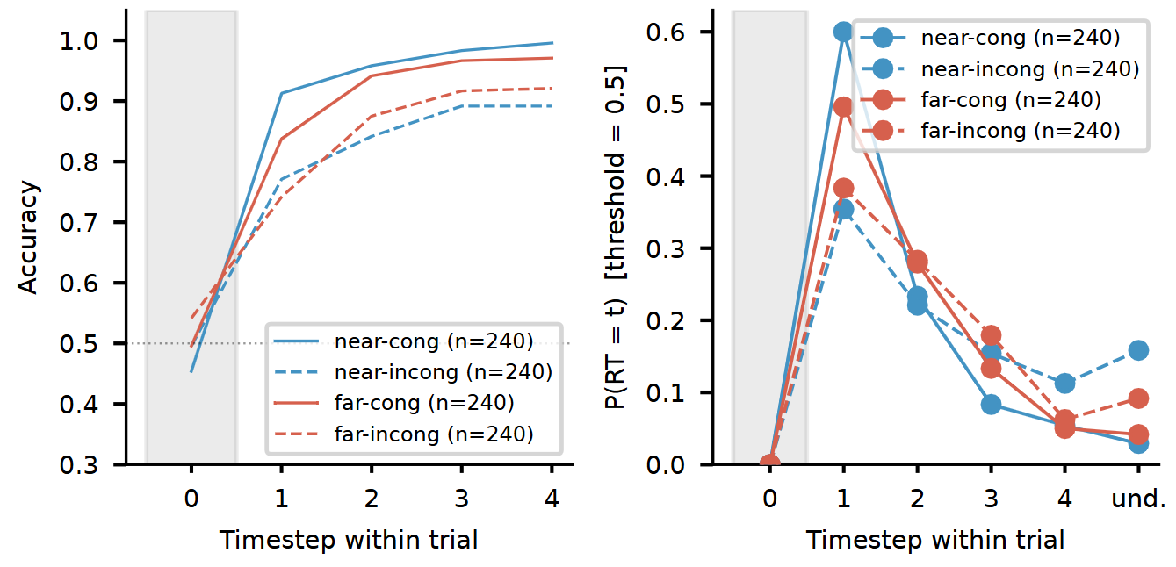

Fig 1: Behavioral fingerprint — congruency × distance. Accuracy and reaction-time distributions across the four near/far × congruent/incongruent flanker conditions. Congruent trials accuracy rises faster within a trial and achieve higher accuracy. Fast even when congruent flankers are close vs. far. Also overall near flankers amplify the results whereas far flanker have less prominent effect. Reactions times follow a similar pattern.
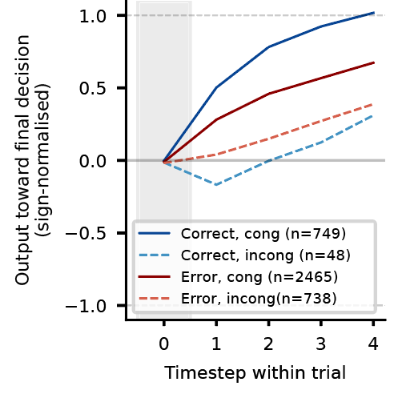

Fig 2: Within-trial evidence-accumulation dynamics. The sign-normalized decision variable over time, showing the early flanker-driven dip and its late reversal — linking the model's internal dynamics to the human BPL signature used to validate the models.

